Overview
ACTIVITIES: WHAT THE FAMILY PARTNER DOES

Engage the Family

Work with Caregiver

Gather Information: Strengths, Needs, Culture Discovery (SNCD)

Agenda Preparation

Care Planning

 | CORE PRINCIPLES
Why | How the Family Partner does it
SE | Check in with the family during and at the end of interactions and activities to determine family satisfaction with the process.
S | Support and encourage positive relationships with immediate and extended family members.
W | Share from your experience of wraparound activities to help the family see how the same activities could work for them.
DS | engage the family in reflective conversation about how the experience shared relates to their own situation.
W | Honor the culture of the family by keeping your own views  in check.

WRAPAROUND PRINCIPLES
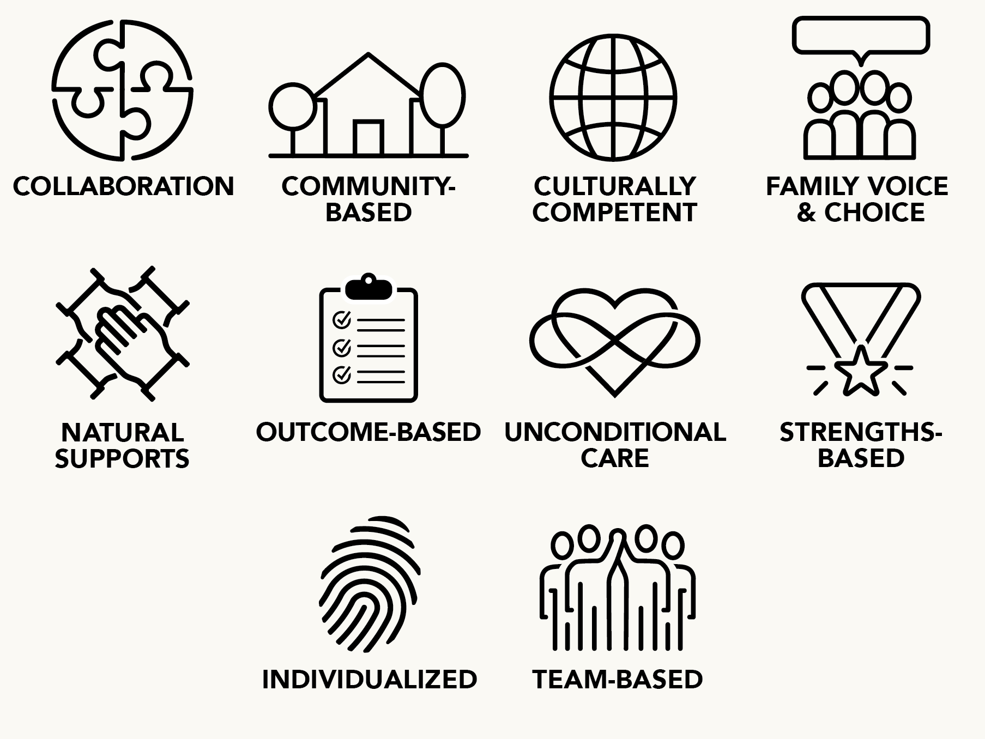

Engage the Family
 | SKILL SET
Why | How the Family Partner does it
S | Actively listen to the family’s concerns about involving natural supports in the process, and explain how the checks and balances within wraparound can address the concerns.
SE | Share a small sample of your own experience facing similar challenges, to establish a sense of empathy and understanding.
FVC | When sharing from your own experience, pay active attention to ensure that the family wants to hear the story and that it is addressing a specific need.
W | Assist the Care Coordinator by doing one-on-one orientation and/or by sharing your own experience with wraparound to help the family to understand how wraparound might be a positive opportunity for them.
W | Be open and welcoming and engage the family in conversation identifying the family’s needs before explaining wraparound.
SE | Explain wraparound for the family in relation to the family’s needs and goals that can be met by the process.
SE | Ask the family about their hopes and dreams, and help them to believe that they can accomplish their vision.
W | Help the family understand what is different about wraparound by explaining wraparound from a family’s perspective.
W | Provide written materials and other resources to help the family understand wraparound, review these materials with the family, and answer questions.
W | Explain the family partner role, including what the family partner may do and the limits on the role.
W | Assist the Care Coordinator in explaining confidentiality and client rights, helping as needed to ease these fears and answer questions from a family perspective.
W | Actively listen to the family and develop an engagement link prior to moving forward with wraparound activities.
W | Be open, welcoming, and available to the family.
SE | Share from your experience of wraparound activities to help the family see how the process can be an opportunity for them.

Work with Caregiver
 | SKILL SET
Why | How the Family Partner does it
S | Brainstorm ways the family can strengthen reciprocal relations with their supports.
S | Help the family identify what makes relationships reciprocal (what each person gets from the relationship) to help define and sustain these natural supports.
S | Do more in-depth work with the family to identify potential natural supports, if they cannot immediately come up with any.
S | Share from lived experience the reasons why natural supports can be important to families.
SE | Help the family identify their current strengths around areas of self-efficacy and signs of confidence that they can make things work for their family.
SE | Educate and support the family in the importance of maintaining and using documentation to advocate and control the process of service and support.
SE | Help the family focus on the strengths of their natural supports and the opportunities provided by these supports.
S | Help the family to plan and reconnect with extended family and natural supports based on family voice and choice.
S | Help the family and natural supports work through barriers to partnership.
DS | Provide as much direct support for the family as is needed for their success, while planning for the fading of support: “do for, do with, cheer on.”
SE | Share from your experience working with other families facing similar challenges.
S | Share examples of how natural supports can help families achieve better or more sustained outcomes.
S | Share from your own experience an example of how being honest and open helped you to get better support.
SE | Recognize when it would be helpful to share personal experiences as a way for the family to reflect on their own situation.
W | Share briefly from your own story (or another family’s story without names or identifying information) with purpose and intent.
W | If a family member is distrustful of systems and does not want to sign consent and release forms, meet with the caregiver one-on-one to help them understand how sharing could benefit their family.
DS | Assist in the development of safety plans that are individualized, realistic for the family, and based on voice and choice.

Gather Information:
Strengths, Needs,
Culture Discovery (SNCD)
 | SKILL SET
Why | How the Family Partner does it
S | Help the family think of needs that could be met by natural sup- ports, and identify current supports that could meet each one.
SE | Focus on the strengths of the family to create hope and motivation for success.
DS | Recognize and value the differences among families, helping the family discover their unique culture, and use this information to determine how they can best advocate for their family.
DS | Help family members understand and explain their culture and strengths to get their plans to match their family culture.
DS | Help the family understand their needs, culture, strengths, and preferences — and support the family in advocating for them.
DS | Help different members of the family come up with consensus needs, vision, and options that can be win/win for all family members.
W | Help the family prepare for the SNCD by helping them understand why sharing their strengths, needs, culture, and vision from a family perspective can lead to a better wraparound experience.
SE | Help the family prepare for the SNCD by explaining why wrap- around works better when negative concerns are reframed as positive needs.
DS | Help the family gather and organize information that they will need to advocate for their child.
FVC | Help gather the information for the SNCD and ensure that this information truly reflects the opinions and priorities of the family.
FVC | Take the completed summary document to the family, sit with them, and go over the document to make sure it is correct and represents the family’s vision of their strengths, needs, and vision.

Agenda Preparation
 | SKILL SET
Why | How the Family Partner does it
SE | Help the family understand and articulate their needs and vision for a better future.
W | Prepare the family to take an active role in the wraparound planning process.
S | Help the family find natural and community supports to help with the planning process.
S | Help the family to identify people, especially natural supports, who can help them achieve their vision.
FVC | Spend additional time with the family to prepare them for the initial wraparound meetings, making sure they understand each part of the agenda and are prepared to use their voice and choice.
SE | Work with the family in advance of each meeting to determine the role you will play during the meeting.
FVC | Work with the CC to make sure family needs are met in the scheduling, location, and agenda for the wraparound planning meetings.
W | Support the family in contacting potential team members to engage and orient them in the process.

Family Partner initial training Skill Set CardS

Care Planning
 | SKILL SET
Why | How the Family Partner does it
DS | Help the family understand and articulate their strengths  and needs.
W | Prepare the family for the meeting, help them define strengths and culture that relate to priority needs, and brainstorm possible options related to these needs based on their strengths and culture.

