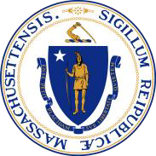

Commonwealth of Massachusetts

Executive Office for Administration and Finance

Family Resource Centers Update:

ORI Community Conversations Nov 5 2025

Maroli Licardie

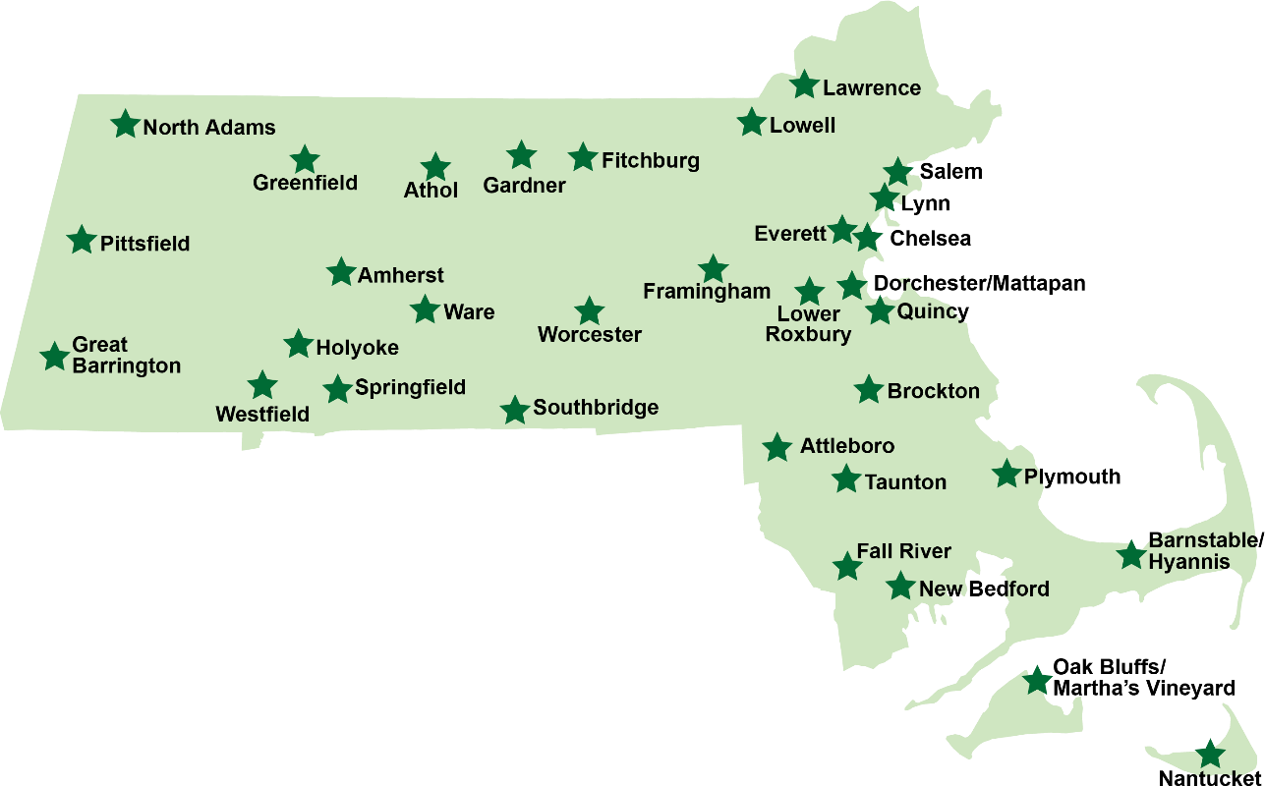
Locations and Services

The map shows service and support locations distributed throughout the state of Massachusetts in the following cities, in alphabetical order: Amherst; Athol; Attleboro; Barnstable/Hyannis; Brockton; Chelsea; Dorchester/Mattapan; Everett; Fall River; Fitchburg; Framingham; Gardner; Great Barrington; Greenfield; Holyoke; Lawrence; Lowell; Lower Roxbury; Lynn; Nantucket; New Bedford; North Adams; Oak Bluffs/Martha’s Vineyard; Pittsfield; Plymouth; Quincy; Salem; Southbridge; Springfield; Taunton; Ware; Westfield; Worcester.

- Information and Referral Services to families with children ages birth to 18 years of age
- Basic Needs
- Evidence-Based Parenting Education Groups
- Peer to Peer Support
- Educational Services and Resources
- CRA Related Services
- Networking and Mentoring Opportunities
- Cultural Opportunities
- Connection to and from state agencies, schools, and the community

Where is the closest FRC?

How can I find more information?

www.frcma.org

