**FAQs – Upcoming Changes to Virtual Gateway**

***When will the NEW Virtual Gateway login site go live?***

The Virtual Gateway (VG) is moving its log in portal to a new site on Sunday, May 19, 2024. All Virtual Gateway users will access the log in page via a new web site.  The exact site will be communicated soon. MyMassGov account creation and multifactor authentication (MFA) set up may be required.

Here is an image of the new Virtual Gateway Log In site.

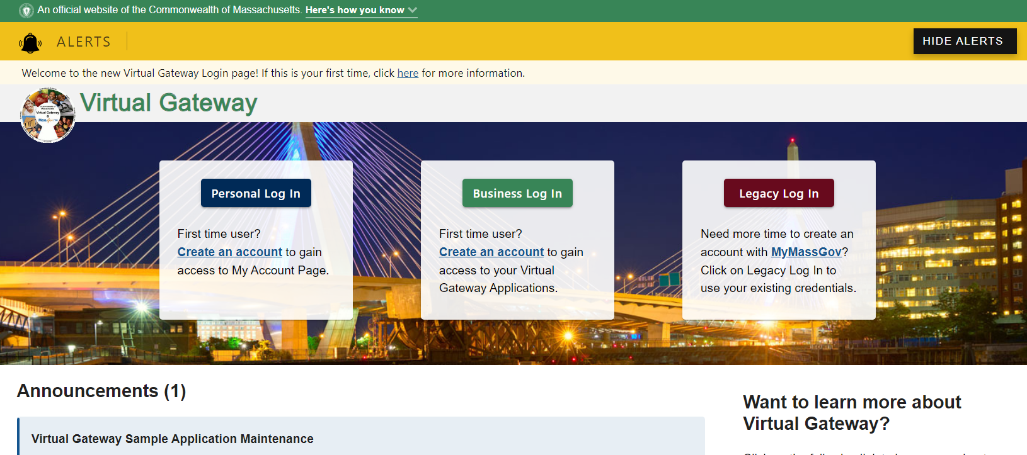

***Is the Virtual Gateway URL or website changing or will I access the same as I do today?***

The Virtual Gateway URL or website is changing (final website URL will be announced shortly). Once we are live with the new Virtual Gateway website on May 19, 2024, you can:

* Visit the [Mass.gov](https://www.mass.gov/) website to access the new Virtual Gateway log in page. Recommend bookmarking as a favorite for easy access. Go to **Mass.gov** > Select **Log In to …** > Select **Virtual Gateway**. Refer to specific web browser (Google Chrome or Microsoft Edge) for instructions on how to bookmark a website as a favorite.
* If you have the current Virtual Gateway Portal page saved as a favorite or bookmarked site in your browser, when you select from your list of favorites after 5/19/2024, the system will automatically take you to the new Virtual Gateway log in website.

***Who is affected by the Virtual Gateway moving to a new login site?***

All users (Agency, Provider and Public) will be affected by this change.

***Why is Virtual Gateway moving its login page?***

The new Virtual Gateway login site contains a secure service that allows users to use a single account and password to login and access their Virtual Gateway applications.

***Can I still access the old Virtual Gateway Portal page once the new Virtual Gateway log in site goes live?***

* All users will need to access the new Virtual Gateway log in site to access their applications and select from the following options:
  + **Personal Log In (Blue)**: This option is only for public users who use My Account Page (MAP) to view their personal MassHealth-related information. If you are a MAP user with 1 Virtual Gateway User ID linked to 1 email address, use this option when logging into the Virtual Gateway. This self-service option requires a user to create a MyMassGov account and set-up multifactor authentication (MFA)*.*
  + **Business Log In (Green)**: This option is for state agency staff, provider users and DCF Mandated Reporters who use applications on the Virtual Gateway. Any user (new or existing) who has 1 Virtual Gateway User ID linked to 1 email, will use this option when logging into the Virtual Gateway prior to accessing their applications. This option requires a user to create a MyMassGov account and set-up multifactor authentication (MFA).
  + **Legacy Log In (Red)**: This option is for any user (*My Account Page* *Public, State Agency staff, Provider staff or DCF Mandated Reporter)* who has multiple Virtual Gateway User ID’s, but only 1 email on file with the Virtual Gateway. Creation of a MyMassGov account and setting up of multifactor authentication (MFA) are not required for these users. This option is available for a limited time.

**I am a State Employee. How will I access the new Virtual Gateway website?**

* + Existing state employees who have 1 Virtual Gateway User ID linked to their Mass.gov email should select the **Business Log In** option, then the **Log in as an MA state employee** link. This link allows a state employe user to log into Virtual Gateway under their network login and enter the multifactor authentication (MFA) verification code when asked.
  + *Note: MA state employees, who have a Mass.gov email, will already have a MyMassGov account and multifactor authentication (MFA) would have been set up per your network log in account—no additional set up is needed.*

***How can I find out what email address is linked to my Virtual Gateway ID?***

* Prior to 5/19/24, access the Virtual Gateway Log In page at <https://sso.hhs.state.ma.us/vgportal>.
* Log in to your Virtual Gateway account and go to the Accessible Applications page.
* Select Manage My Account > Update Personal Information.
* Review and if needed, update your email, and click the Submit button.
* If assistance is needed, contact Virtual Gateway Customer Service.
  + Virtual Gateway Customer Service: (800) 421-0938 - TTY (617) 847-6578  
    Monday - Friday 8:30 am - 5:00 pm

***How will my end users be notified of this change?***

Virtual Gateway has several communication channels in which users will learn about the changes to the Virtual Gateway website and login process.

* **Application Business Teams**: Talk with your point of contact at the state agency your organization works with to find out more about the changes coming and the impact on your application. Note: There are no changes to any applications because of these upcoming changes.
* **Email Notifications**: Emails have been sent to all active users letting you know about the upcoming changes. Emails were sent on:
  + 4/26/24 and 5/6/24 (Al Active Provider users and State Employees)
  + 4/27/24 and 5/7/24 (All Active MAP Public Users)
  + 5/2/24 (All active users with multiple Virtual Gateway User ID’s)
* **Virtual Gateway Portal Notifications**: Virtual Gateway is posting messages about the upcoming changes on the current Virtual Gateway portal page under Announcements.
* **Virtual Gateway Resource Webpage**: Virtual Gateway has set up a dedicated webpage on our website with information about this change and how it will impact users. Visit [Virtual Gateway Resource Assistance for Providers and State Agency Staff | Mass.gov](https://www.mass.gov/info-details/virtual-gateway-resource-assistance-for-providers-and-state-agency-staff) to learn more.

***Is the process for submitting URF’s changing?***

No, the current URF submission and processing procedures will remain as is.

**Is the process for adding new or modifying existing organizations/access administrators (AA) changing?**

No, the current Organization Creation or Existing Organization procedures will remain as is.

***Will how I approve AIMS Work Items change?***

There is no change to the current AIMS Work Item approval process.

***Who will end users call if they need assistance?***

Virtual Gateway users should continue to call Virtual Gateway Customer Service (800-421-0938) if they have questions or issues with accessing the Virtual Gateway or your applications.