**New VPN Service – Answers to Frequently Asked Questions**

**Will I need to install a VPN client?**

Yes.  The Junos Pulse platform requires installation of a client which is compatible with your operating system. The client is installed by signing in to [http://vpn.mass.gov](http://vpn.mass.gov/) with your UIS username, password and passcode.  Administrator rights and Java are required, and ActiveX controls must be allowed for the installation process to complete.

**What benefits will I gain from the Junos Pulse  platform?**

The platform is web-based.  You can maintain your VPN user account on the Universal ID Profile Manager portal at [https://universalid.verizon.com](https://universalid.verizon.com/) from any internet connection using (virtually) any browser.

You will be able to choose the way you prefer to receive your one-time passcode for logging in: via email, audio message to your landline, text to your cellphone, etc.

If/when necessary, you will be able to update your authentication preferences and perform a self-serve password reset by answering challenge questions.

**What is my user name to access the VPN system?**

You will be able to use your existing UAID or the email address that your VPN enrollment email was sent to.

**What network resources will I be able to access while connected to VPN?**

The network resources you will be able to access depend on the group membership designated when your security administrator or security officer submitted your enrollment request.

**Is the Junos Pulse Client compatible with all Virus software?**

Once the software is completely installed it is.  Some Virus software may block part of the installation and make the install roll back even if the software is completely disabled.  Some virus software such as Kaspersky may require complete removal before the pulse client will install correctly.  Once the client is installed correctly the software can be re-installed on the machine without it causing any issues.

**How often does my password expire?**

The VPN password expires one year after creation (please note the Verizon UIS system does NOT provide notification of an approaching password expiration!)  Users can extend the expiration date by proactively changing their password on the Universal ID Profile Manager portal at [https://universalid.verizon.com](https://universalid.verizon.com/)  prior to expiration.

At the time of UIS profile creation, all users are required to select three Security Questions and provide answers.  Users whose passwords have expired (or have been forgotten) can gain access to their profile’s “Reset Password” link by providing the exact answers to their three security questions on the Universal ID Profile Manager portal at [https://universalid.verizon.com](https://universalid.verizon.com/) .  If users whose passwords have expired cannot provide the exact answers to their three security questions, a password reset request will need to be submitted to CommonHelp.

**Does the initial enrollment period ever expire?**

Yes, if you have not validated your UIS profile within 60 days of receiving the enrollment email, you will receive a second notice stating your activation period has expired.  The email will look like this:

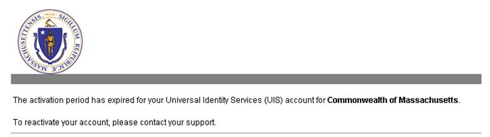

**What do I do if I have received a notice saying the activation period has expired for my UIS account?**

For State Employees, when you’re ready to use the UIS VPN you can call the CommonHelp Service Desk and we’ll resend your activation email.  For Contractors, Vendors and Business Partners please work with the appropriate agency staff to get your activation email resent.

**I’ve read the Reference Guide but still have questions about using the new VPN platform.  Who should I contact?**

The CommonHelp Service Desk will provides support, contact CommonHelp at 866-888-2808 or [commonhelp@state.ma.us](mailto:commonhelp@state.ma.us).