INDOOR AIR QUALITY ASSESSMENT

Farmington River Elementary School
555 North Main Road
Otis, MA

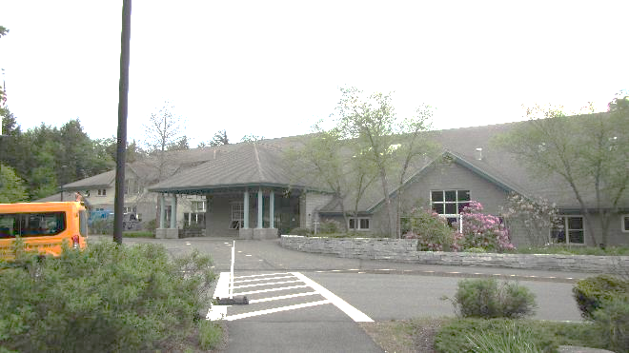

Prepared by:
Massachusetts Department of Public Health
Bureau of Climate and Environmental Health
Indoor Air Quality Program
September 2023

BACKGROUND

Building: | Farmington River Elementary School (FRES)
Address: | 555 North Main Street, Otis, MA
Assessment Requested by: | Robert R. Putnam, Interim Superintendent,  Farmington River Regional School District
Reason for Request: | General indoor air quality (IAQ) and a report of silverfish inside the building
Date of Assessment: | March 31, 2023, and June 2, 2023
Massachusetts Department of Public Health/Bureau of Environmental Health (MDPH/BCEH) Staff Conducting Assessment: | Mike Feeney, Director, IAQ Program, and  Stefanie Santora, Environmental Analyst, IAQ  Program
Building Description: | The FRES is a one-story brick building built in 1998 with classrooms, gymnasium, cafeteria, library, kitchen, and auditorium.
Building Population: | Approximately 400 total students and staff
Windows: | Windows are openable in some areas

RESULTS AND DISCUSSION
Please refer to the IAQ Manual for methods, sampling procedures, and interpretation of results (MDPH, 2015). The following is a summary of indoor air testing results (Table 1).
- Carbon dioxide levels were below 800 parts per million (ppm) in all of the occupied areas tested with the exception of one. Some areas were empty, which can reduce carbon dioxide levels.
- Temperature was close to or above the recommended range of 70°F to 78°F the day of the assessment in all areas tested.
- Relative humidity was within the recommended range of 40 to 60% in all areas the day of assessment.
- Carbon monoxide levels were non-detectable (ND) in all areas tested.
- Fine particulate matter (PM2.5) concentrations measured were below the National Ambient Air Quality (NAAQS) limit of 35 μg/m³ in all areas tested except for one.

Ventilation
A heating, ventilating and air conditioning (HVAC) system has several functions. First it provides heating and, if equipped, cooling. Second, it is a source of fresh air. Finally, an HVAC system will dilute and remove normally occurring indoor environmental pollutants by not only introducing fresh air, but by filtering the airstream and ejecting stale air to the outdoors via exhaust ventilation. Even if an HVAC system is operating as designed, point sources of respiratory irritation may exist and cause symptoms in sensitive individuals.
Fresh air is provided by air handling units (AHUs) located inside mechanical rooms located in spaces below the peaked roof in multiple locations. Each mechanical room has gypsum wallboard walls. Air from the AHUs is filtered, heated or cooled as needed, and delivered to rooms via ducted supply vents (Picture 1) and returned by wall-mounted exhaust vents (Picture 2). Some of the AHUs noted in the building (manufactured by DuChamp, Trane, and others) are of a configuration that is typically used in indoor mechanical rooms as opposed to AHUs designed for installation outdoors, where such equipment would be subjected to temperature extremes and rain/snow. Since winter temperatures in the greater Berkshire area can be significantly below freezing in winter months, insulation that has a sufficient R value for the expected below-freezing temperatures is necessary to prevent AHU coils from freezing. In addition, the placement of the AHU may, in addition to other conditions in the attic, result in the roof becoming heated and causing ice dams.
Some rooms in the FRES may experience difficulty in controlling temperature due to location of thermostats, e.g. behind classroom doors (Picture 3). When the door is kept open, classroom air temperature cannot readily be measured by the thermostat.

It is also important to note that despite ongoing maintenance and replacement of parts/components by facilities staff, many of the HVAC units are at the end of their life cycle. Efficient equipment is difficult to maintain since compatible replacement parts are often unavailable. According to the American Society of Heating, Refrigeration, and Air-Conditioning Engineering (ASHRAE), the service life of this type of unit is 15-20 years, assuming routine maintenance of the equipment (ASHRAE, 1991).

To maximize air exchange, the IAQ program recommends that both supply and exhaust ventilation operate continuously during periods of occupancy. To have proper ventilation with a mechanical ventilation system, the systems must be balanced after installation to provide an adequate amount of fresh air to the interior of a room while removing stale air from the room. It is recommended that HVAC systems be re-balanced every five years to ensure adequate air systems function (SMACNA, 2013). Based on the age and condition of the univents, balancing of the HVAC system may not be possible.

Microbial/Moisture Concerns
FRES staff reported an infestation of silverfish in a classroom. IAQ staff did not observe silverfish in any location within the building. Silverfish tend to grow in damp, dark, and cool places including buildings with wet brick and stone. IAQ staff examined exterior walls and noted significant water exposure (Pictures 4 and 5) to exterior wall brick in a number of locations, particularly along the west, south, and southwest corner of the exterior walls of the building. The FRES exterior walls show a number of locations that have been repeatedly exposed to water due to rainwater runoff from the various roofs (Picture 6). The FRES has a number of locations that have moss growing on exterior wall stone (Picture 4) which indicate chronic water exposure. Moss tends to form on brickwork that retains moisture by lack of drainage and/or is not dried by solar/thermal heat. Many of the wall surfaces of the FRES do not see extended exposure to sunlight due to the topography and trees along the south side of the building.

Lack of roof gutter/downspout
One significant condition causing exterior water exposure is that most of the roof edges do not have a gutter/downspout system to capture rainwater. Rainwater flows off the roof edge to impact the stone at the base of exterior walls (Pictures 5 and 6), as demonstrated by extensive furrows in the stone at the base of exterior walls. As rainwater impacts the ground with force, soil becomes compressed, which creates furrows, allowing water to puddle at the base and splash against exterior walls. The repeated wetting and lack of drying likely provides the condition that results in moss growth on walls, which can accelerate weathering/damage to brick and mortar. Splashing from rainwater can moisten exterior wall stone which requires a drainage system for water to exist the wall system.

Weep Hole Blockage
During the exterior examination, IAQ staff noted exterior wall drainage hindered by clogged/plugged weep holes (Pictures 7 and 8) in areas along the west, south, and southwest corner of the building. In modern construction, brick exterior wall systems are usually designed to prevent moisture penetration into the building interior. An exterior wall system usually consists of an exterior brick curtain wall. Behind the curtain wall is an air space that allows for water to drain downward and for the exterior cladding system to dry. At the base of the curtain wall should be weep holes that allow for water drainage. Opposite the exterior wall and across the air space is a continuous, water-resistant material adhered to the backup wall that forms the drainage plane (Figure 1).
The purpose of the drainage plane is to prevent moisture that crosses the air space from penetrating into interior building systems. The plane also directs moisture downward toward the weep holes. The drainage plane can consist of a number of water-resistant materials, such as tarpaper or, in newer buildings, plastic wraps, and should be continuous. Where breaks exist in the drainage plane (e.g., window systems, door systems and fresh air intakes), additional materials (e.g., flashing) are installed as transitional surfaces to direct water to weep holes. If the drainage plane is discontinuous, missing flashing, or lacking air space, rainwater may accumulate inside the wall cavity and lead to moisture penetration into the building.
To allow water to drain from the exterior brick wall system, a series of weep holes is customarily installed at or near the foundation slab/exterior wall system junction (Figure 1). Weep holes allow for accumulated water to drain from a wall system (Dalzell, 1955). Failure to install weep holes in brickwork or clogging/burial of weep holes below grade will allow water to accumulate in the base of walls, resulting in seepage and possible moistening of building components (Figure 2).

Ice Dams
Water-damaged ceiling tiles were noted in several locations throughout the FRES (Table 1), which are reportedly attributed to ice dams that occur on the roof during winter months:
Ice dams form when snow melts and runs down the roof to the eaves, where it turns to ice. The “dam” created by the ridge of ice along the eaves can trap more water and result in significant water damage. Ice dams occur when snow is present on the roof, the outside temperature is below freezing, and the temperature is above freezing on the roof deck (the foundation or base upon which the entire roofing system depends). Most ice dams form when heat loss into the attic warms the underside of sheathing plywood (the layer of material attached to the roof’s structural frame) that serves as the base for shingles or other materials. Warm air causes snow on the roof deck to melt and the water runs down to the colder edge of the roof where the water refreezes and leads to a buildup of ice and a backup of water — hence the term “dam.” (MDOER, 2017)
There are a number of strategies that may be used to remove/limit snow accumulation on a roof or to limit the development of ice dams:
- Install a roof with limited number of seams and roof valleys.
- Install the components to keep the roof temperature similar to outdoor temperature to limit snow melting and refreezing to cause ice dams.
- Remove snow from the roof as quickly as feasible after snowstorms.
The FRES roof has a complex shape with at least 16 roof valleys (Picture 9), making the first option not feasible. Snow accumulation in roof valleys was noted during the March 31, 2023 visit (Picture 10 and 11). If roof valley flashing contains any openings along the flashing/roof seams, water leaks from ice dams will likely damage the interior space.
A soffit vent system was noted under the edge of the roof (Picture 12). In order to prevent ice dams, soffit vents are installed below the roof edge to allow for outdoor air to enter the attic to keep the roof at a similar temperature to the outdoors and deter melting. In buildings with peaked roofs, a vent is frequently installed along the peak of the roof to allow for waste heat to exit the attic (called a ridge vent). Another method to vent heat is the installation of a vent in the side wall in the roof gable (called a gable vent; Picture 13)
It appears that the attic space has features that are used to prevent ice dams but also contains AHU mechanical rooms that disrupt the design of the attic to prevent ice dams.
There are a number of conditions that limit the venting of waste heat from the roof assembly and make melting and ice dams more likely:
- Fiberglass insulation batts appear to be installed over soffit vents (Picture 14). Typically, outdoor light can be seen inside attic space through soffit vents open to the outdoors. Insulation appears to be installed over the attic floor into the soffits, which blocks outdoor air movement into the attic.
- Roof decking is composed of exposed corrugated metal without insulation (Picture 15). This condition indicates that the roof is intended to be chilled to prevent ice dams by using a soffit-gable vent configuration.
- The building does not appear to have ridge vents (Picture 16). No vents were visible from outdoor observation nor were any located inside the attic.
- Free airflow is blocked by the AHU mechanical rooms. Triangular gable vents (Picture 17) appear to be the means to release waste heat from the attic. In order for this design to work efficiently, free flow of outdoor air movement through the attic is necessary. Disrupting the natural outdoor airflow through the roof attic are the walls of the AHU mechanical rooms which block the free flow of air from attic.
- AHU mechanical rooms and the attic in general can readily release waste heat to warm the roof. The following was noted:
  - Holes in walls adjacent to AHU (Picture 18).
  - Lack of insulation on attic AHU mechanical room attic access doors.
  - Missing or damaged fiberglass insulation batts on attic floor (Picture 19).
  - Attic AHU rooms may have insufficient insulation on walls and ceiling.
Based on these observations, it is possible that these conditions contribute to the development of ice dams.

Assessing Building Materials That May Be Prone to Condensation.
The FRES has many carpeted areas that are installed on a cement slab floor, which if exposed to moisture, can support mold growth. IAQ staff did not observe musty odors on the main floor, however the main entrance hallway floor tiles exhibit signs of frequent condensation along floor seams (Picture 20). In addition, a number of classrooms have bowed ceiling tiles (Table 1), which are another sign of chronic exposure to high relative humidity. It is important to note that Massachusetts experienced extended periods of relative humidity during the summer of 2021. July of 2021 was the wettest ever recorded in Massachusetts, and the three-month period from June through August, known as the meteorological summer, was the fourth wettest on record, according to the National Oceanic and Atmospheric Administration’s (NOAA) Centers for Environmental Information. The three-month period also was the third warmest ever in the state and was tied for the warmest on record across the United States (HG, 2021, NOAA, 2021).
Given the type of floor construction (cement on soil), the FRES was assessed to determine if floors were subject to developing condensation during extended (> 24 hours) hot, humid weather. The key to managing condensation in hot, humid weather indoors is understanding dew point. When warm, moist air passes over a cooler surface, condensation can form. Condensation is the collection of moisture on a surface at or below the dew point. The dew point is the temperature that air must reach for saturation to occur. If a building material/component has a temperature below the dew point, condensation will accumulate on that material.
A method to locate areas in a building prone to condensation is to measure air and building material temperatures using a laser thermometer (Table 1). If a wide temperature range exists between measurements (>5°F), the building materials at the colder end of the range may be prone to becoming moistened with condensation if exposed to hot, humid weather (70% relative humidity) for extended periods of time. According to the test results in Table 1, some areas in offices near an exterior door as well as in below-grade space may develop condensation during extended periods of hot, humid weather.

Note that relative humidity measured in the building was well below 70% in all locations measured during the June 2, 2023, assessment (Table 1). According to American Society of Heating, Refrigerating and Air-Conditioning Engineers (ASHRAE), if relative humidity exceeds 70%, mold growth may occur due to wetting of building materials even in the absence of visible condensation (ASHRAE, 2022). If moistened, porous materials such as gypsum wallboard, cardboard and other materials may become mold colonized.

Exterior Insulation and Finish System
Part of the exterior wall (Picture 21) is clad with an Exterior Insulation and Finish System (EIFS). “An Exterior Insulation and Finish System (EIFS) is a non-load bearing, exterior wall cladding system that consists of an insulation board attached either adhesively or mechanically, or both, to the substrate; an integrally reinforced base coat; and a textured protective finish coat.” (EIMA, 2023) Some EIFS, particularly more recently, is constructed with a drainage plane similar to that described above under weep holes and shown in Figure 1. The EIFS system at the FRES, however, appears to be a barrier wall system. The “barrier EIFS wall systems rely primarily on the base coat portion of the exterior skin to resist water penetration” (Zwayer, 2016). In essence, the rainwater is shed by the exterior “stucco” surface, which functions as drainage plane.
Problems observed with EIFS installations are primarily related to moisture intrusion. EIFS provides protection against moisture infiltration at the base coat; however, moisture migration through openings for windows, flashings and other items, or holes and cracks in the EIFS itself, have allowed for moisture invasion in EIFS clad buildings. With barrier EIFS installations, or where weather barriers and flashing are improperly installed in conjunction with wall drainage EIFS installations, moisture has entered the wall system at these locations and caused damage to the wall sheathing and framing (Zwayer, G.L., 2016).
The EIFS system at the FRES likely does not have an interior drainage plane, as the following was observed:
- Lack of weep holes on the EIFS exterior wall.
- Lack of a visible drainage plane behind the substrate of EIFS wall.
- Seams in sealant exist that can allow moisture to enter the exterior walls. Windowsills in the-EIFS walls have drip edges to minimize direct water contact with sealant between the sill and walls (Picture 22). During installation, windowsills appear to be installed in a manner to fill in the drip edge (Picture 23).
Considering these observations, the EIFS system is most likely a barrier system which has little or no means to drain water from the wall system. In addition, the National Institute of Building Science Whole Building Design Guidelines lists the following problems that may occur in a building clad with EIFS (Zwayer, 2016):
- Failure to install or properly install sealant joints around windows, doors, pipes, conduits, and other penetrations of the field of the EIFS.
- Failure to flash window and door openings in the field of the EIFS to divert leakage through the window or door to the exterior.
- Windows in EIFS wall do not appear to have flashing (Picture 24). Spaces between window frames and EIFS panels were sealed with caulking (Picture 25).
- Failure to properly backwrap edges of EIFS at terminations and penetrations in the field of the EIFS. Note that this condition was not observed at FRES.
- Failure to terminate EIFS above grade, especially in termite prone regions.
  - EIFS system and cement slab juncture are above grade on the west wall (Picture 26).
  - One section near the front entrance may on the east wall may have stone near the EIFS/slab junction. This location should be monitored for water damage due to possible rainwater accumulation in this location (Picture 27).
- Un-repaired impact damage.
  - A number of locations appear to have damaged basecoat that exposes the underlying insulation boards (Pictures 28 and 29).
Each of these conditions can allow for water to penetrate through the EIFS, causing water damage to the interior of the building.

Other IAQ Evaluations

Products of Combustion/Furnace Room
The heating/boiler systems for the school run on combustible fuel. Combustible fuel can produce combustion products, including carbon monoxide (CO) and nitrogen oxides (NO_{x}), which at certain concentrations can be harmful to health if inhaled. A properly functioning heating system will vent all products of combustion from the building away from indoor air and fresh air supply vents. Note that while no CO was detected during this assessment, the boilers were turned off due to warm weather. However, pathways were found that could allow leaking gas or products of combustion from the heating system into occupied areas. Additionally, wind patterns and the chimney height can aid movement of combustion products into the building.
Combustible fuel produces a number of different byproducts, the majority of which are carbon dioxide (CO₂) and water vapor. Depending upon the efficiency of the combustion, type and purity of the fuel, other types of byproducts are generated including NOx, CO, methane (CH₄), nitrous oxide (N₂O), volatile organic compounds (VOCs), trace amounts of sulfur dioxide (SO₂), and particulate matter (PM) (US EPA, 1998). Of note is nitrogen dioxide (NO₂), which has irritant effects on the respiratory system.
As the furnace operates, heat rises up the chimney to exit the flue. If the products of combustion become cooled at the top of the stack due to low chimney temperature, water vapor will condense on the brick and mix with SO₂ to form sulfurous acid and NO₂ to form nitric acid. Of note is staining that appears to emerge from joints in the furnace chimney (Picture 30). This staining may be a result of water vapor condensing inside the chimney, which then erodes the joints to allow for water to enter the furnace room. Accelerating the possible degradation process of the chimney joints is sulfurous and nitric acids that are contained in the condensed water. This process can undermine the integrity of the chimney and may allow furnace pollutants to enter into the interior of the building through damaged/missing chimney mortar and into classrooms.

Freezing Pipes
As reported by FRES staff, the furnace room has experienced pipe freezing. This issue is likely influenced by the following conditions:
    - In order to provide adequate combustion air for the furnace and water heater, two passive vents open to the outdoors (Pictures 31 and 32). These vents allow for direct, unconditioned air to enter the furnace room.
    - Water heaters are located in close proximity to the combustion air vent (Picture 32).
    - Insulation on pipes may be missing or do not have a sufficient R value to prevent freezing during the extreme cold temperatures that occur in the Berkshires.
    - The furnace room is located on the northernmost portion of the building. The north wall receives minimal solar heating, and the east wall is block by large shrubbery (Picture 33).

Other Conditions

Exposure to low levels of total volatile organic compounds (TVOCs) may produce eye, nose, throat, and/or respiratory irritation in some sensitive individuals. To determine if VOCs were present, BCEH/IAQ staff examined rooms for products containing VOCs. BCEH/IAQ staff noted hand sanitizers, cleaners/spray bottles, plug-in air fresheners, and dry erase materials in use within the building. All of these products have the potential to be irritants to the eyes, nose, throat, and respiratory system of sensitive individuals. Due to the pervasive use of these products in schools throughout Massachusetts, the MDPH has produced a guideline called “Clean Air Is Odor-Free” (https://www.mass.gov/doc/clean-air-is-odor-free-removing-fragrances-to-improve-indoor-air-quality-in-schools-and-offices-0/download).
In many areas, accumulated items including books, papers, toys, and decorative items were observed on floors, windowsills, tabletops, counters, bookcases, and desks. Excess items on surfaces can make it more difficult for custodial staff to clean.
Many classrooms/areas had carpeting. Carpeting should be HEPA vacuumed daily and cleaned annually or semi-annually in soiled high traffic areas. Many classrooms had area rugs, which should also be cleaned regularly and discarded when too worn out or soiled to be cleaned.
Note that the Environmental Protection Agency (EPA) conducted a National School Radon Survey in which it discovered nearly one in five schools had “…at least one frequently occupied ground contact room with short-term radon levels above 4 [picocuries per liter] pCi/L” (US EPA 1993). The BCEH/IAQ Program therefore recommends that every school be tested for radon, and that this testing be conducted during the heating season while school is in session in a manner consistent with USEPA radon testing guidelines. Radon measurement specialists and other information can be found at www.nrsb.org and http://aarst-nrpp.com/wp, with additional information at: http://www.mass.gov/eohhs/gov/departments/dph/programs/environmental-health/exposure-topics/iaq/radon.

CONCLUSIONS AND RECOMMENDATIONS
FRES has a number of issues related to moisture in the building. To remedy building problems, two sets of recommendations are made: short-term measures that may be implemented as soon as practicable and long-term measures that will require planning and resources to address overall IAQ concerns:

Short Term Recommendations

Ventilation Recommendations
- Consult with a building and/or HVAC engineer concerning the operation of the HVAC system during hot, humid weather and evaluate methods for reducing condensation-generation in these rooms.
- Operate all supply and exhaust ventilation equipment continuously during occupied periods.
- Ensure all exhaust vents are operating, make repairs as necessary. Check exhaust vents for air draw periodically.
- Consider adopting a balancing schedule of every 5 years for all mechanical ventilation systems, as recommended by ventilation industrial standards (SMACNA, 1994).
- Have a furnace technician examine the chimney for air tightness and make repairs as needed.

Water damage recommendations
- Management of buildings in hot, humid weather, particularly without air conditioning can be challenging. The following documents can provide guidance that can be used to reduce the impact of hot, humid weather in buildings.
  - Mold Growth Prevention During Hot, Humid Weather https://www.mass.gov/service-details/preventing-mold-growth-in-massachusetts-schools-during-hot-humid-weather
  - Remediation and Prevention of Mold Growth and Water Damage in Public Schools https://www.mass.gov/service-details/remediation-and-prevention-of-mold-growth-and-water-damage-in-public-schools-and
  - Methods for Increasing Comfort in Non-air-conditioned Schools https://www.mass.gov/doc/methods-for-increasing-comfort-in-non-air-conditioned-schools/download
- Ensure that all weep holes in exterior wall are open and above grade.
- Do not store porous items or other materials in contact with the floor of the building during summer months. Such materials include carpets, throw pillows, cardboard, paper, and other porous materials.
- Repair damage to EIFS walls as needed.
- Restore all drip edges on windowsills.
- Inspect windowsill caulking at least twice a year and make repairs to render the seams watertight as needed.
- It is recommended that porous material be dried with fans and heating within 24 to 48 hours of becoming wet (US EPA, 2008, ACGIH, 1989). If porous materials are not dried within this time frame, mold growth may occur. Water-damaged porous materials cannot be adequately cleaned to remove mold growth. If porous materials are not dried within this time frame, they should be removed and discarded.

Other recommendations
- Clean/change filters of AC units per manufacturers’ recommendations.
- Regularly clean/vacuum supply/exhaust/return vents and personal fans to avoid aerosolizing accumulated particulate matter.
- Reduce use of products and equipment that create irritating VOCs and only use in well-ventilated areas. Minimize the use of air fresheners (e.g., plug-ins), deodorizers and scented products.
- Keep spray bottles/cleaning products out of the reach of children. Ensure that products are compatible with one another. It is suggested that only school-supplied products be used to avoid product interactions.
- Clean carpeting annually (or semi-annually in soiled high traffic areas) per the recommendations of the Institute of Inspection, Cleaning and Restoration Certification (IICRC, 2012).
- Consider replacing any carpeting that is beyond its service life (i.e., > 11yrs.).
- The school should be tested for radon by a certified radon measurement specialist during the heating season when school is in session. Radon measurement specialists and other information can be found at: www.nrsb.org, and http://aarst-nrpp.com/wp.
- To learn more about radon, review the MDPH’s Radon in Schools and Child Care Programs factsheet, with additional information at: http://www.mass.gov/eohhs/gov/departments/dph/programs/environmental-health/exposure-topics/iaq/radon.
- Consider adopting the US EPA (2000) document, “Tools for Schools”, as an instrument for maintaining a good IAQ environment in the building available at: https://www.epa.gov/iaq-schools/indoor-air-quality-tools-schools-action-kit
- Refer to resource manual and other related IAQ documents located on the MDPH’s website for further building-wide evaluations and advice on maintaining public buildings. These documents are available at: http://mass.gov/dph/iaq.

Long Term Recommendations

Water Damage to Exterior Walls
- Consider installing a gutter/downspout system to gather and drain rainwater from the roof edge.
- Examine whether the EIFS walls have a drainage plane described above. It is difficult to maintain EIFS systems without drainage planes. If water intrusion occurs in multiple locations where EIFS is installed, consider replacing.
- Consider removing all trees that overhang the building or shade exterior walls and prevent drying of brick and EIFS.

Ice Dams
- Address temperature transfer between the attic and the HVAC units and associated piping. Perform these steps prior to any remodeling of attic vents:
  - HVAC mechanical room walls and doors should be fitted with a sufficient amount of insulation to prevent pipe/coil freezing.
  - All attic HVAC ceiling and walls should be insulated in a manner to prevent cold transfer from the attic space to the roof.
  - All pipes in the attic should have continuous insulation of a sufficient R value to prevent freezing during winter weather.
  - All attic doors should have sufficient insulation and weather stripping to become as airtight as feasible to prevent air movement to and from each attic HVAC room.
  - Ensure that attic floor insulation is continuous and in good condition.
  - Install adequate insulation then seal holes in AHU room in Picture 18.
- Remove insulation that covers soffit vent from the roof attic junction.
- Consider installing a fan to capture and eject attic air directly outdoors.

Furnace Room
- Consider installing ducts that connect the combust air vents directly to the furnace and water heater air intakes.
- In order to increase solar drying, remove all shrubbery preventing direct sunlight onto walls of furnace room.
- If feasible, consider reconfiguring the furnace room to move the water pipes and heaters away from the combustion air vent.
- Determine if the chimney has sufficient height and is constructed in a manner to eject products of combustion properly and not be subject to water vapor condensation.

HVAC system
- Since the HVAC system is likely beyond its service life, contact an HVAC engineering firm for advice regarding conditions noted at the FRES. This should include a building-wide HVAC equipment assessment to determine:
  - Whether the existing HVAC system can be balanced as recommended;
  - The operability and feasibility of repairing the existing equipment;
  - If the equipment should be replaced due to age, physical deterioration and availability of parts for ventilation components.

REFERENCES
ACGIH. 1989. Guidelines for the Assessment of Bioaerosols in the Indoor Environment. American Conference of Governmental Industrial Hygienists, Cincinnati, OH.

ASHRAE. 1991. ASHRAE Applications Handbook, Chapter 33 “Owning and Operating Costs”. American Society of Heating, Refrigeration and Air Conditioning Engineers, Atlanta, GA.

ASHRAE, 2022. American Society of Heating, Refrigeration and Air Conditioning Engineers (ASHRAE) Ventilation for Acceptable Indoor Air Quality. ANSI/ASHRAE Standard 62.1-2022. Atlanta, GA.

Dalzell, J.R. 1955. Simplified Masonry Planning and Building. McGraw-Hill Book Company, Inc. New York, NY.

EIMA. 2023. EIFS Industry Members Association. About EIFS. https://www.eima.com/eifs.

HG. 2021. Mold keeps South Hadley High School shuttered. Hampshire Gazette. https://www.gazettenet.com/South-Hadley-High-School-still-closed-amid-mold-remediation-42413519.

MDOER. 2017. Ice Dams. Massachusetts Department of Energy Resources. August 27, 2017. https://www.mass.gov/doc/ice-dams

MDPH. 2015. Massachusetts Department of Public Health. “Indoor Air Quality Manual: Chapters I-III”. Available at: https://www.mass.gov/lists/indoor-air-quality-manual-and-appendices.

NOAA. 2021. Summer 2021 neck and neck with Dust Bowl summer for hottest on record. National Oceanic and Atmospheric Administration, 1401 Constitution Avenue NW, Room 5128, Washington, DC 20230 https://www.noaa.gov/news/summer-2021-neck-and-neck-with-dust-bowl-summer-for-hottest-on-record

SMACNA. 2013. HVAC Systems Commissioning Manual. 2nd ed. Sheet Metal and Air Conditioning Contractors’ National Association, Inc., Chantilly, VA.

US EPA. 1998. Emission Factor Documentation for Ap-42 Section 1.4 Natural Gas. Office of Air Quality Planning and Standards. U.S. Environmental Protection Agency. Research Triangle Park, NC. March 1998 https://www3.epa.gov/ttn/chief/ap42/ch01/bgdocs/b01s04.pdf
US EPA. 1993. Radon Measurement in Schools, Revised Edition. Office of Air and Radiation, Office of Radiation and Indoor Air, Indoor Environments Division (6609J). EPA 402-R-92-014. https://archive.epa.gov/epa/sites/production/files/2014-08/documents/radon_measurement_in_schools.pdf

US EPA. 2000. Tools for Schools. Office of Air and Radiation, Office of Radiation and Indoor Air, Indoor Environments Division (6609J). EPA 402-K-95-001, Second Edition. http://www.epa.gov/iaq/schools/index.html.

US EPA. 2008. “Mold Remediation in Schools and Commercial Buildings”. EPA 402-K-01-001. United States Environmental Protection Agency, Office of Air and Radiation, Indoor Environments Division, Washington, DC. September 2008. http://www.epa.gov/mold/mold-remediation-schools-and-commercial-buildings-guide.

WP. 2018. ‘It’s been relentless’: Smothering summer humidity in the Northeast has crushed records. Washington Post, Washington, DC. https://www.washingtonpost.com/news/capital-weather-gang/wp/2018/08/30/its-been-relentless-smothering-summer-humidity-in-the-northeast-has-crushed-records/

Zwayer, G.L. 2016. Exterior Insulation and Finish System (EIFS). National Institute of Building Sciences, Washington, DC. http://www.wbdg.org/design/env_wall_eifs.php

Figure 1

Drainage Plane Function: Weep Holes Drain Water from the Wall System to

Prevent Moisture Penetration into the Interior

Drainage Plane

Driving Rain

Water
Movement

Exterior Curtain Wall

Weep Hole

Figure 2

Blocked Weep Hole and Water Accumulation in the Drainage Plane

Drainage Plane

Exterior Curtain Wall

Accumulate Water

Moisture Weep Hole Blocked with Wick

Picture 1
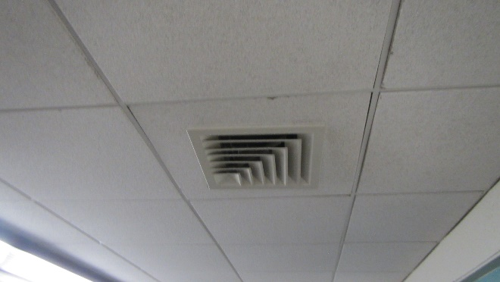
Fresh air supply diffuser
Picture 2
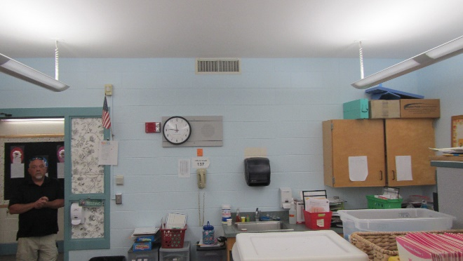
Exhaust vent

Picture 3
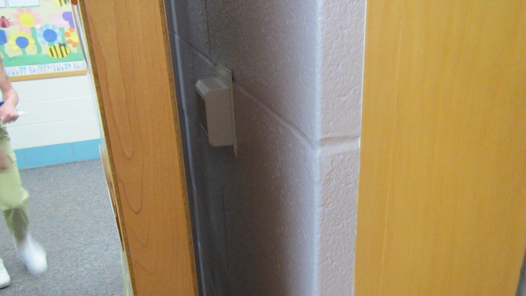
Classroom thermostat installed behind classroom hallway door

Picture 4
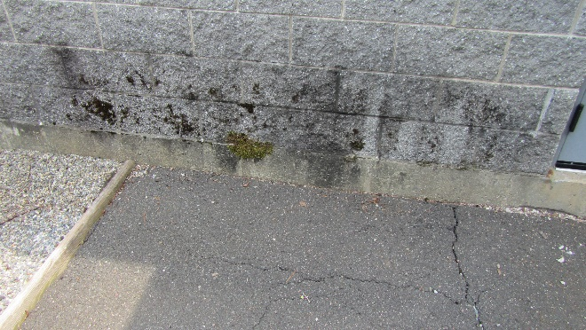
Water staining from repeated rainwater runoff exposure; moss growth indicates significant continuous moisture in stone wall

Picture 5
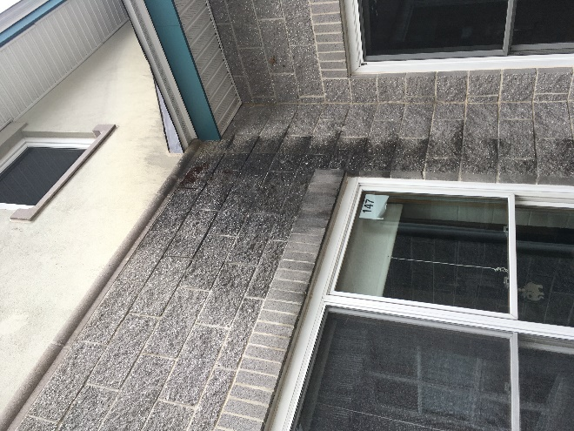
Water staining from repeated rainwater runoff exposure
Moss growth indicates significant continuous moisture in stone wall

Picture 6
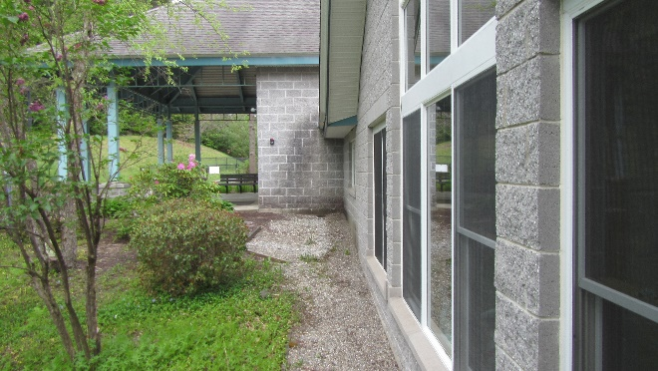
Stone wall staining from rainwater roof runoff

Picture 7
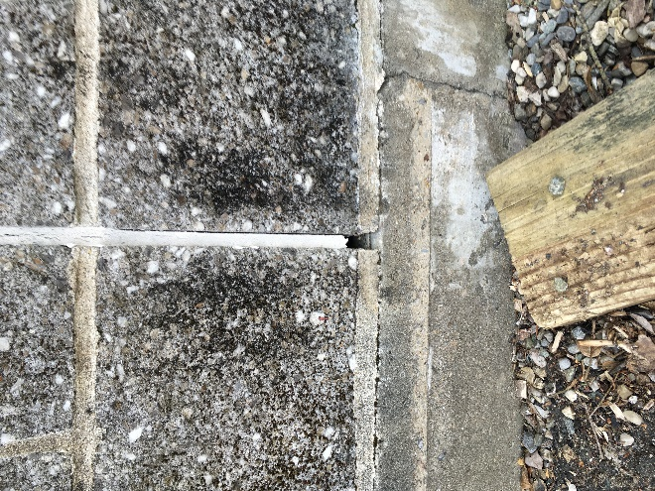
Open weep hole
Picture 8
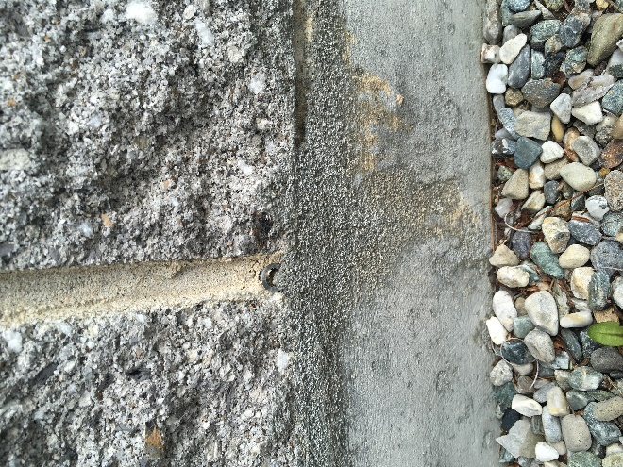
Closed weep hole
Picture 9
The FRES has at least 16 roof valleys (arrows) where snow may accumulate and not readily slide from the roof

Picture 10
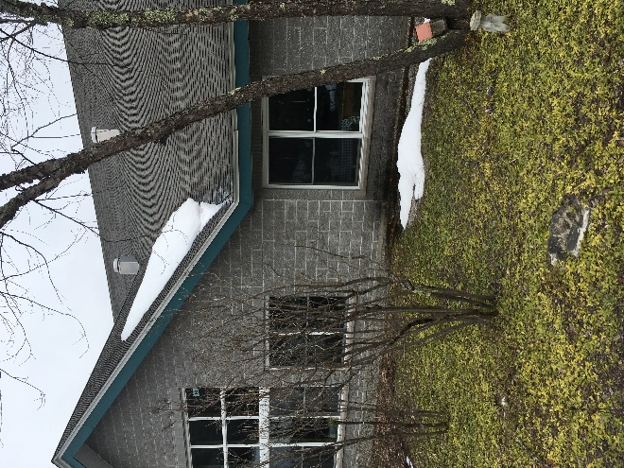
Accumulated snow in roof valley
Picture 11
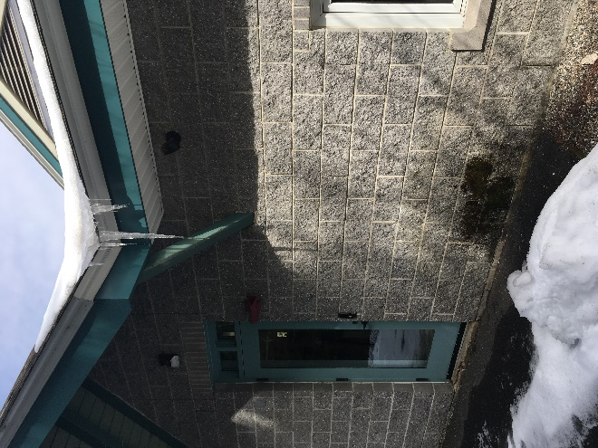
Accumulated snow in roof valley, note water stain below roof valley
Picture 12
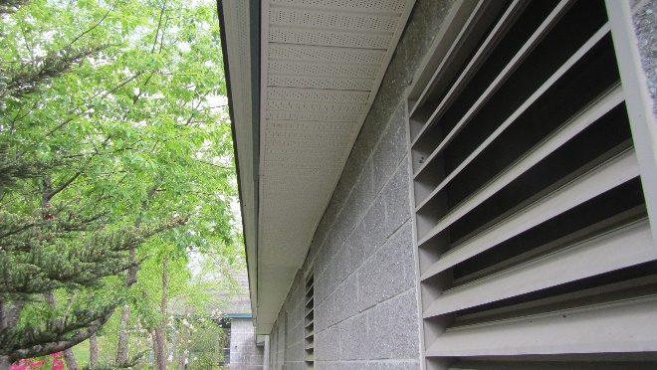
Soffit vent under roof edge

Picture 13
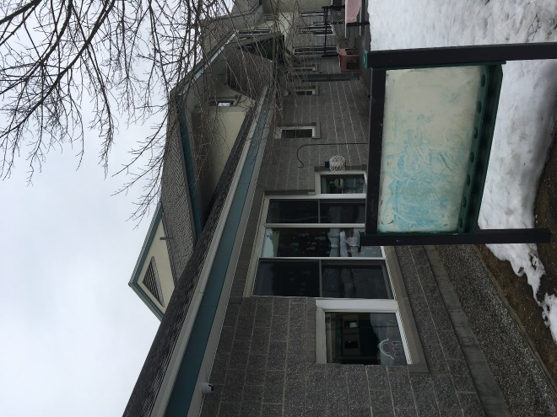
Gable vent
Picture 14
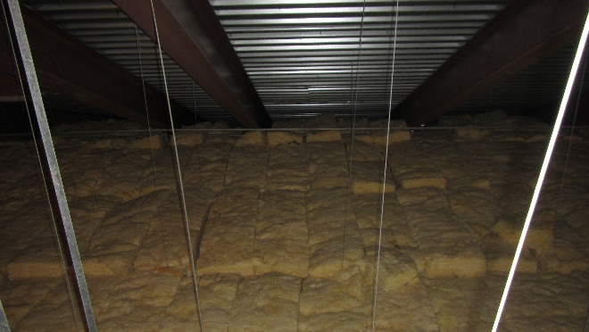
Insulation batts installed over into roof/attic floor angle, likely on top of soffit vents

Picture 15
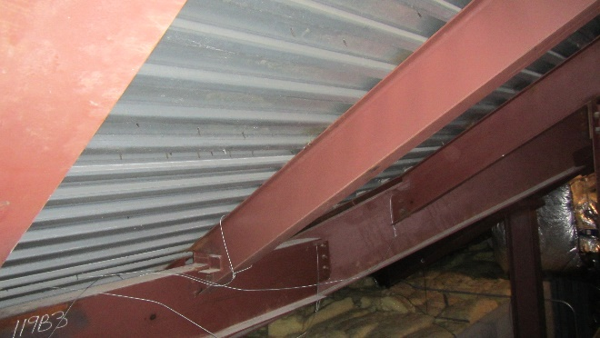
Exposed steel roof decking without visible insulation
Picture 16
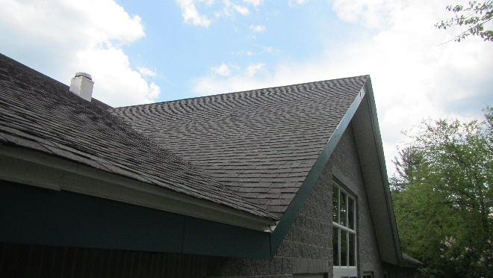
Solid roof peak with no observable ridge vent

Picture 17
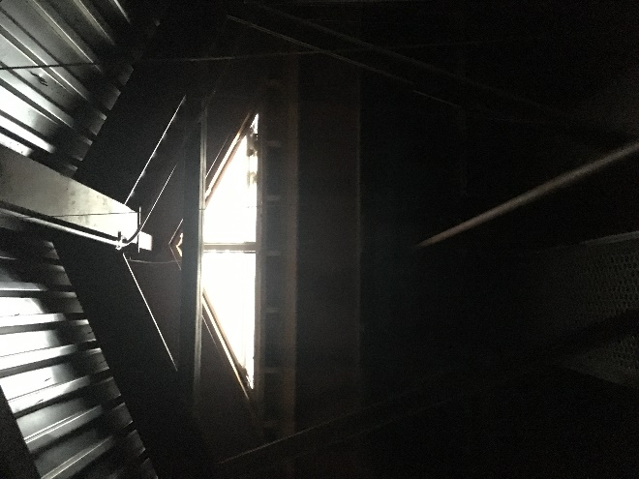
Interior view of gable vent in attic
Picture 18
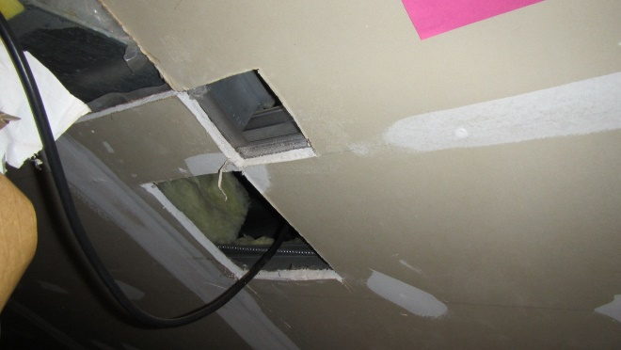
Holes in walls adjacent to AHU

Picture 19
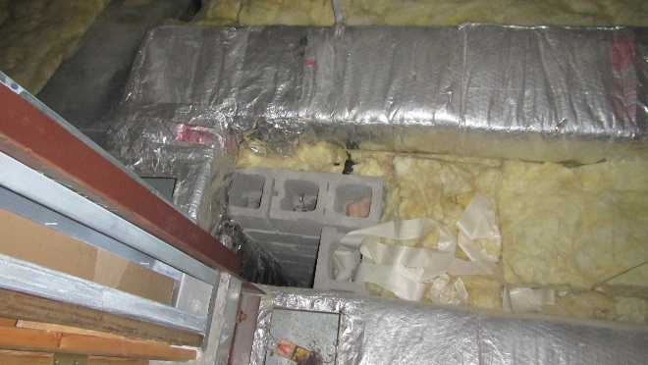
Missing or damaged fiberglass insulation batts on attic floor
Picture 20
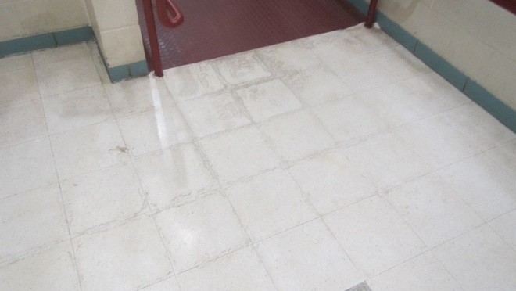
Water-damaged floor tiles from condensation

Picture 21
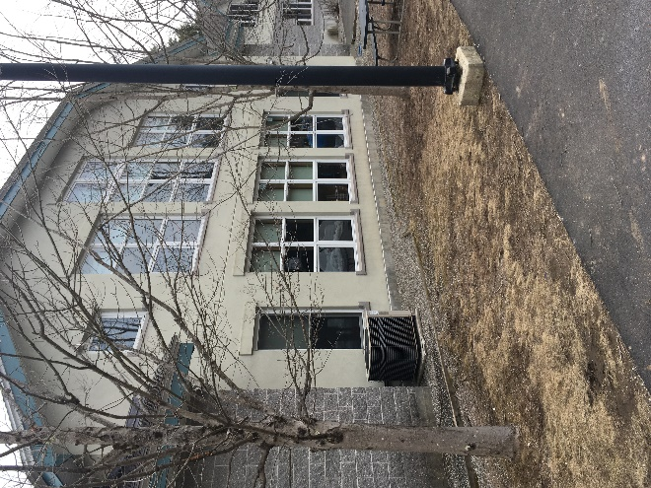
Exterior wall clad with an exterior foam insulating system (EIFS)
Picture 22
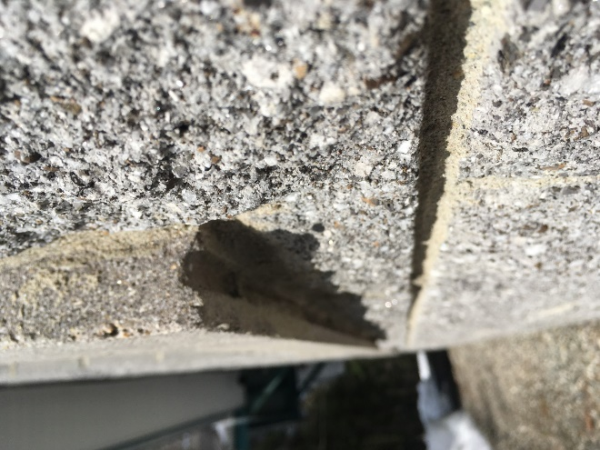
Drip edge under windowsill in EIFS wall
Picture 23
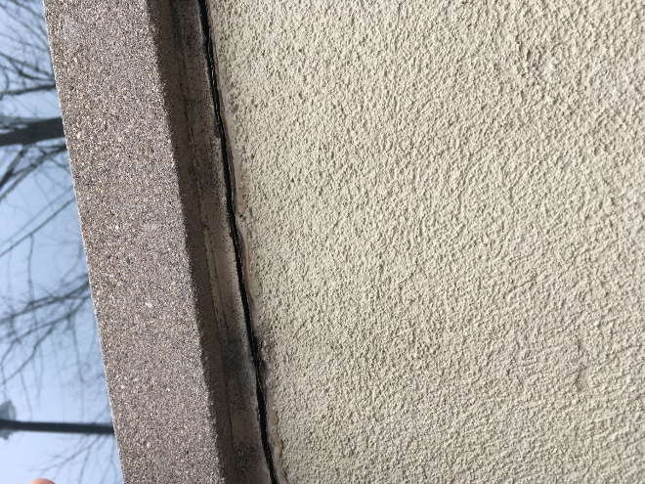
Windowsill installed with drip edge sealed, note damage to caulking beneath sill
Picture 24
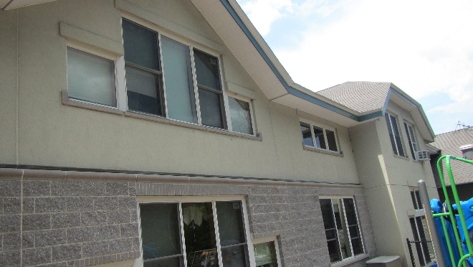
Windows in EIFS wall do not appear to have flashing

Picture 25
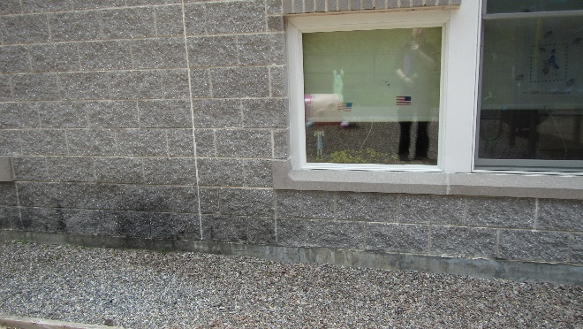
Window frame sealed with caulking
Picture 26
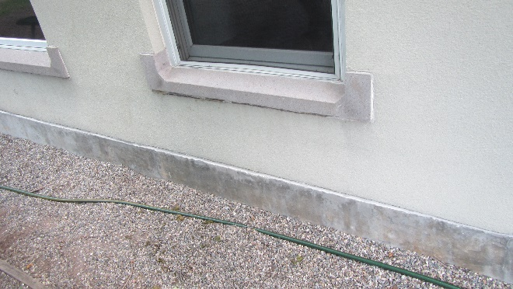
EIFS wall and slab junction exposed

Picture 27
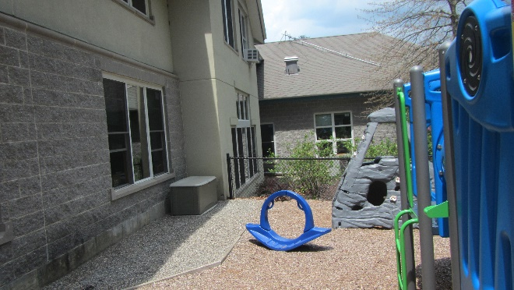
Possible location where wall and slab junction may be buried
Picture 28
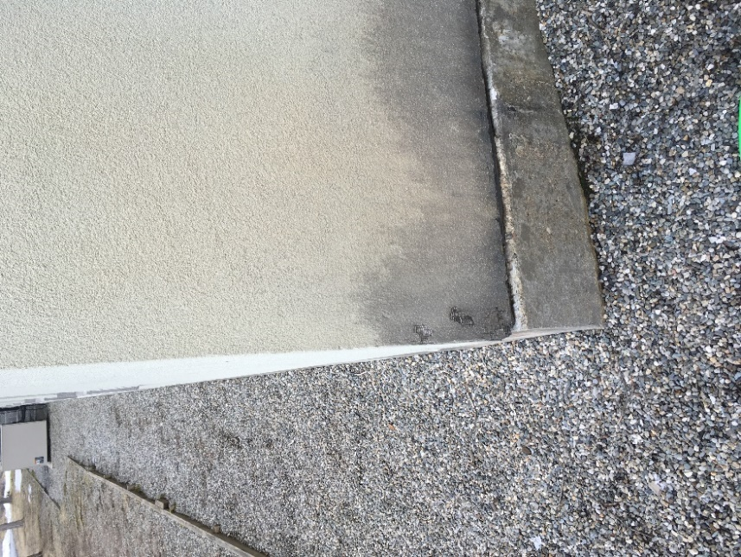
Damaged EIFS section
Picture 29
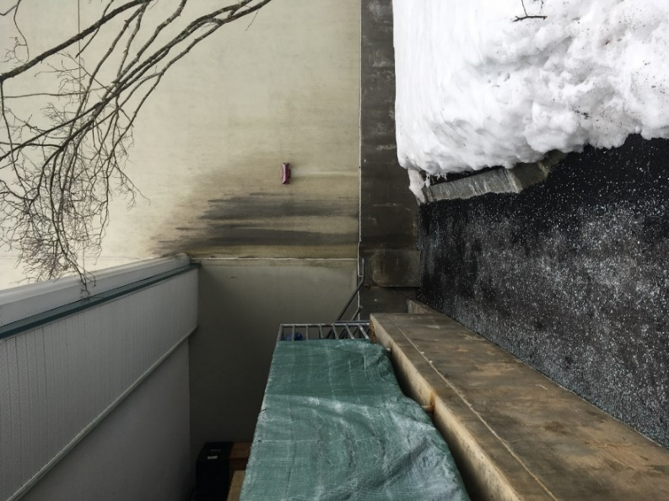
Damaged EIFS section
Picture 30
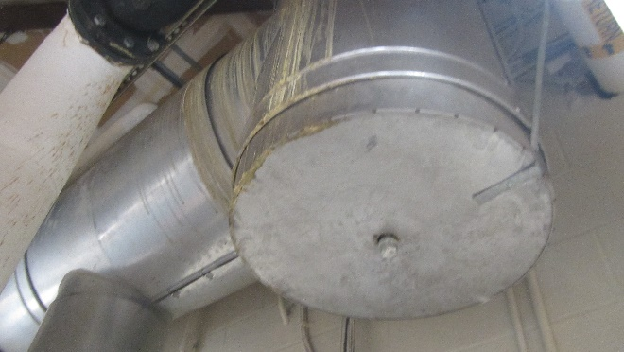
Staining that appears to emerge from joints in the furnace chimney

Picture 31
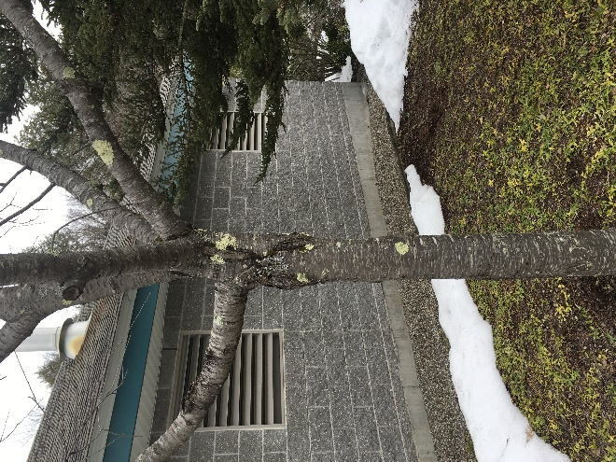
Furnace room passive vents that directly open to the outdoors
Picture 32
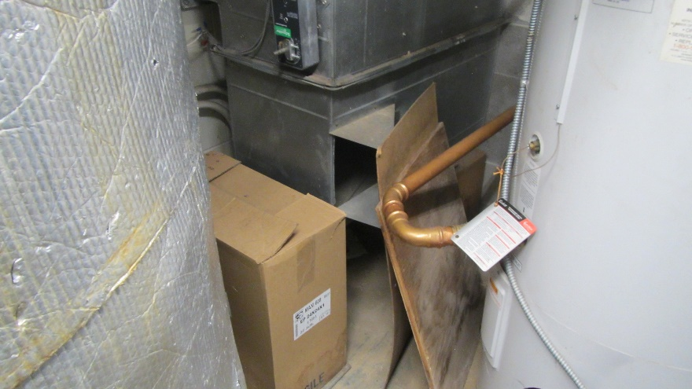
Interior view of passive combustion air vent that directly opens to the outdoors, arrow shows uninsulated water heater pipe near passive combustion air vent opening

Picture 33
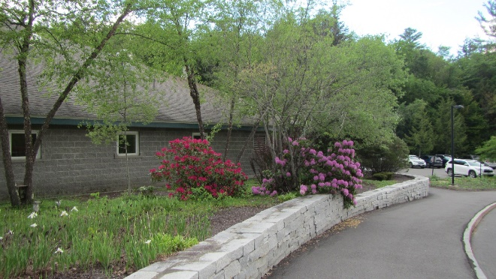
Furnace room receives minimal solar heating, and the east wall is blocked by shrubbery

Location | Carbon  Dioxide  (ppm) | Carbon Monoxide  (ppm) | Temp  (°F) | Relative  Humidity  (%) | PM2.5  (µg/m³) | Dew  Point | Floor Temp  (°F) | Temp at Floor/  Exterior Wall Junction  (°F) | Water Damaged/ Bowed Ceiling Tiles | Occupants  in Room | Windows  Openable | Remarks
Background | 388 | ND | 83 | 47 | 61
Gym | 660 | ND | 75 | 54 | 18 | 57 | 71 | 69 | Y | 4 | Y
109 | 489 | ND | 74 | 55 | 14 | 57 | 65 | 65 | N/A | 3 | N/A
Kitchen | 985 | ND | 77 | 57 | 18 | 61 |  |  | N/A | 6 | Y
Cafeteria | 718 | ND | 83 | 45 | 20 | 60 | 69 | 73 | N/A | 35 | Y | WD on ceiling
Library | 461 | ND | 77 | 48 | 15 | 56 |  |  | N/A | 3 | N/A | W2W
Rm in Library | 474 | ND | 77 | 49 | 13 | 57 |  |  | Y | 0 | N/A | WD CT, W2W
205 | 463 | ND | 78 | 47 | 36 | 57 |  |  | N/A | 0 | Y | W2W
215 | 504 | ND | 78 | 40 | 14 | 52 |  |  | N/A | 0 | Y | Air conditioner
214 | 497 | ND | 78 | 40 | 15 | 51 |  |  | N/A | 0 | Y | W2W
206 | 635 | ND | 78 | 49 | 15 | 57 |  |  | N/A | 0 | Y | W2W
213 | 778 | ND | 79 | 46 | 14 | 57 |  |  | N/A | 0 | Y | W2W
209 Storage |  |  |  |  |  |  |  |  |  |  |  | Cluttered, floor cleaner
123 | 444 | ND | 76 | 49 | 19 | 56 | 69 | 69 | N/A | 5 | Y | Window Open, W2W
127 | 478 | ND | 81 | 44 | 10 | 57 | 69 | 69 | N/A | 4 | Y | W2W, air purifier (Medify Air) on
In-between 127 & 136 | 549 | ND | 77 | 51 | 11 | 57 | 71 | 68 | N | 0 | Y | Adhered CT
136 | 488 | ND | 77 | 50 | 7 | 57 | 68 | 71 | N/A | 0 | Y | W2W, personal fan
121 | 437 | ND | 77 | 48 | 11 | 56 | 72 | 72 | N/A | 2 | Y
120 | 493 | ND | 78 | 48 | 16 | 57 | 74 | 73 | N/A | 7 | Y | W2W, area rug, thermostat behind door
137 | 506 | ND | 81 | 43 | 16 | 57 | 72 | 75 | N/A | 2 | Y | W2W
138 | 527 | ND | 82 | 42 | 14 | 47 | 72 | 73 | N | 0 | N/A | W2W
139 | 494 | ND | 80 | 44 | 13 | 56 | 72 | 72 | N/A | 2 | N/A | W2W
119 | 490 | ND | 80 | 46 | 16 | 65 | 74 | 73 | N/A | 4 | Y | W2W
Music | 430 | ND | 77 | 48 | 15 | 56 | 69 | 69 | Y | 0 | Y | W2W
112A | 467 | ND | 80 | 46 | 15 | 57 | 68 | 68 | 10 | 0 | N/A | W2W
Stage | 437 | ND | 76 | 51 | 14 | 57 | 68 | 68 | N/A | 0 | N/A

The service life is the median time during which a particular system or component of … [an HVAC]… system remains in its original service application and then is replaced. Replacement may occur for any reason, including, but not limited to, failure, general obsolescence, reduced reliability, excessive maintenance cost, and changed system requirements due to such influences as building characteristics or energy prices (ASHRAE, 1991).

