March 2017
Fatal Occupational Injuries in Massachusetts
2008–2013

Acknowledgements

This report was prepared by James Laing, Michael Fiore, Kathleen Grattan, and Letitia K. Davis of the Occupational Health Surveillance Program (OHSP) of the Massachusetts Department of Public Health (DPH). We wish to thank the many agencies and individuals providing data on fatal occupational injuries to OHSP: the Massachusetts Registry of Vital Records and Statistics, the Occupational Safety and Health Administration (OSHA) Region I Office, the Massachusetts Departments of Industrial Accidents and Labor Standards, the Massachusetts State Police and Collision Analysis and Reconstruction Section, the U.S. Coast Guard, the Injury Surveillance Program of DPH, medical examiners, city and town clerks, police departments, and fire departments of Massachusetts. We also appreciate the contribution of the U.S. Department of Labor, Bureau of Labor Statistics, Boston Regional Office.

This work was funded in part through cooperative agreements with the Bureau of Labor Statistics (OS-25598-15-75-J-25 15Q) and the National Institute for Occupational Safety and Health (U60/OH008490).

To obtain additional copies of this report, contact:

Massachusetts Department of Public Health
Bureau of Community Health and Prevention
Occupational Health Surveillance Program
250 Washington Street, 4th floor
Boston, MA 02108

617-624-5632

This report is also available online on DPH’s web site
http://www.mass.gov/dph/ohsp

Preface

This report tells the heartbreaking story of individuals who have been fatally injured at work in Massachusetts from 2008–2013. It is the story of workers who have died doing jobs that enable our communities to function; of construction workers who build our homes and schools and maintain our utility systems; of fishermen and farm workers who provide us with the food we eat; of convenience store workers who work through the night; of firefighters, police, and other first responders who routinely put their lives on the line for the greater public good.

The hazards faced by these workers should not simply be accepted as part of the job. There is sound evidence that with effort, occupational risks and hazards can be reduced or eliminated. Alaska, for example, has documented significant reductions in the number and rate of fatalities in the commercial fishing industry and in aviation after implementing prevention programs. Ontario, Canada has an extensive construction safety program and a rate of occupational injury in the construction industry that is about half the rate in the United States. More recent efforts in the U.S. have demonstrated impact both in reducing fatalities from specific hazards at the state level and in raising awareness of workplace safety through national campaigns., Case reports and investigations have led to policy changes to eliminate life-threatening hazards, such as the banning of the highly flammable floor finishing product that led to the deaths of three Massachusetts workers.

This report would not be complete without acknowledging a group of Massachusetts workers who died during the period 2008–2013 but are not counted in this report: Massachusetts servicemen and women as well as civilian workers who have died overseas. We acknowledge the sacrifices of these individuals and honor their memory.

Table of Contents
Page
Executive Summary⋅⋅⋅⋅⋅⋅⋅⋅⋅⋅⋅⋅⋅⋅⋅⋅⋅⋅⋅⋅⋅⋅⋅⋅⋅⋅⋅⋅⋅⋅⋅⋅⋅⋅⋅⋅⋅⋅⋅⋅⋅⋅⋅⋅⋅⋅⋅⋅⋅⋅⋅⋅⋅⋅⋅⋅⋅⋅⋅⋅⋅⋅⋅⋅⋅⋅⋅⋅⋅⋅⋅⋅⋅⋅⋅⋅⋅⋅⋅⋅⋅⋅⋅⋅⋅⋅⋅⋅⋅⋅⋅⋅⋅⋅⋅⋅⋅⋅⋅⋅⋅⋅⋅⋅ |  | 1
Introduction⋅⋅⋅⋅⋅⋅⋅⋅⋅⋅⋅⋅⋅⋅⋅⋅⋅⋅⋅⋅⋅⋅⋅⋅⋅⋅⋅⋅⋅⋅⋅⋅⋅⋅⋅⋅⋅⋅⋅⋅⋅⋅⋅⋅⋅⋅⋅⋅⋅⋅⋅⋅⋅⋅⋅⋅⋅⋅⋅⋅⋅⋅⋅⋅⋅⋅⋅⋅⋅⋅⋅⋅⋅⋅⋅⋅⋅⋅⋅⋅⋅⋅⋅⋅⋅⋅⋅⋅⋅⋅⋅⋅⋅⋅⋅⋅⋅⋅⋅⋅⋅⋅⋅⋅⋅⋅⋅⋅⋅⋅⋅⋅⋅⋅⋅⋅⋅⋅ |  | 4
Methods⋅⋅⋅⋅⋅⋅⋅⋅⋅⋅⋅⋅⋅⋅⋅⋅⋅⋅⋅⋅⋅⋅⋅⋅⋅⋅⋅⋅⋅⋅⋅⋅⋅⋅⋅⋅⋅⋅⋅⋅⋅⋅⋅⋅⋅⋅⋅⋅⋅⋅⋅⋅⋅⋅⋅⋅⋅⋅⋅⋅⋅⋅⋅⋅⋅⋅⋅⋅⋅⋅⋅⋅⋅⋅⋅⋅⋅⋅⋅⋅⋅⋅⋅⋅⋅⋅⋅⋅⋅⋅⋅⋅⋅⋅⋅⋅⋅⋅⋅⋅⋅⋅⋅⋅⋅⋅⋅⋅⋅⋅⋅⋅⋅⋅⋅⋅⋅⋅⋅⋅⋅⋅⋅⋅ |  | 5
I. Fatal Occupational Injuries in Massachusetts
1.1 Overview⋅⋅⋅⋅⋅⋅⋅⋅⋅⋅⋅⋅⋅⋅⋅⋅⋅⋅⋅⋅⋅⋅⋅⋅⋅⋅⋅⋅⋅⋅⋅⋅⋅⋅⋅⋅⋅⋅⋅⋅⋅⋅⋅⋅⋅⋅⋅⋅⋅⋅⋅⋅⋅⋅⋅⋅⋅⋅⋅⋅⋅⋅⋅⋅⋅⋅⋅⋅⋅⋅⋅⋅⋅⋅⋅⋅⋅⋅⋅⋅⋅⋅⋅⋅⋅⋅⋅⋅⋅⋅⋅⋅⋅⋅⋅⋅⋅⋅⋅⋅⋅⋅⋅⋅⋅⋅⋅⋅⋅⋅⋅⋅⋅⋅⋅ |  | 8
1.2 Sex ⋅⋅⋅⋅⋅⋅⋅⋅⋅⋅⋅⋅⋅⋅⋅⋅⋅⋅⋅⋅⋅⋅⋅⋅⋅⋅⋅⋅⋅⋅⋅⋅⋅⋅⋅⋅⋅⋅⋅⋅⋅⋅⋅⋅⋅⋅⋅⋅⋅⋅⋅⋅⋅⋅⋅⋅⋅⋅⋅⋅⋅⋅⋅⋅⋅⋅⋅⋅⋅⋅⋅⋅⋅⋅⋅⋅⋅⋅⋅⋅⋅⋅⋅⋅⋅⋅⋅⋅⋅⋅⋅⋅⋅⋅⋅⋅⋅⋅⋅⋅⋅⋅⋅⋅⋅⋅⋅⋅⋅⋅⋅⋅⋅⋅⋅⋅⋅⋅⋅⋅⋅⋅⋅ |  | 9
1.3 Age⋅⋅⋅⋅⋅⋅⋅⋅⋅⋅⋅⋅⋅⋅⋅⋅⋅⋅⋅⋅⋅⋅⋅⋅⋅⋅⋅⋅⋅⋅⋅⋅⋅⋅⋅⋅⋅⋅⋅⋅⋅⋅⋅⋅⋅⋅⋅⋅⋅⋅⋅⋅⋅⋅⋅⋅⋅⋅⋅⋅⋅⋅⋅⋅⋅⋅⋅⋅⋅⋅⋅⋅⋅⋅⋅⋅⋅⋅⋅⋅⋅⋅⋅⋅⋅⋅⋅⋅⋅⋅⋅⋅⋅⋅⋅⋅⋅⋅⋅⋅⋅⋅⋅⋅⋅⋅⋅⋅⋅⋅⋅⋅⋅⋅⋅⋅⋅⋅⋅⋅⋅⋅⋅⋅ |  | 10
1.4 Race and Hispanic Origin⋅⋅⋅⋅⋅⋅⋅⋅⋅⋅⋅⋅⋅⋅⋅⋅⋅⋅⋅⋅⋅⋅⋅⋅⋅⋅⋅⋅⋅⋅⋅⋅⋅⋅⋅⋅⋅⋅⋅⋅⋅⋅⋅⋅⋅⋅⋅⋅⋅⋅⋅⋅⋅⋅⋅⋅⋅⋅⋅⋅⋅⋅⋅⋅⋅⋅⋅⋅⋅⋅⋅⋅⋅⋅⋅⋅⋅⋅⋅⋅⋅⋅⋅⋅⋅⋅⋅⋅ |  | 11
1.5 Event or Exposure⋅⋅⋅⋅⋅⋅⋅⋅⋅⋅⋅⋅⋅⋅⋅⋅⋅⋅⋅⋅⋅⋅⋅⋅⋅⋅⋅⋅⋅⋅⋅⋅⋅⋅⋅⋅⋅⋅⋅⋅⋅⋅⋅⋅⋅⋅⋅⋅⋅⋅⋅⋅⋅⋅⋅⋅⋅⋅⋅⋅⋅⋅⋅⋅⋅⋅⋅⋅⋅⋅⋅⋅⋅⋅⋅⋅⋅⋅⋅⋅⋅⋅⋅⋅⋅⋅⋅⋅⋅⋅⋅⋅⋅⋅⋅⋅⋅⋅⋅⋅ |  | 13
1.6 Industry⋅⋅⋅⋅⋅⋅⋅⋅⋅⋅⋅⋅⋅⋅⋅⋅⋅⋅⋅⋅⋅⋅⋅⋅⋅⋅⋅⋅⋅⋅⋅⋅⋅⋅⋅⋅⋅⋅⋅⋅⋅⋅⋅⋅⋅⋅⋅⋅⋅⋅⋅⋅⋅⋅⋅⋅⋅⋅⋅⋅⋅⋅⋅⋅⋅⋅⋅⋅⋅⋅⋅⋅⋅⋅⋅⋅⋅⋅⋅⋅⋅⋅⋅⋅⋅⋅⋅⋅⋅⋅⋅⋅⋅⋅⋅⋅⋅⋅⋅⋅⋅⋅⋅⋅⋅⋅⋅⋅⋅⋅⋅⋅⋅⋅⋅⋅⋅ |  | 17
1.7 Occupation⋅⋅⋅⋅⋅⋅⋅⋅⋅⋅⋅⋅⋅⋅⋅⋅⋅⋅⋅⋅⋅⋅⋅⋅⋅⋅⋅⋅⋅⋅⋅⋅⋅⋅⋅⋅⋅⋅⋅⋅⋅⋅⋅⋅⋅⋅⋅⋅⋅⋅⋅⋅⋅⋅⋅⋅⋅⋅⋅⋅⋅⋅⋅⋅⋅⋅⋅⋅⋅⋅⋅⋅⋅⋅⋅⋅⋅⋅⋅⋅⋅⋅⋅⋅⋅⋅⋅⋅⋅⋅⋅⋅⋅⋅⋅⋅⋅⋅⋅⋅⋅⋅⋅⋅⋅⋅⋅⋅⋅⋅⋅⋅ |  | 21
1.8 Government Workers⋅⋅⋅⋅⋅⋅⋅⋅⋅⋅⋅⋅⋅⋅⋅⋅⋅⋅⋅⋅⋅⋅⋅⋅⋅⋅⋅⋅⋅⋅⋅⋅⋅⋅⋅⋅⋅⋅⋅⋅⋅⋅⋅⋅⋅⋅⋅⋅⋅⋅⋅⋅⋅⋅⋅⋅⋅⋅⋅⋅⋅⋅⋅⋅⋅⋅⋅⋅⋅⋅⋅⋅⋅⋅⋅⋅⋅⋅⋅⋅⋅⋅⋅⋅⋅⋅⋅⋅⋅⋅⋅⋅⋅⋅⋅ |  | 25
1.9 Self-employed Workers⋅⋅⋅⋅⋅⋅⋅⋅⋅⋅⋅⋅⋅⋅⋅⋅⋅⋅⋅⋅⋅⋅⋅⋅⋅⋅⋅⋅⋅⋅⋅⋅⋅⋅⋅⋅⋅⋅⋅⋅⋅⋅⋅⋅⋅⋅⋅⋅⋅⋅⋅⋅⋅⋅⋅⋅⋅⋅⋅⋅⋅⋅⋅⋅⋅⋅⋅⋅⋅⋅⋅⋅⋅⋅⋅⋅⋅⋅⋅⋅⋅⋅⋅⋅⋅⋅⋅⋅⋅⋅⋅ |  | 26
1.10 Foreign-born Workers⋅⋅⋅⋅⋅⋅⋅⋅⋅⋅⋅⋅⋅⋅⋅⋅⋅⋅⋅⋅⋅⋅⋅⋅⋅⋅⋅⋅⋅⋅⋅⋅⋅⋅⋅⋅⋅⋅⋅⋅⋅⋅⋅⋅⋅⋅⋅⋅⋅⋅⋅⋅⋅⋅⋅⋅⋅⋅⋅⋅⋅⋅⋅⋅⋅⋅⋅⋅⋅⋅⋅⋅⋅⋅⋅⋅⋅⋅⋅⋅⋅⋅⋅⋅⋅⋅⋅⋅⋅⋅⋅ |  | 26
1.11 Employer Establishment Size ⋅⋅⋅⋅⋅⋅⋅⋅⋅⋅⋅⋅⋅⋅⋅⋅⋅⋅⋅⋅⋅⋅⋅⋅⋅⋅⋅⋅⋅⋅⋅⋅⋅⋅⋅⋅⋅⋅⋅⋅⋅⋅⋅⋅⋅⋅⋅⋅⋅⋅⋅⋅⋅⋅⋅⋅⋅⋅⋅⋅⋅⋅⋅⋅⋅⋅⋅⋅⋅⋅⋅⋅⋅⋅⋅⋅⋅⋅⋅ |  | 27
1.12 Geographic Distribution of Fatal Occupational Injuries⋅⋅⋅⋅⋅⋅⋅⋅⋅⋅⋅⋅⋅⋅⋅⋅⋅⋅⋅⋅⋅⋅⋅⋅⋅⋅⋅⋅⋅⋅⋅⋅⋅⋅⋅⋅⋅⋅ |  | 28
1.13 Fatal Occupational Injuries Inspected by OSHA ⋅⋅⋅⋅⋅⋅⋅⋅⋅⋅⋅⋅⋅⋅⋅⋅⋅⋅⋅⋅⋅⋅⋅⋅⋅⋅⋅⋅⋅⋅⋅⋅⋅⋅⋅⋅⋅⋅⋅⋅⋅⋅⋅⋅⋅⋅⋅⋅ |  | 30
II. The Fatal Occupational Injury Experience in Massachusetts: Comparison
of Two Surveillance Periods, 2000–2007 and 2008–2013
2.1 Magnitude of the Problem⋅⋅⋅⋅⋅⋅⋅⋅⋅⋅⋅⋅⋅⋅⋅⋅⋅⋅⋅⋅⋅⋅⋅⋅⋅⋅⋅⋅⋅⋅⋅⋅⋅⋅⋅⋅⋅⋅⋅⋅⋅⋅⋅⋅⋅⋅⋅⋅⋅⋅⋅⋅⋅⋅⋅⋅⋅⋅⋅⋅⋅⋅⋅⋅⋅⋅⋅⋅⋅⋅⋅⋅⋅⋅⋅⋅⋅⋅⋅⋅⋅⋅⋅⋅⋅⋅⋅ |  | 31
2.2 Sex and Age ⋅⋅⋅⋅⋅⋅⋅⋅⋅⋅⋅⋅⋅⋅⋅⋅⋅⋅⋅⋅⋅⋅⋅⋅⋅⋅⋅⋅⋅⋅⋅⋅⋅⋅⋅⋅⋅⋅⋅⋅⋅⋅⋅⋅⋅⋅⋅⋅⋅⋅⋅⋅⋅⋅⋅⋅⋅⋅⋅⋅⋅⋅⋅⋅⋅⋅⋅⋅⋅⋅⋅⋅⋅⋅⋅⋅⋅⋅⋅⋅⋅⋅⋅⋅⋅⋅⋅⋅⋅⋅⋅⋅⋅⋅⋅⋅⋅⋅⋅⋅⋅⋅⋅⋅⋅⋅⋅⋅ |  | 31
2.3 Race and Ethnicity⋅⋅⋅⋅⋅⋅⋅⋅⋅⋅⋅⋅⋅⋅⋅⋅⋅⋅⋅⋅⋅⋅⋅⋅⋅⋅⋅⋅⋅⋅⋅⋅⋅⋅⋅⋅⋅⋅⋅⋅⋅⋅⋅⋅⋅⋅⋅⋅⋅⋅⋅⋅⋅⋅⋅⋅⋅⋅⋅⋅⋅⋅⋅⋅⋅⋅⋅⋅⋅⋅⋅⋅⋅⋅⋅⋅⋅⋅⋅⋅⋅⋅⋅⋅⋅⋅⋅⋅⋅⋅⋅⋅⋅⋅⋅⋅⋅⋅⋅ |  | 32
2.4 Fatal Event or Exposure ⋅⋅⋅⋅⋅⋅⋅⋅⋅⋅⋅⋅⋅⋅⋅⋅⋅⋅⋅⋅⋅⋅⋅⋅⋅⋅⋅⋅⋅⋅⋅⋅⋅⋅⋅⋅⋅⋅⋅⋅⋅⋅⋅⋅⋅⋅⋅⋅⋅⋅⋅⋅⋅⋅⋅⋅⋅⋅⋅⋅⋅⋅⋅⋅⋅⋅⋅⋅⋅⋅⋅⋅⋅⋅⋅⋅⋅⋅⋅⋅⋅⋅⋅⋅⋅⋅⋅⋅⋅⋅ |  | 32
2.5 Industry and Occupation⋅⋅⋅⋅⋅⋅⋅⋅⋅⋅⋅⋅⋅⋅⋅⋅⋅⋅⋅⋅⋅⋅⋅⋅⋅⋅⋅⋅⋅⋅⋅⋅⋅⋅⋅⋅⋅⋅⋅⋅⋅⋅⋅⋅⋅⋅⋅⋅⋅⋅⋅⋅⋅⋅⋅⋅⋅⋅⋅⋅⋅⋅⋅⋅⋅⋅⋅⋅⋅⋅⋅⋅⋅⋅⋅⋅⋅⋅⋅⋅⋅⋅⋅⋅⋅⋅⋅⋅⋅⋅ |  | 32
2.6 Self-employed Workers⋅⋅⋅⋅⋅⋅⋅⋅⋅⋅⋅⋅⋅⋅⋅⋅⋅⋅⋅⋅⋅⋅⋅⋅⋅⋅⋅⋅⋅⋅⋅⋅⋅⋅⋅⋅⋅⋅⋅⋅⋅⋅⋅⋅⋅⋅⋅⋅⋅⋅⋅⋅⋅⋅⋅⋅⋅⋅⋅⋅⋅⋅⋅⋅⋅⋅⋅⋅⋅⋅⋅⋅⋅⋅⋅⋅⋅⋅⋅⋅⋅⋅⋅⋅⋅⋅⋅⋅⋅⋅⋅ |  | 33
2.7 Foreign-born Workers⋅⋅⋅⋅⋅⋅⋅⋅⋅⋅⋅⋅⋅⋅⋅⋅⋅⋅⋅⋅⋅⋅⋅⋅⋅⋅⋅⋅⋅⋅⋅⋅⋅⋅⋅⋅⋅⋅⋅⋅⋅⋅⋅⋅⋅⋅⋅⋅⋅⋅⋅⋅⋅⋅⋅⋅⋅⋅⋅⋅⋅⋅⋅⋅⋅⋅⋅⋅⋅⋅⋅⋅⋅⋅⋅⋅⋅⋅⋅⋅⋅⋅⋅⋅⋅⋅⋅⋅⋅⋅⋅⋅⋅ |  | 33
III. Comparison of Massachusetts and the U.S.
3.1 Rates of Fatal Occupational Injury⋅⋅⋅⋅⋅⋅⋅⋅⋅⋅⋅⋅⋅⋅⋅⋅⋅⋅⋅⋅⋅⋅⋅⋅⋅⋅⋅⋅⋅⋅⋅⋅⋅⋅⋅⋅⋅⋅⋅⋅⋅⋅⋅⋅⋅⋅⋅⋅⋅⋅⋅⋅⋅⋅⋅⋅⋅⋅⋅⋅⋅⋅⋅⋅⋅⋅⋅⋅⋅⋅⋅⋅⋅⋅ |  | 34
3.2 Fatal Event or Exposure ⋅⋅⋅⋅⋅⋅⋅⋅⋅⋅⋅⋅⋅⋅⋅⋅⋅⋅⋅⋅⋅⋅⋅⋅⋅⋅⋅⋅⋅⋅⋅⋅⋅⋅⋅⋅⋅⋅⋅⋅⋅⋅⋅⋅⋅⋅⋅⋅⋅⋅⋅⋅⋅⋅⋅⋅⋅⋅⋅⋅⋅⋅⋅⋅⋅⋅⋅⋅⋅⋅⋅⋅⋅⋅⋅⋅⋅⋅⋅⋅⋅⋅⋅⋅⋅⋅⋅⋅⋅⋅ |  | 36
3.3 Sex, Age, Race and Hispanic Origin, Employment Status⋅⋅⋅⋅⋅⋅⋅⋅⋅⋅⋅⋅⋅⋅⋅⋅⋅⋅⋅⋅⋅⋅⋅⋅⋅⋅⋅⋅⋅⋅⋅⋅⋅⋅⋅⋅ |  | 36
 | IV. Appendices
 | Appendix 1: Leading Event and Industry by Race/Ethnicity⋅⋅⋅⋅⋅⋅⋅⋅⋅⋅⋅⋅⋅⋅⋅⋅⋅⋅⋅⋅⋅⋅⋅⋅⋅⋅⋅⋅⋅⋅⋅⋅⋅⋅⋅⋅⋅⋅⋅ | 38
 | Appendix 2: Fatal Occupational Injuries by Select Characteristics, MA and U.S.⋅⋅⋅⋅⋅ | 39
 | Appendix 3: Further Discussion of Statistical Methods ⋅⋅⋅⋅⋅⋅⋅⋅⋅⋅⋅⋅⋅⋅⋅⋅⋅⋅⋅⋅⋅⋅⋅⋅⋅⋅⋅⋅⋅⋅⋅⋅⋅⋅⋅⋅⋅⋅⋅⋅⋅⋅⋅⋅⋅⋅ | 41

Executive Summary

Work-related fatalities are a significant public health problem in Massachusetts, as they are throughout the United States. Information about the occupations, industries and circumstances in which these fatalities occur is essential to guide efforts to prevent future fatalities. Since 1991, the Massachusetts Department of Public Health has collected information on all fatal occupational injuries in the Commonwealth as part of the national Census of Fatal Occupational Injuries, conducted in cooperation with the Bureau of Labor Statistics in the U.S. Department of Labor. The Department of Public Health also conducts on-site investigations of fatalities with the aim of identifying workplace factors that increase the risk of fatal injury.
This report provides a comprehensive summary of fatal occupational injuries in Massachusetts during 2008–2013. It includes a comparison of the occupational fatality experience in Massachusetts during this time with that of the nation as a whole as well as with the Massachusetts findings for the previous surveillance period (2000–2007). Findings are intended to guide the many stakeholders – government agencies, employers, unions, safety professionals, advocacy organizations, researchers, job trainers, and equipment design engineers – all of whom have important roles to play in preventing fatal injuries at work.
Key findings
- During 2008–2013, a total of 356 workers were fatally injured at work in Massachusetts – an average of more than one worker death each week.

- The annual average rate of fatal occupational injury was 2.0 deaths per 100,000 full-time workers. There was no consistent upward or downward trend in the rate over the six-year period (Chart 1). There was, however, a decline in the rate over the ten-year period 2004-2013 (Chart 8).

Sex and Age

- The great majority of victims (93.0%, N=331) were male, and the fatality rate for male workers was more than ten times higher than the rate for female workers (Chart 2).

- The rate of fatal occupational injury increased with the age of the workers (Chart 3). The fatality rate for workers 65 years of age or older was more than three times higher than the rate for workers under 35 years of age.

Race, Hispanic Origin, and Nativity

- Workers of Hispanic origin had a higher rate of fatal occupational injury than White non-Hispanic workers (Chart 4).

- Approximately one in five workers fatally injured at work was born outside of the United States, and the fatality rate among foreign-born workers was higher than the rate for U.S.-born workers.

- The Construction industry, a high hazard industry, accounted for the greatest percentage of fatalities among minority workers (18.8%, N=16) and among foreign-born workers (24.7%, N=21).

Fatal Event

- Falling to a lower level was the single leading fatal event in Massachusetts, claiming 75 lives (21.1%) during the six-year period (Table 1).

- Most fatal falls to a lower level occurred in the Construction industry (47 of 75). The Construction industry rate of fatal falls to a lower level is about 10 times the fatal fall rate for all industry sectors. The majority of these falls were from a height of 20 feet or less.

- Suicide at the workplace (N=54, 15.2%) was the second leading cause of injury death at work in this period.

- Roadway motor vehicle incidents resulted in 41 fatalities (11.5%).

- All transportation-related incidents – including incidents occurring on land, on water, or in the air – accounted for more fatal occupational injuries (N=101, 28.4%) than any other event category.

Industry and Occupation

- The Agriculture, Forestry, Fishing, and Hunting industry sector had the highest fatal occupational injury rate, more than 22 times higher than the rate for all industry sectors (Chart 5). Twenty-two of the 30 victims in this industry sector worked in commercial fishing (Table 4).

- The Construction industry sector had the highest number of fatal injuries (N=85, 23.9%) and one of the highest fatal occupational injury rates. A majority (67.0%) of the victims worked in a specialty trade such as roofing or painting (Table 4). More than half of fatal injuries in the Construction sector resulted when workers fell to a lower level.

- During 2008–2013, workers in the Farming, Forestry and Fishing occupation group had the highest fatal occupational injury rate, nearly 40 times higher than the rate for all occupation groups (Chart 6). Most of the workers in this group (22 of 26) were fishers. More fishing workers lost their lives than any other single occupation (Table 6).

Public Sector, Employment Status, Employer Establishment Size, and Investigations by the Occupational Safety and Health Administration (OSHA)
- During 2008–2013, 51 public sector (government) employees were fatally injured at work. The fatality rate for these government workers was comparable to the rate for all workers.

- Self-employed workers had a fatal occupational injury rate that was more than twice the rate for wage and salary workers. Self-employed workers are disproportionately employed in high risk industries such as Construction.

- Small establishments (with 19 or fewer employees) had a high fatal occupational injury rate, more than double the rate for establishments of all sizes (Chart 7).

- Almost two-thirds of the occupational fatalities were not inspected by OSHA because they did not fall under OSHA’s jurisdiction, they resulted from events that are not routinely investigated by the agency, or because the death occurred more than 30 days after the injury.

Comparison with the previous surveillance period in Massachusetts (2000–2007)

The patterns of fatal occupational injury during the two surveillance periods were generally very similar with several notable exceptions:

- From the period of 2000-2007 to the period of 2008-2013, the average age at death increased from 43 to 48. Correspondingly, the fatality rate for workers over 55 increased, while the rate for workers younger than 45 decreased.

- The percentage of deaths attributed to Black non-Hispanic, Asian non-Hispanic, and Hispanic workers rose slightly.

- Suicides in the workplace surpassed homicides and highway motor vehicle incidents to become the second leading cause of injury death at work in this period.

Comparison with the national occupational fatality experience

- Each year from 2008 through 2013, Massachusetts had a lower fatal occupational injury rate than the nation (Chart 9). The difference in rates was explained in part by differences in the industry makeup of the Massachusetts workforce as compared with that of the United States. Low homicide and motor vehicle-related death rates among the population at large in Massachusetts also contributed to the low fatal occupational injury rate for the state.

- The broad category of “falls” accounted for a much higher proportion (24.2%) of fatal occupational injuries in Massachusetts than in the nation as a whole (14.7%).⁶

Introduction

While the risk of dying on the job in the United States has declined since 1980,,, there is still much work to be done. Fatal occupational injuries continue to be a significant public health concern in Massachusetts as well as nationwide. From 2008 to 2013, 356 workers died as a result of injuries sustained while at work in the Commonwealth. These deaths are all the more tragic because they were largely preventable. Information about the occupations, industries and circumstances in which these fatalities occurred is essential to guide efforts to prevent future deaths.

This report provides a comprehensive overview of fatal occupational injuries in Massachusetts from 2008 through 2013. Although the Massachusetts Department of Public Health published an annual report on fatal injuries at work for each of these years, the numbers from these individual years were too small for meaningful, detailed analysis. Six years of data allow for a more in-depth understanding of the factors associated with fatal occupational injuries in Massachusetts.

This report is based on data collected under two separate but complementary federal programs. The comprehensive surveillance of all fatal occupational injuries sustained in Massachusetts is conducted as part of the national Census of Fatal Occupational Injuries (CFOI), supported by the U.S. Department of Labor, Bureau of Labor Statistics. On-site investigations of selected fatalities are carried out as part of the Fatality Assessment and Control Evaluation (FACE) project funded by the National Institute for Occupational Safety and Health. Both of these projects are carried out in Massachusetts by the Occupational Health Surveillance Program (OHSP) of the Massachusetts Department of Public Health (DPH). The FACE project has primary responsibility for the identification of work-related deaths and collection of the source documents for each case. The CFOI project carries out the data coding and entry into the federal system, with review by federal program staff before a case is accepted to the national data set.

- Section I of this report provides an overview of fatal occupational injuries in Massachusetts during the six-year period.

- Section II includes a comparison of fatal occupational injuries during 2008–2013 with findings for the previous surveillance period (2000–2007).

- Section III includes a comparison of the occupational fatality experience in Massachusetts during 2008–2013 with that of the nation.

Case examples based on FACE investigations are included throughout the report. This resource document is intended to guide the many stakeholders - government agencies, employers, unions, safety professionals and advocacy organizations, researchers, job trainers, product design engineers, and architects – who have important roles to play in preventing fatal injuries at work.

Methods

Definition of Fatal Occupational Injuries
A fatal occupational injury is defined as a death resulting from traumatic injury or other external cause that occurred while the person was at work. This definition includes fatalities due to acute exposure to toxic chemicals or physical agents as well as lack of such essentials as heat or oxygen. Examples include those events traditionally linked with factors in the work environment such as falls, electrocutions, and crushings, as well as workplace homicides and suicides and motor vehicle fatalities that occur while traveling on the job. The CFOI and FACE projects do not include injuries that occur while commuting to or from work. Occupational illnesses that result in death and most fatal heart attacks are also excluded.

Included in this report are all occupational injuries that result in death that occurred while the victims were working or traveling for work in Massachusetts regardless of their state of residence, state of death, or state of origin of travel. The count does not include victims who died in Massachusetts but sustained injuries while working in other states. Fatal occupational injuries that occurred in the ocean are included if: a) the fatal injury occurred within the 200-miles offshore economic zone of the United States and the incident location was more proximal to Massachusetts than any other state; and/or b) a death certificate was issued by the state of Massachusetts.

Definition of Work-relatedness

An injury is considered work-related if the injury a) occurred on the employer’s premises while the person was there to work; or b) occurred off the employer’s premises while the person was there to work or was there as a requirement of his or her job. It includes injuries that occurred while the worker was traveling as part of his or her employment. Work is defined as a duty or activity that produces a product or service, is done in exchange for money, goods, profit or benefit, and is recognized as legal in the census area.

The victims counted in this report include the self-employed as well as those employed by others. Deaths of volunteers who perform the same duties as paid workers are also counted.

Sources of Data

OHSP has collected occupational fatality data as part of CFOI since 1991. Massachusetts data used throughout this report come from files maintained by FACE and CFOI. Data on fatal occupational injuries throughout the United States are from the national CFOI reports and data tables published by the BLS.⁹

In implementing CFOI, OHSP uses multiple data sources to identify and document fatal occupational injuries. They include death certificates, workers’ compensation records, newspaper articles, Occupational Safety and Health Administration (OSHA) records, Coast Guard reports, medical examiner reports, as well as police and other first responder reports. Other available federal and state administrative sources are also used. In some cases, employers are contacted to obtain additional information. CFOI requires that the work relationship be substantiated by two or more independent sources to assure accuracy of the data.
Coding

The fatality data collected are coded using standard classification schemes as required by the national CFOI program:

Industry: This variable reflects the type of establishment or business in which the person was employed at the time of the fatal injury. Since 2003 industry has been coded according to the North American Industry Classification System (NAICS). This system underwent a revision in 2007 that CFOI adopted in 2009.

Occupation: Occupation describes the work that the person was doing at the time of his/her injury. The Standard Occupational Classification (SOC) system is used to classify occupation. This system underwent a revision in 2010 that CFOI adopted in 2011.

The changes to both the industry and occupation coding systems include the addition of new types of work, industry or job titles. For example, there were substantial updates to the information technology and health care occupations. Because of these updates, direct comparison of many specific industries or job titles from before and after the changes is not possible. This report looks at broad industry and occupation groupings or specific titles of key interest. Cases were recoded to the newer systems as necessary.

Event or Exposure and Source of Injury are used to describe what caused the work-related fatal injury. These were coded according to the Occupational Injury and Illness Classification System (OIICS) for 2008-2010 and OIICS Version 2 for 2011-2013., (See www.bls.gov/iif/ oshoiics.htm for more information on the changes made to the system.) In order to characterize all 356 deaths in the same terms, Event or Exposure and Source for the 186 deaths from 2008-2010 were recoded to the OIICS Version 2. This necessitated a careful review of each case as the updated version allows for a different level of detail in certain categories, including priority categories discussed in this report (e.g. falls from height are now coded to specific ranges of height).

Other Data Elements: Other variables such as age, sex, race, ethnicity, employment status and establishment size are coded according to the Census of Fatal Occupational Injuries State Operating Manual. The information about race, ethnicity and nationality is based on information recorded on the death certificate.

Fatal Occupational Injury Rates

Unless otherwise noted in this document, the average annual fatal occupational injury rates for the period 2008–2013 are reported. They were computed as: (a) the average annual sum of fatal occupational injuries over the six-year period, divided by (b) the average annual number of full-time equivalent workers employed in Massachusetts over the six-year period, multiplied by (c) 100,000. These rates are expressed as fatalities per 100,000 full-time workers.

Estimates of the numbers of workers employed in Massachusetts and hours worked were obtained from the Current Population Survey (CPS) using a public use application DataFerrett, except where noted. The CPS is a monthly survey of a sample of households conducted by the U.S. Census Bureau for the Bureau of Labor Statistics that produces estimates of the civilian, non-institutionalized labor force. Fatalities involving young workers less than 16 years old and resident military were excluded from all rate calculations because CPS employment data are limited to civilian workers 16 years and older. The CPS employment data are based upon a sample rather than a complete count; therefore, the CPS estimates and resulting fatality rates have sampling errors. Also, the CPS data include estimates of workers who reside in Massachusetts, whereas the CFOI data include victims (residents and non-residents of Massachusetts) who were fatally injured in Massachusetts. This may result in a slight over-estimation of the fatality rate if deceased persons working in Massachusetts were out-of-state residents and a slight under-estimation if deceased workers were Massachusetts residents but were fatally injured in other states. Rates were not calculated for categories with counts less than five, and rates based on small numbers (less than 20 deaths) should be interpreted with caution.

The fatal occupational injury rate indicates the probability or risk of a worker being fatally injured on the job. In a large industry, many workers may be fatally injured but the rate may be low. Conversely, in a small but high-risk industry, the number of workers fatally injured may be small but the rate or risk may be high. Both rates and numbers should be taken into account when targeting prevention efforts.

Comparison of Trends and Rates

In this report, trends in rates and comparisons across groups were assessed using standard statistical methods. These methods indicate whether the trends or the differences between two rates were unlikely to have occurred by chance. Throughout this report, the comparative terms ‘higher’, ‘lower’, ‘increased’, ‘decreased’, etc. were used only when the difference was statistically significant at the 95% probability level. Further methodological details are discussed in Appendix 3.

I. Fatal Occupational Injuries in Massachusetts

1.1 Overview

- During 2008–2013, a total of 356 workers were fatally injured at work in Massachusetts, an average of 59 fatalities a year or approximately one fatality per week. 83.1% (296) of these victims were residents of Massachusetts.

- The average annual rate of fatal occupational injury for the six-year period was 2.0 deaths per 100,000 full-time workers.

- The 356 fatalities resulted in a total of 9,626 potential years of life lost, an average of 27 years lost per death. Potential years of life lost is the difference between the victim’s age and the age of 75 years.

- The number and rate of fatal occupational injuries per year in Massachusetts fluctuated over time (Chart 1); there was no consistent upward or downward trend over the six year period.

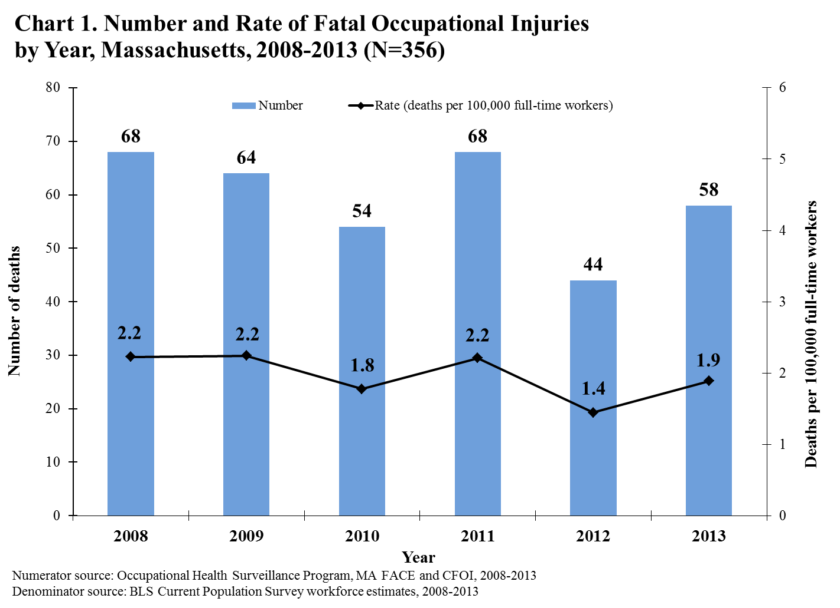

The Great Recession: The economic downturn that spanned December 2007 to June 2009 had a substantial impact on employment across the nation and in Massachusetts. National statistics compiled by the Bureau of Labor Statistics highlight the spike in unemployment near the beginning of the period covered by this fatality report, and reduced consumer spending that continued into the period. The construction industry was hit especially hard, with estimates for the decline in employment of around 15% nationwide over the time of the recession, and with residential construction experiencing the decline before commercial construction., This contributed to the U.S. experiencing its lowest fatality rate, as recorded by CFOI, in 2009. There was a subsequent rebound in the national fatality rate in 2010 and another dip in 2012.

In Massachusetts, 2010 was the year in which the fatality rate declined, followed by a rebound in 2011 and a greater decline in 2012. It is not fully understood how lagging effects of the recession may have played a role, but the number of residential construction deaths in Massachusetts was low in 2009 and 2012-2013.

Sex
- The great majority of workers (93.0%, N= 331) who were fatally injured at work were men. Women accounted for the remaining 7.0% (N=25) of the deaths.

- The fatal occupational injury rates for men were consistently much higher than the rates for women over the six-year time period (Chart 2). The average annual fatality rate for male workers (3.3 deaths per 100,000 full-time workers) was more than ten times the rate for female workers (0.3 deaths per 100,000 full-time workers) – a finding consistent with the national experience. For the U.S. during this time period, the average annual rate of fatal occupational injury for men was 5.7 deaths per 100,000 workers compared with 0.6 deaths per 100,000 full-time workers for women.⁹

- The difference in fatality rates for men and women may be explained in large part by the fact that men are more likely to be employed in high risk jobs. For example, during 2008–2013 in Massachusetts, proportionately more men (20.4%) than women (1.9%) were employed in the following four occupation groups with high fatality rates: Farming, Forestry & Fishing; Construction & Extraction; Installation, Maintenance & Repair; and Transportation & Material Moving. Conversely, 75.8% of female workers compared to 59.3% of male workers were employed in four occupation groups with low fatality rates: Management, Business & Financial; Professional & Related; Sales; and Office & Administrative Support.

- The leading events resulting in death also differed for male and female workers. The leading fatal events among women were homicide (24%, N=6), pedestrian struck by vehicle (16%, N=4), falls to the same level (12%, N=3), and exposures to harmful substances (12%, N=3) which together accounted for more than half of all female deaths. In contrast, falling to a lower level was the leading cause of death among male workers (22.1%, N=73) followed by suicide at the workplace (16.0%, N=53), contact with objects or equipment (11.8%, N=39), and roadway collisions (11.5%, N=38).

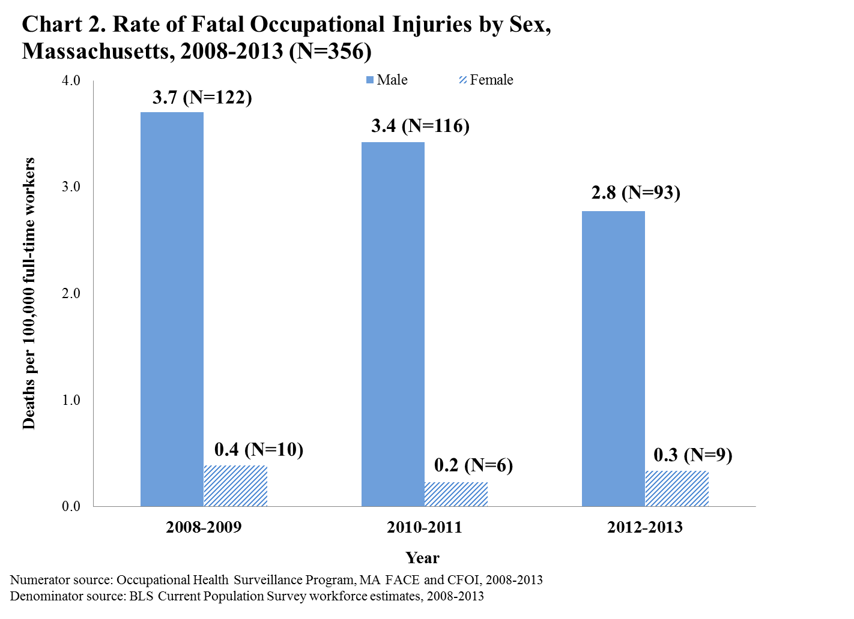

1.3 Age
- The victims ranged in age from 18 to 94 years with an average age at death of 48 years. 89.3% of the workers (N=318) were less than 65 years old.

- The youngest worker was an 18-year-old groundskeeper at a golf course who drowned when the mower he was operating overturned into a pond. The oldest worker was a 94-year-old fiscal supervisor at a medical clinic who fell down a flight of stairs at the office.

- The fatal occupational injury rate increased markedly with increasing age (Chart 3), similar to findings at the national level.⁹ On average, the rate increased with age across the age groups by an estimated 31.8%.

- The fatality rate for workers 65 years of age or older (4.5 deaths per 100,000 full-time workers) was more than three times the rate for workers less than 35 years of age (1.2 deaths per 100,000 full-time workers) (Chart 3). These older victims worked in a wide range of jobs across a variety of industries.

- The events resulting in death varied by age. Thirty-seven percent (14) of the victims 65 years or older died as a result of falling compared with 23% (73) of victims less than 65 years of age.

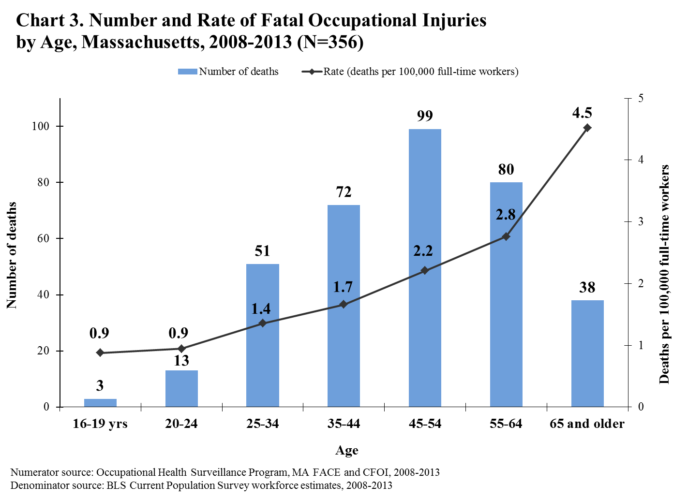

1.4 Race and Hispanic Origin
- 76.4% (272) of the fatally injured workers were White non-Hispanic, 7.3% (26) were Black non-Hispanic and 3.9% (14) were Asian non-Hispanic. Eleven percent (39) were of Hispanic origin; 19 of these Hispanic victims were born outside of the U.S. Seven Hispanic victims were from the Caribbean (all from the Dominican Republic); eight were from Mexico or Central America, including three from El Salvador and three from Guatemala; and four were from South America (Ecuador and Colombia). Five of the fatally injured workers were of other races.

- Hispanic workers had a rate of fatal occupational injury of 3.3 fatalities per 100,000 full-time workers, higher than the rate for White non-Hispanic workers of 1.8 fatalities per 100,000 full-time workers (Chart 4). This finding is consistent with earlier findings for Massachusetts and with findings nationwide. 9,,

- A high fatal occupational injury rate among Hispanic workers is in part explained by the disproportionate employment of Hispanic workers in more dangerous jobs.,, Yet even within a high risk industry – construction – the fatality rate for Hispanic construction workers in Massachusetts during the six-year period (16.9 deaths per 100,000 full-time workers) was higher than that for their White non-Hispanic counterparts (7.3 deaths per 100,000 workers full-time workers). Hispanic workers may be more likely to be employed in construction jobs where hazards are not adequately controlled. Many other factors may also contribute to their increased risk. These include: inexperience; lack of training or supervision; language, literacy and cultural barriers in the workplace; fear of discrimination; and economic pressures that deter workers from speaking up about workplace hazards.^{24,25}

- The industry sectors in which high numbers of fatal injuries occurred varied somewhat by race and ethnicity (Appendix 1). During 2008–2013 in Massachusetts, 30.8% (N=12) of Hispanic worker deaths occurred in the Construction industry. The Construction industry also accounted for the most deaths among the White non-Hispanic (25.4%, N=69). Among Black non-Hispanic victims, the Services industry accounted for the greatest number of deaths (23.1%, N=6). The greatest number of deaths among Asian non-Hispanic workers was in Accommodation and Food Services (28.6%, N=4).

- The events resulting in death varied by race/ethnicity of victims. Falls were the leading event among Hispanic, White non-Hispanic, and Black non-Hispanic workers. Suicide at work was the leading event among Asian workers (Appendix 1).

Immigrant Roofer Struck by a Bag of Gravel that Fell from a Roof

A 39-year-old male roofer was part of a crew repairing the roof of a building when he was struck by a bag loaded with gravel from the building’s roof. The crew was using a portable manual rope pulley system to lower bags of gravel from the roof. The victim’s task was to control the bag’s decent by using the pulley’s rope while standing on the ground. The victim did not realize that a 40 pound bag had begun to be lowered and the bag free-fell three and one half stories, striking him in the head. The company did not have a health and safety program and did not provide adequate safety training.

To prevent similar incidents, Massachusetts FACE recommended that employers should:
- Ensure that only rope pulley systems with brakes are used for hoisting and lowering tasks;
- Develop standard operating procedures (SOPs) for using rope pulley systems that include voice and hand signals to indicate when a task is beginning, and barricading off the pulley’s fall zone to prevent employees from being struck by the object attached to the pulley;
- Develop, implement, and enforce a safety and health program and provide training that includes hazard recognition and avoidance of unsafe conditions, such as the hazards associated with using rope pulley systems.
Massachusetts FACE Report 10MA032

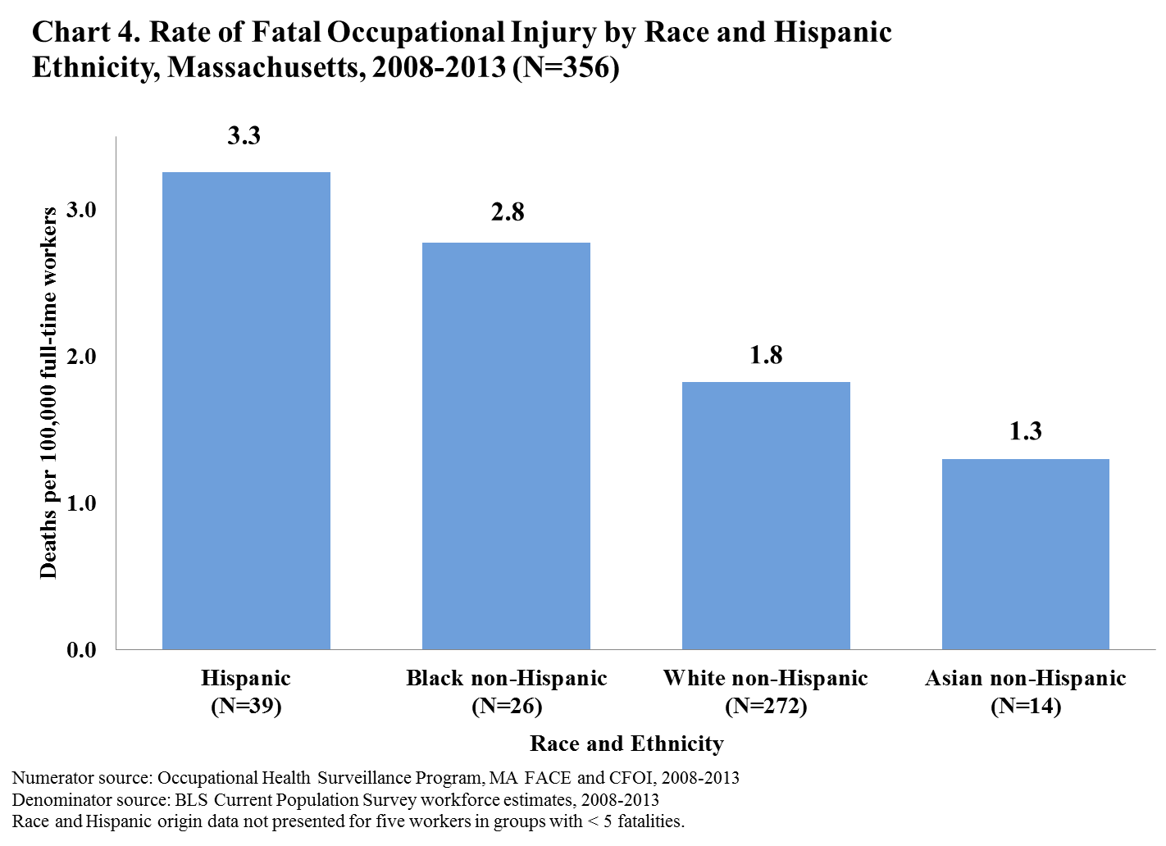

  - Event or Exposure

- Transportation-related incidents accounted for more fatal occupational injuries (28.4%, N= 101) than any other broad event category during the six-year period. Forty-seven victims were vehicle occupants who were fatally injured in vehicle collisions or rollovers. Thirty-nine of these events occurred on a roadway; eight occurred in off-roadway areas such as parking lots. Twenty-four victims were struck by vehicles in parking lots, on roadways, or off-road areas. Seventeen workers died in water vehicle incidents. Eight workers were killed in aircraft crashes (Table 1).

- Of the 24 workers struck by vehicles, five were police officers directing traffic. An additional four workers of other occupations were working in roadway construction zones or work zones when they were struck.

- Violence and Other Injuries by Persons or Animals was the second leading event category, accounting for 24.7% (88) of the fatalities (Table 1). Suicide at work was the second leading event overall, accounting for 54 fatalities. There were 29 workplace homicides. Firearms were used as the means of assault in 59% of workplace homicides (Table 2). Robbery was the leading motive for 41% (12) of the workplace homicides, whereas robbery was responsible for only about 9% of all homicides in Massachusetts during 2008 to 2011.

Workplace Suicide
2013 was the first year since work-related fatality surveillance began in Massachusetts that workplace suicide was the leading cause of injury death at the workplace. In 2013, the Massachusetts Violent Death Reporting System, which tracks all suicides in the state regardless of location, found that in 8% of all suicides that year (48 of 585), a job problem (such as a problem with a supervisor or coworker, poor work performance, or recent job loss) was noted as contributing to the suicide.²⁹ In recent years, the number of all suicide deaths in Massachusetts has increased and has outnumbered the number of deaths from motor vehicle incidents and homicides combined. The leading demographic is working-age men. These findings underscore the importance of educating employers and worker organizations about available suicide prevention resources. In Massachusetts the DPH Suicide Prevention Program provides:
- 24-Hour Crisis Hotlines:
Samaritans: 877-870-HOPE (4673)
National Suicide Prevention Lifeline: 800-273-TALK (8255), Veterans press 1
- Screening of behavioral health conditions for employees
- Suicide prevention awareness training for managers and supervisors
- Services to workplaces in the aftermath of a tragic death of any kind
Contact: 617-624-5438 www.mass.gov/dph/suicideprevention

Table 1. Number and Percent Distribution of Fatal Occupational Injuries by Event or Exposure, Massachusetts, 2008–2013 (N=356)
Event or Exposure |  | Number of Fatalities | Percent
Transportation Incidents  Highway motor vehicle incident  Worker struck by vehicle  Water vehicle incident  Non-highway motor vehicle incident  Aircraft incident |  | 101  41  24  17  8  8 | 28.4  11.5  6.7  4.8  2.2  2.2
Violence/Other Injury by Persons/Animals  Suicide  Homicide  Injury by animal |  | 88  54  29  3 | 24.7  15.2  8.1  0.8
Falls  Fall to a lower level  Fall on same level |  | 87  75  10 | 24.4  21.1  2.8
Contact with objects and equipment  Struck by falling objects  Caught in running machinery or equipment  Struck by powered vehicles that were not in normal operation  Struck, caught, or crushed in collapsing structure, equipment, or material |  | 41  10  9  5  5 | 11.5  2.8  2.5  1.4  1.4
Exposure to Harmful Substances or Environments  Contact with electric current  Nonmedical use of drugs or alcohol—unintentional overdose  Oxygen deficiency (includes drowning) |  | 31  11  8  7 | 8.7  3.1  2.2  2.0
Fires and Explosions |  | 7 | 2.0
Fires |  | 4 | 1.1
Explosions |  | 3 | 0.8
Total |  | 356 | 100.0%
Source: Occupational Health Surveillance Program, MA FACE and CFOI, 2008-2013
NOTE: Bolded numbers and percent of fatalities may not add up to total. Event/Exposure sub-categories with < 3 fatalities were not included in Table 1. One fatality was not classifiable and not included in Table 1. Percentages may not add to 100% due to rounding.
Table 2. Leading Events/Exposures resulting in Fatal Occupational Injuries, Massachusetts, 2008–2013 (N=356)
Event/Exposure Category (N) | Events/Exposures with Three or More Fatalities (N)
Transportation Incident (101) | Highway motor-vehicle related incident (41)  Collision between vehicles or mobile equipment (21)  Collision between vehicles and other objects (10)  Non-collision incident (10)  Worker struck by motor vehicle or mobile equipment (24)  Water vehicle incident (17)  Sinking or capsizing water vehicle (8)  Fall from ship or boat (8)  Non-highway motor vehicle related incident (9)  Non-collision incident (6)  Collision (3)  Aircraft crash (8)
Violence and Other Injuries by Persons or Animals (88) | Suicide (54)  Homicide (29)  By shooting (17)  By hitting, kicking, beating, shoving (5)  By stabbing, cutting, slashing, piercing (5)  Injury by animal (3)
Falls, Slips, Trips (87) | Fall to a lower level (75)  Fall from ladder (30)  Fall from or through roof (12)  Fall from scaffolding (7)  Fall from boom truck (3)  Fall on same level (10)
Contact with Objects and Equipment (41) | Struck by falling objects (10)  Caught in running machinery or equipment (9)  Struck by powered vehicles that were not in normal operation (5)  Struck, caught, or crushed in collapsing structure, equipment, or material (5)
Exposure to Harmful Substances And Environments (31) | Electrocution and other injuries resulting from contact with electric current (11)  Nonmedical use of drugs or alcohol—unintentional overdose (8)  Drowning, submersion (5)
Fires and Explosions (7) | Unintended fire in residence, building, or other structure (4)  Explosion of non-pressurized vessel, drum, or pressurized tire (3)
Source: Occupational Health Surveillance Program, MA FACE and CFOI, 2008-2013
NOTE: Event/Exposure sub-categories with < 3 fatalities were not included in Table 2. One fatality was not classifiable and not included in Table 2.

- Falls, Slips, and Trips accounted for nearly one-quarter (24.4%, N=87) of all fatal occupational injuries (Table 1). Falls to a lower level accounted for the majority of these fatal falls, claiming 75 workers’ lives and resulting in more fatalities than any other single event. Falls from a ladder or falls from a scaffold accounted for half of all falls to a lower level (Table 2).

- Most fatal falls to a lower level occurred in the Construction industry (63%, 47 of 75), and this industry had a high rate of fatal falls to a lower level – about 10 times the fatal fall rate for all industry sectors. Most of these construction falls (83%) were workers employed in small establishments with 10 or fewer employees (data not shown).

- Carpenters (11), construction laborers (8), painters (7), and roofers (7) had the highest number of fatal falls to a lower level (data not shown).

- More than half of fatal falls to a lower level in the Construction industry and three-quarters of fatal falls in other industries occurred from heights of 20 feet or less (data not shown).

- Ten workers died from falls to the same level by falling onto the surface on which they were standing or falling against a nearby object.

- The farthest fall during this period was a fall from a communication tower. The worker was helping to replace sections of ladder on the tower when he fell from a height of over 1,100 feet (data not shown).

Preventing Falls in Construction
The MA FACE project has been promoting the national Campaign to Prevent Falls in Construction that’s being spearheaded by NIOSH, OSHA and The Center for Construction Research and Training (CPWR). Along with help from the Preventing Falls in Residential Construction (PFC) Workgroup, MA FACE developed a local construction falls prevention campaign that complemented the national campaign.

Some of the local campaign activities included:
- Revamping and posting MA FACE’s residential construction fall prevention brochures, in multiple languages, to the DPH and the national campaign websites.
- Reaching out to over 28,000 licensed Massachusetts contractors, with assistance from the Department of Public Safety and to 368 state inspectional service departments and building permit offices to help disseminate the brochures and campaign materials.
- Promoting fall prevention training being offered by the MA On-site Consultation Program at the Department of Labor Standards. Over 350 roofing contractors attended these trainings, one of which was in Spanish.
- Collaborating with six regional transit authorities, including the Massachusetts Bay Transportation Authority (MBTA), to promote the campaign throughout the state by displaying campaign posters on buses and the subway.

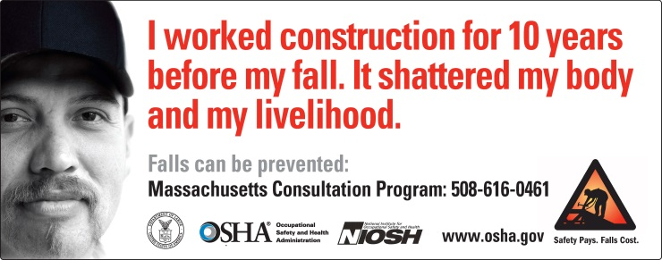

- Contact with objects and equipment accounted for 11.5% (41) of the fatal occupational injuries (Table 1). Ten victims died after being struck by falling objects such as building materials, containers, or trees. Becoming caught in running machinery or equipment claimed the lives of nine workers (Table 2). Another five workers were killed when they were struck by rolling, shifting, or falling vehicles that were not in normal operation.

Day Laborer Dies in Fall from an Extension Ladder at a Residential Construction Site

A 27-year-old day laborer was fatally injured when he fell from an aluminum extension ladder on which he was working to reattach a loose section of vinyl siding to a house. A co-worker was holding the base of the ladder while the victim was using both hands to hold on to the piece of vinyl siding and push it upwards towards the house. The victim lost his balance and fell approximately 20 feet to the ground below. The company had two co-owners and no other employees and they often hired day laborers to help with jobs. The company did not have a designated person in charge of health and safety and did not provide health and safety training to employees. In addition, the company did not have workers’ compensation insurance.

To prevent similar incidents, Massachusetts FACE recommended that employers should:
- When feasible, use other forms of work platforms (not ladders) for work at heights;
- Make sure that ladders are equipped with stabilizers and are set up properly; and
- Provide all employees with training about ladders and work platforms used to complete tasks.
MA FACE report 08MA042

- Thirty-one workers (8.7%) died from exposure to harmful substances or environments at the workplace. Eleven of these workers were electrocuted or otherwise injured from direct or indirect exposure to electrical current, eight died from unintentional drug overdose, and five drowned (Table 2).

- Seven workers (2.0%) were fatally injured in fires and explosions during the six-year period. Fire incidents claimed the lives of four workers while three workers died from explosions (Table 2).

  - Industry

- During the six-year period of 2008–2013, the Agriculture, Forestry, Fishing, and Hunting industry sector had the highest fatal occupational injury rate – more than 20 times the overall state rate – but only the fifth highest fatality count with 30 deaths (8.4%) (Chart 5). Twenty-two (73.3%) of these fatal injuries occurred in the fishing industry (Table 4).

- The Construction industry sector had the highest fatality count with 85 deaths (23.9%) and one of the highest fatal occupational injury rates (8.1 deaths per 100,000 full-time workers) during 2008–2013, more than four times higher than the overall state rate (Chart 5). Two-thirds (67%, N= 57) of the construction workers fatally injured on the job were employed in the specialty trade contractor sector which includes, among others, roofing, painting, site preparation, electrical, and plumbing/heating/HVAC (Table 4). More than half (55%, N=47) of fatal injuries in the construction industry resulted from falls to a lower level.

- The Transportation, Warehousing and Utilities industry sector had the third highest fatality rate (7.8 deaths per 100,000 workers), nearly four times the overall rate for the state (Chart 5). Many of these fatalities (45%, N=17 of 38) occurred in the freight trucking industry. Motor vehicle collisions and rollovers were the leading fatal events, accounting for 13 deaths (Table 4).
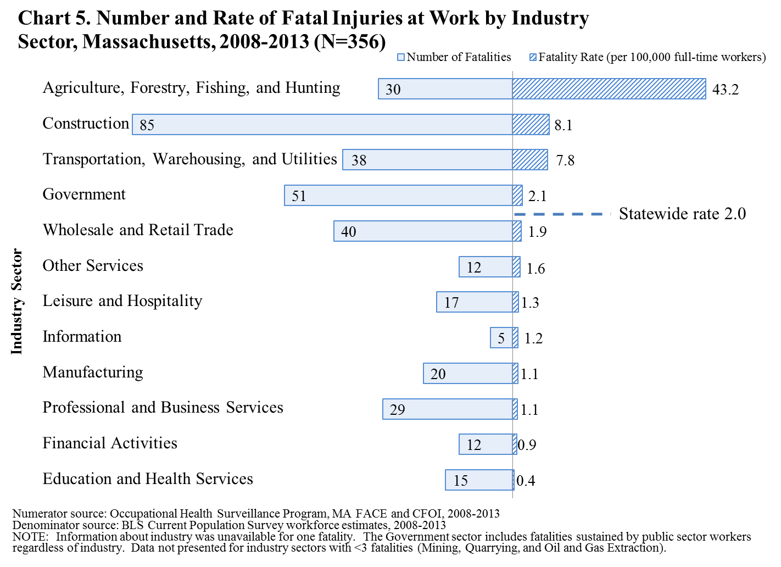

- Fifty-one workers employed in the Government/Public sector sustained fatal injuries, accounting for 14.3% of the deaths from 2008 through 2013. Sixteen of these victims held jobs in police protection, of which two deaths were homicides. Six worked in fire protection. The leading fatal events among government workers were motor vehicle collisions and rollovers (9), suicides (9) and pedestrian (worker) being hit by a moving vehicle in a work zone (7), (Table 4). See Section 1.8 for a further discussion of the public sector fatalities.

- The Wholesale and Retail Trade industry sector had 40 fatalities. The majority of workers in this sector were killed in motor vehicle collisions and rollovers (12) and homicides (9), (Table 4). Six of the homicides were robberies.

- The Other Services industry sector is comprised of equipment and automotive repair/ maintenance establishments, personal care services, and civic and professional organizations. Three of the 12 workers fatally injured in this industry sector were employed in automotive or auto body repair (Table 4).

- Workplace homicide was the leading event resulting in fatal occupational injury among workers in the Leisure and Hospitality industry sector, accounting for four of the 17 fatalities (Table 4). All four of the homicide victims worked for restaurants.

- In the Manufacturing sector, 20 workers were fatally injured. Four of the workers were caught in running machinery (Table 4).

Landscaper Working from a Raised Portable Work Platform Was Electrocuted
When a Pole Saw Contacted Overhead Power Line

A 26-year-old male foreman for a landscaping company was electrocuted while working from a raised portable work platform when a pole saw he had been using to trim tree branches came in contact with energized overhead power lines. The worksite was a private residence and the victim had been working within 10 feet of the power lines. The landscaping company did not have a safety and health program and none of the employees were classified and trained as line-clearance tree trimmers.

To prevent similar incidents, Massachusetts FACE recommended that landscaping companies performing work near energized power lines should:
- Ensure employees remain at least 10 feet away from any energized power lines located on worksites and provide training about the hazards of power lines and appropriate personal protective equipment;
- Ensure that only line-clearance tree trimmers and power companies trim, access and maintain trees that are within 10 feet of energized overhead power lines; and
- Develop, implement, and enforce a safety and health program that addresses hazard recognition and avoidance of unsafe conditions.
In addition, home owners and property owners should:
- Contact power companies and/or “line-clearance tree trimmers” to maintain trees that are within 10 feet of energized power lines.
Massachusetts FACE Report 13MA019

- Twenty-nine (8.2%) of the workers fatally injured from 2008 through 2013 were employed in the
Professional and Business Services sector (Table 4). This is a broad industry sector that includes, company management, administrative/business support services, waste management /remediation, employment services, facilities services (e.g. landscaping, janitorial), and scientific and technical services. Twelve of the victims in this industry sector were employed in landscaping, nine of whom were performing tree work.

- Of the 12 victims who were working in the Financial Activities sector, eight were property managers or landlords (Table 4).

- The Education and Health Services sector, which employs just over one-fifth of the Massachusetts workforce, had a low rate of fatal occupational injuries (0.4 deaths per 100,000 workers), (Chart 5).

- As shown in Table 3 below, 12 industries with the highest number of fatalities accounted for approximately one-third of all fatal occupational injuries in Massachusetts during the six-year period.

- Consistent with the findings from the past period (2000-2007), commercial fishing, made up of shellfish, finfish, and multi-species fishing, claimed more lives (N=22) than any other industry.

Table 3. The Industries with the Highest Numbers of Fatal Occupational Injuries, Massachusetts, 2008–2013
Detailed Industry | Number | % of Total Occupational Fatalities (N=356)
Police protection | 16 | 4.5
Shellfish fishing | 14 | 3.9
Landscaping services | 12 | 3.4
Residential remodelers | 12 | 3.4
Roofing contractors | 12 | 3.4
General freight trucking, long-distance | 11 | 3.1
Painting and wall covering contractors | 10 | 2.8
Electrical contractors | 9 | 2.5
Fire protection | 6 | 1.7
Site preparation contractors | 6 | 1.7
Finfish fishing | 5 | 1.4
Lessors of residential buildings and dwellings | 5 | 1.4
Total | 118 | 33.1%
Source: Occupational Health Surveillance Program, MA FACE and CFOI, 2008-2013
Percentages may not add to 100% due to rounding.

Electrician Electrocuted while Troubleshooting Envelope Manufacturing Machine

A 53-year-old male electrician was electrocuted while troubleshooting an envelope manufacturing machine. The machine’s blower was not working properly and when the victim reached into the machine to access the wiring for the blower, he was electrocuted. The wiring was in a junction box behind the framework of the machine and was both physically and visually inaccessible. The machine had been partially dismantled and moved to a new manufacturing site, and the victim had been working extra hours to help the company get the machine up and running in the new location. The company did not have a safety and health program, but new hires were provided training on multiple health and safety topics during orientation.

To prevent similar incidents, Massachusetts FACE recommended that employers should:
- Ensure that electrical circuits and equipment are de-energized and that lockout/tagout standard operating procedures are implemented and enforced prior to beginning work;
- Provide, and ensure that employees use, appropriate personal protective equipment (PPE) and tools for troubleshooting live circuits;
- Develop, implement, and enforce a safety and health program that addresses hazard recognition and avoidance of unsafe conditions; and
- Ensure that work is scheduled to allow for sufficient rest periods between work shifts.
In addition, machine manufacturers should:
- Implement the concept of Prevention through Design (PtD) to ensure the safety and health of machine users, including machine operators and maintenance workers. (www.cdc.gov/niosh/topics/ptd)
Massachusetts FACE Report 12MA007

Table 4. Fatal Occupational Injuries: Leading Events and Industries within Industry Sectors, Massachusetts, 2008–2013

Industry Sector (N) | Leading fatal events (N) | Industries with three or more fatal injuries (N)
Agriculture, Forestry, Fishing and Hunting (30) | Boat sunk/capsized (7)  Fall or jump from ship or boat (5)  Fall to a lower level (4) | Commercial fishing (22)  Crop production (6)
Construction (85) | Fall to lower level (47)  Suicide (11)  Electrocution (6)  Pedestrian struck by vehicle or mobile equipment (4)  Struck by falling object or equipment (3)  Struck, caught, or crushed in other collapsing structure or equipment (3) | Residential remodelers (12)  Roofing contractors (12)  Painting and wall covering contractors (10)  Site preparation contractors (6)  Nonresidential electrical contractors (5)  Plumbing, heating, and air-conditioning contractors (5)  Commercial and institutional building construction (4)  New single-family housing construction (3)
Transportation,  Warehousing and Utilities (38) | Motor vehicle or mobile equipment collision/ rollover (13)  Aircraft crash (5)  Homicide (3)  Pedestrian struck by vehicle or mobile equipment (3)  Suicide (3) | General freight trucking, long-distance, truckload (8)  Taxi service (4)  General freight trucking, local (3)
Government (51) | Motor vehicle or mobile equipment collision/ rollover (9)  Suicide (9)  Pedestrian struck by vehicle in work zone (7)  Homicide (6)  Pedestrian struck by vehicle, not in work zone (3) | Police protection (16)  Fire protection (6)  Elementary and secondary schools (4)  National security (4)  Public transportation (3)
Wholesale and Retail Trade (40) | Motor vehicle or mobile equipment collision/ rollover (12)  Homicide (9)  Suicide (7)  Fall to a lower level (3) | Gasoline stations (4)  Used merchandise stores (3)
Other Services (12) | Suicide (3) | Automotive repair (3)
Leisure and Hospitality (17) | Homicide (4)  Suicide (3) | Restaurants (6)  Marinas (3)
Manufacturing (20) | Caught in running equipment or machinery (4)  Suicide (4)  Fall to a lower level (3) | Architectural and structural metals manufacturing (3)  Envelope manufacturing (3)  Food processing and manufacturing (3)  Other paper product manufacturing (3)
Professional and Business Services (29) | Fall to a lower level (8)  Suicide (5)  Motor vehicle or mobile equipment collision/ rollover (3) | Landscaping services (12)  Employment services (5)  Janitorial services (3)
Financial Activities (12) | Suicide (4) | Lessors of residential buildings and dwellings (5)  Property managers (3)
Education and Health Services (15) | Homicide (3) | Colleges, universities, and professional schools (4)  General medical and surgical hospitals (3)
Source: Occupational Health Surveillance Program, MA FACE and CFOI, 2008-2013.
Information about industry was unavailable for one fatality. Information sector (5) and Mining, Quarrying, and Oil and Gas Extraction sector (1) not presented.

1.7 Occupation

- From 2008 through 2013, workers in Farming, Fishing, and Forestry occupations had the highest fatal occupational injury rate (74.9 deaths per 100,000 workers) – about 37 times the overall rate for the state, with 26 deaths (Chart 6). All but four fatally injured workers in this group were commercial fishing workers (Table 5). Seven of the 22 fishing deaths involved boats sinking or capsizing. Massachusetts ranked fourth in the number of commercial fishing deaths during this period, behind Alaska, Louisiana, and Washington. The exceptionally high rate of fatalities among commercial fishers is consistent with previous findings in Massachusetts as well as national findings.^{24,25,} NIOSH has reported that the northeast ground fishery has the highest rate of fishing deaths in the nation.

- Transportation and Material Moving occupations had the second highest rate of fatal occupational injuries (11.0 deaths per 100,000 workers) and were second to construction and extraction in terms of the numbers of deaths (21.3%, N=76) during 2008 through 2013 (Chart 6). More than half of these 76 deaths were transportation incidents (N=43) and were the result of a crash or other incident involving a land, air, sea, or rail vehicle in operation. Thirty-six of the 76 workers were drivers, with heavy and tractor-trailer truck drivers (N=17) making up the largest group (Table 5).

- The Construction and Extraction group had the highest number of occupational fatalities (23.3%, N=83) and one of the highest rates (9.8 deaths per 100,000 workers) – almost five times higher than the overall rate for the state (Chart 6). The occupations in this group with the greatest number of deaths were construction laborers (19), carpenters (14), construction supervisors (11), painters (10), roofers (9) and electricians (9) (Table 5). Sixty-three percent of all fatal falls to lower levels (N=47 of 75) and 63% of all fatal electrocutions (N=7 of 11) involved workers in this group (data not shown).
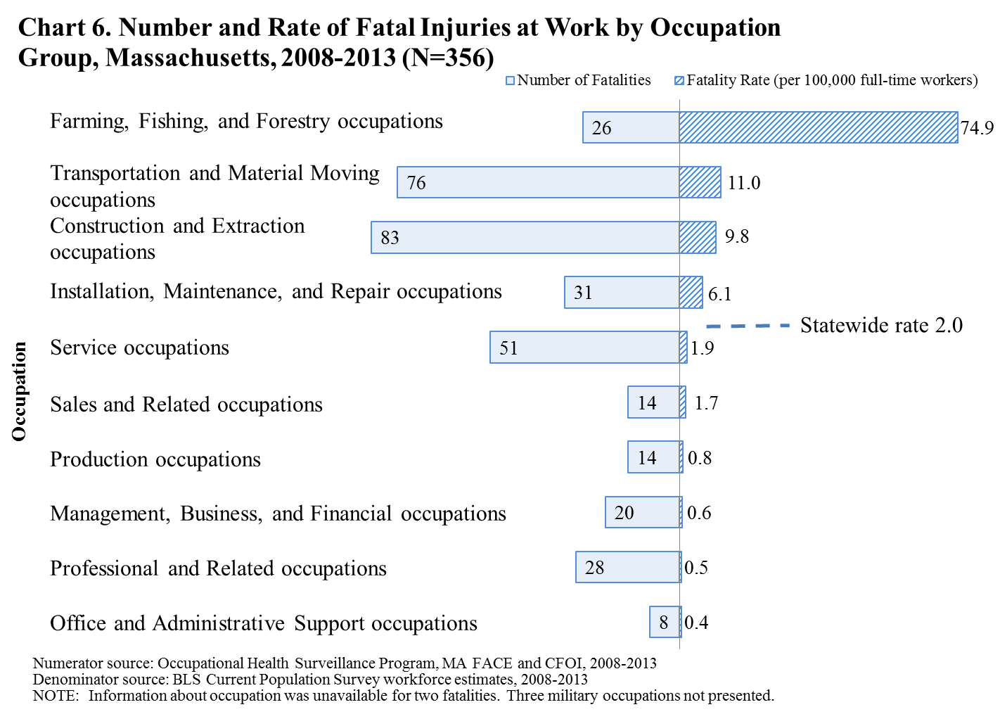
Table 5. Fatal Occupational Injuries: Leading Events and Occupations within Occupational Groups, Massachusetts, 2008–2013
Occupational group (N) | Leading fatal events (N) | Occupations with three or more  fatal occupational injuries (N)
Farming, Fishing, and Forestry (26) | Capsized or sinking water vehicle (7)  Fall or jump from water vehicle (5) | Fishers and related fishing workers (22)
Transportation and Material Moving (76) | Motor vehicle or mobile equipment collision/ rollover (17)  Suicide (7)  Homicide (6)  Pedestrian struck by vehicle (4) | Heavy and tractor-trailer truck drivers (17)  Commercial pilots (8)  Industrial truck and tractor operators (7)  Laborers and freight, stock, and material movers, hand (7)  Light truck or delivery services drivers (7)  Taxi drivers and chauffeurs (7)  Driver/sales workers (4)  Cleaners of vehicles and equipment (3)  Refuse and recyclable material collectors (3)
Construction and Extraction(83) | Fall to lower level (47)  Suicide (10)  Electrocution (7)  Pedestrian struck by vehicle (4)  Struck by falling object or equipment (4)  Struck, caught, or crushed in other collapsing structure or equipment (3) | Construction laborers (19)  Carpenters (14)  Supervisors of construction and extraction workers (11)  Painters, construction and maintenance (10)  Electricians (9)  Roofers (9)  Plumbers, pipefitters, and steamfitters (3)
Installation, Maintenance, and Repair (31) | Fall to lower level (8)  Pedestrian struck by vehicle (4)  Struck by falling object or equipment (4)  Suicide (4)  Motor vehicle or mobile equipment collision/ rollover (3) | Automotive service technicians and mechanics (6)  Maintenance and repair workers, general (6)  Industrial machinery mechanics (4)  Mobile heavy equipment mechanics, except engines (4)  First-line supervisors of mechanics, installers, and repairers (3)  Heating, air conditioning, and refrigeration mechanics and installers (3)
Service (51) | Motor vehicle or mobile equipment collision/ rollover (10)  Suicide (9)  Pedestrian struck by vehicle (8)  Fall to lower level (7)  Homicide (5)  Struck by falling object or equipment (3) | Police and sheriff's patrol officers (13)  Tree trimmers and pruners (5)  Janitors and cleaners, except maids and housekeeping cleaners (5)  Firefighters (4)  Landscaping and groundskeeping workers (4)  Maids and housekeeping cleaners (3)
Sales and Related (14) | Homicide (6)  Suicide (4) | First-line supervisors of retail sales workers (5)  Cashiers (4)  Retail salespersons (3)
Production (14) | Caught in running equipment or machinery during regular operation (3) | Welders, cutters, solderers, and brazers (3)
Management, Business, and Financial (20) | Suicide (8)  Motor vehicle or mobile equipment collision/ rollover (3) | Farmers, ranchers, and other agricultural managers (3)  Property, real estate, and community association managers (3)  Managers, all other (3)
Professional and Related (28) | Homicide (6)  Suicide (6)  Fall to lower level (3) | Registered nurses (3)
Office and Administrative Support (8) | - | -
Source: Occupational Health Surveillance Program, MA FACE and CFOI, 2008-2013
Information about occupation was unavailable for two fatalities. Three military occupations not presented.

Municipal Mechanic Fatally Injured When Crushed Between a Skid-steer Loader’s
Frame and Bucket
A 55-year-old male mechanic for a municipal water department was fatally injured when a raised skid-steer loader’s lift arm came down and crushed him between the bucket and frame of the loader. The lift arm support safety block device had not been installed and the victim was working underneath the raised lift arm and attached bucket. The operator seat restraint interlock bar was in the down position, while no one was in the loader’s operator seat, making the lift arm controls operable. The water department did not have a written safety and health program and did not have lockout/tagout procedures for those working on skid-steer loaders.

To prevent similar incidents, Massachusetts FACE recommended that municipalities should:
- Ensure that safeguards and interlocks are used, readily accessible, and never bypassed;
- Ensure that skid-steer loader lift arm support devices are installed prior to beginning troubleshooting and maintenance tasks requiring the lift arm to be in the raised position;
- Ensure that skid-steer loader operator seat restraint interlock bars are only in the lowered position when a worker is in the operator’s seat;
- Develop, implement and enforce lockout/tagout procedures for skid-steer loader maintenance tasks that include the use of the loader’s lift arm support device; and
- Provide work environments that, at a minimum, meet all relevant OSHA regulations and industry accepted standards of practice per the MA Department of Labor Standards’ policy.
Massachusetts FACE Report 12MA024
- Installation, Maintenance, and Repair workers also had a fatality rate that was higher than the statewide average, at 6.1 deaths per 100,000 workers (Chart 6). Falls to a lower level claimed more lives in this occupation group than any other event (N=8) (Table 5).

- As shown in Table 6 below, the 10 occupations with the highest number of fatalities accounted for over one-third (37.1%) of all occupational fatalities in Massachusetts during the six-year period. Consistent with findings discussed above, fishing claimed more lives than any other single occupation during the period, and six of the occupations on the list are construction occupations (Table 6).

Table 6. The Occupations with the Highest Number of Fatal Occupational Injuries, Massachusetts, 2008–2013
Detailed Occupation | Number | % of Total Occupational Fatalities
Fishers and related fishing workers | 22 |  | 6.2
Construction laborers | 19 |  | 5.3
Heavy and tractor-trailer truck drivers | 17 |  | 4.8
Carpenters | 14 |  | 3.9
Police and sheriff's patrol officers | 13 |  | 3.7
Supervisors of construction and extraction workers | 11 |  | 3.1
Painters, construction and maintenance | 10 |  | 2.8
Roofers | 9 |  | 2.5
Electricians | 9 |  | 2.5
Commercial pilots | 8 |  | 2.2
Total | 132 |  | 37.1
Source: Occupational Health Surveillance Program, MA FACE and CFOI

1.8 Government Workers

- From 2008 through 2013, 51 public sector employees were fatally injured at work, accounting for 14.3% of the work-related deaths. Most of these government workers (6%, N=33) worked for local/municipal government, 22% (11) worked in state government, and the remaining 14% (7) were federal government employees.

- The fatal occupational injury rate for government workers (2.1 deaths per 100,000 workers) was comparable to the rate for all industries (2.0 deaths per 100,000 workers), (Chart 5).

- Government workers were most frequently fatally injured in transportation events (45%, N=23). Ten of these were fatally injured after being struck by vehicles (Table 4).

- Eleven (22%) died from self-inflicted injury or an overdose at work (data not shown).

- Government workers who died from work-related injuries were employed in a wide range of industries. Almost two-thirds (65%, N=33) of these 51 workers were employed in public administration, including police (16) and fire protection (6).

Municipal Crossing Guard Fatally Injured When Struck by a Motor Vehicle

A 71-year-old female municipal crossing guard, employed by a local police department, was fatally injured when she was struck by a pickup truck while assisting school children in crossing a roadway at a pedestrian crosswalk. The department usually provided a 10-minute annual training for the crossing guards but this year the training had not been offered. The department also did not have a written safety and health program. The department did provide crossing guards with high visibility vests, rain jackets and stop paddles, but it was reported by the victim’s co-workers that the paddles were too heavy to use and it was unknown if the vests were American National Standards Institute (ANSI) compliant.

To prevent similar incidents, Massachusetts FACE recommended that municipalities should:
- Develop a school route plan that meets the standards set forth in the national Manual on Uniform Traffic Control Devices (MUTCD);
- Consider installing signs and flashing lights to ensure crosswalks are clearly visible to motorists;
- Ensure that the design of equipment supplied to workers, such as stop paddles, does not prevent employees from using the equipment;
- Provide and ensure that crossing guards are wearing the appropriate personal protective equipment, including ANSI compliant high-visibility safety apparel, when working along roadways;
- Ensure that crossing guards are provided with initial training and annual refresher trainings; and
- Provide work environments for employees that, at a minimum, meet all relevant Occupational Safety and Health Administration (OSHA) regulations and industry accepted standards of practice per the MA Department of Labor Standards’ policy.
Massachusetts FACE Report 12MA010

Deaths of public sector workers raise special concerns because these workers do not come under the jurisdiction of the federal Occupational Safety and Health Administration (OSHA) in Massachusetts. The MA Department of Labor Standards oversees health and safety conditions in state and local government workplaces. DLS provides technical assistance to these agencies and conducts workplace inspections to determine whether proper procedures are being followed to protect workers. In 2014 a state law was passed requiring MA executive branch agencies to comply with OSHA regulations. As a matter of policy, DLS uses OSHA standards, as well as consensus standards, in determining whether proper procedures are being followed to protect workers.

1.9 Self-employed Workers (data not shown)
- Of the 356 workers who were fatally injured from 2008 through 2013, 15.5% (55) were self-employed. However, self-employed workers accounted for, on average, only 6% of the Massachusetts workforce during this period.

- The fatal occupational injury rate for self-employed workers (4.9 deaths per 100,000 workers) was more than twice the rate for wage and salary workers (1.8 deaths per 100,000 workers). This disparity in rates is likely explained, in part, by the disproportionate concentration of self-employed workers in high risk industries compared with wage and salary workers. Proportionately more self-employed workers (22%) than wage and salary workers (5%) were employed in construction, a high hazard industry during this period.³⁵

- The majority of fatal injuries among self-employed workers occurred in high-risk industries and occupations. For example, 75% (41) of fatalities among self-employed workers occurred in three high-risk industry sectors: Construction; Agriculture, Forestry and Fishing; and Services (e.g. landscaping, auto repair). The leading occupations of the self-employed victims were carpenters, painters, electricians, fishers, and construction laborers.

  - Foreign-born Workers (data not shown)

- Approximately one in five (23.3%, N=83) workers fatally injured at work during 2008–2013 was born outside of the United States. However, foreign-born workers accounted for, on average, only 17.4% of the Massachusetts workforce during this period.³⁵

- The largest number of foreign-born workers killed on the job were born in Europe (25), followed by Asia (17) and the Caribbean (11). Eight victims were from the Dominican Republic and eight were from Italy.

- The rate of fatal occupational injury among foreign-born workers (2.6 deaths per 100,000) was higher than the rate for U.S.-born workers (1.8 deaths per 100,000).

- The Construction industry accounted for the greatest percentage (25%, N=21) of fatalities among foreign-born workers. Foreign-born workers in this industry had a fatal occupational injury rate that was higher than the rate of U.S.-born construction workers (12.1 versus 7.3 deaths per 100,000 workers).

- Correspondingly, 28% (N=23) of the foreign-born victims were employed in Construction occupations. Of these construction workers, eight were laborers and four were painters.
- Other occupations resulting in high numbers of deaths of foreign-born workers include drivers (11) and commercial fishers (6).

- The single leading fatal event among both foreign-born and U.S.-born workers was a fall to a lower level, accounting for 20.5% and 20.9% of fatalities, respectively.

- Workplace homicide accounted for a greater percentage of fatal occupational injuries among foreign-born workers (12%, N=10) than among U.S.-born workers (7.0%, N=19). Additionally, the rate of workplace homicide among foreign-born workers (0.31 deaths per 100,000 workers) was more than double the rate among U.S.-born workers (0.13 deaths per 100,000 workers). This finding may be explained in part by the disproportionate employment of foreign-born workers in cash-handling occupations such as gas station cashiers and restaurant delivery: eight of the 10 homicides of foreign-born workers were in cash handling occupations, and six were robbed.

Immigrant Roofer Electrocuted When an Aluminum Ladder Platform Hoist
Contacted Overhead Power Line

A 23-year-old male roofer was electrocuted and two co-workers were severely shocked when an aluminum ladder that was part of a ladder platform hoist came in contact with energized overhead power lines. The workers were in the process of raising the 32-foot ladder from a horizontal position on the ground to a vertical position when they lost their footing. The ladder fell into energized overhead power lines, electrocuting the victim and severely shocking the two co-workers. The company did not have a health and safety program and did not provide employees with health and safety training.

To prevent similar incidents, Massachusetts FACE recommended that employers should:
- Eliminate the use of conductive tools and equipment, including ladders, in proximity to energized overhead power lines;
- Conduct job site surveys prior to the start of construction projects to identify potential hazards, such as energized overhead power lines, and implement appropriate control measures for these hazards; and
- Develop, implement, and enforce a safety and health program, which includes hazard recognition and avoidance of unsafe conditions, such as working around energized overhead power lines.
In addition, manufacturers of ladder platform hoists should:
- Design the ladder section of the platform hoist to be non-conductive.
Massachusetts FACE Report 10MA019

1.11 Employer Establishment Size

- Of the 340 fatal occupational injuries during 2008–2013 for which employers’ establishment size information was available, the majority (59.1%, n=201) occurred in establishments with 19 or fewer employees. These small establishments also experienced the highest fatal occupational injury rate (3.5 deaths per 100,000 workers) compared to other establishment sizes (Chart 7).

- Most of the 201 victims employed in these small establishments (83.1%, n=167) were actually working for employers with 10 or fewer employees, the largest proportion of whom were working in the Construction industry at the time of their death (35.9%, n=60) followed by Agriculture, Forestry, and Fishing (15.0%, n=25) and Transportation and Warehousing (9.0%, n=15), (data not shown).

- Self-employed workers (including workers in unincorporated family businesses) accounted for 32.3% (54) of fatal injuries in the smallest establishments (10 or fewer employees) while they accounted for only 15.2% of all fatal occupational injuries (data not shown).

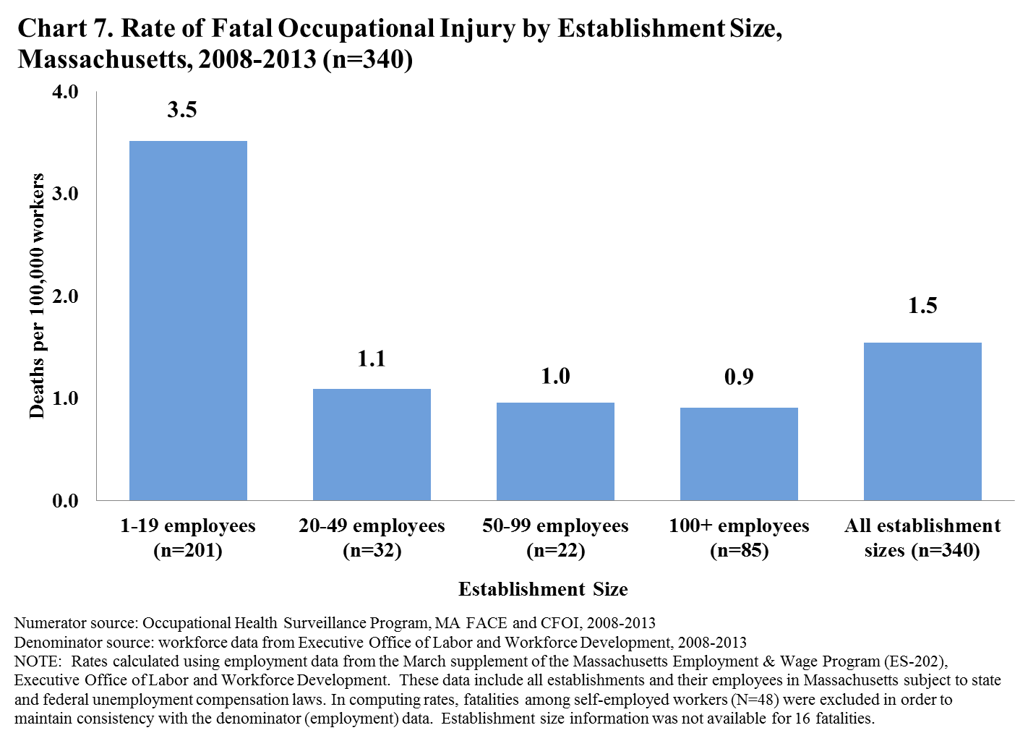

1.12 Geographic Distribution of Fatal Occupational Injuries

- City or town locations with the largest number of work-related fatal injuries were Boston (43), Springfield (13), New Bedford (12) and Brockton (10).

- Sixteen workers died at sea off the coast of Massachusetts. This includes 15 fishing workers and one rescue/tow boat operator.

- The number of fatal occupational injuries varied by county, ranging from one fatality in Nantucket County to 69 in Middlesex County (Table 7).

- Four counties, namely Middlesex, Suffolk, Essex, and Worcester, accounted for over half (55.6%, N=198) of the total occupational fatalities in the state during the six-year period.

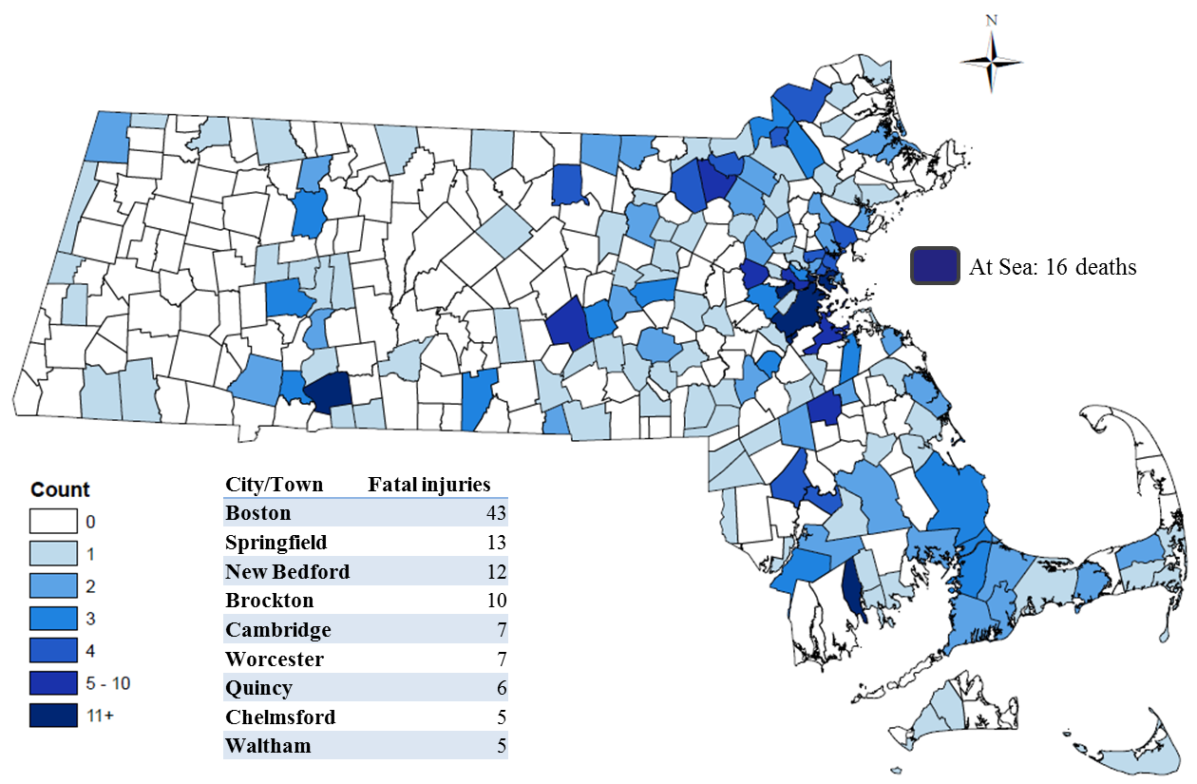
Figure 1. Fatal Occupational Injuries by Location of Incident, Massachusetts,
2008 – 2013 (N=356)

Source: Occupational Health Surveillance Program, MA FACE and CFOI, 2008-2013

Table 7. Fatal Occupational Injuries by Location of Incident, Massachusetts, 2008 – 2013 (N=356)
County | Number | % of Total Occupational Fatalities
Middlesex | 69 | 19.4
Suffolk | 53 | 14.9
Essex | 40 | 11.2
Worcester | 36 | 10.1
Plymouth | 30 | 8.4
Bristol | 30 | 8.4
Norfolk | 24 | 6.7
Barnstable | 24 | 6.7
Hampden | 22 | 6.2
Hampshire | 9 | 2.5
Franklin | 8 | 2.2
Berkshire | 8 | 2.2
Dukes | 2 | 0.6
Nantucket | 1 | 0.3
All Counties | 356 | 100%
Source: Occupational Health Surveillance Program, MA FACE and CFOI, 2008-2013
Percentages may not add to 100% due to rounding. Injuries at sea within U.S. territorial waters are considered to have occurred in the town and county with the closest land mass.
1.13 Fatal Occupational Injuries Inspected by OSHA

The Occupational Safety and Health Administration (OSHA) conducts investigations of workplace fatalities to determine if safety standards have been violated. However, fatalities that occur under certain circumstances or events (e.g. airplane and railway crashes) fall outside of OSHA jurisdiction as do fatalities among workers in some industries and workforce groups (e.g. mine workers, commercial fishing workers at sea, public sector employees in many states including Massachusetts, sole proprietors, and the self-employed). Also, certain types of fatalities (e.g. homicides, suicides, and roadway motor vehicle-related incidents) are not routinely inspected or addressed by OSHA. As discussed above in section 1.8 Government Workers, the Department of Labor Standards (DLS) has jurisdiction over some public sector workplaces in Massachusetts.

Out of the total 356 fatal occupational injuries, OSHA inspected 108 (30.3%). Of the remaining 248 fatalities, many were not inspected because: a) they did not fall under OSHA’s jurisdiction (84); b) they resulted from events that are not routinely inspected by the agency (143); or c) the fatalities occurred more than 30 days after the injury (9). Excluding deaths that fell outside of OSHA jurisdiction, such as municipal and state workers, airplane crashes, or commercial fishing, the OSHA-eligible and uninspected deaths included 36 transportation incidents, 20 homicides, and 54 self-inflicted fatal injuries (i.e. suicide or overdose).

In addition to OSHA’s enforcement inspections, the Massachusetts Department of Public Health conducted research-oriented investigations of approximately 43 occupational fatalities between 2008 and 2013 as part of the national Fatality Assessment and Control Evaluation (FACE) Program. The events covered in these investigations include, but are not limited to the following: young worker deaths, public sector worker deaths, minority worker deaths, temporary worker deaths, falls to a lower level, machine-related incidents, and highway work zone incidents. Summaries of select FACE investigations in Massachusetts with prevention recommendations are included throughout this report.

II. Fatal Occupational Injury Experience in Massachusetts: Comparison of Two Surveillance Periods, 2000–2007 and 2008–2013

Massachusetts Department of Public Health began collecting data on fatal occupational injuries in 1991. In this section, data on fatal occupational injuries in Massachusetts from 2008–2013 are compared with findings from the previous surveillance period (2000–2007).²⁴

2.1 Magnitude of the Problem

- The number of fatal occupational injuries and the fatality rate fluctuated from year to year, with 2012 having the fewest number of deaths since 2000 and tying for the lowest number of deaths since these data have been collected in Massachusetts (Chart 8, earlier data not shown).

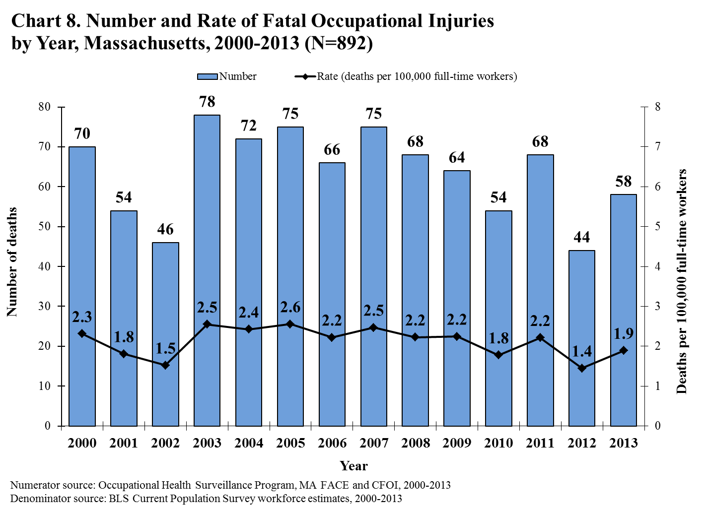

2.2 Sex and Age

- The distribution of deaths by sex was similar in both surveillance periods: the majority of victims (93%) were male in both periods.

- Compared to 2000-2007 the average age at death increased from 43 to 48 in 2008-2013. Correspondingly, the fatality rate for workers over 55 increased, while the rate for workers younger than 45 decreased. The fatality rate for workers in the 45-54 year-old range stayed level. The increased fatality rate of workers over 55 in this time period mirrors national statistics for unintentional injury mortality among older individuals in the general population.

2.3 Race and Ethnicity

- The distribution of deaths by race and ethnicity shifted slightly over the two time periods. Compared to 2000-2007, the percentage of deaths attributed to Black non-Hispanic, Asian non-Hispanic, and Hispanic workers rose slightly by 3.2%, 1.1%, and 0.9%, respectively, for 2008-2013. Correspondingly, the percent attributed to White non-Hispanic dropped slightly by 3.8%.

- Falls continued to be the leading cause of death in White non-Hispanic and Hispanic workers. The leading cause for Black non-Hispanic workers shifted from homicide to falls, and for Asian non-Hispanic workers the leading cause shifted from fire/explosion to suicide in the recent period.

- The greatest number of White non-Hispanic and Hispanic worker deaths continued to be in Construction, and Black non-Hispanic worker deaths remained highest in the Administrative and Support and Waste Management and Remediation Services sector. The highest number of deaths among Asian non-Hispanic workers shifted from Construction to the Accommodation and Food Services sector in the recent period.

2.4 Event or Exposure

- Falling to a lower level was the single leading fatal event in both periods. Transportation incidents remained the category that had the greatest number of deaths, with highway motor vehicle incidents and pedestrians being struck topping the list in this category.

- Suicides in the workplace surpassed homicides and highway motor vehicle incidents to become the second leading single event. As a result, violence became the second leading event category.

2.5 Industry and Occupation

As mentioned previously, there were changes in industry and occupation classification systems introduced in 2009 and 2011. These changes preclude precise comparisons of industry and occupation findings between the two surveillance periods. However, several important findings remained consistent over time.

- During both surveillance periods, fishers and related workers stood out as having an exceptionally high fatality rate.

- The Construction industry had high numbers and rates of fatal occupational injuries during both surveillance periods.

- Fishers, construction laborers, and truck drivers were the three occupations with the highest rates during both time periods.

2.6 Self-employed Workers

- The percent of fatally injured workers who were self-employed went from 17.4% in 2000–2007 to 13.5% in the 2008–2013 period. The fatality rate for the self-employed also dropped slightly, going from 5.3 to 4.3 per 100,000 workers. This decrease does not appear to be explained by a change in the percent of the Massachusetts workforce that was self-employed, which dropped only slightly from 7.0% to 6.3%. In both time periods, the largest proportion of self-employed victims was employed in construction.

2.7 Foreign-born Workers

- While 17 Brazilian immigrants lost their lives at work in Massachusetts in the last period, 2000-2007, that number dropped to five in the current period, though number of deaths of Dominicans rose from three to seven.
III. Comparison of Massachusetts and the U.S.

In this section, CFOI data on fatal occupational injuries in Massachusetts during 2008–2013 are compared with CFOI findings for the nation as a whole.

3.1 Rates of Fatal Occupational Injury

- Massachusetts compares favorably to the nation in terms of many different health outcomes and the fatal occupational injury experience is no exception. During 2008–2013, nearly 5,000 workers were fatally injured on the job annually in the United States. Each year during this time period, Massachusetts had a lower fatal occupational injury rate than the nation (Chart 9).

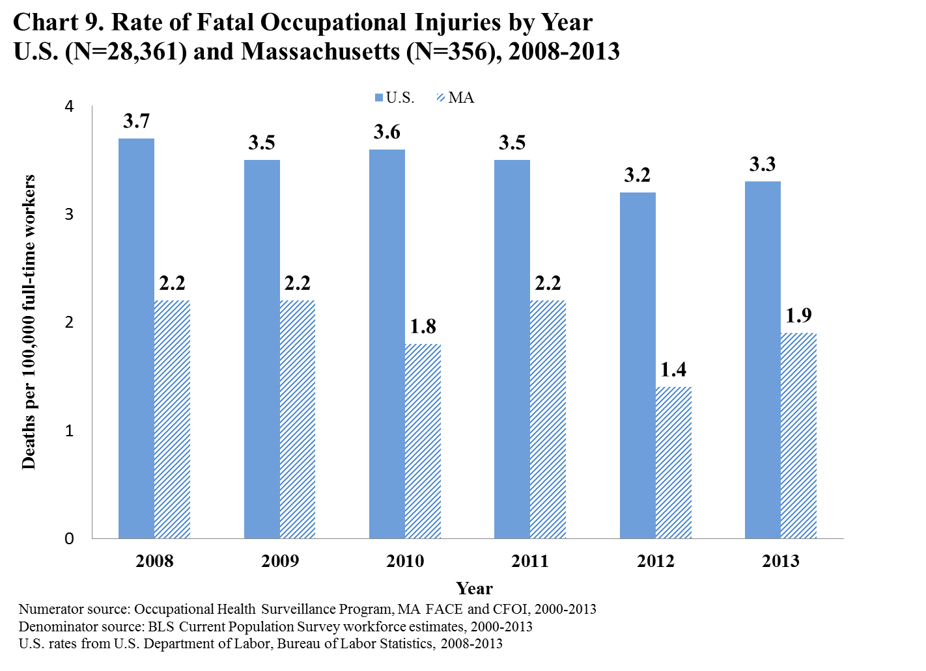

- This difference in fatality rates is likely explained in part by differences in the industrial composition of the Massachusetts workforce as compared with that of the nation. For example, 28.4% of the Massachusetts workforce was employed in Education, Health and Social Services and Financial Services during 2008–2013 as compared to 21.5% of the U.S. workforce. These two sectors have the lowest fatality rates nationally (Table 8).

- Nationwide, a higher percentage of the workforce was employed in higher risk industry sectors such as: Agriculture, Forestry, Fishing, and Hunting; Mining, Quarrying, and Oil and Gas Extraction; Transportation, Warehousing and Utilities; Construction; and Manufacturing (Table 8).

- Most industry sector-specific fatality rates for 2008–2013 were lower in Massachusetts than in the nation as a whole (Table 8). National fatality rates in these sectors were all more than 50% higher than the Massachusetts rates for these industry sectors: Transportation, Warehousing and Utilities; Manufacturing; Professional and Business Services; Leisure and Hospitality; and Education and Health and Services.

- The fatality rate for Government workers (public sector) in Massachusetts was comparable to the U.S. rate.

- The rate for the Agriculture, Forestry, Fishing and Hunting industry sector in Massachusetts was much higher than the U.S. rate even though this sector made up a smaller portion of the workforce in the state. In Massachusetts, the high rate in this sector is driven by deaths in the commercial fishing industry.

Table 8. Distribution of the Workforce Fatal Occupational Injuries, by Industry Sector, Massachusetts and the United States, 2008-2013
 | Massachusetts |  |  |  | United States
Industry Sector |  | % of  Workforce | % of Fatalities | Fatality Rate | % of Workforce | % of Fatalities | Fatality Rate
Agriculture, Forestry, Fishing & Hunting |  | 0.4 | 8.4 | 43.2 | 1.6 | 12.1 | 26.1
Mining |  | 0.1 | <1 | * | 0.8 | 3.3 | 15.6
Construction |  | 5.9 | 23.9 | 8.1 | 6.5 | 17.5 | 9.7
Transportation, Warehousing, & Utilities |  | 2.8 | 10.7 | 7.8 | 4.5 | 15.8 | 12.6
Other Services |  | 4.2 | 3.4 | 1.6 | 4.6 | 3.9 | 2.8
Leisure & Hospitality |  | 7.1 | 4.8 | 1.3 | 7.8 | 4.9 | 2.2
Wholesale & Retail Trade |  | 11.8 | 11.2 | 1.9 | 13.6 | 10.2 | 2.7
Professional & Business Services |  | 14.7 | 8.1 | 1.1 | 11.1 | 8.7 | 2.8
Manufacturing |  | 9.9 | 5.6 | 1.1 | 11.3 | 7.1 | 2.3
Education, Health, & Social Services |  | 20.6 | 4.2 | 0.4 | 14.5 | 3.1 | 0.8
Financial Services |  | 7.7 | 3.4 | 0.9 | 7.0 | 2.1 | 1.1
Information |  | 2.4 | 1.4 | 1.2 | 2.2 | 0.9 | 1.5
Government |  | 12.5 | 14.3 | 2.1 | 14.4 | 10.3 | 2.1
Total |  | 100 | 100 | 2.0 | 100 | 100 | 3.5
Numerator source: Occupational Health Surveillance Program, MA FACE and CFOI, and national data from Bureau of Labor Statistics, CFOI, 2000-2013
Denominator source: BLS Current Population Survey workforce estimates, 2000-2013
Rates are expressed as the number of fatal occupational injuries per 100,000 full-time workers.
* Rate not presented due to small number of fatal injuries (fewer than 5).
Percentages may not add to 100% due to rounding.

- Another explanation for the lower fatal occupational injury rates in Massachusetts is that highway motor vehicle-related fatalities and homicides, two events that contribute substantially to the national occupational fatality burden, are low in the Massachusetts general population compared to the nation: the rates for these events in Massachusetts were each about half their respective national averages for 2008-2013. These events accounted for 19.4% of the workplace fatal injury burden in Massachusetts versus 33.6% in the U.S. Rates computed excluding homicides and highway motor vehicle-related fatalities reduced, but did not eliminate, the gap between the rate for Massachusetts (1.6 deaths per 100,000 workers) and the national rate (2.3 deaths per 100,000 workers).

- Numerous additional factors likely contribute to the lower fatal occupational injury rates in Massachusetts. These include the following: the comparatively high levels of education and socioeconomic status among workers in Massachusetts; the somewhat higher proportion of unionized workers in the state (14.9% for Massachusetts versus 11.8% for the U.S.); and greater access to emergency medical services.

3.2 Fatal Event or Exposure

- The contribution of highway motor vehicle incidents to the occupational fatality burden was low in Massachusetts as compared to the nation (Appendix 2). As a consequence, falls to a lower level accounted for a much higher proportion of the fatal occupational injuries in Massachusetts during the surveillance period. The broad fall category accounted for 24.2% of Massachusetts deaths compared to 14.7% of deaths across the U.S. Notably, the rate of fatal falls to a lower level in Massachusetts (0.4 deaths per 100,000 workers) was similar to the national rate (0.4 deaths per 100,000 workers).

- Suicide at the workplace accounted for 15.2% of workplace fatal injuries in Massachusetts versus 5.6% nationally, though the rate of all suicide in Massachusetts was lower than that of the nation for each year of the period. This may be in part due to collaboration between OHSP and MA NVDRS and increased recognition of workplace suicides.

3.3 Sex, Age, Race and Hispanic Origin, and Employment Status

- The distribution of fatal occupational injuries in Massachusetts was similar to national findings with respect to sex, age, and employment status. However, Massachusetts’ victims were more likely to be White non-Hispanic and less likely to be Hispanic or Black non-Hispanic than victims in the country as a whole, which likely reflects differences in the underlying racial and ethnic compositions of the workforce between Massachusetts and the nation (Appendix 2). As mentioned previously, the high rates of fatal occupational injury for Hispanic workers and older workers observed in Massachusetts have also been reported for Hispanic and older workers nationwide.^{9,24,25}

Municipal Police Officer Fatally Injured When Struck by a Backing Dump Truck

A 53-year-old male municipal police officer was struck by a backing dump truck while performing a traffic detail for a water line replacement project. The victim was facing a front end loader that was moving towards him when a stopped motorist alerted him to a dump truck that was backing behind him. As he tried to get out of the way of the truck he fell and the truck backed onto him. The contractor performing the work did not have an internal traffic control plan or backing procedures. The dump truck was not equipped with monitoring technologies which could have alerted the truck driver of the victim in the blind spot behind the truck. The police department did not have written safety and health procedures or provide training specific to traffic details and work zones, and the municipal police training academy did not cover work zone safety at the time the victim attended the academy.

To prevent similar incidents, Massachusetts FACE recommended that contractors performing work on or around roadways should:
- Develop, implement, and enforce an Internal Traffic Control Plan (ITCP) specific to each construction site to minimize vehicle backing and to help protect workers on foot;
- Ensure backing protocols are in place and that designated individuals are assigned as signalers to direct backing vehicles on construction sites; and
- Consider installing monitoring technology on construction vehicles and equipment to assist operators in detecting workers on foot within blind areas.

Municipalities should:
- Provide work zone safety training for all employees who perform work on or around roadways, including traffic details; and
- Provide work environments that, at a minimum, meet all relevant OSHA regulations and industry accepted standards of practice per the Department of Labor Standards’ policy.

Manufacturers of heavy construction equipment and vehicles, such as dump trucks, should:
- Explore the possibility of incorporating collision avoidance technology on their equipment to assist the operator while backing.
Massachusetts FACE Report 12MA016
IV. Appendices

Appendix 1. Leading Fatal Occupational Events/Exposures and Industries by Racial/Ethnic Groups, Massachusetts, 2008–2013
Hispanic (N=39) | White non-Hispanic (N=272) | Black non-Hispanic (N=26) | Asian non-Hispanic (N=14)
Top Four Events/Exposures (N)
Fall to a lower level (9) | Fall to a lower level (60) | Fall to a lower level (7) | Suicide (4)
Roadway motor vehicle collision or rollover (5) | Suicide (44) | Roadway motor vehicle collision or rollover (7) | Homicide (3)
Homicide (4) | Roadway motor vehicle collision or rollover (25) | Homicide (4) | Exposure to harmful substance (carbon monoxide) (2)
Pedestrian struck by motor vehicle (3) | Worker struck by motor vehicle or mobile equipment (20) | Suicide (3) | Roadway motor vehicle collision or rollover (2)
Top Three Industries (N)
Construction (12) | Construction (69) | Administrative and Support and Waste Management and Remediation Services (6) | Accommodation and Food Services (4)
Transportation, Warehousing & Utilities (5) | Government (44) | Passenger transportation (4) | Manufacturing (3)
Fishing (3)  Manufacturing (3)  Wholesale and Retail Trade (3) | Wholesale and Retail Trade (31) | Construction (3) | Wholesale and Retail Trade (3)
SOURCE: Occupational Health Surveillance Program, MA FACE and CFOI, 2008-2013
NOTE: Information about race and Hispanic origin was obtained from death certificates.

Appendix 2. Fatal Occupational Injuries by Select Characteristics, 2008–2013,
Massachusetts (N=356) and United States (N=28,361)
 | Massachusetts |  | United States
Characteristic | Number of fatalities | % of fatalities | Number of fatalities | % of fatalities
TOTAL | 356 | 100% | 28,361 | 100%
EMPLOYEE STATUS
Wage & Salary workers | 297 | 83.4% | 22,170 | 78.2%
Self-employed workers* | 55 | 15.4% | 6,191 | 21.8%
SEX
Male | 331 | 93.0% | 26,215 | 92.4%
Female | 25 | 7.0% | 2,145 | 7.6%
RACE/ETHNIC ORIGIN
White non-Hispanic | 272 | 76.4% | 19,855 | 70.0%
Hispanic | 39 | 11.0% | 4,538 | 16.0%
Black non-Hispanic | 26 | 7.3% | 2,731 | 9.6%
Asian non-Hispanic | 14 | 3.9% | 822 | 2.9%
American Indian or Alaska Native | -- | -- | 199 | 0.7%
Other or not reported | 5 | 1.4% | 216 | 0.8%
AGE
Under 16 years | -- | -- | 74 | 0.3%
16 - 17 | -- | -- | 87 | 0.3%
18 - 19 | 3 | 0.8% | 356 | 1.3%
20 - 24 | 13 | 3.7% | 1,731 | 6.1%
25 - 34 | 51 | 14.3% | 4,566 | 16.1%
35 - 44 | 72 | 20.2% | 5,446 | 19.2%
45 - 54 | 99 | 27.8% | 7,132 | 25.1%
55 - 64 | 80 | 22.5% | 5,526 | 19.5%
65 years & over | 38 | 10.7% | 3,427 | 12.1%
Source: Occupational Health Surveillance Program, MA FACE and CFOI, and national data from Bureau of Labor Statistics, CFOI, 2000-2013
Totals may include data for subcategories not shown separately. Percentages may not sum to totals due to rounding. Dashes indicate data that are not available or do not meet publication criteria.
* Self-employed includes paid and unpaid family workers as well as owners of unincorporated businesses.

Appendix 2. Fatal Occupational Injuries by Select Characteristics, 2008–2013,
Massachusetts and United States (continued)
 | Massachusetts |  | United States
Characteristic | Number of fatalities | % of fatalities | Number of fatalities | % of fatalities
TOTAL | 356 | 100% | 28,361 | 100%
2008-2010, OIICS 1 | 186 | 100% | 14,455 | 100%
Transportation incidents | 55 | 29.6% | 5,857 | 40.5%
Assaults and violent acts | 36 | 19.4% | 2,532 | 17.5%
Contact with objects and equipment | 25 | 13.4% | 2,450 | 16.9%
Falls | 45 | 24.2% | 2,052 | 14.2%
Exposure to harmful substances or environments | 22 | 11.8% | 1,289 | 8.9%
Fires and explosions | 3 | 1.6% | 483 | 3.3%
2011-2013, OIICS 2 | 169* | 100% | 13,906 | 100%
Violence and other injuries by persons or animals | 51 | 30.2% | 2,367 | 17.0%
Transportation incidents | 46 | 27.2% | 5,725 | 41.2%
Fire or explosion | 4 | 2.4% | 415 | 3.0%
Fall, slip, trip | 41 | 24.3% | 2,109 | 15.2%
Exposure to harmful substances or environments | 10 | 5.9% | 1,094 | 7.9%
Contact with objects and equipment | 16 | 9.5% | 2,154 | 15.5%
Source: Occupational Health Surveillance Program, MA FACE and CFOI, and national data from Bureau of Labor Statistics, CFOI, 2000-2013
Percentages may not sum to totals due to rounding.
* One fatality in this period was included by FACE and deemed out of scope by CFOI.

Appendix 3. Further Discussion of Statistical Methods

Since the occurrence of a fatal occupational injury in the working population is considered relatively rare, and the probability of this event happening is small, a Poisson regression model was used to predict a statistical change (trend) in the occupational fatality rate as a function of time and age.

Ninety-five percent confidence intervals were computed for each rate, defining a range of possible values within which the ‘true’ value for each rate was likely to lie. The Mid-P test 95% confidence intervals for the rates were calculated using the OpenEpi Software Program version 7.5.11, available at http://web1.sph.emory.edu/cdckms/exact-rate.html. These 95% confidence intervals provided not only a measure of precision for a rate, but they also formed the basis for comparing rates to determine if they were statistically different. If the 95% confidence intervals around two rates being compared did not overlap, then the rates were considered significantly different from one another. Also, if the confidence intervals overlapped but neither overlapped with the other mean, the strength of the statistical test (p-value) was considered in determining significance.

For further details about fatal occupational injuries in Massachusetts, please go to: http://www.mass.gov/dph/FACE.

U.S. Department of Health and Human Services Testimony on Commercial Fishing Vessel Safety before the Committee on Transportation and Infrastructure, Subcommittee on Coast Guard and Maritime Transportation, U.S. House of Representatives, April 2007, Accessed at http://www.hhs.gov/asl/testify/2007/04/t20070425e.html; NIOSH Partners with Organizations and Industry to Reduce Aviation Fatalities in Alaska, https://www.cdc.gov/niosh/docs/2013-137.
The Construction Chart Book: The U.S. Construction Industry and its Workforce (4th edition), CPWR – The Center for Construction Research and Training, 2008, Accessed at www.cpwr.com.
Council of State and Territorial Epidemiologists, Occupational Health Success Stories. www.cste.org/general/custom.asp?page=SuccessStories
Stop Construction Falls Campaign. Success stories from the 2014 National Safety Stand-Down. http://stopconstructionfalls.com/?page_id=1902.
NIOSH-funded Program Contributes to a New Massachusetts Law to Protect the Health and Safety of Floor Finishing Workers, https://www.cdc.gov/niosh/docs/2011-181.
Throughout this report, comparative terms such as higher, lower, increased, or decreased, were used only when the difference was statistically significant at the 95% probability level.
Worker Health Chartbook 2004, NIOSH Publication# 2004-146. U.S. Depart. of Health and Human Services, Centers for Disease Control and Prevention, National Institute for Occupational Safety and Health.
Worker Health eChartbook. U.S. Department of Health and Human Services, Centers for Disease Control and Prevention, National Institute for Occupational Safety and Health. Available from http://www.cdc.gov/niosh-survapps/echartbook/Chart.aspx?id=1223&cat=20.
Census of Fatal Occupational Injuries, Bureau of Labor Statistics, U.S. Department of Labor, Current and Revised Data (1992-2013). Available from http://www.bls.gov/iif/oshcfoi1.htm.
Deaths where the worker is commuting to an off-site location or traveling from their employer to a customer site are generally included as travel required to perform the job.
The 2002 and 2007 North American Industry Classification System Manuals area available from http://www.census.gov/eos/www/naics/.
The 2000 and 2010 Standard Occupational Classification Manuals are available from http://www.bls.gov/soc/. Changes are highlighted in the 2010 SOC User Guide available from http://www.bls.gov/soc/soc_2010_user_guide.pdf.
Occupational Injury and Illness Classification Manual, U.S. Department of Labor, Bureau of Labor Statistics. 1992.
Occupational Injury and Illness Classification Manual, U.S. Department of Labor, Bureau of Labor Statistics. 2012.
Program Guide for the Census of Fatal Occupational Injuries Program, U.S. Department of Labor, Bureau of Labor Statistics. 2004.
U.S. Census Bureau, DataFerrett, Current Population Survey.
There were no deaths of workers less than 16 years old in this period.
These numbers do not include Massachusetts residents who were fatally injured while working out-of-state: those victims are included in the census of the state where the injury occurred. Similarly, any workers who were injured out of state and were pronounced deceased at Massachusetts hospitals are included in the counts of the state where the initial injury occurred.
See Chart 8 in Section II for a look at the trend beyond this six-year period.
U.S. Bureau of Labor Statistics, Spotlight on Statistics: The Recession of 2007-2009. http://www.bls.gov/spotlight/2012/recession.
Hadi A. (2011). Construction employment peaks before the recession and falls sharply throughout it. U.S. Bureau of Labor Statistics, Monthly Labor Review, April 2011: 24-27. http://www.bls.gov/opub/mlr/2011/04/art4full.pdf.
Dong XS, Choi SD, Borchardt JG, Wang X, Largay JA. (2013). Fatal falls from roofs among U.S. construction workers. Journal of Safety Research, 44: 17-24.
Employment distribution by occupation group obtained from U.S. Census Bureau, DataFerrett, Current Population Survey data 2008–2013, April 2015.
Massachusetts Department of Public Health. (2009). Occupational Health Surveillance Program. Fatal Occupational Injuries in Massachusetts, 2000 – 2007.
Massachusetts Department of Public Health. (2002). Occupational Health Surveillance Program. Fatal Occupational Injuries in Massachusetts 1991–1999.
Richardson S, Ruser J, Suarez P, Hispanic workers in the United States: An analysis of employment distributions, fatal occupational injuries, and non-fatal occupational injuries. In: Safety is seguridad: a workshop summary. Washington, DC: The National Academies Press. 2003.
Orrenius P, Zavodny M. (2009). Do Immigrants Work In Riskier Jobs? Demography 46(3): 535–551.
Byler C. (2013). Hispanic/Latino fatal occupational injury rates. Mon Lab Rev, 136(2):14-33.
This difference in rates is based on small numbers and is not statistically significant; however it is consistent with findings reported elsewhere. (Dong X, Platner JW, Occupational fatalities of Hispanic construction workers from 1992–2000. Am J Ind. Med. 45(1):45-54. 2004. And Dong XS, Choi SD, Borchardt JG, Wang X, Largay JA. Fatal falls from roofs among U.S. construction workers. J Safety Res 44:17–24. 2013).
Massachusetts Violent Death Reporting System, Injury Surveillance Program, Massachusetts Department of Public Health. http://www.mass.gov/eohhs/gov/departments/dph/programs/community-health/injury-surveillance/reports/violent-death-reporting.html.
These drownings exclude water vessel drownings which are considered transportation events.
As discussed earlier, an updated version of industry coding was adapted by CFOI in 2009. Analyses presented here are at the broadest category, industry sector.
Unpublished statistics from the NIOSH Alaska Pacific Office. Alaska, Louisiana, and Washington had 61, 28, and 24 deaths during the period, respectively.
Centers for Disease Control and Prevention (CDC). Commercial Fishing Deaths -- United States, 2000-2009. Morbidity and Mortality Weekly Report (MMWR) 2010; 59:842-845.
U.S. Census Bureau, DataFerrett, Current Population Survey data, 2008–2013.
Five additional workers died on or near docked vessels or in coastal waters near to shore. In Figure 1 these five deaths are mapped to the town of incident.
OSHA’s jurisdiction may depend on the precise nature or circumstances of the incident. Other agencies such as the Mine Safety & Health Administration (MSHA), the Federal Railroad Administration (FRA), the Federal Aviation Administration (FAA), and the Coast Guard protect the health and safety of workers under their respective jurisdiction.
Kramarow E, Chen LH, Hedegaard H, Warner M. Deaths from unintentional injury among adults aged 65 and over: United States, 2000–2013. NCHS data brief, no 199. Hyattsville, MD: National Center for Health Statistics. 2015.
Estimated homicide rate of 2.5 deaths per 100,000 population for MA versus 4.9 for the U.S. for 2008-2013. Homicide rates from U.S. Department of Justice, Federal Bureau of Investigation, Criminal Justice Information Services Division. Accessed 4/6/16 at https://www.fbi.gov/about-us/cjis/ucr/crime-in-the-u.s; 0.65 deaths per 100 million vehicle miles traveled versus 1.14. National Highway Traffic Safety Administration http://www.fars.nhtsa.dot.gov/States/ StatesFatalitiesFatalityRates.aspx.
The Union Membership and Coverage Database (from the Current Population Survey and Outgoing Rotation Group Earnings, 2008-2013). Covers employed, non-agricultural wage & salary workers 16 years of age and older. Accessed 3/25/16 at http://www.unionstats.com.
Because of the transition to OIICS 2.0 for record year 2011-, this U.S. rate is for 2011-2013.
Annual reports from the DPH Injury Surveillance Program, available from www.mass.gov/dph/isp.
Austin PC, Hux JB. (2002). A brief note on overlapping confidence intervals. J Vasc Surg. 36: 194-195.

