Massachusetts Hemovigilance Program
Febrile Non-Hemolytic Transfusion Reaction (FNHTR) Event Summary
January 1, 2017 – December 31, 2022
Data were extracted from NHSN on June 21, 2023.

Figure 1: FNHTR Events and Total Transfusion Volume by Year, 2017-2022
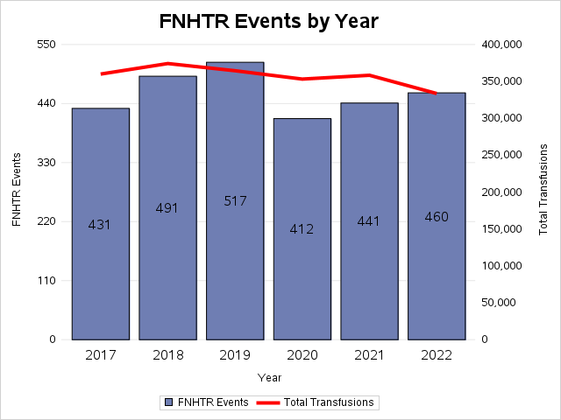

Gender | Total | Percent
Female | 1,355 | 49%
Male | 1,397 | 51%
Table 1: FNHTR Events by Gender

Figure 2: FNHTR Events by Age, 2017-2022

Figure 3: FNHTR Events by Product Type (2017-2022)

Table 2: FNHTR Event Rate Per 10,000 Products Transfused by Product Type (2017-2022)
Product Type | FNHTR Event Rate  (Per 10,000 products transfused)
Platelets | 17.8
Red Blood Cells | 14.8
Plasma | 1.55
TOTAL | 13.5

Figure 4: FNHTR Events by Bed Size Group (2017-2022)

Figure 5: FNHTR Event Rate by Bed Size (per 10,000 Products Transfused)

Summary Findings
- More than half (53%) of reactions occurred in adult hospital wards: the next most common location types were pediatric wards (10%) and the ICU (8%).
- Irradiated, leukocyte-reduced whole blood-derived red blood cells (RBC) accounted for 39% of transfusions associated with a FNHTR: leukocyte-reduced whole blood-derived RBC made up 23%, irradiated, leukocyte-reduced apheresis platelets accounted for 14%, and psoralen-treated platelets accounted for 3%.
- Most individuals recovered with minor or no sequelae (96%): only 0.5% of cases suffered major or long-term sequelae.

As always, report any unusual or unexpected response to blood product transfusion to your Blood Bank
NHSN FNHTR Classification Criteria Tables*
 | Definitive | Probable | Possible
Case Definition | Occurs during or within 4 hours of cessation of transfusion  AND EITHER  Fever (greater than or equal to 38°C/100.4°F oral and a change of at least 1°C/1.8°F) from pre- transfusion value  OR  Chills/rigors are present. | N/A | FNHTR is suspected but reported symptoms and/or available information are not sufficient to meet the criteria defined to the left. Other, more specific adverse reaction definitions do not apply
Imputability | Patient has no other conditions that could explain signs/symptoms. | There are other potential causes present that could explain signs/symptoms, but transfusion is the most likely cause. | Other present causes are most likely, but transfusion cannot be ruled out.
*These surveillance case definitions can be found on page 14 of the February 2023 National Healthcare Safety Network Biovigilance Component Hemovigilance Module Surveillance Protocol and are not intended for clinical decision-making.
Resources:
NHSN Hemovigilance Module Surveillance Protocol: https://www.cdc.gov/nhsn/pdfs/biovigilance/bv-hv-protocol-current.pdf
MDPH Hemovigilance Data:
https://www.mass.gov/service-details/reporting-requirements-for-blood-banks-and-hemovigilance-in-massachusetts

