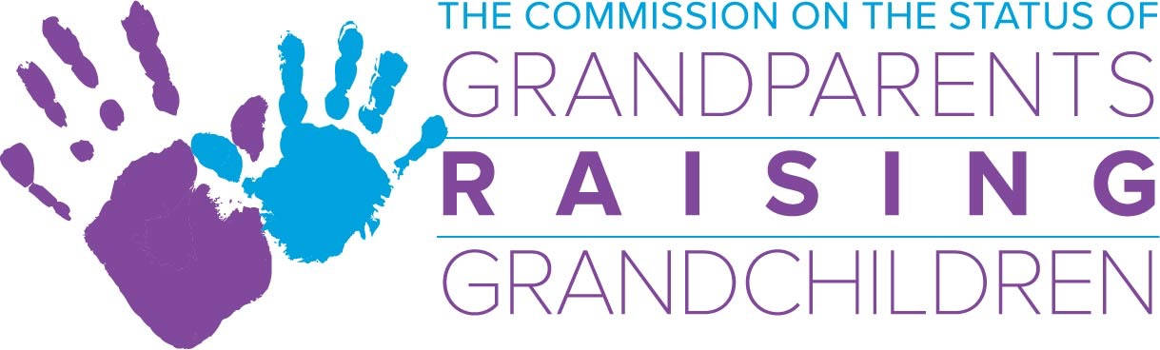

February 14, 2024 Commission Meeting, 1:00 p.m. -3:00 p.m.
This meeting will be conducted via Zoom

If you would like to receive a Zoom invite, please contact colleen.pritoni@mass.gov

Agenda

- Approval of January Minutes
  - Vote Required

- Financial Report/Budget – Joe O’Leary, Treasurer
  - Best practice for spending over $500
  - Discussion on FY’25
  - MCOA account – Lynn Girton

- Directors Report – Colleen Pritoni
  - Grandfamilies FUNd scholarships announced last week
  - Community Presentations/Meetings:
- Brockton Community Services, Age Strong/City of Boston, Holyoke Systems of Care
- Old Colony YMCA Attleboro, DPH/BSAS
  - Winter Workshops – ending February
  - Spring Workshops:
    - Wellness workshop
    - Reunification Panel workshop
  - Roundtables – West, Central, and Southeast held in January
Program Coordinator:
    - Review of FRC websites/GRG support groups
      - Presented findings to DCF Community and Family Engagement Team
    - Launch Northeast in February and Boston Roundtables February
  - Intern Projects:
    - Grand-Stories Team
      - Conducting Interviews
      - Writing the GRG Stories
      - Collecting photos
      - Drafting the booklet format

- Sub-Committee Updates:
- Support Group Sub-Committee: Deb Dowd-Foley
  - Training
  - Created “Best Practice” for GRG Support Groups
- Legal and Advocacy Sub-Committee: Lynn Girton
  - College Tuition Bill Update
  - Wonderfund
- Information and Outreach: Gail Williams
  - Expand outreach to places of worship, libraries, etc.
  - Updating tip sheets
- Resource Development Sub-Committee: Ilene Mitchell

- Chairwoman’s Report-Lynn Girton
  - Appointment Updates – Welcome Commissioner Forist

- Advisory Board Update – Kristen Cipullo

- Other: June Commission Meeting/Volunteer Appreciation Lunch 6/11/24

