Board of Trustees
Meeting Minutes

Meeting Information
Meeting date & time | February 25, 2025 / 1:00pm – 2:55pm
Location | Long Term Care Facility  Trustees’ Conference Room  1st Floor Room N1106
Tommy Lyons
Ira Novoselsky
Christine Baldini
Jessica Rogers
Louise Ford
Jed Barash
John Couillard
Scott Consaul
Valerie Brathwaite
Marc Silvestri
Chad Morin
Jill West
Maggie Brown (DCAMM)
Ryan Kiracofe (Pennrose)
Attendance:  Via Microsoft Teams | Kurt Power (Not present)  Dawn Slaven  Janet Hale  Robert Engell  Mark Yankopoulos  Beth Hill

Meeting Details

Description | Presenter
Call to Order/Role Call | Thomas Lyons
Approval of Minutes  Board of Trustees Meeting – January 28, 2025  First motion made for approval by Mr. Novoselsky and seconded by Ms. Slaven – then verbally accepted by all Board of Trustee members present. | Thomas Lyons
DCAMM/Pennrose - Domiciliary Construction update  - Introductions of Pennrose Representatives:  - Ryan Kiracofe, Developer.  - Joe Gatti, Colleague.  - Timeline:  - The project consists of four phases until completion.  - The presentation focuses on phases I (North of Crest Avenue excluding Power Plant) and II (South of Crest Avenue at the John Adams building and East Parcel building).  - Fall 2025 - Projected start for phase I.  - Locking down Tax Credit Investment.  - DCAMM will be taking on preliminary work (Incinerator Building) within this phase to allow the project to continue into Phases III & IV.  - Early 2026 – Projected start for phase II.  - 150 planned units in Phases I & II.  - Construction Logistics Plan:  - Safety Construction Fence.  - Crest Ave. Direction & Parking.  - Bus Stop Relocation.  Chairman Lyons asked about the plan to inform neighbors, regarding the project and specifically with the takedown of the power plant, incinerator building. Mr. Kiracofe informed the Chairman, in collaboration with DCAMM, the plan is to have a pre-construction meeting with the neighbors. Ms. Brown indicated the scope of the incinerator building is under operation with DCAMM’s design and construction team. The importance of communication with neighbors has been noted.  - Rent Examples:  - Rental subsidy qualification will amount to 30% of monthly income.  - No rent change until 2031.  - One-on-one meetings with residents will be offered to discuss anticipated expenses.  - Reviewed examples in slide deck.  Mr. Kiracofe reviewed questions presented at the last Town Hall meetings:  - Am I responsible for my own utility bills?  - Can someone help me pay my utility bills?  - Are there incentives or other programs to help?  Veterans can apply for funding for those who are financially qualified and may receive support to cover utility expenses. It is the resident’s responsibility to pay utility bills. Pennrose, Soldier On and additional resources will be available to help manage logistical concerns regarding utility expenses.  Chairman Lyons inquired if there were residents who would be eligible for VASH vouchers. Pennrose and DCAMM have been in communication with the VA regarding VASH vouchers. The most recent guidance for VASH vouchers is intended for individuals who are currently homeless. Residents currently residing at the Massachusetts Veterans Home at Chelsea would not qualify for the VASH voucher, as they are not considered homeless. During Phase I and Phase II of the project, we do not anticipate receiving VASH vouchers; however, it is possible in Phase III and Phase IV.  - Campus Historic Items:  - DCAMM is working with staff to identify historic items for preservation.  - Furniture:  - Soldier On obtained funding allocation from EOVS to support apartment furnishings.  Chairman Lyons added there are Veterans organizations who may be willing to sponsor furnishing of a room for a Veteran who is recently coming out of a homeless situation. Chairman Lyons added it might be helpful to have conversations with these organizations and he is happy to participate in the engagement. Ms. Slaven added there may be local furniture companies who may consider donation.  Mr. Kiracofe opened the floor for any questions.  Mr. Novoselsky raised a question regarding parking during the project, specifically construction worker parking and storage of equipment. Mr. Kiracofe explained there will be no construction parking onsite. As for the construction equipment, all equipment will be contained within the Phase I fence.  Ms. Slaven inquired if all apartments will be individually metered? Mr. Kiracofe explained heating and cooling of the apartments and hot water will be considered utilities and confirmed that all apartments will be individually metered. In addition, residents currently residing in the dorm will be accommodated within Phases I and II, rent and subsidies will be provided for the first four years based on the current rate with the difference supported by state assistance.  Ms. Rogers inquired how will you ensure veterans hear about housing availability before the message is communicated to the public and what percentage of the units are for veterans’ preference. Mr. Kiracofe indicated, Pennrose Management Company marketing team markets the project, but Soldier On are experts in this area, which is why they have joined the Pennrose team.  Soldier On operates their own veteran housing across the Commonwealth and the East Coast and they have an understanding what the waitlist is for their projects. Pennrose will work in collaboration with Soldier On to identify and compile a waitlist of veterans. With veteran preference, all veterans who apply and qualify will receive priority over other applicants. Ms. Baldini added that working with the local VSOs will also support growing the waitlist and ensure that veterans who are looking to obtain housing are a priority.  Chairman Lyons thanked Mr. Kiracofe for the update and looks forward to future meetings which will include Consigli Construction to hear their plans as the project progresses.  Mr. Silvestri inquired how the move process will work logistically with Phases I and II completion. Mr. Kiracofe replied, the goal is to have rooms occupied as soon as the certificate of occupancy is received. Ms. Baldini confirmed that those residents with the most seniority will be given priority and advanced planning for relocation will take place. Ms. Rogers inquired on the time frame for Phase I construction. Mr. Kiracofe confirmed two years.  Chairman Lyons turned the meeting over to the next agenda item. | Maggie Brown (DCAMM)  Ryan Kiracofe, Joe Gatti (Pennrose)
Executive Director’s Report  - VA Survey Domiciliary January 2024 Update:  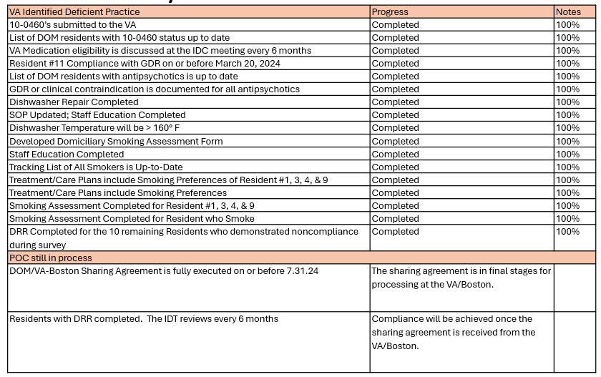  - Department of Public Health Plan of Correction October 2024 Update:  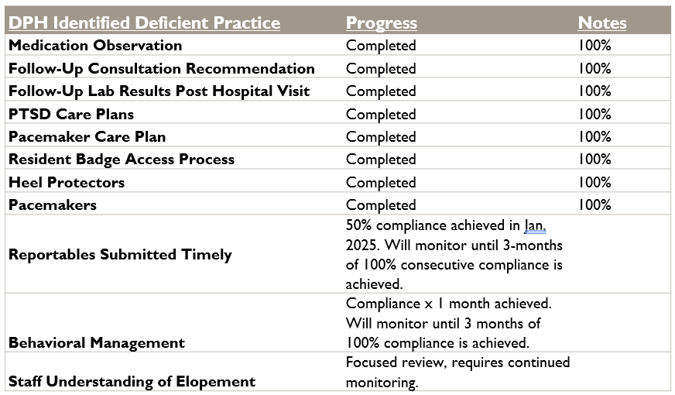  Ms. Brathwaite reported 2 months of compliance with the behavior management deficient practice and will report at the March QAPI meeting. Ms. Baldini shared that compliance will be monitored for the remainder of the year, beyond the three months of consecutive compliance.  - Implementation of Electronic Medical Record:  - Care Plan implementation in process, full implementation expected by May 2025.  - 802 Matrix – acuity report remains in process with WellSky.  - EOTSS/WellSky interface:  - Pharmacy integration anticipated completion March 15th 2025.  - Radiology interface is currently in testing with anticipated go live date of March 10th 2025.  - Dietary communication tunnel testing in process at Holyoke, anticipated go live for Chelsea is April 1st 2025.  - Laboratory has not begun.  - Health Drive has not begun.  - WellSky/CHE continues to work on back-up system for downtime.  - Pinnacle Report February 2025:  - 98% favorable rating.  - Average score 4.85/5.  - Focus Area – Communication.  - Looking to revise the contract to expand more satisfaction surveys beyond the current contract.  - Focus areas/goals 2025:  - Labor management.  - Stabilization of workforce.  - Employee engagement.  - Regulatory compliance DPH, CMS, Life Safety, VA.  - Compliance and confidence with EMR utilization.  - Customer Service.  - Foundation- billing for Medicare part A services and expanded programs for part B services.  - CMS Five Star Rating:  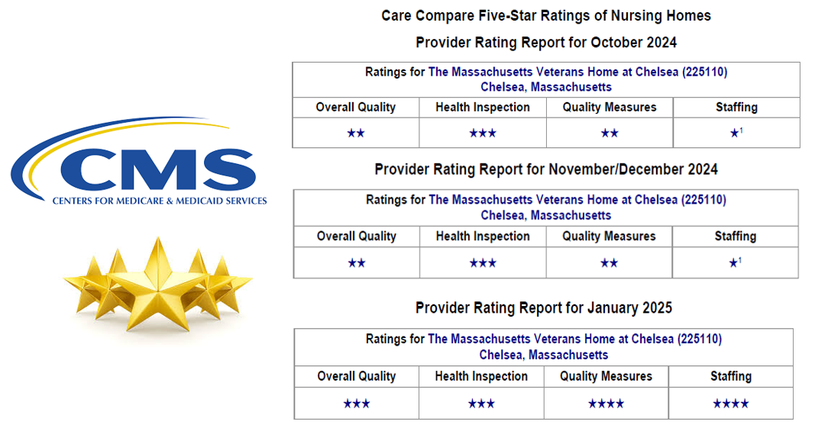  Ms. Baldini added the goal by the end of quarter 2 is for the quality measures and staffing categories increase to five stars, which will then increase the overall quality rating to a 4 star.  Chairman Lyons inquired if there were any questions for the Executive Director’s report, hearing none the Chairman requested a motion to accept the report. Ms. Slaven provided the first motion. Mr. Novoselsky provided the second motion. All Board members present voted to accept the Executive Director report. | Christine Baldini
Department Report: | Presenter
Deputy Executive Director:  - HR Updates:  - January 2025- Hired (4) new employees:  - RN V – Quality Nurse  - Recreation Therapy Supervisor  - RN II  - RN I  - February 2025 – Updates:  - RN I – promotion  - Treasurer’s Office Supervisor – promotion  - Physician II - New Hire  - Offers Extended or Candidates Identified:  - Informatics  - Technology & Systems Project Manager  - (2) Security Specialist I  - (4) Environmental Services Workers  - Human Resources Assistant  - Recreation Therapist  - (1) RN – day shift  - Recruitment and Retention Coordinator  - Human Resource Manager  - RN III – Evening Supervisor  - Nurse Scheduler  - (1) Certified Nursing Assistant  - (1) Clerk III  Chairman Lyons inquired what criteria is reviewed in the hiring process of a Security Specialist. Mr. Consaul replied to the criteria, generally includes security experience, veteran service, experience in a healthcare setting, and additional qualifications based on background. There was some difficulty recruiting candidates but the cadence of that has changed and there have been more qualified candidates applying.  - Interview in progress:  - (10) Kitchen Service Worker  - (1) Clerk III  - (4) Communication Dispatchers  - RN V – Quality Improvement Nurse  - RN IV – Veteran Care Supervisor  - Chauffer  - Certified Nursing Assistant  - Registered Nurse and Licensed Practical Nurse  - Director of Communications  - Executive Assistant  - Active Postings or Positions to be posted:  - Nurse Practitioner  - Physical Therapy Assistant  - Occupational Therapy Assistant  - Registered Dietitian  - Steam Fireman  - Pipeline postings  - Licensed Nurses RN/LPN  - CNA’s  - Recreation Therapist  - Goals for HR 2025:  - Stabilize the workforce by filling open positions.  - Reduce agency utilization in the Nursing Department.  Chairman Lyons complimented the efforts of getting positions posted in the pipeline. | Jessica Rogers
Nursing Department Report  - Nursing Department Accomplishments – January 2025:  - Follow through with the October 2024 DPH Survey Corrective Action Plan continues with the final clinical related measures:  - The process of granting resident badge access is successful in enhancing resident safety.  - 100% compliance with the process of granting badge access was met for three months.  - Compliance met.  - Compliance with staff knowledge related to:  - The definition of elopement and understanding leaving campus with badge access is considered elopement without completion of a separate consent.  - The results decreased from the previous month. Re-education was completed for appropriate staff who did not demonstrate understanding.  - Elopement training is ongoing. Teaching methods such as scenario-based case studies will be incorporated to engage the staff and meet learning outcomes.  - Nursing Hours Per Veteran Day 5.89 for December 2024 vs budget 5.30.  - One-to-one support and transport to appointments are not represented in this number consistently. | Louise Ford
Medical Director Report  - There are currently two primary areas of focus, accomplishments, and goals:  - Meet multiple times weekly and making significant progress in collaboration with Holyoke and WellSky to better coordinate the electronic medical record with our workflow.  - Continue to work on staffing to care for our growing census. In Medicine, we have hired an additional physician who is slated to begin in late February 2025.  - In the process of posting a nurse practitioner position to replace one who departed at the end of January 2025. In Therapy, we worked with an agency to:  - Secured a physical therapy assistant (PTA) who started earlier this month.  - The PTA and OTA positions continue to be posted on MassCareers with an interview pending for an organic PTA candidate. A rehabilitation aide position is pending posting as well.  - The OTA, PTA, and rehabilitation aides are new positions for the rehab department. | Dr. Barash
Director of Facilities Management Report  - VA Life Safety Survey (12/2 -12/6/24):  - Life Safety Code- continue to work with the EOC Director to report to the QAPI Committee the progress on the corrective action plan for the VA.  - LSC documentation issues (primarily with vendors) Working with Finance to go back out to bid on one of the contracts. (Drafted new SOW, running past Contracts Manager, etc.).  - Drafted a new electrical testing form for in-house electricians to better reflect our compliance with the code.  - Reached out to our Architect, Payette re: application to the Board of Elevator Regulators for a variance, to install sprinklers in the elevator machine room.  - Focus areas 2025 - Emergency Preparedness (EOC and Public Safety):  - EM Training, Incident Command (HICS, etc.); Code Reds, Code Yellows.  - Working with Finance to secure a Consultant, etc.  - Continue to work with DCAMM & Pennrose on redevelopment project.  - Pennrose updates:  - Continue to work in partnership with DCAMM Project Manager and representatives from HDR Architects re: Keville and Sullivan Buildings, relocating DCCU, Gym, Computer Room, etc.  - Pennrose updates on schedule for Town Hall Meeting.  - Project updates:  - SNF Rear Doors: NE Schools installed new extra-heavy-duty closers with flat scan laser safety sensors on both sides of doors on February 20th.  - SNF Deck: New closers to be installed as part of the above project.  - Working with DCAMM and Consigli to replace all bathroom doors in the SNF with metal doors, electrostatically painted or epoxy finish.  Chairman Lyons inquired about the cost estimate and concerns or delays with the project for the replacement of bathroom doors. Mr. Consaul responded to the inquiry that DCAMM is going to cover the cost of the project. The total cost is estimated at approximately $500,000.00. The first step is to do a mockup, then review and consideration.  - Personnel updates:  - 3 new ESW’s (EVS) staff in onboarding pipeline – looking at March start dates.  - 2 Switchboard Operators in onboarding pipeline.  - 2 Security Specialists in the pipeline. | Scott Consaul
Ombudsperson Report  - Grievance Update:  - January 2025:  - The leadership team continues to educate staff on understanding the grievance process and the importance in documenting all grievances.  - 30 grievances in 2024; 9 in January 2025, which demonstrates progress with the program.  - 3 grievances in LTC - disagreement of wake-up times, mealtime and lost property.  - 6 grievances in the Domiciliary – destruction of property, 2 resident-to-resident altercations, water inquiry, speeding, use of laundry facilities after hours.  Chairman Lyons inquired if the resident-to-resident altercations were physical in nature. Mr. Silvestri explained the altercations were verbal altercations, and the residents worked through the disagreement. Mr. Novoselsky inquired about the details of the speeding grievance. Mr. Silvestri explained someone was driving too fast in a car past the Headquarters Building. | Marc Silvestri
Census and Admissions Report  - January 2025:  - Admissions:  - LTC – 5  - Domiciliary – 0  - Discharges:  - LTC – 2  - Domiciliary – 0  - Current Waitlist:  - LTC – 99  - Domiciliary – 19  - ADC:  - LTC – 125  - Domiciliary – 107  - Census as of February 21st 2025:  - LTC:  - Census – 126  - Open rooms – 28  - Domiciliary:  - Census – 106  - Open rooms – 19  Chairman Lyons inquired about the timeline to become qualified for residency in the dorm and come off the admissions waitlist. Ms. Brathwaite explained majority of the time there is a hold-up with receiving medical records from an outside facility, the VA and/or the application is not complete.  The Quality Nurse Manager inquired if residents who apply for the dorm can pass an individual already on the waitlist. Ms. Brathwaite responded, due to availability in the dorm, if an individual submits all required documentation and has been admitted post review of documents and interview, then yes, because there are different variables contributing to why an individual is on the waitlist.  Chairman Lyons confirmed residents are aware of required information needed for admission, which Ms. Brathwaite confirmed everyone receives a checklist and there is consistent communication between the home and individual leading up to admission. | Jessica Rogers
Quality & Standards Report  - Policy Development updates:  - Executive Office of Veteran Services continues to work with Health Management Associates.  - There scope of the project consists of 200 policies being developed, reviewed, and implemented over the course of the next year.  - The Governance Committee consists of members of leadership from both homes, and additional staff from HMA.  - Process development.  - Grouping policies.  - Review process by SME’s.  - Joint Committee Working Group establishment.  - Platform utilization and potential changes:  - Sharepoint is currently being used.  - Policy Manager.  - EOVS license will be created.  - Access will be available to EOVS, CHE and HLY.  - Existing HLY policy manager will be archived and preserved.  - There will be a transition to fully using Policy Manager for all policy work.  - The Policy Manager system will guide the automation of policy review and updating as the project continues and following the conclusion of the project.  Chairman Lyons inquired if the goal for both homes is to operate under the same policies, procedures and guidelines. Mr. Morin reported there have been 200 policies identified for review. These policies will be EOVS policies adopted by both Chelsea and Holyoke.  - Domiciliary Room Inspection QAPI Initiative:  - Address areas of opportunity for living space in the Domiciliary.  - Reviewing the current process for Domiciliary room inspections.  - Developed a comprehensive checklist to cover all aspects of room inspection according to both Health and Life Safety standards.  - Established a team to conduct a baseline assessment for room inspections to include members of facilities to address any maintenance related concerns.  - General Counsel review for compliance guidance.  - Communication drafted to residents regarding “what and why” for the change in process.  - Tabled for discussion at monthly Town Hall Meeting.  - Rooms out of compliance are documented with corresponding work orders being tracked through facilities for follow-up and compliance.  Chairman Lyons inquired if leadership is working with resident council to engage residents in discussion with changes with policy and procedures surrounding room inspections. Mr. Morin identified the follow-up to the baseline assessment to include a root cause analysis, which will guide and support changes to the process and the implementation of a new policy. Communication with residents will be ongoing throughout the duration of the project. This topic will be an agenda item for monthly town hall meetings. Resident, JS, shared there is currently no active Resident Council in the Domiciliary. Mr. Silvestri elaborated on efforts to communicate with residents and the difficulty in setting up Resident Council due to the process; however, communication is an area which can be improved upon. Chairman Lyons added wanting to ensure there are groups of residents who will be able to take information updates from the project and update fellow residents. | Chad Morin
Quality Nurse Manager Update:  - Deep dive into the quality measure report to identify areas above or below national trends. This will drive our focus and efforts for QAPI projects.  - To improve the quality of life of the residents we are privileged to serve.  - Goal - four-star overall building by the end of next quarter. | Jill West
Director of Social Services Report:  - Tours.  - Mental Health Services – working on partnering with the Home Base Program at Mass General Hospital which is a collaboration between Mass General Hospital and the Red Sox as part of their PTSD program.  - Domiciliary room inspections.  - Exploring resources for free tax prep for residents.  - A transition group for residents started to support the move from Domiciliary to LTC.  Chairman Lyons inquired if the Home Base Program has been responsive when we refer residents to the program. Ms. Brathwaite explained the program is very responsive and has sent veteran outreach coordinators to the home for initial intakes based on the range of health care issues. Next steps in process with the hope that in person visits can occur since Home Base changed appointments to virtual during the Covid 19 pandemic. | Valerie Brathwaite
Financial Report  - Donation Fund – January 2025:  - Contributions of $4,250.00 from the Kearsage Lodge for transportation and recreation and $775.00 from multiple donors in memory of resident Philip Ceciliano.  - Disbursements of $7,475.06 for petty cash game prizes, bingo, poker, refreshments, Dunkin Donuts, Katz Bagels, North Shore Music Theater trip and restaurant outings.  - Interest - $103.67 and final balance of $78,002.65.  - Legacy Fund:  - Contributions:  - $28,862.05 (transfer from the UBS Investment Fund).  - Disbursements:  - $2,991.88 on entertainment in December and early January for the holidays.  - $14,575.00 on transportation for resident outings which included church services for November and December 2024.  - Income investment of $74,363.48 leaving the balance in the legacy fund at $19,226,506.33.  - There were no special funding requests for this month.  - Update on funding for HQ Kitchen Project.  - Original budget of $3,364,071.02.  - The actual cost was $3,534,032.74.  - Contingency of 15% was built in for the project, the change orders came in at 18.4% which was the reason for the additional requests.  - Call-in to the project manager to verify the remaining balance of $2,993.35.  - Fiscal 26 budget:  - Conversations with Administration, Finance and EOVS.  - Submission of 2026 budget level funded from 2025 at $52.2 million.  - Currently under review with the House and Senate.  Mr. Novoselsky indicated the Kearsage Lodge requested a quarterly usage report of the funding provided and was looking for a status update. Mr. Couillard indicated the report was submitted up to date through the end of the first two quarters. Mr. Couillard will be sending an updated report in response, then will look to get back on the quarterly schedule.  Ms. Slaven inquired about the grease trap follow up on additional expenses incurred from the default equipment and how the expenses were going to be factored in overall. Mr. Couillard indicated he was waiting for a callback from the project manager, which was part of the question regarding the remaining balance due. Mr. Couillard will follow up and ask about the bill. Chairman Lyons requested once the update changes are received, to please share with the Trustees for their review. Mr. Couillard will send the updated report once completed. | John Couillard
Financial Report Motion to accept  Chairman Lyons requested a motion to accept the financial report as given. Motion approved by Mr. Novoselsky and then seconded by Ms. Hale, verbally accepted by all Board of Trustees members present. | Thomas Lyons
Other Business:

Ms. Hale asked for clarification regarding the January meeting minutes, there was no indication of Iraq or Afghanistan Veterans residing in the Domiciliary. Ms. Baldini responded that the team would investigate the details and report back. Mr. Silvestri and Ms. Brathwaite indicated that may not be necessarily true as it may be related to being considered combat veterans when admitted; however, they still should have been included in those categories because there are veterans who were active military during the OEF and OIF eras.

Chairman Lyons tabled for discussion the International Food Fair. Ms. Baldini shared we are working on developing relationships with line staff and encouraging employee engagement. Our goal is to make the International Food Fair an annual event. In addition, we are exploring other activities to support employee engagement on a quarterly basis.

Adjournment:  Chairman Lyons asked for a motion to adjourn. Motion approved by Mr. Novoselsky then seconded by Ms. Hale – then verbally accepted by all Board of Trustee members present.  Next meeting date: March 25, 2025 at 1:00pm | Thomas Lyons

