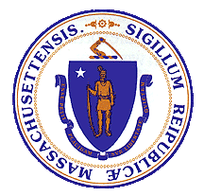

**Advisory Council on Alzheimer’s Disease and All Other Dementias**

**Executive Office of Elder Affairs Elizabeth Chen, Secretary**

**February 6, 2024**

**3:00-5:00 pm**

**Video Conference**

1



**Agenda**

1. **Welcome, Logistics, Introductions *(10 min)***
2. **Interprofessional Dementia Care: Status and Discussion *(30 min)***
3. **Annual Report: Present, Discuss, and Vote *(40 min)***
4. **Discussion of Council’s Role Around Early Dementia Detection and Diagnosis *(25 min)***
5. **Reflections and Future Planning *(10 min)***
6. **Next Steps and Vote to Adjourn *(5 min)***

**Interprofessional Dementia Care**

**Status and Discussion February 6, 2024**

**Alina Sibley, CNP**

**Team Co-Leads**

**Christopher Wight, LICSW**

Team Lead for Geri-Pal Home Care Baystate Health



Springfield, MA

[**alina.sibley@baystatehealth.org**](mailto:alina.sibley@baystatehealth.org)

Clinical Social Worker, Dementia Care Collaborative

Division of Palliative Care and Geriatric Medicine Massachusetts General Hospital

Boston, MA

[**cwight@mgh.harvard.edu**](mailto:cwight@mgh.harvard.edu)

**Team Co-Leads: Alina Sibley, CNP and Christopher Wight, LICSW**

**Yeimy S. Aleman Miranda**



**Our Team**

Patient Service Representative Baystate Memory Assessment and Care Clinic, Department of Medicine Baystate Medical Center, Springfield, MA

**Stephen Bonasera, MD, PhD** Chief, Division of Geriatrics & Palliative Care

Medical Director, Baystate Memory Assessment and Care Clinic Department of Medicine

Baystate Medical Center, Springfield, MA

**Kathryn M. Corelli, MD** Internal Medicine Physician, Chestnut Hill, MA

**Joe Costello**

Organizational Consultant and Dementia Advocate

**Brent P. Forester, MD, MSc. (Council Member)**

Dr. Francis S. Arkin Chair of Psychiatry, Tufts University School of Medicine

Chief and Chair, Department of Psychiatry, Tufts Medical Center

Director of Behavioral Health, Tufts Medicine

**Lenore Jackson-Pope, RN, BSN, MSM, CCRP** Co-Director of Primary Care Outreach Center for Alzheimer Research and Treatment (CART) and

Massachusetts Alzheimer’s Disease Research Center (MADRC)

Mass General Brigham Boston, MA

**Jayne Kelleher**

Home Care Director, Bethany at Home, Framingham, MA

Board Member of Massachusetts Home Care Aide Council

4

**Liz McCarthy**

Health Systems Director

New England Region, Alzheimer’s Association

**Pam Mirick, RN**

Former Family Caregiver, Retired Nurse

**Christine Ritchie, MD, MSPH (Council Member)** Kenneth L. Minaker Endowed Chair in Geriatric Medicine

Research Director, MGH Division of Palliative Care and Geriatric Medicine

Director, Mongan Institute Center for Aging and Serious Illness

Director, MGH Dementia Care Collaborative Professor of Medicine, Harvard Medical School Boston, MA

**Wayne S. Saltsman, MD, PhD, CMD, AGSF** Chief Medical Officer, All Care VNA, Hospice & Private Home Care Services Lynn, MA

**Amy Walsh**

Project Manager

Institute for Health Care Improvement (IHI) Boston, MA



**Interprofessional Dementia Care**



**Goal**

**Develop a plan that ensures that staff in primary care across the state receive the training and support needed to build and retain interprofessional dementia care teams**

5 C

**Updates and Accomplishments**



1. Recruited the Council’s team on Interprofessional Dementia Care.
2. Discussed the team’s goal, originally focused on several health care settings (primary care, acute care, home care, and long-term care); and agreed to prioritize primary care settings as the team’s sole focus in calendar year 2024.
3. Began identifying the services, outcomes, and benefits expected from interprofessional teams to both justify these teams and determine effective team composition.
4. Why we narrowed the focus to primary care:
   * Focusing on one setting improves the team’s ability to make progress in calendar year 2024.
   * The need for coordination and effectiveness is greatest in primary care which experiences significant resource constraints and involves the greatest number of professional roles.
   * The new Alzheimer’s therapies are restricted to MCI and early Alzheimer’s, underscoring the urgency of early detection and diagnosis

through primary care. 6 C

6

**Interprofessional Dementia Care**



a) Identify and articulate key training attributes that would be beneficial for all members of an interprofessional dementia care team

in a primary care setting.

Work with IHI to review and revise our suggested dementia-specific adaptations and approaches to the AFHS Initiative.

**Our Team’s Approach**

**(Calendar Year 2024)**

**January-March April-June July-September October-December**

**(1)**

**Provide Justification for Interprofessional Dementia Care Teams in Primary**

**Care**

**(2)**

**Propose Adaptations & Approaches to the Age-friendly Health System (AFHS) Initiative**

**(3)**

**Collaborate with Institute for Healthcare Improvement (IHI)**

**(4)**

**Develop**

**Training Recommendations and**

**Resource List**

7 A

7

b) To justify interprofessional dementia care teams, reflect on identified outcomes and benefits; and clearly articulate reasons for a collaborative interprofessional care team.

a) Determine effective team composition by identifying services, outcomes, and benefits of primary care professionals on an interprofessional dementia care team.

b) Suggest adjustments to enhance the AFHS initiative’s support for individuals and families at risk of or affected by dementia.

a) With the needs of people affected by dementia in mind, examine the AFHS initiative’s 4M’s *(What Matters, Medication, Mentation, Mobility).*

b) Develop recommendations and resource list around available and effective training.

**Challenges and Potential Solutions**



1. **Multiple stressors and competing demands of frontline clinicians; difficulty in securing protected time for training**
   * Ensure recommended training is practical and valuable, e.g., synchronous & asynchronous options, continuing education opportunities; advise that training be incorporated into training/planning for Annual Wellness Visits; and include guidance on including stakeholders in education plan design.
2. **Lack of funding to implement Age-Friendly Health System (AFHS) initiatives**
   * Link this work to AFHS recognition; and provide advice on grant funding resources.
3. **Gaps in perceived value of dementia care among clinicians, systems, patients, and families; and confusion around the roles of various clinicians and specialists**
   * Describe how interprofessional dementia care teams can effectively address this challenge.
4. **Absence of individual responsible and accountable for planning, communication, and internal team coordination activities required to ensure everyone works together as a cohesive team**
   * Consider recommending that one team member be responsible and accountable for conducting activities that ensure cohesive teamwork; consider training options for that individual; and advise primary care settings to implement a phased-in interprofessional team approach.
5. **An unclear business case is of significant concern. Insufficient funding hinders team creation, and some essential services lack reimbursement**
   * Find ways to address the need for a financial model to support integrated, holistic dementia care from diagnosis to end of life. Place initial focus on the GUIDE initiative participants; and develop an approach to bring other primary care organizations into the fold.

8

8 A

**COUNCIL DISCUSSION *(15 min)***



**Your Questions or Comments? Our Questions:**

**(1) FINANCIAL MODELS?**

**Do you know of any financial models that support integrated, holistic dementia care?**

**(2) POLICIES & LEGISLATION?**

**Are there any policies or legislation that the Council could endorse to improve the likelihood of implementation of our team’s recommendations?**

**(3) COLLABORATION WITH MASSHEALTH?**

**Is there potential to collaborate with MassHealth to promote interprofessional dementia care in primary care for dual eligibles, akin to the successful behavioral health initiatives?**

9

C

**Annual Report Review, 2023 Present Highlights**



**Annual Report Review**

* **Present Highlights**
* **Provide Comments**

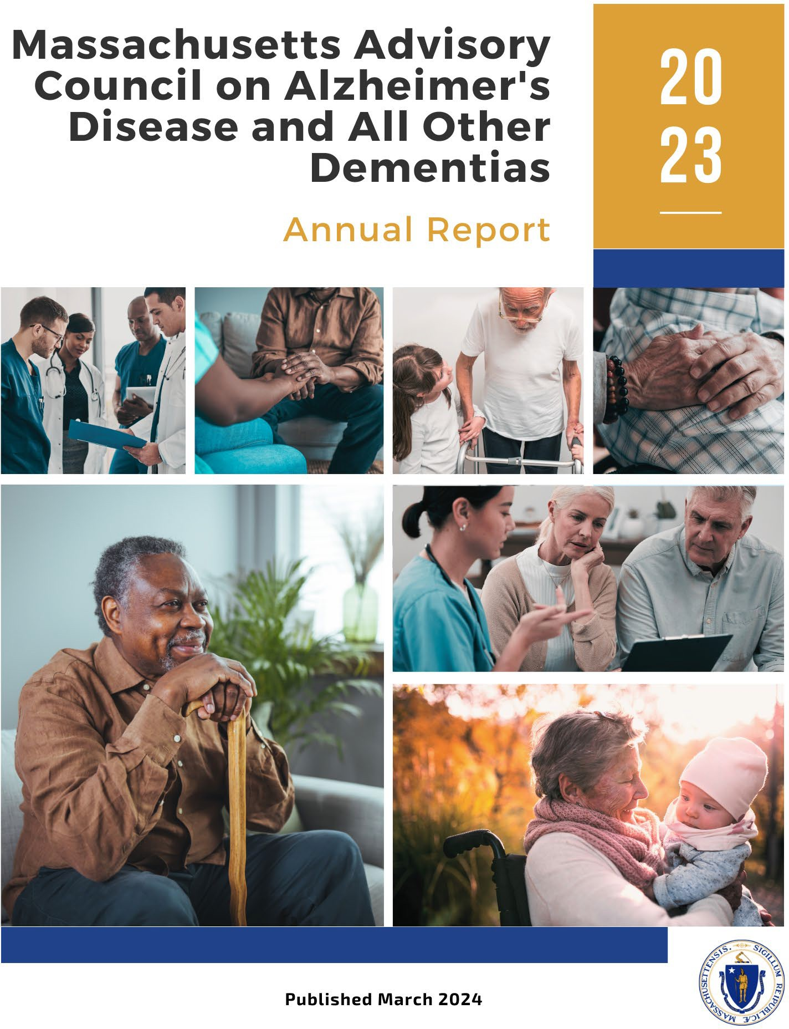

DRAFT

* **Vote**

10

10



**Executive Summary**

1. Briefly highlights progress in 2023 and next steps for 2024.
2. Refers to the state plan as a living document to guide our progress; and lists the state plan’s seven workstreams.
3. Indicates that state plan amendments are documented in our annual reports; five appear in this year’s report.
4. Notes removal of Research workstream from Council’s scope, stating other organizations are more capable of achieving its stated goal and recommendation:
   * Goal - Advance dementia research in Massachusetts
   * Recommendation - Increase diversity of dementia research and researchers
5. Recognizes importance of all types of ADRD research and that recent and upcoming innovations and breakthroughs affect much of our work.
6. Notes an intention to stay abreast of research and reflect on it while developing recommendations, policies, programs, and guidance.



**Introduction**

1. Introduces the report as the work of the Council, established under Chapter 220 of the Acts of 2018.
2. Refers to lists of Council members (Appendix A) and members of the teams working on its behalf (Appendix B).
3. Presents the two figures below.

***Figure 1: The Council’s Goal, Workstreams, and Types of Deliverables***

***Figure 2: Key Activities Impacting the Council’s Goal***

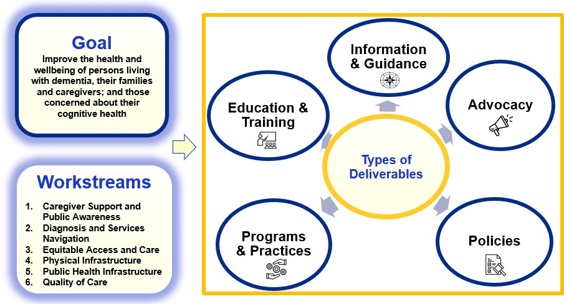

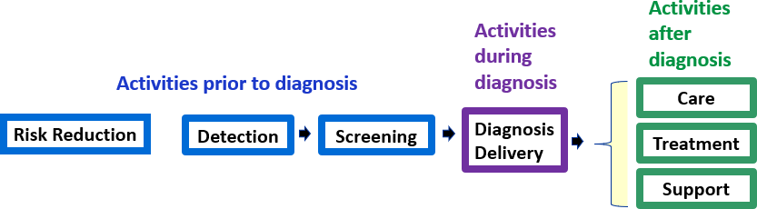

**Introduction**

1. Provides examples of challenges facing our residents affected by dementia.
2. Emphasizes the importance of diversity, equity, and inclusion; and our approach for integrating these concepts into our work.
3. Briefly describes our process of engaging teams to examine challenges; develop recommendations; seek advice from the Council; and implement solutions.
4. Expresses gratitude for the volunteers that make the Council’s progress possible.



**Implementing Effective and Sustainable Solutions**

Includes seven sections, one for each of the following seven workstreams, presenting progress in 2023 and next steps for 2024



* 1. Caregiver Support and Public Awareness
  2. Diagnosis and Services Navigation
  3. Equitable Access and Care
  4. Physical Infrastructure
  5. Public Health Infrastructure
  6. Quality of Care
  7. Research



**1. Caregiver Support and Public Awareness**



**Workstream Leads**

**Barbara Meehan, Council Member -** Dementia Advocate, Former Caregiver

**Hector R. Montesino, Council Member -** President and CEO, Embrace Home Care and Health

Services, Dementia Advocate 15



**1. Caregiver Support and Public Awareness**

**Progress and Next Steps (Some Highlights)**



**Public Service Announcement and Video Production**

* Began developing a brief public service announcement in three languages (English, Spanish, and Portuguese).
* Recruited caregivers to participate in video interviews in Spanish and Portuguese to discuss assistance received and how they received it.

**Caregiver Experience with Aging Services Access Points (ASAPs)**



Executive Office of Elder Affairs (EOEA) attained insights in 2023 on how to better serve older adults and caregivers of people living with dementia:

* Update of ASAP Designation Review Process - EOEA began evaluating interactions between ASAPs and consumers, including caregivers.
* EOEA’s Branding and Market Research - Improved understanding of service needs; how residents engage with services; and barriers that may prevent individuals from accessing services.



**2. Diagnosis and Services Navigation**



**Workstream Lead**

**James Wessler, Council Member -** President and CEO, Alzheimer’s Association, MA/NH Chapter and New England Regional Leader



**2. Diagnosis and Services Navigation**

**Progress and Next Steps (Some Highlights)**



**Expansion of Dementia Care Coordination (DCC)**

* Secured state funding in fiscal year 2024 to expand access to the Alzheimer’s Association Dementia Care Coordination program.

**Toolkit for Acute Care Settings**

* Developed and distributed toolkit for acute care settings with dementia screening and training options for dementia operations plans.



**Screening in Home Care Program**

* Developed approach to identify and implement opportunities for home care consumers to advocate for appropriate

screening, diagnosis, care, support, and treatment. Will reassess in 2025.



**3. Equitable Access and Care**

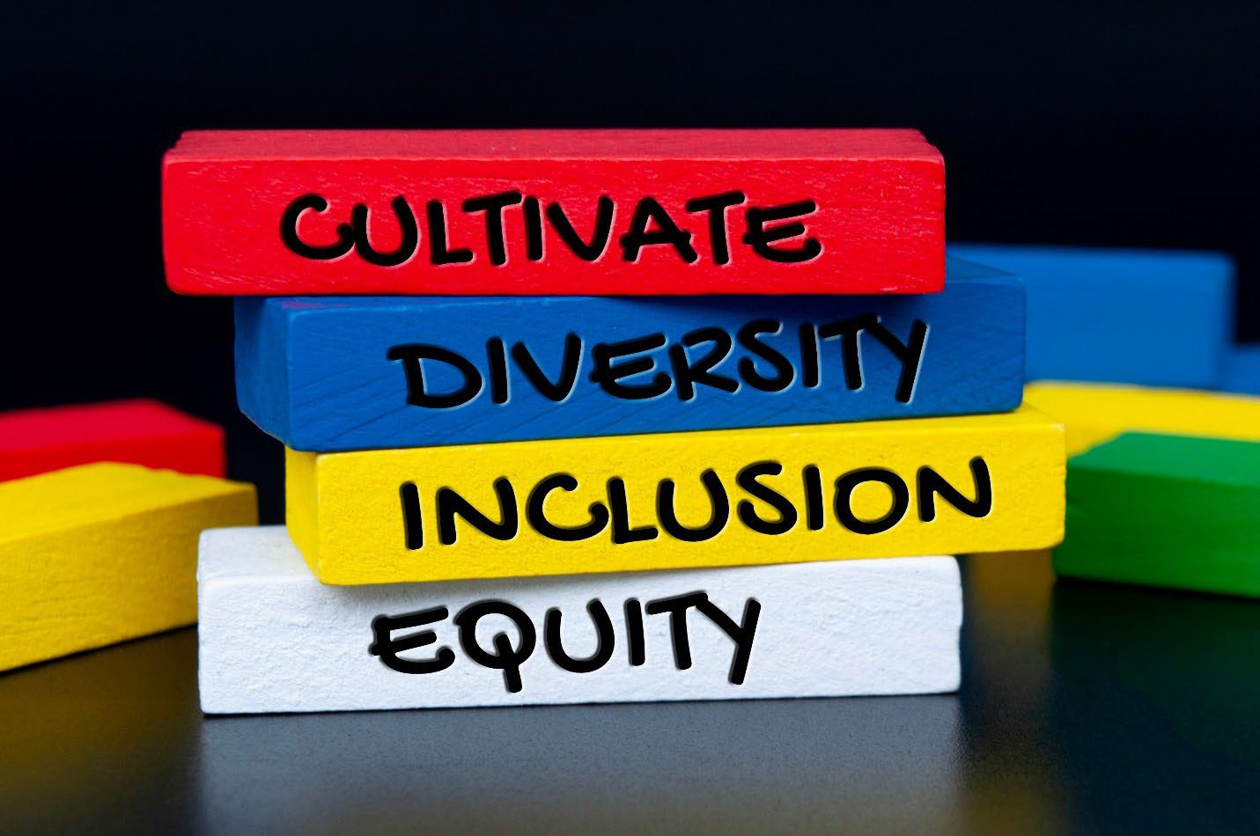

**Workstream Leads**

**Jatin Dave, MD, Council Member -** Chief Medical Officer, MassHealth; Director, Office of Clinical Affairs, Commonwealth Medicine, UMass Chan Medical School

**Hugo Aparicio, MD, MPH, Council Member -** Assistant Professor of Neurology, Boston University School of Medicine; Faculty Lead of the Research and Policy Team Program at the BU Center for Antiracist Research; Stroke Specialist in the Department of Neurology, Boston Medical Center



**3. Equitable Access and Care**

**Progress and Next Steps (Some Highlights)**

# Examined Cultural Barriers and Geographic Health Disparities

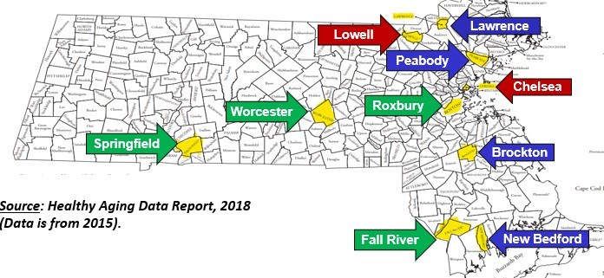

* Convened inclusive discussions about challenges and cultural barriers experienced by individuals affected by dementia and began identifying solutions.
* Reviewed and discussed Massachusetts-specific data on race and geographic health disparities.



**Launched Equity and Inclusion (EI) Team**

* Built a team to review the Council’s work with a “diversity, equity, and inclusion (DEI) lens.”

**DEI**



**4. Physical Infrastructure**



**Workstream Lead**

**Secretary Elizabeth C. Chen, PhD, MBA, MPH, Council Chair** - Secretary, Massachusetts Executive Office of Elder Affairs



**4. Physical Infrastructure**

**Progress and Next Steps (Some Highlights)**

# Physical Infrastructure Projects Seeking State or Municipal Funding

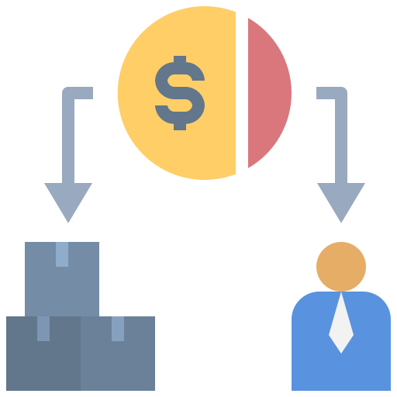

* Identified specific state and municipal funding sources and procurements; prioritized the most promising opportunities; and collaborated with funders.
* Made significant progress in ensuring that funders explicitly prioritize or stipulate requirements for incorporating age and dementia friendly features in physical infrastructure projects.



**Improved Stakeholder Awareness and Understanding**

* Proactively distributed the Council's guide on age and dementia friendly design; and delivered presentations to numerous stakeholders and organizations.



**5. Quality of Care**



**Workstream Lead**

**Linda Pellegrini, MS, GNP-BC, Council Member -** Geriatric Nurse Practitioner, UMass Memorial Medical Center



**5. Quality of Care**

**Progress and Next Steps (Some Highlights)**

# Person-Directed Care Planning



* Identified the essential characteristics of effective

person-driven dementia care plans; and reviewed existing care planning models.

* Agreed on the team’s approach and targeted milestones for 2024.
* Provided advice to Ariadne Labs on its development of a person-centered assessment and care plan tool.



**Interprofessional Dementia Care**

* Formed a team on Interprofessional Dementia Care; made progress in determining effective dementia care team composition, services, outcomes, and benefits.



**6. Research**



**6. Research**

**Progress and Next Steps (Some Highlights)**

# Removed Research Workstream from Council’s Scope



* + Removed this workstream’s goal of “advancing dementia research in Massachusetts;” and its recommendation to “increase diversity of dementia research and researchers.”
  + Acknowledge that better qualified organizations are currently conducting activities designed to achieve this workstream’s goal and objectives.
  + Will continue to use our knowledge about ongoing dementia-related research as we develop recommendations, policies, programs, and guidance.



**7. Risk Reduction and Public Health Infrastructure**



**Workstream Lead(s) To be determined**



**7. Risk Reduction and Public Health Infrastructure**

**Progress and Next Steps (Some Highlights)**



**Assessed Interest in Statewide Grant Opportunity**

* In early 2023, engaged in discussions with DPH officials to discuss 5-year CDC grant opportunity “Building our Largest Dementia (BOLD) Infrastructure.”
* Due to competing and important demands on staff time at DPH, it was determined that 2023 was not an opportune time to apply.

# Springfield’s Healthy Brain Initiative



* In the absence of statewide grant funding around this workstream’s goal; and after examining geographic

disparities in prevalence of dementia and dementia risk factors, shifted to a localized approach.

* Pursued grant opportunities and received a grant in late 2023 to implement “Springfield’s Healthy Brain Initiative,” a community outreach program to promote better brain health.

**Looking to the Future**



* Reminds readers that the Council will regularly amend the state plan and continue to bring appropriate stakeholders to the table to implement solutions.
* Refers to the five amendments to the state plan adopted in 2023, which are included in the final section of the annual report. 29



**Amendments to the State Plan, 2023**



Includes amendments to the state plan’s recommendations around:

* Caregiver Support and Public Awareness
* Equitable Access and Care
* Care Planning
* Interprofessional Dementia
* Research

30

**Annual Report Review, 2023 Provide Comments and Vote *(20 min)***



**Annual Report Review**

 **Present Highlights**

* + **Provide Comments**



DRAFT

* + **Vote**

31



**4. Discussion of Council’s Role Around Early Detection and Diagnosis *(25 min)***

1. **Which two do Council Members believe are the areas of greatest need?**
   1. Equitable access to screening, assessment, and diagnosis
   2. Culturally sensitive provider/patient communication that respects culturally diverse beliefs, which may include stigmatizing perceptions of dementia
   3. MCI and early dementia detection and screening by health care workers
   4. Access to culturally sensitive cognitive assessments, including family observations, clinician interviews, and diagnostic testing (biomarkers)
   5. Public awareness of early warning signs (individuals and health care providers)
   6. Role of emerging technologies on access to screening and diagnosis
   7. Effective communication of diagnosis
   8. Other?
2. **What practical strategies can this Council implement as part of the work of its existing teams to significantly enhance detection and/or diagnosis?**

**Reflections and Future Planning**



**How do you feel about the Council’s progress?**

**Where do you see gaps or areas that need more of our attention?**



**5. Council Discussion *(10 min)***

**What are the challenges or concerns that may hinder our progress?**



**5. Next Steps & Vote to Adjourn**

***(5 min)***

**Next Steps**

1. **Submit the Council’s annual report in March 2024**
2. **Next Council Meeting on May 7, 2024**

**Council Meetings**

***(3:00 pm to 5:00 pm)***

5/7/24

8/6/24

11/5/24

**Vote to Adjourn**