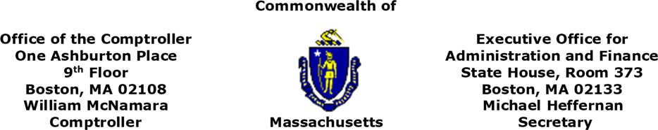

MEMORANDUM

To: Department Heads, Chief Financial Officers, MMARS Liaisons and General Counsels
From: William J. McNamara, Comptroller of the Commonwealth
Michael Heffernan, Secretary, Executive Office for Administration and Finance
Date: April 15, 2020
RE: Federal Reimbursements for COVID-19 Capital Expenditures

The purpose of this policy is to advise departments of procedures that must be followed if a department expects to receive federal reimbursements for COVID-19 related capital fund expenditures.

With an influx of federal relief funding for COVID-19 soon to be available, A&F and CTR wanted to note that reimbursable or potentially reimbursable capital spending must be segregated in separate, federally reimbursable sub-funds and accounts. These accounts and sub-funds will be established in a special capital projects fund (fund ZFFP in MMARS). The purpose of this segregation is to prevent the Commonwealth from issuing debt to fund expenses that will be reimbursed by the federal government.

A&F and CTR request that all department CFO’s review their capital authorizations for COVID-19 related reimbursable or potentially reimbursable expenses as soon as possible. Upon department notification, A&F and CTR will create separate sub-funds and accounts in MMARS (fund ZFFP) for these and future expenditures from an existing authorization. Capital authorizations to cover expected expenditures will be transferred (via BGCN) from the existing capital fund account to the reimbursable account in fund ZFFP. Departments will be responsible for transferring reimbursable expenses already incurred (via relevant transaction: EX and/or PRADJ) to the newly created account.
To do this, departments must do the following:
- Reserve a new account with A&F
- Submit new account information to CTR along with the existing capital account authorization and the amount that it is requesting to transfer (via BGCN) to the new account
- CTR will submit new account creation information to A&F for approval
Again, we ask that you please take the above action as soon as you are aware of federal eligibility.

For any CTR questions, please reach out to Kristin Lacroix at kristinm.lacroix@mass.gov. For any A&F questions, please reach out to your A&F analyst.

