Beyond Bubbles and Blocks
Information for EI Home Visitors

Do you know about Federal Indicator 3: Early Childhood Outcomes?

The Individuals with Disabilities Education Act (IDEA) is a federal statute that ensures all children with disabilities have available to them a free and appropriate public education. Part C of IDEA outlines how early intervention services must be offered to maximize the potential of infants and toddlers and requires states to report on 11 indicators in an Annual Performance Report (APR). Indicator 3 is about Early Childhood Outcomes. These federal Early Childhood Outcomes are different than families’ Individualized Family Service Plan (IFSP) outcomes. They are measured by the Early Intervention Division at the Department of Public Health and reported to the Office of Special Education Programs (OSEP).

The federal reporting requirement for Part C programs includes the percentage of children participating in Part C who have demonstrated developmental improvement when they leave early intervention. States are required to report on three Early Childhood Outcomes:

- Positive social-emotional skills (including social relationships)
- Acquisition and use of knowledge and skills (including early language/communication)
- Use of appropriate behaviors to meet needs

How are the Early Childhood Outcomes measured in Part C, Massachusetts?
Early Childhood Outcomes data are obtained using children’s Battelle Developmental Inventory-2nd edition (BDI-2) scores. More specifically, a child’s initial and last BDI-2 evaluations are compared to determine if the child “substantially increased their rate of growth” from entry to exit and/or if he/she was “functioning at age expectation.” BDI-2 raw scores and developmental quotients are compiled from the Early Intervention Client System (EICS) for children who exited early intervention between July 1 and June 30 of the given fiscal year to generate outcome results for the APR to OSEP.

How are the Early Childhood Outcomes supported in EI?
The three Early Childhood Outcomes focus on (a) children’s ability to participate in their everyday activities and routines, and (b) how children’s skills and participation develop over time. These outcomes are supported through the Massachusetts’ Mission Statement and Key Principles.
Additionally, as an early intervention specialist, you use PIWI strategies in conjunction with caregiver coaching to support the important
people in the child’s life.

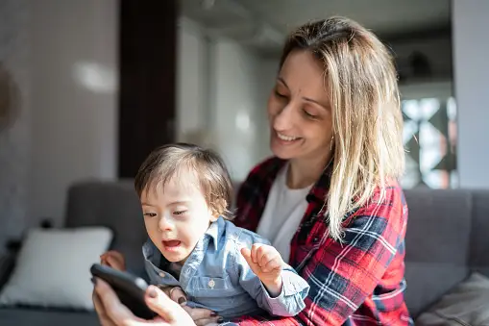

Through observation, you can identify strengths and opportunities during everyday activities to reinforce and promote the caregiver and child’s competence, confidence, and mutual enjoyment. You can observe the strengths of the dyad and identify which dyadic characteristics and strategies the caregiver is already using when interacting with their child (Outcome 1).

During joint planning, you and caregivers determine the dyadic strategies that can be incorporated into caregiver-child interactions throughout the family’s typical day (e.g., mealtime) to support the child’s development and learning (Outcome 2), increase the child’s independence (Outcome 3), and enhance the caregiver-child relationship (Outcome 1). Action/practice provides caregivers opportunities to practice, improve, reflect upon, and receive feedback on existing or new skills with support from you as their EI Specialist.

How do you explain the Early Childhood Outcomes to families?

Early intervention services are designed to help children develop and learn through supporting and strengthening the caregivers’ ability to help their children. These three broad Early Childhood Outcomes encompass children’s functional skills and behaviors that impact their participation across settings and situations (i.e., the daily activities and routines at home, childcare, or wherever the child typically spends time). They are used to measure how well early intervention is doing and how to help programs improve locally and nationally.

How are you incorporating the Early Childhood Outcomes in your work with families?
To what extent are you explaining the three Early Childhood Outcomes to caregivers?

- Regarding Outcome 1, how are you learning about how the child:
  - Relates to family members, strangers, and others?
  - Shows their feelings or calm down when upset?
  - Shows they understand social rules (e.g., sharing, taking turns)?

- Regarding Outcome 2, how are you learning about how the child:
  - Learns new things or copies others’ actions?
  - Tries to solve problems?
  - Understands and responds to directions?
  - Communicates their thoughts and ideas?
  - Understands concepts such as numbers and shapes?

- Regarding Outcome 3, how are you learning about how the child:
  - Moves from place to place?
  - Communicates wants/needs (e.g., food, drink, help to get out of reach toy)?
  - Helps with dressing/undressing, toileting, brushing teeth?
  - Does things on their own? What can they do (e.g., can they feed themself?

- How are you supporting caregivers to support their children’s achievement of each of the three Early Childhood Outcomes? To what extent are you using their everyday activities/routines as the context for learning?

References
Early Childhood Technical Assistance Center (ECTA). Child Outcomes

MA DPH Early Intervention (2015). Massachusetts Early Intervention System.

National Parent Technical Assistance Center (2013). A Family Guide to Participating in the Child Outcomes Measurement Process, Minneapolis, MN, PACER Center.

Rush, D. & Shelden, M. (2020). The early childhood coaching handbook (2nd ed.). Paul H. Brookes Publishing Co.

Yates, T. & McCollum, J. PIWI: Parents interacting with infants and toddlers. Center on the Social and Emotional Foundations for Early Learning.

