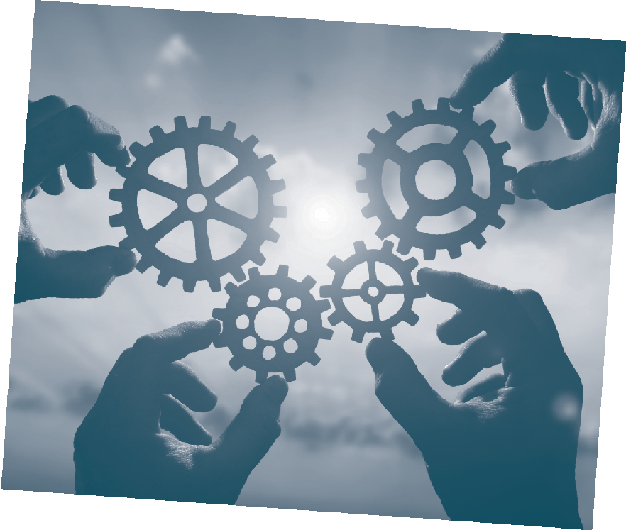T H E F U L L F R A M E I N I T I A T I V E

Download the Wellbeing Toolkit Today!

People who have experienced domestic and sexual violence, like all of us, are more than their problems and crises. And like all of us, they are hard-wired to increase their access to not just safety, but also stability, social connectedness, mastery and meaningful access to relevant resources – the universal needs and experiences essential to health and hope (the Five Domains of Wellbeing).

This toolkit, part of a collaboration between the Full Frame Initiative and Alliance for Hope International, explores the intersection of safety and wellbeing and how existing safety plans can be assessed and improved upon to support survivors in accessing long-term wellbeing. The toolkit contains wellbeing key concepts, including the concept of tradeoffs, and a detailed process by which organizations and programs can analyze their current safety planning tools and approaches through the lens of wellbeing.

To download the toolkit for free, please visit fullframeinitiative.org/wellbeing-planning-toolkit

fullframeinitiative.org /FullFrameInitiative @FullFrameInitv

