 | Massachusetts Department of Environmental Protection  Bureau of Waste Prevention  FIELD DATA FORM - GULL CONTROL PROGRAM  Policy # BWP-98-003 requires that the status of gull control be provided when a Solid Waste Facility Inspection Report is required. |  |  |  |  |  | Facility ID# (if known)
Important: When filling out forms on the computer, use only the tab key to move your cursor - do not use the return key.
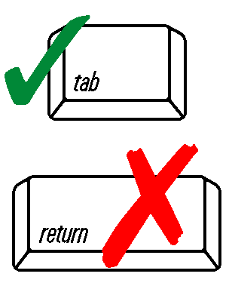
 | Facility Name
 | Data Recorder |  |  |  |  | Date
 | CONDITIONS:
 | SKY |  |  | WIND
 | TEMPERATURE |  |  | PRECIPITATION
 | Gull Observations and Control Activities:
 | Time | # Gulls Present | Location Of Gulls | Gull Control Methods Used | Results
 | COMMENTS:

