Appendix 11

Filing Fee



May 18, 2026

Sent via UPS Express

Fabiola Catulle
Determination of Need Program Department of Public Health
67 Forest Street
Marlborough, MA 01752

Dear Ms. Catulle,

Please find enclosed the Filing Fee in the amount of $585,416.00, which is submitted on behalf of Baystate Health, Inc. in connection with its submission of Determination of Need Application No. BH-25061310-TO for the transfer of ownership of Mercy Hospital, Inc., d/b/a Mercy Medical Center.

Thank you for your attention to this submission.

Sincerely,
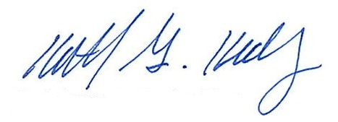
Kathleen G. Healy, Esq.
Senior Vice President and Chief Legal Officer Baystate Health, Inc.

Cc: Peter Banko, President & Chief Executive Officer, Baystate Health, Inc.
Laurie Martin, Chief Financial Officer, Baystate Health, Inc. Crystal Bloom, Esq., Husch Blackwell
Linda Cohen, Esq., Hinkley Allen

Enclosure: Baystate Health Check No.: 40057950

