Report to the Office of the Child Advocate and the Legislature
Regarding
The Department of Children and Families (DCF) Fair Hearing System

June 29, 2015
Contents
Acknowledgments 3
Executive Summary 4
Full Report 9
Introduction 9
DCF Fair Hearings Background 9
Ripples Research Methodology 10
Findings 12
1. Timeliness 12
A. Backlog 14
B. Regulations 15
C. Appellant, Hearing Officer, Attorney Perspectives 16
D. Discussion 16
2. Fairness 19
A. Hearing Officers 20
B. Operational Procedures 22
C. Regulations 23
D. Appellant Perspective 25
E. Continuous Quality Improvement (CQI) 27
F. Discussion 27
3. Independence 28
A. Regulatory Framework 28
B. Hearing Officer Positions 29
C. Reversal Rates 29
D. Appellant Perspective 30
E. Discussion 31
Recommendations 32
1. Recommended Regulatory Changes 32
A. Timeliness 32
B. Fairness 32
C. Independence 33
2. Recommended Operational Changes 33
A. Timeliness 33
B. Fairness 35
C. Independence 37
Conclusion 38
Appendix 39
FamilyNet Data Analysis 40
Appellant Survey Results 87
Appellant Survey Questions 107
Fair Hearing Process – Flow Charts 117
DCF Fair Hearing Documents 120

Acknowledgments

We would like to thank the Legislature for giving us the opportunity to conduct this important study. We would also like to thank the OCA staff for their thoughtful guidance and invaluable support. Judge Gail Garinger and Ms. Christine Palladino-Downs inspired us to raise our own standards while acting as a voice of reason throughout our study.

We are grateful to the DCF Leadership, especially General Counsel Andrew Rome, for the frank discussions and open access to data, documents, and staff. Rather than treating it as a distracting audit, DCF Leadership welcomed this evaluation as an opportunity to improve Fair Hearings. We are thankful for their unwavering collaboration.

Finally, we would like to acknowledge the DCF staff with whom we consulted as we conducted this study. From the Fair Hearing Officers to Area Office Leadership, they candidly shared their views with the sole objective of catalyzing change for the better.

Executive Summary

Urged by advocacy groups to instill greater transparency and accountability within the Massachusetts Department of Children and Families (DCF or “the Department”), the Legislature directed the Office of the Child Advocate (OCA) to “select an independent evaluator to assess the Department's administrative hearing system; provided further, that the evaluation shall report on whether the Department's regulations, funding, staffing levels and processes provide for an administrative hearing system that is timely, independent, and fair” (budget line item 1599-7771). The Ripples Group was chosen to conduct this evaluation in November 2014 through a competitive selection process.

From November 2014 through May 2015, The Ripples Group conducted an in-depth, fact-driven assessment of DCF Fair Hearings, utilizing the DCF databases, expert interviews, a survey of appellants, DCF internal documents, personal observations and recordings of Fair Hearings, and a review of other states’ regulations.

Highlights of our findings are as follows:

Timeliness

Despite significant improvements in Timeliness since 2010, the current trajectory is meeting neither reasonable expectations nor regulatory mandates.

While the Timeliness of Fair Hearings has been improving significantly since 2005, and particularly since 2010, Hearing Officer and Supervisor capacity, historically limited, is still insufficient to service existing demand for Fair Hearing requests. Over time, this mismatch between demand and capacity has resulted in the accumulation of a substantial backlog. As of December 31, 2014, the backlog included more than 1,500 cases, equivalent to more than one full year’s worth of incoming hearing requests on average. As a result, the Department is unable to operate within its mandated Timeliness regulations. It should be noted that the Massachusetts Timeliness regulations are less demanding on the Department than those of other states examined. Feedback provided by past appellants, their attorneys, and the DCF personnel we interviewed consistently pointed to the lack of Timeliness in the process.

Fairness

Despite the best efforts of Fair Hearing Officers, the current DCF Fair Hearing process cannot lead to consistently fair outcomes for appellants due to procedural and regulatory factors.

In our professional judgment, the Hearing Officers are qualified, experienced, well-trained, and professional. We were impressed with the professionalism displayed in the hearings we observed and hearing recordings we reviewed. Moreover, our analysis of data showed no apparent systemic bias by appellants’ race, gender, or age.

We found, however, that the Department’s procedural practices constitute reason for concern: The Department is not proactive in encouraging appellants to comprehend their rights fully; appellants’ requests to review their case file prior to the hearing are not honored by Area Offices consistently; and in the case of abuse or neglect decisions, the initial Area Office investigation at times appears not to be as comprehensive as it could be. We also identified regulatory refinements that should be incorporated into the relatively new DCF Fair Hearing regulations, ranging from revisiting the burden of proof to automating the sending of case documents to appellants.

Independence

The Independence of the DCF Fair Hearings is limited by DCF regulations, and the organizational structure is leading to a perception of limited independence. Despite these limitations, Hearing Officers act impartially.

The regulatory framework of the DCF Fair Hearing process is less conducive to Independence than in other Northeastern states. For instance, among the states we benchmarked, Massachusetts is unique in requiring the DCF Commissioner to review any reversal decision by the Hearing Officer, which raises concerns about ex parte communications after the hearing.

Additionally, a negative public perception of Fair Hearings is being fueled by the organizational structure: The Fair Hearing Unit currently resides within the Department. Fair Hearing data, Hearing Officer interviews, and a review of randomly selected Fair Hearing recordings and decisions, however, suggest that Hearing Officers act independently despite the regulatory framework and the organizational structure. In recordings or decisions we studied, we found no evidence of a Hearing Officer exhibiting partiality toward DCF.

While our conclusions and comments so far may be perceived as criticism of the Fair Hearing Unit, we actually applaud the Fair Hearing team. In recent years they have made tremendous improvements to the process, and appellants are clearly better off than in the past.

Recommendations

To address the Timeliness, Fairness, and Independence issues described above, we recommend the following changes to the Fair Hearing regulations, as well as to DCF staffing and operational procedures.

Recommended Regulatory Changes

Timeliness
- Do not tighten the Timeliness standards in the short-term as DCF has a large number of backlogged cases. The regulatory requirements, however, should match best standards from other states once the backlog is eliminated and staffing gaps have been bridged.

Fairness
- Consider shifting the burden of proof for all decisions to the Department and evaluating such decisions based on how reasonable they were when viewed against the totality of evidence available, particularly for abuse or neglect decisions. The consequences of abuse or neglect reports can be serious and thus should require a higher hurdle of proof, especially when taking into account the potential for concerning procedural issues.
- Automatically send the appellants all relevant documentation relating to the Area Office decision, redacting necessary parts to protect confidentiality required by law, upon scheduling and in a timely manner. While this change would create incremental operational costs for the Department, such costs may be outweighed by savings from reducing appellants’ need for continuances. Crucially, it would afford the appellants an opportunity to review the allegations made against them.
- Mandate the review of appealed decisions by the Area Director (or designee) and require the pre-hearing appellant conference between the Area Director (or designee) and the appellant. Their implementation could reduce the number of appeals requiring a Fair Hearing, alleviating Hearing Officer caseloads and improving Timeliness. Furthermore, the conference could provide the appellant an opportunity to learn about his or her case, rights, and the Fair Hearing process.
- Eliminate ‘business days’ language and require all timeframes throughout the Fair Hearing process to be in calendar days. Not only would this ensure consistency and clarity, but it would also improve Fairness by making the standard for time requirements of both the Department and the appellant the same.
- Consider adding the following language to 110 CMR Section 10.13: “…in no event shall the continuance be longer than 45 days unless the employee’s unavailability is longer than 45 days, in which case the hearing shall be scheduled within 30 days of the employee returning to work.” This addition recognizes that certain circumstances are beyond the control of any party, such as an employee going on maternity leave, but still establishes timeframes that are equitable for all parties involved.

Independence
- Eliminate the Commissioner review requirement for reversal decisions. The DCF Commissioner should not review any decision by a Hearing Officer resulting in a reversal, and DCF should limit Hearing Officer communication about cases on which they are working to Fair Hearing Supervisors and the Director of Fair Hearings only. Not only would this enhance the Independence of Hearing Officers, but it would also eliminate potential infractions regarding ex parte communication or any other type of undue influence that might ensue.

Recommended Operational Changes

Timeliness
- Allow DCF more flexibility in hiring. The Legislature should provide more transferability between line items to DCF on budget allocations such that expenditures already approved for certain positions can be re-purposed and channeled toward the most pressing staffing needs.
- Increase productivity of Hearing Officers by establishing minimally acceptable Hearing Officer decision output and quality requirements and including these targets as metrics in Hearing Officer performance reviews. Additionally, DCF should pilot a different Fair Hearing decision writing approach from the current five-week cycle and implement a training program on structuring and writing decisions.
- Hire support staff to eliminate the current and growing backlogs. Based on our estimates, DCF could fulfill the capacity gap with eight to ten temporary paralegals for one full year; and a pipeline of two to three paralegals could additionally smooth the fluctuating demand for Fair Hearing requests. Moreover, hiring one full-time Supervisor Assistant and two additional full-time Hearing Officer Supervisors could help greatly reduce the volume of Supervisor work.
- Prioritize the issuance of already-decided reversal decisions for backlogged cases such that appellants in these cases benefit from the Fair Hearing decision without further delay.
- Once decision structuring and writing training is complete for existing Hearing Officers, consider revising regulations and limiting the Supervisor review to complex cases and less experienced Hearing Officers’ cases. For our purposes, we define “complex cases” as those with multiple appellants, multiple allegations, or a parallel court case. A Hearing Officer with less than one year of tenure could be designated as “less experienced.” Without modification, the required Supervisor review will continue to create bottlenecks in the system.
- Improve DCF technology to address the demand. DCF should acquire and implement redacting software to meet the current demand for case files. DCF should also ensure a more efficient scheduling process by improving the scheduling functionality in iFamilyNet (the DCF database and user interface) in order to optimize the use of Hearing Officer’s capacity and productivity.

Fairness
- Help appellants understand their rights better by reissuing the Appellant Rights Form in grade-level English and providing more in-depth explanations for subpoenas, continuances, right to legal representation, and further appeals.
- Provide a venue where the appellants can raise questions about their rights and the logistics of the Fair Hearing. Possible options include a brief in-person meeting at the Area Office, a phone call after the Fair Hearing scheduling notice is mailed out, a YouTube video on appellants’ rights, and/or an educational program by the Ombudsman’s Office.
- Maintain an updated list of affordable law organizations interested in representing appellants, and enclose the list with the Fair Hearing scheduling letter. Many appellants express a willingness to use attorneys, and our analysis shows that lawyers do have a positive effect on Fair Hearing proceedings. Making it easier for an appellant to find and utilize an attorney will improve Fairness. DCF has already started encouraging the Committee for Public Counsel Services to provide representation for appellants with related ongoing court cases.
- Ensure that the Area Office investigator, when subpoenaed by the appellant, attends the Fair Hearing. DCF should offer a continuance proactively within the regulated time limits at the appellant’s discretion if the subpoenaed investigator is not available. It is unfair to delay an appellant’s Fair Hearing for a continuance that is the result of Departmental staff not appearing for a hearing.
- Work with interpreter agencies to provide qualified interpreters for appellants. DCF should encourage the interpreter agency to provide qualified interpreters in less common languages, such as Haitian Creole, Vietnamese, and Arabic. This recommendation may warrant contractual changes outside the direct control of DCF.
- Formalize the Fair Hearing Continuous Quality Improvement (CQI) process by periodically tracking and reporting Timeliness, Fairness, and Independence metrics. At a minimum, metrics on all three phases of Timeliness and on Supervisor and Hearing Officer backlogged cases (categorized as “unscheduled,” “scheduled not heard,” “heard not reviewed by Supervisor or Commissioner,” and “heard and reviewed not issued”) should be gathered and reported. Additionally, DCF leadership should incorporate the above metrics into their management priorities. An equivalent CQI Process at the Area Office level would help address procedural issues.
- Improve DCF data quality by incorporating an additional quality assurance step in iFamilyNet. A dedicated analytical resource could ensure data completeness and accuracy and help generate management reports based on iFamilyNet information.

- Provide Fair Hearing training to Area Offices and implement Fair Hearing checklists at the Area Office and Fair Hearing Unit levels. As procedural oversights are currently commonplace, a simple checklist with clear ownership can be drafted and operationalized by the Area Offices and the Fair Hearing Unit, respectively.

Independence
- Consider implementing measures to improve the public perception of Independence. Convey the message that the Fair Hearing process is separate from the underlying investigation by the Department despite the organizational structure. Holding Fair Hearings outside Area Office locations would be an effective first step.
- Post redacted decisions to the DCF website to improve transparency. Currently the Vermont Human Services Board is making all redacted decisions available on its website. The appellants’ ability to argue their cases could improve if they could research similar past cases.

Full Report

Introduction

The General Appropriations Act for Fiscal Year 2015 required the Office of the Child Advocate (OCA) to select an independent evaluator to assess the administrative hearing process of the Department of Children and Families (DCF or “the Department”). Line Item 1599-7771 directed the OCA to “select an independent evaluator to assess the Department's administrative hearing system; provided further, that the evaluation shall report on whether the Department's regulations, funding, staffing levels and processes provide for an administrative hearing system that is timely, independent and fair.” The Ripples Group was selected to conduct this evaluation in November 2014.

This is an in-depth, multi-perspective diagnostic of the DCF Fair Hearing process, incorporating findings from actual Fair Hearing data for the past ten years, direct input from recent DCF clients and their representatives, insights from current DCF employees who are intimately familiar with this process, observations from actual hearings, hearing recordings, and written decisions, and an analysis of the underlying regulations benchmarked against other states in the Northeast.

In the following pages, we lay out our approach, findings, and recommendations to improve Fair Hearings in terms of Timeliness, Fairness, and Independence.

DCF Fair Hearings Background

DCF’s mission is to “strive to protect children from abuse and neglect and, in partnership with families and communities, ensure children are able to grow and thrive in a safe and nurturing environment.” In line with its mission, the Department interacts with thousands of children and adults every year through a workforce of over 3,000 employees in four Regional Offices and 29 Area Offices. According to the 2013 DCF Annual Profile, more than 75,000 adults and children were DCF consumers at some point in 2013.

As stipulated by Massachusetts General Laws Chapter 18B, DCF has the authority to offer services to its consumers, to enforce regulations, to conduct investigations, and to make decisions. When a DCF client disagrees with a decision DCF makes, he or she is entitled to appeal certain Department decisions through a Fair Hearing, as governed by 110 CMR 10.00. Allowable appeal topics range from reduction, suspension, or termination of provided services to a decision finding abuse or neglect, to a listing on the Department’s Registry of Alleged Perpetrators. In 2014 alone, 1,795 such decisions resulted in a request for a Fair Hearing.

According to the DCF Fair Hearing database as of December 31, 2014, abuse or neglect cases constituted the most frequently contended decisions in 2014. Based on the DCF Fiscal Year 2014 (Quarters 1, 2 & 3) Caseload Report, DCF received an estimated average of 86,000 reports of abuse or neglect in 2014, and DCF investigators supported the report of abuse or neglect in an estimated 18,000 cases in the same timeframe.

In a Fair Hearing, a Hearing Officer weighs all evidence presented prior to and during the Fair Hearing and rules, by preponderance of all evidence, whether

- the Department's decision or procedural action violated Department regulations;
- the Department failed to act with a reasonable basis or in a reasonable manner;
- there is reasonable cause to believe that a child has been abused or neglected (for abuse or neglect decisions only);
- there is substantial evidence that the appellant is responsible for the abuse or neglect (for abuse or neglect decisions only).

In addition to the Hearing Officer and the appellant, representatives from the DCF Area Office who conducted the investigation and issued the decision typically also participate in the hearing. Appellants’ witnesses, attorneys, an interpreter (if requested by the appellant), and any subpoenaed individuals may be present as well.

Within 60 to 90 business days following the completion of a Fair Hearing, the Hearing Officer is charged with issuing a written decision. This decision may affirm the Department’s original decision, entirely reverse it, partially reverse it (if multiple allegations have been appealed in the same Fair Hearing), or remand the initial decision back to the Area Office for further review. If the Fair Hearing results in affirming the Department’s decision, the appellant has the right to further appeal to the Massachusetts Superior Court. Thirty-seven such cases were appealed in 2014, and historically the Superior Court has rarely reversed DCF’s decisions.

We have provided an introduction to Fair Hearings above, but it is important to also state why they are important. A Fair Hearing constitutes the additional review by which sound decisions are affirmed, helping DCF fulfill its mission. Undeniably, DCF decisions can have serious consequences on the lives of DCF’s clients. These decisions can at times cause the separation of a family, the loss of a job or job prospect, or, in extreme cases, lead to a listing on the Department’s Registry of Alleged Perpetrators. In cases where the underlying investigation is not comprehensive or new post-investigation evidence is discovered, a Fair Hearing provides the main recourse through which DCF clients can seek relief.

Ripples Research Methodology

To evaluate the Timeliness, Fairness, and Independence of the DCF Fair Hearings, The Ripples Group conducted both primary and secondary research in the November 2014 - May 2015 timeframe:

- Internal Documents – We reviewed relevant documents, including the DCF organizational chart; current and previous Fair Hearing regulations; DCF Fair Hearing quarterly reports; the Child Welfare League of America DCF Quality Improvement Report dated May 22, 2014; the House Committee on Post Audit and Oversight and House Members of the Joint Committee on Children; Families and Persons with Disabilities’ Review of the Massachusetts Department of Children and Families dated January 13, 2015; and the OCA Survey of DCF Employees dated March 31, 2015;
- Interviews with DCF staff – We interviewed 20 subject matter experts from the DCF Central Office staff, various Area Office staff, Hearing Officers, and Supervisors. We talked with many of these individuals more than once;
- Discussions with Attorneys – We met and had in-depth discussions with four independent attorneys active in Fair Hearings;
- FamilyNet Data – We requested, received, cleaned, and analyzed 16,000 lines of Fair Hearing data from the DCF electronic database (FamilyNet) for the 2005-2014 period;
- Regulations in other Northeastern states – We benchmarked the Massachusetts DCF Fair Hearing regulations, 110 CMR 10.00, against five other Northeastern states (Connecticut, New Hampshire, New York, Rhode Island, and Vermont) and held phone conversations with the counterparts of the DCF Fair Hearings Director in all of these states;
- Fair Hearing Recordings & Observations – We listened to the recordings and carefully studied 32 randomly selected Fair Hearings from 2011 to 2014, requiring at least one reversal and one upheld case from all four regions; in addition, we personally observed three Fair Hearings (two in Malden, one in Framingham);
- Fair Hearing Staff Meeting Observation – We observed a Fair Hearing Unit staff meeting at DCF;
- Appellant Survey – We fielded an appellant survey to 1,000+ past appellants from the 2007-2014 period. We received and analyzed 116 responses;
- Focus Group – We conducted a Fair Hearing Officer focus group at DCF;
- Media – We researched DCF-related blogs, news articles, and other relevant content online; and
- OCA Project Steering Committee – We discussed our observations with the OCA Project Steering Committee on January 14, 2015; March 11, 2015; April 22, 2015; and May 14, 2015. Key OCA and DCF senior staff attended these meetings and had a chance to provide feedback on our findings, conclusions, and recommendations.

Findings

1. Timeliness

Despite significant improvements in Timeliness since 2010, the current trajectory is meeting neither reasonable expectations nor regulatory mandates.

As opposed to Fairness and Independence, Timeliness is simple to quantify and measure. The DCF regulations provide clear guidelines on the expectations for Fair Hearings, and the data to assess Timeliness, while not perfect, is available over many years. Using this longitudinal data, we have observed a dramatic improvement in Timeliness in recent years. The Department, however, is still operating beyond the regulatory mandates. Moreover, the regulations regarding Timeliness afford DCF more time than those of other states we reviewed. Our key findings are summarized below.

Using Fair Hearing data in DCF’s FamilyNet database, we evaluated the Timeliness of Fair Hearings in two distinct phases and then for the totality of the two phases of the process:

- Phase 1: The number of business days from the appellant’s initial request for a hearing to the actual Fair Hearing day;
- Phase 2: The number of business days from the Fair Hearing day to the issuance of the decision to the appellant;
- Total: The total number of business days between the appellant’s initial request for a hearing to the issuance of the decision to the appellant.

Our findings suggest that the Timeliness of the Fair Hearing process has been improving significantly under the leadership of the current DCF General Counsel. As illustrated in the charts on the next page, the changes have been remarkable in all phases, with steady improvement since 2005 and particularly impressive since 2010, excluding backlogged cases.
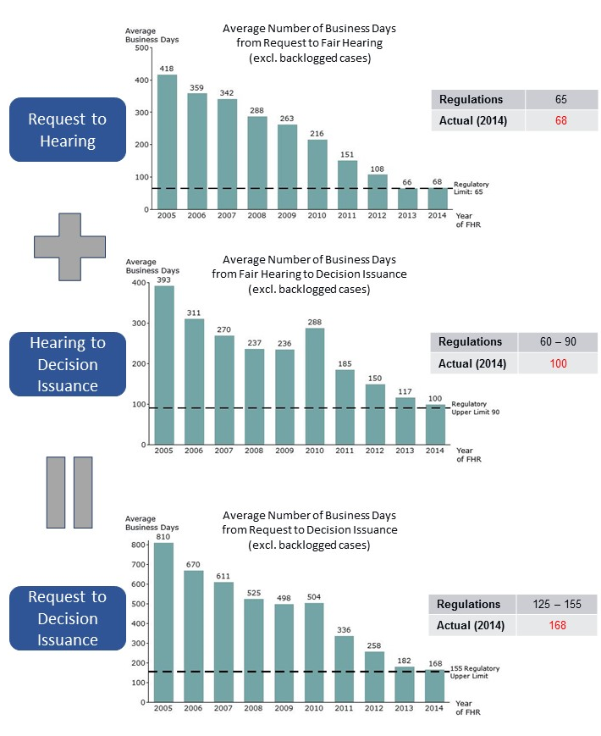
Source: Appendix FamilyNet Data Analysis

The time from the appellant’s request to the actual Fair Hearing was 418 days on average in 2005; whereas in 2014 the average was 68 business days, very close to the 65 business day requirement in the current regulations. Similarly, the average duration from the Fair Hearing to decision issuance decreased from 393 business days in 2005 to 100 business days in 2014, only 10 business days above the upper regulatory limit. When the entire decision cycle from the appellant’s hearing request to decision issuance is considered, the improvement is particularly impressive: from 810 business days to 168 business days in the same time period, which, again, is very close to the regulatory upper limit of 155 business days.

Possibly as a reflection of improving Timeliness metrics, appellants’ voluntary withdrawal rates after having requested a Fair Hearing declined from a staggering 67% in 2005 to 4-7% in the past two years.

Backlog

The above charts unfortunately understate the magnitude of the Timeliness problem as they ignore the backlog. In fact, the number of open and backlogged cases is too substantial for the entire process to qualify as timely. An open case is defined as one that has been in the pipeline without closure for fewer than 180 days, and a backlogged case as one that has been in the pipeline without closure for more than 180 days.

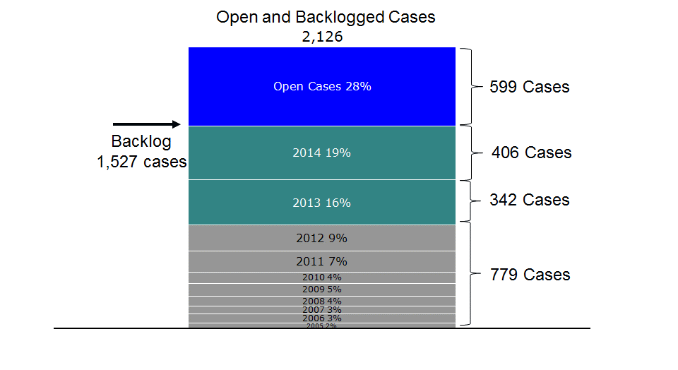
Source: Appendix FamilyNet Data Analysis

As of December 31, 2014, there were 2,126 open and backlogged cases in the pipeline. Some of these cases go as far back as 2005. This volume consists of three components:

- A Hearing Officer segment: 1,307 cases for which Hearing Officers did not yet hear, rule, or issue a decision (59% backlogged, 41% open);
- A Supervisor segment: 604 cases on which a Hearing Officer issued a decision , but a Supervisor has not yet reviewed and signed (89% backlogged, 11% open);
- An unscheduled segment: 215 cases that were accepted but have not yet been scheduled for a Fair Hearing (100% backlogged).

As of December 31, 2014 there was no backlog of reversals awaiting Commissioner review.

Considering the average incoming Fair Hearing volumes over recent years, the accumulated open and backlogged cases are equivalent to more than one full year’s worth of Fair Hearing requests for the Department. In other words, for Fair Hearings to be timely, the Department must process at least twice as high a decision volume in the next year.

Regulations

Massachusetts Fair Hearing regulations, revised recently in September 2013, are not mandating scheduling and decision issuance standards as strict as those in other Northeastern states.

To evaluate the Department’s regulations for Timeliness, we assessed the time that the Department allows itself and the appellant throughout the Fair Hearing process: in particular, the window the appellant is allowed for requesting an appeal, the time given to the Department to schedule a Fair Hearing from the time of the request, and the time given to the Department to issue a decision following the conclusion of a hearing.

- The Department timeframe for an appellant to request a hearing is in line with other states. In Massachusetts, an appellant is given 30 calendar days from the issuance of an initial decision, ruling, or denial of service to request a Fair Hearing. Similarly, Connecticut, New Hampshire, Rhode Island, and Vermont offer a 30-day timeframe in which the appellant can submit an appeal request. The comparable regulations in New York are more generous, allowing up to 90 days to request a Fair Hearing for a substantiated decision of abuse or neglect.
- The Department regulations and those of other states’ agencies diverge significantly following the receipt of a request for a hearing. In Connecticut and New York, the regulatory timeframe for scheduling a Fair Hearing following an appeal request is 30 days; and in Vermont it is 60 days. In contrast, the Department timeframe for scheduling a Fair Hearing is significantly longer at 90 days. New Hampshire and Rhode Island do not explicitly state a time requirement for scheduling a hearing. While we recognize the value of additional time in processing the existing caseload for Hearing Officers, the disparity between Massachusetts and other states suggests a longer than usual timeframe for scheduling a Fair Hearing.
- Massachusetts regulations are also relatively lenient in issuing decisions. Department
regulations provide 84-126 calendar days following a hearing to issue a decision. No other state we studied allows the departmental agency such a long timeframe for a hearing officer to produce a decision. Rhode Island mandates 14 days, whereas Connecticut and Vermont mandate 30 days; New York mandates a window of up to either 60 or 90 days following the record of a hearing being closed, depending on the type of case undergoing a Fair Hearing.

Appellant, Hearing Officer, Attorney Perspectives

Actual FamilyNet data above clearly demonstrate that Fair Hearings are not timely when measured against regulatory requirements, despite the Department having regulations that are more favorable than other states in terms of Timeliness.

Appellants, Hearing Officers, and attorneys also state that Massachusetts’ process is not timely:
- As a reflection of the delays in the Fair Hearing process, the respondents in our appellant survey rated Timeliness (“My case was handled in a timely manner”) 1.9 out of 5.0. As a reference point, this finding can be compared to the results of the 2007-2008 Massachusetts Trial Court “Access & Fairness” survey, which focused on the Timeliness, Fairness, and Accessibility of the Trial Court system through a detailed assessment by Court users. The Trial Court received a score of 3.8 out of 5.0 on Timeliness. To underscore the Timeliness point, one of the many relevant quotes from the Fair Hearing appellant survey read: “[It has] been over 8 months since the original incident and still no decision has been made […] Seems extremely long for an appeal.”
- Echoing the appellants’ opinions, in the Fair Hearing Officer focus group we conducted, the participants were vocal about Timeliness issues and the respective caseloads. One Hearing Officer stated: “When the timeline regulations went into effect September 2013, it was good for a while. I was keeping up to the new timeline, never mind the backlog; then increases came. I am waiting to see what else we are picking up. Our Supervisors have a caseload themselves. I have over 100 cases backlogged that have never been resolved.”
- Independent attorneys who work in the Fair Hearing field indicated in our one-on-one interviews with them that the scheduling step has been improving recently but decisions are still significantly delayed, referring to backlogged cases.

Discussion

What is driving the Timeliness issues and the underlying backlogged cases? While District Attorney stays and appellant—or Department—requested continuances do lead to delays in the process, we should emphasize that they account for only 18% of open and backlogged cases. In our analysis, we identified several major elements that are contributing to the accumulation of the Hearing Officer and Supervisor backlog.

Fair Hearing Request Volume

First and foremost, the DCF Fair Hearing request volume rose 62% from 1,183 cases in 2012 to 1,918 cases in 2014. This increase is likely anchored in the tragic Jeremiah Oliver case in December 2013.

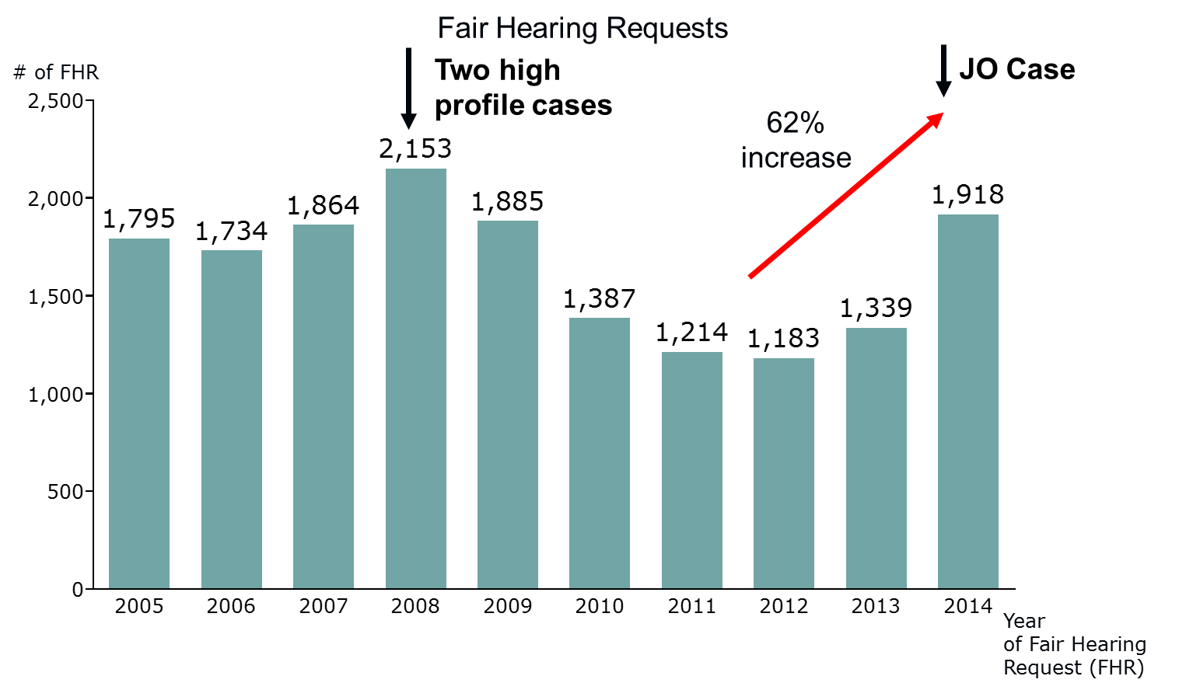
Source: Appendix FamilyNet Data Analysis

Capacity and Productivity

In contrast, compared to the 62% growth in Fair Hearing requests, Hearing Officer capacity (limited historically by budgetary constraints) rose 33% from 7.5 FTEs to only 10 FTEs in the same timeframe.

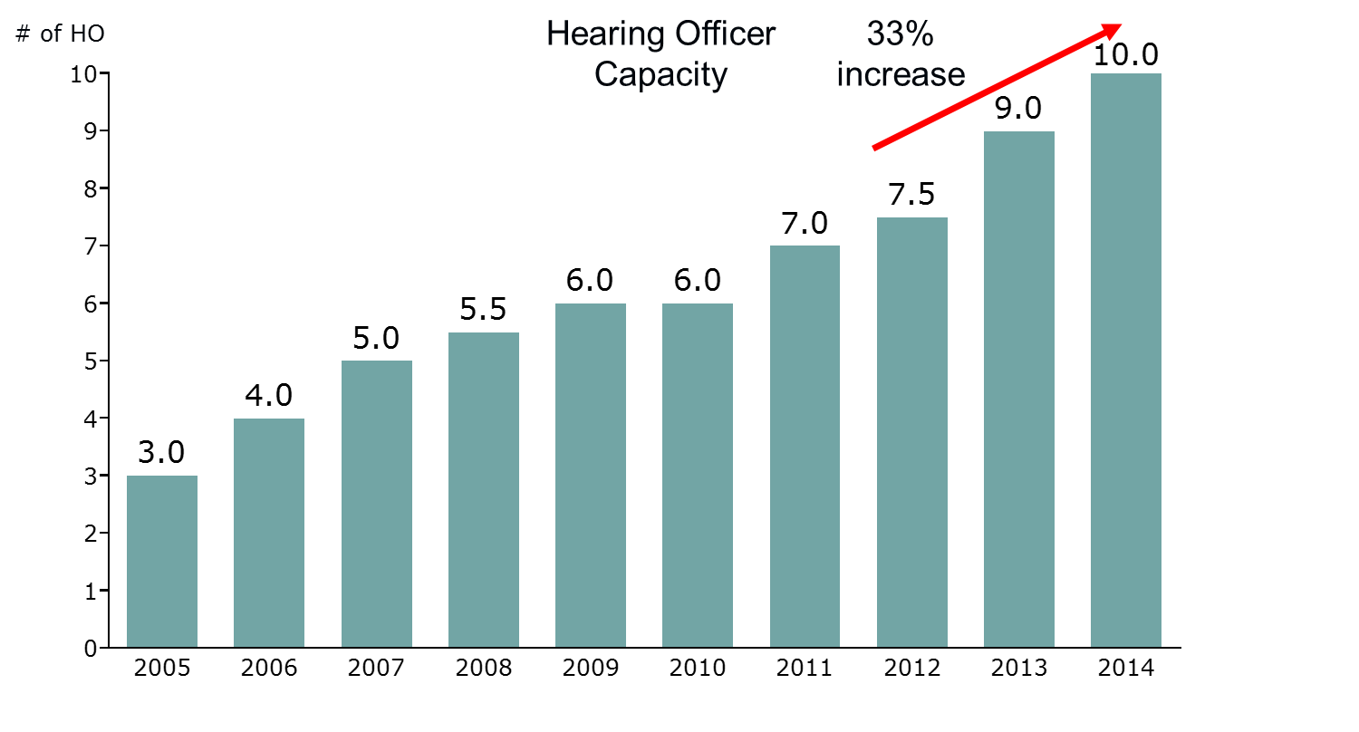
Source: Appendix FamilyNet Data Analysis

As a result of this mismatch between volume and capacity, the Hearing Officer workload is currently not in equilibrium – Hearing Officers are not able to process current incoming volume even when backlogged cases are disregarded entirely.

Furthermore, we observed that Hearing Officer productivity seemed inconsistent; the number of cases undertaken and decisions issued varies widely by Hearing Officer. For example, in 2014, the highest-producing Hearing Officer processed 160 cases, whereas the low end of the spectrum was marked by 75-80 processed cases per Hearing Officer, excluding partial-year Hearing Officers. This stark contrast persisted also for the subset of cases where a decision was issued during 2014: 48 decisions on the high end and 19 decisions on the low end per Hearing Officer.

While this type of numerical analysis admittedly does not differentiate based on the quality of decisions issued, it does point to an opportunity for improving Hearing Officer productivity through more effective training, supervision, and performance management. If below-median Hearing Officers were producing at the median level, overall productivity would increase by 11%, and a steady-state on incoming volume would be reached.

Additionally, a mismatch between current Supervisor capacity and workload volume similar to the Hearing Officer situation above is leading to a large backlog of decisions that require Supervisor approval. Current regulations mandate that the Supervisor sign every Hearing Officer decision, regardless of the complexity of the case. With only one full-time hearing Supervisor on staff and only one new Supervisor hire planned, however, this volume becomes practically prohibitive, even accounting for the part-time involvement of the Director of Fair Hearings in reviewing Hearing Officer decisions. The Supervisor and Director of Fair Hearings roles are intended primarily as managerial positions and should not serve as quality assurance resources for Hearing Officers.

Operational Procedures

Operational procedures are not fully supporting Timeliness. Currently, Hearing Officers operate on a five-week work cycle: They hold hearings for four consecutive weeks (up to six hearings per week) and dedicate the fifth week in the cycle to organizing and writing decisions. The analysis of the FamilyNet data indicates that this approach is resulting in only 54 decisions issued on average per Hearing Officer per year, further contributing to the build-up of a Fair Hearing Officer backlog. Specifically, the time that elapses between the first, second, and third week hearings and the fifth writing week is of particular concern as this arrangement requires the Hearing Officers to consult their Fair Hearing notes and recordings in a time-consuming manner before they can structure and finalize their decision. An alternate arrangement, which would minimize the period between the hearing and the writing of the decision, would be more efficient and support Timeliness (and likely accuracy and Fairness) more effectively. Along those lines, at least one Hearing Officer expressed as a possible alternative in the focus group that Officers could perform “one hearing in the morning and [have] the afternoon free [for writing purposes].”

From a managerial perspective, Timeliness metrics for the two phases described on page 12 are currently not being tracked and reported in a systematic manner. While the current General Counsel collects and analyzes a series of metrics (including backlog levels), he and his team (and DCF Leadership in general) have not had the tools necessary to keep a steady pulse on Timeliness. It should be noted that the improved iFamilyNet system currently being implemented is expected to make such monitoring and reporting easier.

Again, from a managerial standpoint, performance reviews do not incorporate Timeliness and productivity metrics for the Hearing Officers, Supervisors, or the Fair Hearing Unit overall. For instance, the analysis we conducted comparing Hearing Officers’ productivity has not been generated previously. Assuming these metrics can be generated and reported periodically with the new iFamilyNet system, they could be included as performance targets for the Fair Hearing team. Doing so would raise the level of awareness around Timeliness issues and unify efforts toward resolving them.

Additionally, Massachusetts regulations stipulate an option whereby the Area Office, at its sole discretion, can offer a pre-resolution conference. When respondents in the appellant survey were asked if they were contacted by the Area Office prior to the Fair Hearing to resolve the matter, only 5% mentioned such an approach. Consistently and effectively utilizing this pre-hearing conference could lead to a resolution before the actual Fair Hearing, expediting the process for both the appellant and the Department significantly, while helping to reduce backlogged cases. In contrast to Massachusetts, a pre-hearing conference is a requirement in Vermont before moving on to a hearing and at either the appellant’s or the department’s discretion in New Hampshire. Furthermore, New York requires a short pre-hearing scheduling and information session for most cases.

2. Fairness

Despite the best efforts of Fair Hearing Officers, the current DCF Fair Hearing process cannot lead to consistently fair outcomes for appellants due to procedural and regulatory factors.

The Fairness of a process can be judged only when evaluating it holistically. To use a simple metaphor, let us think of a Fair Hearing as if it were the popular block-stacking game Jenga. Each step in the process is like a building block supporting the structure, or Fairness, of the entire proceeding. Take one block away and the impact on the process is minimal, take away multiple blocks and the entire structure may collapse, regardless of how many supporting pieces are still left in place.

Through our analysis below, we will argue that the Fair Hearings currently have too many pieces missing, resulting in an unsound structure that can produce unfair outcomes for appellants. Fair Hearing Officers are qualified and neutral, but procedural and regulatory issues form potential barriers that at times stand in the way of Fairness.

Hearing Officers

First and foremost, the Hearing Officers who conduct the Fair Hearings are qualified, experienced, well-trained, and professional.
- The minimum education requirement for the Fair Hearing Officer position is a Bachelor’s degree in social work, psychology, sociology, counseling, counseling education, or human services. All current Hearing Officers/Supervisors well exceed this education requirement with degrees in
  - Master of Social Work and Juris Doctor (2),
  - Juris Doctor (2),
  - Master of Social Work (3),
  - Master of Education (2),
  - Master in Criminal Justice (1), and
  - Master of Public Administration (1).
- Hearing Officers also easily meet the three-year social work requirement; on average, they have more than 20 years of DCF experience.
- Per regulation, Hearing Officers receive 25 hours of training annually in legal/administrative, trauma/abuse, health, poverty, conflict resolution, and conflict of interest areas.
- Hearing Officers leverage their qualifications and experience consistently to try to ensure the hearings are conducted professionally and according to regulations. The Hearing Officers exhibited professionalism and dedication in the three hearings we attended and the 32 randomly selected Fair Hearing recordings and decisions we studied: they approached the appellants with empathy and courtesy, they listened to the appellants intently, they assisted the appellants in presenting their cases effectively through cross-examination, they offered appellants the opportunity to present evidence even following the hearing by keeping the case open, and they structured their decisions according to the entirety of the evidence presented. Timeliness, as mentioned in the previous section, constitutes the main improvement opportunity for Hearing Officers.
- Annual performance reviews by a Supervisor are in place, rating Hearing Officers based on adherence to DCF regulations, Timeliness, accuracy, data entry diligence, and contributions to the operation of the Fair Hearing Unit.
- Both internal (DCF) and external subject matter experts we interviewed agreed that Hearing Officers are professional and fair. As one Area Manager stated, “The Hearing Officers I have worked with are extremely professional”; and as an outside attorney indicated, “Hearing Officers are very fair [and] listen to both sides and evidence.”
- Consistent with these observations, some respondents in our appellant survey also provided positive comments. For example, one respondent stated, “We are just happy there is a Fair Hearing process that takes all [the information] and really thinks about things before judging a family,” highlighting the focus Hearing Officers place on neutrality. Another respondent stated, "I felt that throughout the hearing the [Fair Hearing Officer] had asked questions of the investigator similar to the questions asked of my attorney and self," alluding to Fairness towards both sides by Hearing Officers.
- Appeals to the Superior Court rarely result in an overturning of the Hearing Officer’s (or Department’s) decision: The Superior Court reversal rate for the 2008-2014 period is only 8%, which provides further support for the Hearing Officers’ Fairness.
Our analysis of the DCF data further supports our findings, with no discriminatory bias by the Department observable in the data.
- We saw no apparent systemic bias in Timeliness by race, gender, or age as illustrated by the charts below:
    - In 2014, metrics for the first phase of Timeliness ranged from 65 to 69 business days across self-reported race identifiers, while the second phase ranged from 98 to 106 business days. In total, the phases spanned between 165 to 171 business days. In all phases, the ranges are narrow, showing no apparent bias for race.
    - Again, narrow ranges for Timeliness were observed across genders: 67 to 69 business days for the first phase, 99 to 102 business days for the second phase, and 166 to 171 business days for the sum of both phases.
    - Across age groups, the Timeliness ranges were wider (likely due to smaller sample sizes as age data was not provided consistently in the FamilyNet database), but not wide enough to indicate any bias.

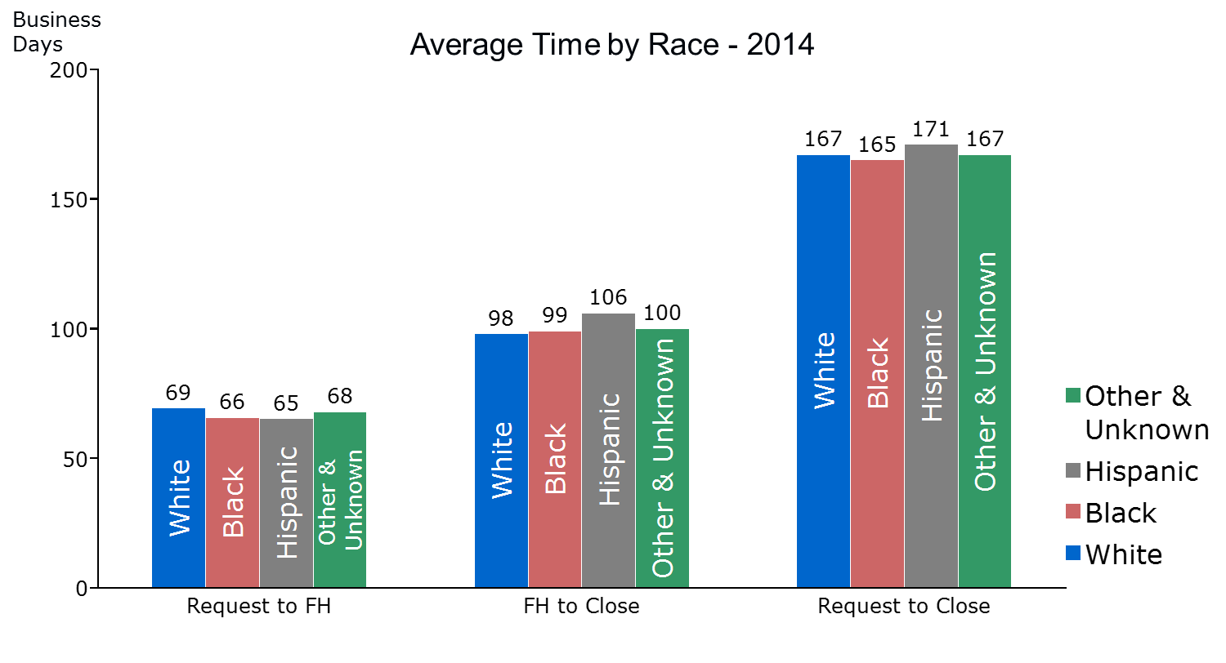
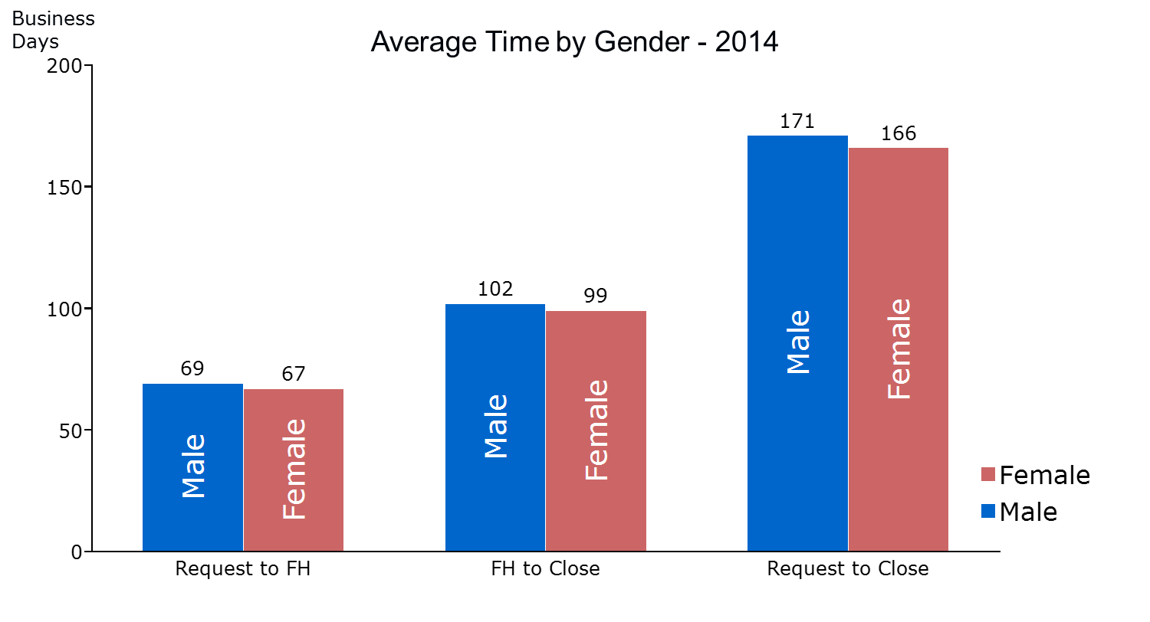
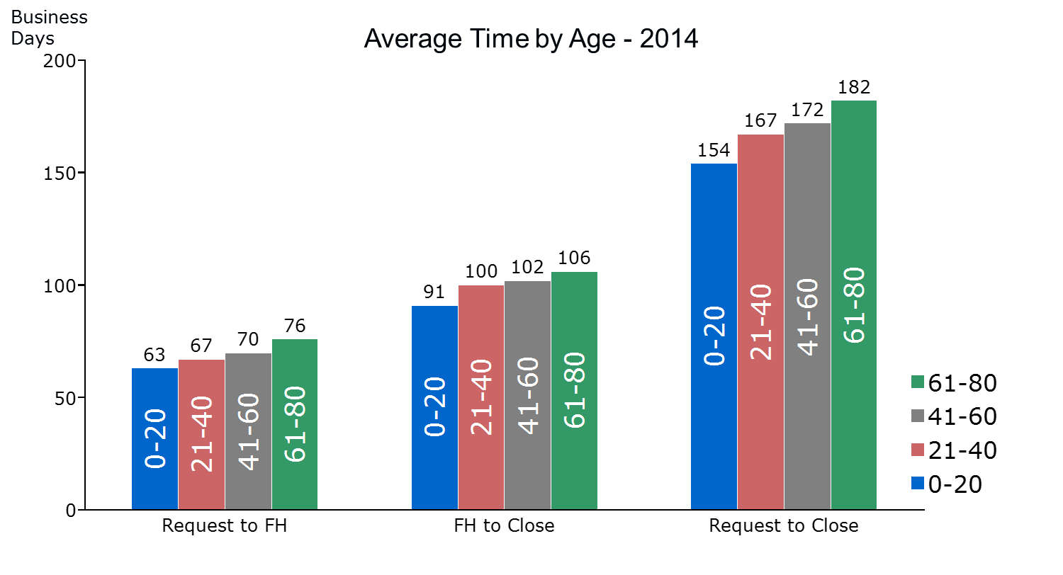
Source: Appendix FamilyNet Data Analysis

- We observed no apparent systemic bias in reversal rates by race, gender or age:
    - In 2014, reversal rates ranged from 23% to 29% across self-reported race identifiers and 23% to 24% across genders as captured in the table below.
    - Across age groups, reversal rate ranges were wider due to data limitations, but not indicative of bias.
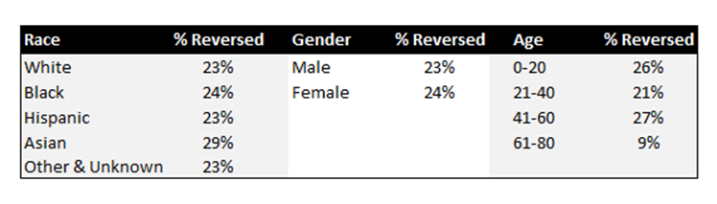
Source: Appendix FamilyNet Data Analysis

    - In addition, we confirmed that denial rates have been steady in the 5%-10% range over time, proving consistency in screening for Fair Hearings. Denial rates refer to the number of Fair Hearing requests that were not granted due to the nature or lack of timeliness of the request as defined by regulations. An inconsistent denial rate trend could be indicative of systemic Fairness issues.

Operational Procedures

There are significant procedural issues that can impact the appellants’ ability to present their case.

To start, the initial investigation and Department decision (on which the appeal is based) at times appear to be problematic based on our review of randomly selected cases and Hearing Officer comments.
- In our review of 32 randomly selected decisions (including documentation on the initial investigation), we found multiple instances where, in our opinion, the quality of the initial investigation was not sufficiently comprehensive.
    - In one case involving serious allegations, for example, the investigator neither interviewed the teenage victim despite no apparent factors negating the need to do so nor gathered readily available evidence from obvious sources. We do not know if there were restrictions imposed on this investigation by the District Attorney.
    - In another case where a seasoned teacher was found to be neglectful, the Area Office investigation relied solely on the testimony of a six-year-old child with a known history of complications and failed to consult with others who were present at the alleged scene (these witnesses fully supported the appellant at the Fair Hearing and the decision was reversed).
- Hearing Officers also explicitly voiced concerns about the quality of some Area Office investigations on which they held hearings. When asked what their personal wish list would include for enhancements in the process, one Hearing Officer stated, “[One improvement] I would like to see, a huge issue on my mind lately, is the quality of the investigations.”

Additionally, in our review of randomly selected Fair Hearing recordings and analysis of appellant survey results, we observed procedural failures, often prior to the Fair Hearing, which made it harder for the appellant to understand or present his or her case:

- Oversights were not uncommon in cases we studied. For example, in one recording the appellant had not received the actual written support decision letter from the Area Office. In another, the appellant had requested a copy of his case file from the Area Office in a timely manner but had not received it prior to the hearing. In a third recording, we observed that the appellant’s attorney did not receive the scheduling letter (it was unclear whether an appearance was filed) and consequently was not present at the hearing. Finally, we witnessed a situation where neither the appellant nor the appellant’s attorney was notified prior to the Fair Hearing that a subpoenaed DCF investigator would not be in attendance due to a personal matter (the appellant’s attorney agreed to proceed without the investigator, conceivably so as not to delay the process).
- In our appellant survey, 27% of appellants who requested their files stated they did not receive their files within 60 days; 22% indicated they never received their files.
- Ancillary to the above, Hearing Officers also touched upon frequent procedural breakdowns as illustrated in the following comment from the Hearing Officer focus group: “We’ve had many, many, many hearings where the people have never seen the [investigation report] before. They get the support letter and it says ‘supported physical abuse,’ ‘supported neglect,’ and that’s all they know. So, of course they come. They want to be heard. They advocate for themselves, as they should. But they’ll come and say, ‘I’ve requested three times for a copy, here I have it in writing, I sent in a request.’ The Area Offices just can’t keep up with the demand.”
- In a more specific comment, one Hearing Officer remarked on the limited availability of interpreters: “Access to quality interpreters in different languages is an issue. I think if you want a Spanish interpreter, that’s not too much of a problem, but if it’s another language, like an African dialect, a Middle Eastern language, it’s much more difficult to find interpreters in languages not spoken as frequently as Spanish.” Another Hearing Officer questioned whether interpreters provided by Area Offices were adequately qualified to translate legal proceedings. Appellants have the right to an interpreter, and providing a qualified interpreter is the role of the Area Office. We do recognize, however, that DCF uses state-wide translation vendors and does not have direct input on the range or quality of the interpreters who appear.

Regulations

The Fair Hearings regulations as they are currently written provide less adequate protections for the appellant than in the other states we reviewed.
- The Burden of Proof – In Massachusetts, the burden of proof for administrative hearings is always on the appellant. Although DCF regulations do require the Department to present its case first, DCF conforms to state practice and places the burden of proof upon the appellant. In contrast, among the various states we studied, there was a clear trend towards placing the burden of proof upon the departmental agency. Connecticut, for instance, places the burden solely upon the agency for any matter that comes before a Fair Hearing. Alternatively, New Hampshire, New York, and Rhode Island place the burden upon the agency in any matter involving an abuse or neglect decision (Abuse or neglect decisions constitute the majority of DCF Fair Hearing cases.). Given the deference Hearing Officers must show to the clinical judgements of DCF investigators, and the potentially life-altering effects of any supported decision, it would seem more equitable to require that the Department prove its case. The burden of proof point, taken in isolation, may not constitute a major concern. When it is combined with other regulatory and procedural gaps, however, its impact on Fairness is amplified.
- Case Files – Appellants’ access to relevant evidence and documentation is not streamlined. In Massachusetts, an appellant must request his or her case file from DCF in order to receive a copy. While some of the other states we reviewed as part of this study also required the appellant to request his or her case file, Connecticut and Vermont are noteworthy in sending appellants the relevant documentation automatically upon acceptance of a hearing request. By doing so, they attempt to ensure that appellants receive their case documents before the hearing date and have a chance to review them, thereby allowing for better informed, more fair presentations of their cases.
- Departmental Review and Pre-hearing Appellant Conference – The departmental review of appealed decisions, as well as an additional pre-hearing resolution conference with the appellant (also mentioned previously in the Timeliness section), while recommended by DCF regulations, are at the discretion of the Area Office. Other states we studied largely require some sort of pre-hearing administrative review or conference before proceeding with a hearing. In particular, Connecticut requires an administrative review as part of its normal process, while Vermont requires a pre-hearing “review conference” that fulfills a similar role. Rhode Island regulations require a review and state, “An attempt should be made to resolve appeals at the level where the decision was made through a discussion with the staff member who made the decision.” Additionally, New Hampshire makes the pre-hearing conference optional, at either the appellant or agency’s discretion. New York requires an administrative review as part of its normal process and, in most cases, requires that appellants appear briefly before the appeals unit to schedule the hearing and learn about their rights prior to the hearing. In addition to the potential for reconsideration brought about by an additional review of the initial decision, the pre-hearing meeting is both an opportunity for appellants to be heard, as well as to learn more about the particular findings of the Department in its case against them. It can lead to swifter resolution of appeals and may eliminate the need for some Fair Hearings. Furthermore, it provides appellants the opportunity to learn directly about their rights from the outset of the Fair Hearing process.
- Legal Representation – Appellant access to legal representation, including pro bono representation, is not explicitly encouraged in Massachusetts for administrative matters. DCF regulations give the appellant the right to have an authorized representative at the hearing. DCF does not, however, specify in the Appellant Rights Form that the authorized representative may be an attorney; and regulations do not require DCF to provide an attorney, as the hearing is informal. DCF has already reached out to the Committee for Public Counsel Services to provide representation for appellants with related ongoing court cases, however. New Hampshire proactively provides a list of organizations that offer free or reduced cost legal services when sending out its notice of hearing.
- Business versus Calendar Days – The use of Timeliness standards in the DCF regulations is inconsistent. Massachusetts regulations mention business days as the unit of measure when stipulating the timeframe in which the Department must schedule a hearing or issue a decision. Calendar days, however, are cited for actions that the appellant must fulfill, such as requesting a Fair Hearing, requesting a subpoena, or requesting evidence. It is also notable that all the other states we studied used calendar days consistently for all time computations in their regulations. Calculations done in business days are longer as they leave out weekends and holidays. Requiring the appellant to make his or her request based on calendar days when the Department itself uses business days raises consistency and Fairness concerns.
- Subpoenas – Regulations regarding continuances for subpoenas are currently too lax. The regulations dealing with subpoenas of Departmental employees state that if a subpoenaed employee is unavailable to testify and the appellant decides to request a continuance until the employee is available, “the time requirement for scheduling as set forth in 110 CMR 10.10,” which stipulates that hearings in which a continuance is requested be rescheduled within 45 days, “shall not apply.” Therefore, the case can be delayed significantly due to a subpoenaed DCF employee not appearing as requested.

Appellant Perspective

It is important to re-focus on the primary agent throughout this process, the appellants, and view the problems presented above through the lens of their experience. The clients DCF serves often come from lower educational backgrounds and/or do not have significant financial resources. These disadvantages not only make it harder to navigate administrative processes, but also present challenges for appellants to secure the resources they might need, such as a lawyer, to support their cases.

In line with this, many appellants we surveyed seemed to neither understand their rights nor have the ability to argue their cases well:
- While every Fair Hearing scheduling letter is accompanied by a statement of the appellants’ rights, respondents in our appellant survey indicated that they were not fully aware of their rights: 23% did not know they could request their case files, 40% did not know they could request a subpoena, and 27% did not know they could request additional time to present their case. 37% of respondents whose case had been affirmed indicated they did not know they could appeal their decision to a Superior Court. Admittedly, these responses may be driven by the fact that some appellants do not read, do not understand or do not recall reading the Appellant Rights Form included with their scheduling letter. The language in the Appellant Rights Form is decidedly too complex for many appellants. Consider an example: “You may issue subpoenas for witnesses. The Department may issue subpoenas for witnesses upon your written request. The request must be made to the Fair Hearing Unit at least 15 calendar days in advance of the scheduled hearing and you must include address of witness.” To put this comment in perspective, in one recording, we came across an 18-year-old appellant who had difficulty understanding the word “appeal.”
- In our review of Fair Hearing decisions, appellants could often make neither effective use of evidence nor coherent arguments that would have helped in securing a reversal decision. In one recording, we heard an appellant shed tears uncontrollably; her case consisted mostly of one statement she repeated throughout the hearing: “I am not a bad mom.”
- 30% of the appellant survey respondents had an attorney representing them in their Fair Hearing. Not surprisingly, our research revealed that appellants would like to have attorneys and fare better when they have one representing them. In our analysis of FamilyNet data, we observed that having an attorney improves the appellants’ likelihood to secure a reversal. For example, in 2014, the reversal rate without an attorney was 21% and significantly higher with an attorney at 28%. This trend has been consistent, as illustrated below, over the past three years.

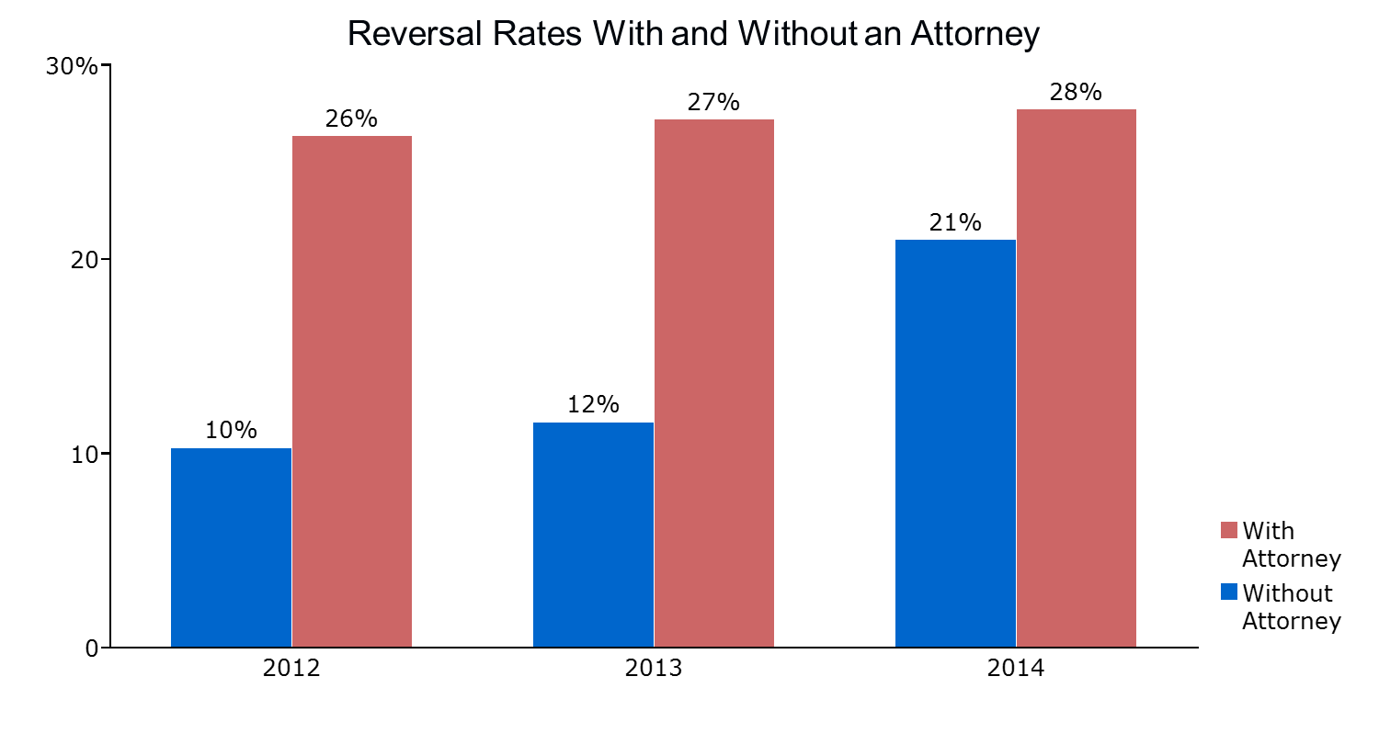
Source: Appendix FamilyNet Data Analysis

- 61% of appellant survey respondents who had not retained an attorney for their hearing indicated that they would do so next time. One appellant stated, "Without an attorney, I would not have had any idea what to do or how to proceed with the hearing. Even with an attorney, I don't believe I was able to submit all information necessary."
- In the hearings we attended and recordings we reviewed, we noticed that a competent, well-prepared attorney helped the appellant’s case significantly. Inversely, an unprepared attorney appeared to negatively impact the appellant’s case.
- Confirming this observation, in our focus group, one Hearing Officer remarked, “The appellant has a lot of rights – they are very powerful rights. Maybe there could be a bit more done to effectively communicate those rights to appellants. The fact that they can request witnesses, they can subpoena them, that they can request a lot of documents, I think a savvy appellant or an appellant represented by an attorney can really bring a lot to bear during a Fair Hearing.”

Understandably, appellants and attorneys have expressed concerns about the Fairness of Fair Hearings.
- Respondents in our appellant survey rated the overall Fairness of the Fair Hearing process very low at 2.0 out of 5.0. As a reference point, the comparable rating on the 2007-2008 Massachusetts Trial Courts “Access & Fairness” survey was 4.1 out of 5.0. Furthermore, respondents to the appellant survey rated Area Office courtesy and respect toward appellants at 2.4. In contrast, the Hearing Officer courtesy and respect rating was higher at 2.9. Again, the comparable Trial Court Survey metric is significantly higher than both at 4.3.
- To further substantiate their point, many survey respondents provided lengthy quotes regarding their negative perception of the Fairness of the process. It should be noted here that appellants at large find it difficult to differentiate Area Office and Fair Hearing decisions. Many of the comments we received are rather ambiguous on this distinction despite specific survey questions.
- The attorneys we interviewed had mixed views on Fairness. Some thought highly of the Hearing Officers while others were more critical of the process.

Continuous Quality Improvement (CQI)

The Timeliness and Fairness of the DCF Fair Hearings are currently affected by the lack of a formalized Continuous Quality Improvement process.

A further issue that has ramifications for both Timeliness and Fairness is the current lack of formalized checks and balances to ensure appellants are treated fairly and that the process is refined over time:
- Procedural failures are not being tracked, and such measures are not being incorporated into the performance management system in any meaningful way. DCF Leadership cannot manage what it does not monitor.
- At present, there is limited formal Continuous Quality Improvement (CQI) process in place. A formalized CQI process could enable DCF Leadership to set operational targets, measure progress toward those targets over time, solidify accountability, and make quality an overarching principle in the organization.

Discussion

It is important to emphasize that our findings in this report cannot be de-coupled from the observations captured in the OCA DCF Employee Survey dated March 31, 2015. It is rational to assume that the overall climate issues prevalent at DCF may also impact the DCF employees involved in the Fair Hearing process, sometimes adversely impacting Fairness. Moreover, it is clear that the Area Offices are overworked and cannot keep up with requirements such as redacting case files to be sent to appellants. The Area Office workload is beyond the scope of our analysis. It has been captured in previous studies on DCF operations and is being addressed. It is reasonable to assume that if Area Offices were operating at an equilibrium with reasonable caseloads, many of the procedural Fairness issues we found in the Fair Hearing system could be alleviated or eliminated.

Because of the above, however, we cannot state with full confidence that the system will respond equitably when procedural issues arise. Furthermore, the Timeliness issues described in the first section negatively impact the Fairness of the process if one believes that “Justice delayed is justice denied.”

DCF can absolutely implement measures to strengthen the safeguards of Fairness and reduce the probability of unwarranted outcomes. Some of our recommendations below point to “low-hanging fruit,” such as refining the Appellant Rights Form and compiling a list of attorneys for appellants. Others will require changes to regulations, injection of additional resources, and enhancements in management routines, which will take time and dedicated effort. It is important to keep in mind that in order to fully rebuild the Jenga tower of Fairness, DCF will need to address the previously identified issues starting with the comprehensiveness of Area Office investigations as they have a major impact on the Fairness of the process as a whole.

3. Independence

The Independence of the DCF Fair Hearings is limited by DCF regulations, and the organizational structure is leading to a perception of limited independence. Despite these limitations, Hearing Officers act impartially.

For the purposes of this study, we defined Independence as the ability of the Fair Hearing Unit to have the final say on decisions without any undue pressure or consequences. As explained in the DCF Fair Hearings Background section, the decision of the Fair Hearing often entails serious consequences for the appellant, and it is therefore crucial that the Hearing Officers be shielded from undue influence by any party, particularly from other Departmental representatives. In the absence of this safeguard, the balance of justice could shift towards the Department and favor the affirmation of the original decision.

Regulatory Framework

To test whether or not the Fair Hearing process is independent using the definition above, we first evaluated the current DCF regulations and compared them to those of other Northeastern states, yielding the following findings:

- The regulatory framework of the DCF Fair Hearing process is relatively less Independent in comparison to other Northeastern states, with a problematic control measure and reporting structure that could have implications for the Independence of any rendered decisions.

- Commissioner’s review – Out of the states we studied, only Massachusetts requires a commissioner-level review of a reversal decision. The DCF Commissioner must review any case where an Area Office decision has been reversed. The fact that any reversal decision a Hearing Officer makes will be scrutinized by a superior might potentially influence the decisions of that Hearing Officer, while also essentially weakening protections against ex parte communications as provided for in the regulations. In contrast, Connecticut, New Hampshire, and New York leave the possibility open for Commissioner review should she or he decide not to delegate decision-making authority, but generally the decisions of hearing officers in these states are final, barring appeal to a Superior Court. Going even further, Rhode Island makes the decisions of its hearing officers not subject to review, barring appeal to a superior court. Vermont, however, does make the recommendations of a hearing officer subject to a vote by its independent appeals unit, the Human Services Board.
- Reporting structure – According to DCF regulations, Hearing Officers report within the Department. This structure creates a perceived conflict of interest for the Department as it leads to a situation whereby Hearing Officers are reporting to stakeholders of the underlying contested decision. This structure is not unique to Massachusetts, but other Northeastern states have taken steps to address it. In New Hampshire and Vermont, hearing officers report to independent appeals units that are not associated with their departmental equivalent of DCF. Furthermore, as part of its pre-hearing administrative review, Vermont hires independent contractors not associated with the state agency.

Hearing Officer Positions

Regulations alone cannot yield a complete overview of how independent the process is, as procedures and operations can lead to independent environments regardless of the regulatory or organizational structure. To account for this, we considered other factors, interviewed DCF staff and attorneys, and surveyed appellants to develop a more complete picture.

First, Hearing Officers appear to behave independently and are perceived as such by both themselves and other DCF staff. In our one-on-one interviews, Hearing Officers, other DCF employees, and Area Office staff all agreed that the Hearing Officers were independent. As one Hearing Officer indicated, “I do not feel any pressure to reverse or affirm a decision.” Similarly, other DCF employees at the Central Office praised the Hearing Officers by stating that “the blinders of Hearing Officers are impressive,” underlining their impartiality.

Moreover, we observed no long-term career considerations that would induce DCF partiality in Hearing Officers:
- The Hearing Officer position is deemed a long-term career option. Other than one Hearing Officer who retired, no others have left their jobs in the last five years. No Hearing Officer in recent memory has taken a position in an Area Office at DCF after they served as a Hearing Officer. When inquired of privately, Hearing Officers consistently responded that they plan to stay at their jobs and are not interested in career paths in other parts of DCF.
- We unearthed no evidence whatsoever of a Hearing Officer unduly penalized for reversing Area Office decisions.

Reversal Rates

The data we have collated and analyzed as part of this evaluation also supports the notion that the Fair Hearing process is independent. Specifically, reversal rates have been rising steadily since 2005, particularly after 2010. In 2014, the reversal rate was 23%. If the reversal rates were declining, we could alternatively infer that the process was being too deferential to decisions at the Area Office level, or that Area Office investigations were improving.

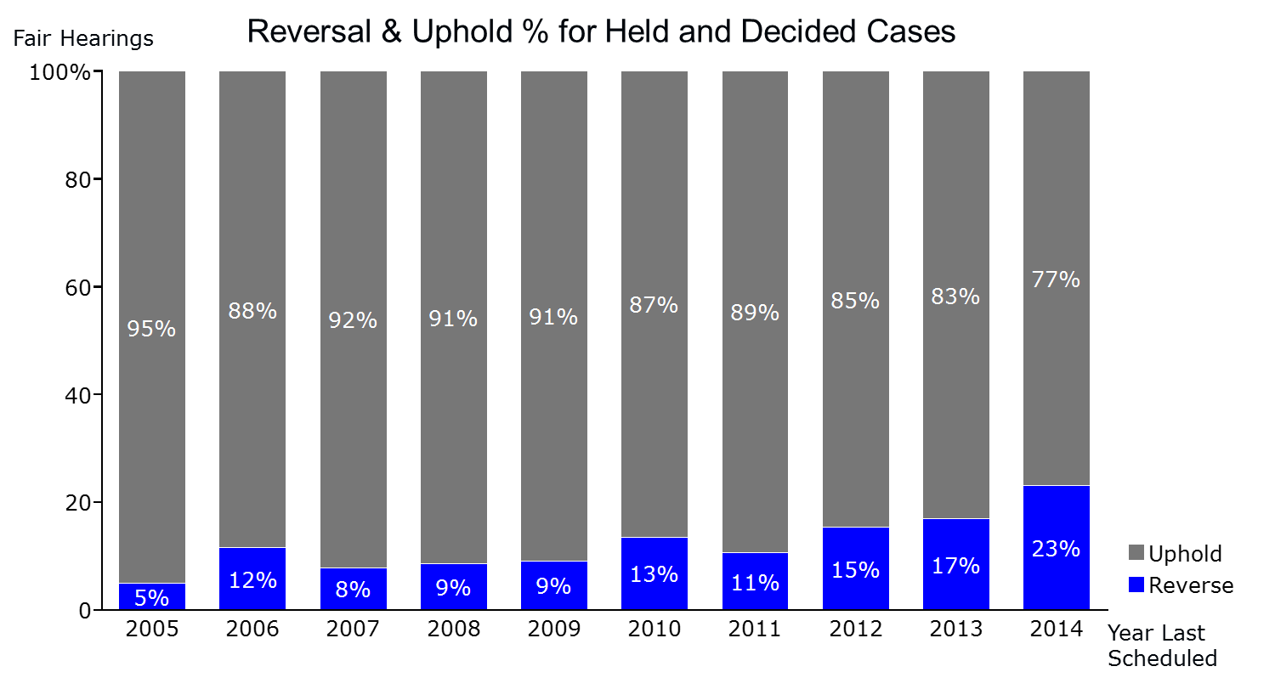
Source: Appendix FamilyNet Data Analysis

Furthermore, in the cases we studied, we saw no evidence of a Hearing Officer showing partiality to DCF.

Appellant Perspective

Despite the findings above, the external perception of Fair Hearing Independence is poor.

Perceptions of independent attorneys and appellants were neutral to strongly negative regarding the Independence of Hearing Officers.
- Attorneys we interviewed had mixed perceptions of Hearing Officer Independence.
- Respondents of the appellant survey rated the Hearing Officers’ objectivity and Independence from DCF at 2.5 on average out of a scale of 5, a fairly low score. As to be expected, there was a pronounced difference regarding this question between appellants whose cases had been reversed and those whose cases had been affirmed: 3.7 out of 5.0 for reversed cases and 1.8 out of 5.0 for affirmed cases.
- In line with the low average rating, we received multiple appellant comments substantiating a perception of lack of Independence. For example, one respondent exclaimed: "Very hard to [be independent], since the Hearing Officers work closely and constantly with the same DCF office and employees. I hope they can truly be impartial and independent, but I am not convinced."

This perception could be fueled by the organizational structure of the Fair hearing process, which blurs the lines between DCF in general and the Fair Hearings Unit. As mentioned previously, Hearing Officers report within the Department. This structure creates the perception that Hearing Officers are DCF employees who could be disposed to rule in favor of the Department. Comments by appellants, attorneys, and DCF staff also seem to indicate that the perception of Independence is being hampered by the structure of the Fair Hearings Unit. One attorney stated, “I don’t understand how DCF can claim to have independent Hearing Officers when they work for the agency.” An Area Manager told us that “Hearing Officers are independent but they are tied to DCF, so appellants may not agree.” Lastly, one of the appellants we surveyed remarked, “Believing [that a] Hearing Officer who is DCF employee is not biased is a silly assumption.”
Additionally, Fair Hearings usually take place within the same Area Office at which the initial decision regarding the appellant was made due to space limitations. Furthermore, many Hearing Officers previously worked as Area Office investigators, which could lead to scenarios where they might appear too sympathetic to the conduct of an investigator or the Department as a whole.

Discussion

While the Fair Hearing process suffers from real or perceived limitations that might hinder Independence, we believe these have not systematically led to issues with Independence in the recent past. The Commissioner review is problematic, but in practice, according to DCF, there have been very few reversals of Hearing Officer decisions by recent Commissioners. Still, it is impossible to determine how many decisions, if any, were not reversed because the Hearing Officer was discouraged by the prospect of a Commissioner review. This exposure can be corrected by eliminating the mandatory Commissioner review from the regulations, along the lines of other states’ approaches.

Placing the Fair Hearings Unit under another entity besides DCF would likely improve the perception of Independence. Similarly, holding Fair Hearings in settings other than the decision-making Area Offices would most likely alleviate perceived concerns. Such solutions come at a cost and complexity the State would have to bear. In our recommendations, we did not prioritize such structural changes as an immediate solution.

Recommendations

In light of the findings presented above, our recommendations are broken into two sections: Regulatory changes and Operational changes. Within each section, the recommendations are sorted under Timeliness, Fairness, and Independence. Many of these recommendations can be implemented at no cost. Where incremental expenses are required, we have provided a cost estimate following the respective recommendation.

Recommended Regulatory Changes

Timeliness

- While the discrepancies in mandated Timeliness between Massachusetts and other states are concerning, we do not recommend tightening the DCF Timeliness standards in the short term given the large number of backlogged cases. Once the backlog is eliminated and staffing gaps have been bridged, however, we recommend that DCF consider matching the best standards from other states regarding Timeliness.

Fairness

- We recommend that DCF consider shifting the burden of proof to the Department for all decisions and, furthermore, that the decisions be evaluated based upon how reasonable they were when viewed within the totality of all available evidence. In particular, we stress the importance of this added protection for abuse or neglect decisions. The consequences of abuse or neglect decisions can be serious and thus should require a higher hurdle of proof, which other states have also recognized. By itself, this change is less important, but when viewed against the procedural failures we noted, and future potential for procedural failure, the additional protections provided to the appellant are desirable.

- We recommend that DCF revise its regulations and implement operational procedures to automatically send appellants all relevant documentation relating to the Area Office decision, redacting as necessary to protect confidentiality as required by law, upon scheduling and in a timely manner. While this change would create incremental operational costs for the Department, such costs may be outweighed by savings from reducing appellants’ need for continuances. Furthermore, it would afford the appellants an opportunity to review the allegations made against them prior to the Fair Hearing. This change might, however, have a negative impact on Timeliness unless redactor capacity and/or redaction technology at the Area Offices were enhanced.

- We recommend that DCF restructure its pre-hearing review process by:
  - Mandating the review of appealed decisions by the Area Director (or designee) prior to a Fair Hearing;
  - Requiring the pre-hearing resolution conference between the Area Director (or designee) and the appellant, with the goal of reaching an agreement that would dispose of the need for, or limit the issues of, a Fair Hearing while informing the appellant of his or her case, rights, and the Fair Hearing process.

Both requirements could reduce the number of requests needing a Fair Hearing, alleviating Hearing Officer caseloads and improving Timeliness. Furthermore, their implementation would help ensure Fairness by requiring additional review of cases while educating the appellant so as to prepare them for a possible Fair Hearing. Ideally, no Fair Hearing should be held before the Area Director review and pre-hearing conference with the appellant have taken place. These additional steps should not, however, delay the scheduling of the Fair Hearing.

- We recommend eliminating the “business days” language and changing all timeframe requirements throughout the Fair Hearing process to calendar days. Not only would this ensure consistency and clarity, but it would also improve Fairness by making the standard for time requirements of both the Department and the appellant the same.

- We recommend that DCF consider adding language to 110 CMR Section 10.13, stating “in no event shall the continuance be longer than 45 days unless the employee’s unavailability is longer than 45 days, in which case the hearing shall be scheduled within 30 days of the employee returning to work.” This recognizes that certain circumstances are beyond the control of any party, such as an employee going on maternity leave, but still establishes timeframes that are equitable for all parties involved.

Independence

- We recommend that DCF eliminate the Commissioner review of any decision by a Hearing Officer resulting in a reversal and consider limiting Hearing Officer communication to his or her Fair Hearing Supervisors and Director of Fair Hearings only. Not only would this enhance the Independence of Hearing Officers, but it would also eliminate potential infractions regarding ex parte communication or any other type of undue influence that might ensue.

Recommended Operational Changes

Timeliness

- We recommend that the Legislature provide more transferability between line items to DCF on budget allocations such that expenditures already approved for certain positions can be re-purposed and channeled toward the most pressing staffing needs.

- We recommend that DCF improve Hearing Officer productivity by:
- Establishing monthly minimally acceptable Hearing Officer decision output and quality requirements and including these targets as metrics in Hearing Officer performance reviews. DCF should consider holding monthly in-person Supervisor-Hearing Officer check-in meetings to monitor progress toward the targets. A 15% overall improvement in Hearing Officer productivity would address the ongoing caseload assuming there were 1,450 requests per year.
- Piloting a different Fair Hearing decision-writing approach from the current five-week cycle. Combined with the output and quality requirements above, a new approach may measurably improve productivity. As one possibility to test selectively, Hearing Officers suggested a ratio of one Fair Hearing to one written decision per day approach.
- Providing decision structuring and writing training as needed to Hearing Officers to ensure their work is up to Supervisors’ standards.

- We recommend adding temporary capacity to the Fair Hearing Unit to eliminate the current and growing backlogs. To estimate required staffing levels, we built a spreadsheet-based model that takes into account current trends in workload, capacity, and productivity. According to our estimates, DCF could fulfill this capacity gap with eight to ten temporary paralegals for one full year. Such resources should be dedicated primarily to assisting Hearing Officers and Supervisors in working down the respective backlogs. Temporary paralegals can bring Hearing Officers and Supervisors up to speed on older cases (some dating to 2002), outline evidence and facts for cases previously heard, serve as discussion partners for Hearing Officers and Supervisors in structuring or reviewing decisions, and ultimately expedite decision issuance. Cost estimate: $400-600K.

- We recommend that DCF prioritize the issuance of already-decided reversal decisions for backlogged cases such that appellants in these cases benefit from the Fair Hearing decisions without further delay.

- In order to help with the ongoing Supervisor work as well as general administrative matters, we recommend that DCF increase Supervisor capacity by:
- Adding one full-time Supervisor assistant. Cost estimate: $50-60K;
- Adding two more full-time Hearing Officer Supervisors, including the one additional hire already planned. Cost estimate: $160K.

This recommendation assumes that the Supervisor decision review requirement will not be eliminated in the short term.

- We recommend that DCF maintain a pipeline of two to three paralegals for further flexibility to enable smoother response to fluctuating Fair Hearing volumes as a result of unforeseen circumstances, such as the noticeable uptick in demand for hearings following high profile cases.

- In addition to the recommendation above entailing Supervisor support staffing, once decision structuring and writing training for current Hearing Officers is completed, we also recommend that DCF consider revising regulations and limiting the Supervisor review to complex cases and less experienced Hearing Officers’ cases only. For our purposes, we define “complex cases” as those with multiple appellants, multiple allegations, or a parallel court case. A Hearing Officer with less than one year of tenure could be designated as “less experienced.” If not modified, the current Supervisor review step will continue to create bottlenecks in the system.

- We recommend that DCF acquire and implement software to accelerate the redaction process. The cost to implement such a solution is low, at $100 to $300 per user, and would help increase the productivity of Area Office redactors. This is important given that they currently cannot meet demand for redacted case files, resulting in many appellants not receiving their case documents until the day of the Hearing.

- We recommend that DCF either improve the scheduling functionality in iFamilyNet or acquire and implement scheduling software to improve general Hearing Officer and Fair Hearing location productivity. This would lessen the burden on scheduling resources and ensure a more efficient scheduling process. Cost estimate: $2K for stand-alone software.

Fairness

- We recommend that DCF re-issue the Appellant Rights Form in grade-level English and provide more in-depth explanations for subpoenas, continuances, right to legal representation, and further appeals to address our finding that appellants generally do not know their rights. To help with this, DCF might consider leveraging the Division of Administrative Law Appeal’s (DALA) Pro Se Guide as a target. (DALA’s Pro Se Guide is a five-page document designed to inform appellants appearing without a lawyer of their appeal rights and the appeal process.)

- Again, to alleviate appellants’ lack of understanding of their rights, we recommend that DCF provide a venue for appellants to raise questions about their rights and the logistics of the Fair Hearing. A brief in-person meeting at the Area Office or phone call after the Fair Hearing scheduling notice is mailed out would be sufficient to serve this need. This may require a new resource. Similarly, a succinct, well-choreographed YouTube video on this topic could also enhance the appellants’ grasp of their rights, assuming appellants can access the internet. Alternatively, DCF could collaborate with the Ombudsman’s Office to establish a program that could educate appellants on their rights.

- We recommend that DCF consider compiling and periodically updating a list of affordable law organizations interested in representing appellants and enclosing this list with the Fair Hearing scheduling letter to provide appellants with the opportunity for legal representation. Many appellants express a willingness to use attorneys, and our analysis shows that lawyers do have a positive effect on Fair Hearing proceedings. Making it easier for an appellant to find and utilize an attorney should improve fairness. DCF has already started encouraging the Committee for Public Counsel Services to provide representation for appellants with related ongoing court cases.

- DCF should ensure the Area Office investigator, when subpoenaed by the appellant, attends the Fair Hearing. If not, DCF should provide a continuance within the regulated time limits at the appellant’s discretion. It is unfair to delay an appellant’s Fair Hearing for a continuance that is the result of Department staff not appearing for a hearing.

- DCF should require the interpreter agency to provide interpreters who have courtroom or similar experience. In addition, DCF should encourage the interpreter agency to provide qualified interpreters in less common languages such as Haitian Creole, Vietnamese, and Arabic. As DCF uses State-wide translation vendors, this recommendation may warrant contractual changes outside the direct control of DCF.

- We recommend that DCF formalize the Fair Hearing Continuous Quality Improvement (CQI) process: The Department should track and report periodically on Timeliness, Fairness, and Independence metrics. At a minimum, metrics on all three phases of Timeliness and on Supervisor and Hearing Officer backlogged cases (broken into unscheduled, scheduled not heard, heard not reviewed by Supervisor or Commissioner, heard and reviewed not issued) should be gathered and reported. Upcoming improvements in iFamilyNet should make reporting easier than it was in FamilyNet. These metrics can then be used for performance and quality tracking purposes. Additionally, we recommend that DCF Leadership incorporate the above metrics into their management priorities. An equivalent CQI Process at the Area Office level would help address procedural issues.

- One major barrier we identified to establishing a CQI process is the limited quality of data in the FamilyNet system. While the new functionality in iFamilyNet will likely improve the data being collected, it will not alone resolve the data quality issues. Data limitations we experienced first-hand in our analysis range from missing case closing dates, to missing hearing decisions (for closed and decided cases), to incomplete Fair Hearing statuses (the phase in which the hearing is). We recommend that DCF improve data quality by incorporating a quality assurance step in iFamilyNet. A dedicated analytical resource could ensure data completeness and accuracy as well as help generate management reports based on iFamilyNet information.

- We recommend that DCF provide Fair Hearing training to Area Offices. Area Office managers should attend Fair Hearings periodically to witness first-hand the appellants’ experience and ultimately to make improvements to the investigation process. This recommendation is already being implemented.

- We recommend that DCF implement Fair Hearing checklists at the Area Office and Fair Hearing Unit levels. As mentioned in the findings section of this report, procedural oversights are currently commonplace. To alleviate this issue, a simple checklist with clear ownership can be drafted and operationalized by the Area Offices and the Fair Hearing Unit, respectively. We are providing an example below that can be used as a starting point. This checklist can be refined over time and, in the long run, eventually incorporated into iFamilyNet.

 | Prior to Fair Hearing | After Fair Hearing
Area Offices | - Did appellant receive written Area Office support decision?  - Did Area Office hold Area Director review?  - Did Area Office hold pre-hearing conference with appellant?  - Did appellant request interpreter? Has one with adequate experience been secured?
Fair Hearing Unit | - Did appellant (and attorney, if applicable) receive scheduling letter?  - Did appellant receive list of pro-bono attorneys  - Did appellant receive, review, and state that they understand rights (call/meeting/video)?  - Did appellant review investigation report?  - Did appellant review other documents in file?  - Did all persons subpoenaed receive notice? Did they accept? If not, has continuance been proposed to appellant?  - Did attorney (if applicable) receive all notices?  - Did attorney (if applicable) receive all case documents?  - Is Area Office manager present to monitor Fair Hearing? | - Is evidence closed? If not, why not? Who has the next step? Until when?  - Has decision been written?  - Has decision been approved by Supervisor (if still required)?  - Has decision been approved by Commissioner? (reversals, if still required)  - Has decision been mailed out?  - Has decision been delivered? If returned, is new address available?  - Did attorney, if present, receive decision?  - Has decision been redacted and posted on website?

Independence

- We recommend that DCF consider implementing measures to improve the public perception of Independence and to convey the message that the Fair Hearing process is separate from the underlying investigation by the Department despite the organizational structure. Holding Fair Hearings outside Area Office locations would be an effective first step.

- DCF should consider posting redacted decisions on the DCF website to improve transparency. Currently the Vermont Human Services Board is making all redacted decisions available on its website. The appellants’ ability to argue their cases might improve if they could research similar past cases.

Conclusion

Our recommendations strive to reduce the backlog and allow the Hearing Officer capacity to keep up with the volume of Fair Hearing requests and improve Timeliness. Furthermore, they seek to strengthen Fairness and Independence, giving the appellants the due process rights they deserve. Over time, we would expect to see more positive client perceptions as a result of their implementation.

We hope our report will be received as a call to action. Further, we hope that the Legislature and the OCA will enable and support the implementation of our suggestions and that the DCF, under the leadership of Commissioner Linda Spears, will dedicate the additional managerial attention to Fair Hearings that appellants rightfully deserve.

http://www.mass.gov/eohhs/gov/Departments/dcf/about-the-Department-of-children-and-families.html
110 CMR 10.06
110 CMR 10.23
110 CMR 10.29 (1), (2)
M.G.L. c. 30A. 14.
Numbers provided by Deputy General Counsel Patricia Casey
110 CMR 4:37
FamilyNet is the desktop-accessible information interface at DCF. In November 2014, DCF transitioned to the web-based iFamilyNet portal.
Decision Issuance dates have been approximated using the Close Date field in the FamilyNet data as actual decision issuance dates are not available.
110 CMR 10.08 (1).
CT Title 17a Chapter 319a Sec. 17a-101k-6 (b). NH He-C 201.03 Time Limit for Appeals (a). RI DCYF Policy 100.0055 Supervisor and Divisional Appeals (C). VT DCF Administrative Review 3005.08. 18 NYCRR 434.3 (b). For Connecticut and Vermont, the timeframe referenced is the one for requesting a hearing following their respective methods of preliminary review.
CT Title 17a Chapter 319a Sec 17a-101k-7 (a). VT VSA 4916b (b) (1). 18 NYCRR 434.3 (b).
110 CMR 10.10 (1). For the sake of consistency with other states, time requirements in business days have been converted to regular calendar days.
110 CMR 10.29 (1). Business days (60 to 90) have been converted into calendar days (84 to 126) to ensure comparability.
RI DCYF Policy 100.0055 the Formal Hearing (F). CT Title 17a Chapter 319a Sec 17a-101k-10 (b). VT VSA 4916b (b) (1). For NY, see 18 NYCRR 434.11 (b), (c).
Appellant Survey Results
2007-2008 Massachusetts Trial Court “Access & Fairness” survey. Results are based on 9,047 respondents who utilized court services.
Per 110 CMR 10.10, if the Department receives a written request from any District Attorney’s Office stating that there is an open criminal investigation pending or formal criminal charges have been instituted, the Department shall stay its review by Fair Hearing of the related agency decisions for six months and notify the parties.
FamilyNet Data Analysis
FamilyNet Data Analysis
110 CMR 10.08 (2) (b).
Appendix Appellant Survey Results
VT DCF Administrative Review 3004. NH He-C 203.07 Prehearing Conference.
Discussion with Steve Connolly, Director, NYS OCFS, Special Hearings Bureau. Cases where appellants’ ability to obtain a job is being impacted are scheduled immediately, omitting the pre-hearing conference.
Appendix DCF Fair Hearing Documents, DCF Fair Hearing Officer/Social Worker (D) posting
Numbers provided by Deputy General Counsel Patricia Casey
110 CMR 10.22, 10.23.
CT Title 17a Chapter 319a Sec 17a-101k-8 (j). Connecticut does place the burden on appellant for cases where appellant is requesting removal from the central registry where a prior investigation or case had previously confirmed it.
NH He-C 203.14 Standards and Burden of Proof (f), 18 NYCRR 434.3 (a) (b), RI DCYF Policy 100.0055 The Formal Hearing (E) 2.
110 CMR 10.14 (2).
CT Title 17a Chapter 319a Sec 17a-101k-5 (b), VT DCF Administrative Review 3005.02. NYCRR 434.8 (f), RI DCYF Policy 100.0055 The Formal Hearing (B).
110 CMR 10.08 (2) (b).
CT Title 17a Chapter 319a Sec 17a-101k-5. VT Administrative Review 3005.
RI DCFY Policy 100.0055.
NH He-C 203.07 Prehearing Conference.
NY SSL 422, Discussion with Steve Connolly, Director, NY OCFS, Special Hearings Bureau.
110 CMR 10.11 (1)
NH He-C 203.04 (2)
110 CMR 10.10 (1), 10.29 (1).
110 CMR 10.08 (1) (a), 10.13 (1), 10.14 (2), (4).
CT Title 17a Chapter 319a Sec 17a-101k-6 (b). NH He-C 201.07 (a). 18 NYCRR 434.3 (b). RI DCYF Policy 100.0055 Supervisory and Divisional Appeals (C). VT Human Services Bd. Fair Hearing Rule 1000.2 G.
2007-2008 Massachusetts Trial Courts “Access & Fairness” survey.
Appellant Survey Results.
See footnote 45.
See footnote 44.
Office of the Child Advocate Interim Report – http://www.mass.gov/childadvocate/docs/interim-report.pdf
110 CMR 10.29 (3).
CT Title 17a Chapter 319a Sec 17a-101k-10 (a). NH He-C 203.22 (d). 18 NYCRR 434.11 (a).
RI DCYF Policy 100.0055 Complaints and Hearings F.
VT Human Services Bd. Fair Hearing Rule 1000.3 R.
110 CMR 10.03
VT 3 V.S.A. § 3091 (a), NH http://www.dhhs.nh.gov/oos/aau/index.htm.
VT DCF Administrative Review 3001 Definitions (“Administrative Care Review Unit” and “Administrative Review”)
Appellant Survey Results
The relevant regulatory language to change this can be found in 110 CMR 10.30, requiring the Director of Fair Hearings or a designee’s signature on any issued decision.

