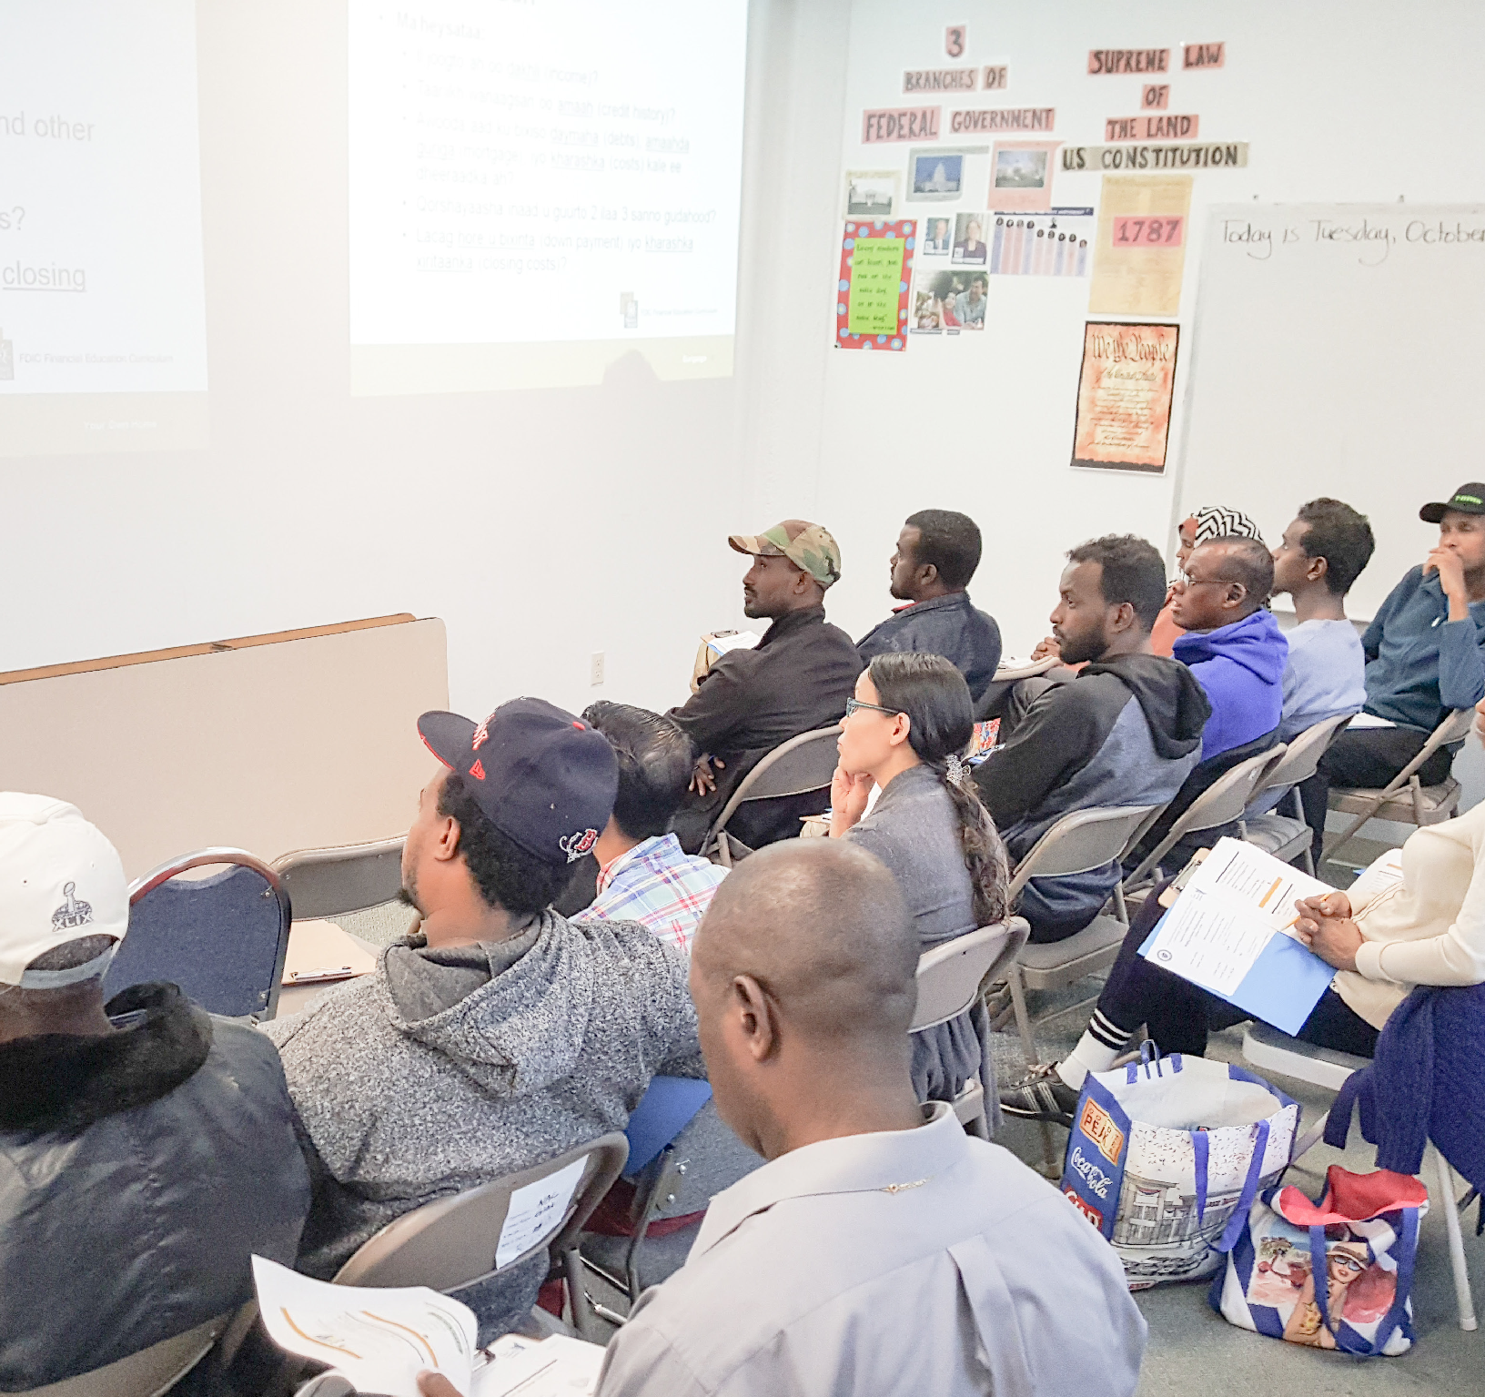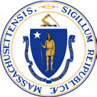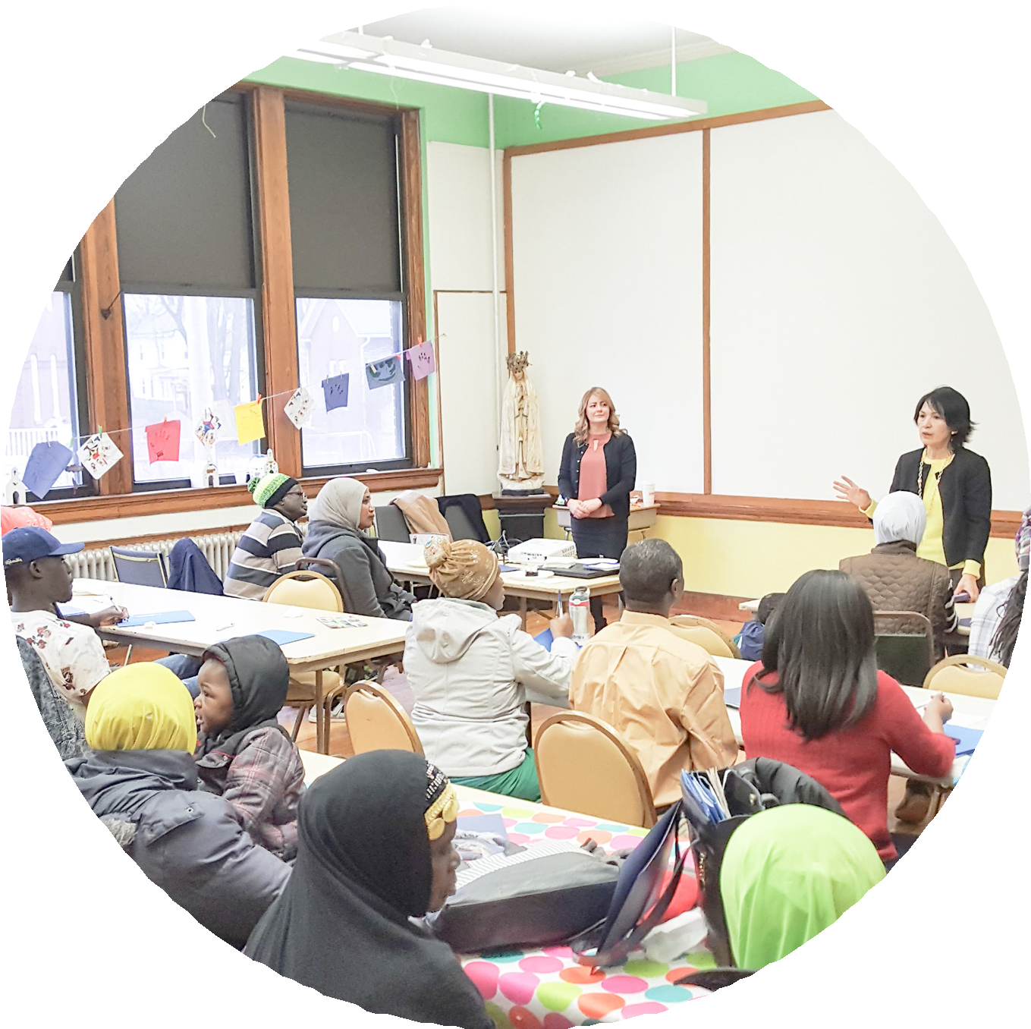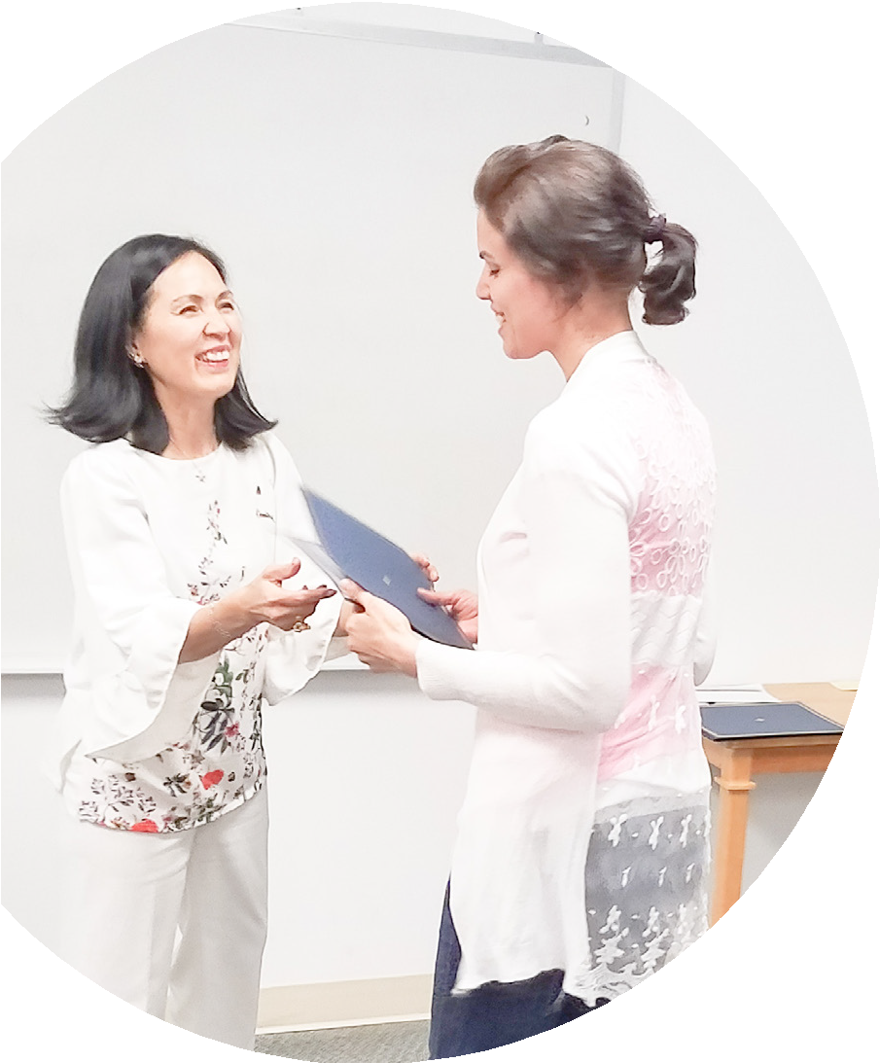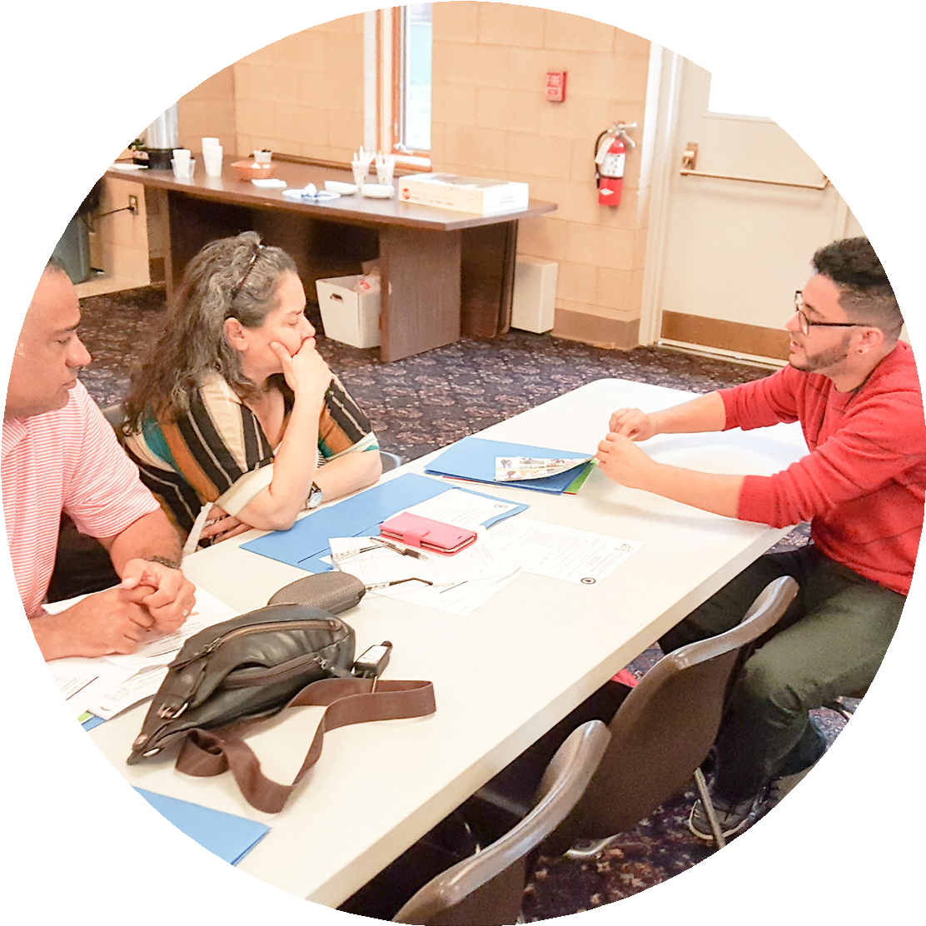FLN*
* FLN means Financial Literacy

for Newcomers. This report on
FLN’s first year will tell you how FLN helps refugees and
immigrants in Massachusetts.

Massachusetts Office for Refugees and Immigrants

WHY FLN?
Financial Education Matters
Financial Literacy for Newcomers | Massachusetts Office for Refugees and Immigrants

I wish someone had
“
told me about budgeting. This training gave me great tips and tools.

To have a successful life, everyone must make good decisions about money matters. But without critical knowledge and skills, too many people struggle and fall behind.
They miss opportunities to build security, use their limited resources less effectively than they should, and even take on debts they
can’t repay.

Lack of financial information hurts many people who have grown up in the United States, but it can be an even bigger problem for those who come from abroad. American banks do offer some services in languages
other than English, but many refugees and immigrants don’t speak those languages. Even if they can get by in English, they often lack the advanced English needed for complex issues.
And because of unstable politics, weak economies, and protracted wars, many have had bad experiences with financial institutions in their original countries. As a result, many avoid the American financial system, and some simply don’t know how its tools can help them. Harmful gaps in their financial understanding can linger
for years.
I will use them to save some money for my financial goals.
- Participant from Somalia

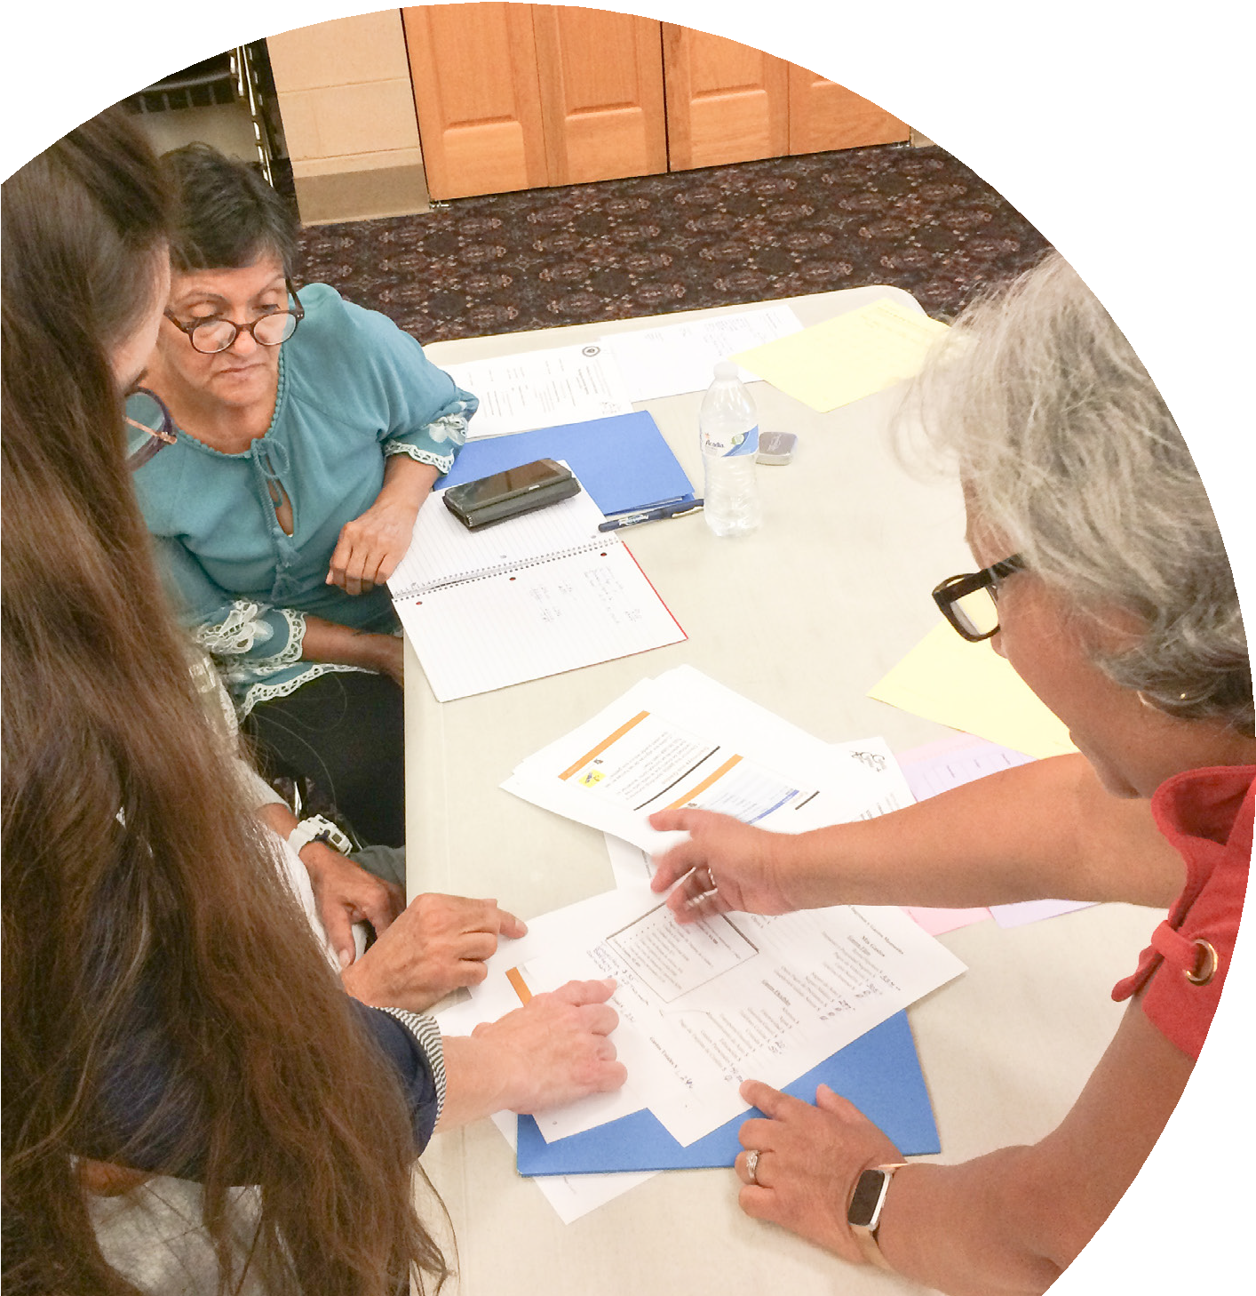
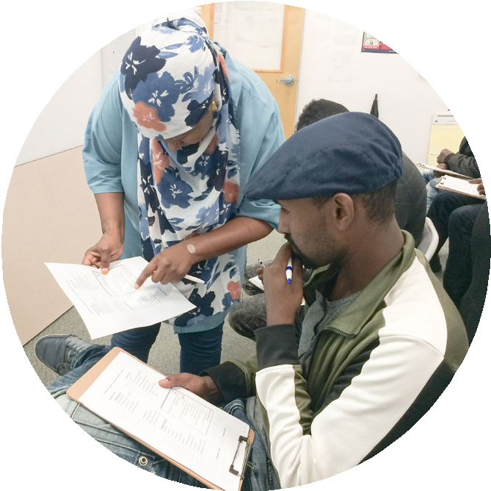A Somali-speaking interpreter and particip discuss budget issues at a Lynn workshop.
ant

Facilitators from People’s United Bank confer with a Spanish-speaking participant at a
budgeting workshop in Springfield.

New Neighbors
  - According to the US Census, since 2000 the foreign-born population of Massachusetts has grown by more than 380,000.
  - Refugee and immigrant communities have grown significantly across the state in such cities as Boston, Lawrence, Lynn, Worcester, and Springfield.
  - Many of these newcomers arrived without resources, and many continue to live close to the edge. 84% of FLN participants in 2018 have family incomes lower than $30,000 per year.
1

WHY FLN? (CONT.)
“
Graduates of a workshop series in Lynn whose participants included speakers
of Somali, French, Rohingya, Swahili, and Haitian Creole—celebrate finishing the series. ORI Executive Director

Mar
—
y Truong joins in (far right).

Thank you for your efforts. The workshop series was
Support Pays Of f very good and we hope

At the Massachusetts Office for Refugees and Immigrants (ORI), we know that there’s a real need for financial education among the people we serve—and a real reward for supporting it.
it will be repeated.

- Participant from Iraq

When newcomers fully engage in our financial system, they thrive.

Getting here took great energy and resourcefulness, which they have in abundance. Those qualities help them and their families make major contributions to our neighborhoods, towns, and cities.
Refugees and immigrants often require more than the basic facts they may have picked up during resettlement. They benefit from comprehensive, relatively advanced financial education, and they deeply value it when it’s available.
That’s why ORI is so glad to have received a substantial gift from the Generation Fund, as well as the help of many other community organizations, financial institutions, and
individual friends. Thanks to these public-private partnerships, we launched Financial Literacy for Newcomers in late 2017 to bring much-needed financial education to low-income refugees and immigrants in their own Massachusetts communities.

ORI in Brief
- The Massachusetts Office for Refugees and Immigrants (ORI) works statewide through local organizations to promote recent arrivers’
full participation in economic, social, and civic life.
- ORI supports such activities as case management, employment services, cash assistance, health promotion, citizenship preparation, and programs for young people and elders.
2

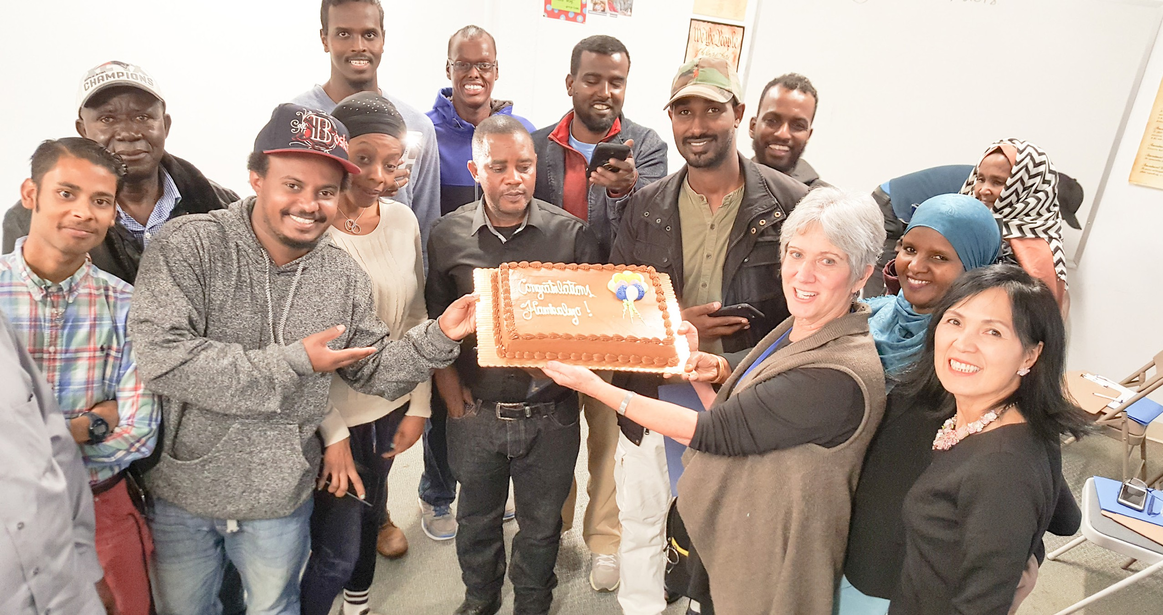

Financial Literacy for Newcomers | Massachusetts Office for Refugees and Immigrants

Financial Literacy for Newcomers | Massachusetts Office for Refugees and Immigrants

HOW FLN HELPS

Major Goals and Ways to Reach Them

It is definitely
“
a great service that [ORI] is providing
to these individuals. Looking forward to the collaboration
in 2019.

- Representative of
MassHousing

FLN has three major goals:
» To increase financial knowledge among refugees and immigrants, thus helping them build relationships with insured institutions, protect their savings, and benefit from credit and other financial services and products.
» To develop appropriate training tools that bridge gaps in language and culture.
» To build strong partnerships among financial institutions, government agencies, private foundations, nonprofits, and community-based organizations.

3

To reach its goals, FLN uses these tools:
» Industry-recognized training and evaluation material based on curricula from the FDIC, the U.S. Small Business Administration, the National Endowment for Financial Education, and Michigan State University.
» Customized workshops led by financial experts, aided by skilled interpreters and using handouts translated into participants’ languages.
» Surveys yielding everything from demographic data to measurements of knowledge gains and satisfaction. Over 1,000 surveys were tabulated.

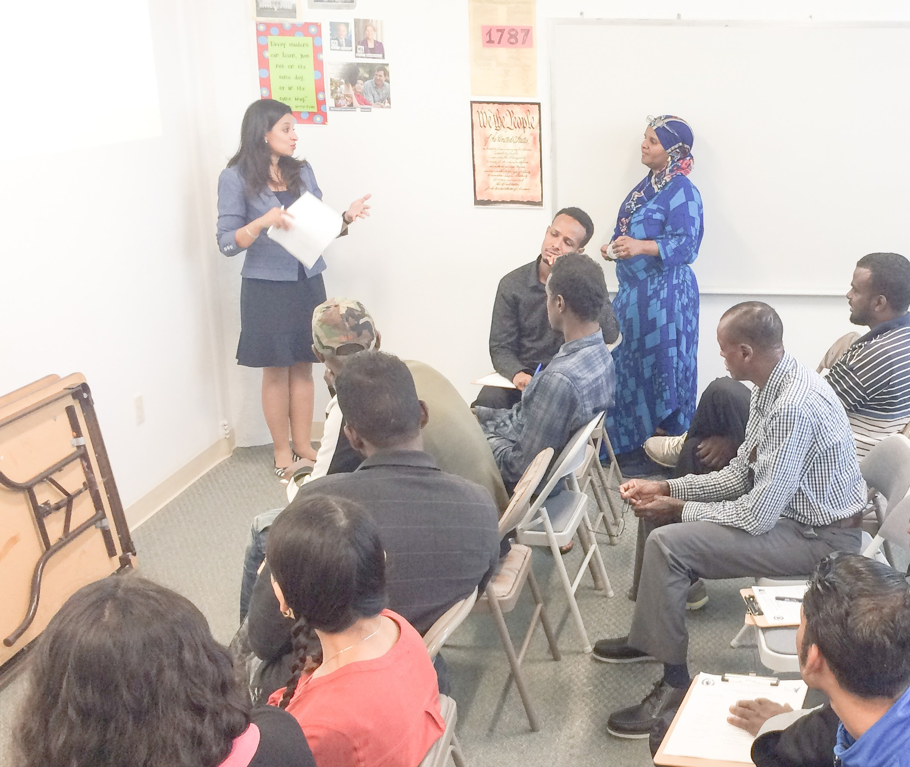
A facilitator from E
about borrowing ba participants in Lynn
astern Bank talks
sics with workshop
.
Customized Teaching
- Thus far, FLN workshops have been taught in
five languages: Arabic, Nepali, Spanish, Somali, and Swahili.
- ORI translates workshop materials into the appropriate languages and adds key words in English to familiarize participants with American terminology.

Financial Literacy for Newcomers | Massachusetts Office for Refugees and Immigrants

A GOOD START

The FLN Project Comes Together

FLN has grown from many minds, all concerned by the need for greater financial education for newcomers. ORI’s statewide connections helped to bring these minds together.
Personal experience also played a major role—for example,
that of people at ORI and the community-based organizations ORI closely works with. Many were refugees or immigrants themselves.
Encouragement from the Commonwealth has been greatly appreciated—and public-spirited awareness in the private sector has been equally so. Several financial

institutions have seen in FLN an important opportunity to strengthen their ties to local communities.
The first of these was People’s United Bank, which sponsored two pilot workshops.
And a private foundation, the Generation Fund, stepped forward with a substantial—and very welcome
—gift for developing and delivering diverse financial education tools and resources through workshop programs for a projected 1,000 immigrants and refugees over three years.

Paired with the unique cultures, traditions and perspectives of
Massachusetts’ newcomer community, [FLN] will add meaningful value to our goal to make Massachusetts the best place to live,
“
work and raise a family.
— Governor Charlie Baker, announcing the creation of FLN

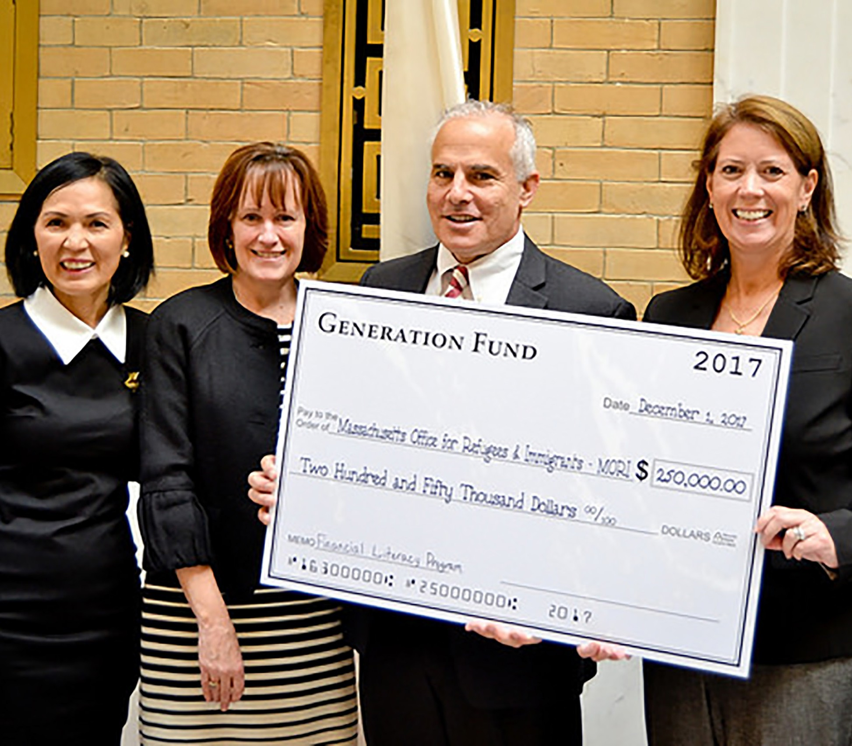
To officially launch FLN, ORI Executive Director Mary Truong joins Undersecretary of Human Services Patricia Mackin,
Chair Jeff Goldman of the Governor’s Advisory Council on
Refugees and Immigrants, and Generation Fund representative Meredith Murphy (l-r) at the State House in December 2017.
Help from the Private Sector
- A $250,000 one-time gift from the Generation Fund will provide major support through the year 2020.
- People’s United Bank, First Republic Bank, and individual donors have also provided welcome support.
4

Financial Literacy for Newcomers | Massachusetts Office for Refugees and Immigrants

A GOOD START (CONT.)

Two Pilot Workshops

In December 2017 and January 2018, ORI partnered with People’s United Bank and the Refugee and Immigrant Assistance Center to conduct pilot workshops in Arabic and Somali at a People’s United Bank branch in Worcester. All the participants were recent refugees or asylees from Somalia, Iraq, and Syria.
The workshops covered the basics of banking and credit. Some participants had specifically asked to receive such training so they could avoid making financial mistakes as newcomers to the United States. When ORI surveyed the participants afterward,

felt confident that they could research ways to avoid banking fees, felt confident about visiting a bank to open an account,
78%
84%
92%
76%
77%
strongly agreed that the workshops were a positive experience,

felt confident that they could use a debit or ATM card, and
44%

In 20+ years of retail banking, I have not met a partner as invested in the true well-being of their participants as the team at ORI.
— Representative of
“
People’s United Bank

Who Attended

GENDER

64%
36%
Male Female

LANGUAGE

56%

felt more knowledgeable about the U.S. banking system.
Arabic
Somali

The pilots confirmed the need for workshops covering advanced topics and also yielded valuable information about when, where, and how to
COUNTRY OF ORIGIN

44% 36% 20%

conduct them. Three groups of workshops, each group addressing several topics, were planned for 2018 in Springfield, Worcester, and Lynn.
Somalia
Iraq Syria

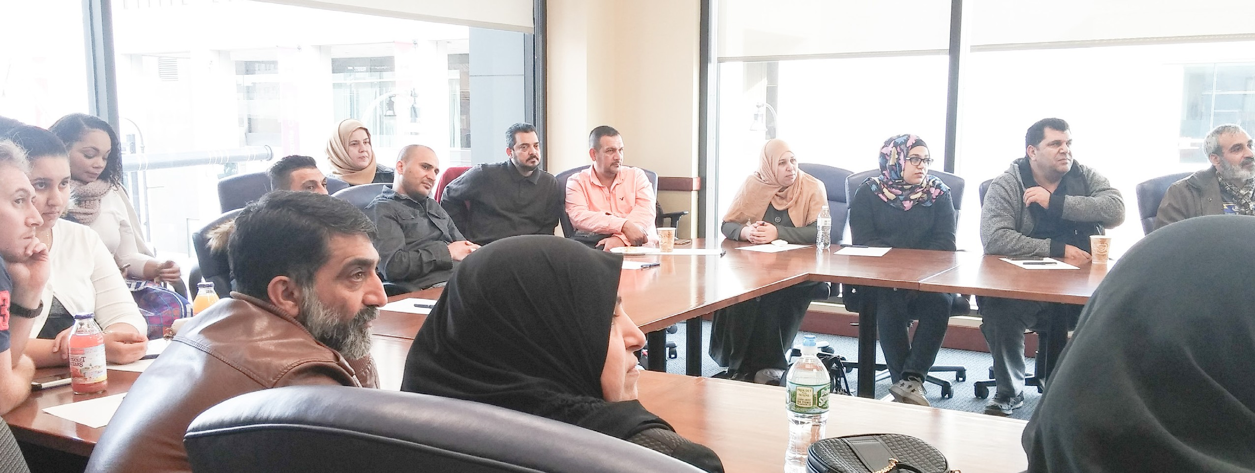

5
During a pilot workshop at a People’s United Bank branch in Worcester, Arabic speakers
learn about banking and credit basics.

5

Financial Literacy for Newcomers | Massachusetts Office for Refugees and Immigrants

FRUITFUL PARTNERSHIPS

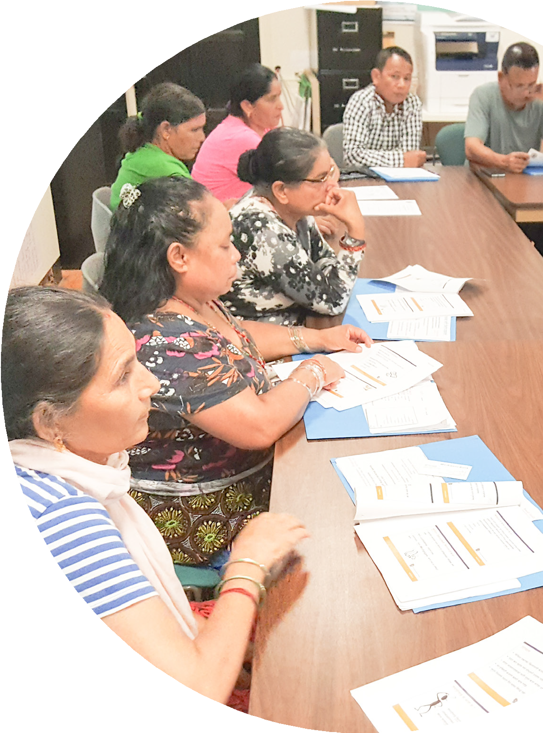Community and Financial Organizations

To host and teach a full program of FLN workshops, ORI used its central position in state government to engage people
with expertise and goodwill from both local community-based organizations (CBOs), and major Massachusetts
financial institutions.

CBOs provide a range of services to international communities, including initial and ongoing help with aspects of resettlement. Employing many refugees and immigrants with local connections, they have become “cultural brokers” skilled in smoothing the way for newer arrivers. Hosting FLN workshops in 2018 were the Catholic Charities Agency of Springfield, Jewish Family Service of Western Massachusetts, the Refugee and Immigrant Assistance Center, the New American Center, and the Southeast Asian Coalition.
“

The budgeting exercise was “particularly powerful.” One client said that the workshop “really opened his eyes and made him think in a whole new way about his finances.”
— Representative of the New American Center

At this workshop in Springfield, Nepali speakers are taking in information about borrowing basics.
Here a Somali interpreter speaks with pilot workshop participants at a People’s United Bank branch.

For financial institutions and other partners, FLN offers ways to
serve and strengthen local communities, and even to begin long-

lasting relationships with their residents. Volunteer workshop facilitators came in 2018 from Eastern Bank, People’s United Bank, Citizen’s Bank, MassHousing, and American Consumer Credit Counseling, Inc. People’s United Bank and First Republic Bank also made modest grants to help with such operational costs as translation services.

Contributors to Success
- CBOs provide community outreach, host workshops and graduation celebrations, and supply interpreters in the participants’ languages. Some can even help with transportation and childcare.
- Banks and other organizations provide experts who specialize in the advanced financial topics discussed at the workshops.
- ORI provides statewide planning and coordination, grants and other support for attracting workshop participants, training material translated into participants’ languages, and evaluation through observation and surveys.

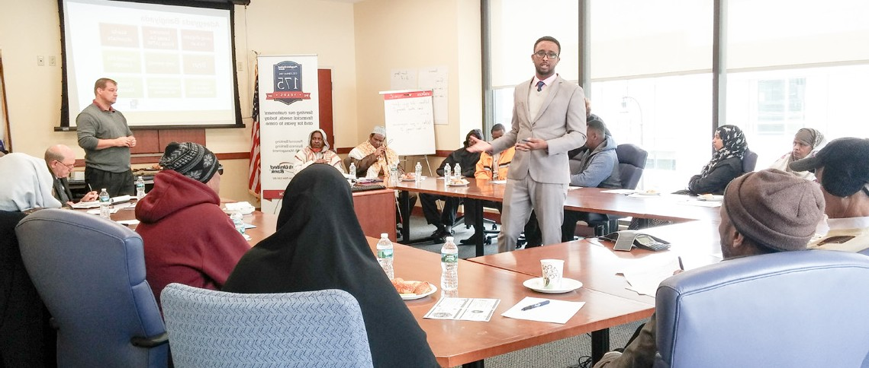6

al Literacy for Newcomers | Massachusetts Office for Refugees and Immigrants

Financi

The participants “understood [the topic] clearly…. They are so excited and got the concept of income and expenses.”
“
— Representative of Jewish Family Service of Western Massachusetts

MULTI-SESSION WORKSHOPS

Critical Topics

A participant asked if workshop materials could be translated into Spanish Braille,
and ORI was glad to help. Here he is presented with the translations.

I wish we had this training earlier so I could have made better decisions
“
and knew how to start building a credit
By spring 2018, FLN had blossomed into a well-developed program of workshops covering a full range of financial education topics.
In its first year, FLN conducted
» three groups of workshops (spring, summer, and fall)
» with at least five sessions in each workshop series*
» and a total participation of more than 220—well over the original goal of 200.
Workshops were held at
» Catholic Charities Agency, in Springfield and Florence,
» The Southeast Asian Coalition, in Worcester,
» The New American Center, in Lynn, and
» The Jewish Family Service of Western Massachusetts, in Springfield.

score and credit history in the right way. It’s not easy to fix our credit scores, especially if we are new to this country.
— Participant from
Democratic Republic of the Congo
Workshop topics included
» Basics of Banking
» Debit and Credit Cards
» Credit Scores and Reports

» Budgeting
» Buying a Home
» Borrowing Basics**

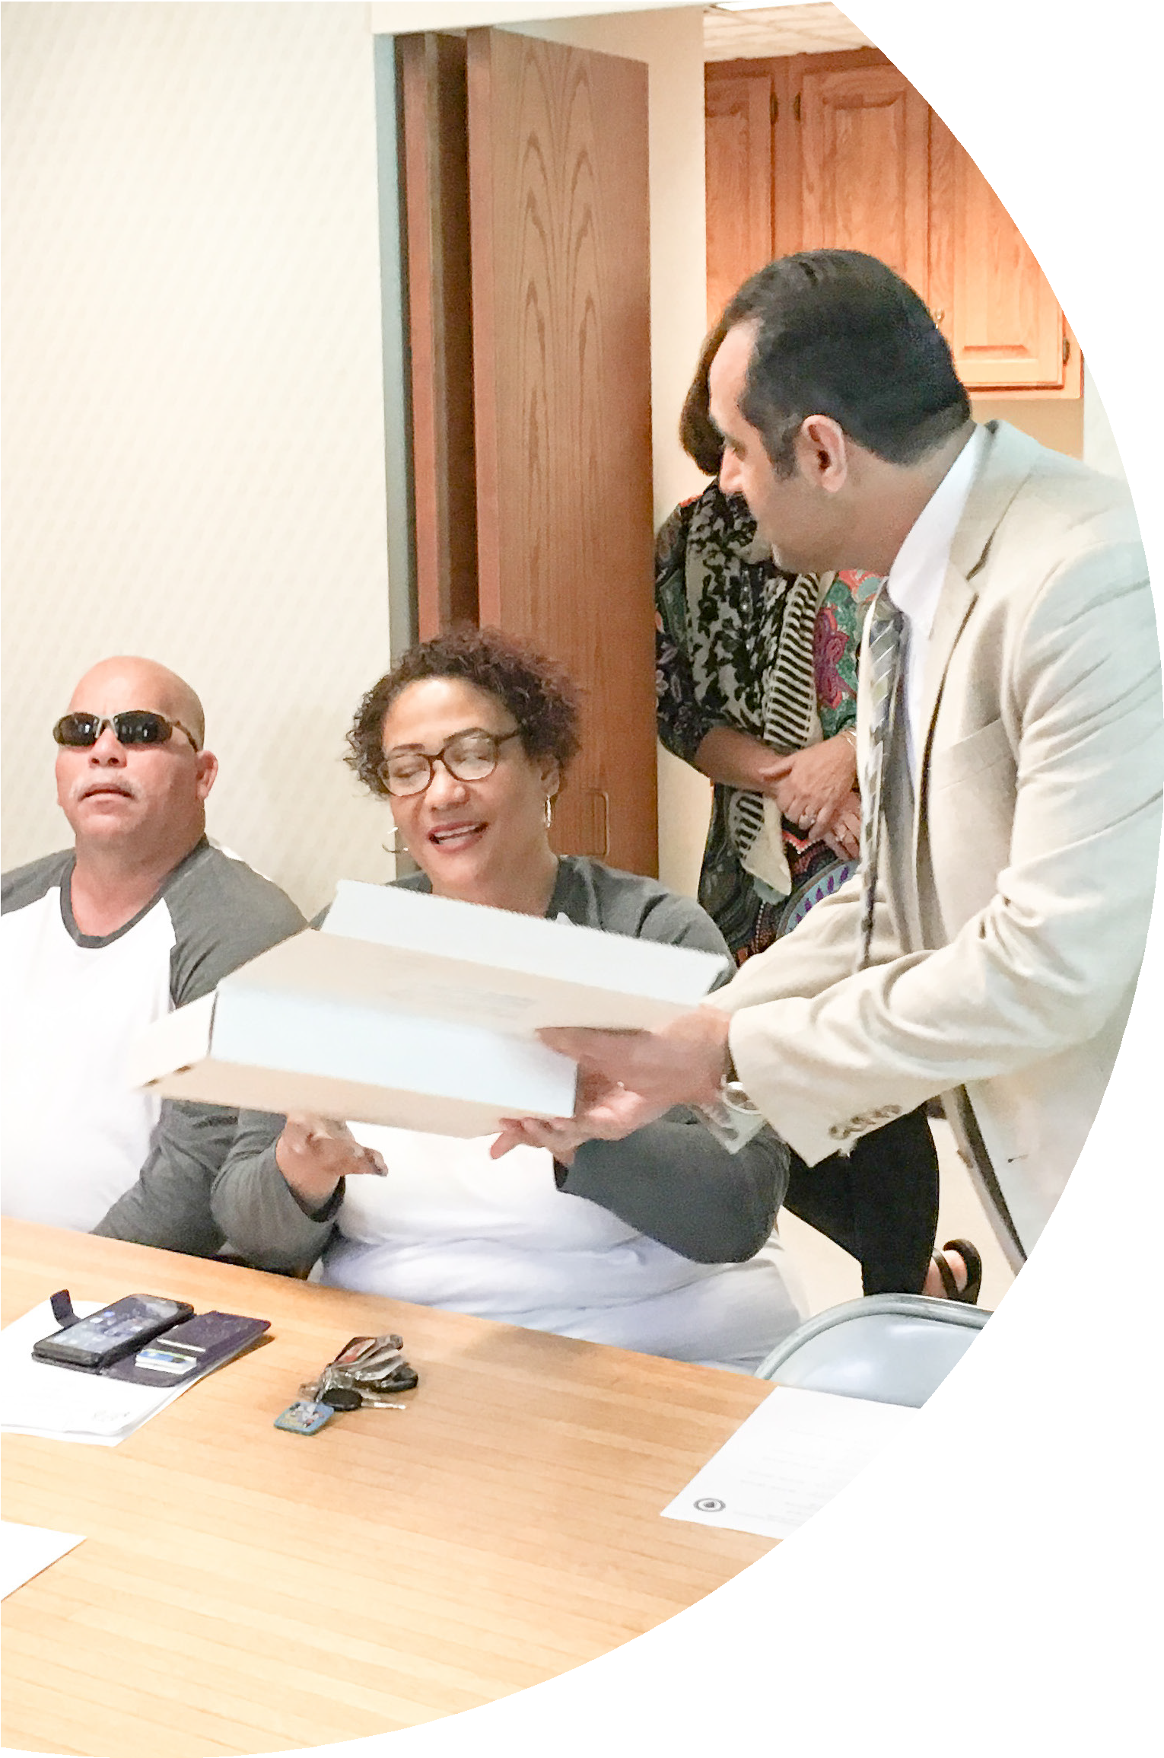
*The workshops were free. Each person who completed all workshops (with no more than one excused absence) and all required surveys received $50 to help with expenses.
**Offered once.

7

Financial Literacy for Newcomers | Massachusetts Office for Refugees and Immigrants

MULTI-SESSION
WORKSHOPS (CONT.)

Frequent Questions, Expert Answers
“

During workshop sessions, ORI noted concerns that came up often. Here are a few typical questions that expert facilitators addressed.

Many of the families were fired up to talk and discuss their own experiences with

About banking basics:
Q1: How do I protect my account from overdraft fees?
Q2: How do I transfer or receive money internationally?

About budgeting:
Q1: How do I create a spending plan?

About credit cards and scores:
Q1: If I am offered a higher credit limit, is that good?
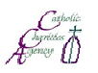Q2: Why would a bank or credit union not approve me for a loan or credit card?

La Oficina para Refugiado en sociedad con la

Les invitan a participar en una serie de tal
educación financi

▪ Conceptos Básicos de la Banca
Agosto 24, 2018, 9AM – 12PM

▪ Tarjetas de Débito y Crédito
Agosto 31, 2018, 9AM – 11:30AM

▪ Calificación y Reporte Crediticio ▪
Septiembre 7, 2018, 9AM – 11:30AM

Los participantes que completen la serie de talleres de requerimientos del programa, recibirán un incentivo de

Se servirán refrigerios ligeros, y se provee

Los asientos son limitados; por favor regístrese
Catholic Charities Agency

Los talleres se llevarán a
65 Elliot St.
Springfield, MA 01105

*Los participantes deben completar la serie de talleres, todas ceremonia de graduación, para poder recibir el incentivo de $50, depen
fondos. Cada serie de talleres están limitados a 25

About buying a home:
borrowing. They definitely learned more in regards to predatory lending practices.
- Representative of Catholic Charities Agency of Springfield

s e Inmigrantes de Massachusetts

Q2: My work hours are not always
Q1: What would I need to do to
get approval for a mortgage?

التوعية المالية للوافدين الجدد )FLN(
The Massachusetts Office for Refugees & Immigrants Southeast Asian Coalition مع باالشتراك
يدعوكم للمشاركة في سلسة حلقات عمل مجانية مكونة من خمسة جلسات عن التوعية المالية. سوف تشمل
Catholic Charities Agency

leres GRATUITOS compuestos de seis clases sobre era. Los temas incluirán:

  - Presupuesto

the same. How can I calculate my income?

Q2: What should I do if I lose

❖ الميزانية
5:30 – ًء مسا 3 ،2018/مايو/15
مسا ًء
❖ شراء منزل
6:30 – ًء مسا 3 ،2018/مايو/22
مسا ًء (ستقع حفلة التخرج عند نهاية هذه
الدرس)
الموضوعات:

❖ أسس العمليات المصرفية
ًء مسا 6 – ًء مسا 3 ،2018/أبريل/24

السحب الفوري وبطاقات االئتمان  بطاقات
ًء مسا 5:30 – ًء مسا 3 ،2018/مايو/01
االئتماني والسجل االئتماني  الرصيد
ًء مسا 5:30 – ًء مسا 3 ،2018/مايو/08
Septiembre 14, 2018, 9AM – 11:30AM

  - Conceptos Básicos sobre Préstamos
Septiembre 21, 2018, 9AM – 11:30AM

Cómo Comprar una Casa (y Ceremonia de Graduación) Septiembre 28, 2018, 9AM – 12:30PM

About borrowing basics:
Q1: What do we need to consider when borrowing?
my job and cannot pay my mortgage?
سيحق للمشاركين الذين يقومون بإكمال حلقات العمل الخاصة بالتوعية المالية للوافدين الجدد FLN باإلضافة
إلى متطلبات البرنامج األخرى التأهل للحصول على حافز قدره $50 مع شهادة إتمام الحلقات. *

سوف يتم تقديم المشروبات المرطبة المنعشة مع توفير ترجمة للمادة المطروحة (إلى اللغة العربية.) سوف
يتم أيضاً تقديم خدمات رعاية األطفال، مع توفيرها بصورة محدودة.
سيتم تخصيص عدد محدود من المقاعد؛ لذا يرجى الحجز في وقت باكر من خالل التواصل مع:

Southeast Asian Coalition (SEAC) at (508) 791-4373

سوف تُعقد حلقات العمل في:
484 Main St, Suite 400
Worcester, MA 01608

*يجب على المشاركين إكمال سلسلة حلقات العمل، جميع التقييمات، مع حضور حفل التخرج من أجل التأهل للحصول على حافز قدره $50 لمرة واحدة، ريثما يتوافر التمويل النقدي. سوف يتم إعطاء األولوية للمشاركين من مقدمي خدمات التوعية المالية للوافدين الجدد
.FLN

educación financiera, y otros
$50, y un certificado de curso.* rá traducción (en Español).
cuánto antes, llamando a:
a 413-452-0577

cabo en:

las evaluaciones, y asistir a la
diendo de la disponibilidad de

Q2: How can we identify predatory lenders and avoid them?
participantes.

To help with outreach, ORI created flyers in Arabic
and Spanish (above) plus Nepali, Somali, and Swahili.
At a Florence workshop for Swahili speakers, credit cards and credit reports are the subject of the day.

8

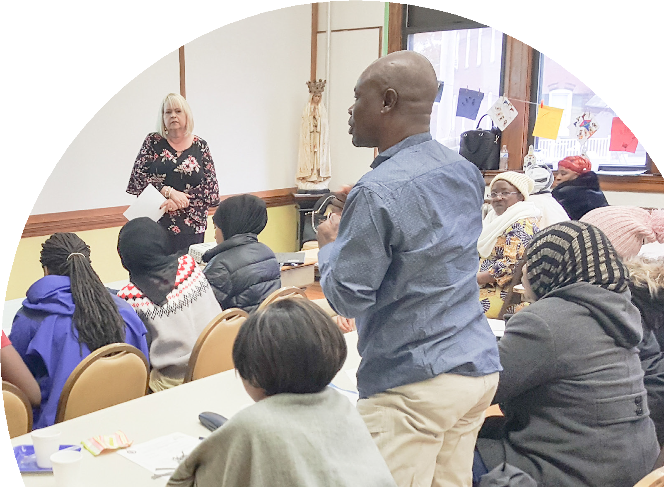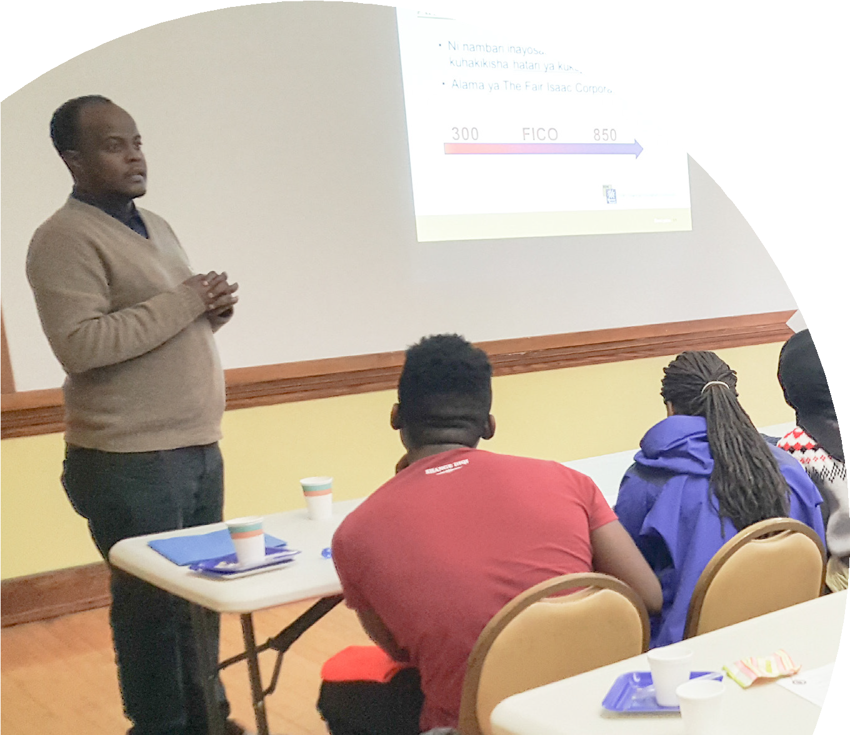

8

Financial Literacy for Newcomers | Massachusetts Office for Refugees and Immigrants

MULTI-SESSION
WORKSHOPS (CONT.)

Who Attended

GENDER

Female Male

LANGUAGE

28% Spanish

64%

36%

29%
16%

11%

9%

Arabic Somali Swahili Nepali
Other (incl. French,

7% Rohingya, Farsi)

COUNTRY OF ORIGIN CITY OF RESIDENCE

24% 16%
12%

19%

13%

26%*
9%

3%
10%
45%
12%

11%

Puerto Rico/U.S.* Iraq
Somalia
Democratic Rep. of Congo Bhutan
Sudan
Springfield Lynn Northampton

Other (incl. El Salvador, Morocco, Kuwait) Worcester

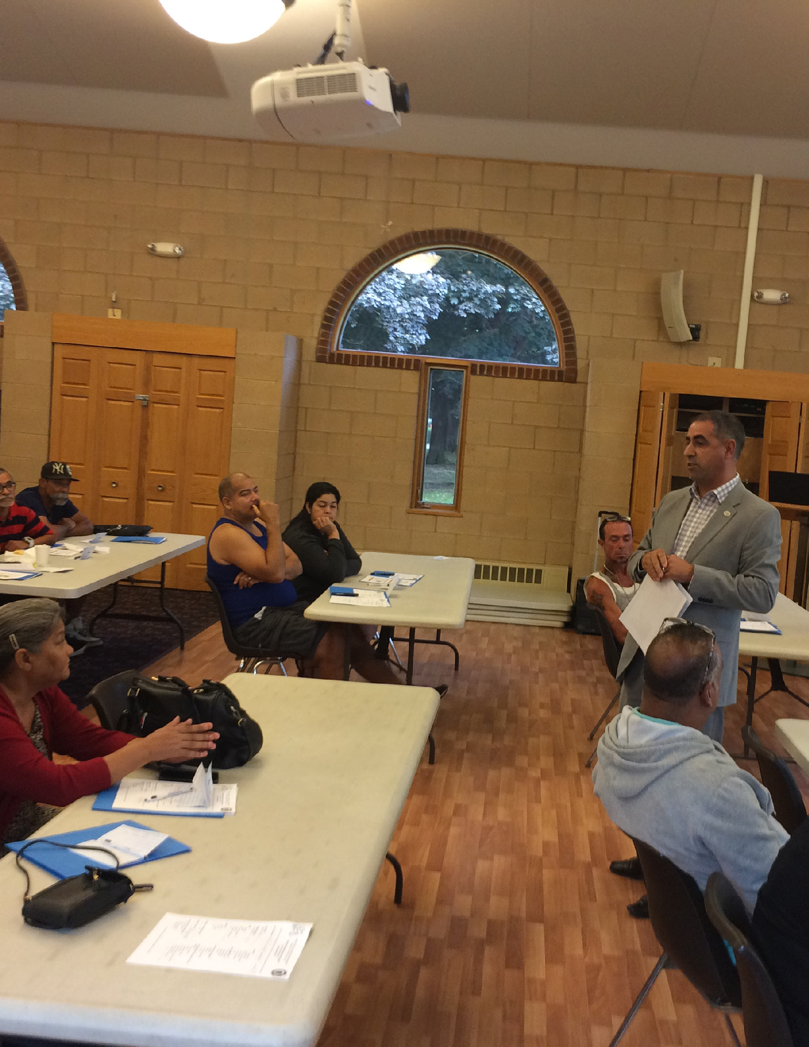*Includes evacuees after Hurricane Maria.

I like the program. It was a wonderful experience and a great help with my home buying concerns.
“
— Participant from Puerto Rico

Other (incl. West Springfield, Salem, Chicopee)

Thanks to the presenters who explained to us and answered all our questions with great pleasure.
“
- Participant from Iraq
9

Financial Literacy for Newcomers | Massachusetts Office for Refugees and Immigrants

MULTI-SESSION
WORKSHOPS (CONT.)

Who Attended

6+ Members
HOUSEHOLD SIZE
16%
15%
12%
35%
12%
10%
4 Members
3 Members
2 Members
1 Member
5 Members
HOUSING SITUATION

72%

15%
10%

3%
CURRENT WORK
25%
21%
34%
20%

Rent Homeless
Living w. Family Own a Home

HS Grad, GED Middle School Other Bachelor’s
EDUCATION
24%
18%
15%
25%
13%
5%
Elementary School Associate’s

STATUS

Unemployed Part-time Full-time Retired

GROSS ANNUAL HOUSEHOLD INCOME

64%
20%

12%

Below $15K
$15K–30K
$30K–50K
Above $50K

I will go home after today’s training and talk with my kids about the importance of a good credit score and how to keep it.
— Participant from Nepal
“

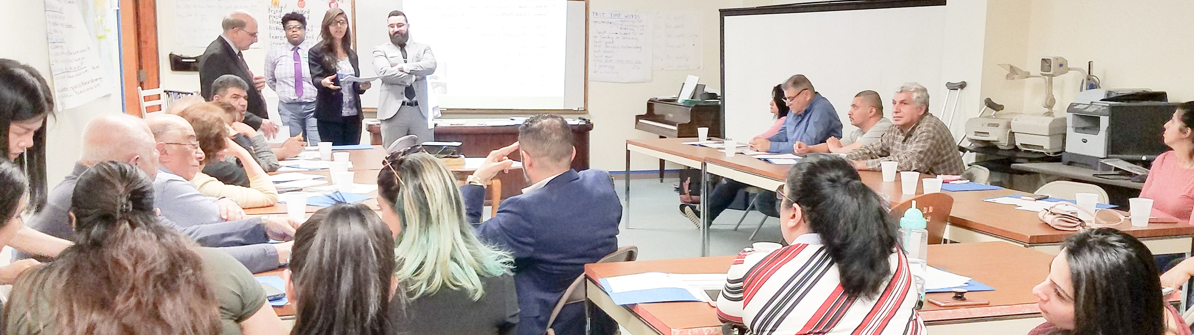4% Arabic speakers consider the

10
basics of American banking
in this Worcester workshop.

10

GOOD OUTCOMES

Meeting Graduation Goals
At a graduation ceremony, Puerto Rican
evacuees display certificates they earned for completing a workshop series in Springfield.

According to pre- and post-workshop surveys, FLN participants gained significant knowledge in these areas:
» Home-buying: correct responses increased 10-59%
» Banking: correct responses increased 13-17%
» Budgeting: correct responses increased 14-20%
» Credit: correct responses increased 19-21%
» Borrowing basics: correct responses increased 42-53%

The workshop went well and meets many of the clients’ needs. Especially to educate them about budgeting that eliminates worries and encourages them to save money.
“
— Representative of the Southeast Asian Coalition
In the percentages below, participants felt confident or very confident:
about visiting a bank to open an account,
79%

that they know how to use a bank debit card,
85%

that they know the amount of a down payment needed for buying a house,
85%

that they understand what a home equity loan is,
86%

that they know what is a good credit score and what is a bad credit score,
88%

that they know how to reduce their spending.
89%
11

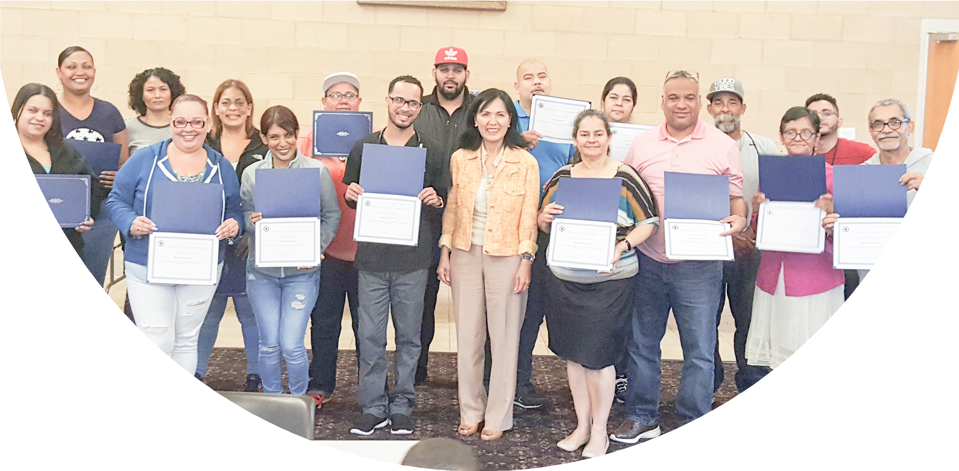

Financial Literacy for Newcomers | Massachusetts Office for Refugees and Immigrants

GOOD OUTCOMES (CONT.)

Working Toward Better Futures

Because of FLN, participants plan to
OPEN A CHECKING
OR SAVINGS ACCOUNT

USE A BUDGET
AND SPENDING PLAN

CHECK THEIR CREDIT REPORT

43%
42%
15%
80%
15%
5%
83%
11%
6%

Yes
Already No have one
Yes
Already No use one
Yes
Already No checked it

PAY BILLS ON TIME

78%
CHANGE HOW THEY SEND MONEY HOME

65%

Wow! I wish I would have known this earlier.

Yes

Already No doing it
18%
4%

Yes

Have already No changed
7%
28%
— No.1 response from surveyed workshop participants.

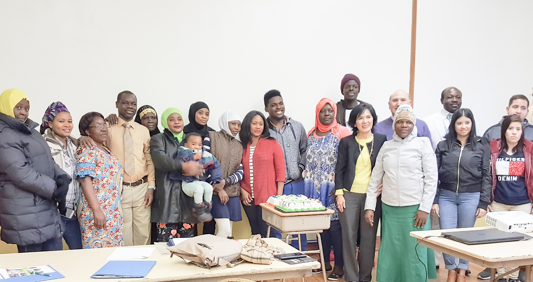

Financial Literacy for Newcomers | Massachusetts Office for Refugees and Immigrants
Swahili- and Spanish-speaking graduates celebrate at a ceremony in Florence.

Satisfaction and Appreciation

12

94% said the education materials were
helpful or very helpful.

100% said they would
recommend FLN to others.

97% said the instructors were helpful or very helpful.
“
When participants were surveyed after their workshops,

Financial Literacy for Newcomers | Massachusetts Office for Refugees and Immigrants

HAPPY CELEBRATIONS

Graduation Ceremonies

Earning an FLN certificate required faithful attendance, regardless of other obligations. Most participants came to at least five workshops, although an excused absence was allowed.
They also had to complete all the FLN surveys. During FLN’s first year, 68% of the participants met every graduation requirement— a real investment of time and thought.
At the graduation ceremonies, many participants thanked
every specialist, staff member, and volunteer—and especially the Generation Fund, which had supported the workshops. Many also said they would like to attend more workshops in the future.
When asked which additional topics should be presented, most voted for borrowing basics, starting your own business, and retirement planning.
Then it was time to celebrate!

I wanted to say thank you for giving us the opportunity to
participate in this series! All the feedback I got from my volunteers
“
was very good.
— Representative of Citizens Bank

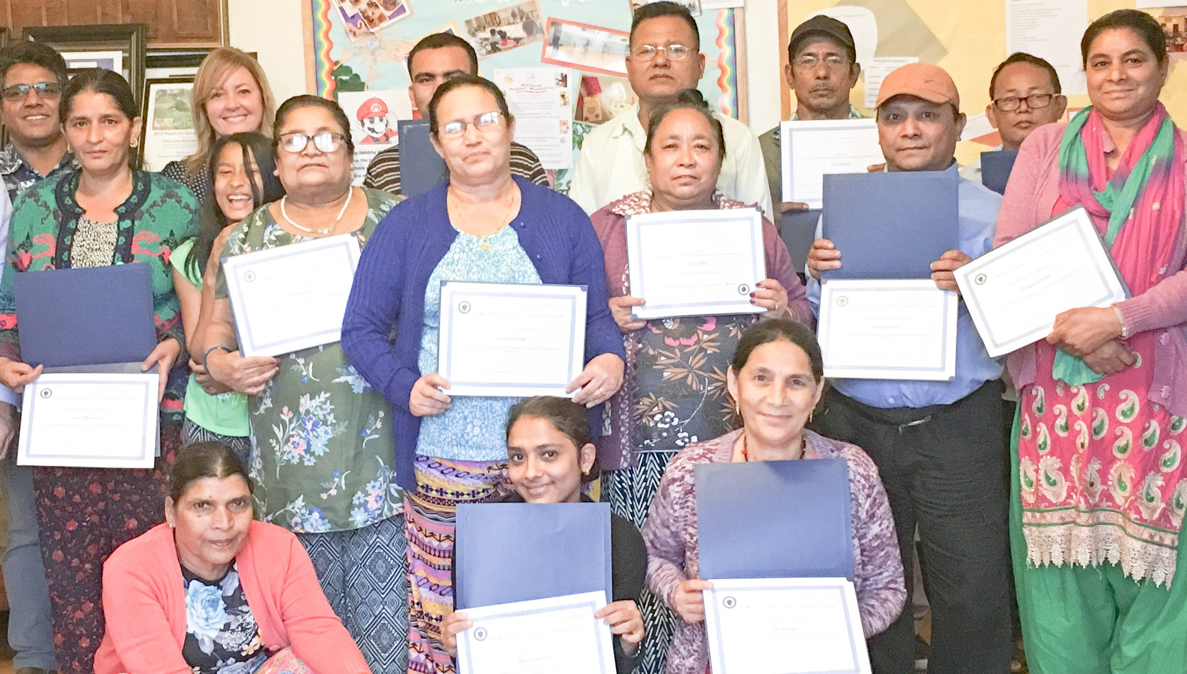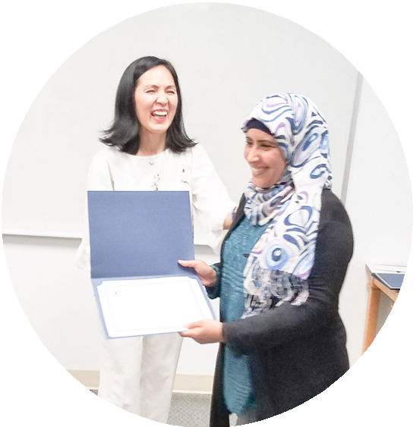

13
An Arabic-speaking graduate in Lynn receives her certificate from ORI’s Mary Truong.
These Nepali speakers display their graduation certificates at a Springfield ceremony.

13

THANK YOU!

Sources of Critical Support

We at the Massachusetts Office for Refugees and Immigrants wish to express heartfelt thanks to FLN’s multi-year funder—
The Generation Fund
—for supporting the FLN program and believing in its importance.
We wish also to thank all of our partners— the community organizations, financial institutions, and individual friends whose indispensable help has make FLN a success.
We appreciate their continuing support of ORI’s mission: promoting the full participation of refugees and immigrants as self-sufficient individuals and families in the economic, social, and civic life
of Massachusetts.
Arabic speakers gather for their
graduation ceremony in Worcester

.
A Swahili-speaking graduate in Florence cuts a cake during the graduation ceremony.

BANKS
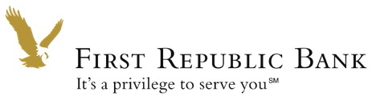
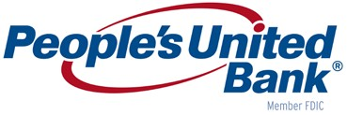
Citizens Bank • Eastern Bank • First Republic Bank • People’s United Bank

OTHER PARTNERS

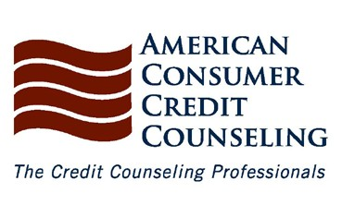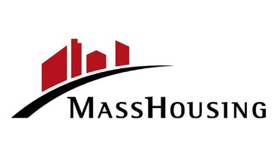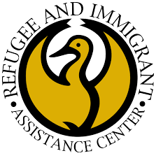
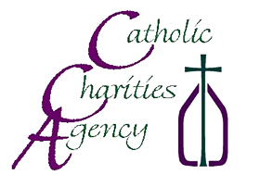
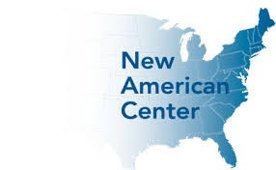
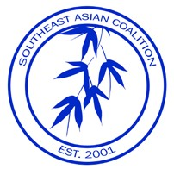
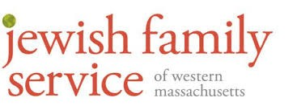

American Consumer Credit Counseling • Catholic Charities Agency Jewish Family Service of Western Massachusetts • MassHousing
Refugee and Immigration Assistance Center • Southeast Asian Coalition The New American Center

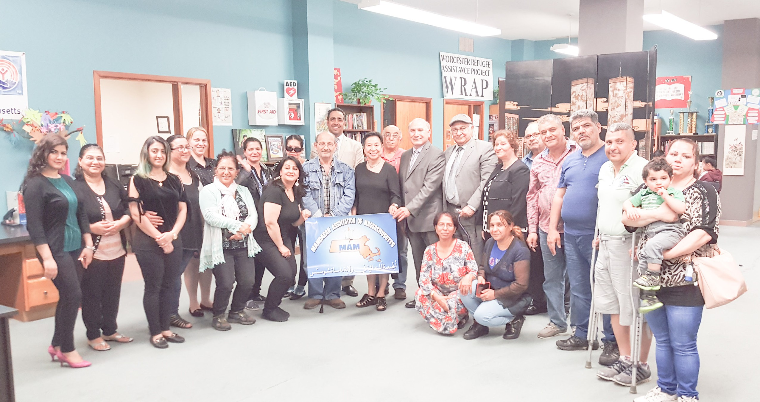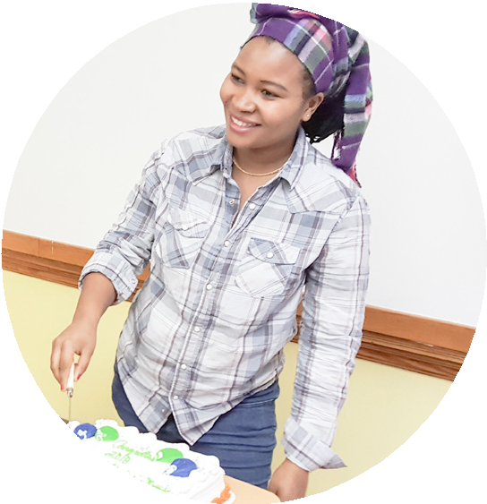14

Financial Literacy for Newcomers | Massachusetts Office for Refugees and Immigrants

Financial Literacy for Newcomers | Massachusetts Office for Refugees and Immigrants

WHAT’S NEXT FOR FLN?

Improving and Expanding

We’ve learned a lot from our experience so far, and we have many more ideas. We aim to improve FLN’s services by
» using workshops to teach additional financial terms in English,
» translating surveys into additional foreign languages,
» simplifying data-collecting procedures to ease participants’ involvement, and

» finding new partners to offer additional services, such as further workshops in advanced subjects.

We plan to expand by
» offering new financial education topics,
» identifying new community-based organizations to partner with statewide, and

15

» offering FLN workshops in new languages.

I would like to thank you for this program because we have learned a lot.
So many things we didn’t know were covered in the workshop. I would like to encourage you
“
to continue…for the new refugee clients to come.
- Participant from
Democratic Republic of Congo

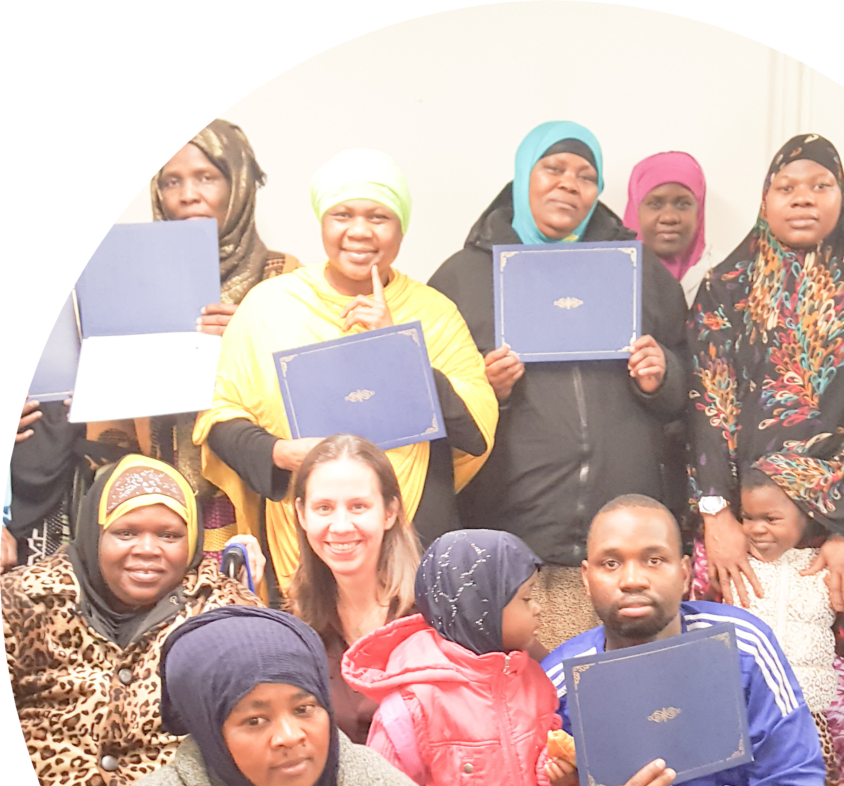

Here the workshop graduates are Somali speakers in Springfield.

15

ORI’S MISSION
ORI staff members assemble for their annual staff photo.

Full Participation

In 1985, an executive order designated responsibility for refugee affairs in Massachusetts to the Office of Refugee Resettlement. ORI, its successor, was established in 1992 by the state legislature to promote the full participation of refugees and immigrants as self-sufficient individuals and families in the economic, social, and civic life of the Commonwealth. Using knowledge of statewide conditions and resources, ORI works through a network of voluntary resettlement agencies,
faith-based organizations, and ethnic-community organizations that have the capacity to serve the culturally and linguistically diverse needs of newcomer populations. Over the years,
ORI-supported programs have directly benefited tens of thousands of refugees and immigrants, hailing from more than 100 countries around the world.
We wish to recognize the participation of

Mary Truong, ORI Executive Director Falah Hashem, ORI Chief of Staff Kierra Ho, FLN Program Manager Emil Farjo, FLN Workshop Consultant Jeffrey Mitchell, Report Text*
Andy Doan, Report Design*
*pro bono

We are also grateful to many others at ORI and our partner organizations who have helped so much to make FLN a success.

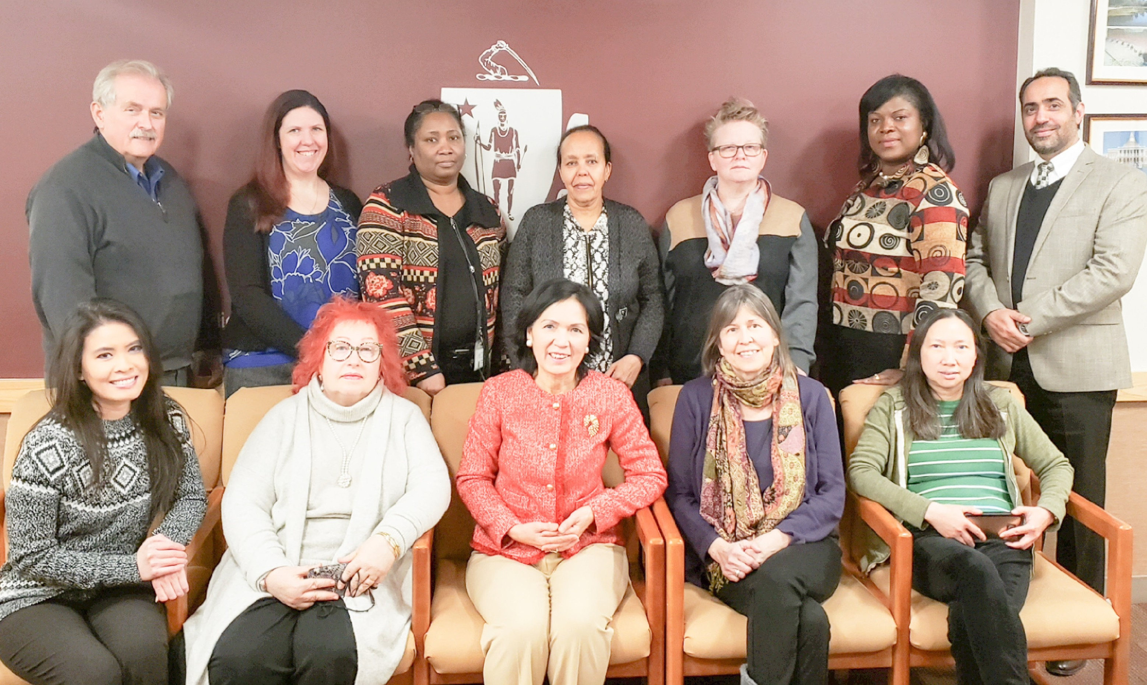

Financial Literacy for Newcomers | Massachusetts Office for Refugees and Immigrants

16

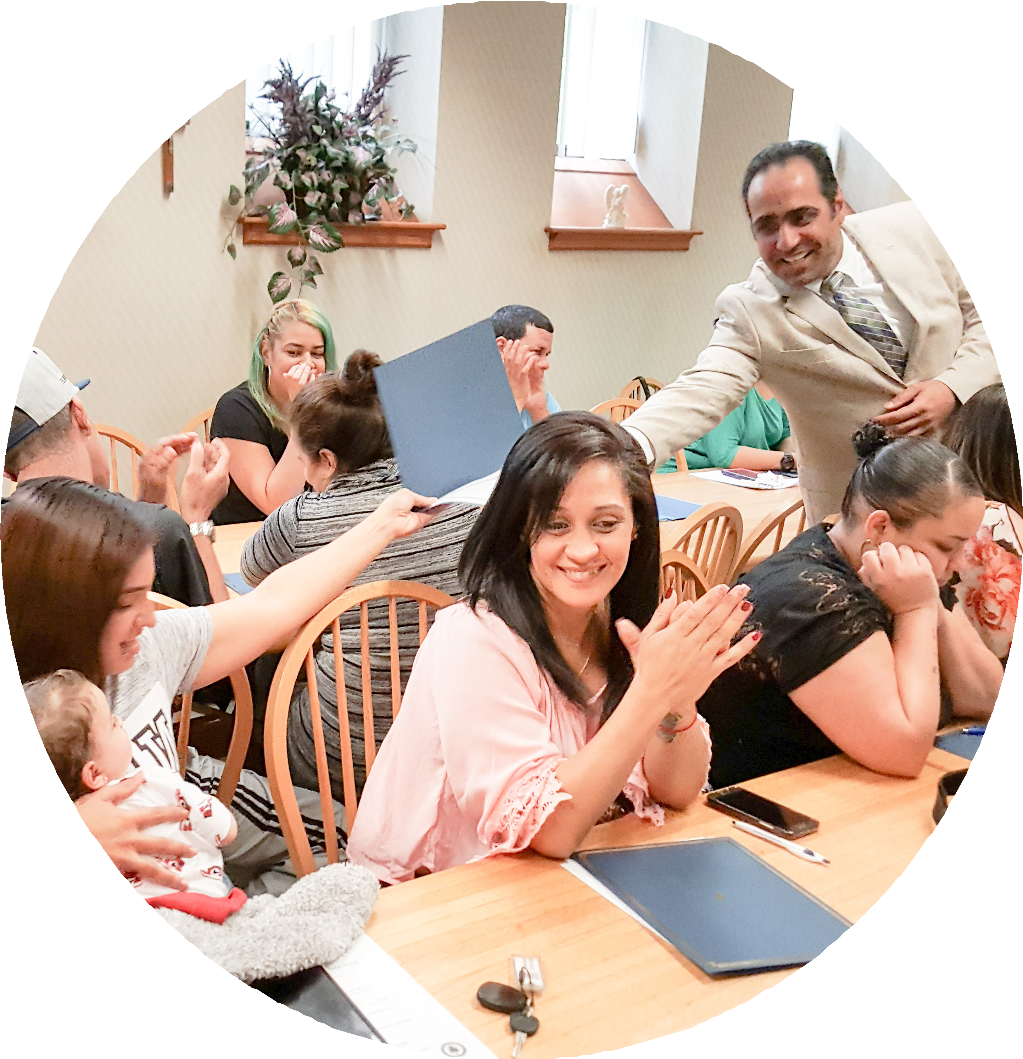

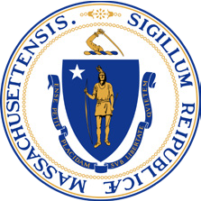
Contact Us
Massachusetts Office for Refugees and Immigrants | T: | 617–727–7888
600 Washington Street, 4th Floor Boston, Massachusetts 02111 | TTY:  Fax: | 617–727–8147  617–727–1822

For more information, or to download this report, please visit: www.mass.gov/ORI

