

Findings from the One Care Quality of Life Survey
Aggregate Results
July 2015

Prepared by:
Alexis Henry, Jennie Fishman, Jack Gettens, Bittie Behl-Chadha, Carla Hillerns and Pei Pei Lei
Center for Health Policy and Research
University of Massachusetts Medical School

Table of Contents

Background 1
Methods 1
MHRM Summary Measures 2
MHRM Item-Level Responses 3
Additional Topics 8
Respondent Profile 9
Appendix I – Survey Response Rate and Final Disposition Summary 10
Appendix II – Sample Counts 13

Background
First implemented by the Massachusetts Executive Office of Health and Human Services’ (EOHHS) Office of Medicaid (MassHealth) in the fall of 2013, One Care is designed to integrate care for dually-eligible (Medicare and Medicaid) members age 21 to 64 by providing for members’ primary, acute, specialty, and behavioral health care needs, as well as prescription medications and long-term services and support (LTSS) needs, under a single health plan. A One Care Quality Workgroup was convened by MassHealth as part of an ongoing effort to continuously improve upon One Care. Quality Workgroup members include representatives from the One Care Implementation Council and the MassHealth Quality Office, along with evaluation and survey staff from the Center for Health Policy and Research (CHPR) at the University of Massachusetts Medical School. One of the Quality Workgroup’s primary objectives has been to develop and implement measures to assess quality of life among One Care members and to provide that information to MassHealth to inform improvement in the One Care plans.
The initial effort at assessing quality of life among One Care members involved the administration of a measure developed specifically for individuals with serious mental health conditions. The Mental Health Recovery Measure (MHRM) was administered to One Care members in January to March 2015 (with 787 respondents); findings were reported to MassHealth in April 2015. The Quality Workgroup was charged with adapting and pilot testing a revision of the MHRM that would be appropriate to administer to all One Care members, regardless of disability or diagnosis.

Methods

Survey Development and Domains
The 2015 One Care Quality of Life (QoL) Survey was developed by the Quality Workgroup in the late winter/early spring of 2015.The domains and items for the One Care Quality of Life Survey were informed by the MHRM, along with other health quality of life surveys, including the World Health Organization (WHO) Quality of Life Scale (brief version) . The pilot version of the One Care QoL Survey includes 28 major questions (with both positive and negative valence) organized into 7 domains, including:
- Overall Health and Quality of Life
- Physical Health and Daily Activities
- General Well-being
- Relationships with Other People
- Other Areas of Life
- Need for Help
- Member Characteristics

The survey was designed to capture members’ perceptions regarding their physical, psychological, spiritual, social, cognitive and environmental wellbeing, as well as their need for and satisfaction with help doing everyday tasks (i.e. activities of daily living and instrumental activities of daily living).

Sample
MassHealth provided CHPR staff with a data set including MassHealth member ID and contact information for all currently enrolled One Care members. OSR screened this list to remove members without telephone numbers and used simple random sampling to draw a total sample of 600 One Care members – 200 from each One Care plan: Commonwealth Care Alliance, Fallon Total Care, and Tufts Health Plan - Network Health.

Data Collection
The One Care QoL Survey was administered during April and May 2015 by OSR staff. Survey administration involved a one-wave mail protocol with telephone follow-up for non-respondents. Sampled members received a survey packet containing a cover letter and questionnaire in English and Spanish and a postage-paid return envelope. The cover letter included a toll-free phone number for respondents to call if they needed help answering the survey. Approximately two weeks after the mailing, OSR’s professional interviewing staff began contacting non-respondents by telephone to complete the survey over the phone. To maximize response rates, the telephone protocol included at least five attempts to reach members, with calls made on different days and different times of day, including evenings and weekends. A Spanish-speaking interviewer was available for respondents who preferred to answer the survey in Spanish. The response rate for the total sample was 29.3% (n=173). A full description of survey disposition codes is included in Appendix I. Member responses were aggregated, and frequencies and percentages were calculated for each question. Bar graphs were generated to display the distribution of member responses to each question in percentages. Bar graphs are presented below.

Quality of Life Summary Measures
The initial three questions in the survey asked members to assess their overall physical health, mental/emotional health and overall satisfaction with life. In general, members rated their physical and mental/emotional health favorably with most ratings ranging from very good/good to excellent. However, about half of members reported their overall satisfaction with life to be fair to poor.
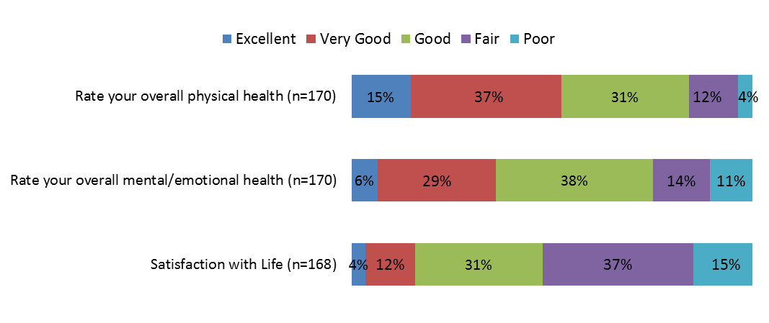

Quality of Life Item-Level Responses
Item-level aggregate responses are presented below. The survey provided members with a set of statements covering a variety of domain/areas. Members were asked to respond using a 5-point Likert scale (strongly disagree to strongly agree). For ease of display, responses were collapsed into 3 points (strongly agree/agree – not sure – disagree/strongly disagree). The number of members responding to each question is shown in parentheses.

Physical Health and Daily Activities
In areas of physical health, the majority of members reported experiencing physical pain on a regular basis as well as low energy and difficulty sleeping. Nearly half reported that physical problems make it difficult to do daily tasks. However, the majority of members reported favorably about doing things to stay fit and healthy; not needing help to get around; and that their everyday tasks get done.
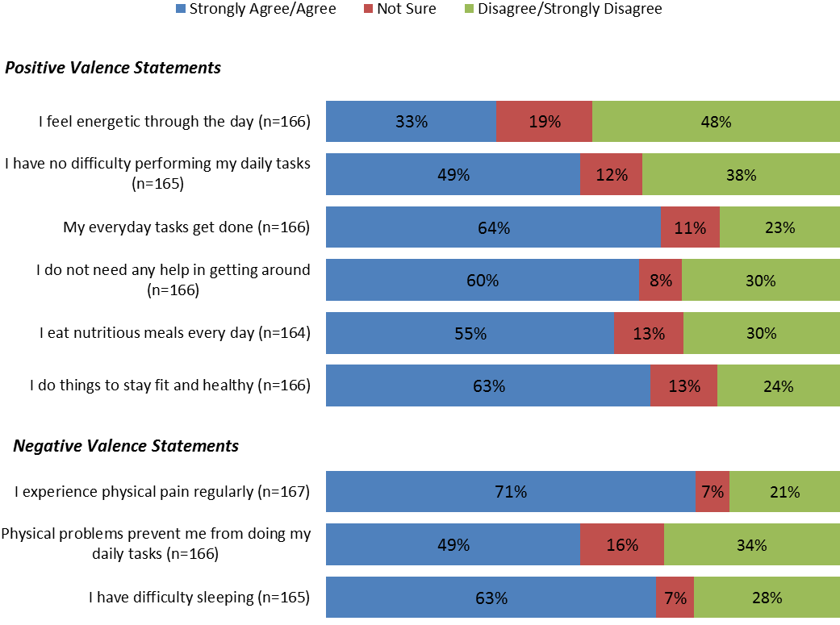

General Well-being
The majority of members reported positively about their general wellbeing. Members mostly strongly agreed/agreed that they enjoy life and are living life to its fullest; that they feel their life has purpose; and that they have an upbeat and positive attitude. 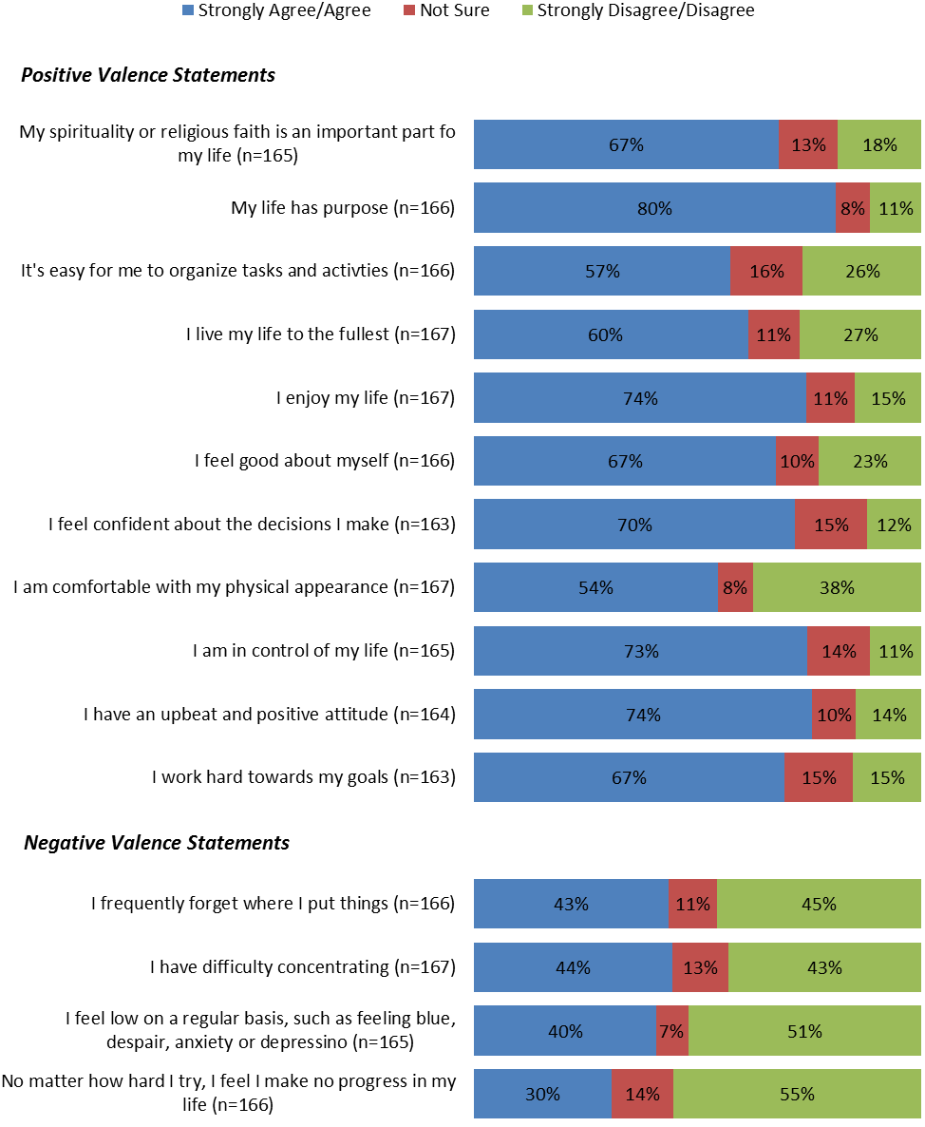

Relationships with Other People
Members mostly strongly agreed/agreed that they have good relationships with their health care providers, friends and family members. The majority reported getting together with people on a regular basis. However, close to a third reported feeling isolated and nearly half would like to have more support from other people.
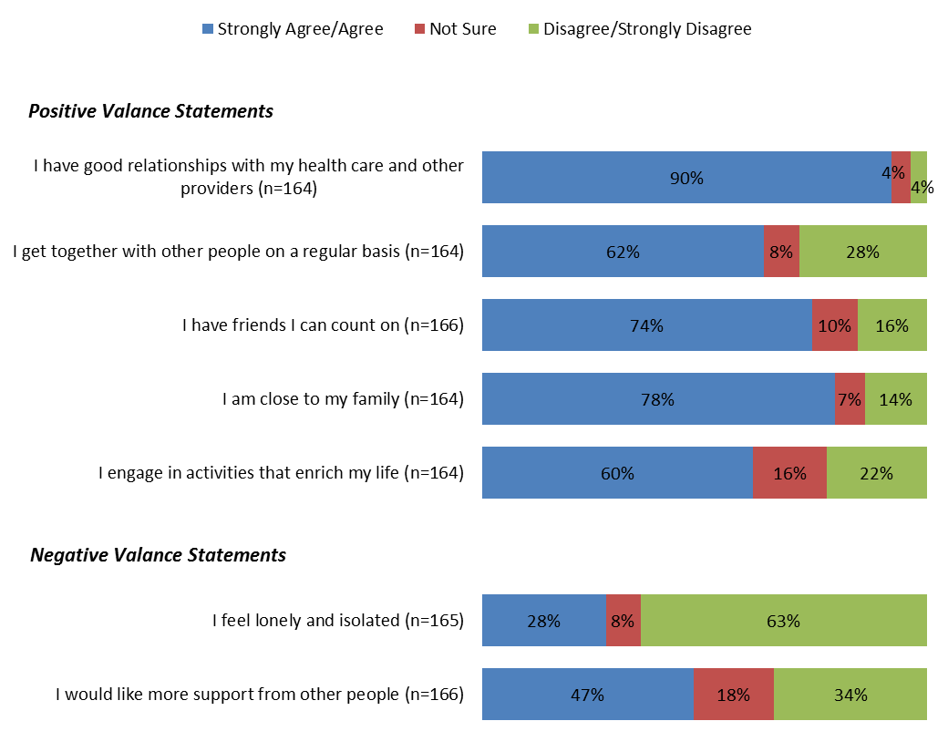

Other Areas of Life
The QoL Survey also asked members about other area of life including financial wellbeing, ability to work, involvement in leisure activities, access to transportation, and being comfortable at home. The majority of members strongly agreed/agreed that they felt safe at home and were comfortable. A majority also strongly agreed/agreed that they have the transportation they need, and can easily get needed medical services. About half reported taking part in leisure activities. Conversely, a little more than half reported having financial troubles and more than 60% reported not being capable of work.
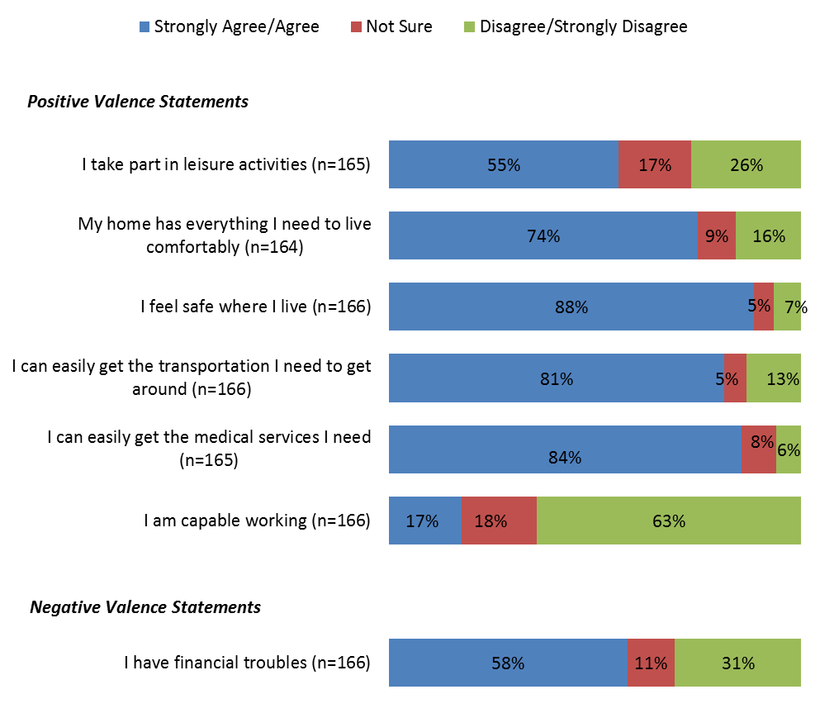

Help Doing Things
The last section of the survey asked members whether they need help doing things both at home and in the community. Members were asked to rate how much help they need (a lot, some, none). Those who answered ‘some’ or ‘a lot’ to these questions were asked two follow-up questions: 1) are you getting enough help; and 2) how satisfied are you with the help you get.

In the home:
The majority of members needing at least some help at home (n=102). Of those who reported needing help, half responded that they got enough and a little over a third reported getting some of what they need. A small percentage (10%) reported not getting any of the help they needed. However, the vast majority reported being very satisfied/satisfied with the help they received at home.

How much help to you need at home?  (n=163) | 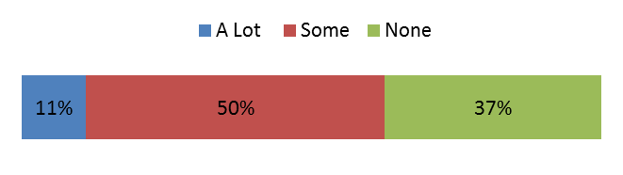
Are you getting enough help?  (n=102) | 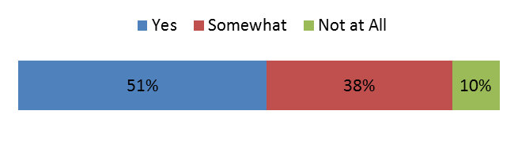
How satisfied are you with the help?  (n=91) | 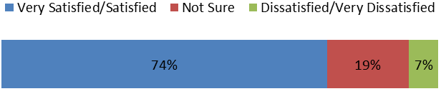

In the community:
Members were asked how much help they needed to do activities in the community, including both errands and social activities. The majority of members reported needing ‘some’ or ‘a lot’ of help in the community. Of those reporting that they need help, more than two-thirds reported that their needs were being completely or somewhat met. Nearly one-third reported that their needs were not met at all. In terms of satisfaction with help in the community, again findings were very positive.
How much help do you need to do things in the community (such as shopping, working, or socializing)?  (n=161) | 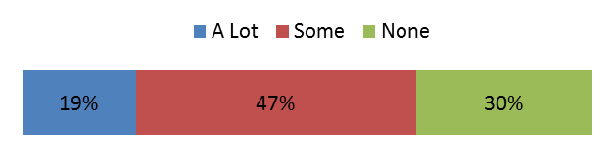
Are you getting the help you need to do things on the community?  (n=110) | 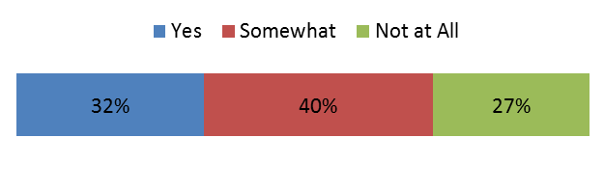
How satisfied are you with the help?  (n=79) | 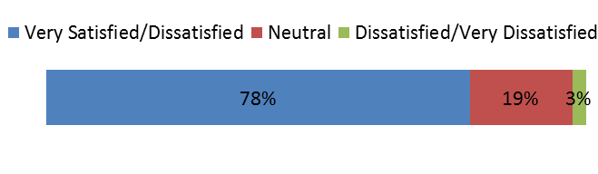

Respondent Profile
Table 1 below shows members’ self-reported demographic information. When reporting about disability or health condition, members were able to report more than one disability or health condition. More than half report having a physical/mobility or long-term illness and just under half reported a mental/psychiatric disability. The majority (82.6%) of members were 45 or older, male (54.5%), white (58.7%), non-Hispanic (78%) and heterosexual (86.8%). The majority of members hold a high school degree or higher (79.6%) and identified English as their primary language (77.3%). The percentage of members reporting working in the last 12 months was less than 20%; however of these members, three-quarters are currently working.
Table 1. Demographic Characteristics of members Responding to the One Care Quality of Life Survey (n=173)
Disability/Health Conditions
Reported conditions | Physical/mobility | 59.3
 | Long-term illness | 55.7
 | Mental/psychiatric | 44.3
 | Visual impairment/blindness | 22.2
 | Learning disability | 21.6
 | Hearing loss/deafness | 16.2
 | Developmental disability | 6.6
 | Alcohol or drug abuse | 6.0
 | Other | 38.3
Demographics
Homelessness | Homeless in the past 12 months | 6.0
Age | 21-34 | 1.8
 | 35-44 | 14.4
 | 45-54 | 33.5
 | 55-64 and over | 49.1
Gender | Male | 54.5
 | Female | 43.7
 | Transgender/intersex/other | 1.2
Sexual Orientation | Heterosexual | 86.8
 | Gay/Lesbian | 4.2
 | Bisexual | 0.6
 | Asexual | 1.2
Marital status | Single, never married | 37.1
 | Unmarried partner | 4.2
 | Married | 17.4
 | Widowed | 5.4
 | Divorced | 27.0
 | Separated | 6.6
Race | White | 58.7
 | Black/African American | 24.0
 | American Indian/Alaska Native | 4.8
 | Asian | 1.8
 | Native Hawaiian/Pacific Islander | 0.6
Ethnicity | Hispanic/Latino | 22.2
Primary Language Spoken at Home | English | 77.3
 | Spanish | 13.2
 | Vietnamese | 1.2
 | Other | 3.0
Education | Less than high school | 16.8
 | High school or GED | 43.7
 | Some college or more | 35.9
Employment | Worked for pay in last 12 months | 19.8
 | Currently working for pay (of above) | 75.8

Appendix I – Survey Response Rate and Final Disposition Summary
The survey response rate (29.3%) was calculated by dividing the total completed surveys by the total sample, excluding ineligible cases. Ineligible cases are sample members who are deceased or were not able to complete the survey due to a language barrier or a mental or physical reason. See the table below for a complete list of final disposition codes in total and by plan.
Final Survey Status/Disposition Codes
 | Total  Sample | Fallon  Total Care | Commonwealth Care Alliance | Tufts Health Plan – Network Health
Sample Counts | 600 | 200 | 200 | 200
Completed Interviews: | % | % | % | %
Mail | 11.5 | 11.5 | 12.5 | 10.5
CATI | 16.3 | 18.0 | 20.0 | 11.0
Partial Interview (All modes) | 1.0 | -- | 0.5 | 0.0
Total Completed Interviews | 28.8 | 29.5 | 33.0 | 24.0
Non-Interviews
Refused | 2.3 | 2.5 | 1.5 | 3.0
Unknown Eligibility:
No Reply | 22.0 | 25.5 | 19.5 | 21.0
Reached Answering Machine | 19.2 | 20.0 | 14.5 | 23.0
Wrong Telephone Number | 13.0 | 9.0 | 15.0 | 15.0
Busy | 5.0 | 4.5 | 4.0 | 6.5
Disconnected | 4.2 | 6.5 | 5.5 | 0.5
Bad Address and Wrong Telephone Number | 0.8 | 1.0 | 1.0 | 0.5
Respondent Not Available | 2.3 | 0.5 | 3.5 | 3.0
Reached Fax Machine | 0.8 | 0.5 | 0.5 | 1.5
Total Unknown Eligibility | 67.3 | 67.5 | 63.5 | 71.0
Ineligible:
Mental or Physical Incapacity | 1.0 | 0.5 | 1.0 | 1.5
Language Difficulty (other than Spanish) | 0.3 | -- | 0.5 | 0.5
Deceased | 0.2 | -- | 0.5 | --
Total Ineligible | 1.5 | 0.5 | 2.0 | 2.0
Total Non-Interviews | 71.2 | 70.5 | 67.0 | 76.0
Response Rate (Completed Interviews/Total Sample-Ineligible Sample) | 29.3 | 29.6 | 33.7 | 24.5
Total number of people with bad addresses* | 13.2 | 9.5 | 15.0 | 15.0
* Since people with a bad address or wrong telephone number could also be included in other disposition categories, these numbers are reported separately.

Appendix II – 2015 Quality of Life Survey

Young, S. L. & Bullock, W. A. (2003). The Mental Health Recovery Measure. University of Toledo, Department of Psychology, Toledo OH: Author.
University of Washington (1997). World Health Organization Quality of Life Scale (WHOQOL-BREF). Seattle, WA: Author.

