
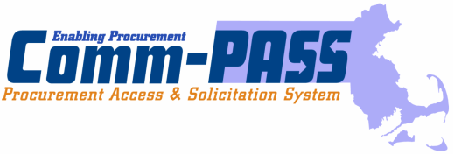
The Commonwealth of Massachusetts

Executive Office for Administration and Finance

Operational Services Division

One Ashburton Place, Boston, MA 02108-1552

Deval L. Patrick
Governor

Timothy P. Murray
Lieutenant Governor
http://www.comm-pass.com

Leslie A. Kirwan
Secretary

Ellen M. Bickelman
State Purchasing Agent

April 11, 2008

Dear UFR Preparers and Users of the UFR eFiling System:

In accordance with the Fair Information Practices Act (FIPA) pursuant to M.G.L. Chapter 66A, the Operational Services Division (OSD) is providing notification to all Uniform Financial Statement and Independent Auditor’s Report (UFR) preparers and Users of the Internet–based UFR eFiling System and database that certain provisions of FIPA prohibit the use of an individual’s social security number as an identifying number on any of the statements, notes or schedules contained in a UFR filing or in a profile for access to the UFR eFiling System. Excluded from this prohibition are identifying numbers that are currently contained in a “public record” as defined M.G.L. Chapter 4 sec. 7.

The Operational Services Division’s UFR filing guidance has never recommended the use of an individual’s social security number as either an identifying number in a UFR filing or as a login number for creating a User’s profile in the UFR eFiling System. In fact, OSD has requested that all contractors and independent auditors (CPAs) use their Federal Employee Identification Number (FEIN#) when setting up a profile in the UFR eFiling System.

However, to ensure OSD and the UFR eFiling System is fully compliant with the provisions of FIPA we are requesting that contractors and independent auditors review their profile in the UFR eFiling System and their UFR filings to ensure that their system login number or identifying number on a UFR filing is not their social security number.

OSD is nearly certain that all contractors filing UFRs with the Division are correctly using their FEIN# on both the system profile and their UFR filings. However, OSD doesn’t have the same level of confidence with respect to certain independent auditors in particular those CPAs that are sole proprietors who may have inadvertently utilized their social security numbers either in setting up the eFiling profile or on a UFR filing.

In addition, OSD has some concerns that human service contractors required to complete the Subcontracted Direct Care Section of the UFR supplemental schedule(s) B_PSI and the Subcontractor Expense Detail Addendum may have inadvertently disclosed social security numbers for their subcontractors.

Page 2
April 11, 2008

Therefore, OSD is requesting that all contractors and independent auditors that determine they may have used a social security number as an identifying number in the UFR eFiling System or in a UFR filing either for their organization or for a subcontractor immediately contact OSD so the Division may take the appropriate corrective actions. OSD requests that any responses to this notification should be emailed to Terrence.McCarthy@state.ma.us.

The Operational Services Division appreciates your cooperation in this effort to ensure personal social security numbers are not disclosed through the UFR eFiling System.

Sincerely,

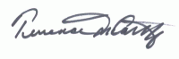

Terrence McCarthy
Operational Services Division
Director of Audit

cc: Ellen Bickelman, State Purchasing Agent
Ellen Phillips, Deputy Purchasing Agent
William McAvoy, OSD Legal Counsel
Nancy Burke, OSD Director MIS

input.doc

