2020  October  Fire Prevention Month | 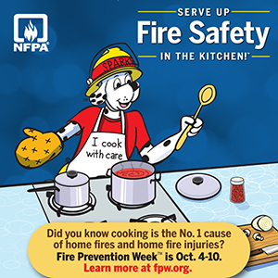
Sunday | Monday | Tuesday | Wednesday | Thursday | Friday | Saturday
 |  |  |  | 1 | 2 | 3
 | Get Ready for Fire Prevention Week! | Replace batteries in smoke or CO alarms unless they are the 10-year sealed alarms. | If you only have a few alarms, install more to keep your family safe. | Replace any alarms that are more than 10 years old. | Help an older adult check their alarms, too. | Use battery operated candles in pumpkins and other Halloween decorations.
4 | 5 | 6 | 7 | 8 | 9 | 10
Fire Prevention Week  Serve up Fire Safety in the Kitchen | Teach small children to stay 3 ft. away from the stove. Take 3 giant steps away from the oven. | Turn pot handles in when cooking. If a fire occurs, cover the pan, turn off the stove and leave the pan on the stove. | Stay in the kitchen when cooking. Stand by your pan! | Keep the cooking area free of clutter. | Wear short or tight fitting clothes when cooking. | Practice putting a lid on cooking fires.
11 | 12 | 13 | 14 | 15 | 16 | 17
Press the test button on smoke alarms so everyone recognizes what it sounds like. | Make a home escape plan with your family. | Make sure all matches and lighters are away from children’s reach. | Remind family members where their meeting place is. | Reinforce “Get Out Stay Out.” | Practice crawling low in smoke. | Make sure all house guests know your home escape plan.
18 | 19 | 20 | 19 | 22 | 23 | 24
Practice your home escape plan at night when children are asleep. | Do a hunt for home hazards. | Practice calling 9-1-1 to report an emergency | Practice Stop, Drop, Cover and Roll. | Blow out all candles before leaving any room. | Make sure your water heater is set at 120 degrees Fahrenheit. | Try your costume on before Halloween. It should be light colored and short enough so you won’t trip.
25 | 26 | 27 | 28 | 29 | 30 | 31
Make sure Halloween costumes are flame retardant and are reflective. | Make sure your house number is visible from the street. replace. | Remind children to never run out between parked cars and to cross only at the lines. | Let children know what time to be home. | Remind children to stay in a group when out for Halloween. | Remind children to cross at the crosswalk. | Halloween  Small children should be with adults when trick or treating.
Your Department Name Here 