One Care Early Indicators Project Quarterly Report
First Quarter 2014
Introduction
The data in this report reflects One Care activity through the beginning of April, 2014. For purposes of this dashboard, MassHealth has selected data of particular interest to stakeholders and data that demonstrate, at a high level, some emerging trends in One Care. Greater detail and additional data are available in the monthly Early Indicators Project data reports on the One Care website.
Figure 1. Trends in monthly One Care enrollment activity
Enrollment Summary
As of April 1, 2014, total enrollment in One Care is 13,191.
Passive enrollment rounds 1 and 2
In Figure 1, the spikes in monthly enrollment at January and April 2014 reflect the first two rounds of passive enrollment, on top of self-enrollments in those months. Passive enrollment is MassHealth’s process of assigning, notifying, and automatically enrolling someone in a One Care plan (also referred to as “auto-assignment”).
Passive enrollment currently happens in large groups, rather than on a rolling basis. In January, 4,187 individuals were included in the first group of passive enrollments; in April, 3,411 individuals were passively enrolled.

Rating Category Enrollment Data. One Care enrollees are categorized based on anticipated or actual service needs.
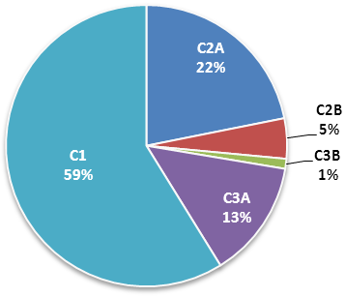
One Care rating categories are as follows:
Figure 2. Total One Care enrollment
by rating category [N = 13,191]

- F1: Residing in an institutional setting
- C3B: Very high community long term services and supports needs
- C3A: High community long term services and supports needs
- C2B: Very high community behavioral health services needs
- C2A: High community behavioral health services needs
- C1: Other individuals living in the community

Enrollment penetration refers to the percent of individuals who are enrolled out of the total number eligible in a given cohort. In the different rating categories, enrollment penetration is currently highest in C2A (18.1%) and lowest in F1 (1.8%). (Figure 3.)

Figure 2. Enrollment penetration by rating category
The F1 rating category represents <1%
of total enrollments in One Care, and therefore does not appear in this chart.

Geographic Enrollment Data
Figure 3. Total One Care enrollment (N=13,191)
One Care is available in nine Massachusetts counties. The three One Care plans each serve a different number of counties. Figure 4 illustrates the geographic distribution of One Care enrollments by county.
In the counties where One Care is available, between 2.5% and 28.0% of eligible MassHealth members were enrolled in One Care as of April 1. The greatest enrollment penetration rate (percent enrolled out of the eligible population) is in Worcester County, where all three One Care plans are available. The overall enrollment penetration rate for One Care is 13.8%.

Counties with ≥2 One Care plans; enrollment includes auto-assigned members

Figure 4. Enrollment penetration by county

There is no auto-assignment in counties with 1 One Care plan

Monthly One Care Plan Transitions and Disenrollments
Figure 6 shows the percentage of One Care members who leave plans either to enroll in a different One Care plan or who disenroll from One Care altogether. Notably, the rate of disenrollment has dropped by well over half since the program began. In October, approximately ten percent of enrolled One Care members disenrolled; in March 2014, the rate was about four percent. Since November, the rate of enrollees switching to a different One Care plan has been less than one percent.
Figure 5. Disenrollments from and plan transfers within One Care

Opt-outs
Figure 6. Monthly Opt-out activity
Figure 7 shows the total number of “active opt-outs.” These are individuals who have indicated to MassHealth since September 2013 that they do not want to participate in One Care, remain eligible, and have not subsequently elected to enroll in a One Care plan.
Understanding the opt-out option: A MassHealth member need not be enrolled in One Care (voluntarily or through the auto-assignment process) to opt out. For instance, members who live in counties with passive enrollment will not be auto-assigned if they have opted out. The opt-out numbers in Figure 7 include opt-outs by members who were not enrolled at the time they opted out and by members who were enrolled at the time they opted out.
Note the spike in opt-outs in October 2013: MassHealth began mailing One Care materials in early September to approximately 82,000 eligible members. The packet included an Enrollment Decision Form that members could use to enroll in or opt out of One Care. At the same time, the One Care plans began their marketing campaigns.
Monitoring opt-out trends by rating category: MassHealth is interested to determine whether individuals with similar types of needs are disproportionately opting out of One Care. To date, this does not appear to be happening. While there is some variation in the rate of opt-outs across the rating categories, the rates are comparable to the overall rate of opt-outs by the total eligible population (see Figure 8). Note that until a member enrolls in One Care and has a comprehensive assessment, the rating category assigned to that member by MassHealth is a proxy. Consequently, the rating categories of members who opt out are generally only proxies.
- F1: Residing in an institutional setting
- C3B: Very high community long term services and supports needs
- C3A: High community long term services and supports needs
- C2B: Very high community behavioral health services needs
- C2A: High community behavioral health services needs
- C1: Other individuals living in the community

Figure 7. Opt-outs as percent of eligible members in rating category
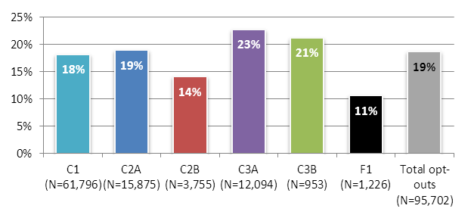
MassHealth established the One Care Early Indicators Project (EIP) in response to stakeholder input as the One Care program launched in September 2013. A nine-member workgroup steers the EIP, and has met on a bi-weekly basis since October 2013. The EIP Workgroup is comprised of four members of the One Care Implementation Council, three MassHealth staff, and two UMass Medical School researchers.
For additional information from the EIP, including monthly data reports and survey and focus group reports, please visit the Early Indicators Project page on the One Care website: www.mass.gov/masshealth/onecare.
For assistance understanding or interpreting the data in this report, please email MassHealth at OneCare@State.MA.US.

