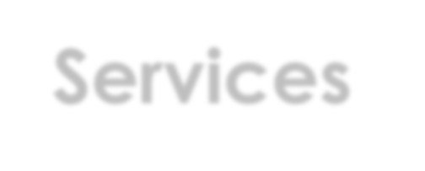Executive Office of Health & Human Services
and Executive Office of Education Highlights

FY2020 Budget Proposal February 6, 2019

1

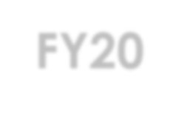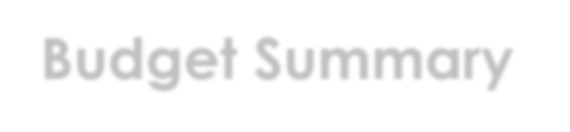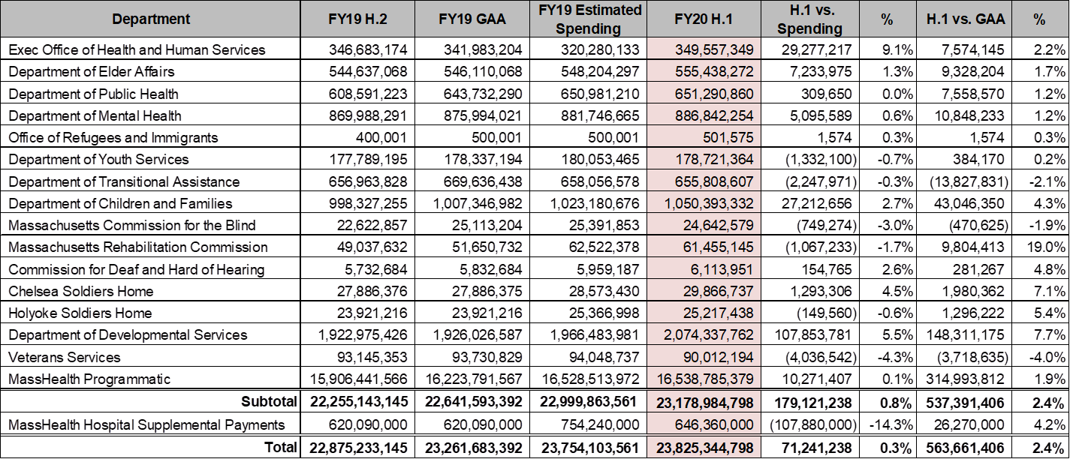Secretariat FY20 Budget Summary – Spending

2

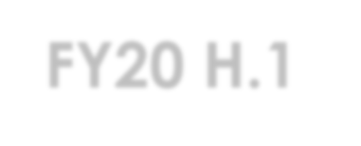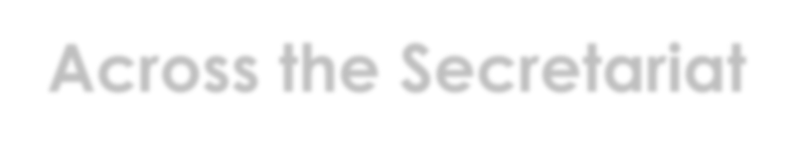FY20 H.1 – Across the Secretariat

House 1 (H.1) Budget
- H.1 funds HHS at $23.178 B, a $179.1 M (.8%) increase above FY19 spending and a
$537.3 M (+2.4%) increase above FY19 GAA

H.1 Budget Highlights
- Maintains MassHealth program without reducing benefits
- Increases funding to combat opioid epidemic by an additional $23.8 M over FY19 across EOHHS Agencies
- Expands the eligibility of the Medicare Savings Program (MSP) which will reduce out of pocket medical expenses for seniors by generating more than $100 M in Medicare prescription drug subsidies at a $7 M net annual cost to the Commonwealth
- Fully funds Turning 22 classes at DDS and smaller disability agencies
- Maintains MRC core services despite reduction in federal funding and federal audit
findings (audit dates October 1, 2013 through September 30, 2016)
- Chapter 257 funding for human service provider rate review
- Revises DTA benefit structures to better align with other public benefit programs, simplify the grant structure, lifts the family cap and increase incentives to work
- Increases Safe and Successful Youth Initiative to include young women and high need
communities
- Increases funding for Sexual Assault and Domestic Violence prevention
- Increased rates for chapter 766 schools by $2.2 M (2.63%)

Wednesday, October 16, 2019 3

Department of Developmental Services (DDS)

Agency Summary
DDS creates opportunities for individuals with intellectual disabilities to participate in and contribute meaningfully to their communities. DDS provides specialized services and supports approximately 41,000 adults and children with intellectual and developmental disabilities including those with Autism Spectrum Disorder. DDS also provides residential services to individuals with acquired brain injury. Services include day and employment, residential, family support, and transportation. Services through state operated facilities, 261community-based state operated program, and with more than 255 private provider agencies.

House 1 (H.1) Budget
The H.1 budget funds DDS at $2.074 B, a $107.9 M (+5.5%) increase above FY19 spending and a $148.3 M (+7.7%) increase above FY19 GAA

H.1 Budget Highlights
  - Turning 22 – H.1 includes significant investments for the Department’s Turning 22 population for the third year in a row
    - Fully funds services for nearly 1,300 members of FY19 Turning 22 class ($25 M)
    - $67.3 M increase to fund services for1,171 members aging out of the Turning 22 class

Wednesday, October 16, 2019 4

Department of Developmental Services (DDS)

H.1 Budget Highlights (cont.)

$28.5 M increase to cover changing needs within the existing DDS client
base – caused by increasing acuity and aging caretakers

- $4.2 M increase for an additional day of residential and day and work services due to the leap year

- Includes an additional $4 million increase ($10.5M total funding) at the Department of Elementary and Secondary Education to increase available capacity in its highly successful existing partnership program with DDS to support youth at home in their communities. The program will support approximately 264 new, 760 total youth and their families

Wednesday, October 16, 2019 5

Notable Investments Across the Budget

FY20 Chapter 70 increase of more than $200M. Building on FY18-19 reforms involving healthcare and English Learners increases Foundation Budget by over $1 B (in current dollars) for a total of $3.3 B in FY26.

- Phases in an increase to the Foundation Budget increment for low-income students in the highest poverty districts by more than $600/pupil, plus
$180/pupil in supplemental funds for low-income districts with the highest English Language Learner populations . Over 85 percent of Chapter 70 increase in FY20 goes to high-need districts.

- Establishes $50 M School Improvement Trust Fund of to be committed over 3 years by Commissioner of Elementary and Secondary Education to support improvement in low-performing schools. Additionally, H1 includes $26.5 M in targeted assistance funds, an increase of $18.9 M over FY19 GAA, and is a result of consolidation with Expanded Learning Time and FY18 one-time funding.

Wednesday, October 16, 2019 6

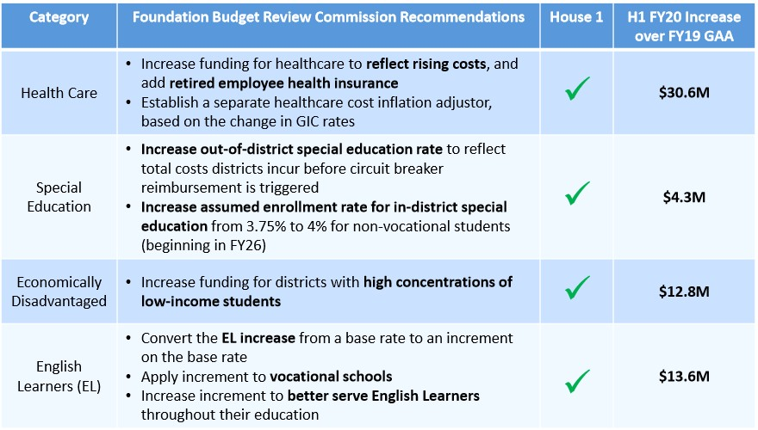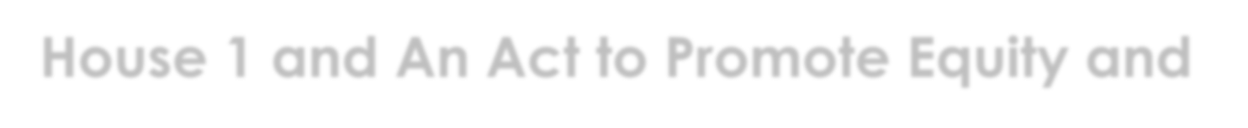House 1 and An Act to Promote Equity and Excellence in Education

7

