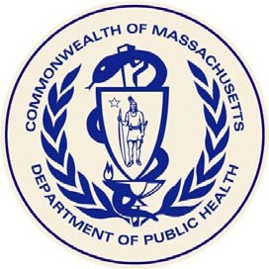

**Massachusetts Department of Public Health**

**Fish Consumption Advice  
for Marine and Fresh Water Bodies**

# Guidelines for children under 12 years old; and people who are pregnant, nursing, or may become pregnant:

**Do Not Eat:**

* Freshwater fish caught in streams, rivers, lakes, and ponds in Massachusetts
  + See more specific consumption advice here (<https://www.mass.gov/lists/fish-consumption-advisories>) for certain freshwater bodies that have been tested. You may also call the Bureau of Climate and Environmental Health at 617-624-5757.
* Bluefish caught off the Massachusetts coast
* Lobsters, flounder, soft-shell clams and bivalves from Boston Harbor

**Safe To Eat:**

* Fish that are stocked in streams, rivers, lakes, and ponds in Massachusetts, with the exception of waterbodies where there are consumption advisories for per- and polyfluoroalkyl substances (PFAS)
  + See waterbody-specific consumption advice here: <https://www.mass.gov/lists/fish-consumption-advisories>

# Guidelines for everyone, including the groups listed above:

**Do Not Eat:**

* Fish, shellfish, or lobsters from Area I of New Bedford Harbor
* Lobsters or bottom feeding fish from Area II of New Bedford Harbor
* Lobsters from Area III of New Bedford Harbor
* Lobster tomalley

# A varied diet, including safe fish, will lead to good nutrition and better health.

|  |
| --- |
| For additional advice about safe fish consumption, please visit:[www.fda.gov/fishadvice](http://www.fda.gov/fishadvice) and [www.epa.gov/fishadvice](http://www.epa.gov/fishadvice) |

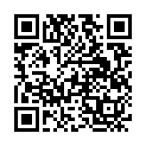

**DPH Fish Consumption**

**Advisory website**

**For information on Fish Consumption Advisories, please scan the QR codes from a mobile device.**

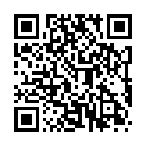

**EPA Choose Fish and Shellfish Wisely website**

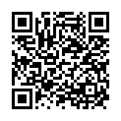

**FDA Advice**

**about Eating Fish website**

Revised 2024