Emerging Contaminant Surveillance: PFAS in Surface Water and Fish

Results from Cape Cod Pilot Study November 1, 2021

Marc A. Nascarella, MS, PhD, CPH
Director, Environmental Toxicology Program
Bureau of Environmental Health

Massachusetts Department of Public Health

DPHToxicology@mass.gov ||www.mass.gov/dph

Recreational Waterbody Focus

- 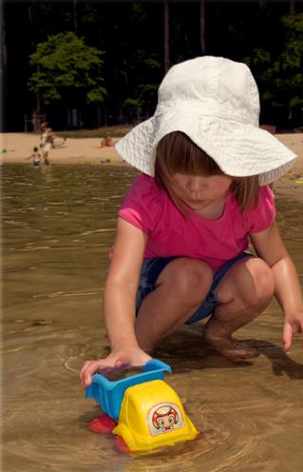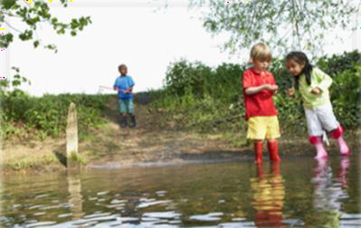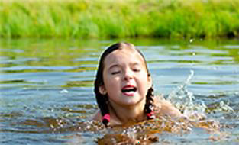Recreational waterbodies that are used for swimming as public and semi-public beaches are regulated by MDPH.

- Two types of “beaches”
included in MDPH regulations:
  - Public ― open to general public
(e.g., town and state beaches)
  - Semi-public ― open to individuals through a common access (e.g., hotels, condo associations, camps)

2

40 PFAS Analytes Included in this Assessment

Perfluorobutanoate (PFBA) | 6:2 fluorotelomersulfonate (6:2 FTS)
Perfluoropentanoate (PFPeA) | 8:2 fluorotelomersulfonate (8:2 FTS)
Perfluorohexanoate (PFHxA) Perfluoroheptanoic acid (PFHpA) | N-Methylperfluorooctanesulfonamidoacetic acid (N-MeFOSAA)
 | N-Ethylperfluorooctanesulfonamidoacetic acid (N-EtFOSAA)
Perfluorooctanoate (PFOA) | Perfluorooctanesulfonamide (PFOSA)
Perfluorononanoate (PFNA) | N-Methylperfluorooctanesulfonamide (N-MeFOSA)
Perfluorodecanoate (PFDA) Perfluoroundecanoate (PFUnA) | N-Ethylperfluorooctanesulfonamide (N-EtFOSA)
 | N-Methylperfluorooctanesulfonamidoethanol (N-MeFOSE)
Perfluorododecanoate (PFDoA) | N-Ethylperfluorooctanesulfonamidoethanol (N-EtFOSE)
Perfluorotridecanoate (PFTrDA) | Perfluoro-2-propoxypropanoate (HFPO-DA)
Perfluorotetradecanoate (PFTeDA) | 4-dioxa-3H-perfluorononanoate (ADONA)
Perfluorobutanesulfonate (PFBS) | 9-chlorohexadecafluoro-3-oxanonane-1-sulfonate (9Cl-PF3ONS)
Perfluoropentanesulfonate (PFPeS) | 11-chloroeicosafluoro-3-oxaundecane-1-sulfonate (11Cl-PF3OUdS)
Perfluorohexanesulfonate (PFHxS) | 3:3 perfluorohexanoic acid (3:3 FTCA)
Perfluoroheptanesulfonate (PFHpS) | 5:3 perfluorooctanoic acid (5:3 FTCA)
Perfluorooctanesulfonate (PFOS) | 7:3 perfluorodecanoic acid (7:3 FTCA)
Perfluorononanesulfonate (PFNS) | Perfluoro(2-ethoxyethane)sulfonic acid (PFEESA)
Perfluorodecanesulfonate (PFDS) | Perfluoro-4-methoxybutanoate (PFMBA)
Perfluorododecanesulfonate (PFDoS) | Perfluoro-3-methoxypropanoate (PFMPA)
4:2 fluorotelomersulfonate (4:2 FTS) | Perfluoro-3,6-dioxaheptanoate (NFDHA)

3

PFAS concentrations
evaluated in surface water
PFAS concentrations
evaluated in fish

Collection of Surface Water and Fish Samples on Cape Cod

- 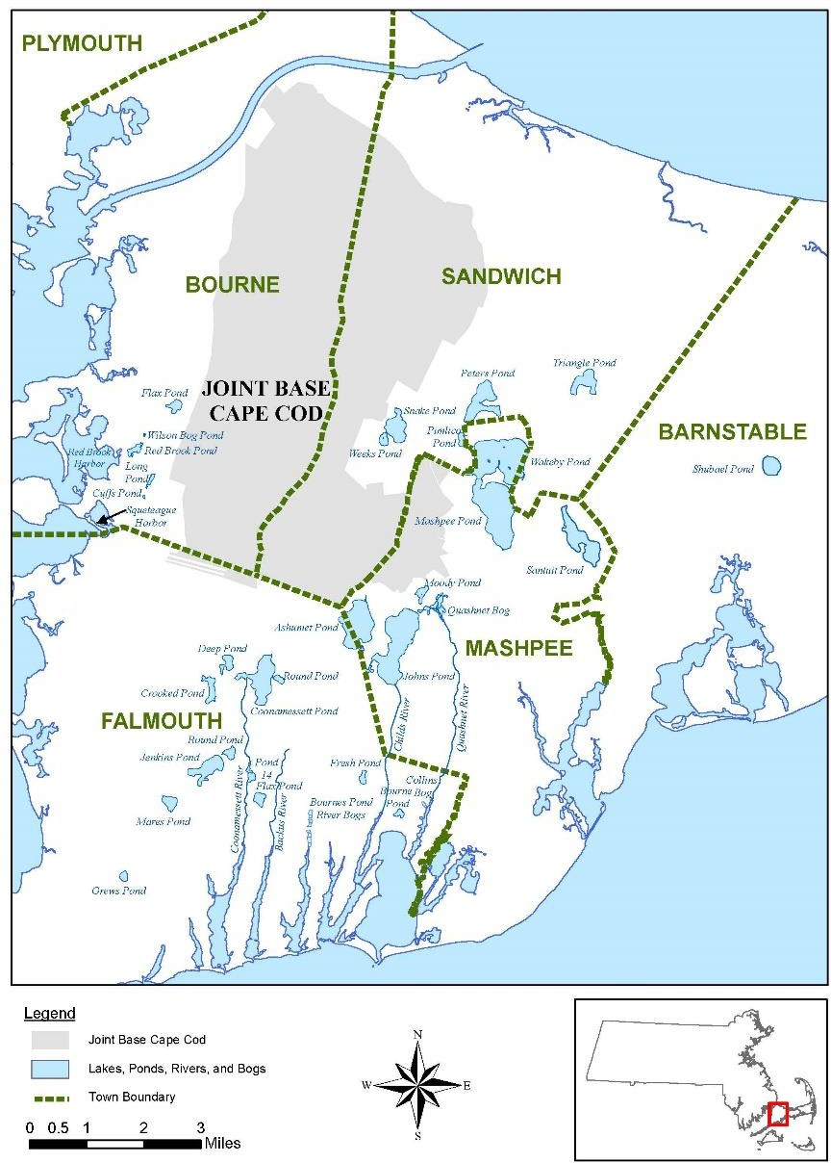Permitted public or semi-public bathing
beaches (n = 16)
Fish & Water Samples Collected
Water Samples Collected

4
Sampling Locations
Location | Waterbody | # of Water Samples | # Fish Samples
Barnstable | Shubael Pond | 1 | -
 | Squeteague Harbor | 1 | -
Bourne | Hen Cove | 1 | -
 | Flax Pond (Picture Lake) | 1 | 9
 | Snake Pond | 1 | -
Sandwich | Peter's Pond | 2 | -
 | Triangle Pond | 1 | -
 | Santuit Pond | 1 | -
Mashpee | Mashpee-Wakeby Pond | 2 | 16
 | Johns Pond | 1 | 17
 | Crooked Pond | 1 | -
 | Round Pond | 1 | -
Falmouth | Flax Pond | 1 | -
 | Jenkins Pond | 2 | 5
 | Mares Pond | 1 | -
 | Grews Pond | 1 | 4

Surface Water Collection & Analysis

DPH conducted surface water sampling at 16 waterbodies on Cape Cod (May 2021)
- Waterbodies selected based on having permitted public or semi-public bathing beaches in area where PFAS contamination was previously identified and DPH asked to prepare annual recreational use of waterbody fact sheet
- A total of 20 surface water samples collected (grab method, depth 1 to 1.5 feet) and analyzed for 40 PFAS.

Sampling conducted using PFAS-specific sample collection and handling protocol
- Only PFAS-free materials used at all points of sample collection and decontaminated sampling equipment
prior to mobilization and between sampling sites
- Samples collected in HDPE containers
- Collected two field duplicate samples and two field blanks per field day
- Completed and tracked chain-of-custody forms and stored and shipped samples on ice

Samples analyzed by SGS AXYS Analytical Services (British Columbia, Canada)
- SGS AXYS Method MLA-110 Rev. 02 Ver. 08, targets all PFAS from EPA Method 537.1 and Method 533
(Reporting Limit = 0.4-1.6 ng/L water).

Surface Water Results: PFAS Analytes
(ng/L)
Analyte Short Name | Frequency of Detection | Min | Max | Average
PFAS6 Sum* | 100% | 0.57 | 168.20 | 20.27
PFBA | 30% | <RL | 5.30 | 0.89
PFPeA | 65% | <RL | 12.70 | 2.28
PFHxA | 100% | 0.46 | 17.00 | 2.84
PFHpA | 90% | <RL | 9.57 | 1.79
PFOA | 90% | <RL | 18.40 | 3.14
PFNA | 30% | <RL | 24.90 | 2.58
PFDA | 10% | <RL | 0.46 | <RL
PFUnA | 0% | <RL | <RL | <RL
PFDoA | 0% | <RL | <RL | <RL
PFTrDA | 0% | <RL | <RL | <RL
PFTeDA | 0% | <RL | <RL | <RL
PFBS | 85% | <RL | 5.48 | 1.30
PFPeS | 10% | <RL | 6.06 | 0.59
PFHxS | 80% | <RL | 55.30 | 5.93
PFHpS | 10% | <RL | 1.02 | <RL
PFOS | 75% | <RL | 64.30 | 6.79
PFNS | 0% | <RL | <RL | <RL
PFDS | 0% | <RL | <RL | <RL
PFDoS | 0% | <RL | <RL | <RL

Analyte Short Name | Frequency of Detection | Min | Max | Average
4:2 FTS | 0% | <RL | <RL | <RL
6:2 FTS | 5% | <RL | 3.14 | <RL
8:2 FTS | 0% | <RL | <RL | <RL
PFOSA | 5% | <RL | 0.45 | <RL
N-MeFOSA | 0% | <RL | <RL | <RL
N-EtFOSA | 0% | <RL | <RL | <RL
MeFOSAA | 0% | <RL | <RL | <RL
EtFOSAA | 0% | <RL | <RL | <RL
N-MeFOSE | 0% | <RL | <RL | <RL
N-EtFOSE | 0% | <RL | <RL | <RL
HFPO-DA | 0% | <RL | <RL | <RL
ADONA | 0% | <RL | <RL | <RL
9Cl-PF3ONS | 0% | <RL | <RL | <RL
11Cl-PF3OUdS | 0% | <RL | <RL | <RL
3:3 FTCA | 0% | <RL | <RL | <RL
5:3 FTCA | 0% | <RL | <RL | <RL
7:3 FTCA | 0% | <RL | <RL | <RL
PFEESA | 0% | <RL | <RL | <RL
PFMPA | 0% | <RL | <RL | <RL
PFMBA | 0% | <RL | <RL | <RL
NFDHA | 0% | <RL | <RL | <RL

Analysis used accredited SGS AXYS Method MLA-110 Rev. 02 Ver. 08, which targets all PFAS from EPA Method 537.1 and Method 533; Reporting Limit (RL) = 0.4-1.6 ng/L water

PFAS compared to DPH screening value

Surface Water Results: PFAS Sum6 per Waterbody

(ng/L)

Waterbody | PFHpA | PFOA | PFNA | PFDA | PFHxS | PFOS | PFAS6 Sum
Crooked Pond | 0.744 | 1.25 | <RL | <RL | 0.461 | <RL | 2.46
Flax Pond | <RL | 0.622 | <RL | <RL | 0.626 | <RL | 1.25
Grews Pond | 1.08 | 2.12 | 0.621 | <RL | <RL | 0.538 | 4.36
Hen Cove | <RL | <RL | <RL | <RL | 1.08 | 3.48 | 4.56
Jenkins Pond (N) | 0.554 | 1.45 | <RL | <RL | 0.497 | 0.510 | 3.01
Jenkins Pond (NE) | 0.736 | 1.19 | <RL | <RL | 0.499 | 0.624 | 3.05
 | 0.742 | 1.56 | <RL | <RL | 0.561 | 0.676 | 3.54
Johns Pond (NE) | 9.57 | 17.40 | 24.9 | <RL | 55.3 | 51.8 | 159.0
Johns Pond (SE) | 8.90 | 18.40 | 24.2 | <RL | 52.4 | 64.3 | 168.2
 | 8.82 | 15.50 | 24.4 | <RL | 52.9 | 53.7 | 155.3
Mares Pond | 0.568 | <RL | <RL | <RL | <RL | <RL | 0.568
Mashpee-Wakeby Pond (S) | 0.703 | 0.757 | <RL | <RL | 0.711 | 0.591 | 2.76
Mashpee-Wakeby Pond (SW) | 0.732 | 0.943 | <RL | <RL | 0.897 | 0.537 | 3.11
Peters Pond (N) | 1.54 | 2.17 | <RL | <RL | 0.636 | 0.578 | 4.92
Peters Pond (S) | 1.63 | 2.13 | 0.490 | 0.42 | 0.795 | 1.95 | 7.41
 | 1.71 | 2.63 | 0.468 | <RL | 0.971 | 1.80 | 7.58
Picture Lake (Flax Pond) | 1.88 | 4.29 | <RL | <RL | 1.64 | 1.66 | 9.47
Round Pond | 0.725 | 1.26 | <RL | <RL | 0.599 | 0.616 | 3.20
Santuit Pond | 0.562 | 1.46 | <RL | <RL | 0.947 | 0.542 | 3.51
Shubael Pond | 0.916 | 1.79 | <RL | <RL | 0.733 | 0.484 | 3.92
Snake Pond | 0.680 | 0.720 | <RL | <RL | <RL | <RL | 1.40
Squeteague Harbor | 0.723 | 2.62 | 0.959 | 0.46 | 0.748 | 7.67 | 13.2
 | 0.568 | 2.79 | 1.03 | 0.41 | 0.727 | 8.55 | 14.1
Triangle Pond | 3.46 | 2.25 | 0.421 | <RL | <RL | <RL | 6.13
Analysis used accredited SGS AXYS Method MLA-110 Rev. 02 Ver. 08, which targets all PFAS from EPA Method 537.1 and Method 533; Reporting Limit (RL) = 0.4-1.6 ng/L water

Interpretation of Surface Water Data

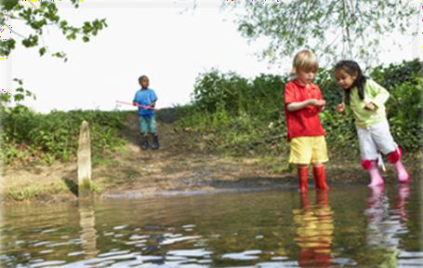PFAS concentrations are evaluated using a two-step process:
- Surface water levels are compared to DPH’s screening value of 23 ng/L, which is used to indicate when unlimited swimming by the most sensitive person would be unsafe.
  - Screening value is calculated using reasonable maximum estimates of exposure, and the toxicity criterion for PFOS (i.e., the most potent PFAS). If the surface water concentration of PFOA, PFNA, PFHxS or PFOS exceeds this screening value, then:
- A risk assessment is conducted. The assessment is based on realistic estimates of exposure such as time spent swimming, or amount of water ingested while swimming.
  - The risk assessment is conducted for all PFAS for

Surface Water Results

- PFAS were detected in all 16 waterbodies

- Number of PFAS analytes detected at each waterbody:
- Average: 7 compounds
- Range: 2 – 11 compounds
- Max # of detections: John’s Pond (11 compounds)

- Only one waterbody, John’s Pond, had levels that exceeded screening
value of 23 ng/L (159 and 162 ng/L) and required a risk assessment.

- Following risk assessment, all 16 waterbodies found safe for recreational activities such as swimming, wading, and boating.

Collection of Fish Samples on Cape Cod

- 5 of 16 waterbodies were sampled for fish,
resulting in collection of 51 fish (total)

Fish & Water Samples Collected

Water Samples Collected

10
Sampling Locations
Location | Waterbody | # of Water Samples | # Fish Samples
Barnstable | Shubael Pond | 1 | -
 | Squeteague Harbor | 1 | -
Bourne | Hen Cove | 1 | -
 | Flax Pond (Picture Lake) | 1 | 9
 | Snake Pond | 1 | -
Sandwich | Peter's Pond | 2 | -
 | Triangle Pond | 1 | -
 | Santuit Pond | 1 | -
Mashpee | Mashpee-Wakeby Pond | 2 | 16
 | Johns Pond | 1 | 17
 | Crooked Pond | 1 | -
 | Round Pond | 1 | -
Falmouth | Flax Pond | 1 | -
 | Jenkins Pond | 2 | 5
 | Mares Pond | 1 | -
 | Grews Pond | 1 | 4

Fish Collection & Analysis

DPH sampled fish from five waterbodies (May 2021)
- Sites selected from among the 16 waterbodies where surface water sampling was conducted
- Secured Scientific Collection Permit (152.21SCF, 5/17/21) and notified waterbody operators, MA Division of Fisheries and Wildlife, local police, and environmental police.

Employed three techniques for fish collections
- Electrofishing from a motorboat (Mashpee-Wakeby Pond and Johns Pond)
- Electrofishing from a modified cartop boat (Jenkins Pond, Grews Pond, and Flax Pond)
- Hook and line angling was used to supplement electrofishing (Jenkins Pond)

Fish were packed and shipped on ice to the contracted analytical laboratory
- Whole fish were wrapped in aluminum foil, placed in a plastic bag, frozen, and shipped on wet ice.
- Field blanks, collected at each site, consisted of aluminum placed in a plastic bag.
- Prior to analysis, SGS AXYS skinned, filleted, and homogenized the fish samples.
- Analysis used SGS AXYS Method MLA-110 Rev. 02 Ver. 08 which targets all PFAS from EPA Method
537.1 and Method 533 (Reporting Limit = 0.1 μg/kg tissue)

Fish Results: PFAS Analytes
(μg/kg)

Analysis used accredited SGS AXYS Method MLA-110 Rev. 02 Ver. 08, which targets all PFAS from EPA Method 537.1 and Method 533; Reporting Limit (RL) = 0.1 μg/kg tissue
PFAS compared to DPH screening value
Analyte short name | Frequency of Detection | Min | Max | Average
PFBA | 0% | <RL | <RL | <RL
PFPeA | 0% | <RL | <RL | <RL
PFHxA | 2% | <RL | 0.14 | <RL
PFHpA | 0% | <RL | <RL | <RL
PFOA | 7% | <RL | 0.31 | <RL
PFNA | 39% | <RL | 5.69 | 0.54
PFDA | 78% | <RL | 0.52 | 0.20
PFUnA | 94% | <RL | 1.45 | 0.39
PFDoA | 89% | <RL | 1.45 | 0.33
PFTrDA | 100% | 0.10 | 2.45 | 0.58
PFTeDA | 89% | <RL | 1.03 | 0.26
PFBS | 0% | <RL | <RL | <RL
PFPeS | 0% | <RL | <RL | <RL
PFHxS | 30% | <RL | 2.14 | 0.19
PFHpS | 24% | <RL | 0.42 | <RL
PFOS | 100% | 0.33 | 170 | 32.6
PFNS | 0% | <RL | <RL | <RL
PFDS | 2% | <RL | 0.15 | <RL
PFDoS | 0% | <RL | <RL | <RL

Analyte short name | Frequency of Detection | Min | Max | Average
4:2 FTS | 0% | <RL | <RL | <RL
6:2 FTS | 7% | <RL | 17.1 | 0.47
8:2 FTS | 0% | <RL | <RL | <RL
PFOSA | 20% | <RL | 0.82 | <RL
N-MeFOSA | 0% | <RL | <RL | <RL
N-EtFOSA | 0% | <RL | <RL | <RL
MeFOSAA | 0% | <RL | <RL | <RL
EtFOSAA | 0% | <RL | <RL | <RL
N-MeFOSE | 0% | <RL | <RL | <RL
N-EtFOSE | 7% | <RL | 3.30 | 0.11
HFPO-DA | 0% | <RL | <RL | <RL
ADONA | 0% | <RL | <RL | <RL
9Cl-PF3ONS | 0% | <RL | <RL | <RL
11Cl-PF3OUdS | 0% | <RL | <RL | <RL
3:3 FTCA | 0% | <RL | <RL | <RL
5:3 FTCA | 4% | <RL | 7.79 | 0.23
7:3 FTCA | 2% | <RL | 9.09 | 0.17
PFEESA | 0% | <RL | <RL | <RL
PFMPA | 0% | <RL | <RL | <RL
PFMBA | 0% | <RL | <RL | <RL
NFDHA | 0% | <RL | <RL | <RL

Fish Results: Average PFAS Concentrations in Fish (μg/kg)

Waterbody | Town(s) | Fish Species (# sampled) | PFOA | PFNA | PFHxS | PFOS
Flax Pond (Picture Lake) | Bourne | Bluegill (n=8) | <RL | <RL | <RL | 2.54
 |  | Yellow perch (n=1) | <RL | 0.28 | <RL | 3.44
 |  | All Fish (n = 9) | <RL | <RL | <RL | 2.64
Grews Pond | Falmouth | Bluegill (n=4) | <RL | <RL | <RL | 0.97
 |  | All Fish (n = 4) | <RL | <RL | <RL | 0.97
Jenkins Pond | Falmouth | Largemouth Bass (n=2) | <RL | <RL | <RL | 2.71
 |  | Smallmouth bass (n=2) | <RL | <RL | <RL | 4.68
 |  | Yellow Bullhead (n=1) | <RL | <RL | <RL | 0.34
 |  | All Fish (n = 5) | <RL | <RL | <RL | 2.80
Johns Pond | Mashpee | Bluegill (n=3) | <RL | 0.93 | 0.32 | 144.3
 |  | Chain Pickerel (n=1) | <RL | 1.78 | 0.83 | 86.10
 |  | Largemouth bass (n=3) | <RL | 0.18 | 0.16 | 73.37
 |  | Pumpkinseed (n=3) | 0.22 | 2.06 | 1.38 | 45.70
 |  | White perch (n=4) | <RL | 1.29 | 0.13 | 140.3
 |  | Yellow perch (n=3) | <RL | 3.89 | 1.01 | 74.90
 |  | All Fish (n = 17) | <RL | 1.65 | 0.58 | 97.76
Mashpee- Wakeby Pond | Mashpee/Sandwich | Chain Pickerel (n=3) | <RL | <RL | <RL | 0.40
 |  | Largemouth bass (n=1) | <RL | <RL | <RL | 0.91
 |  | Pumpkinseed (n=3) | <RL | 0.10 | <RL | 0.62
 |  | Smallmouth bass (n=3) | <RL | <RL | <RL | 1.02
 |  | White perch (n=1) | <RL | <RL | <RL | 0.87
 |  | White sucker (n=2) | <RL | <RL | 0.16 | 0.69
 |  | Yellow perch (n=3) | <RL | <RL | <RL | 0.55
 |  | All Fish (n = 16) | <RL | <RL | <RL | 0.67
Analysis used accredited SGS AXYS Method MLA-110 Rev. 02 Ver. 08, which targets all PFAS from EPA Method 537.1 and Method 533; Reporting Limit (RL) = 0.1 μg/kg tissue

Analysis of Fish Data

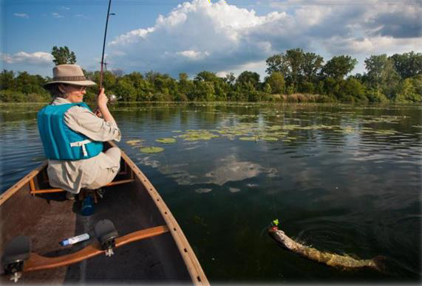PFAS concentrations in fish tissue are evaluated in a 3-step process:

- Concentrations in fish tissue are compared to DPH’s screening value of 0.22 μg/kg (ppb), designed to be protective of a sensitive individual.
  - 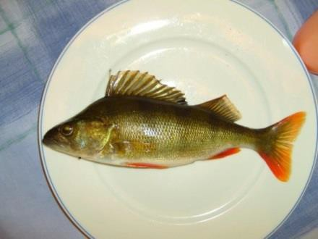The screening value is calculated using reasonable maximum estimates of fish consumption, for sensitive populations, and the toxicity criterion for PFOS (i.e., the most potent PFAS).

- If the fish tissue level of PFOA, PFNA, PFHxS or PFOS exceed the screening value, then a waterbody specific analysis is conducted to evaluate how frequently individuals should consume fish from the waterbody.

- Waterbody-specific fish consumption advisories are issued whenever the screening value is exceeded. This ensures that consumption of PFAS from fish does not exceed an estimated safe daily dose.

Fish Results: Observations

- PFAS were detected in all of the 51 fish sampled
– Most frequently detected analytes: PFTrDA (100%), PFOS (100%), PFUNA (94%), PFTeDA (88%), PFDoA (88%), and PFDA (76%)

- Number of PFAS analytes detected in each sample:
- Average: 7 compounds
- Range: 2 – 11 compounds
- Max # of detections: 11 compounds

- Highest PFAS levels were found in:
– John’s Pond (Mashpee) – PFOS concentrations as high as 170 μg/kg in Bluegill and White Perch

- PFOS levels were high enough in all fish to trigger a DPH fish consumption advisory for all five waterbodies sampled in 2021

For Additional Information

MDPH JBCC Waterbody Fact Sheet
https://www.mass.gov/doc/recreational-use-of-waterbodies-on-or-near-joint-base-cape-cod-
jbcc/download

MDPH Public Health Fish Consumption Advisories
https://www.mass.gov/lists/fish-consumption-advisories

MDPH Advice on Eating fish safely in Massachusetts
https://www.mass.gov/info-details/eating-fish-safely-in-massachusetts

CDC/ATSDR PFAS and Your Health
https://www.atsdr.cdc.gov/pfas/resources/pfas-faqs.html

For additional information, contact the Environmental Toxicology Program at the:

Massachusetts Department of Public Health (MDPH)
Bureau of Environmental Health
617-624-5757 - DPHToxicology@mass.gov https://www.mass.gov/orgs/bureau-of-environmental-health

Appendix I.

Changes to Fish Consumption Advisories at 5 waterbodies

Waterbody | Population | Current Advisory (basis of advisory) | New Consumption Advice  (based on PFAS) | Recommended New  Advisory (applies to all fish) | Practical Impact
Flax Pond (Picture Lake) | Sensitive | Do not eat any fish (State Guidance*) | 1 meal/month | Do not eat any fish | None
 | General | 2 meals/week (State Guidance*) | 1 meal/week | 1 meal/week | Eat slightly less frequently
Grews Pond | Sensitive | Do not eat any fish (State Guidance*) | 1 meal/week | Do not eat any fish | None
 | General | 2 meals/week (State Guidance*) | 2 meals/week | 2 meals/week | None
Jenkins Pond | Sensitive | Do not eat any fish (State Guidance*) | 1 meal/month | None | None
 | General | 2 meals/week (Mercury*) | 1 meal/week | 1 meal/week | Eat slightly less frequently
Johns Pond | Sensitive | Do not eat any fish (Mercury) | Do not eat any  fish | None | None
 | General | Do not eat smallmouth bass (Mercury); Limit other species to 2 meals/month (Mercury) | 1 meal/year | 1 meal/year | No change for smallmouth bass; Eat other species less frequently
Mashpee- Wakeby Pond | Sensitive | Do not eat smallmouth and largemouth bass (Mercury); No advisory for other species | 1 meal/week | Do not eat smallmouth and largemouth bass; Limit other species to 1 meal/week | None for smallmouth and largemouth bass; Eat other species slightly less frequently
 | General | Limit of 2 meals/month for smallmouth and largemouth bass (Mercury);  No advisory for other species | 1 meal/week | Limit of 2 meals/month for smallmouth and largemouth bass; Limit other species 1 meal/week | None for smallmouth and largemouth bass; Consume other species slightly less frequently
*This advisory was assigned per DPH’s statewide fish consumption advisory for mercury. Because this waterbody has not yet been evaluated for mercury, sensitive populations should not eat fish from this waterbody and the general population should limit consumption to 2 meals per week until more

Appendix II.

DPH PFOS Guidelines for Issuing Recreational Fish Consumption Advisories (FCA)

Target Population | Frequency | Meals*/ Year | PFOS Threshold (ppb)
General Population | 7 meals/week, or unlimited | 365 | < 0.50
 | 2 meals/week | 104 | < 1.76
 | 1 meal/week | 52 | < 3.52
 | 2 meals/month | 24 | < 7.62
 | 1 meal/month | 12 | < 15.2
 | 1 meal/2 months | 6 | < 30.5
 | 1 meal/6 months | 2 | < 91.4
 | 1 meal/year | 1 | < 183
 | Do Not Consume | 0 | >183
Sensitive Populations | 7 meals/week, or unlimited | 365 | < 0.22**
 | 2 meals/week | 104 | < 0.78
 | 1 meal/week | 52 | < 1.56
 | 2 meals/month | 24 | < 3.38
 | 1 meal/month | 12 | < 6.76
 | 1 meal/2 months | 6 | < 13.5
 | 1 meal/6 months | 2 | < 40.6
 | 1 meal/year | 1 | < 81.1
 | Do Not Consume | 0 | >81.1

*Uncooked serving size is approximately 8 oz. for adults and children over 12, with smaller amounts for younger children
**This value also serves as the DPH Fish Action level (FAL). Exceeding this level would trigger a waterbody specific advisory and a FCA recommendation.
18

