INDOOR AIR QUALITY ASSESSMENT

Fisher Elementary School
65 Gould Street
Walpole, MA

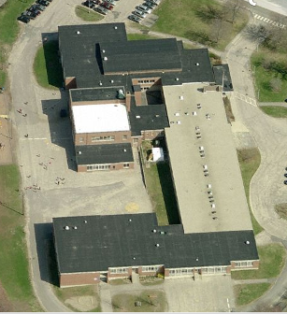

Prepared by:
Massachusetts Department of Public Health
Bureau of Environmental Health
Indoor Air Quality Program
January 2015

Background/Introduction
At the request of Ms. Robin Chapell, Health Director, Walpole Board of Health (WBOH), the Massachusetts Department of Public Health (MDPH), Bureau of Environmental Health (BEH) provided assistance and consultation regarding indoor air quality (IAQ) at the Fisher Elementary School (FES) located at 65 Gould Street, Walpole, Massachusetts. The assessment was prompted by parental concerns regarding symptoms attributed to the indoor environment. On November 10, 2014, a visit to conduct an assessment of the FES was made by Cory Holmes and Jason Dustin, Environmental Analysts/Inspectors within BEH’s IAQ Program.
The FES is a two-story, brick building constructed in the 1950s. An addition was completed in 1969. The school houses general classrooms, small rooms for specialized instruction, a cafeteria/gymnasium, media center, art/music rooms, teachers’ workrooms and office space. Reportedly, the roof in a number of areas was recently replaced. Windows are openable throughout the building and appear to have been replaced in some areas, where in some areas windows appear to be original to the building.

Methods
Air tests for carbon dioxide, carbon monoxide, temperature and relative humidity were conducted with the TSI, Q-Trak, IAQ Monitor, Model 7565. Air tests for airborne particle matter with a diameter less than 2.5 micrometers were taken with the TSI, DUSTTRAK™ Aerosol Monitor Model 8520. MDPH staff also performed visual inspection of building materials for water damage and/or microbial growth.

Results
The school houses approximately 375 students in grades K through 5 with approximately 50 staff members. Tests were taken during normal school operations and results appear in Table 1.

Discussion

Ventilation
It can be seen from Table 1 that carbon dioxide levels were above 800 parts per million (ppm) in 12 of 35 areas, indicating adequate air exchange in two thirds of the areas surveyed. Elevated carbon dioxide levels appeared to be directly related to a lack of ventilation components (i.e., exhaust vents) or deactivated and/or blocked ventilation equipment, particularly in rooms with full occupancy. Several areas had open windows or were empty/sparsely populated at the time measurements were taken, which can greatly reduce carbon dioxide levels. Carbon dioxide levels would be expected to increase with windows closed and greater occupancy.
Fresh air is supplied to classrooms by unit ventilator (univent) systems (Pictures 1 and 2). A univent draws outdoor air through an air intake located on the exterior wall (Picture 3) or in the case of the 1969 wing, the roof (Picture 4) of the building and returns air from the room through an air intake located at the base of the unit (Figure 1). Fresh and return air are mixed, filtered, heated and then delivered to the room through an air diffuser located in the top of the unit.
In a few cases univent airflow was determined to be weak (Table 1). In many other cases univent air diffusers and return intakes were blocked by books, furniture and other items placed in front and on top of the unit, thereby limiting airflow (Pictures 5 through 7). In order for univents to provide fresh air as designed, air diffusers and intakes must remain free of obstructions. Importantly, these units must remain on and be allowed to operate while rooms are occupied.
Exhaust ventilation could not be identified in many classrooms (Table 1). In a few classrooms exhaust vents were located in coat closets (Pictures 8 and 9); however they were observed to be backdrafting cold air instead of exhausting air from the classroom as designed. BEH/IAQ staff inspected exhaust motors on the roof and found several of them not operating and/or missing components (Picture 10). Classrooms in the original portion of the building had ceiling-mounted exhaust vents (Picture 11), which were operating in most rooms.
Note that the univents and exhaust vents are original equipment, and therefore greater than 45 years old. Function of equipment of this age is difficult to maintain, since compatible replacement parts are often unavailable. According to the American Society of Heating, Refrigeration and Air-Conditioning Engineers (ASHRAE), the service life for a unit heater, hot water or steam is 20 years, assuming routine maintenance of the equipment (ASHRAE, 1991). Despite repeated attempts to maintain these units, the operational lifespan of the equipment has been exceeded. Maintaining the balance of fresh air to exhaust air will become more difficult as the equipment ages and as replacement parts become increasingly difficult to obtain.
To maximize air exchange, the MDPH recommends that both supply and exhaust ventilation operate continuously during periods of occupancy. In order to have proper ventilation with a mechanical supply and exhaust system, the systems must be balanced to provide an adequate amount of fresh air to the interior of a room while removing stale air from the room. It is recommended that heating, ventilating and air conditioning (HVAC) systems be re-balanced every five years to ensure adequate air systems function (SMACNA, 1994). The date of the last balancing of these systems was not available at the time of the assessment.
Minimum design ventilation rates are mandated by the Massachusetts State Building Code (MSBC). Until 2011, the minimum ventilation rate in Massachusetts was higher for both occupied office spaces and general classrooms, with similar requirements for other occupied spaces (BOCA, 1993). The current version of the MSBC, promulgated in 2011 by the State Board of Building Regulations and Standards (SBBRS), adopted the 2009 International Mechanical Code (IMC) to set minimum ventilation rates. Please note that the MSBC is a minimum standard that is not health-based. At lower rates of cubic feet per minute (cfm) per occupant of fresh air, carbon dioxide levels would be expected to rise significantly. A ventilation rate of 20 cfm per occupant of fresh air provides optimal air exchange resulting in carbon dioxide levels at or below 800 ppm in the indoor environment in each area measured. MDPH recommends that carbon dioxide levels be maintained at 800 ppm or below. This is because most environmental and occupational health scientists involved with research on IAQ and health effects have documented significant increases in indoor air quality complaints and/or health effects when carbon dioxide levels rise above the MDPH guidelines of 800 ppm for schools, office buildings and other occupied spaces (Sundell et al., 2011). The ventilation must be on at all times that the room is occupied. Providing adequate fresh air ventilation with open windows and maintaining the temperature in the comfort range during the cold weather season is impractical. Mechanical ventilation is usually required to provide adequate fresh air ventilation.
Carbon dioxide is not a problem in and of itself. It is used as an indicator of the adequacy of the fresh air ventilation. As carbon dioxide levels rise, it indicates that the ventilating system is malfunctioning or the design occupancy of the room is being exceeded. When this happens, a buildup of common indoor air pollutants can occur, leading to discomfort or health complaints. The Occupational Safety and Health Administration (OSHA) standard for carbon dioxide is 5,000 parts per million parts of air (ppm). Workers may be exposed to this level for 40 hours/week, based on a time-weighted average (OSHA, 1997).
The MDPH uses a guideline of 800 ppm for publicly occupied buildings. A guideline of 600 ppm or less is preferred in schools due to the fact that the majority of occupants are young and considered to be a more sensitive population in the evaluation of environmental health status. Inadequate ventilation and/or elevated temperatures are major causes of complaints such as respiratory, eye, nose and throat irritation, lethargy and headaches. For more information concerning carbon dioxide, consult Appendix A.
Temperature measurements in the building ranged from 70° F to 77° F, which were within the MDPH recommended temperature range (Table 1). The MDPH recommends that indoor air temperatures be maintained in a range of 70º F to 78º F in order to provide for the comfort of building occupants. In many cases concerning indoor air quality, fluctuations of temperature in occupied spaces are typically experienced, even in a building with an adequate fresh air supply. In addition, it is difficult to control temperature and maintain comfort without operating the ventilation equipment as designed (e.g., univents/exhaust vents deactivated/obstructed).
The relative humidity measured in the building ranged from 24 to 37 percent, which were below the MDPH recommended comfort range (Table 1). The MDPH recommends a comfort range of 40 to 60 percent for indoor air relative humidity. Relative humidity levels in the building would be expected to drop during the winter months due to heating. The sensation of dryness and irritation is common in a low relative humidity environment. Low relative humidity is a very common problem during the heating season in the northeast part of the United States.

Microbial/Moisture Concerns
In order for building materials to support mold growth, a source of water exposure is necessary. Identification and elimination of the source of water moistened building materials is necessary to control mold growth. Water-damaged ceiling tiles were observed in a number of areas, indicating roof leaks and/or water penetration through the exterior (Pictures 12 and 13). Water-damaged ceiling tiles can provide a source of mold and should be replaced after a water leak is discovered and repaired. It is also important to note the ceiling tile system consists of interlocking tiles that are directly adhered to the ceiling/substrate, which may necessitate destruction and/or removal of surrounding portions of the system.
Water-damaged wall tiles were observed in classroom 23 on the upper portion of the right interior wall. BEH/IAQ staff reported a noticeable musty odor and what appears to be a chronic water leak in this area. Water-damaged wall tiles can also provide a source of mold and should be replaced after the water leak is discovered and repaired. The musty odor in this classroom may be further compounded by the debris-clogged subterranean fresh air intake vent as discussed later in this section.
Open seams between the sink countertop and backsplash were observed in a number of rooms (Table 1; Picture 14). If seams are not watertight, water can penetrate the seam, causing water damage. Water penetration and chronic exposure of porous and wood-based materials can cause these materials to swell, show signs of water damage and lead to potential mold growth. Discoloration on caulking observed in several rooms is likely mold growth (Picture 15). In addition, a dripping faucet was observed in classroom 112 which can contribute to moisture issues around the sink.
The US Environmental Protection Agency (US EPA) and the American Conference of Governmental Industrial Hygienists (ACGIH) recommend that porous materials be dried with fans and heating within 24 to 48 hours of becoming wet (US EPA, 2001; ACGIH, 1989). If not dried within this time frame, mold growth may occur. Once mold has colonized porous materials, they are difficult to clean and should be removed/discarded.
A number of classrooms had plants (Table 1), some of which were flowering. Plants can be a source of pollen and mold, which can serve as respiratory irritants for some sensitive individuals. Plants should be properly maintained and equipped with drip pans to prevent water damage to porous building materials. Plants should also be located away from ventilation sources (e.g., univent air diffusers) to prevent the aerosolization of dirt, pollen or mold.
Around the exterior of the building were subterranean air intake pits for some classroom univents (Picture 16). Several of these pits had accumulated leaves and debris (Picture 17). Also noted along the perimeter of the building were shrubbery in close proximity to univent fresh air intakes (Picture 18); both these conditions can hold moisture and grow mold, which can be drawn into the building while univents are operating. The pits should be cleaned and shrubbery should be trimmed away (~5-feet) from the building on a regular basis.
Finally, missing/damaged exterior caulking was observed around original single-paned windows at the rear of the building/cafeteria (Pictures 19 through 21). Missing caulking and/or loose fitting window panes can make it difficult to control temperature and allow a means for water penetration into the building, leading to comfort complaints and/or water damage and subsequent microbial growth. Depending on its age, window (and joint) sealant may be composed of regulated materials [e.g., asbestos, polychlorinated biphenyls (PCBs)]. If so, materials should be addressed in accordance with US Environmental Protection Agency (US EPA) regulations. For additional information regarding PCBs, please consult MDPH guidance (Appendix B).

Other IAQ Evaluations
Indoor air quality can be negatively influenced by the presence of respiratory irritants, such as products of combustion. The process of combustion produces a number of pollutants. Common combustion emissions include carbon monoxide, carbon dioxide, water vapor and smoke (fine airborne particle material). Of these materials, exposure to carbon monoxide and particulate matter with a diameter of 2.5 micrometers (μm) or less (PM2.5) can produce immediate, acute health effects upon exposure. To determine whether combustion products were present in the indoor environment, BEH/IAQ staff obtained measurements for carbon monoxide and PM2.5.

Carbon Monoxide
Carbon monoxide is a by-product of incomplete combustion of organic matter (e.g., gasoline, wood and tobacco). Exposure to carbon monoxide can produce immediate and acute health affects. Several air quality standards have been established to address carbon monoxide and prevent symptoms from exposure to these substances. The MDPH established a corrective action level concerning carbon monoxide in ice skating rinks that use fossil-fueled ice resurfacing equipment. If an operator of an indoor ice rink measures a carbon monoxide level over 30 ppm, taken 20 minutes after resurfacing within a rink, that operator must take actions to reduce carbon monoxide levels (MDPH, 1997).
The American Society of Heating Refrigeration and Air-Conditioning Engineers (ASHRAE) has adopted the National Ambient Air Quality Standards (NAAQS) as one set of criteria for assessing indoor air quality and monitoring of fresh air introduced by HVAC systems (ASHRAE, 1989). The NAAQS are a reference standard used by the US EPA and others to protect the public health from six criteria pollutants, including particulate matter (US EPA, 2006). As recommended by ASHRAE, pollutants in indoor air should not exceed the NAAQS levels (ASHRAE, 1989). The NAAQS were adopted by reference in the Building Officials & Code Administrators (BOCA) National Mechanical Code of 1993 (BOCA, 1993), which is now an HVAC standard included in the Massachusetts State Building Code (SBBRS, 2011). According to the NAAQS, carbon monoxide levels in outdoor air should not exceed 9 ppm in an eight-hour average (US EPA, 2006).
Carbon monoxide should not be present in a typical, indoor environment. If it is present, indoor carbon monoxide levels should be less than or equal to outdoor levels. On the day of the assessment slight outdoor levels of carbon monoxide were detected from 0.2 to 0.6 ppm (Table 1), most likely due to nearby vehicle traffic/parking. No measurable levels of carbon monoxide were detected in the building during the assessment (Table 1).

Particulate Matter
The US EPA has established NAAQS limits for exposure to particulate matter. Particulate matter includes airborne solids that can be irritating to the eyes, nose and throat. The NAAQS originally established exposure limits to PM with a diameter of 10 μm or less (PM10). In 1997, US EPA established a more protective standard for fine airborne particulate matter with a diameter of 2.5 μm or less (PM2.5). This more stringent PM2.5 standard requires outdoor air particle levels be maintained below 35 μg/m³ over a 24-hour average (US EPA, 2006). Although both the ASHRAE standard and BOCA Code adopted the PM10 standard for evaluating air quality, MDPH uses the more protective PM2.5 standard for evaluating airborne PM concentrations in the indoor environment.
Outdoor PM2.5 concentrations the day of the assessment were measured at 6 μg/m³. PM2.5 levels measured indoors ranged from 5 to 12 μg/m³ (Table 1), which were below the NAAQS PM2.5 level of 35 μg/m³ in all surveyed at the time of the assessment. Frequently, indoor air levels of particulate matter (including PM2.5) can be at higher levels than those measured outdoors. A number of mechanical devices and/or activities that occur indoors can generate particulate matter during normal operations. Sources of indoor airborne particulate matter may include but are not limited to: particles generated during the operation of fan belts in the HVAC system; cooking in the cafeteria stoves and microwave ovens; use of photocopiers, fax machines and computer printing devices; operation of an ordinary vacuum cleaner; and, heavy foot traffic indoors.

Volatile Organic Compounds
Indoor air concentrations can be greatly impacted by the use of products containing volatile organic compounds (VOCs). VOCs are carbon-containing substances that have the ability to evaporate at room temperature. Frequently, exposure to low levels of total VOCs (TVOCs) may produce eye, nose, throat and/or respiratory irritation in some sensitive individuals. For example, chemicals evaporating from a paint can stored at room temperature would most likely contain VOCs. In an effort to identify materials that can potentially increase indoor VOC concentrations, BEH/IAQ staff examined rooms for products containing these respiratory irritants.
Two photocopiers were noted in the Specialist Room (near the Library). Photocopiers can be sources of pollutants such as VOCs, ozone, heat and odors, particularly if the equipment is older and in frequent use. Both VOCs and ozone are respiratory irritants (Schmidt Etkin, 1992). Photocopiers should be kept in well ventilated rooms, and should be located near windows or exhaust vents; this area had neither openable windows nor exhaust ventilation.
Several classrooms contained dry erase boards and related materials. Materials such as dry erase markers and dry erase board cleaners may contain VOCs, such as methyl isobutyl ketone, n-butyl acetate and butyl-cellusolve (Sanford, 1999), which can be irritating to the eyes, nose and throat.
In an effort to reduce noise, tennis balls had been sliced open and placed on the base of desk/chair legs in some classrooms (Picture 22). Tennis balls are made of a number of materials that are a source of respiratory irritants. Constant wearing of tennis balls can produce fibers and cause VOCs to off-gas. Tennis balls are made with a natural rubber latex bladder, which becomes abraded when used as a chair leg pad. Use of tennis balls in this manner may introduce latex dust into the school environment. Some individuals are highly allergic to latex (e.g., spina bifida patients) (SBAA, 2001). It is recommended that the use of materials containing latex be limited in buildings to reduce the likelihood of symptoms in sensitive individuals (NIOSH, 1997).

Other Conditions
Other conditions that can affect indoor air quality were observed during the assessment. In several classrooms, items were observed on windowsills, tabletops, counters, bookcases and desks. The large number of items stored in classrooms provides a source for dusts to accumulate. These items (e.g., papers, folders, boxes) make it difficult for custodial staff to clean. Items should be relocated and/or be cleaned periodically to avoid excessive dust build up. In addition, these materials can accumulate on flat surfaces (e.g., desktops, shelving and carpets) in occupied areas and subsequently be re-aerosolized causing further irritation.
A number of personal fans, exhaust vents, univent diffusers/return vents were observed to have accumulated dust/debris (Pictures 23 and 24; Table 1). Re-activated univents or fans can aerosolize accumulated dust. If exhaust vents are not functioning, backdrafting can occur, which can re-aerosolize dust particles.
Open utility holes in walls/ceilings/floors and missing ceiling tiles were observed in a number of areas (Pictures 25 and 26). Missing ceiling tiles and open utility holes can provide a means of transfer of odors, fumes, dusts and vapors between rooms and floors.
Several classrooms had area carpets, pillows and cushions on the floor (Picture 27). The Institute of Inspection, Cleaning and Restoration Certification (IICRC), recommends that carpeting be cleaned annually (or semi-annually in soiled high traffic areas) (IICRC, 2012). Pillows and cushions are covered with fabric that comes in contact with human skin. This type of contact can leave oils, perspiration, hair and skin cells. Dust mites feed upon human skin cells and excrete waste products that contain allergens. In addition, if relative humidity levels increase above 60 percent, dust mites tend to proliferate (US EPA, 1992).
Restrooms are equipped with mechanical exhaust vents that were drawing air weakly at the time of the assessment. Exhaust ventilation is necessary in restrooms to remove excess moisture and to prevent odors from penetrating into adjacent areas. Installing passive ventilation in the door to aid in dilution of bathroom odors should be considered.
Missing light covers were noted in a number of areas (Picture 28). Fixtures should be equipped with access covers installed with bulbs fully secured in their sockets. Breakage of glass can cause injuries and may release mercury and/or other hazardous compounds.
The type of filter medium for air handling equipment used by the school comes in a bulk roll and must be cut to size before it is inserted into a metal lattice “cage” (Picture 29). This method is extremely time intensive, and the results are variable. If the filter medium is not properly fitted, gaps can allow unfiltered air into the room and/or reduce the useful life of the unit. It should be determined if disposable filters with an appropriate dust spot efficiency and similar cost can be installed.
Finally, classroom 114 had a self-contained “breakout room” that was reported to be a former language lab (Picture 30). This breakout room consists of thick metal walls, floors and ceiling with unopenable windows and is not equipped with ventilation. Therefore, it should not be used without proper ventilation (e.g., with door shut).

Conclusions/Recommendations
In view of the findings at the time of the assessment, the following recommendations are made to improve indoor air quality in the building. Some of these conditions can be remedied by actions of building occupants. Other remediation efforts will require alteration to the building structure and equipment. For these reasons, a two-phase approach is required for remediation. The first consists of short-term measures to improve air quality and the second consists of long-term measures that will require planning and resources to adequately address overall IAQ conditions.

Short Term Recommendations
The following short-term measures should be considered for implementation:
- Operate all ventilation systems (e.g., univents, exhaust vents and AHUs) throughout the building continuously during periods of occupancy. To increase airflow in classrooms, set univent controls to “high”. School staff should be encouraged not to deactivate classroom univents and to report any temperature/comfort complaints to the facilities department.
- Restore exhaust ventilation throughout the building. Inspect motors and belts for proper function, and perform repairs and adjustments as necessary.
- Remove all blockages from the top and front of univents and exhaust vents to ensure adequate airflow. Ensure plants and dust generating items (e.g., pencil sharpeners) are located away from univents.
- Change filters for air handling equipment (univents and AHUs) 2-4 times a year. Vacuum interior of units prior to activation to prevent the aerosolization of dirt, dust and particulate matter. Ensure filters fit flush in their racks with no spaces in between allowing bypass of unfiltered air into the unit.
- Consider replacing metal filter racks with properly fitting disposable filters with an equal or greater dust-spot efficiency to eliminate the time needed to replace filters from bulk material rolls. Prior to any increase of filtration, each piece of air handling equipment should be evaluated by a ventilation engineer as to whether it can maintain function with more efficient filters.
- Clean and vacuum univent exterior and interiors on a regular bases (e.g., during filter changes) to remove dust/debris.
- Use openable windows in conjunction with mechanical ventilation to facilitate air exchange. Care should be taken to ensure windows are properly closed at night and weekends to avoid the freezing of pipes and potential flooding.
- Consider adopting a balancing schedule of every 5 years for all mechanical ventilation systems, as recommended by ventilation industrial standards (SMACNA, 1994).
- For buildings in New England, periods of low relative humidity during the winter are often unavoidable. Therefore, scrupulous cleaning practices should be adopted to minimize common indoor air contaminants whose irritant effects can be enhanced when the relative humidity is low. To control for dusts, a high efficiency particulate arrestance (HEPA) filter equipped vacuum cleaner in conjunction with wet wiping of all surfaces is recommended. Avoid the use of feather dusters. Drinking water during the day can help ease some symptoms associated with a dry environment (throat and sinus irritations).
- Ensure roof/plumbing leaks are repaired and replace any remaining water-damaged ceiling tiles, wall tiles and other building materials. Disinfect areas of water leaks with an appropriate antimicrobial, as needed.
- Inspect all sinks for leaks (e.g., dripping sink in room 112) as well as missing/moldy backsplash caulking and repair as needed. Refrain from storing porous items or large quantities of items under sinks.
- Remove plants close to the exterior of the school (~5-feet), particularly in close proximity to air intakes.
- Remove leaves and debris from subterranean fresh air intake pits seasonally.
- Indoor plants should be properly maintained and equipped with drip pans to prevent water damage to porous building materials and be located away from ventilation sources to prevent the aerosolization of dirt, pollen or mold.
- Trim tree branches and plants/shrubbery away (~5-feet) from exterior walls.
- Relocate photocopiers to well-ventilated areas/areas with local exhaust ventilation or install local exhaust ventilation in areas where this equipment is used to reduce excess heat and odors.
- Replace tennis balls on chair legs with latex-free tennis balls or glides.
- Relocate or consider reducing the amount of materials stored in classrooms to allow for more thorough cleaning of classrooms. Clean items regularly with a wet cloth or sponge to prevent excessive dust build-up.
- Clean univent air diffusers/return vents, exhaust vents and personal fans periodically of accumulated dust.
- Replace missing ceiling tiles.
- Seal around open utility holes in walls/ceilings/floors with fire proof expanding foam insulation or suitable material to prevent vapors and particulate matter from passing into occupied areas.
- Clean pencil sharpeners, chalkboards and dry erase board trays regularly to avoid the build-up of dust and particulate matter.
- Replace missing light covers. Light fixtures should be equipped with access covers installed with bulbs fully secured in their sockets.
- Clean area carpets annually or semi-annually in soiled high traffic areas as per the recommendations of the Institute of Inspection, Cleaning and Restoration Certification (IICRC, 2012).
- Clean any upholstered furniture, cloth curtains, stuffed animals, and pillows/cushions on a regular schedule. If not possible/practical, consider removing from classrooms.
- Restore working ventilation to “breakout room” in classroom 114 or consider discontinuing use/removal.
- Consider adopting the US EPA document, “Tools for Schools” to maintain a good indoor air quality environment on the building (US EPA, 2000). This document can be downloaded from the Internet at: http://www.epa.gov/iaq/schools/index.html.
- Refer to resource manual and other related indoor air quality documents located on the MDPH’s website for further building-wide evaluations and advice on maintaining public buildings. These documents are available at: http://mass.gov/dph/iaq.

Long Term Recommendations
The following long-term measures should be considered:
- Contact an HVAC engineering firm for an assessment of ventilation system components building-wide (univents, exhaust vents/motors, control systems, etc.). Based on the age, physical deterioration and availability of parts for ventilation components, such an evaluation is necessary to determine the future operability and feasibility of repairing/replacing the equipment.
- Consider a long-term plan to replace windows (rear/cafeteria side of the building) to prevent air/moisture infiltration. Address deteriorating sealant/caulking materials in accordance with EPA regulations/MDPH guidance (Appendix B).
- Consider replacing existing ceiling tile system with a suspended ceiling tile system.

References
ACGIH. 1989. Guidelines for the Assessment of Bioaerosols in the Indoor Environment. American Conference of Governmental Industrial Hygienists, Cincinnati, OH.
ASHRAE. 1989. Ventilation for Acceptable Indoor Air Quality. American Society of Heating, Refrigeration and Air Conditioning Engineers. ANSI/ASHRAE 62-1989.
ASHRAE. 1991. ASHRAE Applications Handbook, Chapter 33 “Owning and Operating Costs”. American Society of Heating, Refrigeration and Air Conditioning Engineers, Atlanta, GA.
BOCA. 1993. The BOCA National Mechanical Code/1993. 8th ed. Building Officials and Code Administrators International, Inc., Country Club Hill, IL.
IICRC. 2012. Institute of Inspection, Cleaning and Restoration Certification. Carpet Cleaning: FAQ. Retrieved from http://www.iicrc.org/consumers/care/carpet-cleaning/#faq.
MDPH. 1997. Requirements to Maintain Air Quality in Indoor Skating Rinks (State Sanitary Code, Chapter XI). 105 CMR 675.000. Massachusetts Department of Public Health, Boston, MA.
NIOSH. 1997. NIOSH Alert Preventing Allergic Reactions to Natural Rubber latex in the Workplace. National Institute for Occupational Safety and Health, Atlanta, GA.
OSHA. 1997. Limits for Air Contaminants. Occupational Safety and Health Administration. Code of Federal Regulations. 29 C.F.R 1910.1000 Table Z-1-A.
Sanford. 1999. Material Safety Data Sheet (MSDS No: 198-17). Expo® Dry Erase Markers Bullet, Chisel, and Ultra Fine Tip. Sanford Corporation. Bellwood, IL.
SBAA. 2001. Latex In the Home And Community Updated Spring 2001. Spina Bifida Association of America, Washington, DC.
SBBRS. 2011. Mechanical Ventilation. State Board of Building Regulations and Standards. Code of Massachusetts Regulations, 8th edition. 780 CMR 1209.0.
Schmidt Etkin, D. 1992. Office Furnishings/Equipment & IAQ Health Impacts, Prevention & Mitigation. Cutter Information Corporation, Indoor Air Quality Update, Arlington, MA.
SMACNA. 1994. HVAC Systems Commissioning Manual. 1st ed. Sheet Metal and Air Conditioning Contractors’ National Association, Inc., Chantilly, VA.
Sundell. 2011. Sundell, J., H. Levin, W. W. Nazaroff, W. S. Cain, W. J. Fisk, D. T. Grimsrud, F. Gyntelberg, Y. Li, A. K. Persily, A. C. Pickering, J. M. Samet, J. D. Spengler, S. T. Taylor, and C. J. Weschler. 2011. Ventilation rates and health: multidisciplinary review of the scientific literature. Indoor Air, Volume 21: pp 191–204.
US EPA. 1992. Indoor Biological Pollutants. US Environmental Protection Agency, Environmental Criteria and Assessment Office, Office of Health and Environmental Assessment, research Triangle Park, NC. EPA 600/8-91/202. January 1992.
US EPA. 2000. Tools for Schools. Office of Air and Radiation, Office of Radiation and Indoor Air, Indoor Environments Division (6609J). EPA 402-K-95-001, Second Edition. http://www.epa.gov/iaq/schools/tools4s2.html.
US EPA. 2001. Mold Remediation in Schools and Commercial Buildings. US Environmental Protection Agency, Office of Air and Radiation, Indoor Environments Division, Washington, D.C. EPA 402-K-01-001. March 2001.
US EPA. 2006. National Ambient Air Quality Standards (NAAQS). US Environmental Protection Agency, Office of Air Quality Planning and Standards, Washington, DC. http://www.epa.gov/air/criteria.html.

Picture 1
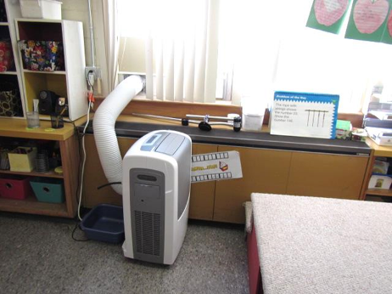
Classroom univent in original building, 1950s vintage, also note portable air conditioning unit
Picture 2
Classroom univent in 1969 addition, top vent is supply; vent at floor level is return
Picture 3
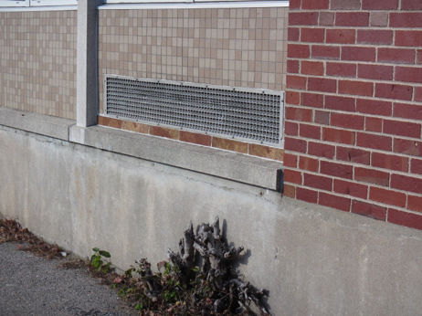
Univent fresh air intake for 1950s units
Picture 4
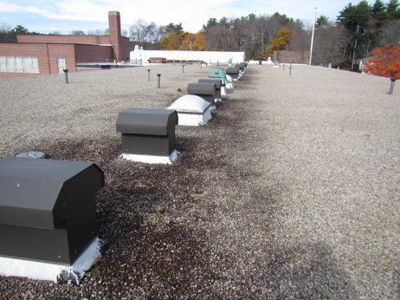
Univent fresh air intake for 1969 units
Picture 5
Classroom univent obstructed by various items
Picture 6
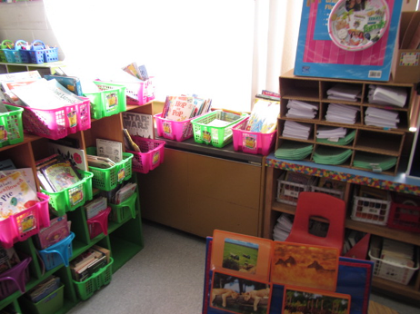
Classroom univent obstructed by various items
Picture 7
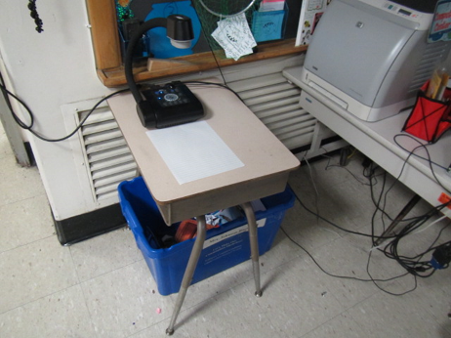
Classroom univent obstructed by various items
Picture 8
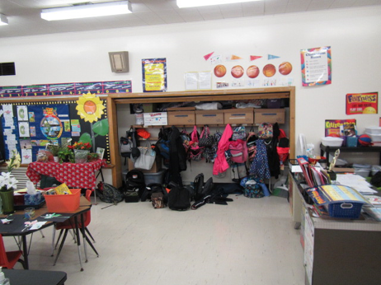
Coat closet containing exhaust vent
Picture 9
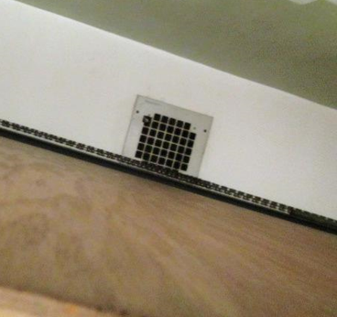
Exhaust vent on ceiling inside closet
Picture 10
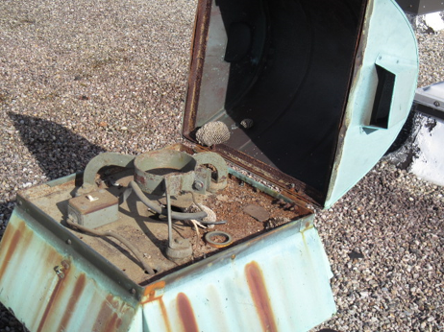
Abandoned exhaust vent missing components; note bees’ nests (arrows) indicating lack of airflow
Picture 11
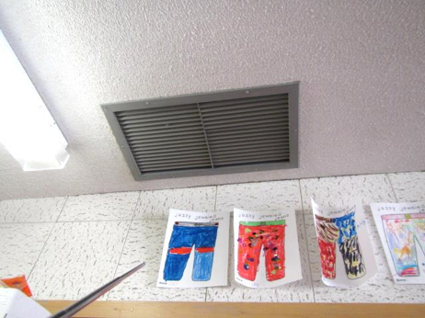
Ceiling-mounted exhaust vents
Picture 12
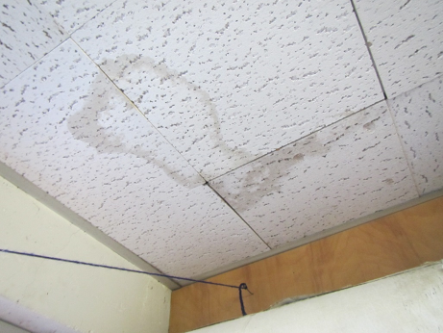
Water-damaged ceiling tiles
Picture 13
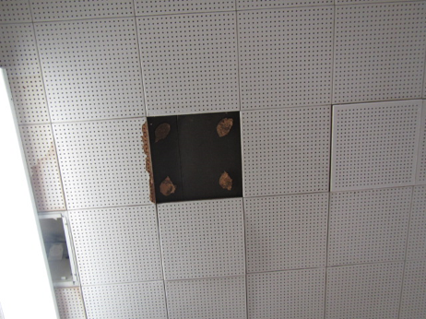
Water-damaged/missing ceiling tiles
Picture 14
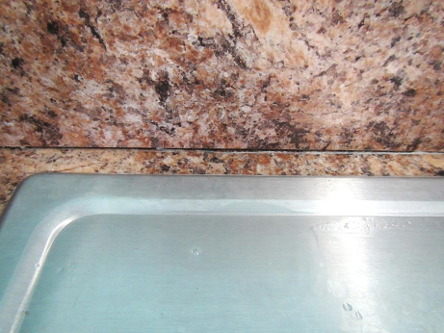
Space between sink and countertop
Picture 15
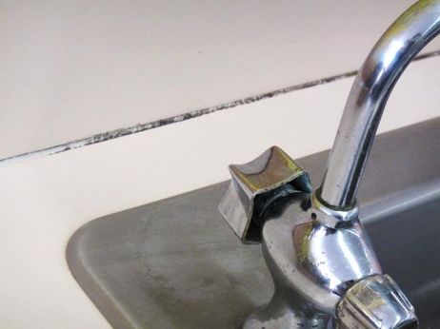
Discoloration on sink/countertop caulking which is likely mold growth
Picture 16
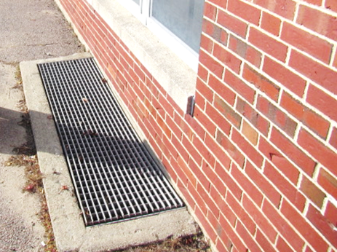
Subterranean air intake pit for below grade univent
Picture 17
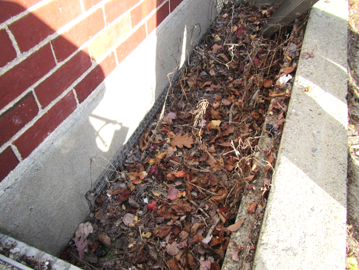
Subterranean air intake pit full of leaves/debris
Picture 18
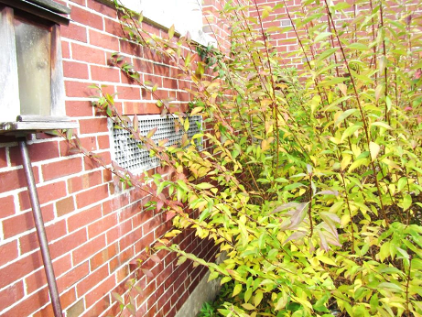
Shrubbery in close proximity to univent fresh air intake
Picture 19
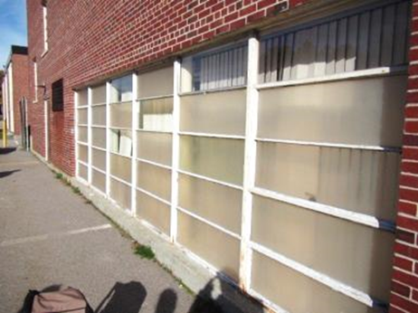
Original windows along the rear/cafeteria
Picture 20
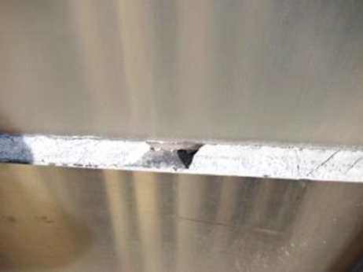
Close-up of missing/damaged caulking around windows along the rear/cafeteria
Picture 21
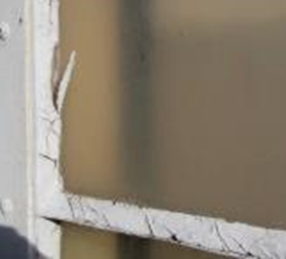
Close-up of missing/damaged caulking around windows along the rear/cafeteria
Picture 22
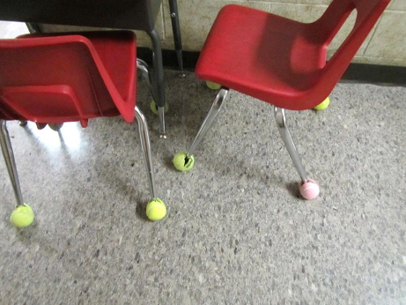
Tennis balls on chair legs in classroom
Picture 23
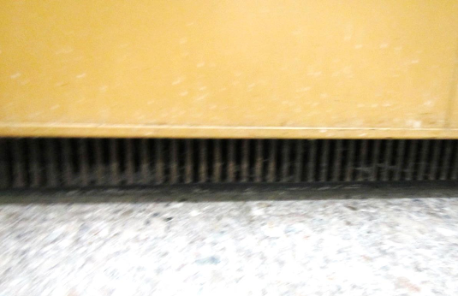
Dust/debris accumulation in univent return vent
Picture 24
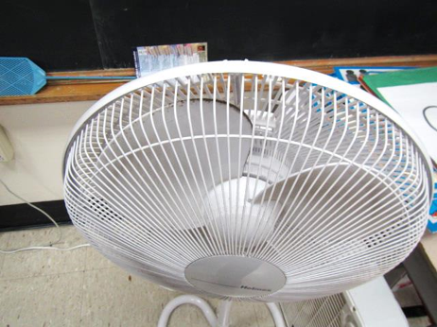
Dust/debris accumulation on fan blades
Picture 25
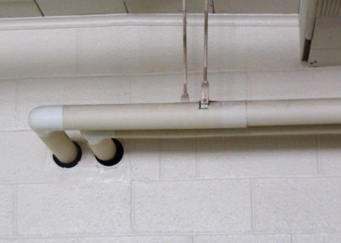
Open utility holes around pipes in classroom
Picture 26
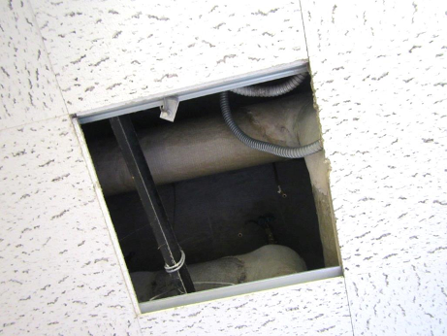
Missing ceiling tile
Picture 27
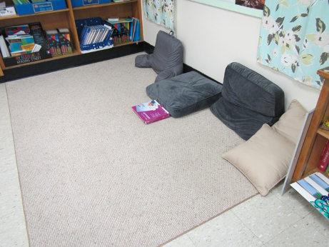
Pillows, cushions and area rug on classroom floor
Picture 28
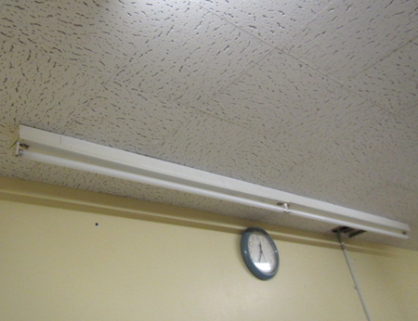
Missing florescent light covers
Picture 29
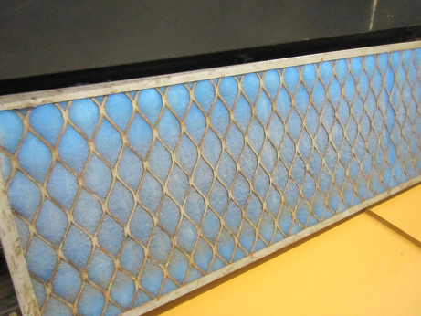
Measure-to-cut filter media in metal cage filter rack
Picture 30
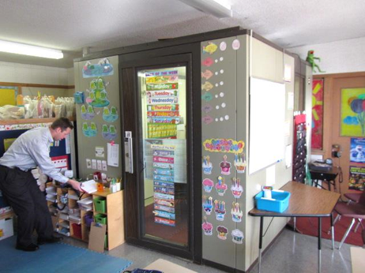
Self-contained “breakout room” in classroom 114
Location | Carbon  Dioxide  (ppm) | Carbon Monoxide  (ppm) | Temp  (°F) | Relative  Humidity  (%) | PM2.5  (µg/m³) | Occupants  in Room | Windows  Openable | Ventilation |  |  | Remarks
 |  |  |  |  |  |  |  | Supply | Exhaust
Background | 446 | 0.2-0.6 | 59 | 34 | 6 |  |  |  |  |  | Clear, light SE wind
1 | 656 | ND | 74 | 27 | 7 | 0 | N | Y |  | Y | Carpet, DEM, damaged interlocking CTs, cut tiles/hatch near return/exhaust
6 | 752 | ND | 75 | 26 | 7 | 2 | Y | Y |  | Y off | Closet exhaust not drawing
7 | 778 | ND | 74 | 31 | 11 | 3 | Y | N |  | N | PF
8 | 732 | ND | 76 | 29 | 10 | 4 | Y | N |  | N | PF-dusty
10 | 714 | ND | 73 | 32 | 6 | 1 | N | Y |  | N | PF, DO, stuffiness complaints
11 | 615 | ND | 73 | 27 | 5 | 1 | Y | Y |  | N | Complaints of cold temp & stuffiness
20 | 561 | ND | 73 | 24 | 6 | 2 | Y | Y |  | Y weak | Chalk dust, PF, DO, Univent, area rug, DEM
22 | 495 | ND | 72 | 26 | 10 | 11 | Y | Y |  | Y | 2 portable AC units
23 | 823 | ND | 72 | 31 | 6 | 23 | Y | Y |  | Y off | Chronic water damage, musty odor, complaints of constant mold smell
101 | 1204 | ND | 71 | 37 | 7 | 21 | Y | Y |  | Y | WAC, exhaust backdraft, DO, plants
102 | 895 | ND | 73 | 32 | 9 | 16 | Y
103 | 780 | ND | 74 | 29 | 5 | 15 | Y | Y |  | Y | Chalk, HS,CP, exhaust/return partially blocked
104 | 666 | ND | 74 | 28 | 7 | 17 | Y | Y |  | N | PF dusty
105 | 722 | ND | 75 | 26 | 5 | 3 | Y | Y |  | Y | DEM, part. blocked exhaust
106 | 1204 | ND | 73 | 34 | 9 | 21 | Y | Y |  | N | PF-dusty, DO
107 | 1210 | ND | 74 | 30 | 5 | 17 | Y | Y |  | Y | DEM, chalk, part. blocked exhaust
108 | 950 | ND | 72 | 31 | 9 | 20 | Y | Y |  | N | Weak air, DO, area rug, return vent obstructed, PF, plants
109 | 974 | ND | 74 | 29 | 5 | 16 | Y | Y |  | Y | DEM, area rug, Lysol wipes
110 | 875 | ND | 73 | 29 | 12 | 18 | Y | Y |  | N | Area rug, DO
111 | 948 | ND | 74 | 29 | 6 | Class just left | Y | Y |  | Y | DEM, Lysol wipes, HS, PF
112 | 986 | ND | 72 | 31 | 10 | 1 | Y | Y |  | Y | Dripping sink, 23 occ. Gone ~5 min, area rug, UV, ceiling exhaust, CP on sink, UV blocked
113 | 775 | ND | 73 | 27 | 8 | Class left 15 min ago | Y | Y |  | Y | 18 occupants gone ~15 min., area rugs, discolored caulking (mold/mildew), hermit crab, UV-return blocked, DO
114 | 675 | ND | 75 | 24 | 6 | Class left 15 min | Y | Y |  | Y | Small soundproof room ventilation not on; used with door closed
120 | 685 | ND | 75 | 26 | 10 | 22 | Y | Y |  | Y | PF, missing/damaged/  discolored caulking (mold/mildew)
121 | 721 | ND | 73 | 28 | 9 | 6 | Y | Y |  | Y | Discolored caulking/moldy, PF
122 | 610 | ND | 72 | 27 | 5 | 11 | Y | Y |  | Y | Univent, HS, Lysol wipes/spray, chalk
Hallway | 1110 | ND | 73 | 31 | 6 | Hall traffic
Boys Room |  |  |  |  |  |  |  | Y |  | Y off | Exhaust not drawing
Auditorium | 492 | ND | 70 | 28 | 7 | 0 | Y | Y |  | Y | Slight polyurethane odor
Computer Lab | 637 | ND | 73 | 26 | 5 | 0 | Y | Y |  | N | Univent filter ok
Teacher’s Room | 1326 | ND | 75 | 33 | 11 | 3 | N | Y |  | Y off | Food odors, PF, DEM
Mrs. Barend | 743 | ND | 72 | 29 | 7 | 21 | Y | Y |  | Y off | Univent, hall exhaust backdraft, WD-CT’s, MT
Gym | 652 | ND | 74 | 28 | 12 | 0 | Y | Y |  | Y
Cafeteria | 774 | ND | 73 | 28 | 9 | ~125 | Y | Y |  | Y | Missing/damaged caulking
Library | 535 | ND | 75 | 24 | 9 | 1 | Y | Y |  | Y
Specialist Room (near Library) | 689 | ND | 77 | 26 | 10 | 2 | N | N |  | N | 2 PC, missing light covers, passive vent in door, hole in ceiling, PF

The service life is the median time during which a particular system or component of …[an HVAC]… system remains in its original service application and then is replaced. Replacement may occur for any reason, including, but not limited to, failure, general obsolescence, reduced reliability, excessive maintenance cost, and changed system requirements due to such influences as building characteristics or energy prices (ASHRAE, 1991).

