HEALTHY LUNCH? DEPENDS
Calories count. Mayo, sour cream and other fixings add up.
Ask for them on the side to help turn a high calorie meal into a lower one.
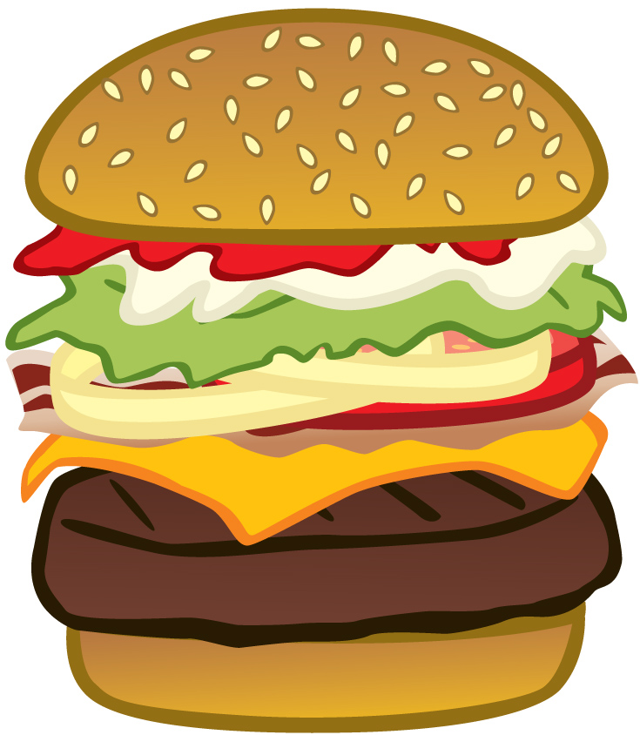

Bun145calories Ketchup15 calories Onions 0 calories
Bacon 110 calories
Cheese 65 calories

Mayo 160 calories
Lettuce 0 calories Tomato 3 calories

Burger110 calories

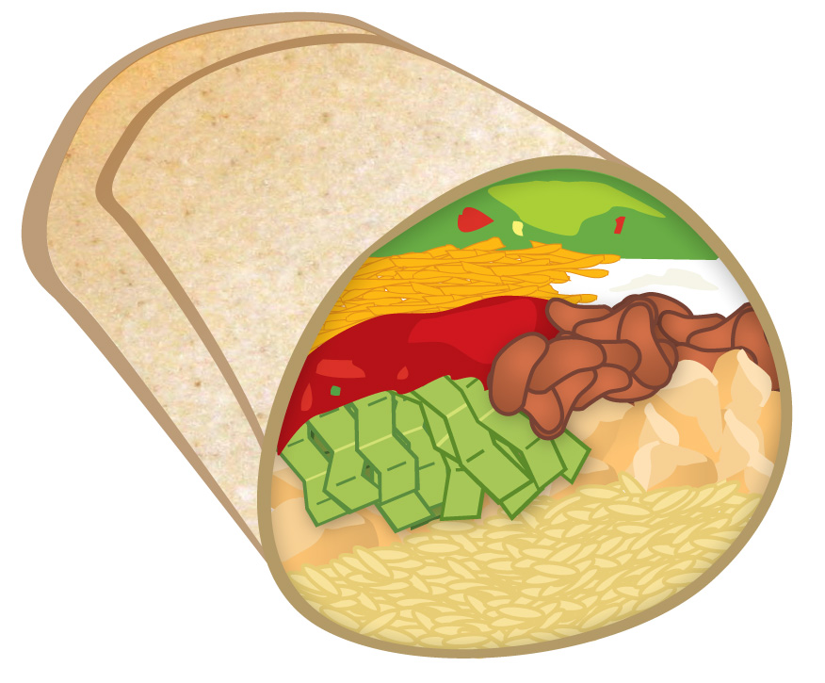
Wrap 290 calories

Cheese100 calories Salsa 8 calories Lettuce 0 calories

Guacamole 93 calories SourCream 120 calories Beans 120 calories
Chicken 190 calories

Rice 130 calories

Cheeseburger Burrito





2000 calories per day is what most adults need to control their weight.


Learn more at mass.gov/massinmotion

