# BACKGROUND

**INDOOR AIR QUALITY**

**ASSESSMENT**

**Flint Memorial Library**

**147 Park Street**

**North Reading, MA**

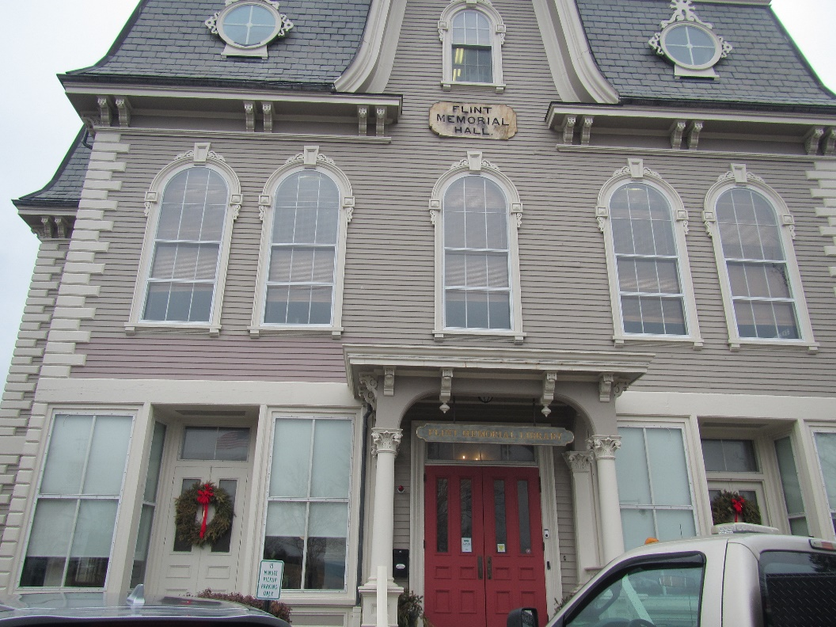

Prepared by:

Massachusetts Department of Public Health

Bureau of Climate and Environmental Health

Indoor Air Quality Program

March 2024

|  |  |
| --- | --- |
| Building: | Flint Memorial Library (FML) |
| Address: | 147 Park Street, North Reading, MA |
| Assessment Requested by: | Sharon Kelleher, Director |
| Reason for Request: | General indoor air quality (IAQ) |
| Date of Assessment: | February 28, 2024 |
| Massachusetts Department of Public Health/Bureau of Climate and Environmental Health (MDPH/BCEH) Staff Conducting Assessment: | Ruth Alfasso, Environmental Engineer/Inspector, and Jen LaJoie Environmental Analyst/Inspector, IAQ Program |
| Building Description: | The FML was originally Flint Memorial Hall built in 1875. The building has been used as a Town Hall, Police Department, and for other purposes. The building was expanded and renovated in 1991 to house the town’s public library. The building has a mansard roof shingled in slate, and wood siding. |
| Windows: | Openable in most areas |

# METHODS

Please refer to the IAQ Manual for methods, sampling procedures, and interpretation of results (MDPH, 2015).

# RESULTS AND DISCUSSION

The following is a summary of indoor air testing results (Table 1).

* ***Carbon dioxide*** levels were below the MDPH guideline of 800 parts per million (ppm), in most areas tested at the time of assessment. Levels slightly above 800 ppm were measured in the Local History room which was heavily occupied.
* ***Temperature*** was within the MDPH recommended range of 70°F to 78°F in areas tested.
* ***Relative humidity*** was within the MDPH recommended range of 40 to 60% in most areas tested, which is reflective of rainy conditions outdoors. Note that humidity levels were slightly above 60% in the basement activity room. This is discussed further below under moisture concerns.
* ***Carbon monoxide*** levels were non-detectable (ND) in all areas tested.
* ***Fine particulate matter (PM2.5)*** concentrations measured indoors were below the National Ambient Air Quality Standard (NAAQS) limit of 35 μg/m3 in all areas tested.

## Ventilation

A heating, ventilating, and air conditioning (HVAC) system has several functions. First it provides heating and, if equipped, cooling. Second, it is a source of fresh air. Finally, an HVAC system will dilute and remove normally occurring indoor environmental pollutants by not only introducing fresh air, but by filtering the airstream and ejecting stale air to the outdoors via exhaust ventilation.

The carbon dioxide measurements indicate that sufficient fresh air is being supplied in most occupied areas. Fresh air ventilation should be on at all times the building is occupied. This building is provided with fresh air through a mechanical ventilation system. Air is supplied to vents (Picture 1) from HVAC units located in the building. Air is returned to the HVAC system via return vents (Picture 2). The filters on an HVAC unit were noted to not quite fit such that the door to the filter slot was unable to close (Picture 3). This can allow air to circumvent the filter during operation.

Additional ventilation is provided by unit ventilators on the lower level (Picture 4) which bring in air from outside, heat it, and mix it with a portion of return air. Cooling in some areas is provided by wall-mounted ductless (mini-split) units (Picture 5). These recirculate and cool room air, but do not provide any additional fresh air.

Fresh air can also be provided through openable windows in the building. Windows should be tightly closed at the end of the day and during wet weather to prevent water damage in the building. All windows should also be kept closed when air conditioning is operating to prevent conditions leading to condensation on chilled surfaces.

Restrooms are equipped with exhaust vents. Some of these were noted not to be working at the time of the assessment (Table 1). Exhaust vents in restrooms should be on during all periods of building occupancy to remove water vapor and odors from the room.

In order to have proper ventilation with a mechanical ventilation system, the systems must be balanced after installation to provide an adequate amount of fresh air to the interior of a room while removing stale air from the room. It is recommended that HVAC systems be re-balanced every five years to ensure adequate air systems function (SMACNA, 2013). If balancing has not been done recently, balancing of the systems can be done along with “recommissioning” to bring all the systems back into proper function.

AHUs and univent filters should be changed 2-4 times a year or per the manufacturer’s recommendations. Filters should be at least a Minimum Efficiency Rating Value (MERV) of 8 *or higher*, if they fit and the equipment can handle the pressure reductions caused by more restrictive filters.

## Moisture Concerns

Water-damaged ceiling tiles were observed on the second floor near the stacks (Picture 6). Based on the location, which appear to be due to leaks from the sprinkler system. Water damage was not reported or noted to carpeting or books in this area. Water-damaged ceiling tiles should be replaced once a water leak is repaired.

Water dispensers and water fountains were noted in carpeted areas (Pictures 7 and 8). These appliances can spill or leak and damage carpeting. Items were noted in the cabinet under a sink (Picture 9). The area under a sink is a moist environment, so porous items or large amounts of items should not be stored there.

Plants were noted in a few areas (Picture 10). Plants can be a source of mold or odors, particularly if not well maintained. Plants should be placed on waterproof drop trays and not in the airstream of ventilation equipment.

Note that humidity levels on the lowest level of the building (activity room) were measured at 69%. This is in part reflective of outdoor conditions, which were showery at the time of the assessment. However, basement/lower levels of building may be subject to high humidity (particularly during hot, humid weather) which can lead to feelings of dampness/discomfort along with the potential for condensation on the floor. This may also lead to mold growth on porous items on the floor such as carpeting, furnishings and stored materials. The use of a dehumidifier can reduce humidity levels and increase comfort. If used, dehumidifiers should be kept clean and emptied regularly. During periods of cold, dry weather, they may not be needed and can be turned off and stored.

Note that mini-split air conditioners produce condensation during operation, particularly when the outside air is hot and humid. These units are typically equipped with condensation drain tubing, and sometimes a small pump. The tubing and pumps should be examined periodically to ensure they do not become clogged or malfunction. Porous items should not be stored directly beneath the units in case of leaks.

The exterior of the building was examined for conditions that may lead to water infiltration or other IAQ concerns. Plants were noted next to and against the building (Picture 11). Plants can shade the building exterior, preventing drying, and can lead to building envelope damage due to root systems. Plants can also be a source of odors and pollen to the indoors, particularly if they are near openable windows, and can provide harborage and food for pests. Plants should be trimmed away from the building at least five feet.

## Other Concerns

Air purifiers were noted in several areas of the FML (Table 1; Picture 12). According to product information found on the internet regarding this unit, they use High-Efficiency Particulate Arrestance (HEPA) filtration to remove small particles, and a carbon filter for odor removal. Air purifiers need to be cleaned and have filters changed in accordance with the manufacturers’ recommendations.

A number of areas are covered with carpeting. Carpets in office areas should be cleaned annually (or semi-annually in soiled/high traffic areas) in accordance with Institute of Inspection, Cleaning and Restoration Certification (IICRC) recommendations (IICRC, 2012).

# CONCLUSIONS AND RECOMMENDATIONS

In view of the findings at the time of assessment, the following recommendations are made:

## Ventilation recommendations

1. Operate all supply and exhaust ventilation equipment *continuously* during occupied hours.
2. Periodically check exhaust vents in restrooms for draw and make adjustments/repairs as needed.
3. Clean the interior of AHUs during regular filter changes using a HEPA-filtered vacuum cleaner with brush attachment or compressed air.
4. Ensure that the filter slot on the AHU shown in Picture 3 can close properly, either through using a different filter size or through adjustments to the filter slot.
5. Use MERV 8 or better filters in HVAC units and change them at least twice a year.
6. Have the HVAC system balanced every 5 years in accordance with SMACNA recommendations (SMACNA, 2013).
7. Use openable windows for fresh air during temperate weather. Ensure windows are tightly closed during wet weather, when the air conditioning is operating to prevent condensation, or extreme cold to prevent pipe freezing.

## Water damage recommendations

1. Replace water-damaged ceiling tiles and monitor for additional leaks.
2. Monitor the tubing and any associated pumps from mini-split air conditioners to ensure they do not clog, leak, or malfunction. Avoid storing porous materials underneath mini-splits to prevent water damage in case of leaks or condensation.
3. Consider using a waterproof mat under water fountains and dispensers.
4. Avoid storing porous items or large amounts of items under sinks.
5. Consider using a dehumidifier on the lower level during humid or wet weather. Ensure any units are kept emptied and cleaned.
6. Trim plants away from the building.

## Other recommendations

1. Maintain air purifiers in accordance with manufacturer’s instructions including filter changes and cleaning. If purchasing new units, avoid those that may produce ozone or other byproducts.
2. Clean mini-splits/filters to remove dust and debris at least twice a year.
3. Clean carpeting in accordance with IICRC recommendations (IICRC, 2012); annually (or semi-annually in soiled/high traffic areas).
4. For buildings in New England, periods of low relative humidity during the winter are often unavoidable. Therefore, scrupulous cleaning practices should be adopted to minimize common indoor air contaminants whose irritant effects can be enhanced when the relative humidity is low. To control for dusts, a high efficiency particulate arrestance (HEPA) filter equipped vacuum cleaner in conjunction with wet wiping of all surfaces is recommended. Avoid the use of feather dusters. Drinking water during the day can help ease some symptoms associated with a dry environment (throat and sinus irritations).
5. Refer to resource manual and other related IAQ documents located on the MDPH’s website for further building-wide evaluations and advice on maintaining public buildings. These documents are available at: <http://mass.gov/dph/iaq>.

# REFERENCES

IICRC. 2015. Institute of Inspection, Cleaning and Restoration Certification. Commercial Carpet Cleaning: FAQ.

MDPH. 2015. Massachusetts Department of Public Health. “Indoor Air Quality Manual: Chapters I-III”. Available at: [Indoor air quality - manual and appendices | Mass.gov](https://www.mass.gov/lists/indoor-air-quality-manual-and-appendices)

SMACNA. 2013. HVAC Systems Commissioning Manual. 2nd ed. Sheet Metal and Air Conditioning Contractors’ National Association, Inc., Chantilly, VA

**Picture 1**

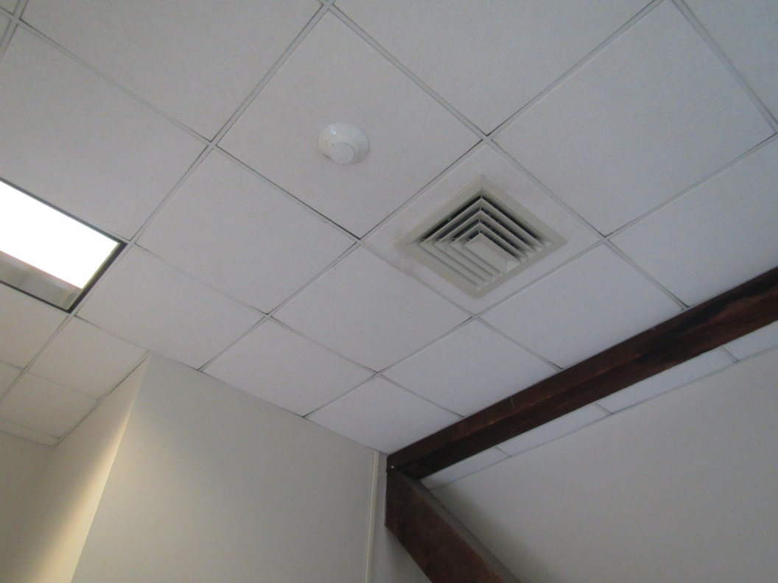

**Supply vent**

**Picture 2**

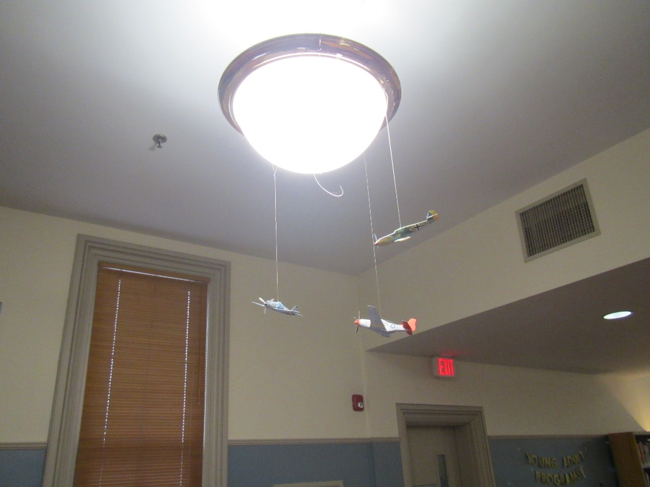

**Wall-mounted return vent**

**Picture 3**

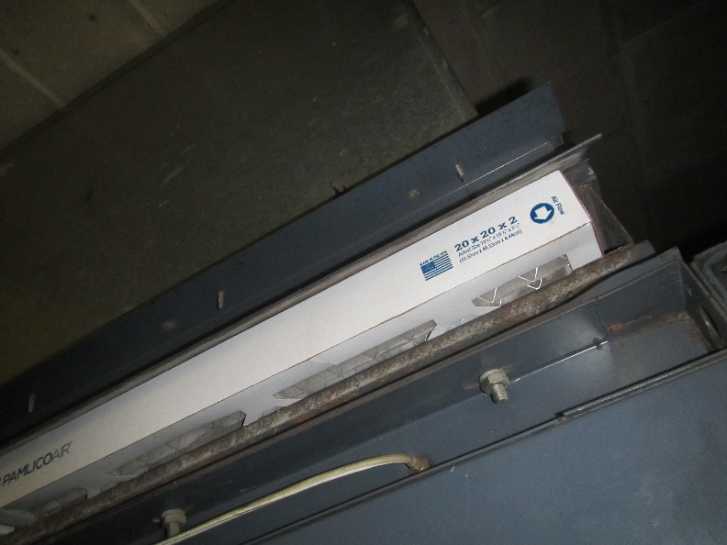

**Filter slot with filter that doesn’t quite fit so slot door can’t close**

**Picture 4**

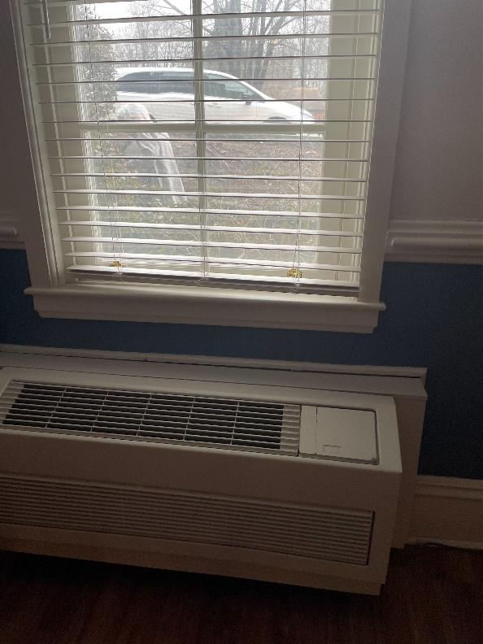

**Unit ventilator (univent)**

**Picture 5**

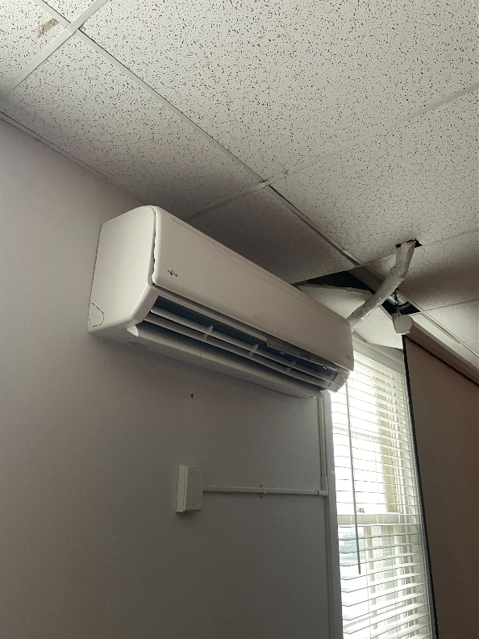

**Ductless air conditioner (mini-split)**

**Picture 6**

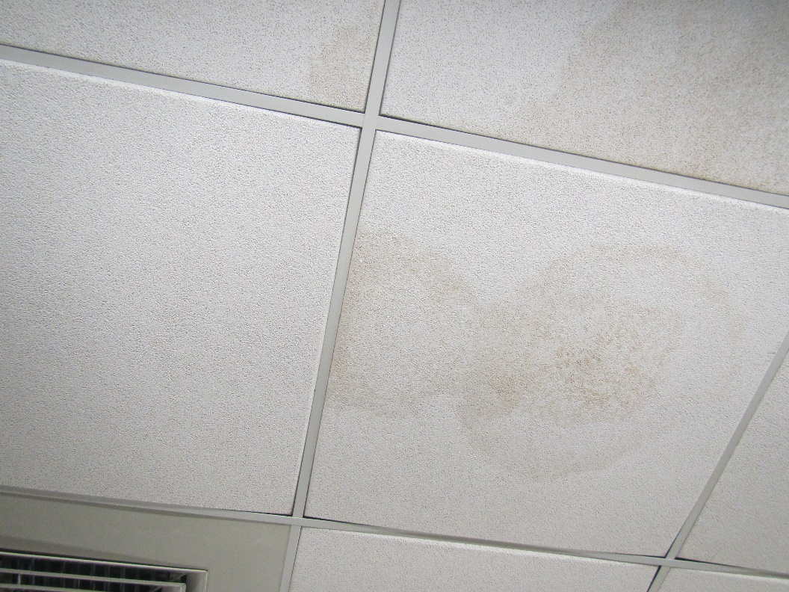

**Water-damaged ceiling tiles near sprinkler system**

**Picture 7**

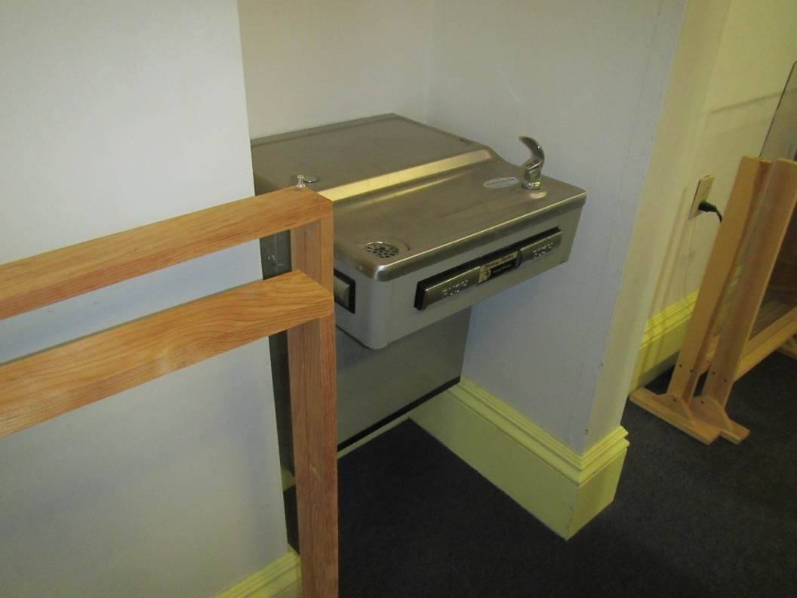

**Water fountain over carpet**

**Picture 8**

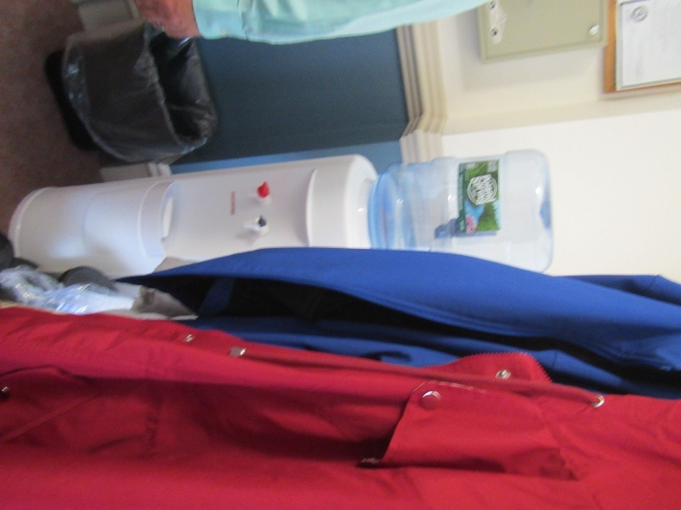

**Water cooler in a carpeted area**

**Picture 9**

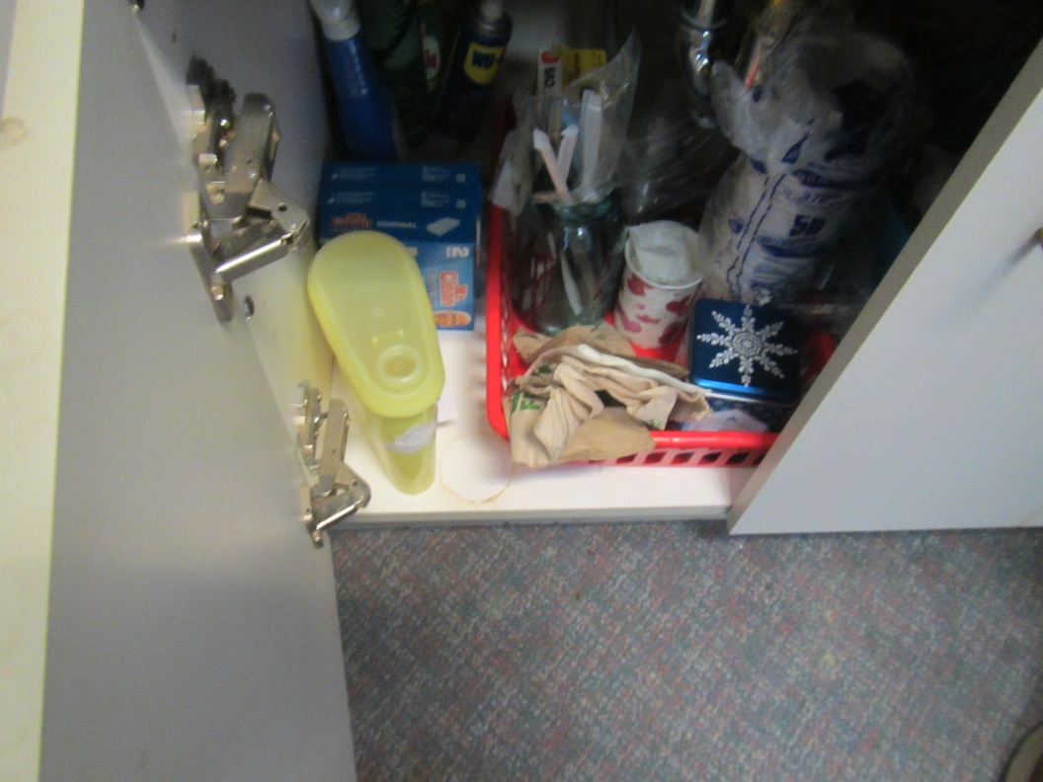

**Items under a sink, including porous items like paper towels**

**Picture 10**

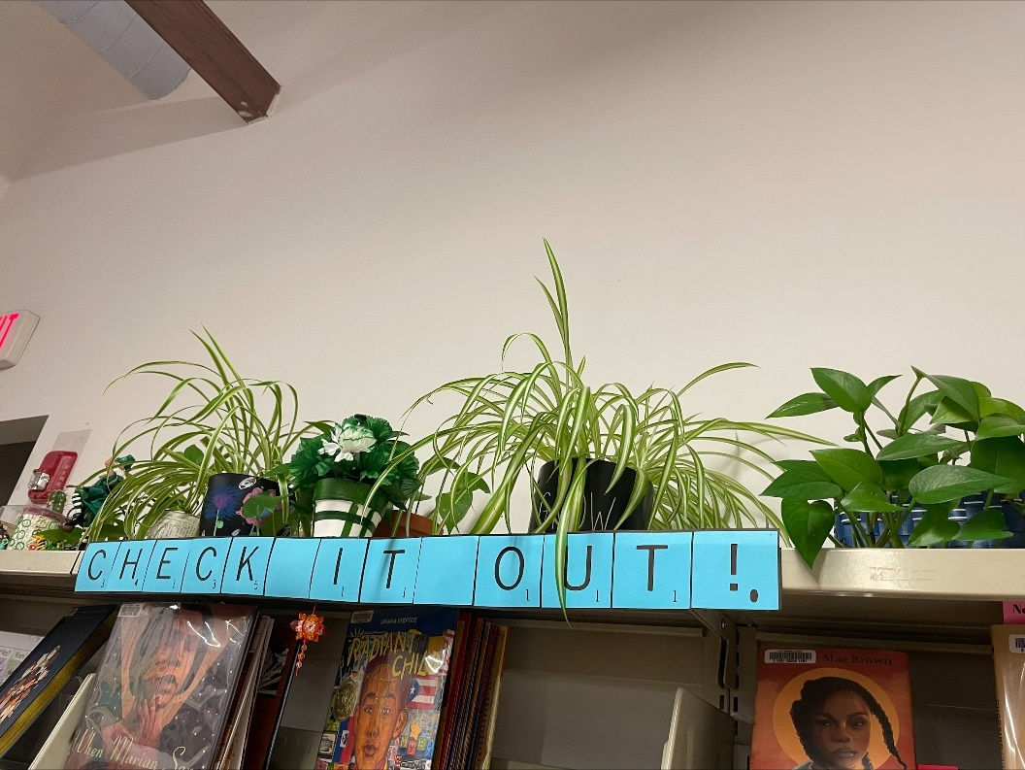

**Plants**

**Picture 11**

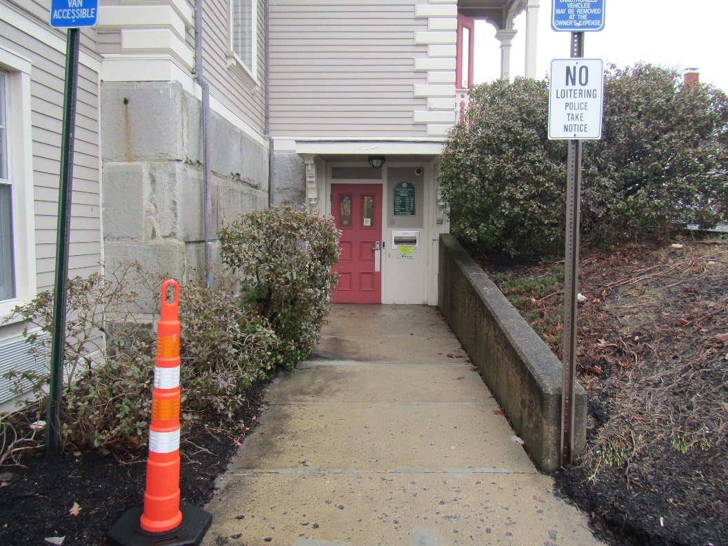

**Bushes next to the building**

**Picture 12**

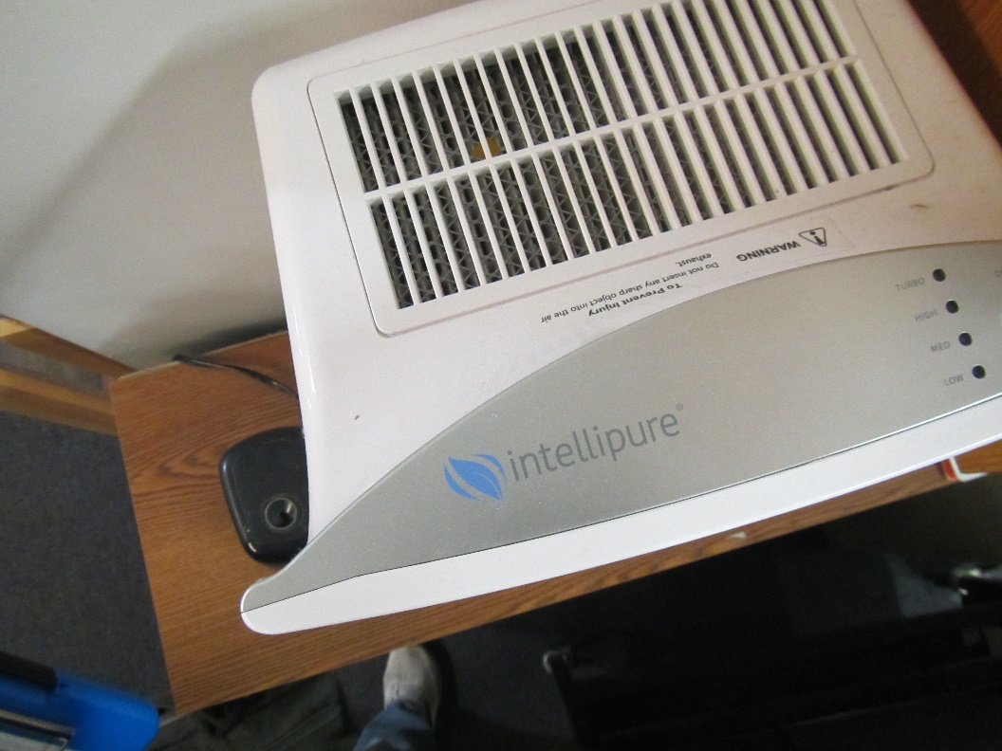

**Top view of an air purifier**

| **Location** | **Carbon**  **Dioxide**  **(ppm)** | **Carbon Monoxide**  **(ppm)** | **Temp**  **(°F)** | **Relative**  **Humidity**  **(%)** | **PM2.5**  **(µg/m3)** | **Occupants**  **in Room** | **Windows**  **Openable** | **Ventilation** | | **Remarks** |
| --- | --- | --- | --- | --- | --- | --- | --- | --- | --- | --- |
| **Supply** | **Exhaust** |
| Background | 387 | ND | 61 | 72 | ND |  |  |  |  | showers |
| Basement Activities Room | 1166 | ND | 69 | 64 | ND | 0 | Y | Y | Y | Ductless mini split |
| Lower level women’s restroom |  |  |  |  |  |  | N |  | Y not on |  |
| Lower level men’s restroom |  |  |  |  |  |  | N |  | Y on |  |
| 1st Floor |  |  |  |  |  |  |  |  |  |  |
| First floor open area | 653 | ND | 76 | 49 | ND | 4 | Y | Y | Y |  |
| Young Adult area | 663 | ND | 75 | 48 | ND | 1 | Y | Y | Y |  |
| Assistant Directors Office | 710 | ND | 75 | 50 | ND | 2 | Y | Y | Y |  |
| 2nd Floor |  |  |  |  |  |  |  |  |  |  |
| Room No. 1 | 675 | ND | 76 | 47 | ND | 0 | Y | Y | Y |  |
| Room No. 2 | 709 | ND | 76 | 47 | ND | 0 | Y | Y | Y |  |
| Room No. 3 | 710 | ND | 76 | 47 | ND | 0 | Y | Y | Y |  |
| Local History Rm | 890 | ND | 76 | 49 | ND | 5 | Y | Y | Y |  |
| Directors Office | 703 | ND | 75 | 44 | ND | 0 | Y | Y | Y |  |
| Reference Office | 783 | ND | 75 | 49 | ND | 1 | N/A | Y | Y |  |
| Open Book Area | 685 | ND | 75 | 50 | ND | 1 | Y | Y | Y |  |
| 3rd Floor |  |  |  |  |  |  |  |  |  |  |
| Book stacks | 739 | ND | 73 | 50 | ND | 0 | Y | Y | Y |  |
| Childrens Room Office | 757 | ND | 70 | 47 | ND | 0 | Y | Y | Y |  |
| Childrens Room | 796 | ND | 71 | 48 | ND | 12 | Y | Y | Y |  |