Attachment APR

Delivery System Reform Incentive Payment (DSRIP) Program

Accountable Care Organization (ACO) PY2 Annual Progress Report Response Form

Part 1: PY2 Progress Report Executive Summary

General Information

Full ACO Name: | Wellforce in partnership with Fallon Community Health Plan
ACO Address: | 10 Chestnut Street, Worcester, MA 01608

Part 1. PY2 Progress Report Executive Summary

1.1 ACO Goals from its Full Participation Plan

Goals for our DSRIP Program:
- Integrating physical health, behavioral health, long-term services and supports, health-related social services, and overall member care
- Increasing the member-centeredness and member experience of care
- Increasing member access to culturally and linguistically appropriate services and to medical and diagnostic equipment that is accessible to members with disabilities
- Reducing avoidable costs of care, including avoidable inpatient admissions and readmissions, increasing the quality of member care
- Adding or improving existing health information technology infrastructure or capabilities, including use of the Mass HIway

Basis for Choosing Identified Goals:
Reducing total medical expenses is critical to the financial viability of the ACO. The ACO experienced a rapid increase in costs particularly in admissions in the first half of 2019. As a result, the total costs of care on a Per Member Per Month (PMPM) basis for the ACO ran significantly above 2018 results, particularly for the first half of the year.
The rise in costs was driven primarily by increased inpatient expenses. Reducing admissions requires a multipronged approach. Longer term reductions require reducing the future likelihood of an initial admission by better integration of primary and physical health and providing culturally competent care to patients. Shorter term reductions involve better care coordination and discharge planning to reduce the likelihood of readmissions. We believe all of our goals support the reduction of total medical expense.

1.2 PY2 Investments Overview and Progress toward Goals
Programmatic Strategy: Our vision is to deliver integrated, person-centered care at the right time, right place, and at the right level of intensity using best practices. To this end, Wellforce and Fallon Health have developed several priorities that guide our use of DSRIP funds and our alignment with EOHHS’ goals for Delivery System: Our funding priorities are indicated below:
• Priority 1: Develop high-value, integrated provider partnerships that address Members’ medical, behavioral and psychosocial needs in a person-centered, culturally and linguistically appropriate manner.
• Priority 2: Increase BH/LTSS integration through partnerships with PCPs, Community Partners (CPs) and Care Management staff.
• Priority 3: Fund “flexible services” that address social determinants of health.
• Priority 4: Build a foundation to expand our role in accountable care delivery.
• Priority 5: Materially improve Member experience and relationships with PCPs.
ACO Approach to Population Health Management, Provider Accountability, Total Cost of Care Management, Path to Sustainability: Wellforce uses a population health management tool and care management platform to monitor and manage the entire membership and to identify areas at the Wellforce, hospital, regional, practice, and clinician levels that can be improved through intervention. Wellforce’s effective targeting and intervention strategy is comprehensive: the strategy is built on a primary care foundation that utilizes care management teams, community partners, and patient-centered programs with a focal point of the strategy designed to decrease unnecessary ED and inpatient utilization. This approach was designed to bend the cost curve and set the ACO on the path to financial sustainability after grant funding tapers down and eventually expires.
Example 1:
- Investment Identifier and Specific Investment or Program: S/O D: 409 -- Clinical Integration and Clinical Integration and S/O D: 407 (partial funding)
  - Investment Description: The Lowell Community Health Center (CHC) accounts for a significant portion of the Lowell region’s membership, this resource is essential to supporting and guiding the clinical integration strategy between the Lowell CHC, PHO, community partners, and other ACO partners to optimize care for Lowell patients. Prior to Plan Year 2 the Lowell CHC and the Lowell General PHO essentially had separate models of care for the ACO, each with their own staff.
- Status: In the later half of 2019 we streamlined our program to create one Model of Care in the Lowell region with an initial focus on coordinating care for adult members where we were experiencing higher than expected claims.
- Target Goals
- Reducing avoidable costs of care, including avoidable inpatient admissions and readmissions
- Increasing the quality of member care and integrating physical health, behavioral health, long-term services and supports, health-related social services, and overall member care
Example 2:
- Investment Identifier and Specific Investment or Program: S/O D: 429 -- Health Information Technology: Health Information Technology
  - Investment Description: Wellforce extended its current Patient Ping contract to include ACO members so care teams can be notified when patients present at facilities across the state. This funding also included working with Patient Ping to expand the network of facilities using Patient Ping.
- Status: Patient Ping along with Collective Medical is now used across Wellforce to receive notifications when patients are admitted, discharged or transferred from acute care facilities as well as post-acute facilities While a majority of care is delivered within the ACO, these platforms allow timelier notification for care outside of Wellforce providers.
- Target Goals: Integrating physical health, behavioral health, long-term services and supports, health-related social services, and overall member care.
Example 3:
- Investment Identifier and Specific Investment or Program: S/O D: 417 -- Clinical Integration, Referral Management
  - Investment Description: Wellforce ACO invested in a Referral Management program to assist practices with access to appropriate provider referrals as needed. This investment supported the development of high-value, integrated provider partnerships and improved member experience by promoting access to services within the Medicaid ACO.
- Status: In 2019 approximately 73% of all facility care (based on reimbursed services) was provided by one of the three hospitals that founded the ACO. This allows for a significant improvement in care coordination.
- Target Goal: Integrating physical health, behavioral health, long-term services and supports, health-related social services, and overall member care

Example 4:
- Investment Identifier and Specific Investment or Program: S/O D: 407 and S/O PC: 401 Care Coordination & Care Management: Regional Care Team
  - Investment Description: ACO has invested in regional care teams for NEQCA, Hallmark, Tufts MC, Lowell PHO and Lowell CHC to support the Model of Care. The regional care teams serve as the primary contact for PCP practices and ensure every patient with complex needs is assigned a care manager.
- Status: The care teams have been implemented and staffed. They acatively coordinate multidisciplinary care teams, PCP sign-offs on care plans, and facilitate flow of information between providers, community partners, Fallon, Beacon for behavioral health, and acute and subacute partners. They also assist with care plans; collaborate with PCPs; provide model development, training and modifications; coordinate BH community referrals; and document in PCP EHRs. Members of the teams also provide health and disease education; assist with patient navigation; and assist with home visits, applications, transportation needs, and community referrals. During the last half of 2019 after a difficult start we have seen a moderation of total medical expenses that has continued to improve in early 2020.
- Target Goals: Integrating physical health, behavioral health, long-term services and supports, health-related social services, and overall member care
  - Increasing the member-centeredness and member experience of care
  - Increasing member access to culturally and linguistically appropriate services and to medical and diagnostic equipment that is accessible to members with disabilities
  - Reducing avoidable costs of care, including avoidable inpatient admissions and readmissions, increasing the quality of member care

1.3 Success and Challenges of PY2
Success Example 1:
- Investment Identifier and Specific Investment or Program: S/O D: 409 -- Clinical Integration: Clinical Integration and S/O D: 407 (partial funding)
  - Prior to Plan Year 2 the Lowell CHC and the Lowell General PHO essentially had separate models of care for the ACO, each their own staff. In the later part of 2019 we streamlined our program to create one Model of Care in the Lowell region with a focus on adults. Both the CHC and Lowell General PHO saw positive results (displayed below).

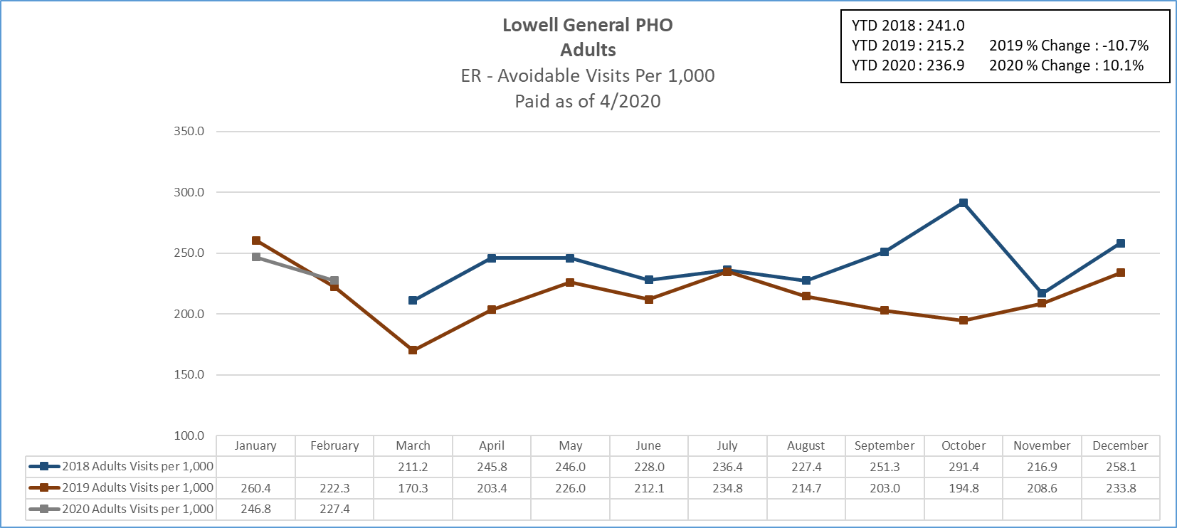

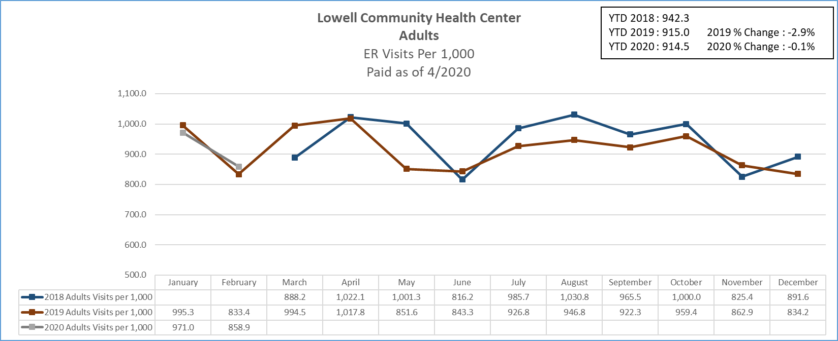
Success Example 2:
- Investment Identifier and Specific Investment or Program: S/O D: 407 and S/O PC: 401 Care Coordination & Care Management: Regional Care Team
  - The ACO has invested in regional care teams for NEQCA, Hallmark, Tufts MC, Lowell PHO and Lowell CHC to support the Model of Care. The regional care teams serve as the primary contact for PCP practices and ensure every patient with complex needs is assigned a care manager. The care teams also assemble multidisciplinary care teams, coordinate PCP sign-offs on care plans, and facilitate flow of information between providers, community partners, Fallon, Beacon for behavioral health, and acute and subacute partners. They also assist with care plans; collaborate with PCPs; provide model development, training and modifications; coordinate BH community referrals; and document in PCP EHRs. Provide health and disease education; assist with patient navigation; and assist with home visits, applications, transportation needs, and community referrals. Administrative oversight is provided to ensure that teams are properly resourced and effective in their goals. During the last half of 2019 after a difficult start we have seen a moderation of total medical expenses that has continued to improve in early 2020.

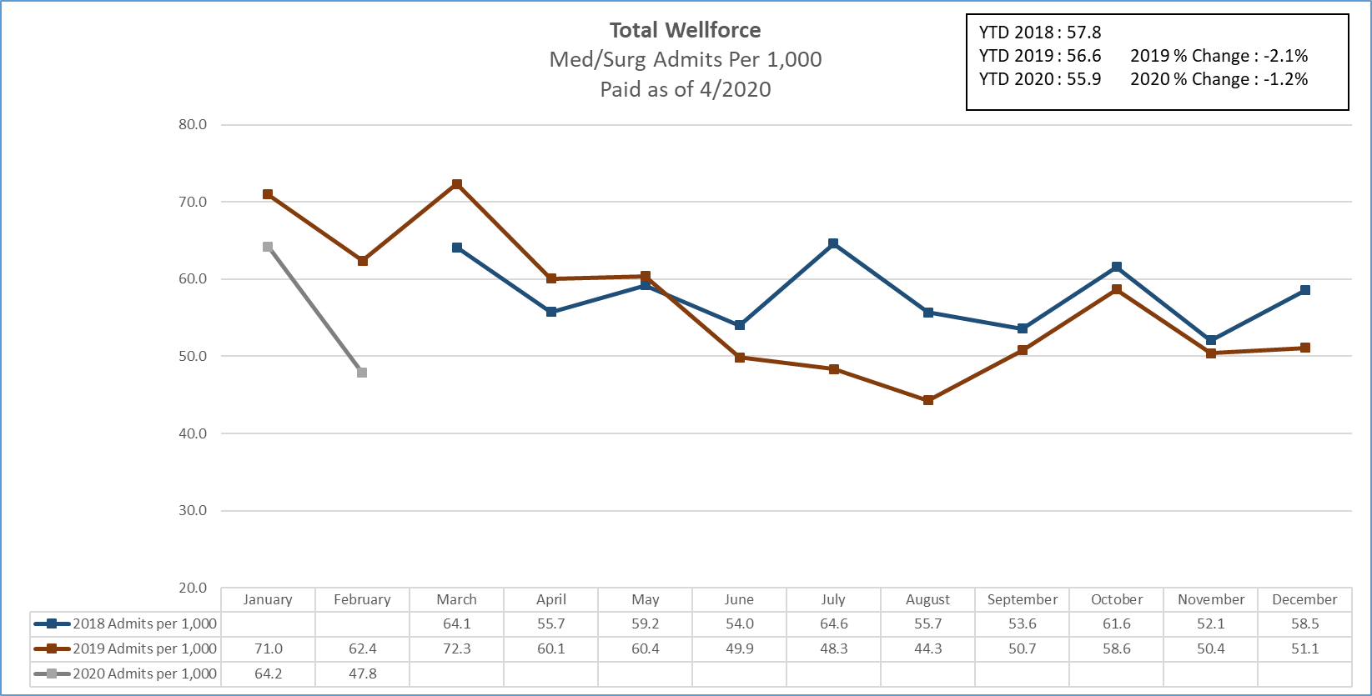

Challenges:
The most significant challenges in 2019 centered on refining the Model of Care. Wellforce Care Plan is a relatively new entity. Prior the ACO program patients were serviced by a number of different managed care plans as well as the state Primary Care Clinician program. Since the provider system uses multiple EMRs a full data set of the ACO membership was elusive. After the first year of experience we realized our model was not focused enough on “emerging risks”. Rethinking how we stratify risk has been a key part of 2019 and has resulted in necessary changes.

An additional challenge has been the launch of the Community Partners (CP) program. While we believe this program can have a meaningful impact on our patients the number of CPs, lack of standardization, and differing views of responsibilities has hampered progress. As a result, many of the members that should be managed by CPs are still receiving a great deal of coordination by our care teams.

