WATER DAMAGE ASSESSMENT

Florence Sawyer School
100 Mechanic Street
Bolton, MA

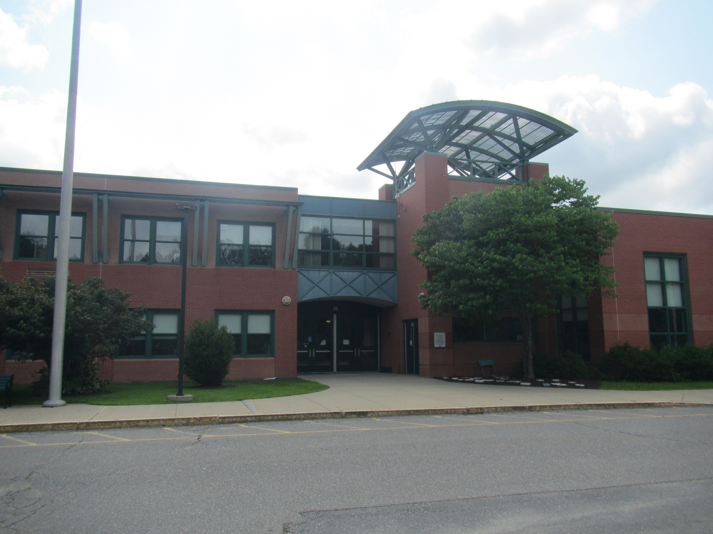

Prepared by:
Massachusetts Department of Public Health
Bureau of Environmental Health
Indoor Air Quality Program
August 2021

BACKGROUND
Building: | Florence Sawyer School (FSS)
Address: | 100 Mechanic Street, Bolton, MA
Assessment Requested by: | Robert Frieswick, Director of Facilities, Nashoba Regional School District
Reason for Request: | Water damage assessment in multiple classrooms
Date of Assessment: | July 29, 2021
Massachusetts Department of Public Health/Bureau of Environmental Health (MDPH/BEH) Staff Conducting Assessment: | Mike Feeney, Director, Indoor Air Quality (IAQ) Program, and Ruth Alfasso Environmental Engineer/Inspector, IAQ Program
Building Description: | The FSS is a two-story brick school building with an interior courtyard constructed in 1997.
Windows: | Openable in most areas

METHODS
DPH staff conducted testing for temperature, relative humidity, and dew point with a Qtrak 7565-x, surface temperature testing using a laser thermometer, moisture testing of flooring and other materials using a moisture meter, and a visual assessment of water-damaged materials. Please refer to the IAQ Manual for methods, sampling procedures, and interpretation of results (MDPH, 2015). Note that no testing for carbon dioxide was conducted, as the building was unoccupied.
This building was visited previously by the IAQ program, most recently in 2018. A copy of the report from that visit is available on the DPH website at: https://www.mass.gov/info-details/indoor-air-quality-reports-cities-and-towns-b#bolton-

RESULTS AND DISCUSSION
The following is a summary of indoor air testing results (Table 1):
- Temperature was within or slightly above the MDPH recommended range of 70°F to 78°F in areas tested; note that most areas in the school are not equipped with air conditioning.
- Relative humidity was mostly above the MDPH recommended range of 40 to 60% in all areas.
- Dew point temperatures ranged from 60-65 °F in unairconditioned areas and were lower where air conditioning was operating.
- Floor temperatures were above the corresponding dew points in room air, but for some areas on the first floor, these temperatures were close to the dew point. Surfaces that are at or below the dew point will collect condensed moisture from the air.

Ventilation
A heating, ventilating and air conditioning (HVAC) system has several functions. First it provides heating and, if equipped, cooling. Second, it is a source of fresh air. Finally, an HVAC system will dilute and remove normally occurring indoor environmental pollutants by not only introducing fresh air, but by filtering the airstream and ejecting stale air to the outdoors via exhaust ventilation. Even if an HVAC system is operating as designed, point sources of respiratory irritation may exist and cause symptoms in sensitive individuals.
Fresh air is provided by a combination of unit ventilators (univents) located in most individual classrooms (Picture 1) and roof top air handling units (AHUs) for common areas (e.g., library, gymnasium, etc.). The univents draw fresh air through a vent on the exterior wall (Picture 2). Air is mixed with return air from the room, filtered, heated (if needed) and delivered to the room (Figure 1). Both the top and the vent at the bottom need to be kept clear of obstructions for the units to operate as designed. Air from the AHUs is filtered, heated or cooled as needed, and delivered to rooms via ducted supply vents.
To maximize air exchange, the IAQ program recommends that both supply and exhaust ventilation operate continuously during periods of occupancy. In order to have proper ventilation with a mechanical ventilation system, the systems must be balanced after installation to provide an adequate amount of fresh air to the interior of a room while removing stale air from the room. It is recommended that HVAC systems be re-balanced every five years to ensure adequate air systems function (SMACNA, 1994).
Note that the school was unoccupied at the time of the visit. However, many univents and the air handling system were operating in the building in part to increase drying of materials that had become moistened due to hot, humid, stagnant conditions in the building. On the second floor, nearly all doors between classrooms and the hallway, and laterally between classrooms, were open and equipped with air-moving equipment such as fans, air purifiers, or high-capacity blowers (Picture 3).

Microbial Concerns
The reason for this visit to the FSS was concerns about water-damaged and mold-colonized materials that were discovered by FSS janitorial staff during a weekly walkthrough. FSS facilities staff reported that surfaces such as floors and carpeting, and items such as chairs and stored materials, were found to be colonized with mold in several classrooms on the first floor of the building (Table 1). Prior to the DPH visit, much of this material had been removed or properly cleaned. Moisture testing of flooring found that carpeting and area rugs in several classrooms on the first floor were moist at the time of the visit. In one location, the water moistening the carpet appears to have come from a leak from a univent. However, most of the moisture is likely from condensation. During the summer of 2021, several periods of extended hot, humid weather have occurred, in conjunction with extended periods of heavy rain. If a building does not have adequate exhaust ventilation and air chilling capacity to remove/reduce relative humidity, then hot/moist air can linger to increase discomfort as well as possibly wet materials that may lead to mold growth.
The key to managing condensation in hot, humid weather indoors is understanding dew point. When warm, moist air passes over a cooler surface, condensation can form. Condensation is the collection of moisture on a surface at or below the dew point. The dew point is the temperature that air must reach for saturation to occur. If a building material/component has a temperature below the dew point, condensation will accumulate on that material. If this material is porous, such as carpeting, it may become colonized by mold.
The first floor of the FSS is on a cement slab. It is not known if insulation or vapor control layers were used in the slab’s construction. As shown by the surface temperature measurements conducted on the day of assessment, the temperature of the floor on the first floor is lower than that of the air. On a day with higher outdoor humidity or rain, the humidity indoors would be higher. For example, with a temperature of 78°F and a relative humidity of 75%, the dew point would be 72°F, which would mean floor temperatures at or below that temperature would be prone to collect moisture.
According to American Society of Heating, Refrigerating and Air-Conditioning Engineers (ASHRAE), if relative humidity exceeds 70%, mold growth may occur due to wetting of building materials (ASHRAE, 1989). It is recommended that porous material be dried with fans and heating within 24 to 48 hours of becoming wet (US EPA, 2008, ACGIH, 1989).
In general, the DPH IAQ program does not recommend the use of carpeting or other porous flooring in areas that are likely to be subject to moistening, particularly in below-grade or at-grade rooms without basements or crawl spaces beneath them. Area rugs used in classrooms should be rolled and stored in a clean, dry location over summer vacation.
There are other potential sources of liquid water and increased humidity to classrooms at the FSS, particularly on the first floor. In many areas along the exterior of the building, the ground slopes towards the building slightly, which would allow rainwater to drain against the building (Picture 4). In some spots, there is a visible depression in the ground directly adjacent to the exterior wall (Picture 5), which both indicates that water accumulates next to the building and makes continued water accumulation more likely to occur. Exterior walls on the north side of the building are always in shade, and thus very slow to dry; this chronic dampness is indicated by the presence of moss on the ground and the growth of lichens on the exterior (Picture 6). Trees and shrubs were also found along the exterior wall in some places (Picture 7). Plants will prevent the walls of the building from drying, and may be a source of pollen, odors and mold spores to univent air intakes. In addition, plant roots can, over time, damage exterior building walls and lead to increased water infiltration.
Water-damaged ceiling tiles were noted in a hallway on the second floor (Picture 8). Water-damaged ceiling tiles indicate a leak from the roof or plumbing system and should be replaced once the leak has been fixed. FSS facilities staff indicated that sometimes ceiling-mounted plumbing “sweats” leading to damage to ceiling tiles. Appropriate insulation of plumbing can reduce this occurrence.
Some areas of the building, including the central office and the media center/library have air conditioning. To prevent condensation, doors between areas with air conditioning and without should be kept closed. The door to the Media center had a gap under the door where cold air from the library could chill the floor of the hallway outside (Picture 9). A door sweep should be used to reduce air transfer from this air-conditioned area. Door sweeps should also be installed and maintained for doors to the exterior to reduce the infiltration of outside air, moisture and pests.

Other Issues
Univents are all equipped with filters. These filters need to be changed regularly 2-4 times a year. Univent filters were noted to be of a Minimum Efficiency Rating Value (MERV) of 8, which is likely the best quality filter that can be used in the current equipment. Filters for the AHUs should also be changed regularly with the best quality filter that can be used with the equipment.
The air purifiers that were observed on the second floor appeared to be a HEPA-type filter unit. These should be maintained, including filter changes, in accordance with manufacturer’s instructions. Air purifiers that may produce ozone should not be used in any occupied areas.
In a few classrooms, a large amount of items were noted on tables and shelves and the floor (Picture 10). Large amounts of items make it more difficult for custodial staff to clean. Items should be stored neatly so that dust removal can be conducted regularly; excess items should be kept in enclosed storage or removed from classrooms.

CONCLUSIONS AND RECOMMENDATIONS
In view of the findings at the time of the visit, the following recommendations are made:

Water Damage Recommendations:
- Inspect all area rugs for water damage and moldy odors. Discard any that have been wet for more than 48 hours or show signs of mold colonization. Roll up the remainder and store them off the floor
- Continue with plans to remove carpeting from affected classrooms on the first floor and replace with non-porous flooring.
- All water-damaged material should be removed in a manner consistent with recommendations listed in the US EPA’s “Mold Remediation in Schools and Commercial Buildings” (US EPA, 2008). This work should be performed when the building is unoccupied.
- Consider using the methods described in the document “Preventing Mold Growth in Massachusetts Schools During Hot, Humid Weather” to help reduce the impact of hot, humid weather in the balcony space. This guideline is attached as Appendix A and can be found online at: https://www.mass.gov/service-details/preventing-mold-growth-in-massachusetts-schools-during-hot-humid-weather
  - As noted in this document, according to ASHRAE, if relative humidity exceeds 70%, mold growth may occur due to wetting of building materials (ASHRAE, 1989).
  - Monitoring weather for predicted outdoor relative humidity over 70% for over 2 consecutive days is recommended. It is highly recommended to implement these guidelines during these weather events. This is mostly likely to occur during summer heatwave conditions in New England.
- Consider methods to improve drainage and drying around the exterior of the building, including sloping of the ground away from the building.
- Remove trees and shrubs away from the building a minimum of 5 feet.
- Consider insulation of ceiling-mounted water pipes to reduce condensation.

Other Recommendations
- Continue with regular filter changes for univents and AHUs using the best quality/highest MERV rating filters that can be used with current equipment.
- Maintain stand-alone air filters in accordance with manufacturer’s instructions.
- Reduce clutter in classrooms and ensure that items are stored neatly and off the floor.
- Refer to the resource manual and other related indoor air quality documents located on the MDPH’s website for further building-wide evaluations and advice on maintaining public buildings. These documents are available at http://mass.gov/dph/iaq.

REFERENCES
ACGIH. 1989. Guidelines for the Assessment of Bioaerosols in the Indoor Environment. American Conference of Governmental Industrial Hygienists, Cincinnati, OH.
ASHRAE. 1989. Ventilation for Acceptable Indoor Air Quality. American Society of Heating, Refrigeration and Air Conditioning Engineers. ANSI/ASHRAE 62-1989.
MDPH. 2015. Massachusetts Department of Public Health. Indoor Air Quality Manual: Chapters I-III. Available at: https://www.mass.gov/lists/indoor-air-quality-manual-and-appendices#indoor-air-quality-manual-
SMACNA. 1994. HVAC Systems Commissioning Manual. 1st ed. Sheet Metal and Air Conditioning Contractors’ National Association, Inc., Chantilly, VA.
US EPA. 2008. “Mold Remediation in Schools and Commercial Buildings”. Office of Air and Radiation, Indoor Environments Division, Washington, DC. EPA 402-K-01-001. September 2008. Available at: http://www.epa.gov/mold/mold-remediation-schools-and-commercial-buildings-guide.

Figure 1

Unit Ventilator (Univent)

Mixed Air

Air Diffuser

Outdoors Indoors

Fan

Heating/Cooling Coil

Air Mixing Plenum

Filter

Outdoor Return
Air Air

Air
Flow
Control
Louvers

Air Flow

= Fresh Air/Return Air

= Mixed Air

Picture 1

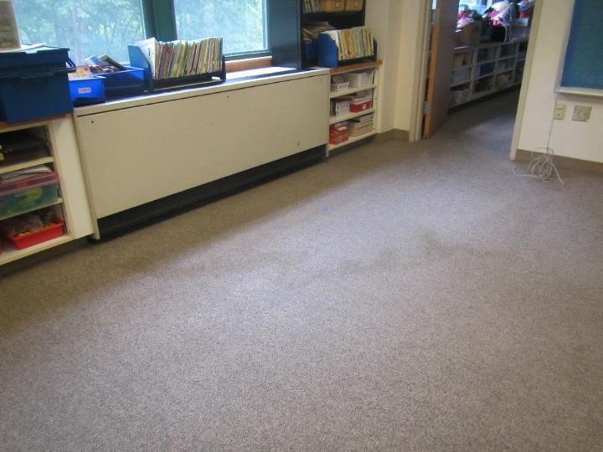

Classroom univent, note stain on carpet from recent univent leak

Picture 2

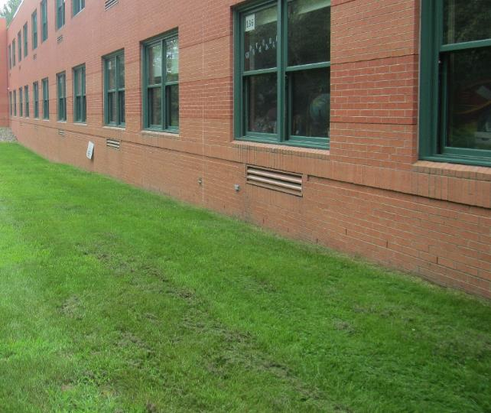

Typical univent intake on the outside of the building

Picture 3

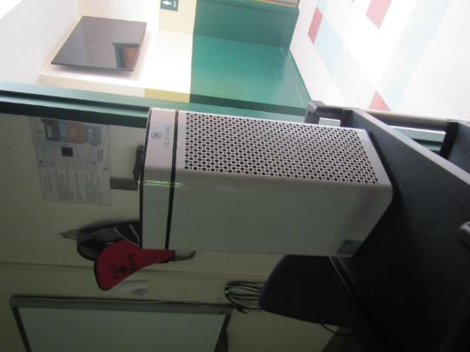

Air purifier in the doorway of a classroom on the second floor

Picture 4

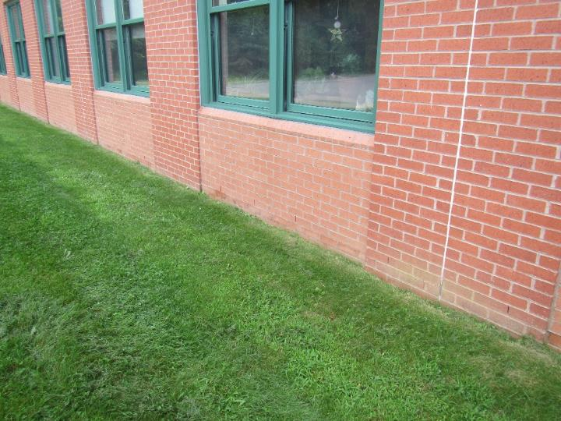

Slope of ground towards building exterior

Picture 5
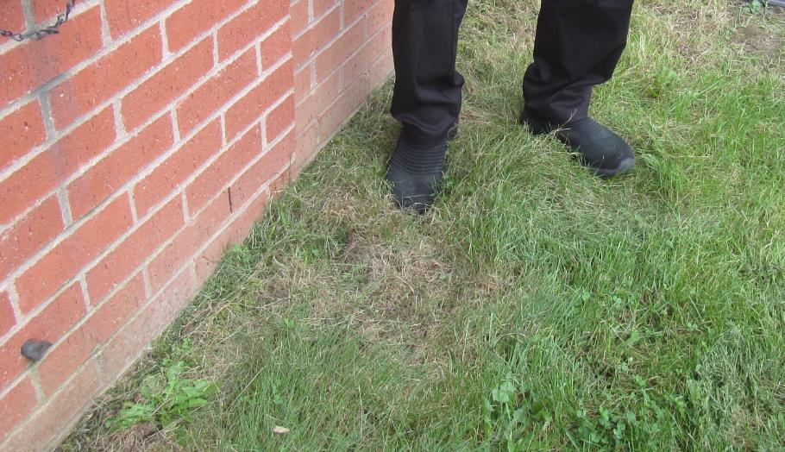
Depression in the ground next to the building exterior
Picture 6
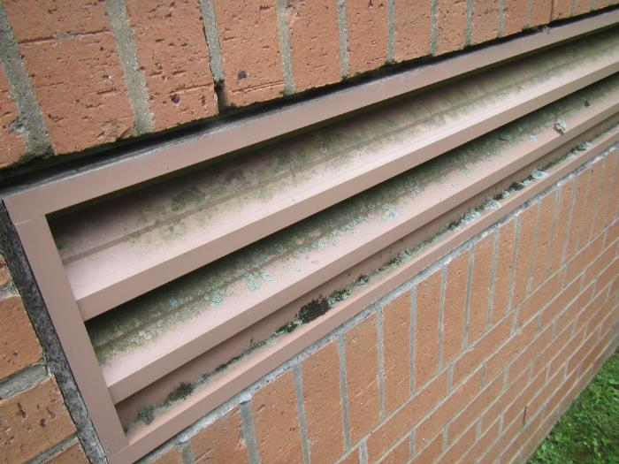
Lichen on the univent air intake
Picture 7
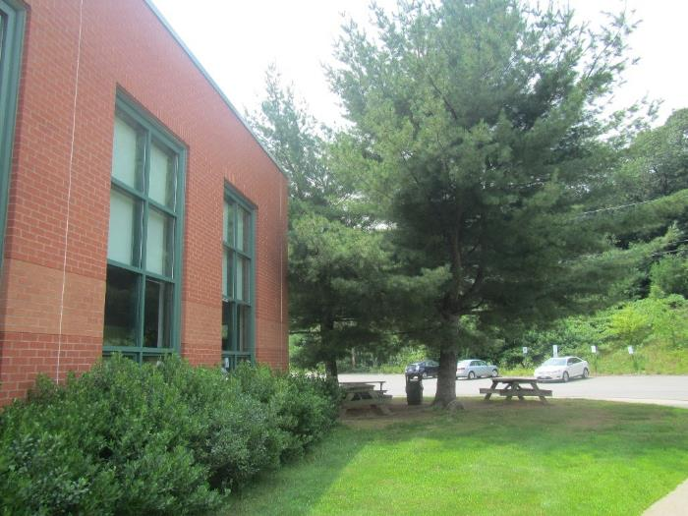
Trees and shrubs close to the building
Picture 8
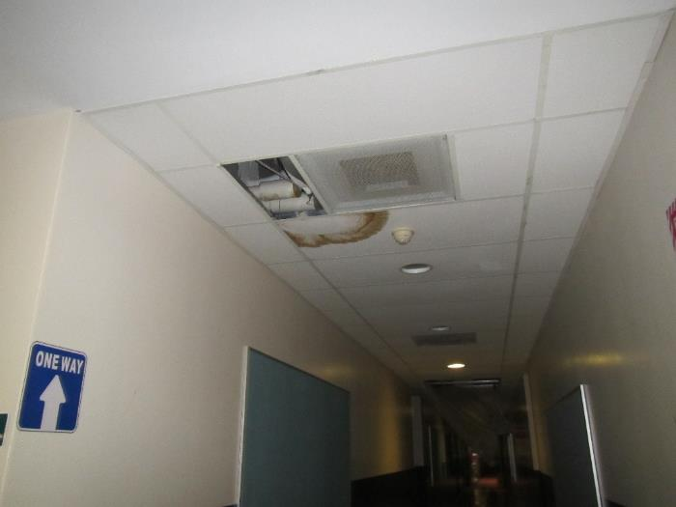
Water-damaged ceiling tile in second floor hallway
Picture 9
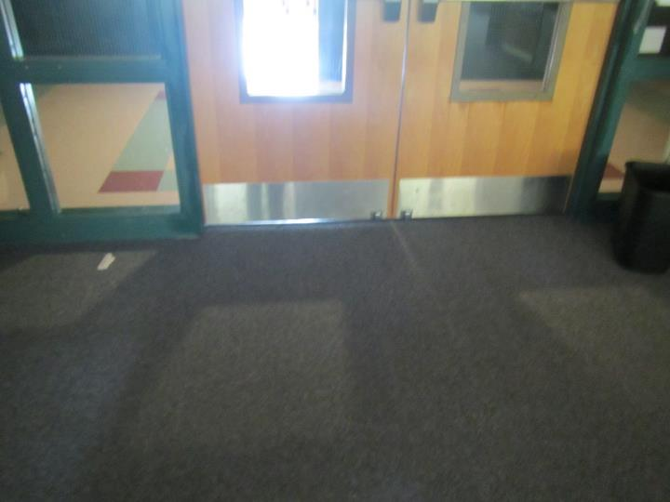
Gap underneath the doors between the Media Center and the hallway
Picture 10
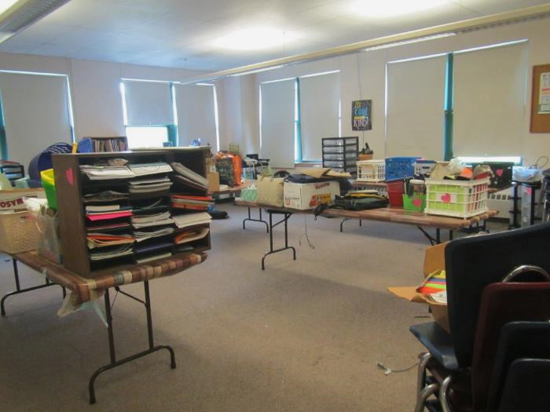
Items in a classroom
Location | Temp  (°F) | Relative  Humidity  (%) | Dew Pt.  (°F) | Floor Temp  (°F) | Floor/ Wall Junct. Temp  (°F) | Air-Floor temp  (°F) | Water-Damaged CT  (#) | Bowed CT  (#) | Window  Openable | Ventilation |  | Remarks
 |  |  |  |  |  |  |  |  |  | Supply | Exhaust
Background (outside) | 74 | 65 | 62 |  |  |  |  |  |  |  |  | Breezy, partly cloudy
First Floor
162 | 77 | 61 | 63 | 65 | 68 | 12 |  | N | Y | Y | Y | Carpet
157 | 78 | 62 | 63 | 65 | 68 | 13 | N | N | Y | Y | Y | Moldy carpet
155 | 78 | 63 | 63 | 66 | 66 | 12 | N | N | Y | Y | Y
151 | 77 | 60 | 62 | 64 | 64 | 13 | N | N | Y | Y | Y | Carpet moisture 10-77%
150 | 78 | 58 | 62 | 66 | 68 | 12 | N | N | Y | Y | Y | WD drywall
136 | 80 | 48 | 59 | 76 | - | 4 | N | N | Y | Y | Y
140 | 77 | 58 | 61 | 71-72 | - | 5-6 | N | N | Y | Y | Y | Not impacted by mold
143 | 78 | 58 | 62 | 68-72 | - | 6-10 | N | N | Y | Y | Y | Former leak from univent, carpet up to 100% moisture in this area. Carpet also has high moisture under area rug
Second
202 | 77 | 60 | 62 | 72 | - | 5 | N | N | Y | Y | Y | Non-carpeted room, Doors open from hallway to all rooms and between rooms, each doorway equipped with an air purifier
207 | 74 | 66 | 62 | 72-73 | - | 1-2 | 3 | slight | N | Y | Y | UV on
216 | 77 | 65 | 64 | 73-75 | - | 2-4 | N | N | Y | Y | Y
220 | 77 | 63 | 63 | 74-76 | - | 1-3 | N | N | Y | Y | Y | Carpet dry
221 | 77 | 65 | 63 | 74-75 | - | 2-3 | N | N | Y | Y | Y | Extra-large blower fan
226 corner room | 79 | 64 | 63 | 76-78 | - | 1-3 | N | N | Y | Y | Y | Sink backsplash
228 | 78 | 62 | 64 | 75-76 | - | 2-3 | N | N | Y | Y | Y
230 | 79 | 61 | 65 | 76-77 | - | 2-3 | N | N | Y | Y | Y | UV on
231 | 79 | 60 | 64 | 75 | - | 4 | N | N | Y | Y | Y | UV on
234 science | 78 | 59 | 64 | 73-74 | - | 4-5 | N | N | Y | Y | Y | UV on, NC, sinks
239 | 79 | 64 | 60 | 74-76 | - | 3-5 | N | N | Y | Y | Y | Plant
243 | 79 | 64 | 60 | 74-76 | - | 3-5 | N | N | Y | Y | Y | UV on, clutter
Media/library | 74 | 51 | 54 | 72 | - | 2 | N | N | N | Y | Y | AC- on, needs door sweep

BUREAU OF ENVIRONMENTAL HEALTH
Indoor Air Quality Program

Preventing Mold Growth in Massachusetts Schools
During Hot, Humid Weather

June 2004

Background/Statement of the Problem
During the summers of 2002 and 2003, schools and other municipal buildings experienced significant mold problems. As a result, at least thirty school systems have experienced delayed school openings and/or have spent substantial funds on cleaning and remediating mold growth in schools. These mold growth problems are directly related to unusual weather patterns in New England (e.g., extended periods of hot, humid weather).

Mold growth in a building can produce eye, nose, throat, and respiratory irritation. Mold may also exacerbate pre-existing respiratory problems (e.g., asthma) and cause symptoms in hypersensitive individuals. For these reasons, it is recommended that mold contaminated materials be removed or cleaned, where feasible (US EPA, 2001).

This document provides guidance on preventing or minimizing mold growth within a building. Most mold prevention steps can be employed in any building. However, certain steps involving dehumidification can only be achieved with dehumidifiers and/or heating, ventilating, and air-conditioning (HVAC) equipment

Understanding Dew Point
In general, two water phases - liquid and vapor - can create conditions conducive to fungal colonization of vulnerable materials. Leaks through the building envelope (e.g., roof, exterior wall components, foundation) or plumbing problems are obvious water sources. If the indoor environment is improperly managed, high relative humidity combined with hot weather can also cause damage. Under certain conditions, condensation can accumulate and moisten materials, especially porous, carbon-containing items (e.g., gypsum wallboard, carpeting, cloth, paper, cardboard).

The key to managing condensation within a building is understanding dew point. When warm, moist air passes over a cooler surface, condensation can form. Condensation is the collection of moisture on a surface at or below the dew point. The dew point is the temperature that air must reach for saturation to occur. If a building material/component has a temperature below the dew point, condensation will accumulate on that material. Over time, condensation can collect and form water droplets.

For example, at a temperature of 76ºF and relative humidity of 30%, the dew point temperature at which condensation can collect on a surface is approximately 42ºF. At temperatures less than 43ºF, water vapor can condense and form droplets on a surface. During humid weather, when the temperature is 85ºF and relative humidity is 90%, the dew point is approximately 82ºF. Therefore, surfaces with a temperature below 83ºF are prone to condensation formation.

According to American Society of Heating, Refrigerating and Air-Conditioning Engineers (ASHRAE), if relative humidity exceeds 70%, mold growth may occur due to wetting of building materials (ASHRAE, 1989). It is recommended that porous material be dried with fans and heating within 24 to 48 hours of becoming wet (US EPA, 2001, ACGIH, 1989). If porous materials are not dried within this time frame, mold growth may occur. Water-damaged porous materials cannot be adequately cleaned to remove mold growth. To prevent condensation formation, the following points are recommended:
Action Step: Monitor weather through extended weathercasts to determine if hot, humid weather for more than 2 days is predicted. Many web-based weather services will provide a dew point listing.
Action Step: Monitor temperature of condensation prone building components with a laser thermometer. If the temperature of the building component is below the dew point during hot, humid weather, steps should be taken to decrease humidity levels.

Reducing Relative Humidity through Mechanical Means

Cooling
Cooling air is the easiest method to reducing airborne water vapor. Window-mounted air conditioners and most HVAC systems are equipped with cooling coils. Each of these cooling efforts operates by drawing air over cooling coils that are set to a temperature below the dew point. As a result, condensation forms. In this manner, moisture is removed, before air is provided to a room. Although this method is the easiest for reducing indoor relative humidity, two disadvantages exist. First, drainage for condensation must be adequate to remove water at a sufficient rate. If a significant amount of water accumulates and lingers in the drip pan, the operation of HVAC system fans can reintroduce the moisture into the air stream. In addition, stagnant water can provide a medium for mold growth and associated odors.
Action Step: If systems equipped with cooling coils are used to remove moisture, ensure drain pans are operating as designed. Drain pans should not rely on evaporation to remove condensation; rather, water should drain rapidly. If pans are draining improperly, the drainage should be repaired. If proper drainage cannot be provided, this method of relative humidity reduction should be avoided.
Another problem associated with using cooling coils to reduce relative humidity is the potential for condensation generation on building components. This occurs when the HVAC system chills building components below the dew point. Most problems experienced in schools occurred in August 2003, when the buildings were unoccupied. HVAC systems are typically configured for occupied rooms, where room occupants generate heat. However, lack of building occupancy reduces the waste heat in a room. If the HVAC system operates at settings for occupied rooms during extended periods of vacancy, the chilling system operates at a temperature below the design. In this manner, building components are chilled below the dew point, causing condensation to form. Under these circumstances, monitoring of building component temperatures is vital to preventing/ minimizing condensation development.
Action Step: Monitor temperature of condensation prone building components with a laser thermometer. If the temperature of building components is below the dew point, raise the HVAC system set point to elevate the temperature of building materials above the dew point. The temperature of insulated chilled water pipes and HVAC components in contact with chilled air should also be monitored.

Dehumidifying
As with window-mounted air conditioners and HVAC systems, dehumidifiers also remove moisture from an indoor environment by cooling air drawn into the system. Although this method is effective, the dehumidification process also has limitations. Condensation usually drips into a collection well. If the water in the collection well becomes stagnant, it can provide the potential for mold growth.
Action Step: Clean and maintain dehumidifiers as per manufacturer’s instructions. Some dehumidifiers are also equipped with condensation drain hoses. Measures should be taken to ensure water is draining out of hoses when dehumidifiers are operating.
Action Step: Ensure drain hoses are pointed downwards into a suitable receptacle (e.g., sink) and away from porous materials. Monitor draining when the dehumidifier is actively operating.

Heating
Although counterintuitive, the application of heat to building components (e.g., slab floors and foundation in contact with soil, below grade areas) can reduce condensation generation and prevent mold growth. This method is typically employed in areas lacking mechanical ventilation (e.g., storage rooms).
Action Step: Use carpet-drying fans to apply heat to slab floors with carpeting and below grade occupied areas with carpeting, gypsum wallboard, particleboard, plywood, or ceiling tiles.

Increasing airflow
By increasing the airflow of a building, accumulation of hot, moist air can be reduced, decreasing the opportunity for porous materials to become wet. Areas particularly prone to elevated moisture include storage closets and occupied spaces without mechanical ventilation.
Action Step: Implement the following methods to promote increased airflow:
- Open all interior doors between rooms and closets.
- Operate HVAC systems not equipped with chilling components (e.g., unit ventilators, or univents) with the fresh air intake vents closed.
- Operate general exhaust ventilation system normally.
- Arrange floor fans in hallways to circulate air.

Operating specialized exhaust ventilation
Activities in some non-classroom areas can generate water vapor. These areas include pools, kitchens, restrooms, and locker rooms/showers. Specially designed exhaust ventilation systems in these areas should be provided to remove both odors and water vapor. This equipment is designed to prevent migration of odors and water vapor to other areas of a building.
Action Step: Operate exhaust vents in restrooms and locker rooms/showers during hot, humid weather to remove water vapor. The pool exhaust ventilation should be operating at all times.

Removing Porous Materials from Exposure to Water Vapor
To prevent mold growth in buildings, a number of mitigation steps can be taken. Measures may include the removal of porous materials from areas likely to be in contact with surfaces that have a temperature below the dew point, or removal of porous materials from hot, humid areas.
Action Step: The following measures can be used to reduce fungal growth of porous materials.
- Avoid placing wall-to-wall carpeting or other porous materials on slab in contact with soil or on floors in below grade areas.
- Avoid placing porous materials on temperature bridges. A temperature bridge is a structure that allows cooler temperatures to transfer between two areas. Furniture made of metal is more likely to be susceptible to temperature fluctuations. Avoid storing porous materials on metal objects that are low and in contact with floor or foundation walls.
- Store porous materials in airtight, hard plastic containers.
- Avoid placing porous materials between fresh air supply vents and exhaust vents. The air between this equipment is likely to hold moisture since these systems are used to remove water vapor from a building interior.

Preventing Moisture Intrusion

Separating occupied areas from unoccupied areas
A crawlspace is an unoccupied area that typically consists of a dirt floor, which holds moisture. As a result, this area is prone to high relative humidity and mold growth. The crawlspace is often used as a chase way to run pipes and electrical services to rooms through a building. Crawlspaces are usually present in schools that are equipped with univents connected to heating pipes. Spaces and holes in walls and floors provide a pathway for crawlspace air to penetrate classrooms. Breaches around pipes also provide a means for crawlspace air and associated odors/particles to be drawn and distributed to classrooms via univents. In order to prevent moisture and potential fungal pollutant migration from the crawlspace to occupied areas, penetrations should be rendered airtight.
Action Step: Seal holes/breaches with an appropriate fire-rated sealant compound to prevent air draw from the crawlspace.

Reducing the Water Load on the Building Envelope
Breaches in the building envelope or water pooling on/against a building structure can also result in water penetration and subsequent mold growth. Buildings are typically designed for minimal water impingement via building envelope components, including the roof, exterior walls, foundation, and other penetration points through the structures. For example, exterior wall systems should be designed weep holes and drainage plans to prevent moisture accumulation penetration.

An exterior wall system of many buildings contains an exterior curtain wall. Behind the curtain wall is an air space that allows for water to drain downward and for the exterior cladding system to dry. At the base of the curtain wall should be weep holes that allow for water drainage. Opposite the exterior wall and across the air space is a continuous, water-resistant material adhered to the back up wall that forms the drainage plane.

The purpose of the drainage plane is to prevent moisture that crosses the air space from penetrating the interior building system. The plane also directs moisture downwards toward the weep holes. The drainage plane can consist of a number of water-resistant materials, such as tarpaper or, in newer buildings, plastic wraps. The drainage plane should be continuous. Where breaks exist in the drainage plane (e.g., window systems, door systems and univent fresh air intakes), additional materials (e.g., copper flashing) are installed as transitional surfaces to direct water to weep holes. If the drainage plane is discontinuous, missing flashing or lacking air space, rainwater may accumulate inside the wall cavity and lead to water vapor/moisture penetration into the building.

In order to allow water to drain from the exterior brick wall system, a series of weep holes is customarily installed at or near the foundation slab/exterior wall system junction. Weep holes allow for accumulated water to drain from a wall system (Dalzell, 1955). Lack of weep holes in brickwork or burial of weep holes below grade will allow water to accumulate in the base of walls, resulting in seepage and possible moistening of building components.

Unless a structure is designed to be in contact with pooling water, efforts should be made to prevent water from pooling for extended periods. For example, standing water on flat roofs as well as water in contact with foundations and floor slabs should be removed. Mitigation efforts may include modifications to the building design and construction.
Action Step: Reduce pooling water around the building envelope and around the exterior wall system through the following methods:
- Install gutters and downspouts to direct rainwater at least five feet away from the foundation. Gutters should extend along the entire roof edge.
- Remove foliage and wood chips to no less than five feet from the foundation.
- Improve the grading of the ground away from the foundation at a rate of 6 inches per every 10 feet (Lstiburek & Brennan, 2001).
- Install a water impermeable layer (e.g., clay cap) on ground surface to prevent water saturation of ground near foundation (Lstiburek & Brennan, 2001).
- Remove trees in close proximity to building to increase drying of exterior walls.
- Ensure weep holes in exterior walls are not blocked with wicks or buried below grade. Weep holes must be free of blockage and located above grade to allow water to drain and air to penetrate and aid in drying into the drainage plane. Configure the weep hole opening to prevent insect entry into the drainage plane.
Questions
If you have any questions concerning these guidelines, please contact:

Massachusetts Department of Public Health
Bureau of Environmental Health
Indoor Air Quality Program
250 Washington Street, 7th Floor
Boston, MA 02108

Phone: (617) 624-5757
Fax: (617) 624-5777
Document Reviewed: August 2008
References
ACGIH. 1989. Guidelines for the Assessment of Bioaerosols in the Indoor Environment. American Conference of Governmental Industrial Hygienists, Cincinnati, OH.
ASHRAE. 1989. Ventilation for Acceptable Indoor Air Quality. American Society of Heating, Refrigerating, and Air-Conditioning Engineers, Atlanta, GA. ANSI/ASHRAE 62-1989.
Dalzell, J.R. 1955. Simplified Masonry Planning and Building. McGraw-Hill Book Company, Inc. New York, NY.
Lstiburek, J. & Brennan, T. 2001. Read This Before You Design, Build or Renovate. Building Science Corporation, Westford, MA. U.S. Department of Housing and Urban Development, Region I, Boston, MA
US EPA. 2001. Mold Remediation in Schools and Commercial Buildings. US Environmental Protection Agency, Office of Air and Radiation, Indoor Environments Division, Washington, D.C. EPA 402-K-01-001. March 2001. http://www.epa.gov/iaq/molds/mold_remediation.html

