INDOOR AIR QUALITY ASSESSMENT

Florence Sawyer School
100 Mechanic Street
Bolton, MA

Prepared by:
Massachusetts Department of Public Health
Bureau of Environmental Health
Indoor Air Quality Program
November 2018

Background

Building: | Florence Sawyer School (FSS)
Address: | 100 Mechanic Street, Bolton, MA
Assessment Requested by: | Robert Frieswick, Interim Director of Facilities, Nashoba Regional School District
Reason for Request: | General indoor air quality (IAQ)
Date of Assessment: | October 18, 2018
Massachusetts Department of Public Health/Bureau of Environmental Health (MDPH/BEH) Staff Conducting Assessment: | Mike Feeney, Director, IAQ Program  Jason Dustin, Environmental Analyst, IAQ Program
Building Description: | The FSS is a two-story brick building built in 1997
Building Population: | Approximately 800 total students and staff
Windows: | Windows are openable in some areas

IAQ Testing Results
Please refer to the IAQ Manual for methods, sampling procedures, and interpretation of results (MDPH, 2015). The following is a summary of indoor air testing results (Table 1).
- Carbon dioxide levels were above 800 parts per million (ppm) in the majority of occupied areas tested, indicating a lack of air exchange in these areas. Some areas were empty, which can reduce carbon dioxide levels.
- Temperature was within or close to the recommended range of 70°F to 78°F the day of the assessment.
- Relative humidity was below the recommended range of 40 to 60% in all areas the day of assessment as is typical during the heating season.
- Carbon monoxide levels were non-detectable (ND) in all areas tested.
- Fine particulate matter (PM2.5) concentrations measured were below the National Ambient Air Quality (NAAQS) limit of 35 μg/m³ in all areas tested.

Ventilation
A heating, ventilating and air conditioning (HVAC) system has several functions. First it provides heating and, if equipped, cooling. Second, it is a source of fresh air. Finally, an HVAC system will dilute and remove normally occurring indoor environmental pollutants by not only introducing fresh air, but by filtering the airstream and ejecting stale air to the outdoors via exhaust ventilation. Even if an HVAC system is operating as designed, point sources of respiratory irritation may exist and cause symptoms in sensitive individuals.
Fresh air is provided by a combination of unit ventilators (univents) located in most individual classrooms (Picture 1) and roof top air handling units (AHUs) for common areas (e.g., library, gymnasium, etc.). The univents draw fresh air through a vent on the exterior wall (Picture 2). Air is mixed with return air from the room, filtered, heated (if needed) and delivered to the room (Figure 1). Some univents were obstructed by items placed on top or in front (Picture 3). Both the top and the vent at the bottom need to be kept clear of obstructions for the units to operate as designed. Air from the AHUs is filtered, heated or cooled as needed, and delivered to rooms via ducted supply vents (Picture 4).
FSS facilities personnel reported that there has been an ongoing problem with the computerized control system for the univents in classrooms. BEH staff noted that most univent fans were not operating during the assessment. Nashoba facilities staff reported that the controls impact the fan operation as well as the fresh air intake louvre control, which may help explain why most of the carbon dioxide readings were elevated in classes having full attendance. In addition, it was reported that occupants shut off the units. This prevents fresh air from being supplied to classrooms. To maximize air exchange, the MDPH recommends that both supply and exhaust ventilation operate continuously during periods of occupancy.
In order to have proper ventilation with a mechanical supply and exhaust system, these systems must be balanced to provide an adequate amount of fresh air while removing stale air from a room. It is recommended that existing ventilation systems be re-balanced every five years to ensure adequate air systems function (SMACNA, 1994). It is unknown the last time these systems were balanced.

Microbial/Moisture Concerns
Water-damaged ceiling tiles were observed in a few areas (Picture 5, Table 1), which indicate leaks from the building envelope or plumbing system. In most cases, these leaks were reported to be historic (i.e., inactive). These tiles should be replaced after the leak is found and repaired.
It appeared most building materials were non-porous (e.g., concrete, tile). However, porous items (e.g., carpeting, books, boxes, etc.) stored on the floors or against exterior walls may be a source for microbial colonization if exposed to chronic moisture/condensation.
Classroom #136 was reported to have been vandalized in August. The vandals reportedly urinated and defecated on the carpeting in the classroom. Facilities personnel reported that when this damage was discovered the following day, carpeting was professionally cleaned/disinfected and dried. Since carpeting is considered a porous material, it is typically recommended to be discarded following such an incident involving bio effluents.
Some first floor classrooms were reported to have high humidity and associated odors during the warmer months. Carpeting is generally not recommended in areas prone to chronic moisture and/or condensation since it may allow microbial colonization of the carpeting or in the dust/debris within the carpeting itself. Non porous, nontoxic closed cell foam mats may be used in place of carpeting if floor activities are required.
Indoor plants were observed in a few areas (Picture 6). Some of these plants were placed on porous materials. Plants can be a source of pollen and mold, which can be respiratory irritants to some individuals. Plants should be properly maintained, equipped with non-porous drip pans, and should be located away from air diffusers to prevent the aerosolization of dirt, pollen and mold.
Some classroom sinks were noted to have a gap between the counter and the backsplash (Picture 7; Table 1). This condition may allow chronic moisture to porous building materials which may lead to microbial growth.
An inspection was conducted of the building exterior to identify other issues which could lead to water penetration. Overflow scuppers draining against the building exterior were noted (Picture 8). Some weep holes were found covered by soil/mulch (Picture 9). These weep holes should be kept clear to allow the free draining of water from the inner drainage plenum which has penetrated the brick. Also, vegetation was growing on or against the building, some of which was growing in front of fresh air intakes for univents (Picture 10). Lastly, the ground outside of room #136 appeared to be chronically moist. This side of the building does not receive sunlight so that it remains damp. In addition, the grading of the surface allows water to collect in a depression against the perimeter of the slab (Picture 11). Concrete can have a wicking effect to produce chronically moist conditions above the slab in this area.

Other IAQ Evaluations
Exposure to low levels of total volatile organic compounds (TVOCs) may produce eye, nose, throat, and/or respiratory irritation in some sensitive individuals. To determine if VOCs were present, BEH/IAQ staff examined rooms for products containing VOCs. BEH/IAQ staff noted hand sanitizers, cleaners/spray bottles, plug-in air fresheners, and dry erase materials in use within the building (Pictures 12 and 13). All of these products have the potential to be irritants to the eyes, nose, throat, and respiratory system of sensitive individuals. Due to the pervasive use of these products in schools throughout Massachusetts, the MDPH has produced a guideline called “Clean Air Is Odor-Free” which is included as Appendix A.
BEH staff noted that the univents have a small hole in the cabinet that may draw air from unconditioned areas and bypass the filter. Other pathways such as holes in ceiling tiles or around utilities were also discovered (Picture 14).
Some classrooms had personal fans. Some of these had dusty blades/housings (Table 1). Some supply diffusers and exhaust/return vents were also observed to be dusty. This dust can be reaerosolized when the equipment is activated.
In many areas, accumulated items including books, papers, toys and decorative items were observed on floors, windowsills, tabletops, counters, bookcases, and desks. Excess items on surfaces can make it more difficult for custodial staff to clean.
Many classrooms/areas had carpeting. Carpeting should be HEPA vacuumed daily and cleaned annually or semi-annually in soiled high traffic areas. Many classrooms had area rugs, which should also be cleaned regularly and discarded when too worn out or soiled to be cleaned.
Windows and window frames were uninsulated. Table 2 shows the temperature differences experienced between the window pane, frame, and inner walls throughout the classrooms. Note that there was a large impact on window temperature due to the windows being in sun or shade as well. This can have an effect on occupant comfort and perceived indoor air quality and be a source of excess energy use in the building.
Note that the Environmental Protection Agency (EPA) conducted a National School Radon Survey in which it discovered nearly one in five schools had “…at least one frequently occupied ground contact room with short-term radon levels above 4 [picocuries per liter] pCi/L” (US EPA 1993). The BEH/IAQ Program therefore recommends that every school be tested for radon, and that this testing be conducted during the heating season while school is in session in a manner consistent with USEPA radon testing guidelines. Radon measurement specialists and other information can be found at www.nrsb.org and http://aarst-nrpp.com/wp, with additional information at: http://www.mass.gov/eohhs/gov/departments/dph/programs/environmental-health/exposure-topics/iaq/radon.

Conclusions/Recommendations
Most of the above noted conditions are commonly found in schools throughout Massachusetts. The MDPH guideline “Indoor Air Quality in Schools” is included as Appendix B to explain in further detail how to remedy most commonly-found issues.
The following recommendations are made to assist in improving IAQ:
- Make necessary repairs to univent controls to allow for proper function of fans and fresh air intake louvers.
- Operate all supply and exhaust ventilation equipment continuously during occupied hours. Fresh air should be supplied even when the thermostat set points are met to avoid intermittent ventilation that may allow indoor pollutants to build up.
- Remove items and furniture blocking univents both on top and along the front.
- Educate occupants that the univents provide not only heat but fresh air and should never be shut off. Temperature/comfort complaints should be made through proper channels and followed up by facilities staff.
- Consider installing anti-tamper plates on top of univents to prevent the units from being shut off by occupants.
- Use openable windows to supplement fresh air during temperate weather. Ensure all windows are tightly closed at the end of the day or during the use of air conditioning.
- Check exhaust vents (in classrooms and restrooms) for draw periodically and repair any non-operating motors/vents.
- Remove vandalized carpeting in room #136. Consider using nontoxic, closed cell foam mats if floor activities are required.
- Remove any carpeting exposed to chronic moisture/condensation (e.g., rooms on slab).
- Seal any holes within univent cabinets to ensure that no air bypasses the filter. Seal other pathways in walls, floors, and ceilings (e.g., around utilities).
- Consider adopting a balancing schedule of every 5 years for all mechanical ventilation systems, as recommended by ventilation industrial standards (SMACNA, 1994).
- For buildings in New England, periods of low relative humidity during the winter are often unavoidable. Therefore, scrupulous cleaning practices should be adopted to minimize common indoor air contaminants whose irritant effects can be enhanced when the relative humidity is low. To control dusts, a high efficiency particulate arrestance (HEPA) filter equipped vacuum cleaner in conjunction with wet wiping of all surfaces is recommended. Avoid the use of feather dusters. Drinking water during the day can help ease some symptoms associated with a dry environment (throat and sinus irritations).
- Ensure roof and plumbing leaks are repaired and replace any remaining water-damaged ceiling tiles and building materials.
- Inspect any stored supplies or porous items (e.g., books, papers, boxes, etc.) in areas prone to chronic moisture (e.g. slab floors). Discard any porous items noted to be water-damaged or have a musty odor. Store porous items on shelving and away from walls.
- Regularly inspect roof drains to ensure they are free from debris and allow for proper drainage and prevent unnecessary use of overflow scuppers.
- Consider removing the shed beneath the overflow scupper to avoid water splashing against building exterior.
- Inspect all weep holes to ensure they are not covered with soil/mulch and allow for the free draining of water from inner drainage plenum.
- Remove any vegetation growing on or within 5 feet of the building.
- Consider re-grading the area outside of room #136 to allow storm water to drain away from the building exterior rather than pool adjacent to building slab.
- Properly maintain plants, including drip pans, to prevent water damage to porous materials. Plants should also be located away from air diffusers to prevent the aerosolization of dirt, pollen, and mold.
- Seal any gaps between the sink counter and backsplashes with appropriate caulking.
- Eliminate the use of products and equipment that contain VOCs (e.g., air fresheners, scented cleaning wipes, scented hand sanitizer, etc.).
- Continue to change filters for HVAC equipment 2-4 times a year. The MDPH recommends using pleated filters of Minimum Efficiency Reporting Value (MERV) of 8, which are adequate in filtering out pollen and mold spores (ASHRAE, 2012), if these can be used with current equipment.
- Regularly clean/vacuum univent cabinets, supply/return/exhaust vents and fans to avoid aerosolizing accumulated particulate matter. To clean ceiling grills, remove and wash.
- Consider reducing the amount of items stored in classrooms to make cleaning easier. Periodically move items to clean flat surfaces.
- Univent fresh air intakes on the exterior of the building should be monitored for debris and cleaned periodically. Ensure any vegetation is removed that is growing in front of these air intakes.
- HEPA vacuum carpeting daily and clean carpeting annually (or semi-annually in soiled high traffic areas). Clean area rugs similarly.
- The school should be tested for radon by a certified radon measurement specialist during the heating season when school is in session. Radon measurement specialists and other information can be found at: www.nrsb.org, and http://aarst-nrpp.com/wp.
- Consider adopting the US EPA (2000) document, “Tools for Schools”, as an instrument for maintaining a good IAQ environment in the building available at: http://www.epa.gov/iaq/schools/index.html
- Refer to resource manual and other related IAQ documents located on the MDPH’s website for further building-wide evaluations and advice on maintaining public buildings. These documents are available at: http://mass.gov/dph/iaq.

Long Term Recommendation:
- Consider upgrading window systems to high efficiency windows and properly insulated window frames to increase occupant comfort.

References
ASHRAE. 2012. American Society of Heating, Refrigeration and Air Conditioning Engineers (ASHRAE) Standard 52.2-2012 -- Method of Testing General Ventilation Air-Cleaning Devices for Removal Efficiency by Particle Size (ANSI Approved).
MDPH. 2015. Massachusetts Department of Public Health. “Indoor Air Quality Manual: Chapters I-III”. Available at: http://www.mass.gov/eohhs/gov/departments/dph/programs/environmental-health/exposure-topics/iaq/iaq-manual/.
SMACNA. 1994. HVAC Systems Commissioning Manual. 1st ed. Sheet Metal and Air Conditioning Contractors’ National Association, Inc., Chantilly, VA.
US EPA. 1993. Radon Measurement in Schools, Revised Edition. Office of Air and Radiation, Office of Radiation and Indoor Air, Indoor Environments Division (6609J). EPA 402-R-92-014. https://www.epa.gov/sites/production/files/2014-08/documents/radon_measurement_in_schools.pdf
US EPA. 2000. Tools for Schools. Office of Air and Radiation, Office of Radiation and Indoor Air, Indoor Environments Division (6609J). EPA 402-K-95-001, Second Edition. http://www.epa.gov/iaq/schools/index.html.
Picture 1
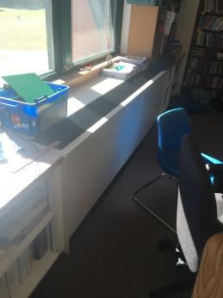
Univent in classroom
Picture 2
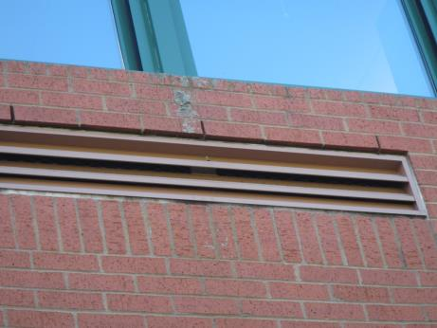
Exterior fresh air intake vent for classroom univent
Picture 3
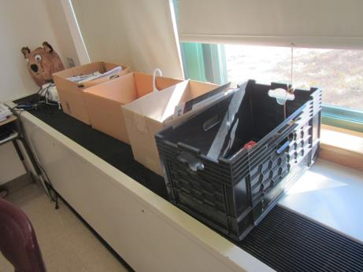
Univent with items obstructing supply air flow
Picture 4
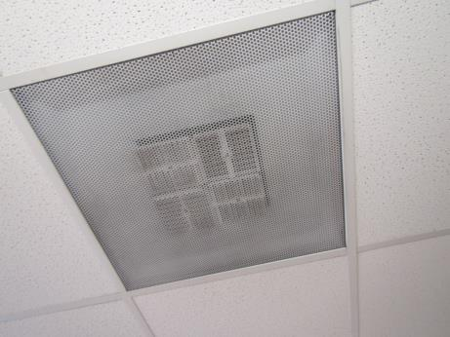
Ceiling-mounted supply air diffuser ducted from AHU
Picture 5
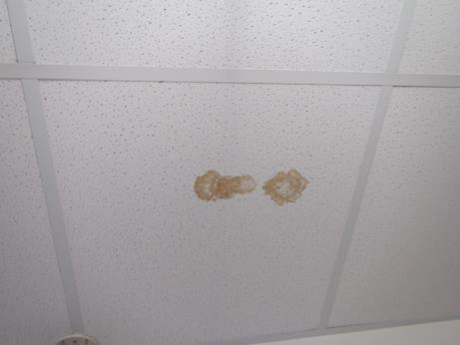
Water-damaged ceiling tile
Picture 6
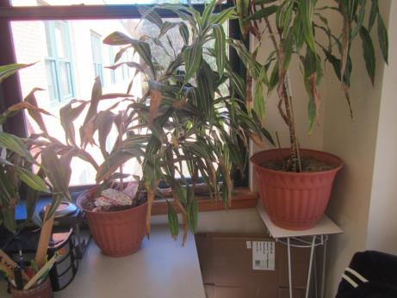
Plants located in occupied space
Picture 7
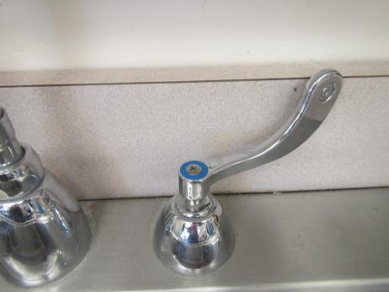
Gap between sink and backsplash
Picture 8
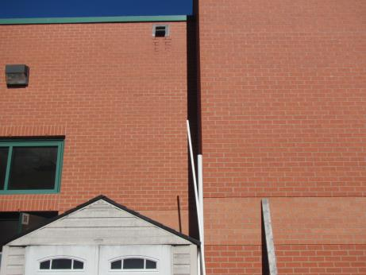
Overflow roof scupper drains on shed below and against building
Picture 9
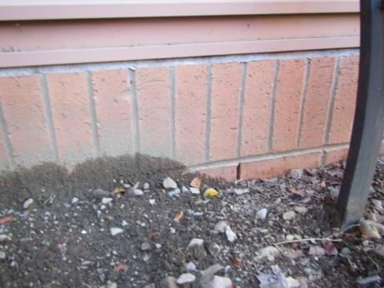
Weep hole (right arrow) and higher backfill covering other weep holes to the left
Picture 10
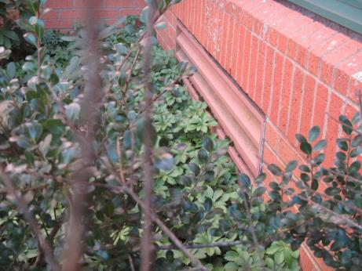
Vegetation against building and univent
Picture 11
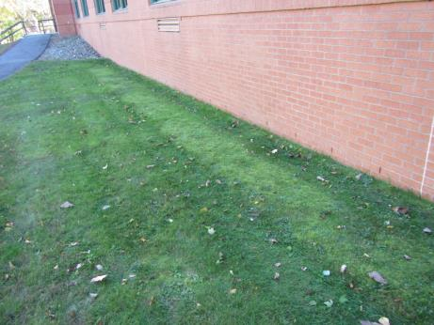
Improper grading showing depression which allows water to collect against building
Picture 12
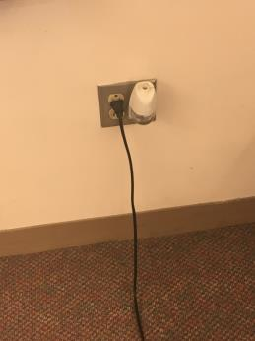
Plug-in air freshener
Picture 13
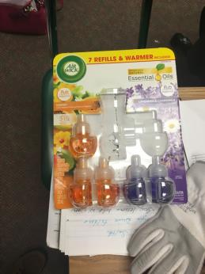
Fragrance refill package
Picture 14
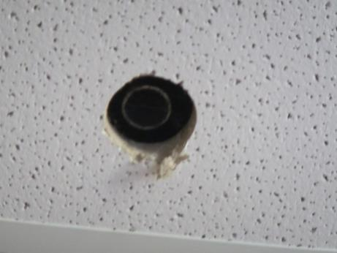
Hole in ceiling tile showing abandoned utility pipe
Location | Carbon  Dioxide  (ppm) | Carbon Monoxide  (ppm) | Temp  (°F) | Relative  Humidity  (%) | PM2.5  (µg/m³) | Occupants  in Room | Windows  Openable | Ventilation |  | Remarks
 |  |  |  |  |  |  |  | Supply | Exhaust
Library | 945 | ND | 74 | 27 | 13 | 14 | Y | Y | Y | Carpet, served by roof top AHU
201 | 1108 | ND | 73 | 28 | 1 | 21 | Y | Y | Y
204 | 1240 | ND | 72 | 28 | 11 | 2 | Y | Y | Y | WD CT
206 | 1238 | ND | 73 | 29 | 13 | 19 | Y | Y on | Y | Floor tile, DEM
207 | 1223 | ND | 73 | 31 | 2 | 18 | Y | Y | Y
211 | 1479 | ND | 72 | 34 | 1 | 16 | Y | Y | Y | Carpet
215 | 874 | ND | 72 | 26 | 0 | 0 | Y | Y on | Y
216 | 1458 | ND | 74 | 34 | 15 | 18 | Y | Y on | Y | Carpet, CPs
218 | 1619 | ND | 73 | 36 | 15 | 12 | Y | Y on | Y | Carpet, DEM
221 | 819 | ND | 73 | 24 | 0 | 0 | Y | Y on | Y | AF, carpet
223 | 1591 | ND | 73 | 30 | 1 | 18 | Y | Y on | Y | Books and items on vent
224 | 1955 | ND | 72 | 39 | 17 | 23 | Y | Y off | Y | Carpet, PF, DEM
226 | 1612 | ND | 73 | 34 | 16 | 8 | Y | Y | Y | WD CT
227 |  | ND | 73 | 36 | 3 | 16 | Y | Y on | Y | Paper on vent, carpet
228 | 1970 | ND | 73 | 35 | 18 | 21 | Y | Y off | Y | HS, carpet
230 | 1873 | ND | 72 | 37 | 19 | 20 | Y | Y | Y | Carpet, PF
231 | 1970 | ND | 72 | 37 | 1 | 23 | Y | Y on | Y | Carpet, bowed CT
232 | 1429 | ND | 73 | 27 | 15 | 4 | Y | Y | Y | Carpet, PF
233 | 2019 | ND | 71 | 36 | 1 | 1 | Y | Y on | Y
235 | 1501 | ND | 72 | 34 | 4 | 1 | Y | Y on | Y | Bowed CT
238 | 1362 | ND | 74 | 32 | 17 | 2 | Y | Y | Y | Plants, DEM
239 | 1024 | ND | 73 | 34 | 0 | 2 | Y |  |  | Carpet
242 | 1200 | ND | 72 | 31 | 18 | 2 | Y | Y | Y | Carpet, DEM
243 | 1448 | ND | 68 | 38 | 1 | 23 | Y | Y on | Y | Clutter, carpet
244 | 717 | ND | 71 | 26 | 11 | 0 | Y | Y off | Y | Carpet
249 | 987 | ND | 75 | 29 |  | 3 | Y | Y | Y | Lemongrass odor, plant, carpet
251 guidance | 1005 | ND | 74 | 30 | 2 | 0 | Y | N | N
Gym | 624 | ND | 69 | 18 | 2 | 0 | N | Y | Y
Cafeteria | 891 | ND | 71 | 32 | 2 | 100+ | Y | Y | Y | Bowed CT
Main Office | 752 | ND | 70 | 26 | 2 | 1 | Y | Y | Y
Nurse | 778 | ND | 70 | 27 | 2 | 0 | N | Y | Y
Principal | 809 | ND | 71 | 26 | 1 | 0 |  | Y | N?
Gym | 709 | ND | 70 | 19 | 8 | 2 | N | Y | Y | Floor polyurethane odor
Auditorium | 650 | ND | 70 | 32 | 9 | 0 | N | Y | Y
Main office conference room | 841 | ND | 70 | 29 | 8 | 4 | N | Y | Y | Plant
129 | 857 | ND | 73 | 27 | 2 | 2 | Y | Y | Y | AF
130 | 1102 | ND | 72 | 31 | 9 | 22 | Y | Y off | Y on | Carpet, paint odor
136 | 953 | ND | 72 | 30 | 9 | 16 | Y | Y on | Y | Carpet cleaner odor, gap in univent cabinet, reports of carpeting soiled/vandalized
140 | 1127 | ND | 72 | 33 | 10 | 4 | Y | Y | Y | AI, carpet, hole in CT
141 | 1095 | ND | 72 | 31 | 2 | 2 | N | Y | Y | Heavy perfume odor
142 | 1129 | ND | 71 | 31 | 9 | 0 | Y | Y off | Y | Carpet, univent
143 | 1070 | ND | 74 | 29 | 3 | 0 | Y | Y | Y | Carpet
145 | 944 | ND | 74 | 24 | 0 | 0 | Y | Y on | Y | Carpet
147 | 936 | ND | 73 | 27 | 1 | 0 | Y | Y on | Y | Carpet
148 | 1055 | ND | 70 | 28 | 9 | 2 | Y | Y | Y | Carpet
149 | 1261 | ND | 72 | 32 | 3 | 1 | Y | Y | Y | Vent blocked by paper and bookcase, carpet
150 | 1408 | ND | 71 | 32 | 12 | 2 | Y | Y | Y
151 | 1166 | ND | 72 | 31 | 1 | 0 | Y | N | N | Carpet
154 | 1250 | ND | 72 | 33 | 10 | 2 | Y | Y | Y | Carpet
155 | 1413 | ND | 72 | 37 | 2 | 0 | Y | Y on | Y | AF
156 | 1390 | ND | 70 | 31 | 10 | 2 | Y | Y | Y
157 | 1954 | ND | 74 | 38 | 4 | 1 | Y | Y on | Y | Carpet
158 | 542 | ND | 70 | 21 | 8 | 4 | Y open | Y | Y | Tiles
160 | 1880 | ND | 72 | 34 | 11 | 17 | Y | Y | Y | Art supplies, AI, air handling unit and univent
162 | 1428 | ND | 73 | 34 | 10 | 23 | Y | Y | Y | Carpet, computers
165 lab | 1145 | ND | 74 | 28 | 2 | 0 | Y | Y on | Y | Wood grinder, 3 WD CT
166 | 978 | ND | 74 | 25 | 10 | 15 | Y | Y on | Y | AI, area rug
171 | 1250 | ND | 74 | 31 | 11 | 0 | N | N | N
172 | 1269 | ND | 74 | 32 | 10 | 1 | Y | N | N | Radiator, window
173 | 1067 | ND | 74 | 28 | 10 | 0 | N | N | N | Band storage

Location | Window Glass Temperature  (°F) | Window Frame  Temperature  (°F) | Interior Wall  Temperature  (°F) | Remarks
Lab | 83 | 81 | 75 | Sun, shade
154 | 85 | 83 | 73 | Sun
155 | 86 | 85 | 76 | Shade
136 | 68 | 56 | 75 | Shade
140 | 68 | 61 | 73 | Shade
Main Office | 60 | 59 | 69 | Shade
134 | 80 | 78 | 72 | Sun
129 | 70 | 65 | 78 | Shade
Band | 97 | 85 | 76 | Sun
160 | 61 | 59 | 71 | Shade
162 | 64 | 70 | 75
158 | 64 | 60 | 72 | Shade
150 | 64 | 63 | 71 | Shade
148 | 62 | 60 | 71 | Shade
149 | 67 | 66 | 75 | Shade
143 | 60 | 63 | 74 | Shade
145 | 72 | 73 | 76 | Sun
Staff Lounge | 62 | 69 | 74
Conference | 61 | 63 | 73 | Shade
130 | 83 | 81 | 73 | Sun
Café 1 | 68 | 62 | 75 | Shade
Café 2 | 93 | 91 | 75 | Sun
147 | 64 | 60 | 72 | Shade
201 | 66 | 63 | 75 | Shade
204 | 57 | 63 | 75 | Shade
Library | 72 | 82 | 74 | Sun
216 | 67 | 67 | 75 | Shade
218 | 66 | 66 | 76 | Shade
221 | 65 | 66 | 77 | Shade
223 | 61 | 65 | 72 | Shade
227 | 69 | 81 | 77 | Shade
228 | 64 | 62 | 73 | Shade
230 | 75 | 81 | 76
238 | 80 | 78 | 79 | Shade
239 | 68 | 70 | 78 | Shade
242 | 69 | 77 | 74
Guidance | 57 | 59 | 69 | Shade
207 | 71 | 66 | 69 | Shade
206 | 66 | 60 | 74 | Shade
226 | 81 | 82 | 76 | Sun
226 | 69 | 64 | 76 | Shade
224 | 68 | 66 | 73
235 | 66 | 60 | 74 | Shade
232 | 77 | 75 | 71
233 | 66 | 60 | 73
231 | 63 | 50 | 77 | Sun
243 | 92 | 87 | 78 | Shade
245 | 70 | 73 | 77
249 | 67 | 64 | 75

