Fluoride Varnish in the Non-Dental Setting
Increasing Children’s Access to
Preventive Dental Care





Oral Health in Massachusetts: A Fact Sheet
What is the public health issue?
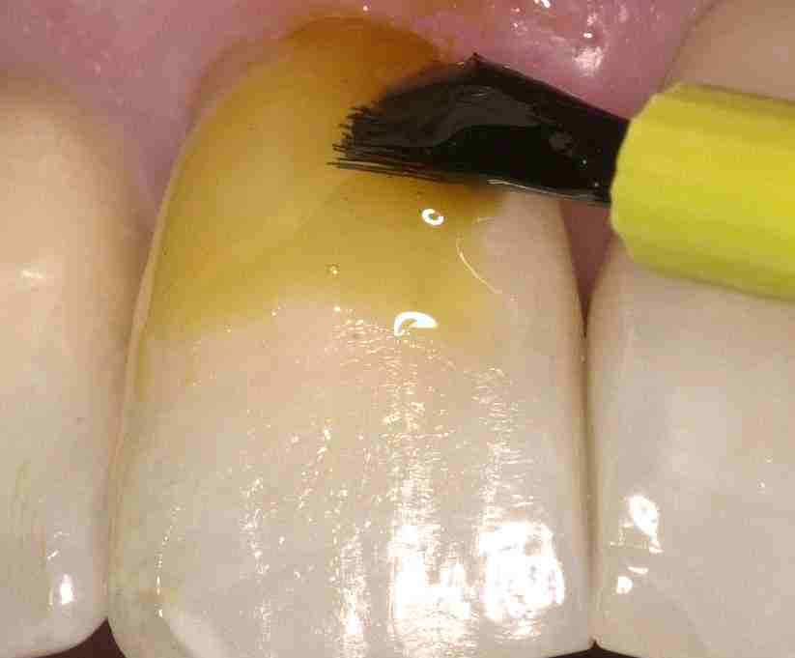
Tooth decay is a preventable chronic disease that affects children across all age groups. In fact, it is the most common chronic disease of childhood. Untreated tooth decay can cause pain and tooth loss, which can have negative effects on a child’s self esteem. Tooth decay can also affect eating, sleeping, learning, and proper nutrition. Community water fluoridation as well as access to prevention and treatment services decreases the risk for developing tooth decay; however, many children lack access. One way to deliver preventive oral health services to high-risk children is to apply fluoride varnish on children’s teeth in the medical setting.

What is the impact of fluoride varnish?
On October 1, 2008, MassHealth began covering the application of fluoride varnish by physicians and other qualified health professionals to at-risk members ages 21 and younger. This service is valuable to children because fluoride has been shown to be safe, inexpensive and extremely effective in preventing tooth decay. When acid from plaque bacteria begin taking minerals out of the tooth enamel, fluoride can put minerals back in, and therefore prevent tooth decay! Fluoride varnish provides topical fluoride, and it is not swallowed by the child. This type of topical fluoride can prevent tooth decay by 20-40%. Other important sources of fluoride include toothpaste, fluoridated community drinking water, and drinks/food prepared with fluoridated water.

Is fluoride varnish safe?
Yes. Fluoride varnish is a topical fluoride treatment, and it is safe even for children drinking fluoridated water and/or taking fluoride supplements. However, in rare cases, some children with colophonium and pine nut allergies have experienced adverse reactions to fluoride varnish.

What is the Massachusetts Department of Public Health (MDPH) doing?
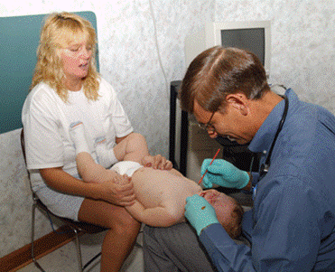
A 2007 survey found over 40% of Massachusetts third-graders had experienced tooth decay, and only about 46% of third-graders had at least 1 dental sealant (a material put into the grooves of teeth to prevent cavities). To help reduce the number of children who suffer from tooth decay, the MDPH is supporting MassHealth in their effort to expand fluoride varnish into the medical setting. The Office of Oral Health (OOH) serves as a resource for health care providers and other non-licensed persons who wish to learn more about fluoride varnish and oral health topics.

How do health professionals obtain training for fluoride varnish?
Any individual eligible to apply the fluoride varnish must obtain proof of fluoride varnish application training. Various in-person trainings throughout the State are available to medical professionals, as well as online trainings such as the:
- American Academy of Pediatrics oral health training on Cavity Risk Assessment: http://www.aap.org/commpeds/dochs/oralhealth/cme/
- The Smiles for Life program: www.smilesforlife2.org, Module 6
How do medical providers bill MassHealth for fluoride varnish?
Providers can bill using the 837P electronic transaction, or MassHealth claim form no.5 or no.9. The code for the fluoride varnish application is D1206. You can contact the Massachusetts Department of Public Health Office of Oral Health for more information on MassHealth fluoride varnish coverage, or visit the MassHealth website: http://www.mass.gov/?pageID=eohhs2constituent&L=2&L0=Home&L1=Provider&sid=Eeohhs2

How is fluoride varnish applied?
- Complete an oral health assessment (including the Caries Risk Assessment) looking at all tooth surfaces. Identify visual indicators of dental caries risk (white spots on teeth, plaque on teeth, special health care needs, and/or previous caries experience). Fluoride varnish is indicated only for children at moderate to high-risk for dental caries who do not receive routine preventive dental care.
- Obtain the necessary consent from the parent/guardian, and educate parents about post- fluoride varnish application instructions. Inform the parent/guardian that the child:
- Should not find fluoride varnish unpleasant, although they may fuss during the application;
- May have temporary discoloration of teeth, but the discoloration will go away once the varnish is brushed off the next day;
- Should eat a soft diet for the rest of the day; and
- Should not brush or floss until the next morning.
3. Once you gain cooperation from the child with the help of the parent/guardian, dry the teeth by
wiping them with a gauze sponge. Then, “paint” on a thin layer of the fluoride varnish to all of
the accessible tooth surfaces. The entire application should take no longer than 2 minutes, and will
not harm the gums if the fluoride varnish comes in contact. Saliva will set the varnish and it will
appear as a thin coating on the teeth.

References

Centers for Disease Control and Prevention. Fluoridation of drinking water to prevent dental caries. Morbidity and Mortality Weekly Report 48 (1999): 933–40.
U.S. Department of Health and Human Services, National Institute of Dental and Craniofacial Research. Oral Health in America: A Report of the Surgeon General. Rockville, MD: U.S. Department of Health and Human Services, National Institute of Dental and Craniofacial Research, 2000.
Truman BI, Gooch BF, Sulemana I, et al., and the Task Force on Community Preventive Services. Reviews of evidence on interventions to reduce dental caries, oral and pharyngeal cancers, and sports-related craniofacial injury. American Journal of Preventive Medicine 23 (2002, 1S): 1–84.
U.S. Department of Health and Human Services, Centers for Disease Control and Prevention. Preventing Dental Caries. Atlanta, GA: U.S. Department of Health and Human Services, Centers for Disease Control and Prevention, 2002. http://www.cdc.gov/OralHealth/factsheets/dental_caries.htm.
Massachusetts Oral Health Collaborative Report; “Statewide Oral Health Survey of Third Graders”, 2003. For more information, contact: Office of Oral Health Massachusetts Department of Public Health 250 Washington Street Boston, MA 02108-4619 Oral.Health@state.ma.us 