U.S. Department of Health and Human Services
Health Resources and Services Administration

Maternal and Child Health Bureau
Division of Child, Adolescent and Family Health

Affordable Care Act -
Maternal, Infant and Early Childhood Home Visiting Program

Announcement Type: New
Modified: June 2, 2011
Announcement Number: HRSA-11-179

Catalog of Federal Domestic Assistance (CFDA) No. 93.505

FUNDING OPPORTUNITY ANNOUNCEMENT

Fiscal Year 2011

Application Due Date: July 1, 2011

Ensure your Grants.gov registration and passwords are current immediately!
Deadline extensions are not granted for lack of registration.
Registration may take up to one month to complete.

Release Date: June 1, 2011
Issuance Date: June 1, 2011

This announcement has been modified as follows:
Page 33: Points updated for Review Criterion 7

Audrey M. Yowell, PhD, MSSS
Health Resources and Services Administration
Maternal and Child Health Bureau
Parklawn Building, Room 10-64
5600 Fishers Lane
Rockville, MD 20857
Email: ayowell@hrsa.gov
Telephone: (301) 443-4292
Fax: (301) 443-8918

Authority: Social Security Act, Title V, Section 511 (42 U.S.C. §701), as amended by Section 2951 of the Patient Protection and Affordable Care Act of 2010 (Public Law 111-148).
Table of Contents
I. Funding Opportunity Description 1
1. Purpose 1
2. Background 2
II. Award Information 7
1. Type of Award 7
2. Summary of Funding 7
III. Eligibility Information 8
1. Eligible Applicants 8
2. Cost Sharing/Matching 8
3. Other 8
IV. Application and Submission Information 9
1. Address to Request Application Package 9
2. Content and Form of Application Submission 10
i. Application Face Page 14
ii. Table of Contents 14
iii. Application Checklist 14
iv. Budget 14
v. Budget Justification 15
vi. Staffing Plan and Personnel Requirements 17
vii. Assurances 17
viii. Certifications 17
ix. Project Abstract 17
x. Program Narrative 17
xi. Program Specific Forms 21
xii. Attachments 21
3. Submission Dates and Times 23
4. Intergovernmental Review 23
5. Funding Restrictions 24
6. Other Submission Requirements 24
V. Application Review Information 25
1. Review Criteria 25
2. Review and Selection Process 33
3. Anticipated Announcement and Award Dates 34
VI. Award Administration Information 34
1. Award Notices 34
2. Administrative and National Policy Requirements 34
3. Reporting 36
VII. Agency Contacts 37
VIII. Other Information 38
ix. Tips for Writing a Strong Application 60
Appendix A: Home Visiting Program Priority Elements 61
Appendix B: A Table of the estimated amount of FY 11 formula-based MIECHV awards 63
Appendix C: Specific guidance Regarding individual benchmark areas 65

I. Funding Opportunity Description

- Purpose

The goal of the Maternal, Infant, and Early Childhood Home Visiting (MIECHV) competitive grant program is to award additional funding to states that have sufficiently demonstrated the interest and capacity to expand and/or enhance their evidence-based home visiting programs to improve outcomes for children and families who reside in high-risk communities. Of the $224,000,000 available to support grants to eligible states and jurisdictions under the MIECHV program in FY 2011, $99 million will support competitive grants and $125 million will be awarded on a formula basis to eligible entities in a companion funding opportunity announcement (FOA) for the overall MIECHV program. This FOA provides instructions for application for competitive grants under MIECHV. The FY 2011 FOA for formula grants will include the same requirements for collecting data to meet benchmarks and for Continuous Quality Improvement (CQI) as required under the FY 2010 FOA, HRSA-10-275 (See Appendix C. Specific Guidance Regarding Specific Benchmark Areas). These same requirements regarding benchmarks and CQI will apply to all grants funded under this competitive FOA for FY 2011.

Successful applicants will be awarded Federal fiscal year (FY) 2011 competitive grant funds, in addition to the FY 2011 MIECHV formula based funds, to support the effective expansion and implementation of home visiting programs that are part of comprehensive, high-quality early childhood systems in all states. The purpose of this announcement is to promote expansion and quality implementation of home visiting programs to attain the outcomes desired.

These competitive awards will continue the Health Resources and Services Administration’s (HRSA) and Administration for Children and Families’ (ACF) commitment to comprehensive family services, coordinated and comprehensive statewide home visiting programs, and effective implementation of evidence-based practices by offering a competitive opportunity to amplify program efforts supported by the MIECHV formula grants program and other state resources. Applicants will be evaluated by their demonstrated commitment to implementing high-quality home visitation programs and the quality of plans to expand services and improve outcomes for vulnerable children and families.

Some states have already made positive strides towards conceptualizing and implementing statewide home visiting programs that are part of comprehensive early childhood systems. Likewise, other states would benefit from additional fiscal support and technical assistance to build comprehensive, statewide home visiting programs. Accordingly, this FY 2011 FOA looks to accomplish two goals:

(1) To award funds to states and jurisdictions that demonstrate interest and capacity to expand and/or enhance high-quality, evidence-based home visiting programs serving vulnerable families, which are embedded in comprehensive, high-quality early childhood systems, and

(2) To support states and jurisdictions that may be taking initial steps toward building high-quality, evidence-based home visiting programs that are part of comprehensive early childhood systems.

To support these goals, this FOA provides two possible funding opportunities: Expansion Grants and Development Grants.

Expansion Grants recognize states and jurisdictions that have already made significant progress towards implementing a high-quality home visiting program as part of a comprehensive, high-quality early childhood system and are ready and able to take effective programs to scale. Grantees will use the funds to (1) expand the scale and/or scope of evidence-based home visiting programs and/or (2) enhance or improve existing home visiting programs. Approximately $66 million of the competitive funding will be awarded in FY 2011 for seven to ten (7–10) four-year grants.

Development Grants are for states and jurisdictions that currently have modest home visiting programs and want to build on existing efforts. Approximately $33 million of the competitive FY11 funding will be awarded for 10–12, two-year grants.

This FOA continues the emphasis on rigorous research in the MIECHV program by grounding the proposed work in relevant empirical literature and by including requirements to evaluate work proposed under this grant. Please see Section VIII.1 Other Information: Guidelines for Evaluation.

- Background

On March 23, 2010, the President signed into law the Patient Protection and Affordable Care Act of 2010 (Affordable Care Act) (P.L. 111-148), historic and transformative legislation designed to make quality, affordable health care available to all Americans, reduce costs, improve health care quality, enhance disease prevention, and strengthen the health care workforce. Through a provision authorizing the creation of the MIECHV program , the Affordable Care Act responds to the diverse needs of children and families in communities at risk and provides an unprecedented opportunity for collaboration and partnership at the Federal, state, and community levels to improve health and development outcomes for at-risk children through evidence-based home visiting programs.

This program is designed: (1) to strengthen and improve the programs and activities carried out under Title V; (2) to improve coordination of services for at-risk communities; and (3) to identify and provide comprehensive services to improve outcomes for families who reside in at-risk communities. The legislation reserves the majority of funding for one or more evidence-based home visiting models. In addition, the legislation supports continued innovation by allowing for up to 25 percent of funding supporting promising approaches that do not yet qualify as evidence-based models.

HRSA and ACF believe that home visiting should be viewed as one of several service strategies embedded in a comprehensive, high-quality early childhood system that promotes maternal, infant, and early childhood health, safety, and development, strong parent-child relationships, and promotes responsible parenting among mothers and fathers. Together, we envision high-quality, evidence-based home visiting programs as part of an early childhood system for promoting health and well-being for pregnant women, children through age eight, and their families. This system would include a range of other programs such as child care, Head Start, pre-kindergarten, special education and early intervention, and early elementary education. Recognizing that the goal of an effective, comprehensive early childhood system that supports the lifelong health and well-being of children, parents, and caregivers is broader than the scope of any one agency, HRSA and ACF are working in close collaboration with each other and with other Federal agencies and look forward to partnering with states and other stakeholders to foster high-quality, well-coordinated home visiting programs for families in at-risk communities. HRSA and ACF realize that coordination of services with other agencies has been an essential characteristic of state and local programs for many years and will continue to encourage, support, and promote the continuation of these collaborative activities, as close collaboration at all levels will be essential to effective, comprehensive home visiting and early childhood systems.

HRSA and ACF believe further that this law provides an unprecedented opportunity for Federal, state, and local agencies, through their collaborative efforts, to effect changes that will improve the health and well-being of vulnerable populations by addressing child development within the framework of life course development and a socio-ecological perspective. Life course development points to broad social, economic, and environmental factors as contributors to poor and favorable health and development outcomes for children, as well as to persistent inequalities in the health and well-being of children and families. The socio-ecological framework emphasizes that children develop within families, families exist within a community, and the community is surrounded by the larger society. These systems interact with and influence each other to either decrease or increase risk factors or protective factors that affect a range of health and social outcomes.

Supporting Infrastructure for Quality Implementation of Evidence-based and Evidence-Informed Home Visiting Programs

A growing body of research points to the importance of implementation and infrastructure as necessary factors to support evidence-based programs.,,, In a meta-analysis of treatment impacts across a range of social service interventions Wilson and Lipsey (2000) found implementation quality was one of the strongest predictors of achieved effect size of the programs.⁷

The implementation science field has identified, and continues to identify, implementation factors related to whether expected outcomes are obtained and the strength of those impacts. Research has begun to highlight the role of the multiple levels of the infrastructure and system to support implementation of evidence-based programs. For example, Wandersman and colleagues (2008) proposed the Interactive Systems Framework to elucidate the role of communities in selecting and implementing evidence-based programs and to draw attention to the multi-layered implementation system necessary to support evidence-based programs. The model highlights the necessity of building capacity at all levels of the infrastructure, including service provision and the technical assistance network. Durlak and Dupre (2008) analyzed over 500 empirical studies and identified over 23 different contextual factors related to quality of implementation, including: communities, providers, organizational capacity, and training or technical assistance.

In the largest synthesis of research on implementation to date, Fixsen and colleagues (2005) conclude that quality implementation occurs in a complex ecological framework that includes several aspects: professional development (including initial training, ongoing technical assistance, and fidelity monitoring), staff selection, administrative supports, and systems interventions. Three key aspects of implementation that are currently receiving the most attention in the research field are fidelity, community context, and professional development.

Fidelity. A program must be implemented with an acceptable level of fidelity in order to achieve expected outcomes. Dane and Schneider (1998) examined the extent to which evidence-based programs were implemented as intended and found only approximately 10% of studies even documented adherence; for those that did, lower adherence was related to smaller effects. Hamre and colleagues (2010) found basic adherence was necessary but not sufficient to obtaining child outcomes and instead quality of delivery was the variable most strongly related to outcomes. In order to obtain quality in fidelity, multiple aspects of implementation must be addressed, including such things as recruiting and retaining the clients best suited for the program, establishing a management information system to track data related to fidelity and services, providing ongoing training and professional development for staff, and establishing an integrated resource and referral network to support client needs.

Community context. At a recent meeting on scaling-up of evidence-based practices, there was consensus among the research, practice and policy attendees on the critical nature of community systems to support implementation (Emphasizing Evidence Based Programs for Children and Youth Forum, April 27-28, 2011). In one example, Rubin and colleagues (2010) reported that the effects of the Nurse Family Partnership were found only after three years of implementation and were moderated by community context. Rubin notes that the delayed achievement of the impacts was consistent with the research around implementation in community-based settings. In addition, Rubin and colleagues (2010) found stronger impacts for rural versus urban sites.⁶ The researchers noted that aspects of the community may explain these differences; for example, the tendency to facilitate referrals through word of mouth, or the lack of other community resources in the rural communities.
Professional development. The Fixsen and colleagues (2005) review identified professional development, including coaching and ongoing support, to be critical to implementation. Evidence indicates that although initial training is critical, ongoing professional development is also important for implementation. For example, Aarons and colleagues (2009a, 2009b) found home visitors who were given fidelity monitoring along with supervision and consultation had lower levels of emotional exhaustion and burnout, two variables found to negatively impact fidelity., In addition, the home visitors with supervision and consultation were more likely to remain employed by the program, therefore reducing costs and time of hiring and retraining staff.

Infrastructure to support implementation is critical to the success of an evidence-based home visiting program (including promising approaches) in achieving the intended impacts. Though the field is growing, rigorous research in real-world settings at scale is necessary to better identify key elements of infrastructure related to the achievement of the desired effects in evidence-based programs and promising approaches.

Researchers regularly state that the available information in many of the efficacy trials currently is lacking in depth and breadth around implementation of the programs. In their detailed synthesis of the literature, Fixsen and colleagues (2005) noted that the proportion of research studies on implementation that utilized rigorous designs was small. An important component of the purpose of the activities to be supported under this grant program is to support quality implementation and the building of infrastructure necessary for quality implementation of evidence-based practices and to rigorously evaluate those supports, with the ultimate goal of building knowledge about the necessary factors to support the capacity of evidence-based programs to achieve their intended outcomes, as well as to build solid foundations to support evidence-based home visiting services to families in at-risk communities.

Home Visiting Program Priority Elements
HRSA and ACF have identified the following eight priority elements. Applicants may propose to address one or more of these priority elements through either an Expansion or Development Grant.

  - Priority Element 1: To support improvements in maternal, child, and family health
  - Priority Element 2: To support effective implementation and expansion of evidence-based home visiting programs or systems with fidelity to the evidence-based model selected
  - Priority Element 3: To support the development of statewide or multi-state home visiting programs
  - Priority Element 4: To support the development of comprehensive early childhood systems that span the prenatal-through-age-eight continuum
  - Priority Element 5: To reach high-risk and hard-to-engage populations
  - Priority Element 6: To support a family-centered approach to home visiting
  - Priority Element 7: To reach families in rural or frontier areas
  - Priority Element 8: To support fiscal leveraging strategies to enhance program sustainability

Additional information about each priority element is provided under Appendix A, Home Visiting Program Priority Elements.

Please note: Enhancements of evidence-based home visiting models with one or more of the aforementioned priority elements may constitute an adaptation to the model. For the purposes of the MIECHV program, an acceptable adaptation of an evidence-based model includes changes to the model that have not been tested with rigorous impact research but are determined by the model developer not to alter the core components related to program impacts.

Changes to an evidence-based model that alter the components related to program outcomes could undermine the program’s effectiveness. Such changes (otherwise known as “drift”) will not be allowed under the funding allocated for evidence-based models. Adaptations that alter the core components related to program impacts may be funded with funds available for promising approaches if the state wishes to implement the program as a promising approach instead of as an acceptable adaptation of an evidence-based model. Per the authorizing legislation, at least 75 percent of the total grant funds (i.e., formula and competitive funds combined) must be used for evidence-based home visiting models. The state may propose to expend up to 25 percent of the total grant funds to support a model that qualifies as a promising approach.

Accordingly, applicants must provide documentation of approval by the model developer to implement the model, with the priority element enhancement, as proposed. The documentation should include verification that the model developer has reviewed and agreed to the competitive application submitted, including any proposed adaptations, support for participation in the national evaluation, and any other related HHS effort to coordinate evaluation and programmatic technical assistance. This documentation should include the state’s status with regard to any required certification or approval process required by the developer.

Applicants are also expected to ground their proposal in relevant empirical work and include an articulated theory of change. As previously mentioned, all grantees must include an evaluation plan specifying how the proposed initiative will be evaluated using a well-designed and rigorous process. The criteria provided are in line with the guidance provided for evaluation of promising approaches in the Supplemental Information Request (SIR) for the Submission of the Updated State Plan for a State Home Visiting Program. Grantees are also expected to participate in a community of practice relevant to the goal of the grant award (Please see Section VIII.1 Other Information: Evaluation Criteria).

II. Award Information

- Type of Award

Funding will be provided in the form of a grant.

- Summary of Funding

This program will provide funding for two possible grant categories: Expansion Grants for FY 2011–2014 and Development Grants for FY 2011–2012.

Expansion Grants
These grants recognize states and jurisdictions that have already made significant progress towards implementing a high-quality home visiting program or in successfully embedding their home visiting program into a comprehensive, high-quality early childhood system. Grantees will use the funds to (1) expand the scale and/or scope of evidence-based home visiting programs and/or (2) enhance or improve implementation of current home visiting programs.

Approximately $66 million of the competitive funding will be awarded in FY 2011 for 7–10 four-year grants. The total grant award may range between $6.6 million to $9.43 million annually. The number of grants awarded for FY 2011 will be contingent upon the quality of the applications and availability of funding. Applicants may apply for a ceiling amount of up to $9.43 million annually. There will be four Expansion Grant cycles, for FY 2011– 2014. For all four cycles, funding beyond the first year is dependent on the availability of appropriated funds for the MIECHV program in subsequent fiscal years, grantee satisfactory performance, and a decision that continued funding is in the best interest of the Federal government.

Development Grants
Development Grants are for states and jurisdictions that currently have modest home visiting programs and want to build on existing efforts. The intent is for states to use Development Grants as stepping stones towards becoming competitive in receiving an Expansion Grant in the future.

Approximately $33 million of the competitive FY2011 funding will be awarded for 10–12, two-year grants. The total grant award may range between $2.75 million and $3.3 million annually. Applicants may apply for a ceiling amount of up to $3.3 million per year. There will be two Development Grant cycles, for FY 2011 and FY 2012. For each cycle, funding beyond the first year is dependent on the availability of appropriated funds for the MIECHV program in subsequent fiscal years, grantee satisfactory performance, and a decision that continued funding is in the best interest of the Federal government.

III. Eligibility Information

- Eligible Applicants

Eligible applicants for this competitive grant opportunity include the following eligible entities listed in Section 511(k)(1)(A): States (including the District of Columbia), Puerto Rico, Guam, the Virgin Islands, the Northern Mariana Islands, and America Samoa. The Governor has the responsibility and authority to designate which entity or group of entities will apply for and administer MIECHV funds on behalf of the State.

- Cost Sharing/Matching

There are no cost sharing/matching requirements for the MIECHV competitive grant program.

- Other

Maintenance of Effort/Non-Supplantation
Funds provided to an eligible entity receiving a grant shall supplement, and not supplant, funds from other sources for early childhood home visitation programs or initiatives. The grantee must agree to maintain non-Federal funding (State General Funds) for grant activities at a level which is not less than expenditures for such activities as of the date of enactment of this legislation, March 23, 2010.

For purposes of maintenance of effort/non-supplantation in this FOA, home visiting is defined as an evidence-based program, implemented in response to findings from a needs assessment, that includes home visiting as a primary service delivery strategy (excluding programs with infrequent or supplemental home visiting), and is offered on a voluntary basis to pregnant women or children birth to age five targeting the participant outcomes in the legislation which include improved maternal and child health, prevention of child injuries, child abuse, or maltreatment, and reduction of emergency department visits, improvement in school readiness and achievement, reduction in crime or domestic violence, improvements in family economic self-sufficiency, and improvements in the coordination and referrals for other community resources and supports.”

As with state formula funding for the MIECHV program, if state general revenue funds for evidence-based home visiting programs have fallen below the amount spent under state law and policies in place on March 23, 2010, the award of Federal funds under this program will be presumed to constitute supplantation. The state may rebut this presumption by demonstrating that any reduction in state funding was unrelated to the receipt or availability of federal home visiting program funds. States wishing to provide a rationale which demonstrates compliance with the non-supplantation requirement should submit a justification in writing, to HRSA’s Maternal and Child Health Bureau.

Ceiling Award Amount
Applications that exceed the ceiling amount will be considered non-responsive and will not be considered for funding under this announcement.

Deadlines
Any application that fails to satisfy the deadline requirements referenced in Section IV.3 will be considered non-responsive and will not be considered for funding under this announcement.

Number of Applications
An applicant may only submit one application in response to this FOA. The application may be for either an Expansion Grant or a Development Grant. An applicant may not submit applications for both grant categories. Any applicant submitting applications to both grant categories will be in violation of the application requirements and will not be considered for funding under this announcement.

IV. Application and Submission Information

- Address to Request Application Package

Application Materials and Required Electronic Submission Information
HRSA requires applicants for this funding opportunity announcement to apply electronically through Grants.gov. This robust registration and application process protects applicants against fraud and ensures only that only authorized representatives from an organization can submit an application. Applicants are responsible for maintaining these registrations, which should be completed well in advance of submitting your application. All applicants must submit in this manner unless they obtain a written exemption from this requirement in advance by the Director of HRSA’s Division of Grants Policy. Applicants must request an exemption in writing from DGPWaivers@hrsa.gov, and provide details as to why they are technologically unable to submit electronically through the Grants.gov portal. Your email must include the HRSA announcement number for which you are seeking relief, the organization’s DUNS number, the name, address, and telephone number of the organization and the name and telephone number of the Project Director as well as the Grants.gov Tracking Number (GRANTXXXX) assigned to your submission along with a copy of the “Rejected with Errors” notification you received from Grants.gov. HRSA and its Grants Application Center (GAC) will only accept paper applications from applicants that received prior written approval. However, the application must still be submitted under the deadline. Suggestion: submit application to Grants.gov at least two days before the deadline to allow for any unforeseen circumstances. Applicants that fail to allow ample time to complete registration with CCR or Grants.gov will not be eligible for a deadline extension or waiver of the electronic submission requirement.

All applicants are responsible for reading the instructions included in HRSA’s Electronic Submission User Guide, available online at http://www.hrsa.gov/grants/userguide.htm. This Guide includes detailed application and submission instructions for both Grants.gov and HRSA’s Electronic Handbooks. Pay particular attention to Sections 2 and 5 that provide detailed information on the competitive application and submission process.

Applicants are also responsible for reading the Grants.gov Applicant User Guide, available online at http://www.grants.gov/assets/ApplicantUserGuide.pdf. This Guide includes detailed information about using the Grants.gov system and contains helpful hints for successful submission.

Applicants must submit proposals according to the instructions in the Guide and in this funding opportunity announcement in conjunction with Application Form SF-424. The forms contain additional general information and instructions for applications, proposal narratives, and budgets. The forms and instructions may be obtained from the following site by:

- Downloading from http://www.grants.gov, or

- Contacting the HRSA Grants Application Center at:
910 Clopper Road
Suite 155 South
Gaithersburg, MD 20878
Telephone: (877) 477-2123
HRSAGAC@hrsa.gov

Each funding opportunity contains a unique set of forms and only the specific forms package posted with an opportunity will be accepted for that opportunity. Specific instructions for preparing portions of the application that must accompany Application Form SF-424 appear in the “Application Format” section below.

- Content and Form of Application Submission

Application Format Requirements
The total size of all uploaded files may not exceed the equivalent of 80 pages when printed by HRSA. The total file size may not exceed 10 MB. This 80-page limit includes the abstract, project and budget narratives, attachments, and letters of commitment and support. Standard forms are NOT included in the page limit.

Applications that exceed the specified limits (approximately 10 MB, or 80 pages when printed by HRSA) will be deemed non-responsive. All application materials must be complete prior to the application deadline. Applications that are modified after the posted deadline will also be considered non-responsive. Non-responsive applications will not be considered under this funding announcement.

Application Format
Applications for funding must consist of the following documents in the following order:

SF-424 Non-Construction – Table of Contents

- It is mandatory to follow the instructions provided in this section to ensure that your application can be printed efficiently and consistently for review.
- Failure to follow the instructions may make your application non-responsive. Non-responsive applications will not be considered under this funding opportunity announcement.
- For electronic submissions, applicants only have to number the electronic attachment pages sequentially, resetting the numbering for each attachment, i.e., start at page 1 for each attachment. Do not attempt to number standard OMB approved form pages.
- For electronic submissions, no Table of Contents is required for the entire application. HRSA will construct an electronic table of contents in the order specified.
- When providing any electronic attachment with several pages, add a Table of Contents page specific to the attachment. Such pages will not be counted towards the page limit.

Application Section | Form Type | Instruction | HRSA/Program Guidelines
Application for Federal Assistance (SF-424) | Form | Pages 1, 2 & 3 of the SF-424 face page. | Not counted in the page limit
Project Summary/Abstract | Attachment | Can be uploaded on page 2 of SF-424 - Box 15 | Required attachment. Counted in the page limit. Refer to the funding opportunity announcement for detailed instructions.
Additional Congressional District | Attachment | Can be uploaded on page 3 of SF-424 - Box 16 | As applicable to HRSA; not counted in the page limit.
Application Checklist Form HHS-5161-1 | Form | Pages 1 & 2 of the HHS checklist. | Not counted in the page limit.
Project Narrative Attachment Form | Form | Supports the upload of Project Narrative document | Not counted in the page limit.
Project Narrative | Attachment | Can be uploaded in Project Narrative Attachment form. | Required attachment. Counted in the page limit. Refer to the funding opportunity announcement for detailed instructions. Provide table of contents specific to this document only as the first page.
SF-424A Budget Information - Non-Construction Programs | Form | Page 1 & 2 to supports structured budget for the request of Non-construction related funds. | Not counted in the page limit.
Budget Narrative Attachment Form | Form | Supports the upload of Project Narrative document. | Not counted in the page limit.
Budget Narrative | Attachment | Can be uploaded in Budget Narrative Attachment form. | Required attachment. Counted in the page limit. Refer to the funding opportunity announcement for detailed instructions.
SF-424B Assurances - Non-Construction Programs | Form | Supports assurances for non-construction programs. | Not counted in the page limit.
Project/Performance Site Location(s) | Form | Supports primary and 29 additional sites in structured form. | Not counted in the page limit.
Additional Performance Site Location(s) | Attachment | Can be uploaded in the SF-424 Performance Site Location(s) form. Single document with all additional site location(s) | Not counted in the page limit.
Disclosure of Lobbying Activities (SF-LLL) | Form | Supports structured data for lobbying activities. | Not counted in the page limit.
Other Attachments Form | Form | Supports up to 15 numbered attachments. This form only contains the attachment list. | Not counted in the page limit.
Attachment 1-10 | Attachment | Can be uploaded in Other Attachments form 1-10. | Refer to the attachment table provided below for specific sequence. Counted in the page limit.

- To ensure that attachments are organized and printed in a consistent manner, follow the order provided below. Note that these instructions may vary across programs.
- Evidence of Non-Profit status and invention related documents, if applicable, must be provided in the other attachment form.
- Additional supporting documents, if applicable, can be provided using the available rows. Do not use the rows assigned to a specific purpose in the program funding opportunity announcement.
- Merge similar documents into a single document. Where several pages are expected in the attachment, ensure that you place a table of contents cover page specific to the attachment. The Table of Contents page will not be counted in the page limit.

Attachment Number | Attachment Description (Program Guidelines)
Attachment 1 | Tables, Charts, etc.
Attachment 2 | Job Descriptions for Key Personnel
Attachment 3 | Biographical Sketches of Key Personnel
Attachment 4 | Letters of Agreement or Description(s) of Proposed/Existing Contracts
Attachment 5 | Project Organizational Chart
Attachment 6 | Summary Progress Report
Attachment 7 | Timeline
Attachment 8 | Model Developer Approval Letter
Attachment 9 | Other Relevant Documents not specified elsewhere in the Table of Contents

Application Format

- Application Face Page
Complete Application Form SF-424 provided with the application package. Prepare according to instructions provided in the form itself. For information pertaining to the Catalog of Federal Domestic Assistance, the CFDA Number is 93.505.

DUNS Number
All applicant organizations (and subrecipients of HRSA award funds) are required to have a Data Universal Numbering System (DUNS) number in order to apply for a grant or cooperative agreement from the Federal Government. The DUNS number is a unique nine-character identification number provided by the commercial company, Dun and Bradstreet. There is no charge to obtain a DUNS number. Information about obtaining a DUNS number can be found at http://fedgov.dnb.com/webform or call 1-866-705-5711. Please include the DUNS number in item 8c on the application face page. Applications will not be reviewed without a DUNS number. Note: A missing or incorrect DUNS number is the number one reason for applications being “Rejected for Errors” by Grants.gov. HRSA will not extend the deadline for applications with a missing or incorrect DUNS. Applicants should take care in entering the DUNS number in the application.

Additionally, the applicant organization (and any subrecipient of HRSA award funds) is required to register annually with the Federal Government’s Central Contractor Registration (CCR) in order to do electronic business with the Federal Government. CCR registration must be maintained with current, accurate information at all times during which an entity has an active award or an application or plan under consideration by HRSA. It is extremely important to verify that your CCR registration is active and your MPIN is current. Information about registering with the CCR can be found at http://www.ccr.gov.

- Table of Contents
The application should be presented in the order of the Table of Contents provided earlier. Again, for electronic applications no table of contents is necessary as it will be generated by the system. (Note: the Table of Contents will not be counted in the page limit.)

- Application Checklist
Complete the HHS Application Checklist Form HHS 5161-1 provided with the application package.

- Budget
Complete Application Form SF-424A Budget Information – Non-Construction Programs provided with the application package.

Please complete Sections A, B, E, and F, and then provide a line item budget for each year of the project period. In Section A use rows 1 - 4 to provide the budget amounts for the first four years of the project. Please enter the amounts in the “New or Revised Budget” column- not the “Estimated Unobligated Funds” column. In Section B Object Class Categories of the SF-424A, provide the object class category breakdown for the annual amounts specified in Section A. In Section B, use column (1) to provide category amounts for Year 1 and use columns (2) through (4) for subsequent budget years (up to four years for Expansion Grants, and up to two years for Development Grants).

- Budget Justification
Provide a narrative that explains the amounts requested for each line in the budget. The budget justification should specifically describe how each item will support the achievement of proposed objectives. The budget period is for ONE year. However, the applicant must submit one-year budgets for each of the subsequent budget periods within the requested project period (usually one to four years) at the time of application. Therefore, for Expansion Grants applicants must submit one-year budgets for years one (1) through four (4). Development Grant applicants must submit budgets for years one (1) and two (2).

Line item information must be provided to explain the costs entered in the SF-424A budget form. The budget justification must clearly describe each cost element and explain how each cost contributes to meeting the project’s objectives/goals. Be very careful about showing how each item in the “other” category is justified. For subsequent budget years, the justification narrative should highlight the changes from year one or clearly indicate that there are no substantive budget changes during the project period. The budget justification MUST be concise. Do NOT use the justification to expand the project narrative.

Budget for Multi-Year Award
This announcement is inviting applications for project periods up to four (4) years. Expansion Grant applicants may submit applications for a four-year project period. Development Grant applicants may submit applications for two-year project periods. Awards, on a competitive basis, will be for a one-year budget period; although the project period may be four (4) years for Expansion Grants and two (2) years for Development Grants.

Submission and HRSA approval of your Progress Report(s) and any other required submission or reports is the basis for the budget period renewal and release of subsequent year funds. Funding beyond the one-year budget period but within the four-year and two-year project periods is subject to availability of funds, satisfactory progress of the awardee, and a determination that continued funding would be in the best interest of the Federal government.

Include the following in the Budget Justification narrative:

Personnel Costs: Personnel costs should be explained by listing each staff member who will be supported from funds, name (if possible), position title, percentage of full-time equivalency, and annual salary.

Fringe Benefits: List the components that comprise the fringe benefit rate, for example health insurance, taxes, unemployment insurance, life insurance, retirement plans, and tuition reimbursement. The fringe benefits should be directly proportional to that portion of personnel costs that are allocated for the project.

Travel: List travel costs according to local and long distance travel. For local travel, the mileage rate, number of miles, reason for travel and staff member/consumers completing the travel should be outlined. The budget should also reflect the travel expenses associated with participating in meetings and other proposed trainings or workshops.

Equipment: List equipment costs and provide justification for the need of the equipment to carry out the program’s goals. Extensive justification and a detailed status of current equipment must be provided when requesting funds for the purchase of computers and furniture items that meet the definition of equipment (a unit cost of $5,000 or more and a useful life of one or more years).

Supplies: List the items that the project will use. In this category, separate office supplies from medical and educational purchases. Office supplies could include paper, pencils, and the like; medical supplies are syringes, blood tubes, plastic gloves, etc., and educational supplies may be pamphlets and educational videotapes. Remember, they must be listed separately.

Contractual: Applicants are responsible for ensuring that their organization or institution has in place an established and adequate procurement system with fully developed written procedures for awarding and monitoring all contracts. Applicants must provide a clear explanation as to the purpose of each contract, how the costs were estimated, and the specific contract deliverables. Reminder: recipients must notify potential subrecipients that entities receiving subawards must be registered in the Central Contractor Registration (CCR) and provide the recipient with their DUNS number.

Other: Put all costs that do not fit into any other category into this category and provide an explanation of each cost in this category. In some cases, rent, utilities and insurance fall under this category if they are not included in an approved indirect cost rate.

Applicants may include the cost of access accommodations as part of their project’s budget, including sign interpreters, plain language and health literate print materials in alternate formats (including Braille, large print, etc.); and cultural/linguistic competence modifications such as use of cultural brokers, translation or interpretation services at meetings, clinical encounters, and conferences, etc.

Indirect Costs: Indirect costs are those costs incurred for common or joint objectives which cannot be readily identified but are necessary to the operations of the organization, e.g., the cost of operating and maintaining facilities, depreciation, and administrative salaries. For institutions subject to OMB Circular A-21, the term “facilities and administration” is used to denote indirect costs. If an organization applying for an assistance award does not have an indirect cost rate, the applicant may wish to obtain one through HHS’s Division of Cost Allocation (DCA). Visit DCA’s website at: http://rates.psc.gov/ to learn more about rate agreements, the process for applying for them, and the regional offices which negotiate them.

- Staffing Plan and Personnel Requirements
Applicants must present a staffing plan and provide a justification for the plan that includes education and experience qualifications and rationale for the amount of time being requested for each staff position. Position descriptions that include the roles, responsibilities, and qualifications of proposed project staff must be included in Attachment 2. Biographical sketches for any key employed personnel that will be assigned to work on the proposed project must be included in Attachment 3. When applicable, biographical sketches should include training, language fluency and experience working with the cultural and linguistically diverse populations that are served by their programs.

- Assurances
Complete Application Form SF-424B Assurances – Non-Construction Programs provided with the application package.

- Certifications
Use the Certifications and Disclosure of Lobbying Activities Application Form provided with the application package.

- Project Abstract
Provide a summary of the application. Because the abstract is often distributed to provide information to the public and Congress, please prepare this so that it is clear, accurate, concise, and without reference to other parts of the application. It must include a brief description of the proposed project including the needs to be addressed, the proposed services, and the population group(s) to be served.

Please place the following at the top of the abstract:
- Project Title
- Applicant Name
- Address
- Contact Phone Numbers (Voice, Fax)
- E-Mail Address
- Web Site Address, if applicable

The project abstract must be single-spaced and limited to one page in length.

- Program Narrative
This section provides a comprehensive framework and description of all aspects of the proposed program. It should be succinct, self-explanatory, and well organized so that reviewers can understand the proposed project.

Instructions for preparing each major section of the project narrative are outlined below. Follow them carefully, as they form the basis for addressing the Review Criteria (see Section V), which will be used for the evaluation and rating of applications submitted to the MIECHV program. Applicants are strongly encouraged to organize their project narratives by these seven major headings, each of which is explained below:

Use the following section headers for the Narrative:

- Introduction
The introduction must provide:

- A brief description of the project’s proposed purpose;

- Applicants for Expansion Grants: A description of the state’s history of significant progress towards implementing a high-quality home visiting program, in a comprehensive, high-quality early childhood system. Applicants will be awarded points in the competitive review process for additional commitment to sustaining support for early childhood home visiting programs using state and federal funds. Under “Sustainability and Commitment to Home Visiting,” see Section V.1: Application Review Information–Review Criteria # 7 for both Expansion and Development Grants.

- Applicants for Development Grants: A description of the steps previously taken toward building a high-quality home visiting program. Applicants will be awarded points in the competitive review process for additional commitment to sustaining support for early childhood home visiting programs using state and federal funds. Under “Sustainability and Commitment to Home Visiting,” see Section V.1: Application Review Information–Review Criteria # 7 for both Expansion and Development Grants.

- A clear description of the problem, the proposed intervention, and the anticipated benefit of the project;

- A description of the priority elements to be addressed, if applicable;

- A description of how the priority element(s) identified and the proposal will build on, or enhance, the applicant’s existing MIECHV program, if applicable;

- A logic model for the proposed project that builds on the logic model for the existing state MIECHV program, but makes a distinction between the existing program and what this additional grant would provide.

- NEEDS ASSESSMENT
This section should provide a thorough discussion of the applicant’s current home visiting program. Accordingly, this discussion must:

- Identify the selected community(ies) to be served and discuss the rationale for each selection. Provide detail on the community(ies);the rationale for each selection. Provide detail for each targeted community:

- Provide the estimated number of families that will be reached by the proposed project; and

- Explain how the priority element(s) selected will reach the applicant’s desired outcomes for the proposed program, if applicable.

Demographic data should be used and cited whenever possible to support the information provided.

- Methodology
- Specify the evidence-based model(s) or promising approach(es) that will be supported by the competitive funding. The HHS criteria for evidence-based models and a list of the approved evidenced-based models is located under Section VIII—Other Information.

- Clearly describe the goals and objectives using an approach that is specific, time-oriented, measurable, and responds to the identified challenges facing the proposed project.

- Applicants are expected to ground their proposed methods in relevant empirical work and have an articulated theory of change. For the purposes of this FOA, empirical work includes evidence from research, theory, practice, context, or cultural knowledge.

- Work Plan
- Describe the activities or steps that will be used to achieve each of the activities proposed during the entire project period in the Methodology section.

- Use a timeline that includes each activity and identifies responsible staff. The description of the project methodology should extend across the two or four years of the project efforts. A project timeline that spans the two or four years of project effort should be formulated and attached as Attachment 8.

- As appropriate, identify meaningful support and collaboration with key stakeholders in planning, designing, implementing and evaluating all activities, including development of the application and, further, the extent to which these contributors reflect the cultural, racial, linguistic, and geographic diversity of the populations and communities served. A list of required and recommended partners is provided in Section VIII.5—Other Information: List of Required and Recommended Partners. Consistent with the guidance in the 2nd SIR, these partners have been identified to demonstrate agreement and support for the proposed initiative and to ensure that home visiting is part of a continuum of early childhood services within the state.

Building on the elements of the State Home Visiting Plan, provide an implementation plan addressing the items listed below. Applicants should respond to each specific item as it pertains to the proposal for use of competitive funds. It is acceptable to address these items using information in the Updated State Plan to the extent that it is pertinent, and where responses differ, applicants should explain the rationale.

Discussion of implementation should include the following information:
- Plan to engage community
- Plan for monitoring, program assessment and support, and technical assistance
- Plan for professional development and training
- Plan for staffing and subcontracting
- Plan for recruiting and retaining participants
- CQI plan
- Plan to maintain fidelity to model
- Plan to collect data on legislatively-mandated benchmarks
- Plan to coordinate with appropriate entities/programs
- Description of how the proposed activities would fit into the state administrative structure
- Plan to ensure incorporation of project goals, objectives, and activities into the ongoing work of the eligible applicant and any other partners at the end of the federal grant

- Resolution of Challenges
Discuss challenges that are likely to be encountered in designing and implementing the activities described in the Work Plan, and approaches that will be used to resolve such challenges.

- Evaluation and Technical Support Capacity
- Describe current experience, skills, and knowledge, including individuals on staff, materials published, and previous work of a similar nature.

- Demonstrate evidence of organizational experience and capability to coordinate and support planning, implementation, and evaluation of a comprehensive plan to meet the objectives of this initiative.

- Describe an evaluation plan that will: (1) measure whether the intended outcomes of the project were attained (2) monitor the efficiency of the proposed project activities, and (3) meet the definitions of rigor and other evaluation criteria stipulated under Section VIII.1—Other Information: Guidelines for Evaluation. Project level evaluation methodology should be specific and related to the stated goals, objectives, and priorities of the project. Applicants shall include a proposed evaluation plan with all of the elements discussed in Section (i) under Other Information below.

- The evaluation plan should:
- Discuss how the evaluation will be conducted;
- Articulate the proposed evaluation methods, measurement, data collection, sample and sampling (if appropriate), timeline for activities, plan for securing IRB review, and analysis;
- Identify the evaluator, cost of the evaluation, and the source of funds;
- Use an appropriate comparison condition, if the research is measuring the impact of the promising or new home visiting model on participant outcomes; and
- Include a logic model or conceptual framework that shows the linkages between the proposed planning and implementation activities and the outcomes that these are designed to achieve.

- Organizational Information
- Provide information on the applicant organization’s current mission and structure, the scope of the organization’s current activities related to home visiting and early childhood systems Include an organizational chart as Attachment 5. Describe how these all contribute to the ability of the organization to conduct the program requirements and meet program expectations.

- Information about the organization’s record of accomplishments may be included under Attachment 7: Summary Progress Report.

- Provide information on the program’s resources and capabilities to support provision of culturally and linguistically competent and health literate services.

- Describe how the unique needs of target populations of the communities served are routinely assessed and improved. Also describe the organizational capacity of any partnering agencies or organizations involved in the implementation of the project.

- Describe the adequacy of resources to continue the proposed project after the grant period ends and the state’s demonstrated commitment to home visiting.

- Provide an assurance that cuts in state funding will not be made to a broad array of home visiting programs in the future.

- Program Specific Forms
There are no program specific forms for the MIECHV program’s competitive grant application.

- Attachments
Please provide the following items to complete the content of the application. Please note that these are supplementary in nature, and are not intended to be a continuation of the project narrative. Unless otherwise noted, attachments count toward the application page limit. Each attachment must be clearly labeled.

Attachment 1: Tables, Charts, etc.
To give further details about the proposal (e.g., Gantt or PERT charts, flow charts, etc.).

Attachment 2: Job Descriptions for Key Personnel
Keep each to one page in length as much as is possible. Include the role, responsibilities, and qualifications of proposed project staff.

Attachment 3: Biographical Sketches of Key Personnel
Include biographical sketches for persons occupying the key positions described in Attachment 2, not to exceed two pages in length. In the event that a biographical sketch is included for an identified individual who is not yet hired, please include a letter of commitment from that person with the biographical sketch.

Attachment 4: Letters of Agreement or Description(s) of Proposed/Existing Contracts (project specific)
Provide any documents that describe working relationships between the applicant organization and other agencies and programs cited in the proposal. Documents that confirm actual or pending contractual agreements should clearly describe the roles of the subcontractors and any deliverable. Letters of agreement must be dated.

Attachment 5: Project Organizational Chart
Provide a one-page figure that depicts the organizational structure of the project, including subcontractors and other significant collaborators.

Attachment 6: Summary Progress Report - Required

A well planned accomplishment summary can be of great value by providing a record of accomplishments. The accomplishments of applicants are carefully considered during the review process; therefore, applicants are advised to include a brief summary (no more than five pages) of their accomplishments. The summary should provide a concise, yet thorough, presentation of the applicant’s experience, including but not limited to the following:

The applicant’s experience in:
- Implementing home visiting programs;
- Fostering the integration of home visiting programs into early childhood systems;
- Promoting effective policy to support and strengthen home visiting programs;
- Evaluating programs and using the information received to improve the quality of home visiting programs and early childhood systems;
- Improving outcomes for families served by the home visiting program; and
- Providing services to vulnerable or high-risk populations.

Attachment 7: Timeline (Required. To be developed by applicant)
The timeline links activities to project objectives and should cover the four-year project period for Expansion Grants or the two-year project period for Development Grants. This table, chart, or figure details activities necessary to carry out each methodological approach, including approaches to major categories of activities and appropriate tracking methods. It includes a format to describe the “who, what, when, where, and how” of each approach.

Attachment 8: Model Developer Approval Letter
States electing to implement an approved evidence-based model must provide documentation of approval by the developer to implement the model as proposed. The documentation should include verification that the model developer has reviewed and agreed to the plan as submitted, including any proposed adaptation, support for participation in the national evaluation, and any other related HHS efforts to coordinate evaluation and programmatic technical assistance. This documentation should include the state’s status with regard to any required certification or approval process required by the developer.

Attachment 9: Other Relevant Documents
Include here any other documents that are relevant to the application, including letters of support. Letters of support must be dated.

Include only letters of support which specifically indicate a commitment to the project/program (in-kind services, dollars, staff, space, equipment, etc.). Letters of agreement and support must be dated. List all other support letters on one page.

- Submission Dates and Times

Application Due Date
The due date for applications under this funding opportunity announcement is July 1, 2011 at 8:00 P.M. ET. Applications completed online are considered formally submitted when the application has been successfully transmitted electronically by your organization’s Authorized Organization Representative (AOR) through Grants.gov and has been validated by Grants.gov on or before the deadline date and time.

The Chief Grants Management Officer (CGMO) or designee may authorize an extension of published deadlines when justified by circumstances such as natural disasters (e.g., floods or hurricanes) or other disruptions of services, such as a prolonged blackout. The CGMO or designee will determine the affected geographical area(s).

Late applications:
Applications which do not meet the criteria above are considered late applications and will not be considered in the current competition.

- Intergovernmental Review

The MIECHV program is subject to the provisions of Executive Order 12372, as implemented by 45 CFR 100. Executive Order 12372 allows states the option of setting up a system for reviewing applications from within their states for assistance under certain Federal programs. Application packages made available under this funding opportunity will contain a listing of states which have chosen to set up such a review system, and will provide a State Single Point of Contact (SPOC) for the review. Information on states affected by this program and State Points of Contact may also be obtained from the Grants Management Officer listed in the Agency Contact(s) section, as well as from the following Web site: http://www.whitehouse.gov/omb/grants_spoc.

All applicants other than federally recognized Native American Tribal Groups should contact their SPOC as early as possible to alert them to the prospective applications and receive any necessary instructions on the state process used under this Executive Order.

Letters from the State Single Point of Contact (SPOC) in response to Executive Order 12372 are due sixty days after the application due date.

- Funding Restrictions

Applications with budget requests exceeding the specified ceiling for each grant (up to $9.43 million per year for Expansion Grants or up to $3.3 million per year for Development Grants) will be deemed non-responsive, and will not be considered for funding. Awards to support projects beyond the first budget year but within the two to four year project period will be contingent upon Congressional appropriation, satisfactory progress in meeting the project’s objectives, and a determination that continued funding would be in the best interest of the Federal government.

- Other Submission Requirements

As stated in Section IV.1, except in very rare cases HRSA will no longer accept applications in paper form. Applicants submitting for this funding opportunity are required to submit electronically through Grants.gov. To submit an application electronically, please use the APPLY FOR GRANTS section at http://www.Grants.gov . When using Grants.gov you will be able to download a copy of the application package, complete it off-line, and then upload and submit the application via the Grants.gov site.

It is essential that your organization immediately register in Grants.gov and become familiar with the Grants.gov site application process. If you do not complete the registration process you will be unable to submit an application. The registration process can take up to one month.

To be able to successfully register in Grants.gov, it is necessary that you complete all of the following required actions:

• Obtain an organizational Data Universal Numbering System (DUNS) number
• Register the organization with Central Contractor Registration (CCR)
• Identify the organization’s E-Business Point of Contact (E-Biz POC)
• Confirm the organization’s CCR “Marketing Partner ID Number (M-PIN)” password
• Register and approve an Authorized Organization Representative (AOR)
• Obtain a username and password from the Grants.gov Credential Provider

Instructions on how to register, tutorials and FAQs are available on the Grants.gov web site at http://www.grants.gov. Assistance is also available 24 hours a day, 7 days a week (excluding Federal holidays) from the Grants.gov help desk at support@grants.gov or by phone at 1-800-518-4726. Applicants should ensure that all passwords and registration are current well in advance of the deadline.

It is incumbent on applicants to ensure that the AOR is available to submit the application to HRSA by the published due date. HRSA will not accept submission or re-submission of incomplete, rejected, or otherwise delayed applications after the deadline. Therefore, you are urged to submit your application in advance of the deadline. If your application is rejected by Grants.gov due to errors, you must correct the application and resubmit it to Grants.gov before the deadline date and time. Deadline extensions will not be provided to applicants who do not correct errors and resubmit before the posted deadline.

If, for any reason, an application is submitted more than once prior to the application due date, HRSA will only accept the applicant’s last validated electronic submission prior to the application due date as the final and only acceptable submission of any competing application submitted to Grants.gov.

Tracking your application: It is incumbent on the applicant to track application by using the Grants.gov tracking number (GRANTXXXXXXXX) provided in the confirmation email from Grants.gov. More information about tracking your application can be found at http://www07.grants.gov/applicants/resources.jsp. Be sure your application is validated by Grants.gov prior to the application deadline.

V. Application Review Information

- Review Criteria

Procedures for assessing the technical merit of applications have been instituted to provide for an objective review of applications and to assist the applicant in understanding the standards against which each application will be judged. Critical indicators have been developed for each review criterion to assist the applicant in presenting pertinent information related to that criterion and to provide the reviewer with a standard for evaluation. Review criteria are outlined below with specific detail and scoring points.

Review criteria are used to review and rank Expansion and Development Grant applications for the Maternal, Infant, and Early Childhood Home Visiting Program. This competitive grant application has seven review criteria for each type of grant:

EXPANSION GRANTS (Total 100 points)

- NEED (10 points)—Refer to Narrative Section’s “Introduction” and “Needs Assessment” Building on the targeted community needs assessment and the State Home Visiting Plan, the proposal should justify the selection of communities it is proposing to serve (or improvements/enhancements proposed) and the rationale.

In determining the need for the project, the following factor will be considered:

  - The extent to which the applicant clearly describes the problem and the proposed intervention, and the extent to which the applicant clearly describes the anticipated benefit of the project.

- RESPONSE (25 points)—Refer to Narrative Section’s “Introduction,” “Methodology,” “Work Plan,” and “Resolution of Challenges”

- Purpose, Goals and Objectives (5 points):

The extent to which the proposed project responds to the “purpose” included in the program description as well as the strength of the proposed goals and objectives and the relationship to the identified project. In determining these aspects of the proposal, the following factors will be considered:

  - The extent to which the activities described in the application are capable of addressing the problem and attaining the project objectives; and

  - The extent to which the proposed project has a clear set of goals and an explicit strategy (i.e., logic model), with actions that are (i) aligned with the priorities the applicant is seeking to meet, and (ii) expected to result in achieving the goals, objectives, and outcomes of the proposed project.

(b) Strength of Evidence (20 points)

- (10 points) In determining fit with goals and capacities, the following factors will be considered:
- Fit of the evidence base for the selected model with each of the program goals, capacities, and needs of the at-risk community(ies) identified by the applicant;
- Applicant’s experience with the selected model(s); and
- Local conditions and capacities that increase the likelihood of successful model implementation. Reviewers are looking for proposals that emphasize fit, not just those that argue that the selected home visiting models have a high-quality evidence-base.

  - (10 points) Applicants will be evaluated by the extent to which the applicant selects a model(s) with the strongest evidence base from among models that fit the applicant’s goals, capacities, and needs of the at-risk community(ies) i.e., the extent to which the effectiveness of the home visiting model(s) selected has been supported by rigorous research and fits with the applicant’s goals and capacities.
- (5 points) In determining the quality of the evidence base, the following factors will be considered:
    - (1 point) Study design quality;
    - (1 point) The substantive impact for the individuals served;
    - (1 point) Duration of findings, replication of findings;
    - (1 point) Quality of measures on which impacts were obtained; and
    - (1 point) Presence of null effects or unfavorable/ambiguous findings, and independence of the evaluator.
    - (5 points) The degree to which the evidence – taken together - supports that the model will improve outcomes for the targeted population consistent with the goals identified by the state.

3) IMPACT (20 points)––Refer to Narrative Section’s “Work Plan”

- The strength of the proposed implementation plan and the extent to which the activities described in the application are capable of attaining the proposed objectives for:
    - Engaging the community(ies) around the proposed plan
    - Providing program assessment and support, monitoring, and technical assistance
          - Providing training and professional development
          - Recruiting and retaining program participants
          - Ensuring effective implementation, with fidelity to the model
          - Collecting benchmark data

4) EVALUATIVE MEASURES (15 points)— Refer to Narrative Section’s “Methodology, “Background,” “Evaluation Technical Support Capacity,” and Appendix A

The extent to which the state’s work plan/implementation plan proposes to address one or more Priority Elements, either by scaling up existing effective programs or testing new innovations, and the effectiveness of the method proposed to monitor and evaluate the proposed activities. Evaluative measures must be able to assess: 1) the extent to which the program objectives have been met for scale-up or innovations, and 2) the extent to which the attainment of program objectives can be attributed to the project. In determining the quality of the evaluation, the following factors will be considered:

• The extent to which the methods of the evaluation will include a rigorous, well-implemented design (as defined under Section VIII.1 Other Information: Guidelines for Evaluation) and the extent to which the methods of the evaluation will provide high quality implementation data and performance feedback.
• The extent to which the proposed project plan includes sufficient resources to effectively carry out the project evaluation.
• For innovations related to one or more Priority Elements, the extent to which the evaluation will provide sufficient information about the key elements and approach of the project to facilitate replication or testing in other settings.
• The extent to which the proposed evaluation meets the standards of a high or moderate quality study design as defined by the Home Visiting Evidence of Effectiveness review, and is independent, as defined for the purposes of this FOA as the project implementer is not evaluating the impact of the project.

5) RESOURCES/CAPABILITIES (15 points)—Refer to Narrative Section’s “Introduction,” “Evaluation Technical Support Capacity,” and “Organizational Information”

The capabilities of the applicant organization, the facilities, and the personnel to fulfill the needs and requirements of the proposed project. Past performance will also be considered. The application will also be evaluated based on the experience of the applicant in implementing the proposed project. In determining this review criterion, the following factors will be considered:

- The extent to which the applicant provides history of significant progress towards implementing a high-quality home visiting program in a comprehensive, high-quality early childhood system.

- The extent to which the applicant provides information and the data to demonstrate that it has already significantly addressed the priority area at a regional or state level and has made significant improvements in other areas of early childhood systems.

- The extent to which the applicant proposes to reach an appropriate number of individuals by the proposed project and has the capacity to reach the proposed number of individuals during the course of the grant period.

- The extent to which project personnel are qualified by training or experience to implement and carry out the projects.

- The extent to which the applicant demonstrates capacity (e.g., in terms of qualified personnel, financial resources, management capacity) to bring the project to scale on a regional or state level working directly or through partners, either during or following the end of the grant period.

6) SUPPORT REQUESTED (5 points)—Refer to Budget Section

Includes the reasonableness of the proposed budget for each year of the project period in relation to the objectives, the complexity of the research activities, and the anticipated results. The following will be taken into consideration:

- The extent to which costs, as outlined in the budget and required resources sections, are reasonable given the scope of work; and

- The extent to which key personnel have adequate time devoted to the project to achieve project objectives.

7) SUSTAINABILITY AND COMMITMENT TO HOME VISITING (10 points)—Refer to Narrative Section’s “Methodology” and “Work plan”

The adequacy of resources to continue the proposed project after the grant period ends and the state’s demonstrated commitment to home visiting. The following will be taken into consideration:

- (4 points) The extent to which the eligible applicant demonstrates:
- The resources to operate the project beyond the length of the grant;
- Commitment of any other partners;
- Evidence of broad support from stakeholders critical to the project’s long-term success; and
- A significant state-funding commitment to home visiting. These points are only available if the applicant qualifies for points under the next criterion—maintaining overall effort.

- (3 points): Commitment that cuts in federal or state funding will not be made in the future to the total amount of funding now directed toward home visiting programs that are funded in whole or in part with state or federal funds.

- (2 points) The extent to which a state commits to increasing its overall state spending on home visiting programs from the spending level in place on the date the FOA is released.

- (1 point) A plan for the incorporation of project goals, objectives, and activities into the ongoing work of the eligible applicant and any other partners at the end of the federal grant.

DEVELOPMENT GRANTS (Total 100 Points)

- NEED (10 points)—Refer to Narrative Section’s “Introduction” and “Needs Assessment” Building on the targeted community needs assessment and the State Home Visiting Plan, the proposal should justify the selection of communities it is proposing to serve (or improvements/enhancements proposed) and the rationale.

In determining the need for the project, the following factor will be considered:

  - The extent to which the applicant clearly describes the problem and the proposed intervention, and the extent to which the applicant clearly describes the anticipated benefit of the project.

- RESPONSE (25 points)—Refer to Narrative Sections “Introduction,” “Methodology,” “Work Plan,” and “Resolution of Challenges”

(a) Purpose, Goals, and Objectives (5 points):

The extent to which the proposed project responds to the “purpose” included in the program description. The strength of the proposed goals and objectives and their relationship to the identified project. In determining these aspects of the proposal, the following factors will be considered:

  - The extent to which the activities described in the application are capable of addressing the problem and attaining the project objectives; and

  - The extent to which the proposed project has a clear set of goals and an explicit strategy (i.e., logic model), with actions that are (i) aligned with the priorities the applicant is seeking to meet, and (ii) expected to result in achieving the goals, objectives, and outcomes of the proposed project.

- Strength of Evidence (20 points)

- (10 points) In determining fit with goals and capacities, the following factors will be considered:
- Fit of the evidence base for the selected model with each of the program goals, capacities, and needs of the at-risk community(ies) identified by the applicant;
- Applicant’s experience with the selected model(s); and
- Local conditions and capacities that increase the likelihood of successful model implementation. Reviewers are looking for proposals that emphasize fit, not just those that argue selected home visiting models have a high-quality evidence-base.

  - (10 points) Applicants will be evaluated by the extent to which the applicant selects a model(s) with the strongest evidence base from among models that fit the applicant’s goals, capacities, and needs of the at-risk community(ies) i.e., the extent to which the effectiveness of the home visiting model(s) selected has been supported by rigorous research and fits with the applicant’s goals and capacities.

- (5 points) In determining the quality of the evidence base, the following factors will be considered:
    - (1 point) Study design quality;
    - (1 point) The substantive impact for the individuals served;
    - (1 point) Duration of findings, replication of findings;
    - (1 point) Quality of measures on which impacts were obtained; and
    - (1 point) Presence of null effects or unfavorable/ambiguous findings, and independence of the evaluator.
    - (5 points) The degree to which the evidence – taken together - supports that the model will improve outcomes for the targeted population in a manner consistent with the goals identified by the state.

3) IMPACT (20 points) ––Refer to Narrative Section’s “Work Plan”

- The strength of the proposed implementation plan and the extent to which the activities described in the application are capable of attaining the proposed objectives for:
          - Engaging the community(ies) around the proposed plan
          - Providing program assessment and support, monitoring, and technical assistance
          - Providing training and professional development
          - Recruiting and retaining program participants
          - Ensuring effective implementation, with fidelity to the model
          - Collecting benchmark data

4) EVALUATIVE MEASURES (15 points) — Refer to Narrative Sections “Methodology,” “Background,” “Evaluation Technical Support Capacity,” and Appendix A

The extent to which the state’s work plan/implementation plan proposes to address one or more Priority Elements, either by building capacity to scale-up effective programs or testing new innovations, and the effectiveness of the method proposed to monitor and evaluate the proposed activities. Evaluative measures must be able to assess: 1) the extent to which the program objectives have been met for scale-up or innovations, and 2) the extent to which the attainment of program objectives can be attributed to the project. In determining the quality of the evaluation, the following factors will be considered:

• The extent to which the methods of the evaluation will include a rigorous, well-implemented design (as defined under Section VIII.1 Other Information: Guidelines for Evaluation) and the extent to which the methods of the evaluation will provide high quality implementation data and performance feedback.
• The extent to which the proposed project plan includes sufficient resources to effectively carry out the project evaluation.
• For innovations related to one or more Priority Elements, the extent to which the evaluation will provide sufficient information about the key elements and approach of the project to facilitate replication or testing in other settings.
• The extent to which the proposed evaluation meets the standards of a high or moderate quality study design as defined by the Home Visiting Evidence of Effectiveness review, and is independent, as defined for the purposes of this FOA as the project implementer is not evaluating the impact of the project.

5) RESOURCES/CAPABILITIES (15 points)—Refer to Narrative Section’s “Introduction,” “Evaluation Technical Support Capacity,” and “Organizational Information”

The capabilities of the applicant organization, the facilities, and the personnel to fulfill the needs and requirements of the proposed project. Past performance will also be considered. The application will also be evaluated based on the experience of the applicant in implementing the proposed project. In determining this review criterion, the following factors will be considered:

- The extent to which the applicant has demonstrated commitment to implementing a high-quality home visiting program and successfully embedding their home visiting program into a comprehensive, high-quality early childhood system.

- The extent to which the applicant proposes to reach an appropriate number of individuals by the proposed project and has the capacity to reach the proposed number of individuals during the course of the grant period.

- The extent to which project personnel are qualified by training or experience to implement and carry out the projects.

- The extent to which the applicant demonstrates capacity (e.g., in terms of qualified personnel, financial resources, management capacity) to bring the project to scale on a regional or state level working directly or through partners, either during or following the end of the grant period.

6) SUPPORT REQUESTED (5 points)—Refer to Budget Section

Includes the reasonableness of the proposed budget for each year of the project period in relation to the objectives, the complexity of the research activities, and the anticipated results. The following will be taken into consideration:

- The extent to which costs, as outlined in the budget and required resources sections, are reasonable given the scope of work; and

- The extent to which key personnel have adequate time devoted to the project to achieve project objectives.

7) SUSTAINABILITY AND COMMITMENT TO HOME VISITING (10 points)—Refer to Narrative Section’s “Methodology” and “Work plan”

The adequacy of resources to continue the proposed project after the grant period ends and the state’s demonstrated commitment to home visiting. The following will be taken into consideration:

- (4 points) The extent to which the eligible applicant demonstrates:
- The resources to operate the project beyond the length of the grant;
- Commitment of any other partners;
- Evidence of broad support from stakeholders critical to the project’s long-term success; and
- A significant state-funding commitment to home visiting. These points are only available if the applicant qualifies for points under the next criterion—maintaining overall effort.

- (3 points) Commitment that the eligible applicant (a) will not reduce the total amount of state funding for home visiting programs, and (b) will not reduce the amount of federal funding spent by the eligible applicant on home visiting programs unless the amount of federal funding provided to the eligible applicant is reduced by the federal government.

- (2 points) The extent to which a state commits to increasing its overall state spending on home visiting programs from the spending level in place on the date the FOA is released.

- (1 points) A plan for the incorporation of project goals, objectives, and activities into the ongoing work of the eligible applicant and any other partners at the end of the federal grant.

- Review and Selection Process

The Division of Independent Review is responsible for managing objective reviews within HRSA. Applications competing for Federal funds receive an objective and independent review performed by a committee of experts qualified by training and experience in particular fields or disciplines related to the program being reviewed. In selecting review committee members, other factors in addition to training and experience may be considered to improve the balance of the committee, e.g., geographic distribution. Each reviewer is screened to avoid conflicts of interest and is responsible for providing an objective, unbiased evaluation based on the review criteria noted above. The committee provides expert advice on the merits of each application to program officials responsible for final selections for award.

Applications that pass the initial HRSA eligibility screening will be reviewed and rated by a panel based on the program elements and review criteria presented in relevant sections of this program announcement. The review criteria are designed to enable the review panel to assess the quality of a proposed project and determine the likelihood of its success. The criteria are closely related to each other and are considered as a whole in judging the overall quality of an application.

- Anticipated Announcement and Award Dates

It is anticipated that awards will be announced prior to the start date of September 30, 2011.

VI. Award Administration Information

- Award Notices

Each applicant will receive written notification of the outcome of the objective review process, including a summary of the expert committee’s assessment of the application’s merits and weaknesses, and whether the application was selected for funding. Applicants who are selected for funding may be required to respond in a satisfactory manner to conditions placed on their application before funding can proceed. Letters of notification do not provide authorization to begin performance.

The Notice of Award sets forth the amount of funds granted, the terms and conditions of the award, the effective date of the award, the budget period for which initial support will be given, the non-Federal share to be provided (if applicable), and the total project period for which support is contemplated. Signed by the Grants Management Officer, it is sent to the applicant’s Authorized Organization Representative, and reflects the only authorizing document. It will be sent prior to the start date of September 30, 2011.

- Administrative and National Policy Requirements

Successful applicants must comply with the administrative requirements outlined in 45 CFR Part 74 Uniform Administrative Requirements for Awards and Subawards to Institutions of Higher Education, Hospitals, Other Nonprofit Organizations, and Commercial Organizations or 45 CFR Part 92 Uniform Administrative Requirements For Grants And Cooperative Agreements to State, Local, and Tribal Governments, as appropriate.

HRSA grant and cooperative agreement awards are subject to the requirements of the HHS Grants Policy Statement (HHS GPS) that are applicable based on recipient type and purpose of award. This includes, as applicable, any requirements in Parts I and II of the HHS GPS that apply to the award. The HHS GPS is available at http://www.hrsa.gov/grants/. The general terms and conditions in the HHS GPS will apply as indicated unless there are statutory, regulatory, or award-specific requirements to the contrary (as specified in the Notice of Award).

Cultural and Linguistic Competence
HRSA is committed to ensuring access to quality health care for all. Quality care means access to services, information, and materials delivered by competent providers in a manner that factors in the language needs, cultural richness, and diversity of populations served. Quality also means that, where appropriate, data collection instruments used should adhere to culturally competent and linguistically appropriate norms. For additional information and guidance, refer to the National Standards for Culturally and Linguistically Appropriate Services in Health Care (CLAS) published by HHS and available online at http://www.omhrc.gov/CLAS. Additional cultural competency and health literacy tools, resources and definitions are available online at http://www.hrsa.gov/culturalcompetence and http://www.hrsa.gov/healthliteracy.

Trafficking in Persons
Awards issued under this funding opportunity announcement are subject to the requirements of Section 106 (g) of the Trafficking Victims Protection Act of 2000, as amended (22 U.S.C. 7104). For the full text of the award term, go to http://www.hrsa.gov/grants/trafficking.html. If you are unable to access this link, please contact the Grants Management Specialist identified in this funding opportunity to obtain a copy of the Term.

PUBLIC POLICY ISSUANCE

Healthy People 2020
Healthy People 2020 is a national initiative led by HHS that sets priorities for all HRSA programs. The initiative has four overarching goals: (1) Attain high-quality, longer lives free of preventable disease, disability, injury, and premature death; (2) Achieve health equity, eliminate disparities, and improve the health of all groups; (3) Create social and physical environments that promote good health for all; and (4) Promote quality of life, healthy development, and healthy behaviors across all life stages. The program consists of over 40 topic areas, containing measurable objectives. HRSA has actively participated in the work groups of all the topic areas and is committed to the achievement of the Healthy People 2020 goals. More information about Healthy People 2020 may be found online at http://www.healthypeople.gov/.

National HIV/AIDS Strategy (NHAS)
The National HIV/AIDS Strategy (NHAS) has three primary goals: 1) reducing the number of people who become infected with HIV, 2) increasing access to care and optimizing health outcomes for people living with HIV, and 3) reducing HIV-related health disparities. The NHAS states that more must be done to ensure that new prevention methods are identified and that prevention resources are more strategically deployed. Further, the NHAS recognizes the importance of early entrance into care for people living with HIV to protect their health and reduce their potential of transmitting the virus to others.

HIV disproportionately affects people who have less access to prevention, care and treatment services and, as a result, often have poorer health outcomes. Therefore, the NHAS advocates adopting community-level approaches to identify people who are HIV-positive but do not know their serostatus and reduce stigma and discrimination against people living with HIV.

To the extent possible, program activities should strive to support the three primary goals of the NHAS. As encouraged by the NHAS, programs should seek opportunities to increase collaboration, efficiency, and innovation in the development of program activities to ensure success of the NHAS. Programs providing direct services should comply with Federally-approved guidelines for HIV Prevention and Treatment (see http://www.aidsinfo.nih.gov/Guidelines/Default.aspx as a reliable source for current guidelines). More information can also be found at http://www.whitehouse.gov/administration/eop/onap/nhas

Smoke-Free Workplace
The Public Health Service strongly encourages all award recipients to provide a smoke-free workplace and to promote the non-use of all tobacco products. Further, Public Law 103-227, the Pro-Children Act of 1994, prohibits smoking in certain facilities (or in some cases, any portion of a facility) in which regular or routine education, library, day care, health care or early childhood development services are provided to children.

- Reporting

The successful applicant under this funding opportunity announcement must comply with the following reporting and review activities:

- Audit Requirements
Comply with audit requirements of Office of Management and Budget (OMB) Circular A-133. Information on the scope, frequency, and other aspects of the audits can be found on the Internet at http://www.whitehouse.gov/omb/circulars_default.

- Payment Management Requirements
Submit a quarterly electronic Federal Financial Report (FFR) Cash Transaction Report via the Payment Management System. The report identifies cash expenditures against the authorized funds for the grant or cooperative agreement. The FFR Cash Transaction Reports must be filed within 30 days of the end of each calendar quarter. Failure to submit the report may result in the inability to access award funds. Go to http://www.dpm.psc.gov for additional information.

- Status Reports
1) Federal Financial Report. The Federal Financial Report (SF-425) is required within 90 days of the end of each budget period. The report is an accounting of expenditures under the project that year. Financial reports must be submitted electronically through EHB. More specific information will be included in the Notice of Award.

2) Progress Report(s). The awardee must submit a progress report to HRSA on an annual basis. Submission and HRSA approval of your Progress Report(s) triggers the budget period renewal and release of subsequent year funds. This report has two parts. The first part demonstrates grantee progress on program-specific goals. The second part collects core performance measurement data including performance measurement data to measure the progress and impact of the project. Further information will be provided in the award notice.

3) Final Report(s). A final report is due within 90 days after the project period ends. The final report collects program-specific goals and progress on strategies; core performance measurement data; impact of the overall project; the degree to which the grantee achieved the mission, goal and strategies outlined in the program; grantee objectives and accomplishments; barriers encountered; and responses to summary questions regarding the grantee’s overall experiences over the entire project period. The final report must be submitted on-line by awardees in the Electronic Handbooks system at https://grants.hrsa.gov/webexternal/home.asp.

- Transparency Act Reporting Requirements
New awards (“Type 1”) issued by HRSA are subject to the reporting requirements of the Federal Funding Accountability and Transparency Act (FFATA) of 2006 (Pub. L. 109–282), as amended by section 6202 of Public Law 110–252, and implemented by 2 CFR Part 170. Grant and cooperative agreement recipients must report information for each first-tier subaward of $25,000 or more in Federal funds and executive total compensation for the recipient’s and subrecipient’s five most highly compensated executives as outlined in Appendix A to 2 CFR Part 170 (FFATA details are available online at http://www.hrsa.gov/grants/ffata.html). Competing continuation awardees, etc. may be subject to this requirement and will be so notified in the Notice of Award.

VII. Agency Contacts

Applicants may obtain additional information regarding business, administrative, or fiscal issues related to this funding opportunity announcement by contacting:

Mickey Reynolds
Grants Management Specialist
HRSA Division of Grants Management Operations, OFAM
Parklawn Building, Room 11A-02
5600 Fishers Lane
Rockville, MD 20857
Telephone: (301) 443-0724
Fax: (301) 443-6686
Email: mreynolds@hrsa.gov

Additional information related to the overall program issues or technical assistance regarding this funding announcement may be obtained by contacting:

Audrey M. Yowell, PhD, MSSS
Health Resources and Services Administration
Maternal and Child Health Bureau
Parklawn Building, Room 10-64
5600 Fishers Lane
Rockville, MD 20857
Telephone: (301) 443-4292
Email: ayowell@hrsa.gov

Applicants may need assistance when working online to submit their application forms electronically. Applicants should always obtain a case number when calling for support. For assistance with submitting the application in Grants.gov, contact Grants.gov 24 hours a day, seven days a week, excluding Federal holidays at:

Grants.gov Contact Center
Telephone: 1-800-518-4726
E-mail: support@grants.gov
iPortal: http://grants.gov/iportal

VIII. Other Information

    - Guidelines for Evaluation

HRSA and ACF expect that initiatives funded under this grant will contribute to the development of a knowledge base around successful strategies for the effectiveness, implementation, adoption and sustainability of evidence-based home visiting programs.

HRSA and ACF have a particular interest in approaches that develop knowledge about:
- Efficacy in achieving improvements in the benchmark areas and participant outcomes specified in the legislation;
- Factors associated with developing or enhancing the state’s capacity to support and monitor the quality of evidence-based programs; and
- Effective strategies for adopting, implementing, and sustaining evidence-based home visiting programs.

Furthermore, HRSA and ACF are especially interested in the use of evaluation strategies that emphasize the use of research to help guide program planning and implementation (e.g., participatory or empowerment evaluation). To support the state’s evaluation efforts, states must allocate an appropriate level of funds for a rigorous evaluation in all years of the grant.

HRSA and ACF expect states to engage in an evaluation of sufficient rigor to demonstrate potential linkages between project activities and improved outcomes. Rigorous research incorporates the four following criteria:
Credibility: Ensuring what is intended to be evaluated is actually what is being evaluated; making sure that descriptions of the phenomena or experience being studied are accurate and recognizable to others; ensuring that the method used is the most definitive and compelling approach that is available and feasible for the question being addressed. If conclusions about program efficacy are being examined, the study design should include a comparison group (i.e., randomized control trial or quasi-experimental design); see the HomVEE website for standards for study design in estimating program impacts: http://www.acf.hhs.gov/programs/opre/homvee).
Applicability: Generalizability of findings beyond current project (i.e., when findings "fit" into contexts outside the study situation). Ensuring the population being studied represents one or more of the population being served by the program.
Consistency: When processes and methods are consistently followed and clearly described, someone else could replicate the approach, and other studies can confirm what is found.
Neutrality: Producing results that are as objective as possible and acknowledge the bias brought to the collection, analysis, and interpretation of the results.
Accordingly, the evaluation plan should:
- Discuss how the evaluation will be conducted;
- Articulate the proposed evaluation methods, measurement, data collection, sample and sampling (if appropriate), timeline for activities, plan for securing IRB review, and analysis;
- Identify the evaluator, cost of the evaluation, and the source of funds;
- Use an appropriate comparison condition, if the research is measuring the impact of the promising or new home visiting model on participant outcomes; and
- Include a logic model or conceptual framework that shows the linkages between the proposed planning and implementation activities and the outcomes that these are designed to achieve.

For assistance in developing a logic model, see http://toolkit.childwelfare.gov/toolkit/. HHS has already initiated a contract for the provision of technical assistance for evaluation of the initiatives funded by this grant and will be providing information about the technical assistance available to states.

If the state does not have the in-house capacity to conduct an objective, comprehensive evaluation of the promising approach, then HRSA and ACF advise that the state subcontract with an institution of higher education, or a third-party evaluator specializing in social sciences research and evaluation, to conduct the evaluation. In either case, it is important that the evaluators have the necessary independence from the project to assure objectivity. A skilled evaluator can help develop a logic model and assist in designing an evaluation strategy that is rigorous and appropriate given the goals and objectives of the proposed project.

Additional assistance may be found in a document titled "Program Manager's Guide to Evaluation." A copy of this document can be accessed at: http://www.acf.hhs.gov/programs/opre/other_resrch/pm_guide_eval/reports/pmguide/pmguide_toc.html.

    - Criteria for Evidence-Based Model(s)

On July 23, 2010, a Federal Register Notice was published requesting comment on proposed evidence criteria for home visiting models. Approximately 140 letters providing comments were received and considered in developing the final criteria to identify evidence-based home visiting models for the purposes of the MIECHV program.

Taking into account the legislative requirements, the original criteria contained in the Federal Register Notice, and the comments received, HHS will consider a model eligible for evidence-based funding for the purposes of the Affordable Care Act MIECHV program if it meets one of the two criteria below.

A program is considered evidence-based and eligible for funding if it meets either of the following minimum criteria:

- At least one high-quality or moderate-quality impact study of the model has found favorable, statistically significant impacts in two or more of the eight outcome domains described below, or

- At least two high-quality or moderate-quality impact studies of the model using non-overlapping analytic different samples with one or more favorable, statistically significant impacts in the same domain.

For the purposes of the criteria, different samples are defined as non-overlapping participants in the analytic sample. To meet either criterion, the impacts must be found for the full sample or, if found for subgroups but not for the full sample, impacts must be replicated in the same domain in two or more studies using different samples. Isolated positive findings, and effects found only for a subgroup but not the full sample in a study, raise concerns about false positives that may be artifacts of multiple statistical tests rather than reflecting true results. The requirements for replication of positive findings across samples or for findings in two or more outcome domains are meant to guard against this problem. HHS recognizes the importance of subgroup findings for determining effects on subgroups of the population of interest, including specific racial or ethnic groups, and the HomVEE website includes information on subgroup findings, whether replicated or not.

Additionally, per the legislation, if the model has met the above criteria based on findings from randomized control trial(s) only, then one or more impacts in an outcome domain must be sustained for at least one year after program enrollment, and one or more impacts in an outcome domain must be reported in a peer-reviewed journal (as required under section 511(d)(3)(A)(i)(I) of the law) (42 U.S.C. 711(d)(3)(A)(i)(I)). Information regarding duration of impacts and publication venue will be available for all studies on the HomVEE website.

The relevant outcome domains are:

(1) Maternal health
(2) Child health
(3) Child development and school readiness, including improvements in cognitive, language, social-emotional, or physical development
(4) Prevention of child injuries and maltreatment
(5) Parenting skills
(6) Reductions in crime or domestic violence
(7) Improvements in family economic self-sufficiency
(8) Improvements in the coordination and referrals for other community resources and supports

HRSA and ACF acknowledge that there is not a one-size-fits-all program for any individual grantee and therefore encourage states to consider more than one model to adopt for their home visiting needs.
    - HomVEE Executive Summary

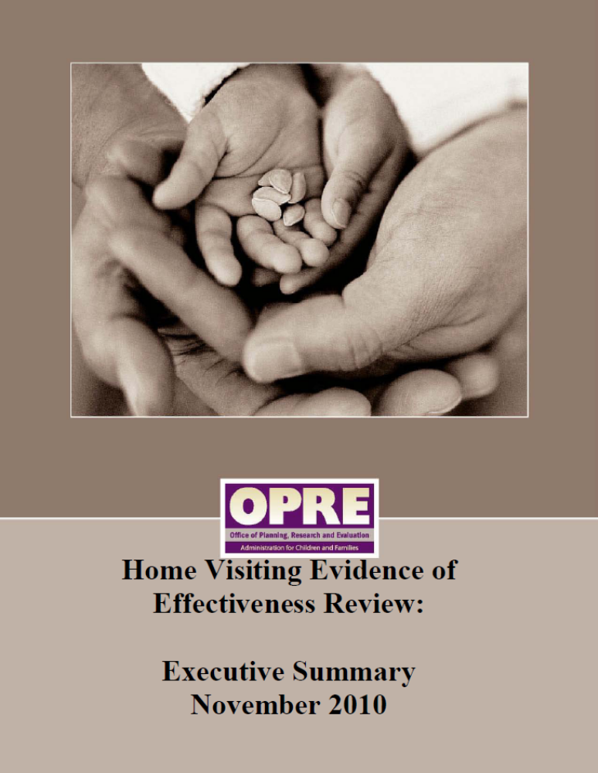

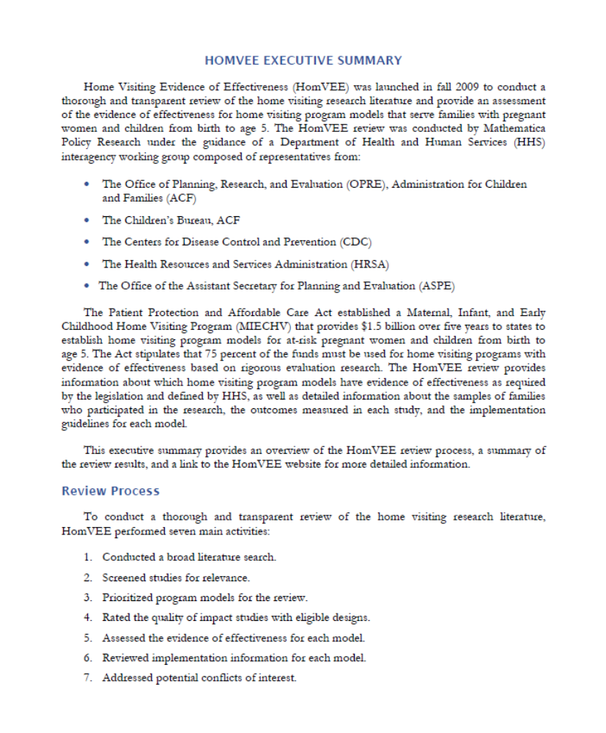
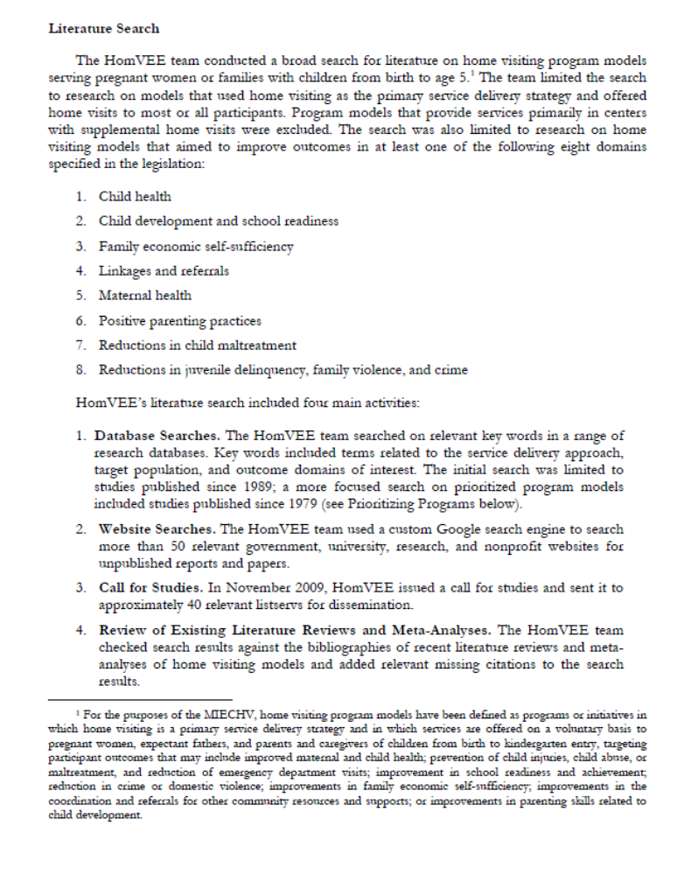
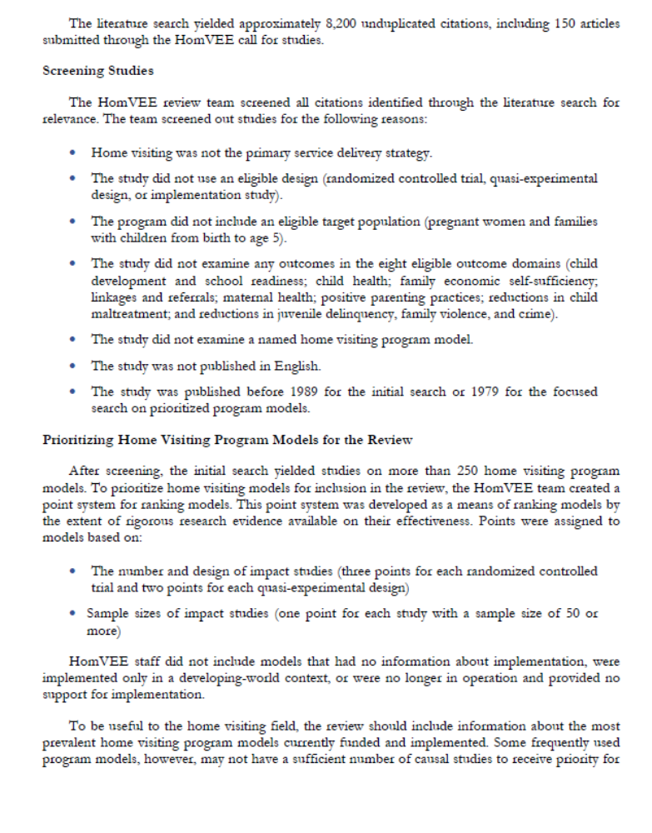
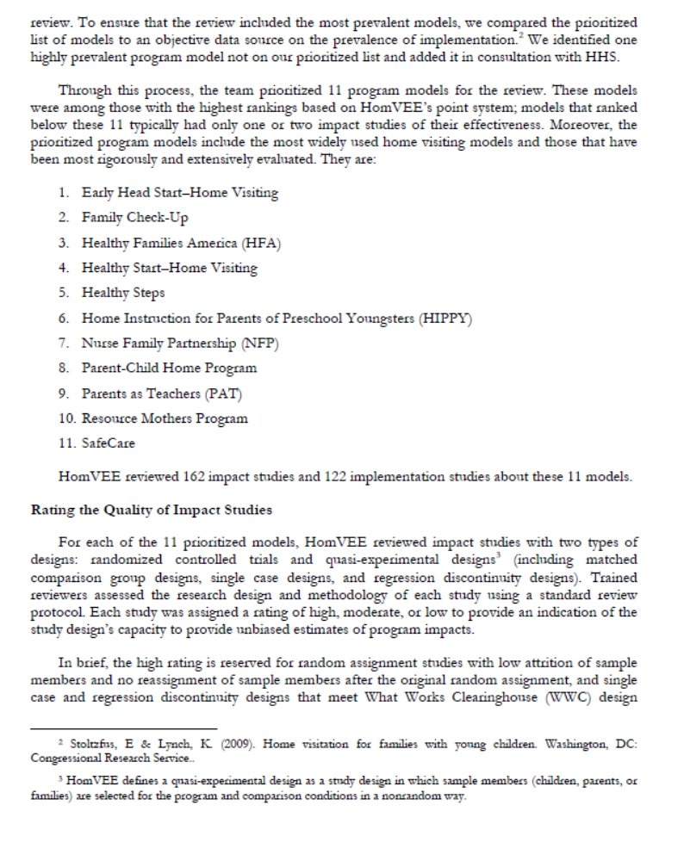
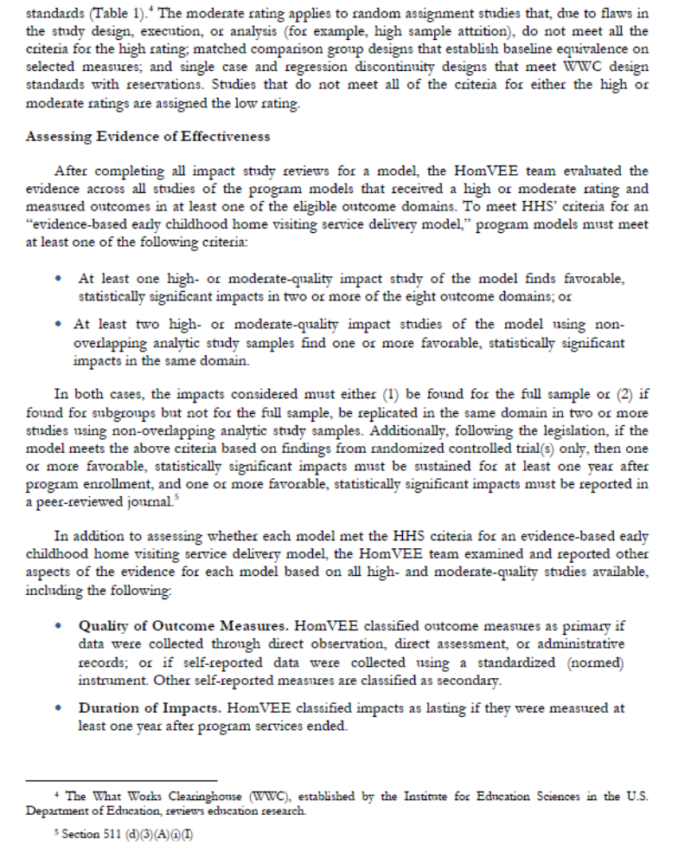
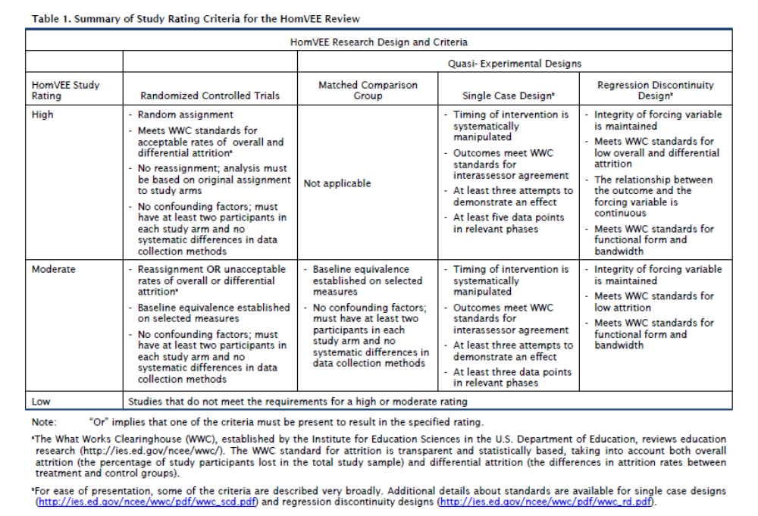
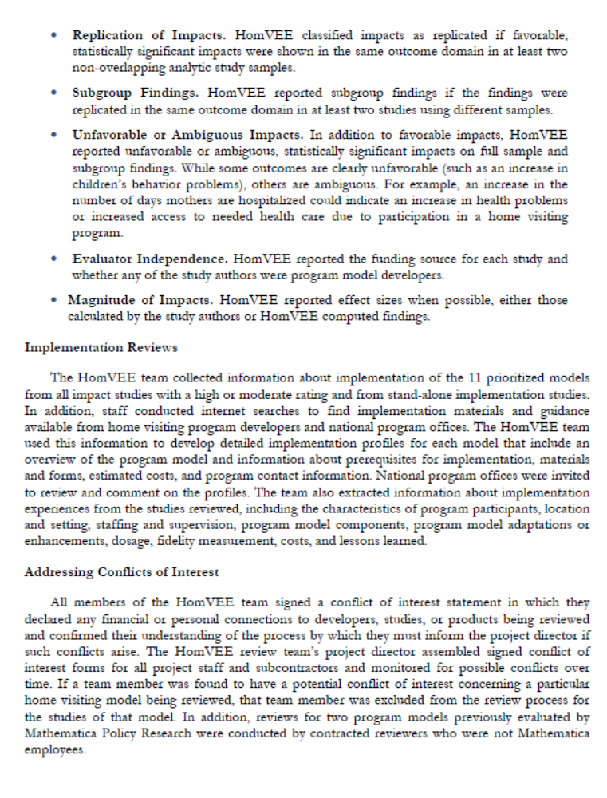
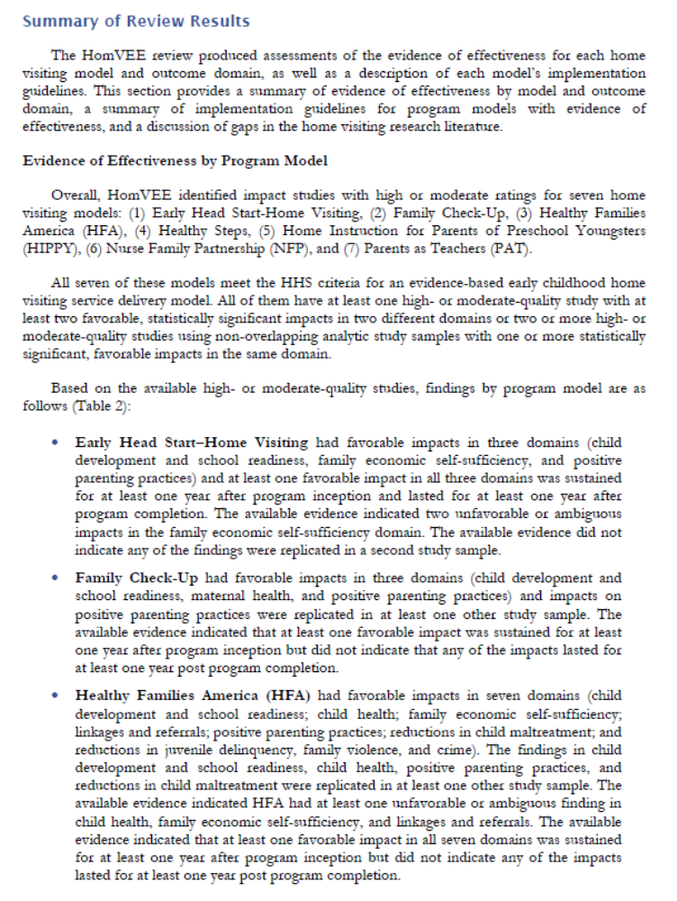
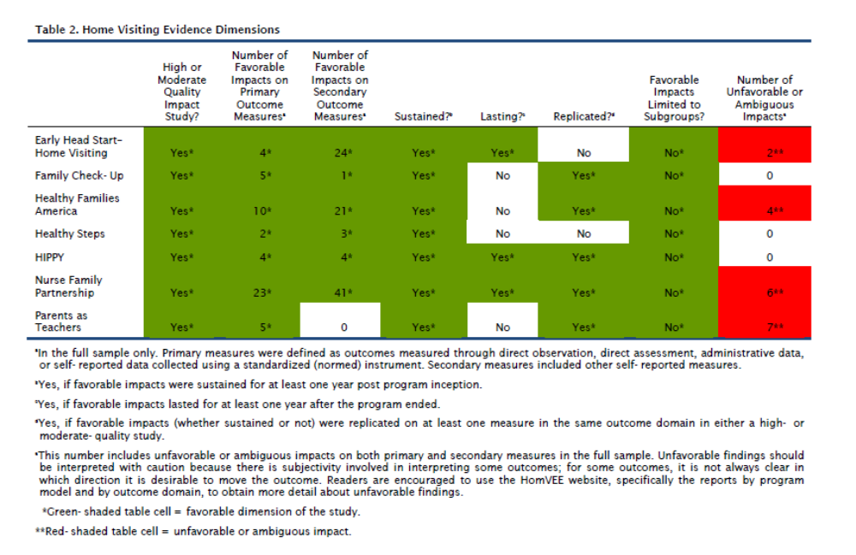
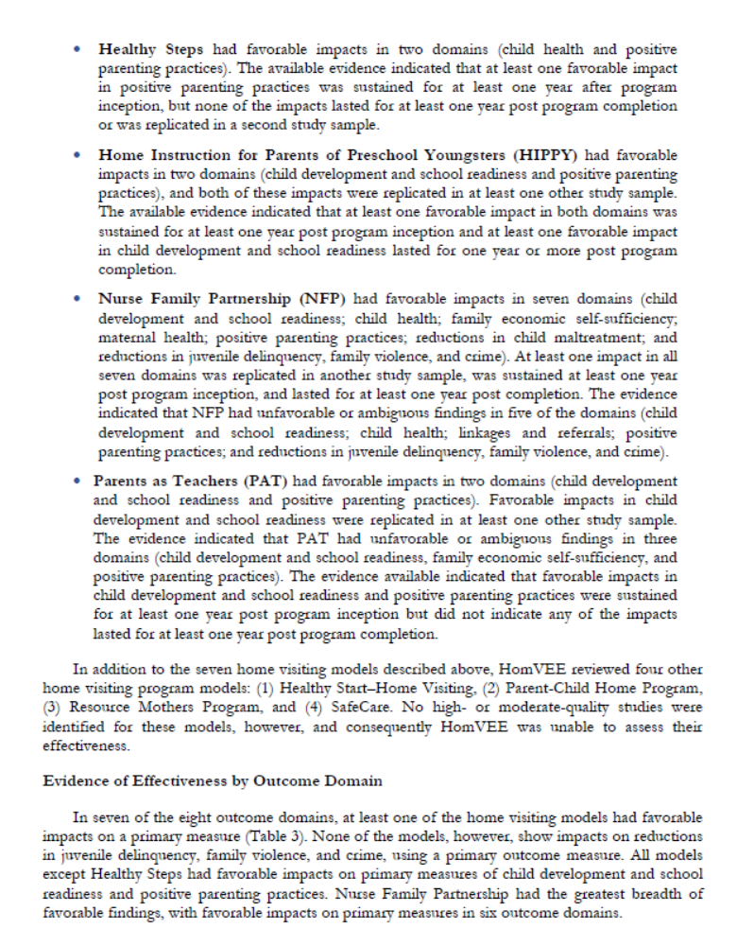
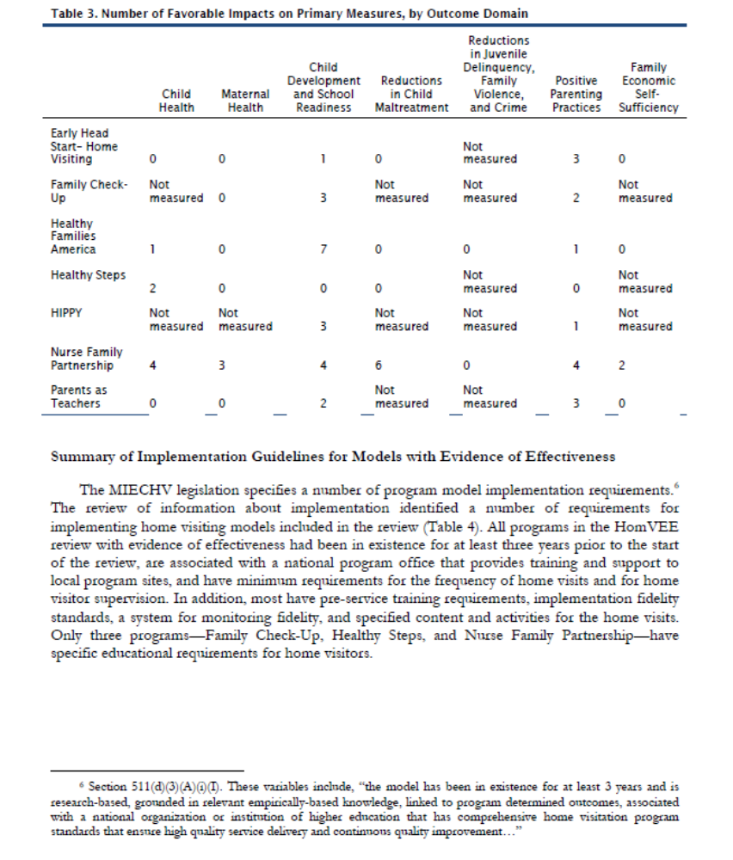
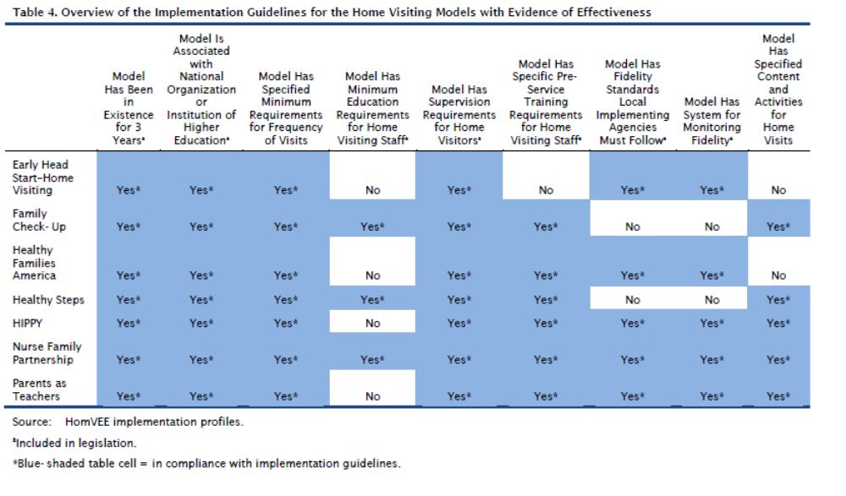
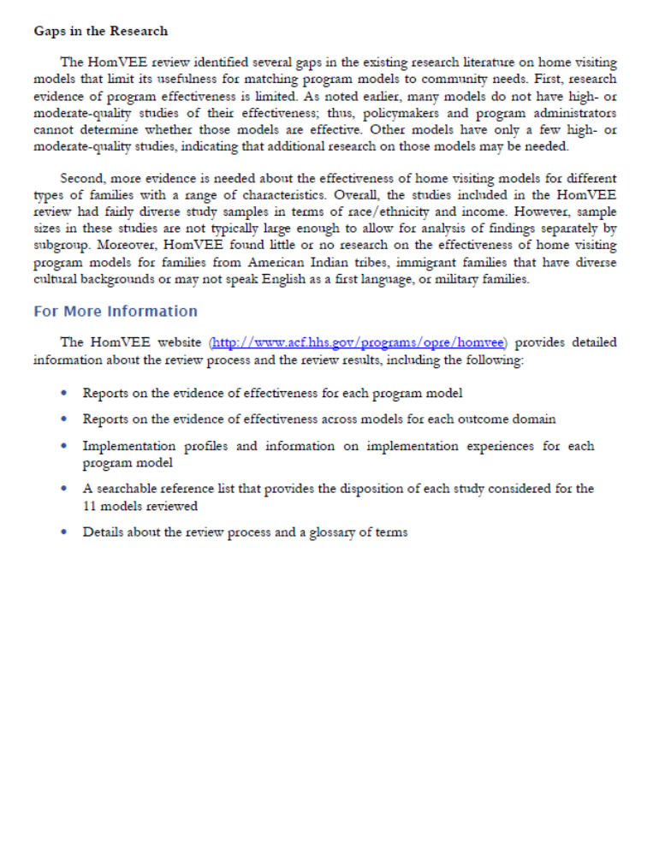
    - Models That Meet The HHS Criteria for Evidence of Effectiveness

As of the date of release of this FOA, the following models meet the criteria for evidence of effectiveness for the MIECHV program (as described above). HHS intends to continue to review the available evidence of effectiveness for other home visiting models and, as described above, will review models that have not been reviewed at the request of a state and will re-review models that were determined not to meet the evidence-based criteria at the request of a state, model developer, researcher, or others.

All states will be notified of determinations made as a result of a request for a review or re-review of a program model.

As noted, extensive information about these and other programs that have been reviewed is available on the HomVEE website (http://www.acf.hhs.gov/programs/opre/homvee).

(Note: Models are listed alphabetically)

Early Head Start – Home-Based Option

Population served: Early Head Start (EHS) targets low-income pregnant women and families with children birth to age three years, most of whom are at or below the Federal poverty level or who are eligible for Part C services under the Individuals with Disabilities Education Act in their state.

Program focus: The program focuses on providing high quality, flexible, and culturally competent child development and parent support services with an emphasis on the role of the parent as the child’s first, and most important, relationship. EHS programs include home- or center-based services, a combination of home- and center-based programs, and family child care services (services provided in family child care homes).

Family Check-Up

Population served: Family Check-Up is designed as a preventative program to help parents address typical challenges that arise with young children before these challenges become more serious or problematic. The target population for this program includes families with risk factors including: socioeconomic; family and child risk factors for child conduct problems; academic failure; depression; and risk for early substance use. Families with children age 2 to 17 years old are eligible for Family Check-Up.

Program focus: The program focuses on the following outcomes: (1) child development and school readiness and (2) positive parenting practices.

Healthy Families America (HFA)

Population served: HFA is designed for parents facing challenges such as single parenthood, low income, childhood history of abuse, substance abuse, mental health issues, or domestic violence. Individual programs select the specific characteristics of the target population they plan to serve. Families must be enrolled prenatally or within the first three months after a child’s birth. Once enrolled, services are provided to families until the child enters kindergarten.

Program focus: HFA aims to (1) reduce child maltreatment; (2) increase use of prenatal care; (3) improve parent-child interactions and school readiness; (4) ensure healthy child development; (5) promote positive parenting; (6) promote family self-sufficiency and decrease dependency on welfare and other social services; (7) increase access to primary care medical services; and (8) increase immunization rates.

Healthy Steps

Population served: Healthy Steps is designed for parents with children from birth to age 30 months. Healthy Steps can be implemented by any pediatric or family medicine practice. Residency training programs can also implement Healthy Steps. Community health organizations, private practices, hospital based clinics, child health development organizations, and other types of clinics can also become Healthy Steps sites if a health care clinician is involved and the site is based in or linked to a primary health care practice. Any family served by the participating practice or organization can be enrolled in Healthy Steps.

Program focus: The program focuses on the following outcomes: (1) child development and school readiness; and (2) positive parenting practices.

Home Instruction for Parents of Preschool Youngsters (HIPPY)

Population served: Home Instruction for Parents of Preschool Youngsters (HIPPY) aims to promote preschoolers’ school readiness by supporting parents in the instruction provided in the home. The program is designed for parents who lack confidence in their ability to prepare their children for school, including parents with past negative school experiences or limited financial resources. HIPPY offers weekly activities for 30 weeks of the year, alternating between home visits and group meetings (two one-on-one home visits per month and two group meetings per month). HIPPY sites are encouraged to offer the three-year program serving three to five year olds, but may offer the two-year program for four to five year olds. The home visiting paraprofessionals are typically drawn from the same population that is served by a HIPPY site, and each site is staffed by a professional program coordinator who oversees training and supervision of the home visitors.

Program focus: Home Instruction for Parents of Preschool Youngsters aims to promote preschoolers’ school readiness.

Nurse-Family Partnership (NFP)

Population served: The Nurse-Family Partnership (NFP) is designed for first-time, low-income mothers and their children. It includes one-on-one home visits by a trained public health nurse to participating clients. The visits begin early in the woman’s pregnancy (with program enrollment no later than the 28th week of gestation) and conclude when the woman’s child turns two years old. During visits, nurses work to reinforce maternal behaviors that are consistent with program goals and that encourage positive behaviors and accomplishments. Topics of the visits include: prenatal care; caring for an infant; and encouraging the emotional, physical, and cognitive development of young children.

Program focus: The Nurse-Family Partnership program aims to improve maternal health and child health; improve pregnancy outcomes; improve child development; and improve economic self-sufficiency of the family.

Parents as Teachers

Population served: The goal of the Parents as Teachers (PAT) program is to provide parents with child development knowledge and parenting support. The PAT model includes home visiting for families and professional development for home visiting. The home visiting component of PAT provides one-on-one home visits, group meetings, developmental screenings, and a resource network for families. Parent educators conduct the home visits, using the Born to Learn curriculum. Local sites decide on the intensity of home visits, ranging from weekly to monthly and the duration during which home visiting is offered. PAT may serve families from pregnancy to kindergarten entry.

Program focus: The Parents as Teachers program aims to provide parents with child development knowledge and improve parenting practices.

    - List of Required and Recommended Partners

Both the initial FOA and the subsequent Supplemental Information Requests required sign-off by the agencies listed below. For purposes of meeting requirements of this competitive FOA, states must provide evidence of substantive involvement in the project planning, implementation, and evaluation by representatives of the agencies listed below:

- Director of the state’s Title V agency;
- Director of the state’s agency for Title II of the Child Abuse Prevention and Treatment Act (CAPTA);
- The state’s child welfare agency (Title IV-E and IV-B), if this agency is not also administering Title II of CAPTA;
- Director of the state’s Single State Agency for Substance Abuse Services;
- The state’s Child Care and Development Fund (CCDF) Administrator;
- Director of the state’s Head Start State Collaboration Office; and
- The State Advisory Council on Early Childhood Education and Care authorized by 642B(b)(1)(A)(i) of the Head Start Act.

To ensure that home visiting is part of a continuum of early childhood services, HRSA and ACF also strongly urge states to seek consensus from:
- The state’s Individuals with Disabilities Education Act (IDEA) Part C and Part B Section 619 lead agency(ies);
- The state’s Elementary and Secondary Education Act Title I or state pre-kindergarten program; and
- The state’s Medicaid/Children’s Health Insurance program (or the person responsible for Medicaid Early Periodic Screening, Diagnosis, and Treatment (EPSDT) Program).
The state is encouraged to coordinate this application to the extent possible with:
- The state’s Domestic Violence Coalition;
- The state’s Mental Health agency;
- The state’s Public Health agency, if this agency is not also administering the state’s Title V program;
- The state’s identified agency charged with crime reduction;
- The state’s Temporary Assistance for Needy Families agency;
- The state’s Supplemental Nutrition Assistance Program agency; and
- The state’s Injury Prevention and Control (Public Health Injury Surveillance and Prevention) program (if applicable).

    - Public Burden Statement:
An agency may not conduct or sponsor, and a person is not required to respond to, a collection of information unless it displays a currently valid OMB control number. The OMB control number for this project is 0915-0339. Public reporting burden for this collection of information is estimated to average 128 hours per response, including the time for reviewing instructions, searching existing data sources, and completing and reviewing the collection of information. Send comments regarding this burden estimate or any other aspect of this collection of information, including suggestions for reducing this burden, to: HRSA Reports Clearance Officer, 5600 Fishers Lane, Room 10-33, Rockville, MD 20857.

ix. Tips for Writing a Strong Application

A concise resource offering tips for writing proposals for HHS grants and cooperative agreements can be accessed online at: http://www.hhs.gov/asrt/og/grantinformation/apptips.html.

Appendix A: Home Visiting Program Priority Elements

As previously mentioned, HRSA and ACF have identified the following priority elements as important components of a home visiting program or system, and of a comprehensive, high-quality early childhood system:

Priority Element 1: To support improvements in maternal, child, and family health. Such innovations may include, but are not limited to, the following:
  - Home visiting to women at high medical risk;
  - Interconception care and counseling;
  - The provision of mental health services;
  - Obesity prevention;
  - Establishing a medical home;
  - Tobacco cessation programs;
  - Behavioral health (including services for substance abusing caregivers);
  - Engaging health service providers in at-risk communities to encourage identification and referral of pregnant women, young children, and families to home visiting programs;
  - Fostering partnerships between home visiting programs and other state and local partners to reduce health disparities;
  - Innovations to address child development within the framework of life course development and a socio-ecological perspective; or,
  - Innovations to support the use of technology in delivery of home visiting services.

Priority Element 2: To support effective implementation and expansion of evidence-based home visiting programs or systems with fidelity to the evidence-based model selected. Such innovations may include, but are not limited to, the following:
  - Supporting, recruiting, training, and retaining staff;
  - High-quality supervision;
  - Recruiting and retaining participants; or
  - Building strong local organizational and management capacity for implementation (e.g., innovations regarding fidelity assessment, monitoring and continuous quality improvement, training and technical assistance, and other quality improvement strategies to support high quality statewide implementation).

Priority Element 3: To support the development of statewide or multi-state home visiting programs. These innovations may include, but are not limited to, the following:
  - Developing cross-model program standards;
  - Developing core competencies for home visitors and supervisors;
  - Integrated home visiting data systems;
  - Common benchmarks across models or states;
  - Centralized intake systems; or
  - Integrating home visiting services with other medical services (e.g., community health centers, medical homes, etc.).

Priority Element 4: To support the development of comprehensive early childhood systems that span the prenatal-through-age-eight continuum. These innovations may include, but are not limited to, the following:
  - Integrated early childhood data systems that include home visiting programs;
  - Coordinated early childhood workforce and professional development systems that include home visitors (including career ladders and pathways, and centralized professional development and training systems);
  - The use of home visiting as a “hub” for the development of local place-based early childhood systems that leverage public-private partnerships, data and measurement tools (such as the Early Development Instrument (EDI)); and
  - Centralized intake and referral systems to facilitate coordinated strategic planning and service delivery to improve the community environment and support positive child and family health, learning, and development outcomes.

Priority Element 5: To reach high-risk and hard-to-engage populations. These innovations may include, but are not limited to, the following:
  - Families at greatest risk for negative outcomes related to child maltreatment, substance abuse, domestic violence, or other adversities;
  - Families with children involved with the child welfare system;
  - Families with dual language learner children;
  - Children with developmental delays; parents with disabilities; or
  - Families with members in the Armed Forces.

Priority Element 6: To support a family-centered approach to home visiting. These innovations may include, but are not limited to, the following:
  - Engagement of fathers;
  - Engagement of non-custodial parents; or
  - Engagement of other primary caregivers including grandparents, other relatives and kinship caregivers, or foster parents.

Priority Element 7: To reach families in rural or frontier areas through home visiting programs.

Priority Element 8: To support fiscal leveraging strategies to enhance program sustainability. These innovations may include, but are not limited to, the following:
  - Public/private partnerships;
  - Medicaid reimbursement; or
  - Medicaid/CHIP partnerships.

Appendix B: A Table of the estimated amount of FY 11 formula-based MIECHV awards

Alabama | $1,976,665 |  | Nevada | $1,136,889
Alaska | $1,000,000 |  | New Hampshire | $1,000,000
Arizona | $2,631,887 |  | New Jersey ¹ | $2,574,098
Arkansas | $1,534,677 |  | New Mexico | $1,228,531
California ² | $11,510,679 |  | New York ¹ | $5,604,010
Colorado ¹ | $2,290,650 |  | North Carolina | $3,209,123
Connecticut | $1,026,087 |  | North Dakota | $1,000,000
Delaware ¹ | $1,673,000 |  | Ohio ¹ | $4,252,919
District of Columbia | $1,000,000 |  | Oklahoma ¹ | $2,340,796
Florida | $4,964,887 |  | Oregon | $1,407,493
Georgia | $3,635,264 |  | Pennsylvania | $3,010,846
Hawaii ¹ | $1,673,000 |  | Rhode Island ¹ | $1,673,000
Idaho | $1,000,000 |  | South Carolina ¹ | $2,589,218
Illinois ¹ | $4,296,218 |  | South Dakota | $1,000,000
Indiana | $2,218,380 |  | Tennessee ² | $3,812,421
Iowa | $1,140,642 |  | Texas ¹ | $10,483,330
Kansas | $1,172,802 |  | Utah ¹ | $1,770,713
Kentucky | $1,905,970 |  | Vermont | $1,000,000
Louisiana | $2,082,723 |  | Virginia | $1,940,266
Maine | $1,000,000 |  | Washington | $1,819,698
Maryland | $1.336,085 |  | West Virginia | $1,060,259
Massachusetts | $1,463,681 |  | Wisconsin | $1,600,310
Michigan | $3,013,935 |  | Wyoming | $1,000,000
Minnesota ¹ | $2,049,101 |  | American Samoa | $1,000,000
Mississippi | $1,769,606 |  | Guam | $1,000,000
Missouri | $2,120,142 |  | No. Mariana Islands | $1,000,000
Montana | $1,000,000 |  | Puerto Rico | $1,000,000
Nebraska | $1,000,000 |  | Virgin Islands | $1,000,000
 |  |  | Total Awards | $125,000,000
U. S. Census Bureau, Small Area Income and Poverty Estimates, Estimates for The United States 2008, 2009, Under age 5 in poverty, 2008, 2009 http://www.census.gov/cgi-bin/saipe/national.cgi?year=2009&ascii=
¹ Includes $673,000 for one EBHV Program grantee site
² Includes $1,346,000 for two EBHV Program grantee sites

Appendix C: Specific guidance Regarding individual benchmark areas

States will be required to report to the Secretary data on all benchmark areas in a format to be specified at a later date. At this time, states are required to collect data on all constructs listed below each benchmark area. It should be noted that one benchmark requires collection of data for “reduction in crime or domestic violence.” Given this language, states are not required to report on both domains, but may elect one or the other. For all other benchmark areas, the states must collect data for all benchmark areas and for all constructs listed under each benchmark area. States may choose to collect data for additional constructs within a benchmark area or in additional areas in which the state is interested. In order to capture quantifiable, measurable improvement, grantees must collect, at a minimum, data for each benchmark area and construct when the family is enrolled in the program and at one year post-program enrollment.

Technical assistance related to the benchmark requirement will be available to the state during the process of preparing for and submitting the plan as well as during the implementation of the program. Requests for technical assistance should be made to the state’s Project Officer, identified in Appendix E.

- Improved Maternal and Newborn Health

- Constructs that must be reported for this benchmark area (all constructs must be measured that are relevant for the population served; if newborns are not being served, constructs related to birth outcomes will not need to be reported):
          - Prenatal care
          - Parental use of alcohol, tobacco, or illicit drugs
          - Preconception care
          - Inter-birth intervals
          - Screening for maternal depressive symptoms
          - Breastfeeding
          - Well-child visits
(viii) Maternal and child health insurance status (note: some of these data may also be utilized for family economic self-sufficiency benchmark area)
- Definition of quantifiable, measurable improvement:
  - For prenatal care, preconception care, inter-birth intervals, screening of maternal depression, breastfeeding, adequacy of well-child visits, and health insurance coverage, improvement is defined as changes over time for mothers and infants;
  - For pre- and post-natal parental use of alcohol, tobacco, or illicit drugs improvement is defined as rate decreases over time.
- Sources of data:
- Data can be collected from interviews and surveys with families or through administrative data, if available, at the individual and family level.
- Maternal and Child Health Bureau National Performance Measures- https://perfdata.hrsa.gov/MCHB/TVISReports/MeasurementData/MeasurementDataMenu.aspx
- For more information, see Healthy People 2020 at http://www.healthypeople.gov/hp2020.
- Format to report data
- Depending on the measure used and the grantee’s plan for data utilization, the format of the data should include rates for each relevant construct. For example, the percentage of children birth to age five in families participating in the program who receive the recommended schedule of well-child visits; the percentage of mothers enrolled in the program prenatally who breastfeed their infants at six months of age.

- Child Injuries, Child Abuse, Neglect, or Maltreatment and Reduction of Emergency Department Visits

- Constructs that must be reported for this benchmark area (all constructs must be measured):
- Visits for children to the emergency department from all causes

- Visits of mothers to the emergency department from all causes

- Information provided or training of participants on prevention of child injuries including topics such as safe sleeping, shaken baby syndrome or traumatic brain injury, child passenger safety, poisonings, fire safety (including scalds), water safety (i.e. drowning), and playground safety

- Incidence of child injuries requiring medical treatment.

- Reported suspected maltreatment for children in the program (allegations that were screened in but not necessarily substantiated)

- Reported substantiated maltreatment (substantiated/indicated/alternative response victim) for children in the program

- First-time victims of maltreatment for children in the program

- Definition of quantifiable, measurable improvement:
- Decreases over time for identified constructs other than information provided or training on preventing child injuries, for which increases are considered improvement.
- Specifying source of data:
- For reductions in emergency department visits and child injury prevention: Data can be collected through participant report, medical records, emergency department patient records or hospital discharge systems. Injury-related medical treatment includes ambulatory care, emergency department visits, and hospitalizations due to injury or ingestions.
- For child abuse, neglect and maltreatment: It is preferred that data be collected through administrative data provided by the state and local child welfare agencies. Grantees may propose collecting the data through self-report or direct measurement if it utilizes a valid and reliable tool.
For more information see:
- List of the state contacts for National Child Abuse and Neglect Data System collection are available at: http://www.acf.hhs.gov/programs/cb/pubs/cm08/appendd.htm
- Child Maltreatment: http://www.acf.hhs.gov/programs/cb/pubs/cm08
- National Data Archive on Child Abuse and Neglect (NDACAN): http://www.ndacan.cornell.edu.
- Centers for Disease Control Injury Prevention: http://apps.nccd.cdc.gov/NCIPC_SII/Default/Default.aspx?pid=2
- National Health Survey: ftp://ftp.cdc.gov/pub/Health_Statistics/NCHS/Survey_Questionnaires/NHIS/2010/english
- Children’s Safety Network and Child Death Review Resource Center’s Best Practices website: www.childinjuryprevention.org

- State Injury Prevention Profiles; http://www.childrenssafetynetwork.org/stateprofiles/state.asp
- Format to report data:
- For reductions in emergency department visits: The data format should include emergency department visits divided by the number of children or mothers enrolled in the program.
- For child injuries training or information: The construct can be reported as the percentage of participants who receive information or training on injury prevention by the total number of families participating in the program.
- For reduction of incidence of child injuries: The construct should be reported as the rate of child injuries requiring medical treatment (i.e., ambulatory care, emergency department visits or hospitalizations) for children participating in the program.
- For child abuse, neglect and maltreatment: Each construct can be reported as a rate for children prior to kindergarten entry participating in the program.
  - The rate for suspected maltreatment is the number of cases of suspected maltreatment of children in the program, divided by the number of children in the program.
  - The rate for substantiated maltreatment would be calculated by counting the number of cases of substantiated maltreatment of children in the program and dividing by the number of children in the program.
  - To calculate the rate of first-time victims: Count the number of children in the program who are first-time victims divided by the number of children in the program. A first time victim is defined as a child who:
    - had a maltreatment disposition of “victim” and
    - never had a prior disposition of victim
- Data should be reported overall for a program and also should be broken down for each construct by:
    - Age category (0-12 months, 13-36 months, and 37-84 months, as appropriate given population served by the home visiting program)
    - For child abuse, neglect or maltreatment only: maltreatment type (i.e., neglect, physical abuse, sexual abuse, emotional maltreatment, other).
- Improvements in School Readiness and Achievement.

- Constructs that must be reported for this benchmark area (all constructs must be measured):
- Parent support for children's learning and development (e.g., having appropriate toys available, talking and reading with their child)
- Parent knowledge of child development and of their child's developmental progress
- Parenting behaviors and parent-child relationship (e.g., discipline strategies, play interactions)
- Parent emotional well-being or parenting stress (note: some of these data may also be captured for maternal health under that benchmark area).
- Child’s communication, language and emergent literacy
- Child’s general cognitive skills
- Child’s positive approaches to learning including attention
- Child’s social behavior, emotion regulation, and emotional well-being
- Child’s physical health and development.
For more information see:
      - http://www.acf.hhs.gov/programs/opre/ehs/perf_measures/index.html
      - http://eclkc.ohs.acf.hhs.gov/hslc/ecdh/eecd/Assessment/Child%20Outcomes/edudev_art_00090_080905.html
      - Kagan, S. L., Moore, E., & Bradekamp, S. (1995). Reconsidering children’s early development and learning: Toward common views and vocabulary. Washington, DC: National Education Goals Panel, Goal 1 Technical Planning Group. (See Child Trends summary here: http://www.childtrends.org/schoolreadiness/testsr.htm#_Toc502715209)
- Definition of quantifiable, measurable improvement:
  - Increases over time in the developmental progress of children between entry to the program and one year after enrollment.
- Specifying source of data:
- Data can be collected from a variety of sources including observation (e.g., teacher or other independent observer), direct assessment, administrative data or health records (e.g. program-specific clinical information systems), parent-report, teacher-report or samples of children’s work. The grantee must collect and report data from the source appropriate to the method and measurement of the construct proposed.
D. Format to report data:
- Depending on the measure used and the grantee plan for using the data, the data reported should be either one or both of the following:
- Scale scores. When they are available, scores should be the calculated score for individual scales in the measure. Individual item-level data should not be reported. The scale scores should be calculated as instructed in the manual or other documentation provided by the measure developer; and,
- Rates of children in a particular risk category (e.g., rates of children at risk for language delay).
The following are some suggested ideas or sources for measures within the area of “Improvements in School Readiness and Achievement:”

- http://www.acf.hhs.gov/programs/opre/ehs/perf_measures/reports/resources_measuring/res_meas_title.html
- Maternal and Child Health Bureau National Performance Measures- https://perfdata.hrsa.gov/MCHB/TVISReports/MeasurementData/MeasurementDataMenu.aspx
- http://www.casel.org/downloads/Compendium_SELTools.pdf
- http://journal.naeyc.org/btj/200401/Maxwell.pdf
- http://www.earlylearning.ubc.ca/research/initiatives/early-development-instrument/

- Crime or Domestic Violence
The legislation includes a requirement for states to report on reduction in “crime or domestic violence.” Given this language, states are not required to report on both domains, but must report on at least one.
Crime
- If the grantee chooses to report crime, constructs that must be reported for this benchmark area (all constructs must be measured) for caregivers served by the home visiting program:
    - Arrests
    - Convictions

- Definition of quantifiable, measurable improvement:

- For family-level crime rates, improvement shall be defined as rate decreases over time in the identified constructs.

- Sources of data:

- Data can be collected from interviews and surveys with families (i.e. with validated and reliable instruments) or through administrative data if available at the individual level.

- Format to report data:

- Data can be reported as annual aggregate rates for parents participating in the program. Data should be reported broken down by reason for the arrest or conviction.
Domestic Violence
A. If the grantee chooses to report on domestic violence, constructs that must be reported for this benchmark area (all constructs must be measured) include:
  - Screening for domestic violence

    - Of families identified for the presence of domestic violence, number of referrals made to relevant domestic violence services (e.g., shelters, food pantries);

    - Of families identified for the presence of domestic violence, number of families for which a safety plan was completed.

- Definition of quantifiable, measurable improvement:

- For screenings, improvement shall be defined as increases in the rate compared to the population served completed over time.

- For referrals and completion of safety plans related to domestic violence, improvement shall be defined as an increase over time.

- Sources of data:
- For family-level data, data can be collected from interviews and surveys with families using either administrative data or reliable and valid measures.

For more information see:

- http://www.cdc.gov/ncipc/dvp/Compendium/Measuring_IPV_Victimization_and_Perpetration.htm

- http://www.cdc.gov/ViolencePrevention/intimatepartnerviolence/datasources.html

- Format to report data:

- Depending on the measure used for each construct and the grantee plan for using the data, the data reported should be either one or both of the following:

  - Percentage of screenings for domestic violence of program participants.

  - Referrals and safety plans should be reported as a rate of appropriate services identified and referrals and safety plans made by the total number of identified participants in need of these services.

- Family Economic Self-Sufficiency.

- Constructs that must be reported for this benchmark area (all constructs must be measured):
  - Household income and benefits
    - Household shall be defined as all those living in a home (who stay there at least 4 nights a week on average) who contribute to the support of the child or pregnant woman linked to the HV program. Tenants/boarders shall not be counted as members of the household
    - Income and benefits shall be defined as earnings from work, plus other sources of cash support. These sources may be private, i.e., rent from tenants/boarders, cash assistance from friends or relatives, or they may be linked to public systems, i.e. child support payments, TANF, Social Security (SSI/SSDI/OAI), and Unemployment Insurance.
  - Employment or Education of adult members of the household
  - Health insurance status

- Definition of quantifiable, measurable improvement:
  - For household income, improvement shall be defined as an increase in total household income and benefits over time.
  - Note that the second construct above refers to employment or education. We recognize that there can be an inverse relationship between the two in the short-run, i.e., while people are pursuing education, they may reduce their participation in the labor force, and vice versa. Therefore, while sites should measure both constructs, improvement in one or the other shall be considered sufficient to show positive results for this construct.
    - For employment, improvement shall be defined as an increase in the number of paid hours worked plus unpaid hours devoted to care of an infant by all adults in participating households over time.
    - For education, improvement shall be defined as an increase in the educational attainment of adults in participating households over time. Educational attainment shall be defined by the completion not only of academic degrees, but also of training and certification programs.
  - For health insurance status, improvement shall be defined as an increase in the number of household members who have health insurance over time.
- Specifying source of data:
  - Data can come from interviews or surveys with families. Data on child support and public benefit receipt may be able to be gathered or verified from the relevant agencies, if data-sharing agreements can be developed. For employment, family-level data may also be gathered or verified using Unemployment Insurance data.
- Format to report data:
  - For the purposes of Federal reporting, family economic self-sufficiency data should be collected for the month of enrollment and the month one-year post enrollment.
    - Household income and benefits, specifying each source of income or benefits and the amount gathered from each source;
    - Number of adult household members employed during the month, and average hours per month worked by each adult household member
    - Educational benchmarks achieved (e.g., program completion, degree attainment) by each adult household member, number of adult household members participating in educational activities since the previous survey, and hours per month spent by each adult household member in educational programs and;
    - Health insurance status of all household members.
The following are suggested ideas or sources for measures within the area of “Family Self-Sufficiency:”
- “Observations from the Interagency Technical Working Group on Developing a Supplemental Poverty Measure,” March 2010, http://www.census.gov/hhes/www/povmeas/SPM_TWGObservations.pdf.
- “National Directory of New Hires,” http://www.acf.hhs.gov/programs/cse/newhire/ndnh/ndnh.htm
- Evaluation Data Coordination Project http://www.acf.hhs.gov/programs/opre/other_resrch/eval_data/index.html
- Maternal and Child Health Bureau National Performance Measures- https://perfdata.hrsa.gov/MCHB/TVISReports/MeasurementData/MeasurementDataMenu.aspx
- Coordination and Referrals for Other Community Resources and Supports
For the purposes of the home visiting benchmarks, referrals include both internal referrals (to other services provided by the local agency) and external referrals (to services provided in the community but outside of the local agency). As part of their initial and ongoing needs assessments, grantees should track the number of services available and appropriate for the participants in the program. The construct of coordination includes capturing linkages at the agency and the individual family level.
- Constructs that must be reported for this benchmark area (all constructs must be measured):
- Number of families identified for necessary services
- Number of families that required services and received a referral to available community resources
- MOUs: Number of Memoranda of Understanding or other formal agreements with other social service agencies in the community
- Information sharing: Number of agencies with which the home visiting provider has a clear point of contact in the collaborating community agency that includes regular sharing of information between agencies
- Number of completed referrals (i.e., the home visiting provider is able to track individual family referrals and assess their completion, e.g., by obtaining a report of the service provided).
- Definition of quantifiable, measurable improvement:
- Increase in the proportion of families screened for needs, particularly those relevant for affecting participant outcomes.
- Increase in the proportion of families identified with a need who receive an appropriate referral, when there are services available in the communities.
- MOU: Increase in the number of formal agreements with other social service agencies.
- Information sharing: Increase in the number of social service agencies that engage in regular communication with the home visiting provider.
- Number of completed referrals: Increase in the percentage of families with referrals for which receipt of services can be confirmed.
- Specifying source of data:
- Data for each of the constructs can be collected through direct measurement by the home visitors and/or administrative data provided by the local agency.

The Secretary of HHS will provide technical assistance specifically around measuring this domain.

- Format to report data:
- Number of screenings and number of referrals provided divided by the total number of participating families.
- Total number of social service agencies with an MOU and/or regular communication.
- Proportion of referrals of participating families with identified needs whose receipt of service was verified divided by the total number of participating families with identified needs.

FY 2011 funds will be distributed to states as follows: - A base allocation of $1,000,000 for each state; - An amount based on the number of children under age five in families at or below 100% of the Federal poverty line in the state as compared to the number of such children nationally; in no case will a state or jurisdiction receive less than 120% of the amount received by formula in FY 2010; and - An amount equal to the funds, if any, currently provided to a state (or entity within that state) to implement one of the projects formerly known as the Supporting Evidence Based Home Visiting (EBHV) Program administered by ACF’s Children’s Bureau.
A “state home visiting program” is an overall effort, by the MIECHV grantee, to effectively implement home visiting models (or a single home visiting model) in the state’s at-risk community(ies) to promote improvements in the benchmark and participant outcome areas as specified in the legislation.
See http://www.gpo.gov/fdsys/pkg/PLAW-111publ148/pdf/PLAW-111publ148.pdf , pages 334-343.
Dulak, J. A., & Dupre, E.P. (2008). Implementation matters: A review of research on the influence of implementation on program outcomes and factors affecting implementation. American Journal of Community Psychology, 41, 327-350.
Fixsen, D. L., Naoom, S., F., Blasé, K. A., Friedman, R. M., & Wallace, F. (2005). Implementation research: A synthesis of the literature. Tampa, FL: University of South Florida, Louis de la Parte Florida Mental Health Institute, The National Implementation Research Network (FMHI Publication #231).
Rubin, D. M., O’Reilly, A. L. R., Luan, X., Dai, D., Localio, R., & Christian, C. W. (2010). Variation in pregnancy outcomes following statewide implementation of a prenatal home visitation program. Archieves of Pediatric and Adolescent Medicine. Downloaded on 11/2/10 from: www.archpediatrics.com.
Wilson, D. B., & Lipsey, M. W. (2001). The role of method in treatment effectiveness research: Evidence from a meta-analysis. Psychological Methods, 6(4), 413-429.
Wandersman, A., Duffy, J., Flaspohler, P., Nooan, R., Lubell, K., Stillman, L., Blachman, M., Dunville, R., & Saul, J. (2008). Bridging the gap between prevention research and practice: The interactive systems framework for dissemination and implementation. American Journal of Community Psychology, 41, 171-181.
Ibid. 4.
Ibid. 5.
Ibid.
Dane, A.V., & Schneider, B. H. (1998). Program integrity in primary and secondary prevention: Are implementation effects out of control? Clinical Psychology Review, 18, 23-45.
Hamre, B.K., Justice, L. M., Pianta, R. C., Kilday, C., Sweeney, B. Downer, J. T., & Leach, A., (2010). Implementation fidelity of MyTeachingPartner literacy and language activities: Association with preschoolers’ language and literacy growth. Early Childhood Research Quarterly, 25, 329-347.
Ibid. 6.
Ibid. 5.
Aarons, G. A., Fettes, D. L., Flores, L. E., & Sommerfeld, D. H. (2009a). Evidence-based practice implementation and staff emotional exhaustion in children’s services. Behavior Research and Therapy. Downloaded online on 9/3/09 from www.elsevier.com/locate/brat
Aarons, G.A., Sommerfeld, D. H.,Hect, D. B., Silvosky. J. F., & Chaffin, M., J. (2009b). The impact of evidence-based practice implementation and fidelity monitoring on staff turnover: Evidence for a protective effect. Journal of Consulting and Clinical Psychology, 77 (2), 270-280.
Ibid. 5.
This 25% limit on expenditures pertains to the total funds awarded to the grantee for the fiscal year, i.e., the amount equal to state’s formula grant plus the amount of the competitive grant award, if the state’s application is successful. The formula allocation for each state is provided in Appendix B of this FOA.
“Empirical work” includes evidence from research, theory, practice, context, or cultural knowledge.
See VIII, Other Information, 3. HomVEE Executive Summary.
”Home visiting programs” include all programs that meet the following definition of home visiting: a program that includes home visiting as a primary service delivery strategy (excluding programs with infrequent or supplemental home visiting), and is offered on a voluntary basis to pregnant women or children birth to age 5 targeting one or more of the participant outcomes in the legislation: improved maternal and child health, prevention of child injuries, child abuse, or maltreatment, and reduction of emergency department visits, improvement in school readiness and achievement, reduction in crime or domestic violence, improvements in family economic self-sufficiency, and improvements in the coordination and referrals for other community resources and supports.
See VIII, Other Information, 3. HomVEE Executive Summary.
“Home visiting programs” include all programs that meet the following definition of home visiting: a program that includes home visiting as a primary service delivery strategy (excluding programs with infrequent or supplemental home visiting), and is offered on a voluntary basis to pregnant women or children birth to age five targeting one or more of the participant outcomes in the legislation: improved maternal and child health, prevention of child injuries, child abuse, or maltreatment, and reduction of emergency department visits, improvement in school readiness and achievement, reduction in crime or domestic violence, improvements in family economic self-sufficiency, and improvements in the coordination and referrals for other community resources and supports.
Participatory evaluation engages stakeholders in the development, implementation, and interpretation of evaluation results to maximize the usefulness of the results for stakeholders. Empowerment evaluation supports stakeholders to learn the tools on conducting effective evaluation to foster inquiry and self-evaluation or installation of continuous quality improvement.
Department of Health and Human Services, Health Resources and Services Administration, Administration for Children and Families, Maternal, Infant, and Early Childhood Home Visiting Program; Request for Public Comment, 75 Federal Register 141 (23 July 2010), pp. 43172-43177.
For the purposes of the MIECHV, home visiting models have been defined as programs or initiatives in which home visiting is a primary service delivery strategy and in which services are offered on a voluntary basis to pregnant women, expectant fathers, and parents and caregivers of children birth to kindergarten entry, targeting participant outcomes which may include improved maternal and child health; prevention of child injuries, child abuse, or maltreatment, and reduction of emergency department visits; improvement in school readiness and achievement; reduction in crime or domestic violence; improvements in family economic self-sufficiency; improvements in the coordination and referrals for other community resources and supports; or improvements in parenting skills related to child development.
We recommend that programs utilize these and other appropriate data for CQI to enhance program operation and decision-making and to individualize services.

