Food Allergies
What you need to know

Millions of people have food allergies that can range from mild to life-threatening.

Most Common Food Allergens

Peanuts Tree nuts Fish Shellfish

Eggs Milk Wheat Soy

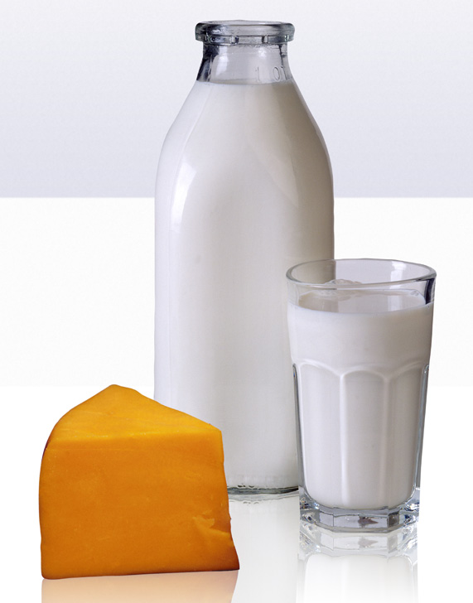

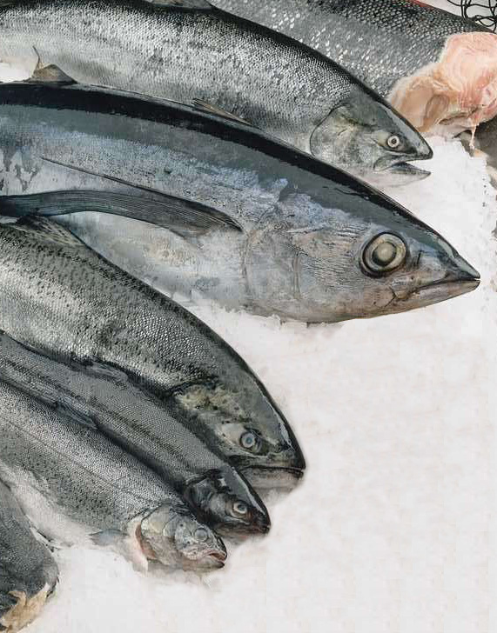

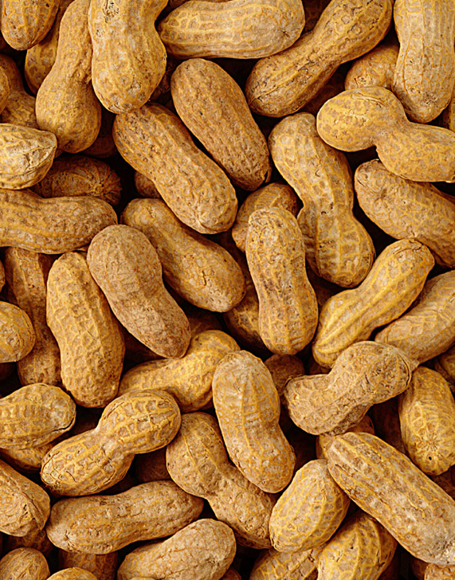

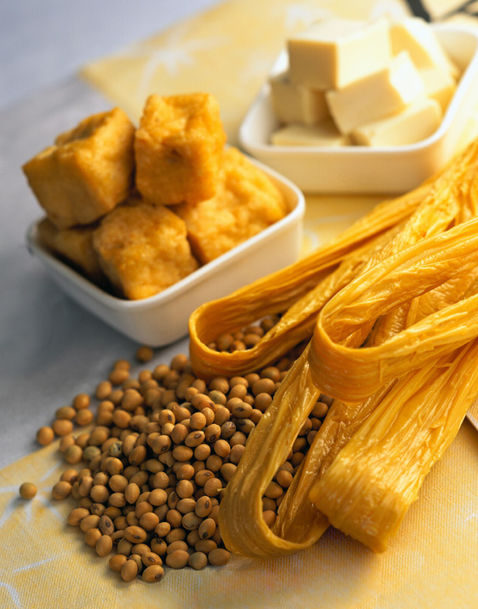

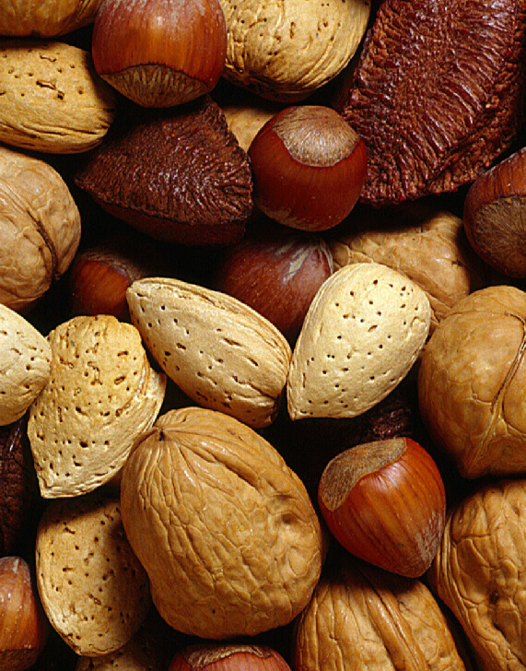

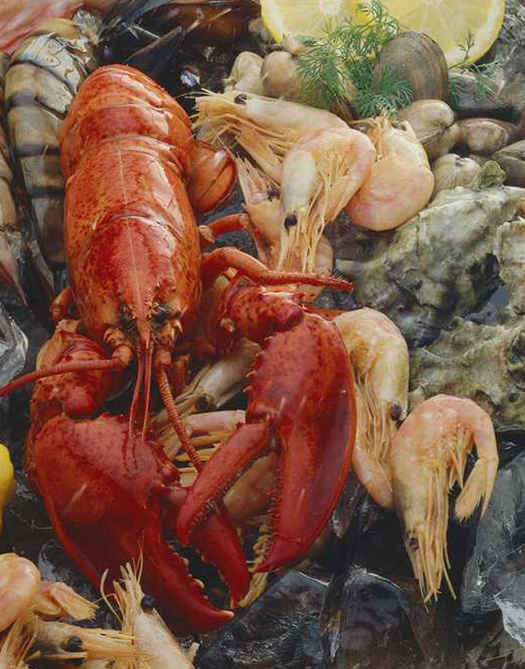

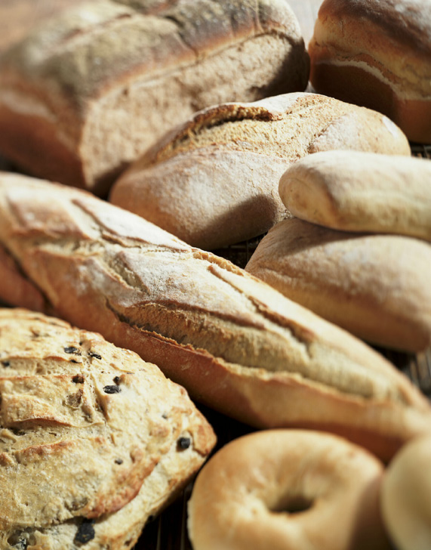

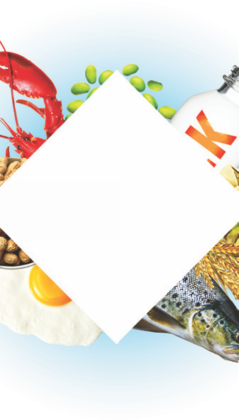

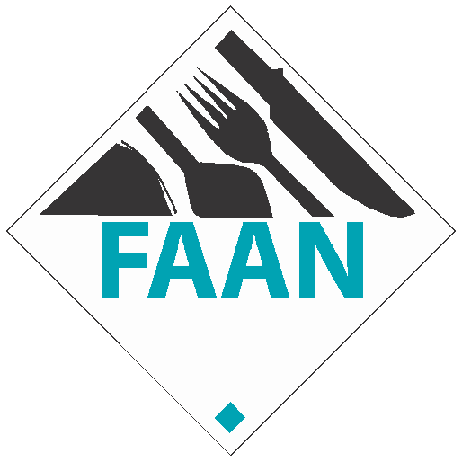

Always let the guest make their own informed decision.

When a guest informs you that someone in their party has a food allergy, follow the four R's below:

Refer the food allergy concern to the department manager, or person in charge. Review the food allergy with the customer and check ingredient labels. Remember to check the preparation procedure for potential cross-contact. Respond to the customer and inform them of your findings.
Sources of Cross-Contact:

Cooking oils, splatter, and steam from cooking foods.

Allergen-containing foods touching or coming into contact with allergy-free foods
(i.e. a nut-containing muffin touching a nut-free muffin).
Any food equipment used for the processing of allergy-free foods must be thoroughly cleaned and sanitized prior to use.
All utensils (i.e.,spoons, knives, spatulas, tongs), cutting boards, bowls, pots, food pans, sheet pans, preparation surfaces.
Fryers and grills.

Wash hands and change gloves after handling potential food allergens.

If a guest has an allergic reaction, call 911 and notify management.

© 2009 The Food Allergy & Anaphylaxis Network

