Your gift card can be used to buy food, baby formula, diapers or other household necessities.
- Market Basket and Big Y Cards can ONLY be used for in-store shopping. If you are in isolation or quarantine, please try to find a friend or family member who lives in another household to shop for you.
- Stop & Shop cards can be used for delivery or curbside pick-up and in-store shopping. You MUST spend $75 or more for free delivery.
- If you have questions or need help, please contact the program coordinator: Jhana Wallace, 617-230-4487, MAfoodsecurity@mass.gov
DIRECTIONS: USING YOUR STOP AND SHOP CARD FOR DELIVERY OR PICK-UP

To use your Stop and Shop card for delivery or pickup,
HOW TO USE YOUR STOP AND SHOP, MARKET BASKET OR BIG Y GIFT CARD(S)

you will need to set up an account on their website mobile app. Follow the steps below.

1. Go to the website www.stopandshop.com or download the Stop and Shop app on your phone (from the App Store or Google Play Store)

2. Create an account  Click “sign In” to create an account  Click the lines to create an account | 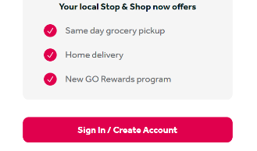  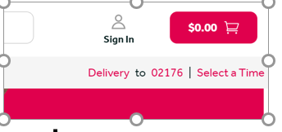   | Stop and Shop has a few different ways to create an account. It can look different depending on which device you use.
3. Enter your email address and create a password for your account. If you do not have an email address, we are able to give you one. | 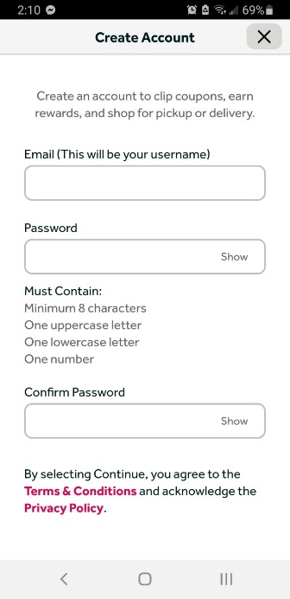 | IF YOU NEED AN EMAIL ADDRESS: Please call Jhana Wallace at 617-230-4487.
4. Set up a Stop and Shop rewards card or link your exisiting card if you have one. | 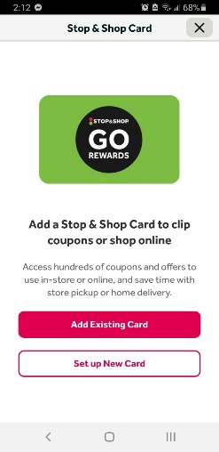 | You will need a rewards card to set up an account. You can’t skip this step.
THAT’S IT! YOUR ACCOUNT IS SET UP AND YOU ARE READY TO START SHOPPING!
HOW TO SHOP FOR DELIVERY OR PICK UP

1. Before you start shopping, choose either “delivery” or “pick-up.” You will need to choose a store location for pick-up. | 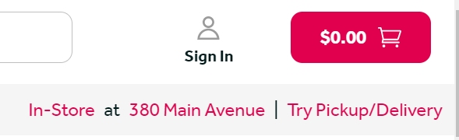  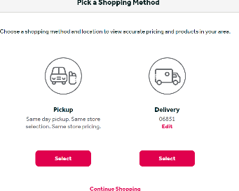  Picture 1  OR Picture 2 | You can choose “delivery” or “pick-up” before you start shopping (Picture 1). If you have not signed up for an account yet, you will need to provide a zip code to check for delivery to your area. (You can also skip this step for now and just start shopping.)  If you skip this step now, you will be asked to choose later when it’s time to check out (picture 2) .
2. If you choose delivery, you need to pick a time. If you choose pick-up, you need to pick a store location and then a time. | Picture 1  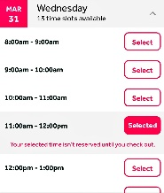  Picture 2  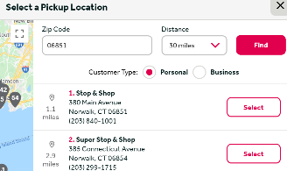  Picture 3 | Picture 1=Delivery times  Picture 2=Store location for pick-up  Picture 3=Pick up time
2. Add items to your cart. | 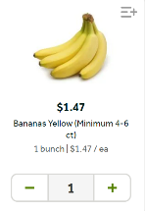  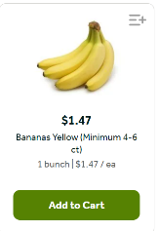 | 1. Find items you want to buy.  2. Click the “add to cart” button.  3. Select the + or – to change the amount.
3. When you’re finished shopping, click your shopping cart. | 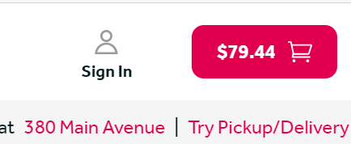 | You MUST spend at least $75.00 to get free shipping.
4. Do NOT click “checkout” yet: approve substitute items and add the promo code SSFREE for free delivery or pick-up.  After you have done both of these, then click “Checkout” | 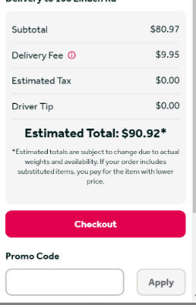  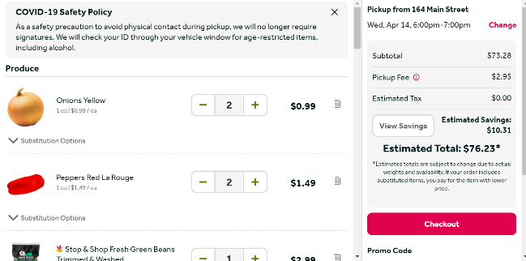  3rd  1st  2nd  SSFREE | IMPORTANT. Follow these steps to check out.  Don’t forget-Approve any subsitutes if your items are not available  1st: Add the promo code SSFREE to get free shipping or pick-up. Note: this code can only be used ONCE per account holder.  2nd: Click “Apply”  3rd: click “Checkout”
5. Add your credit/debit card # (you will not be charged unless you spend over $100).  You need a debit or credit card to use the delivery or pickup service.  If you do not have a credit or debit card, see Step 6. | 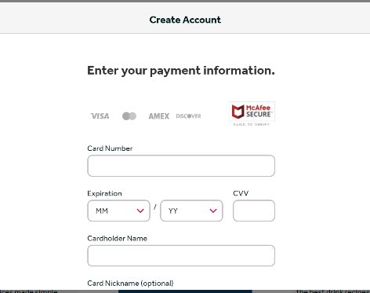 | Before you checkout, you will be asked to add a debit/credit card. Your card will not be charged unless you spend over $100.  You do not have to use a card with your name. Someone else can use their card on your Stop and Shop account.
6. If you do not have a debit/credit card, call 1-800-377-7129 for assistance. A dedicated customer service person is available Monday-Friday, 8:00am-5:00pm. | Picture 1  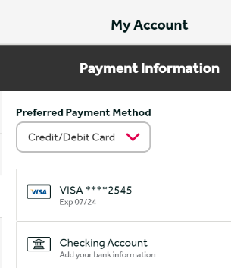  Picture 2  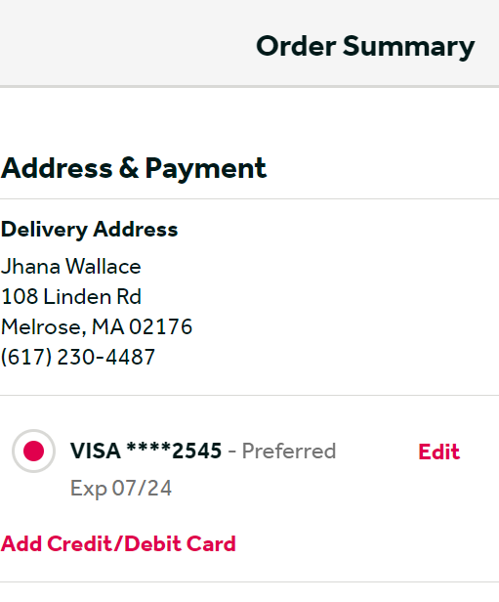 | When you call 1-800-377-7129, a Stop and Shop staff person will help you finish your order.  He will ask you to “log out” of your account. Once you have done this, he is able to add a payment method to your account. He will then have you “log in”. When you log back in, if you go to your account settings you will see a credit card # has been filled in (Picture 1).  When you check out, this # will show up as your payment method (Picture 2) in addition to your gift card #.  NOTE: You can’t use this credit card # , and you can’t use it without the gift card that was given to you.  This credit card # will not work to make any additional purchases.

CHECKING OUT FOR DELIVERY OR PICKUP – THE CHECKING OUT PAGE

1. You can’t checkout until you have added your gift card number at the very bottom of this screen.  Do not click “Place Order” until AFTER you have entered your gift card number the very bottom of this section.  Scroll down to review your order and add the gift card #. | 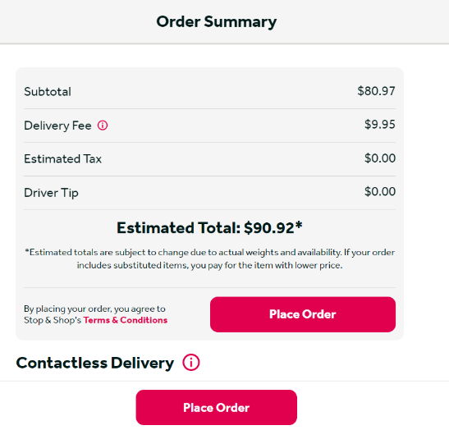  DO NOT CLICK PLACE ORDER YET | This section of the checkout page shows:  1. Delivery fee (will be $0.00)  2. Tax  3. Driver tip (once added if desired)  4. The estimated amount of your order (the order total can change if the store does not have your items)
2. Scroll down to see the next section | 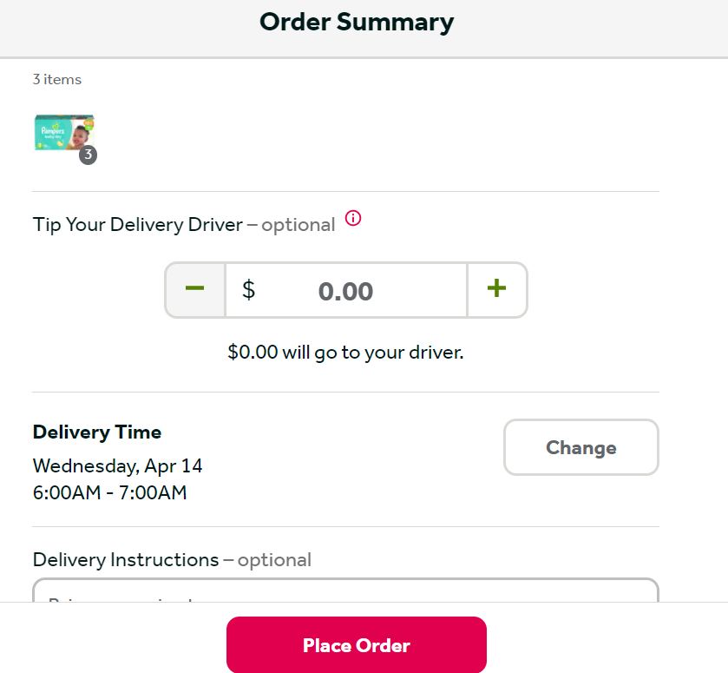  DO NOT CLICK PLACE ORDER YET | This section of the checkout page shows:  1. The items in your cart  2. A place to add a tip if you like (no tip option if picking up)  3. A place to confirm or change the delivery or pick-up time (and location)
3. Scroll down to see the next section | 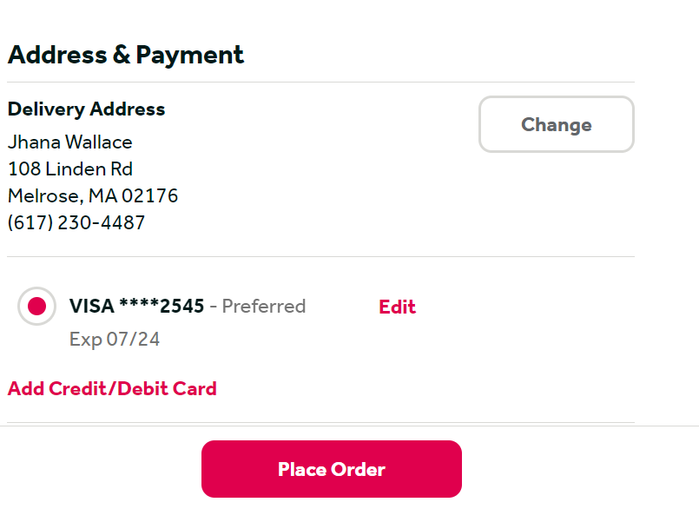  DO NOT CLICK PLACE ORDER YET | This section of the checkout page shows:  1. A place to confirm or change the delivery address  2. Your credit/debit card OR the # provided for you (you will not see this #-you will only see a series of *****’s).
4. Scroll to here to enter the promo code if you haven’t already AND enter your gift card # found on the back of your card. | 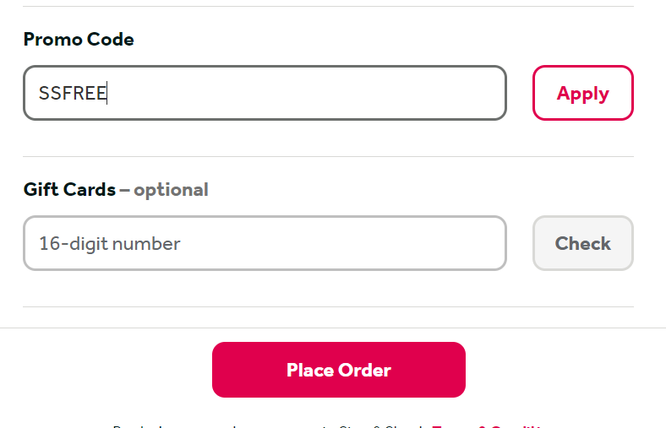  NOW CLICK PLACE ORDER | After you enter the promo code if needed AND your gift card number, NOW you can click place order.
5. Confirmed order | 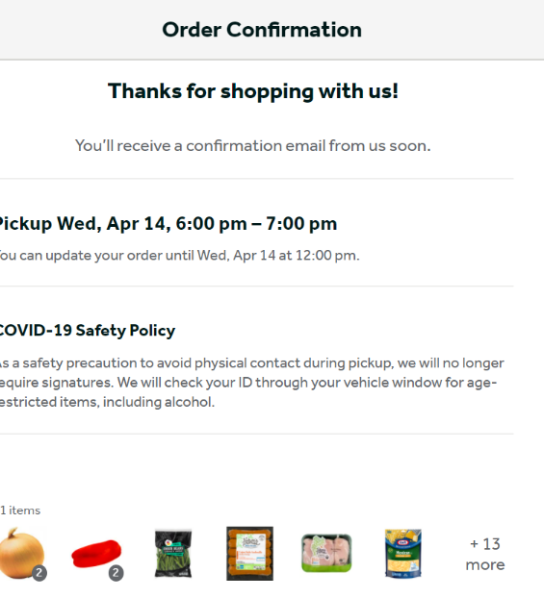 | Once you click “place order” you should see this screen-confirmation of your order.

