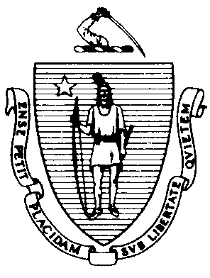
The Commonwealth of Massachusetts Executive Office of Health and Human Services Department of Public Health Food Protection Program

305 South Street, Jamaica Plain, MA 02130-3597
617-983-6712 617-524-8062 - Fax

Food Export/Certificate of Free Sale Application
Return To: Food Protection Program, 305 South St., Jamaica Plain, MA 02130

Provide Check or Money Order Number:

1. Food Manufacturer’s Information:
_____________________________________________________ __MA-_____________________________
Manufacturer’s Name MA Registration Number

Doing Business as Name (if other than above, and you wish this name to Contact Person’s Name appear on the export certificate)

Street Address Contact’s Phone Number Fax Number

City State Zip Country Contact’s Email Address (mandatory)

2. Exporting Company’s Information: (if applicable)

Exporting Company’s Name State License/Registration Number

Street Address

City State Zip Country Contact Person

Contact’s Phone Number Fax Number
Contact’s Email Address

3. Notarization Required? Yes
No

4. Product Description:
Continue on additional page(s) as needed.

5. Send Certificate to: Manufacturer

Exporter

6. Send Certificate via:
For expedited certificate(s), please provide a pre-paid Fedex, UPS label, or envelope with this application. Please allow 21 days for processing.

7. Fees: Quantity of Certificates Requested x $ 75.00 = $ (Total) Attach a check made payable to the Commonwealth of Massachusetts and mail to the above address.
8. Signature: The undersigned verifies that all ingredients are approved for use by the USFDA or appear on the GRAS list, and each product is intended for human consumption and available for sale in the U.S. without restriction. I hereby certify that the above information is true to the best of my knowledge and that I will comply with all applicable laws and regulations of the Commonwealth of Massachusetts and the Department of Public Health pertaining to the activity for which I am applying. In addition, pursuant to M.G.L. c. 62C, § 49A, I certify under the penalties of perjury that to the best of my knowledge and belief, have filed all state tax returns and paid all state taxes required under law.

Revised: 06/17
/ /
Signature Title Date Tax or Federal ID#

