
Massachusetts Department of Public Health
Bureau of Infectious Disease and Laboratory Sciences
Bureau of Climate and Environmental Health

Foodborne Illness Outbreak Report
Massachusetts
2023

305 South Street Published: December 30, 2025
Jamaica Plain, MA 02130
Suggested Citation:
Massachusetts Department of Public Health (DPH), Bureau of Infectious Disease and Laboratory Sciences. 2023 Foodborne Illness Outbreak Report. https://www.mass.gov/lists/infectious-disease-data-reports-and-requests. Published December 2025. Accessed [date].
Requests for additional data:
https://www.mass.gov/infectious-disease-surveillance-reporting-and-control
List of Commonly Used Acronyms
LBOH - Local Board of Health
DPH - Massachusetts Department of Public Health
SPHL - State Public Health Laboratory
STEC - "Shiga toxin-producing" E. coli
WGS - Whole Genome Sequencing
Foodborne Illness
Foodborne illness, or 'food poisoning,' is caused by the consumption of food or drinks that have been contaminated with bacteria, viruses, parasites, toxins, or chemicals. Typical symptoms include vomiting, diarrhea, and abdominal cramps. Cases of foodborne illness caused by certain pathogens or toxins, and suspected outbreaks of foodborne illness are reportable in Massachusetts to local boards of health (LBOH) and the Massachusetts Department of Public Health (DPH) in accordance with 105 CMR 300.000.
Foodborne Outbreaks
A foodborne outbreak is defined as two or more people from different households becoming ill after consuming the same contaminated food. Many people associate foodborne outbreaks with events like a group falling ill after eating at the same restaurant or potluck meal. However, outbreaks can also involve individuals who live far apart if the consumed food was contaminated during production or preparation before being distributed to stores or restaurants across various states. Foodborne outbreaks have been linked to a wide range of contaminated foods and beverages, including fruits, vegetables, unpasteurized (raw) dairy products, seafood, chicken, beef, pork, and processed items such as flour, frozen meals, and peanut butter. Raw or undercooked meats, including chicken and seafood, and animal products like eggs or milk are especially likely to carry germs that can cause illness and trigger outbreaks. In addition to foodborne transmission, many of the germs that cause illness can also spread through other routes, such as direct contact with animals, swallowing contaminated recreational water, or person-to-person transmission, where an infected individual passes the germs to others through close contact.
Certain diseases that can be transmitted through food are reportable to LBOH and DPH. When an individual is diagnosed with a foodborne illness, the LBOH will contact them to gather information about their symptoms, food history, and potential exposures. Even suspected cases without a clinical diagnosis are required to be reported to public health by certain reporters as this information helps identify potential outbreaks. Health departments collect positive laboratory test results from affected individuals, which are essential for determining whether multiple cases are linked to the same germ. When DPH detects a pattern of illness caused by a common pathogen, they collaborate with LBOH, and state and federal health agencies to investigate whether a shared source, such as a contaminated food item, is responsible. As part of this investigation, DPH and LBOH may conduct additional interviews to better understand recent food consumption and activities of affected individuals. Participation in these interviews is valuable and contributes to public health efforts. Public health officials may also conduct focused inspections, environmental assessments, risk assessments and tracebacks to identify the source of illness to determine where contamination occurred, whether food handling practices contributed to illness or if other food safety issues were present. To prevent further illness, the LBOH may require corrective actions to prevent future incidents, facilitate the removal of contaminated food products from stores, or temporarily close a restaurant associated with an outbreak.
If you suspect you have a foodborne illness:
- If necessary, see a doctor or healthcare provider. They may recommend certain tests that can determine the germ or chemical that made you sick.
- Report your illness to your LBOH because they share this information with DPH to identify and control outbreaks, helping to prevent more people from getting sick. By reporting your illness, you can contribute to protecting others in your community.
- Make a record of what and where you ate in the past week since the food responsible for your illness is often not the last thing you consumed. Writing down everything you ate or drank in the seven days before you got sick, including where you ate or shopped for food, can provide crucial details. Reviewing your calendar as well as your credit card and bank statements can assist with recall.
- Collect receipts from restaurants, grocery stores, or online food orders, as well as any photos of the food you ate or menus you ordered from, to aid the investigation. If you participate in a food benefits program or use store rewards or loyalty programs, they can provide records of recent purchases, including food brands and dates, which might otherwise be difficult to recall.
- Share all this information with your LBOH and healthcare provider to support outbreak investigations and help protect others from getting sick. The more details you can provide, the more effective these efforts will be.

Whole Genome Sequencing Clusters
Whole genome sequencing (WGS) is used to investigate foodborne illness outbreaks by analyzing the genetic material of some bacteria that cause foodborne illness. The process begins when individuals who are ill submit samples, such as stool or blood, which are tested to isolate the pathogen responsible for the illness. Laboratories are required to submit certain isolates and specimens directly to the Massachusetts State Public Health Laboratory (SPHL) , where all viable Listeria, shiga toxin-producing E.coli, Salmonella, and Shigella isolates along with some isolates from other bacterial diseases are sequenced. This involves extracting the DNA of the pathogen, sequencing the genome, and comparing the genomes for potential genetic relatedness. The genome is compared to other samples across the state and country to detect potential matches.
The threshold for a local cluster, as defined by CDC PulseNet, is when three or more bacterial isolates from Massachusetts cases are identified as highly genetically related within a set period of time, suggesting they may have a common source that made them ill, such as a specific restaurant or food product. The sequence data is uploaded to PulseNet by SPHL, a national database managed by the Centers for Disease Control and Prevention (CDC). By comparing bacterial genomes on a national scale, public health officials can determine if similar cases are happening in other states. When matches are found across multiple states, this is called a multistate cluster, often pointing to a widely distributed contaminated food item.
These clusters, whether local or multistate, help public health officials focus their investigations and identify the source of outbreaks more quickly. The integration of state-level sequencing and the PulseNet database highlights the importance of coordinated efforts to protect public health and ensure the safety of the food supply. By using WGS, public health agencies can respond rapidly to outbreaks, limiting their spread and preventing further illnesses.

Listeriosis
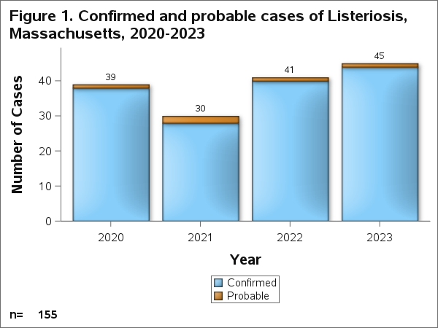
Listeriosis is an infection caused by Listeria monocytogenes bacteria. The infection can be invasive and cause sepsis (a dangerous whole body response to infection) or meningitis (infection of the brain and spinal cord) and occurs most frequently in pregnant people and their newborns, older adults, and those with weakened immune systems. People get listeriosis by eating food contaminated with Listeria bacteria. Listeria has been found in deli-style or ready-to-eat meats, unpasteurized (raw) milk, dairy products such as soft cheeses, and in other processed foods that become contaminated during or after processing. SPHL routinely performs WGS, a type of DNA fingerprinting, on human Listeria samples to identify individuals who may have become ill from the same source. Learn more about listeriosis.
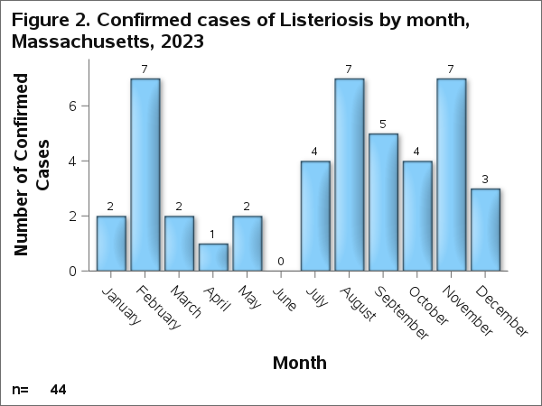
Confirmed cases are cases for which the pathogen of interest was isolated via culture. Probable cases are cases for which the pathogen of interest was detected via a culture-independent diagnostic test or is a clinically compatible case that is epidemiologically linked to a confirmed or probable case, but lacks laboratory evidence.
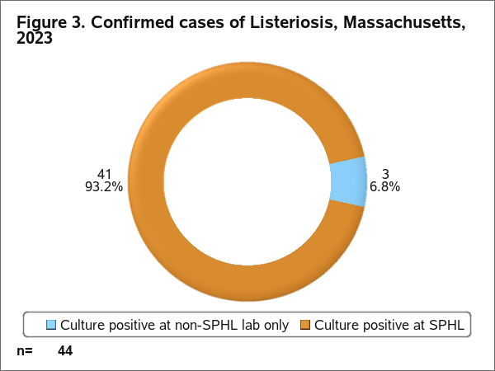
Isolates that were culture positive at a non-SPHL lab only may have been cultured at a different state's public health laboratory, never arrived at SPHL or arrived at SPHL but were unable to be confirmed.
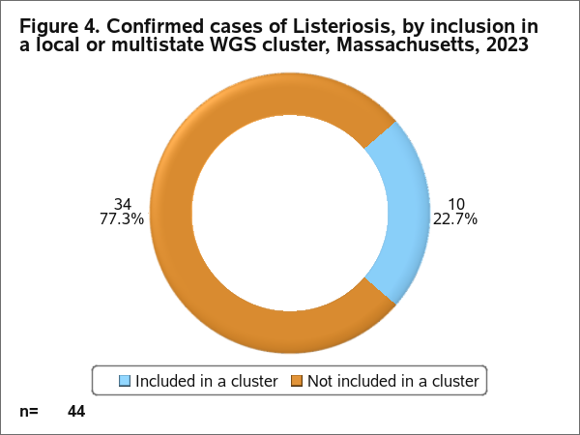

Table 1. Multistate WGS clusters of Listeriosis investigated by DPH, Massachusetts, 2023
Cluster Type | Number of Clusters | Number of Cases:  Median | Number of Cases:  Range (Min-Max)
Multistate | 5 | 2 | 1-6
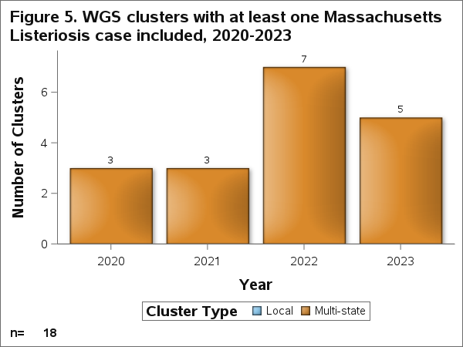

Salmonellosis
Salmonellosis is an infection caused by Salmonella bacteria. In the United States, salmonellosis results in more hospitalizations than any other foodborne pathogen. People can get salmonellosis through the fecal-oral route by swallowing contaminated food or water, or from not washing their hands thoroughly after having contact with certain animals such as backyard chickens and reptiles, their food, or their surroundings. Infection can also spread from one person to another through unwashed hands or sexual contact. This can include oral-anal contact or anal sex, which may facilitate the transmission of Salmonella. SPHL routinely performs WGS, a type of DNA fingerprinting, on human Salmonella samples to identify clusters of individuals who may have become ill from the same source. Learn more about salmonellosis.
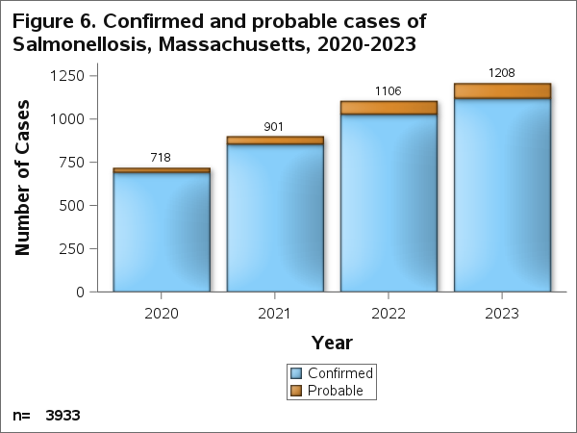
Confirmed cases are cases for which the pathogen of interest was isolated via culture. Probable cases are cases for which the pathogen of interest was detected via a culture-independent diagnostic test or is a clinically compatible case that is epidemiologically linked to a confirmed or probable case, but lacks laboratory evidence.
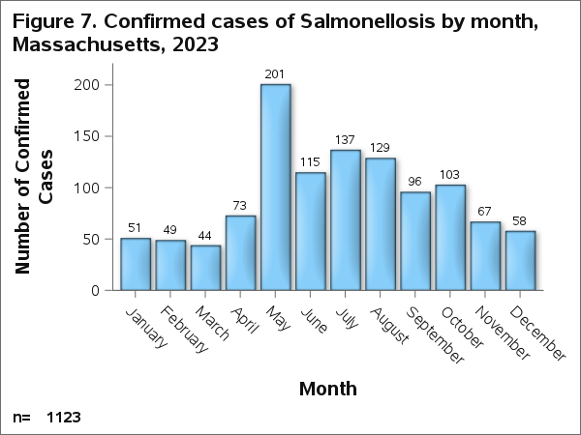

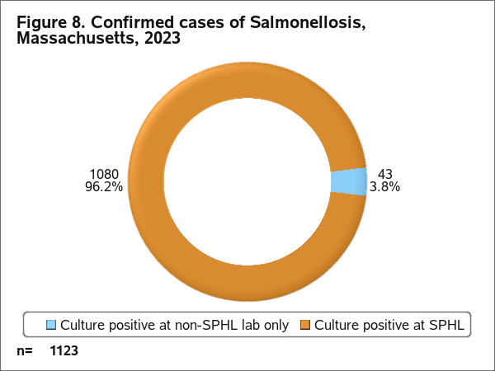

Isolates that were culture positive at a non-SPHL lab only may have been cultured at a different state's public health laboratory, never arrived at SPHL or arrived at SPHL but were unable to be confirmed.
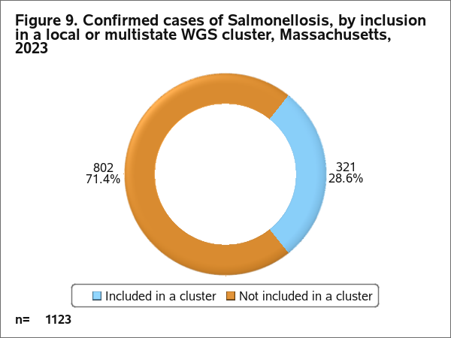
Table 2. Local and multistate WGS clusters of Salmonellosis investigated by DPH, Massachusetts, 2023

Cluster Type | Number of Clusters | Number of Cases:  Median | Number of Cases:  Range (Min-Max)
Multistate | 29 | 2 | 1-162
Local | 17 | 3 | 2-6
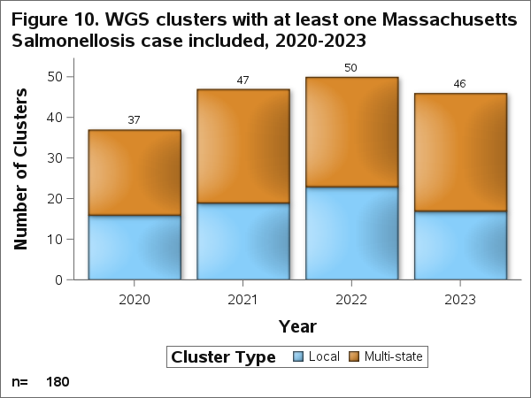

Shigellosis
Shigellosis is an infection caused by Shigella bacteria. The most common symptoms are diarrhea that can be bloody, fever, stomach cramps, and straining to have a bowel movement. Shigella germs are in the stool of infected people or animals, and anything contaminated by their stool can potentially spread the germ. This could occur through contaminated food or water, contaminated surfaces, or direct contact, including sexual contact. Gay, bisexual, or other men who have sex with men (MSM) are at a higher risk of infection, especially from Shigella germs that are resistant to antibiotics. SPHL routinely performs WGS, a type of DNA fingerprinting, on human Shigella samples to identify clusters of individuals who may have become ill from the same source and to monitor trends in antibiotic resistance. Learn more about shigellosis.
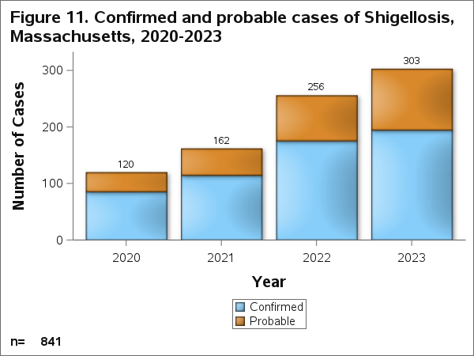
Confirmed cases are cases for which the pathogen of interest was isolated via culture. Probable cases are cases for which the pathogen of interest was detected via a culture-independent diagnostic test or is a clinically compatible case that is epidemiologically linked to a confirmed or probable case, but lacks laboratory evidence.
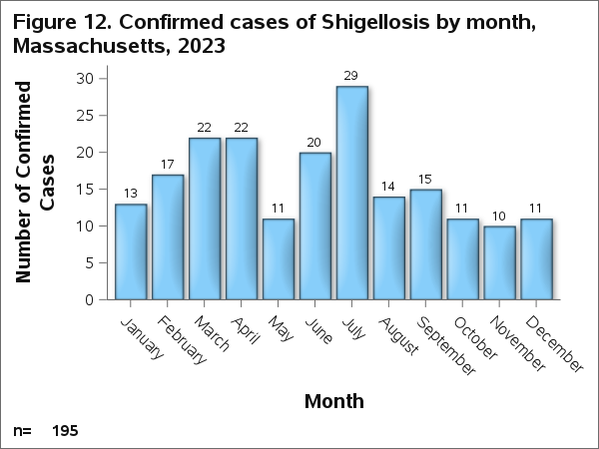
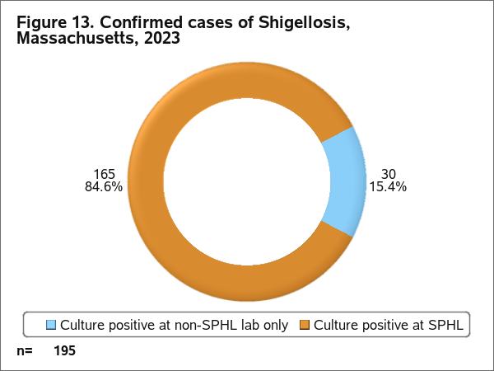
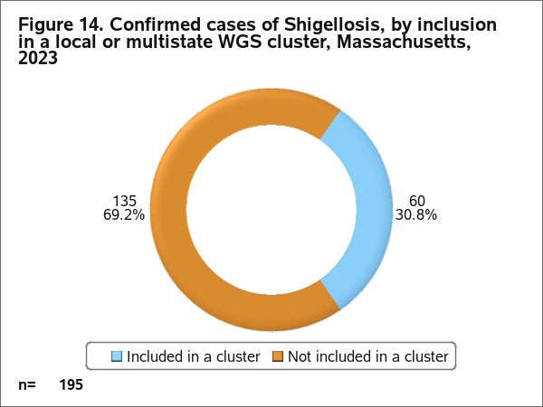
Isolates that were culture positive at a non-SPHL lab only may have been cultured at a different state's public health laboratory, never arrived at SPHL or arrived at SPHL but were unable to be confirmed.

Table 3. Local and multistate WGS clusters of Shigellosis investigated by DPH, Massachusetts, 2023

Cluster Type | Number of Clusters | Number of Cases:  Median | Number of Cases:  Range (Min-Max)
Multistate | 2 | 9 | 2-15
Local | 7 | 3 | 3-8

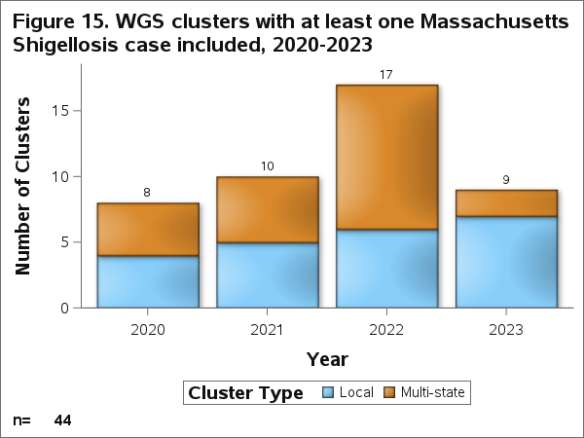

Shiga toxin-producing E. coli
Shiga toxin-producing E. coli (STEC) are a type of bacteria that produce a poison called Shiga toxin. The most common symptoms of an STEC infection are bloody diarrhea, severe stomach cramps, and vomiting. In a small number of affected people, STEC can cause a serious and sometimes life-threatening problem called hemolytic uremic syndrome that affects blood clotting functions and kidneys. STEC must be swallowed to cause infection. The germ can spread through ingesting contaminated food or water; through contact with animals (especially cattle), their stool, or their environment; or via contact with an infected person. National outbreaks of STEC have been associated with raw leafy greens, undercooked ground beef, cookie dough, and raw flour. SPHL routinely performs WGS, a type of DNA fingerprinting, on human STEC samples to identify clusters of individuals who may have become ill from the same source and to monitor trends in antibiotic resistance. Learn more about STEC.
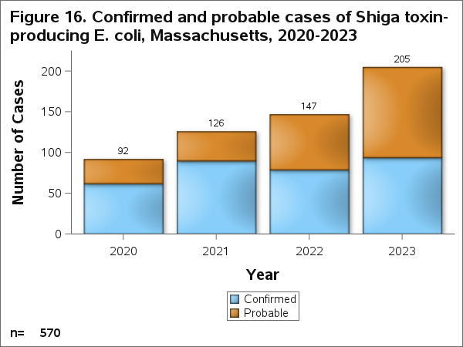
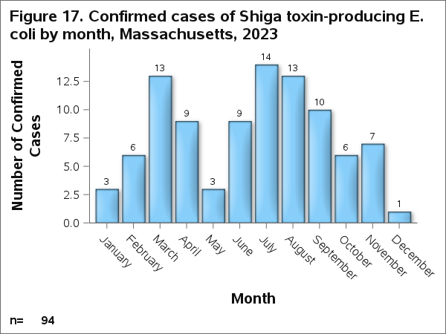
Confirmed cases are cases for which the pathogen of interest was isolated via culture. Probable cases are cases for which the pathogen of interest was detected via a culture-independent diagnostic test or is a clinically compatible case that is epidemiologically linked to a confirmed or probable case, but lacks laboratory evidence.
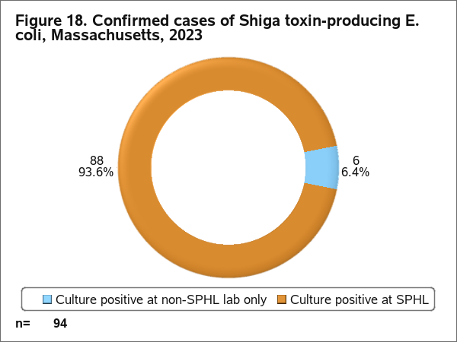
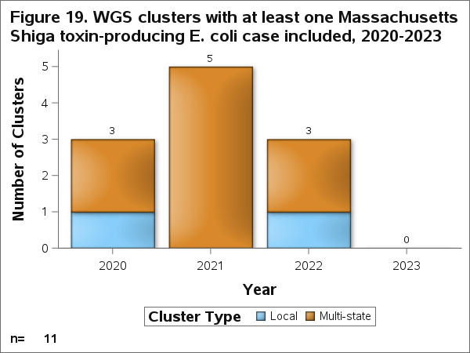
Isolates that were culture positive at a non-SPHL lab only may have been cultured at a different state's public health laboratory, never arrived at SPHL or arrived at SPHL but were unable to be confirmed.

Multistate Clusters
Below are links to multistate Salmonella, Shigella, E. coli, and Listeria WGS clusters that led to publication of a CDC outbreak notice that included at least one Massachusetts resident in 2023. Not all multistate clusters identify a common exposure or warrant an outbreak notice.

Listeriosis
No outbreak notices published

Salmonellosis
Ground Beef
Fresh Diced Onions
Cantaloupes

Shigellosis
No outbreak notices published

STEC
No outbreak notices published

Foodborne Illness Complaints
Foodborne illness complaints serve as a vital surveillance tool for detecting illnesses caused by contaminated food or beverages. By collecting and analyzing complaints from individuals who suspect they have experienced foodborne illness, DPH and LBOH can identify potential outbreaks more quickly. This early detection enables the implementation of control measures and educational efforts to protect others from becoming ill.
Foodborne illness complaints provide a way for the public to report their concerns through established channels. In Massachusetts, consumers can report a foodborne illness complaint via a call to their LBOH or DPH (617-983-6712). Typically, the information collected includes the complainant’s name and contact details, demographic information, details about their illness, the suspected food product or establishment, a 72-hour food history and information about other members of the dining party.
Once a complaint is submitted, it is sent to the appropriate LBOH for review. Health department staff may follow up to clarify details or gather additional information. After collecting the necessary information, the LBOH will evaluate the complaint and determine the appropriate course of action. If warranted, the LBOH may conduct an inspection of the suspected food establishment to assess food safety practices. DPH may also analyze complaint trends to identify patterns or commonalities across reports that could indicate an outbreak. If multiple illnesses associated with the same establishment or event are identified then a foodborne outbreak investigation is conducted.
The goal of this process is to act swiftly based on the information provided by consumers. By reporting suspected foodborne illnesses, the public plays a crucial role in helping DPH and LBOHs identify and control outbreaks, ultimately preventing others from getting sick.

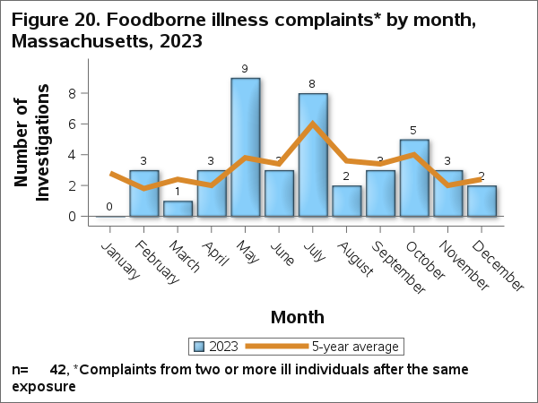
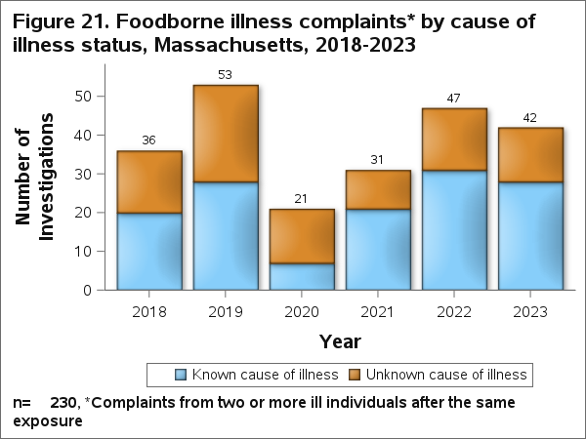
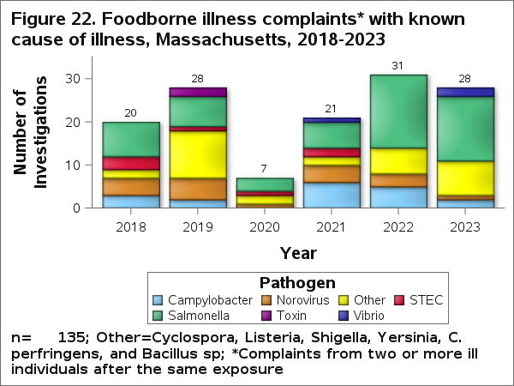

105 Mass. Code Regs.§ 300.100.
105 CMR § 300.100.
105 CMR § 300.190.
105 CMR § 300.131.
105 CMR § 300.170.
105 CMR § 300.190.
105 CMR §§ 590.008, 590.012, 590.014.
105 CMR § 300.172.
105 CMR § 300.190.
105 CMR §§ 590.008.

