INDOOR AIR QUALITY ASSESSMENT

Forbush Memorial Library
118 Main Street
Westminster, Massachusetts

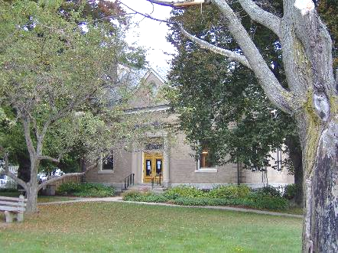

Prepared by:
Massachusetts Department of Public Health
Bureau of Environmental Health
Indoor Air Quality Program
December 2007

Background/Introduction
At the request of Elizabeth Swedberg, Health Agent for the Westminster Board of Health (WBOH), the Massachusetts Department of Public Health (MDPH), Bureau of Environmental Health (BEH) conducted an indoor air quality assessment at the Forbush Memorial Library (FML), 118 Main Street, Westminster, Massachusetts. On August 31, 2007, a visit was made to the FML by Michael Feeney, Director of BEH’s Indoor Air Quality (IAQ) Program. The assessment was prompted by concerns about mold and water damage to carpeting in the ground level of the 1997 wing.
The FML was constructed in 1901 as a two-story, brown brick building (Picture 1). An addition was made to the north wall of the building in 1997 (Picture 2). During the 1997 addition construction, ventilation equipment and renovations were made to the 1901 building. Windows are openable throughout the building.

Methods
BEH staff performed a visual inspection of building materials for water damage and/or microbial growth. Air tests for carbon dioxide, temperature and relative humidity were taken with the TSI, Q-Trak, IAQ Monitor, Model 8551.

Results
The FML is staffed by approximately 6 employees on a daily basis, and can be visited by 200 individuals during the day. The tests were taken under normal operating conditions. Test results appear in Table 1.

Discussion
Ventilation
It can be seen from Table 1 that carbon dioxide levels were below 800 parts per million (ppm) in all areas surveyed. Please note that the assessment was conducted with few individuals in the building; low occupancy can greatly reduce carbon dioxide levels. Carbon dioxide levels would be expected to rise with increased occupancy.
The 1901 portion of the FML was not originally designed with a mechanical ventilation system. When the building was renovated in 1997, a heating, ventilating, and air-conditioning (HVAC) system was installed. However, the system does not appear to have the capacity to introduce fresh air into the building, but rather recirculates air. BEH staff identified two ducts on the exterior of the building that are presumed to be exhaust vents for the restrooms (Pictures 3 and 4).
Air is supplied by an air handling unit (AHU) that appears to be retrofitted into the peak of the original building’s roof over the Eloranta Room, a large meeting area that formerly housed the town museum (Picture 5). Air is distributed to offices and other areas by wall-mounted fresh air diffusers and returned to the AHU via ductwork. The AHU system could not be examined due to safety concerns. Fan coil units (FCUs) located in a number of areas facilitate airflow and temperature control throughout the library (Picture 6). FCUs do not have the capability of introducing outside air; these units recirculate air only (Figure 1).
The Massachusetts Building Code requires that each room have a minimum ventilation rate of 20 cubic feet per minute (cfm) per occupant of fresh outside air or openable windows (SBBRS, 1997; BOCA, 1993). The ventilation must be on at all times that the room is occupied. Providing adequate fresh air ventilation with open windows and maintaining the temperature in the comfort range during the cold weather season is impractical. Mechanical ventilation is usually required to provide adequate fresh air ventilation.
Carbon dioxide is not a problem in and of itself. It is used as an indicator of the adequacy of the fresh air ventilation. As carbon dioxide levels rise, it indicates that the ventilating system is malfunctioning or the design occupancy of the room is being exceeded. When this happens a buildup of common indoor air pollutants can occur, leading to discomfort or health complaints. The Occupational Safety and Health Administration (OSHA) standard for carbon dioxide is 5,000 parts per million parts of air (ppm). Workers may be exposed to this level for 40 hours/week, based on a time-weighted average (OSHA, 1997).
The MPDH uses a guideline of 800 ppm for publicly occupied buildings. A guideline of 600 ppm or less is preferred in schools due to the fact that the majority of occupants are young and considered to be a more sensitive population in the evaluation of environmental health status. Inadequate ventilation and/or elevated temperatures are major causes of complaints such as respiratory, eye, nose and throat irritation, lethargy and headaches. For more information concerning carbon dioxide, please see Appendix A.
Temperature readings the day of the assessment ranged from 71º F to 75º F, which were within the MDPH recommended comfort range in all areas surveyed. The MDPH recommends that indoor air temperatures be maintained in a range of 70º F to 78º F in order to provide for the comfort of building occupants. In many cases concerning indoor air quality, fluctuations of temperature in occupied spaces are typically experienced, even in a building with an adequate fresh air supply.
Relative humidity measurements ranged from 51 to 66 percent, which were within or above the MDPH recommended comfort guidelines on the day of the assessment. The MDPH recommends that indoor air relative humidity is comfortable in a range of 40 to 60 percent. It is important to note that relative humidity measured indoors exceeded outdoor measurements by a range 26 to 41 percent. One major source of water vapor entering the building is likely the book drop, which has no means for preventing hot, moist air from penetrating the building and the wall system (Pictures 7 and 8). This increase in relative humidity can indicate that the HVAC system and restroom exhaust vents are not operating sufficiently to remove normal indoor air pollutants (e.g., water vapor from respiration). Moisture removal is important, since the sensation of heat conditions increases as relative humidity increases; the relationship between temperature and relative humidity is called the heat index. As indoor temperature rises, the addition of moisture which increases relative humidity will make occupants feel warmer. If moisture is removed, the comfort of the individuals is increased. During winter months, outdoor relative humidity levels tend to drop. The sensation of dryness and irritation is common in a low relative humidity environment. Relative humidity levels in the building would be expected to drop during the winter months due to heating. Low relative humidity is a common problem during the heating season in the northern part of the United States.

Microbial/Moisture Concerns
The FML has a number of significant problems regarding water penetration that are directly related to the 1997 construction and renovation. Most moisture related problems occur on the ground level of the 1997 wing, which is the children’s section of the FML. Much of the problem is related to the building exterior of the 1997 wing.
The exterior of the 1997 wing is clad with an exterior foam insulating system (EFIS). EFIS, commonly known as fake stucco, “is an exterior wall cladding that utilizes rigid insulation boards on the exterior of the wall sheathing with a plaster type exterior skin” (Zwayer, 2007). “An EFIS wall typically consists of several layers of materials sandwiched together into a single panel, which is attached to a substrate mounted on the wall studs” (Figure 1) (FEMA, Unknown). In buildings constructed with a curtain wall, water is intercepted by a drainage plane once it penetrates through the brickwork; the drainage plane allows water to exit the wall system through weep holes (Figure 2). The EIFS system on the 1997 wing appears to be a barrier wall system. The “barrier EIFS wall systems rely primarily on the base coat portion of the exterior skin to resist water penetration” (Zwayer, 2007). In essence, the rainwater is shed by the exterior “stucco” surface, which functions as drainage plane (Figure 1). However, a number of problems exist with such a system:

Problems observed with EIFS installations are primarily related to moisture intrusion. EIFS provides protection against moisture infiltration at the base coat; however, moisture migration through openings for windows, flashings and other items, or holes and cracks in the EIFS itself, have allowed for moisture invasion EIFS clad buildings. With barrier EIFS installations, or where weather barriers and flashing are improperly installed in conjunction with wall drainage EIFS installations, moisture has entered the wall system at these locations and caused damage to the wall sheathing and framing (emphasis added) (Zwayer, G.L., 2007).

Since the initial introduction of EIFS, a second type of system (e.g., wall drainage system), which contains a water drainage system similar to Figure 2 was developed. The EFIS system at the FML is not likely a water drainage system due to the following:
- Lack of weep holes exist on the exterior wall;
- Lock of drainage plane behind the substrate;
- Fiberglass insulation batts were in direct contact with the substrate (Picture 9); and
- Fiberglass insulation was enclosed using clear polyethylene plastic sheets (Picture 10).
Considering these observations, the EIFS system installed in the 1997 wing of the FML is most likely a barrier system which has little or no means to drain water from the wall system.
According to the National Institute of Building Science (NIBS), the following are problems typical of buildings clad with EFIS; these same conditions were also observed at the FML:
- Failure to install or properly install sealant joints around windows, doors, pipes, conduits, and other penetrations of the field of the EIFS.
- As noted by FML maintenance staff, windows in the 1997 wing were observed to leak in wind driven rain weather conditions.
- Failure to flash window and door openings in the field of the EIFS to divert leakage through the window or door to the exterior.
- Windows of the FML did not appear to have flashing. Spaces between window frames and EIFS panels were sealed with caulking (Picture 11).
- Failure to properly backwrap edges of EIFS at terminations and penetrations in the field of the EIFS.
    - Spaces were noted along the slab/EIFS junctions that appears to expose the vapor barrier to the outdoors (Pictures 12 and 13)
- Failure to terminate EIFS above grade, especially in termite prone regions.
- It appears that the EIFS system on the west wall of the 1997 addition is actually buried beneath soil and leaves (Picture 14). In addition, the ground next to this wall is actually sloped toward the FML, subjecting the west wall to repeated moistening from rainwater.
- Un-repaired impact damage.
- A number of locations appear to have damaged basecoat that exposes the underlying insulation boards (Pictures 15 through 16).
Each of these conditions can allow for water to penetrate through the EIFS, causing water damage to carpet and interior walls in the children’s section of the 1997 wing.
Water damage was also noted in the children’s restrooms, which were retrofitted in the original building’s basement as part of the 1997 renovation. Air in the restrooms was stagnant due to deactivation of the restroom exhaust vents. BEH staff detected a musty odor in the restrooms. BEH staff agitated the gypsum wallboard (GW) beneath the restroom windows, which produced a strong musty odor. This indicates probable mold colonization within the wall cavity formed by the GW and the original foundation wall. The source of moisture causing damage to the restroom GW is likely water penetrating through the foundation wall and/or the restroom window frames. Water penetration in this location appears to be a chronic issue. In an effort to divert rainwater from the ground outside the restrooms, a series sheet metal pieces was placed on top of the soil at the foundation wall of the original building (Pictures 17 and 18). For the following reasons, these sheet metal barriers are not only ineffective in draining rainwater away from the foundation, but its presence likely enhances moisture penetration through the foundation, resulting in chronic water damage to the restroom GW:
- Cement, brick, stone and mortar are porous materials that can allow for water penetration into the interior space by capillary action. If the exterior of the foundation of the original building was not treated in a manner to prevent/reduce water penetration, it is highly likely that moisture has traveled through the foundation wall to accumulate within the wall cavity created by the gypsum wallboard beneath the restroom windows.
- The sheet metal is not attached to the building in a manner that prevents water penetration between the foundation and the metal covering (Picture 19)
- The individual sheets of metal are not joined to create a continuous apron, leaving seams that allow water to penetrate to the soil/ground.
- The sheet metal is actually sloped toward the building, which will enhance water pooling and subsequent moisture penetration.
- The sheet metal serves to keep the soil around the foundation moist in a manner similar to a wood chip covering.
- The restroom windows are located in cement-lined pits (Pictures 20 and 21). Cracks have formed below seams where the cement slabs and foundation walls are joined, allowing groundwater to penetrate into the window pits. BEH staff could not determine whether drains exist in the bottom of each window pit to provide adequate water drainage.
All of these conditions have likely played a role in the moistening of the restroom GW.
BEH staff examined the interior of FCUs in a number of locations. FCUs provide both heating and air-conditioning and are equipped with drip pans to collect and drain condensation from cooling coils. When warm, moist air passes over a surface that is cooler than the air, water condensation can collect on the cold surface. Over time, water droplets can form, which can then drip from a suspended surface. The pipes that supply chilled water for the FCUs had water droplets on the outside of the pipe insulation (Picture 22). These pipes are outside or below the condensation drain pan. The presence of condensation indicates that the pipe insulation is not adequate in preventing condensation formation on the pipes. Water damage noted on floors and carpeting around each FCU is likely the result of condensation drippage from these pipes (Picture 23).
An evaluation of pipes located above the ceiling of the activity room supply water for the building demonstrated condensation on the pipes. It does not appear that the pipes were ever insulated. In turn, condensation is chronically dampening ceiling tiles in this area.
Chronic water penetration also appears to be a problem in the vicinity of the lower level exterior door on the east wall of the 1997 wing. There appears to be minimal slope to the sidewalk, which would make the door prone to water penetration during easterly-driven rain events. A drain appears to be retrofitted in front of this door (Picture 24), but is not installed at the door threshold. This may allow for rain to penetrate through the door around the drain and through spaces under the door (Picture 25).
As previously discussed, the west wall of the 1997 wing is buried beneath soil. It appears that the ground at the junction of the original building and the 1997 wing is sloped towards the building. There does not appear to be any means for draining water (Picture 26).

Other Concerns
BEH staff noted a number of cracks on the wall and ceiling plaster in the Eloranta Room of the original building. In addition, several plaster walls around the south section of the Eloranta Room appeared to be both compressed and bowing (Picture 27). BEH staff examined the roof from the exterior and noted a pronounced downward bowing in the ridge of the original building’s roof to the center of the roof line (Picture 28), as well as an outward bowing in the cornice of the southeast corner of the building. Based on these observations, it appears that a significant weight is pulling at the center of the original building’s roof. The most likely source of this weight is the AHU equipment and false ceiling, which were retrofitted beneath the roof peak in the Eloranta Room. A report by Linn Associates, Inc. indicates that “[s]everal of the old roof rafters were cut to make room for new HVAC ductwork” (LAI, 2007).
The roof of the original building has slate shingles, which are significantly heavier than asphalts or other modern roofing materials. In addition, the roof of the original building was designed to support the weight of the slate roof and the snow load typical for the area; such support is contingent on a full compliment of original rafters. The removal of the original rafters would serve to undermine the ability of the roof to carry the weight, or deadload, of the roof structure as well as load created by accumulating snow on the roof. The renovations, which included installation of AHU, associated ductwork and the attic floor, created additional weight to an already load-compromised roof. This compounding weight load coupled with the removal of supporting rafters has likely caused instability, resulting in a variety of damage (i.e. bowing, cracking) noted in the original building.

Conclusions/Recommendations
The conditions observed at the FML raise of concerns. Rainwater penetration has caused damage to the building. It appears that water penetration is a chronic problem that persistently moistens building materials, such as GW, wood, insulation and carpeting. All means to mechanically provide fresh air and exhaust air from the building appear to be minimal. Without a mechanical ventilation system, environmental pollutants (including water vapor) can neither be diluted nor removed from the FML. This can result in a buildup of airborne dust, moisture and other pollutants in the indoor environment. When considering the moisture problem and the water damage experienced at the FML, individuals who are hypersensitive to mold may have problems with entering the ground floor of the building.
Removing water damaged materials from the building in an appropriate manner will most likely addresses issues of immediate concern. However, the condition of the building envelope will likely result in repeated water damage to materials stored in the ground level. Based upon these observations, a building engineer should examine the building.
BEH staff agree with the decision to restrict access to the Eloranta Room, due to the obvious sinking of the roof in the original building. In this condition, high winds or significant snow cover may result in further damage to the roof and exterior walls.
To remedy building problems, a two-phase approach is recommended consisting of immediate (short-term) measures to remove mold-colonized materials and remediate water damaged sections of the building and long-term measures that will require planning and resources to adequately address the overall indoor air quality concerns.

In view of findings at the time of the assessment, the following short-term measures are recommended:
- Continue to restrict access to the Eloranta Room until roof repairs are completed.
- Remove GW in the 1997 wing restrooms. All water damaged/mold colonized building materials (e.g., ceiling tiles, carpeting and GW) should be removed in a manner consistent with recommendations in “Mold Remediation in Schools and Commercial Buildings” published by the US Environmental Protection Agency (US EPA, 2001). This document is available from the US EPA website: http://www.epa.gov/iaq/molds/mold_remediation.html.
- Replace carpeting on the ground floor with a non-porous material (e.g., non-slip tile) in areas subject to repeated water damage. If carpeting is necessary, use an area carpet that can be easily be replaced if damaged.
- Ensure all pipes that carry chilled water in the HVAC system are properly insulated with a material of a sufficient R Rating to prevent condensation.
- Ensure all water service pipes are properly insulated with a material of a sufficient R Rating to prevent condensation.
- Seal the book drop opening with appropriate materials to prevent unconditioned air from penetrating the building.
- Remove sheet metal from the foundation base of the west exterior wall of the original building. Consider the following actions to prevent moisture penetration into the basement:

Repair the cement lined window pits so each seam is sealed and the floor has proper drainage. If no drains exist, then consider placing a properly installed awning/roof system above each cement-lined window pit to direct water away from window opening and admit light to the restrooms.

Improve the grading of the ground away from the foundation at a rate of 6 inches per every 10 feet (Lstiburek & Brennan, 2001).
  - Install a water impermeable layer on ground surface (clay cap) to prevent water saturation of ground near foundation (Lstiburek & Brennan, 2001).
  - Fill in cracks and crevices along the foundation/exterior walls.

Ensure that gutters and downspouts direct rainwater at least five feet away from the foundation. Gutters should be extended along the entire roof edge.

Remove foliage to no less than five feet from the foundation.
- Ensure restroom exhaust vents operate at all time during business hours.
- For buildings in New England, periods of low relative humidity during the winter are often unavoidable. Therefore, scrupulous cleaning practices should be adopted to minimize common indoor air contaminants whose irritant effects can be enhanced when the relative humidity is low. To control for dusts, a high efficiency particulate arrestance (HEPA) filter equipped vacuum cleaner in conjunction with wet wiping of all surfaces is recommended. Avoid the use of feather dusters. Drinking water during the day can help ease some symptoms associated with a dry environment (throat and sinus irritations).
- Refer to resource manuals and other related indoor air quality documents for further building-wide evaluations and advice on maintaining public buildings. These materials are located on the MDPH’s website at: http://mass.gov/dph/indoor_air.

Long Term Recommendations
The key to addressing on-going water penetration and indoor air quality problems in the building is to re-establish the integrity of the building envelope and provide a fully functional HVAC system that exchanges air. These remedial efforts can include the following activities:
- Continue with efforts to repair the roof and exterior walls of the original building. Further damage to the building envelope will likely lead to leaks through the roof or exterior walls.
- Continue with efforts to evaluate the exterior wall of the 1997 wing to provide adequate water drainage from the wall system. Based on BEH staff observations, these efforts likely include installing a full drainage plane with weep holes beneath the EFIS walls and proper flashing around all windows and door frames. Please note that the only feasible manner in which to install a proper drainage plane behind the EFIS would be to remove the entire existing system.
- Re-grade the area around the west wall of the library to both unearth the slab and exterior wall of the 1997 wing and direct water away from the building.
- Re-grade the area shown in Picture 26 in a manner that directs water away from the building or install drainage of an adequate capacity prevents water accumulation in this area.
- Extend the drain in front of the east exterior wall door to a length that covers the entire length of the door sill.
- Consider reconfiguring the HVAC system in the following manner:
  - Relocate the HVAC system to an appropriate area within the 1997 wing that can support the weight of the equipment.
  - Ensure a proper fresh air intake and exhaust ventilation system is installed to dilute and remove normally occurring indoor air pollutants.
  - Once installed, ensure the HVAC system is balanced.

References
ACGIH. 1989. Guidelines for the Assessment of Bioaerosols in the Indoor Environment. American Conference of Governmental Industrial Hygienists, Cincinnati, OH.

BOCA. 1993. The BOCA National Mechanical Code-1993. 8th ed. Building Officials & Code Administrators International, Inc., Country Club Hills, IL. M-308.1.

Dalzell, J.R. 1955. Simplified Masonry Planning and Building. McGraw-Hill Book Company, Inc. New York, NY.
FEMA. Unknown. Protecting Your Business From Wind. Federal Emergency Management Agency, Washington, DC. http://www.fema.gov/pdf/plan/prevent/howto/how2027.pdf

IICRC. 1999. IICRC S500. Standard and Reference Guide for Professional Water Damage Restoration, 2nd Edition. Institute of Inspection Cleaning and Restoration, Vancouver, WA.

Lstiburek, J. & Brennan, T. 2001. Read This Before You Design, Build or Renovate. Building Science Corporation, Westford, MA. U.S. Department of Housing and Urban Development, Region I, Boston, MA

Nelson, P.E. 1999. Brick Cavity Walls and Associated Flashings. Third Annual Westford Symposium on Building Science Course Book. Building Science Corporation, Westford, MA.

OSHA. 1997. Limits for Air Contaminants. Occupational Safety and Health Administration. Code of Federal Regulations. 29 C.F.R. 1910.1000 Table Z-1-A.

Rowlett, R. 2005 How Many? A Dictionary of Units of Measurement. University of North Carolina at Chapel Hill, Chapel Hill, NC. http://www.unc.edu/~rowlett/units/index.html

SBBRS. 1997. Mechanical Ventilation. State Board of Building Regulations and Standards. Code of Massachusetts Regulations. 780 CMR 1209.0

SMACNA. 1994. HVAC Systems Commissioning Manual. 1st ed. Sheet Metal and Air Conditioning Contractors’ National Association, Inc., Chantilly, WV.

US EPA. 2001. Mold Remediation in Schools and Commercial Buildings. US Environmental Protection Agency, Office of Air and Radiation, Indoor Environments Division, Washington, DC. EPA 402-K-01-001. March 2001.
Zwayer, G.L. 2007. Exterior Insulation and Finish System (EIFS). National Institute of Building Sciences, Washington, DC. http://www.wbdg.org/design/env_wall_eifs.php

Picture 1

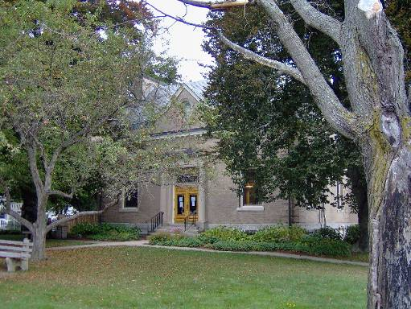

Original FML Constructed In 1901

Picture 2

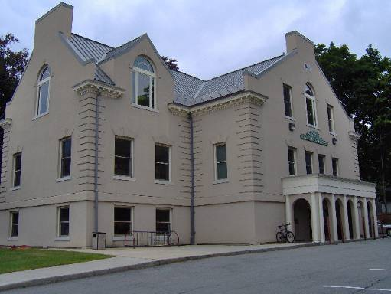

New FML Wing Constructed In 1997
Picture 3

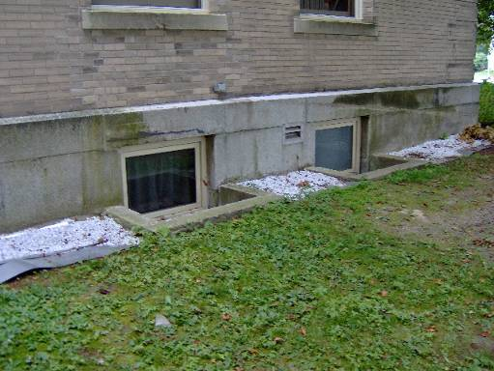

Presumed Exhaust Vent, Original Building

Picture 4

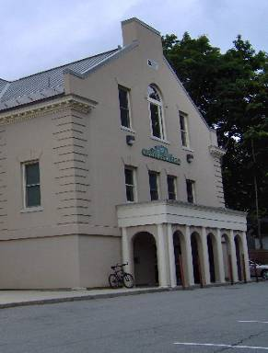

Presumed Exhaust Vent, New Wing
Picture 5

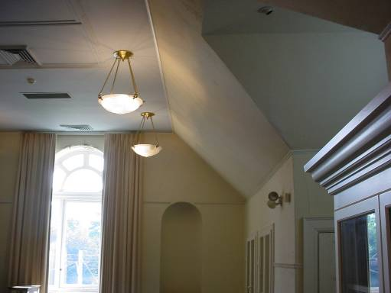

False Ceiling below AHU, Note Crack above Doorway

Picture 6

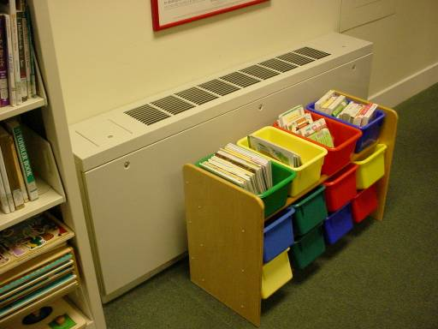

FCU
Picture 7

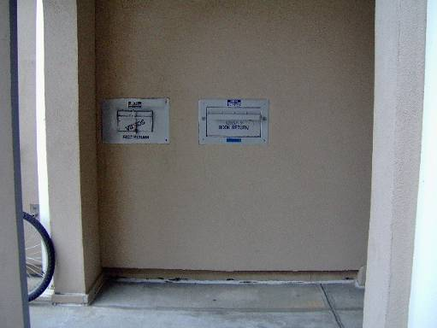

Book Drop

Picture 8

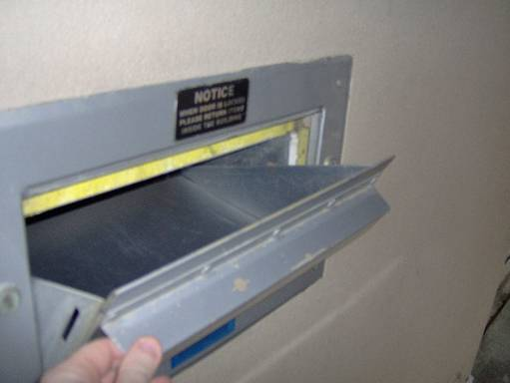

Book Drop Interior, Note Space in Wall and Lack of Gaskets to Prevent Air Penetration
Picture 9

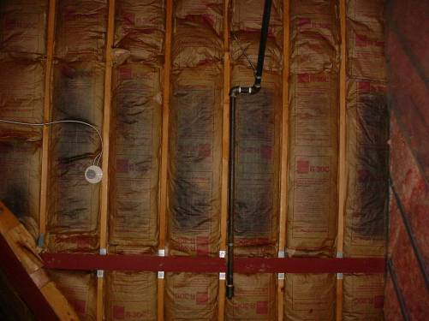

Fiberglas Batts In Contact With EIFS Backing With Plastic Removed, Note Blackening Of Paper, Indicating Possible Mold Growth

Picture 10

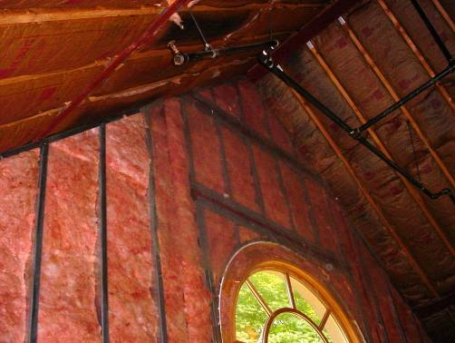

Insulation Sealed Behind Polyethylene Plastic
Picture 11

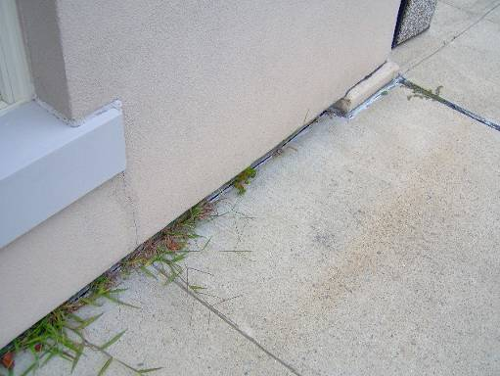

Window frame Sealed with Caulking in EIFS, Instead Of Flashing

Picture 12

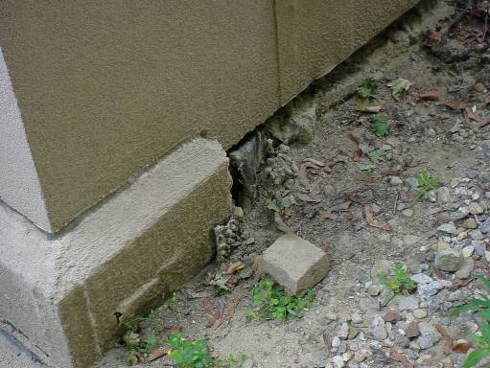

Exposed Vapor Barrier, West Wall
Picture 13

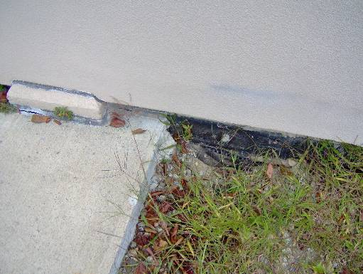

Exposed Vapor Barrier, East Wall

Picture 14

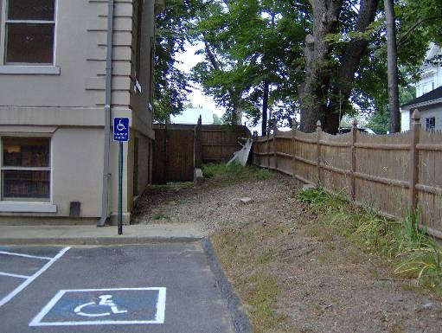

West Wall, New Wing, Buried Beneath Soil That Is Sloped Towards the Building
Picture 15

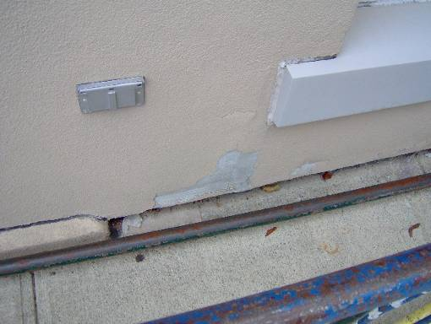

Damaged Basecoat That Exposes the Underlying Insulation Boards

Picture 16

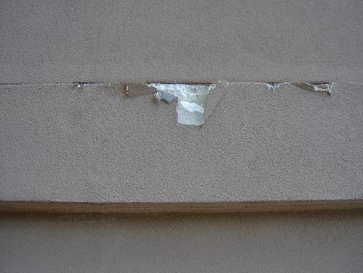

Damaged Basecoat That Exposes the Underlying Insulation Boards
Picture 17

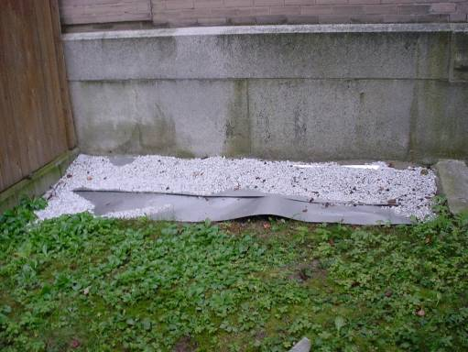

Sheet Metal on Soil West Wall

Picture 18

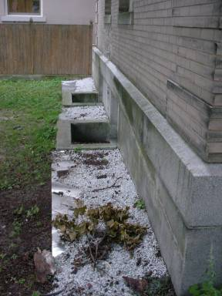

Sheet Metal on Soil, West Wall
Picture 19

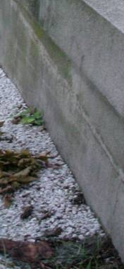

Seam between Sheet Metal and Foundation Wall, Note Curl of Sheet Metal Away From Wall

Picture 20
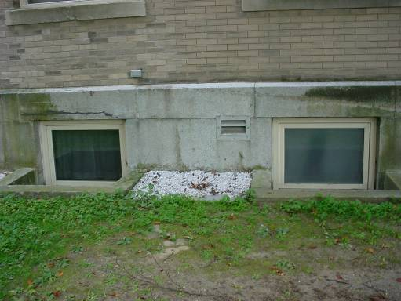

Window Pit
Picture 21

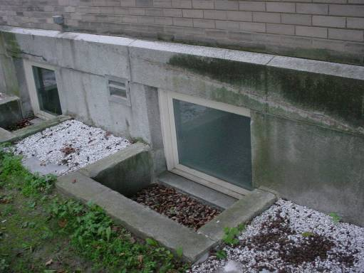

Window Pit, Note Seams between Slabs and Foundation

Picture 22

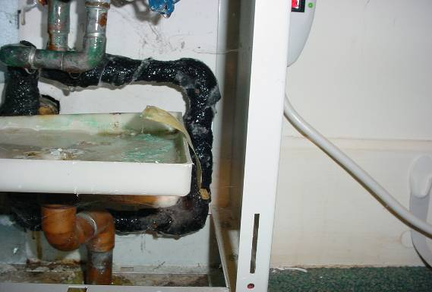
Drip Pan

Condensation on Chilled Water Pipes inside FCU
Picture 23

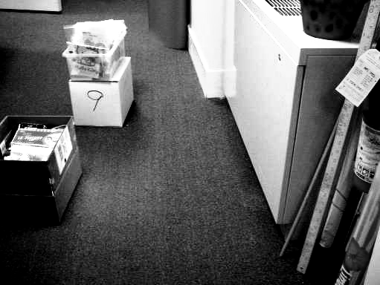

Water Damage to Carpeting

Picture 24

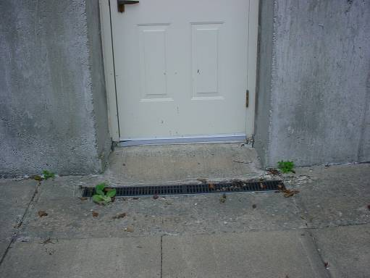

Drain In Front of East Exterior Door, Note Spaces around Drain, Crack in Cement
Picture 25

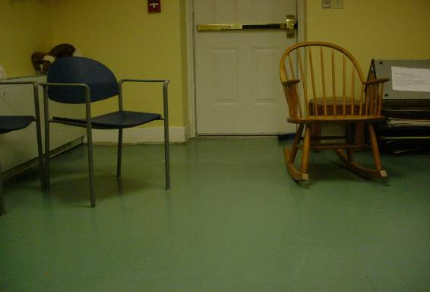

Space in Exterior Door, East Wall

Picture 26

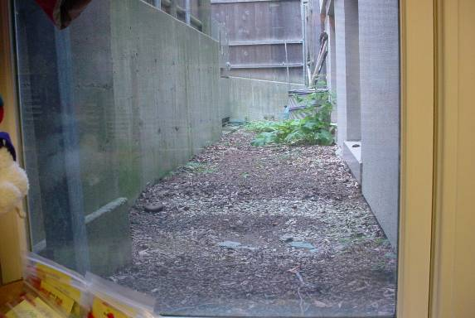

Ground Sloped Toward Building with No Apparent Drainage
Picture 27

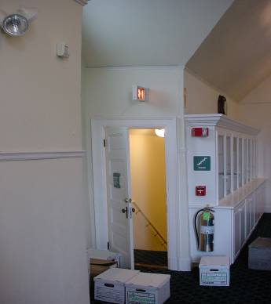

Bowing Wall in Eloranta Room (Dotted Line Inserted For Reference)

Picture 28

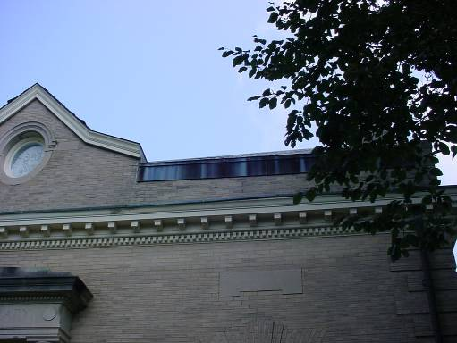

Depressed Roof Line of Original Building
Location | Carbon  Dioxide  (ppm) | Temp  (°F) | Relative  Humidity  (%) | Occupants  in Room | Windows  Openable | Ventilation |  | Remarks
 |  |  |  |  |  | Supply | Exhaust | Remarks
Outside  (Background) | 335 | 76 | 25
Reference | 552 | 72 | 61 | 0 | Y | N | N | Fan Coil Unit
Periodicals | 552 | 72 | 60 | 0 | Y | N | N | Fan Coil Unit
Front Desk | 550 | 72 | 60 | 4 | N | N | Y | Fan Coil Unit
Kendig Room | 564 | 74 | 58 | 2 | Y | N | N | Fan Coil Unit
Young Adults | 539 | 74 | 58 | 0 | Y | N | N | Fan Coil Unit
2nd Floor Stacks 202 | 414 | 72 | 58 | 0 | Y | N | Y | Fan Coil Unit
2nd Floor Elevator Lobby | 451 | 72 | 58 | 0 | Y | N | Y | Fan Coil Unit
Elevator | 624 | 72 | 57 | 0 | N | N | Y  Off | Fan Coil Unit
Children’s | 641 | 72 | 51 | 3 | Y | N | N | Fan Coil Unit, water damaged gypsum wallboard
Children’s Desk | 642 | 71 | 52 | 1 | N
Children’s Reading Area | 545 | 70 | 53 | 0 | Y | N | N | Fan Coil Unit-obstructed by furniture, replaced carpet, water damaged gypsum wallboard, dehumidifier
Children’s Work Room (G-2) | 653 | 71 | 51 | 0 | Y | N | N | Fan Coil Unit, water damaged carpet, dehumidifier, insects
G-1 | 554 | 71 | 52 | 0 | N | N | N | Fan Coil Unit, water damaged cement wall, 2-water damaged ceiling tiles, outdoor space
?????? |  |  |  |  |  | N | Y  Off | Musty odor
????? |  |  |  |  |  | N | Y  Off | Musty odor
Director | 703 | 75 | 66 | 2 | Y | N | N | Fan Coil Unit, door open

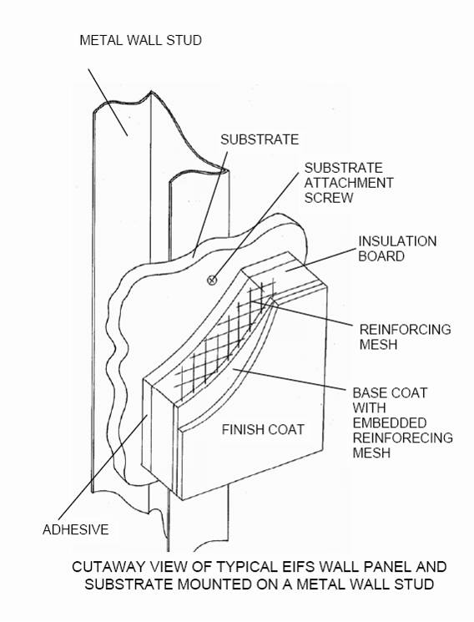

R rating is a commercial unit used to measure the effectiveness of thermal insulation (Rowlett et al., 2002)

