**INDOOR AIR QUALITY ASSESSMENT**

**Forestdale Elementary School**

**151 Route 130  
Forestdale, MA**

Forestdale Elementary School
151 Route 130
Forestdale, MA

Main Entrance Sign "Through These Doors Pass the Greatest Children in the World" 

Prepared by:

Massachusetts Department of Public Health

Bureau of Environmental Health

Indoor Air Quality Program

June 2023

# BACKGROUND

|  |  |
| --- | --- |
| Building: | Forestdale Elementary School (FES) |
| Address: | 151 Route 130, Forestdale, Massachusetts |
| Assessment Requested by: | Chris George, Facilities Director, Sandwich Public Schools (SPS) |
| Reason for Request: | Collaborative effort to perform general indoor air quality (IAQ) assessments throughout the SPS District |
| Date of Assessment: | May 18, 2023 |
| Massachusetts Department of Public Health/Bureau of Environmental Health (MDPH/BEH) Staff Conducting Assessment: | Cory Holmes, Assistant Director, IAQ Program |
| Date of Building Construction: | Originally constructed in late 1980s, opened in 1990, with a modular wing added in the early 2000s. Note that FES shares a design with the Oak Ridge Elementary School that was built at the same time. |
| Building Description: | The FES is two-story brick building housing grades pre-k through 2nd grade. Building materials consist of carpeting (both wall-to-wall and carpet squares), with gypsum wallboard (GW) walls, and suspended ceiling tiles throughout most of the school. |
| Windows: | Windows are openable throughout the building. |

# METHODS

Please refer to the IAQ Manual and appendices for methods, sampling procedures, and interpretation of results (MDPH, 2015).

Note that this building was visited by the BEH/IAQ program in February 2023 to inspect remediation efforts to water-damaged building materials in response to a frozen pipe burst. At the time of the visit all water-damaged materials had been removed or remediated. The report from this visit is available on the MDPH website at [Indoor air quality reports - cities and towns: S | Mass.gov](https://www.mass.gov/info-details/indoor-air-quality-reports-cities-and-towns-s#sandwich-)

# RESULTS and DISCUSSION

The following is a summary of indoor air testing results (Table 1).

* ***Carbon dioxide*** levels were slightly above the MDPH recommended level of 800 parts per million (ppm) in 9 of 67 areas surveyed, indicating some areas could use an increase in air exchange at the time of assessment.
* ***Temperature*** was within or close to the MDPH recommended range of 70°F to 78°F in occupied areas.
* ***Relative humidity*** was below the MDPH recommended range of 40 to 60% in all areas tested the day of assessment which is reflective of outdoor conditions.
* ***Carbon monoxide*** levels were non-detectable (ND) in all areas tested.
* ***Particulate matter (PM2.5)*** concentrations measured were below the National Ambient Air Quality (NAAQS) level of 35 μg/m3 in all areas tested.

## Ventilation

A heating, ventilating and air conditioning (HVAC) system has several functions. First it provides heating and, if equipped, cooling. Second, it is a source of fresh air. Finally, an HVAC system will dilute and remove normally-occurring indoor environmental pollutants by not only introducing fresh air, but by filtering the airstream and ejecting stale air to the outdoors via exhaust ventilation. Even if an HVAC system is operating as designed, point sources of respiratory irritation may exist and cause symptoms in sensitive individuals.

It was reported that HVAC components are managed by a computerized control system. The control system should respond to changing conditions and feed back to a centralized computer for monitoring and adjustment. However, due to the program age, type of software and likely obsolescence of the underlying computer operating system, computerized control of HVAC systems can often go out of calibration, which in turn require an update or assessment by an HVAC engineering firm.

Ventilation is provided by air handling units (AHUs) located in mechanical rooms (Picture 1). Fresh air is drawn in through air intakes on the exterior of the building and distributed to classrooms via ceiling or wall-mounted air diffusers (Picture 2). Wall or ceiling-mounted exhaust vents remove stale air from classrooms and provide air exchange (Picture 2).

An issue that may prevent proper air exchange, is the location of both the supply and exhaust vents on the same interior wall of some classrooms (Picture 2). This condition is known as *short circuiting* (Figure 1), “Short circuiting of ventilation air occurs when ventilation air enters and leaves a space or duct before it has a chance to mix well enough with room air to do the job it was intended to do—that is, to adequately dilute pollutants…Lack of ventilation air distribution always occurs when short circuiting occurs.” (Building Science Corporation, 2013).

The location of some exhaust vents (i.e., above the hallway door) can also limit exhaust efficiency (Picture 3). If doors are left open, the vents will tend to draw air from the hallway *into* the classroom instead of stale air and airborne pollutants *out* of the classroom, as designed.

For a few classrooms, fresh air is supplied by unit ventilators (univents). Univents draw air from the outdoors through a fresh air intake located on the exterior wall of the building and return air through an air intake located at the base of the unit. Fresh and return air are mixed, filtered, heated or cooled and provided to rooms through an air diffuser located in the top of the unit ([Figure 2](https://www.mass.gov/doc/unit-ventilator-univent-0/download)). In order for univents to provide fresh air as designed, intakes/returns must remain free of obstructions (Picture 4). Importantly, these units must remain on and be allowed to operate while rooms are occupied.

To maximize air exchange, the IAQ program recommends that both supply and exhaust ventilation operate *continuously* during periods of occupancy. In order to have proper ventilation with a mechanical ventilation system, the systems must be balanced after installation to provide an adequate amount of fresh air to the interior of a room while removing stale air from the room. It is recommended that HVAC systems be re-balanced every five years to ensure adequate air systems function (SMACNA, 1994).

It is also important to note that the majority of HVAC system components are original to the building’s construction, which are over 30 years old at the date of this report. According to the American Society of Heating, Refrigeration, and Air-Conditioning Engineering (ASHRAE), the service life[1] of this type of unit is 15-20 years, assuming routine maintenance of the equipment (ASHRAE, 1991).

## Microbial/Moisture Concerns

Water-damaged ceiling tiles were observed in some areas of the building (Table 1, Pictures 5 and 6), which indicate historic leaks from the building envelope or plumbing system. Ceiling tiles are considered a porous material which, if exposed to chronic moisture, may become a source for mold growth. These tiles should be discarded and replaced. However, some ceiling tiles are of a type that are adhered directly to the ceiling substrate. These tiles are difficult to replace and necessitate the destruction of the tile, furthermore, replacement tiles are often obsolete and difficult to obtain.

Several rooms contained portable or wall-mounted ductless air conditioners (ACs). Condensate drains and pumps from ductless AC units should be monitored periodically for leaks and clogs to prevent water damage.

Plants were present in some classrooms and other areas (Table 1). Plants should be well maintained, not overwatered, and not placed on porous materials or in the airstream of ventilation equipment. A few aquariums and terrariums were observed in classrooms (Table 1). These items should also be kept in good condition to prevent mold, scale, and associated odors.

Visible mold was observed on refrigerator gaskets in the teacher’s lunchroom (room 201, Pictures 7 and 8). Refrigerators should be kept clean to prevent microbial growth and odors.

## Other Conditions

Other conditions that can affect IAQ were observed during the assessment. The MDPH recommends pleated filters with a Minimum Efficiency Reporting Value (MERV) of 8, which are adequate in filtering out pollen and mold spores (ASHRAE, 2012). Filters should also be changed two to four times a year, or per the manufacturer’s recommendations.

In some areas, supply diffusers (and surrounding ceiling tiles), exhaust vents and personal fans had accumulated dust/debris (Table 1, Pictures 9 and 10). This dust can be reaerosolized under certain conditions and can also be a medium for mold growth.

Most areas had carpeting (Table 1). Carpeting should be vacuumed regularly with a high efficiency particulate arrestance (HEPA) filter equipped vacuum cleaner to avoid particulates from causing further irritation or serving as a reservoir for microbial colonization. Also, carpeting and rugs should be cleaned at least once per year according to IICRC recommendations (IICRC 2012). It should be noted that the usable life of carpeting in schools is approximately 10-11 years (IICRC, 2002). Aging carpet can produce fibers that can be irritating to the respiratory system. Area carpets too worn to be effectively cleaned should be replaced. Area rugs (and plastic mats, Picture 11) should be rolled up and stored in a clean, dry place when rooms are not occupied during the summer months to prevent *moistening due to condensation*. Fabric-covered pillows and cushions were also present in a number of areas (Table 1, Picture 12). These items should be cleaned periodically to remove the build-up of dust, dirt, and debris.

In several classrooms, large numbers of items were on floors, windowsills, tabletops, counters, bookcases, and desks, which provide a source for dusts to accumulate. These items (e.g., papers, folders, boxes) make it difficult for custodial staff to clean. Items should be relocated and/or be cleaned periodically to avoid excessive dust build up. In addition, dust and debris can accumulate on flat surfaces (e.g., desktops, shelving, and carpets) in occupied areas and subsequently can be re-aerosolized causing further irritation.

Exposure to low levels of total volatile organic compounds (TVOCs) may produce eye, nose, throat, and/or respiratory irritation in some sensitive individuals. BEH/IAQ staff examined rooms for products containing VOCs. BEH/IAQ staff noted hand sanitizers, plug-in air fresheners (Picture 13), and dry erase materials in use within the building. All of these products have the potential to be irritants to the eyes, nose, throat, and respiratory system of sensitive individuals.

Several kinds of equipment that may produce odors and other pollutants were observed (Table 1), including a laminator and photocopier in room 109, which had no functional exhaust ventilation. Photocopiers can be a source of odors, particulates, and VOCs, particularly if older or heavily used. Laminators melt plastic and can create odors and waste heat. They should be used away from occupants and with good ventilation, preferably a direct exhaust vent.

Missing, broken or ajar ceiling tiles were observed in some areas (Table 1). These breaches can provide a pathway for dust, debris, and particulates from the ceiling plenum into occupied areas, which can be a source of eye, skin, or respiratory irritation.

The majority of classrooms contained high efficiency particulate arrestance (HEPA)-filtered air purifiers (Pictures 14 and 15). It is important to note that filters should be cleaned/changed, and these units be maintained in accordance with the manufacturers’ recommendations, these units should also be free of obstructions (~3-6 feet) to operate as designed (Picture 16).

Abandoned water fountains were observed covered in plastic (Picture 17). If these units are to be permanently discontinued, they should be removed and/or properly capped to avoid dry drain traps (if water is not poured into the traps occasionally). Dry traps can allow moisture and odorous gases to enter occupied spaces.

Classrooms in the modular wing, contain several vintage-style thermostats that contain mercury (Picture 18). Although the mercury while contained (within a glass ampoule), poses no risk, if the ampoule is removed or damaged it can lead to a costly hazardous waste cleanup and lead to an unwanted environmental health exposure. Consideration should be made to replace these units with modern, digital thermostats and properly dispose of the mercury-containing units.

Note that the Environmental Protection Agency (EPA) conducted a National School Radon Survey in which it discovered nearly one in five schools had “…at least one frequently occupied ground contact room with short-term radon levels above 4 [picocuries per liter] pCi/L” (US EPA, 1993). The BEH/IAQ Program therefore recommends that every school be tested for radon, and that this testing be conducted during the heating season while school is in session in a manner consistent with USEPA radon testing guidelines. Radon measurement specialists and other information can be found at [www.nrsb.org](http://www.nrsb.org) and <http://aarst-nrpp.com/wp>, with additional information at: <https://www.mass.gov/radon>.

# CONCLUSIONS/RECOMMENDATIONS

In view of the findings at the time of the visit, the following recommendations are made:

## Ventilation Recommendations

1. Make necessary adjustments to HVAC controls/air intakes to allow an increase in fresh air to rooms with elevated carbon dioxide levels (Table 1).
2. As previously discussed, the age (> 30 years old), software limitations, and availability of parts for mechanical ventilation system components and controls should be fully evaluated by an HVAC engineering firm to determine the operational lifespan of existing equipment and the feasibility of repair vs. replacement.
3. Work with HVAC engineering firm to evaluate design of interior wall vents (short circuiting) and make recommendations to facilitate proper distribution/mixing of air in classrooms.
4. Operate all supply and exhaust ventilation equipment *continuously* during occupied hours.
5. Ensure all univents, supply and exhaust/return vents are free of obstructions to facilitate airflow.
6. Periodically check exhaust vents in classrooms and restrooms for draw and repair any non-operating motors/vents.
7. Close hallway doors during occupancy to allow for more effective air exchange within classrooms.
8. Temperature/comfort complaints should be made through proper channels and followed up by facilities staff using an electronic reporting system.
9. Use openable windows to supplement fresh air during temperate weather. Ensure all windows are tightly closed at the end of the day or during periods of elevated relative humidity to avoid condensation/mold issues, or extreme cold and freezing of pipes.
10. Continue to change filters for HVAC equipment 2-4 times a year using MERV 8 or the highest MERV rating the ventilation system can accommodate to improve air filtration as much as possible without significantly reducing airflow.
11. Clean the interior of AHUs and univents during regular filter changes using a HEPA-filtered vacuum cleaner with brush attachment or compressed air.

## Water Damage Recommendations

1. Continue to ensure any roof and plumbing leaks are repaired promptly and replace any remaining water-damaged suspended ceiling tiles or other porous building materials.
2. Consider long-term plans to replace interlocking ceiling tile systems.
3. Periodically monitor drains from ductless AC units for clogs and leaks, and repair promptly.
4. Clean and maintain aquariums and terrariums to prevent mold/algal growth and associated odors.
5. Roll up area rugs and plastic floor mats and store in a clean, dry place when rooms are unoccupied during summer months to prevent moistening due to condensation.
6. Ensure all refrigerators are kept clean to prevent microbial growth and odors. Clean gaskets and other surfaces with a mild antimicrobial solution to remove debris and mold. If gaskets cannot be adequately cleaned, replace them.
7. If water fountains/plumbing fixtures are no longer needed, have them removed and/or properly cut and capped.
8. Consider using the methods described in the document “Preventing Mold Growth in Massachusetts Schools During Hot, Humid Weather” to help reduce impact of conditions during hot, humid weather. This guideline can be found online at: <https://www.mass.gov/service-details/preventing-mold-growth-in-massachusetts-schools-during-hot-humid-weather>

## Other Recommendations

1. Ensure copy rooms (e.g., room 109) are equipped with local exhaust ventilation, make repairs/adjustments as necessary.
2. Reduce use of products and equipment that create irritating volatile organic compounds (VOCs) and only use in well-ventilated areas. Minimize the use of air fresheners (e.g., plug-ins), deodorizers and scented products.
3. Change filters and maintain portable air purifiers/HEPA units in accordance with manufacturers’ recommendations.
4. Ensure air purifiers are located away from walls and free of obstructions (~3-6 feet) to operate as designed.
5. Regularly clean supply/return/exhaust vents and fans to avoid aerosolizing accumulated particulate matter. To clean ceiling vents/grills, remove and wash, refinish/replace if necessary.
6. If ceiling tiles around dusty vents cannot be cleaned, replace.
7. Clean AC filters prior to the start of the cooling season and on a regular basis while in use.
8. Replace missing and/or broken suspended ceiling tiles.
9. Consider reducing the number of items stored in rooms to make cleaning easier. Periodically move items to clean flat surfaces. Store porous items on shelving and away from walls.
10. For buildings in New England, periods of low relative humidity during the winter are often unavoidable. Therefore, scrupulous cleaning practices should be adopted to minimize common indoor air contaminants whose irritant effects can be enhanced when the relative humidity is low. To control dusts, a high efficiency particulate arrestance (HEPA) filter equipped vacuum cleaner in conjunction with wet wiping of all surfaces is recommended. Avoid the use of feather dusters. Drinking water during the day can help ease some symptoms associated with a dry environment (throat and sinus irritations).
11. Clean carpeting annually or semi-annually in soiled high traffic areas as per the recommendations of the Institute of Inspection, Cleaning and Restoration Certification (IICRC, 2012).
12. Consider replacing any carpeting that is beyond its service life (i.e., > 11 yrs.).
13. Fabric covered pillows and cushions should be cleaned periodically to remove the build-up of dust, dirt, and debris.
14. Replace vintage, mercury-containing thermostats with modern digital ones in the Modular wing and properly dispose of the old units.
15. The school should be tested for radon by a certified radon measurement specialist during the heating season when school is in session. Radon measurement specialists and other information can be found at: [www.nrsb.org](http://www.nrsb.org/), and <http://aarst-nrpp.com/wp>.
16. To learn more about radon, review the MDPH’s [Radon in Schools and Child Care Programs](https://www.mass.gov/info-details/radon-in-schools-and-child-care-programs?utm_source=IAQP&utm_medium=reports) factsheet, with additional information at: <https://www.mass.gov/radon>.
17. Consider including an IAQ component in the school’s Wellness Advisory Committee program. An IAQ plan should have an IAQ liaison/teacher representative, a member of maintenance/facilities and administration that conduct regular walk-throughs to identify on-going and/or potential environmental issues.
18. Utilize the US EPA’s (2000), “Tools for Schools”, as an instrument for maintaining a good IAQ environment in the building available at: <https://www.epa.gov/iaq-schools>.
19. For guidance on maintaining an asthma-friendly healthy school environment, please consult the MDPH Asthma Prevention and Control Program’s [Clearing the Air: An Asthma Toolkit for Healthy Schools](https://www.maasthma.org/schooltoolkit).
20. Refer to resource manual and other related IAQ documents located on the MDPH’s website for further building-wide evaluations and advice on maintaining public buildings. These documents are available at: <http://mass.gov/dph/iaq>.

# REFERENCES

ASHRAE. 1991. ASHRAE Applications Handbook, Chapter 33 “Owning and Operating Costs”. American Society of Heating, Refrigeration and Air Conditioning Engineers, Atlanta, GA.

ASHRAE. 2012. American Society of Heating, Refrigeration and Air Conditioning Engineers (ASHRAE) Standard 52.2-2012 – Method of Testing General Ventilation Air-Cleaning Devices for Removal Efficiency by Particle Size (ANSI Approved).

Building Science Corporation. 2013. BSD-016: Top Ten Issues in Residential Ventilation Design. [*Armin Rudd*](https://buildingscience.com/users/arudd). January 15, 2013. [BSD-016: Top Ten Issues in Residential Ventilation Design | buildingscience.com](https://buildingscience.com/documents/insights/bsi-016-ventilation-top-ten-list)

IICRC. 2002. Institute of Inspection, Cleaning and Restoration Certification. A Life-Cycle Cost Analysis for Floor Coverings in School Facilities.

IICRC. 2012. Institute of Inspection Cleaning and Restoration Certification. Institute of Inspection, Cleaning and Restoration Certification. Carpet Cleaning: FAQ.

MDPH. 2015. Massachusetts Department of Public Health. Indoor Air Quality Manual: Chapters I-III. Available at: [Indoor air quality – manual and appendices | Mass.gov](https://www.mass.gov/lists/indoor-air-quality-manual-and-appendices)

SMACNA. 1994. HVAC Systems Commissioning Manual. 1st ed. Sheet Metal and Air Conditioning Contractors’ National Association, Inc., Chantilly, VA.

US EPA. 1993. Radon Measurement in Schools, Revised Edition. Office of Air and Radiation, Office of Radiation and Indoor Air, Indoor Environments Division (6609J). EPA 402-R-92-014.

US EPA. 2000. Tools for Schools. Office of Air and Radiation, Office of Radiation and Indoor Air, Indoor Environments Division (6609J). EPA 402-K-95-001, Second Edition. <https://www.epa.gov/iaq-schools>.

**Figure 1**

**HVAC “Short-Circuiting”**

**Both Supply and Exhaust Vents on Same Interior Wall, Limiting Air Circulation across Classroom**

Exhaust Supply

E

**Figure 2**

**Unit Ventilator (Univent)**

Mixed Air

Air Diffuser

**Outdoors Indoors**

Fan

Heating/Cooling Coil

Air Mixing Plenum

Filter

Outdoor Return

Air Air

Air

Flow

Control

Louvers

**Air Flow**

= Fresh Air/Return Air

= Mixed Air

**Picture 1**

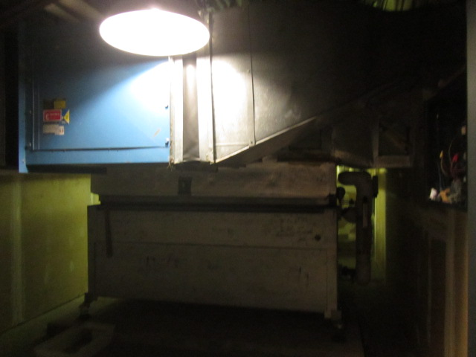

**Air handling unit in mechanical room**

**Picture 2**

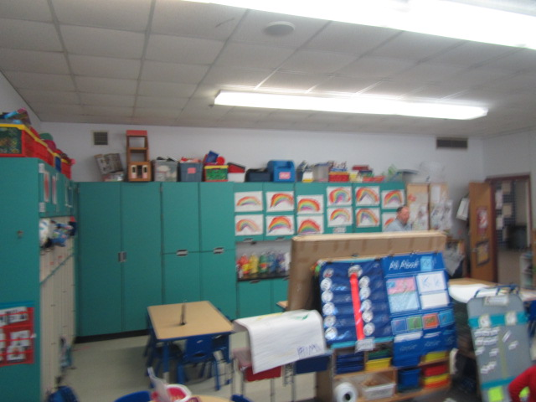

**Supply and exhaust vent on same interior wall of classroom (arrows)**

**Picture 3**

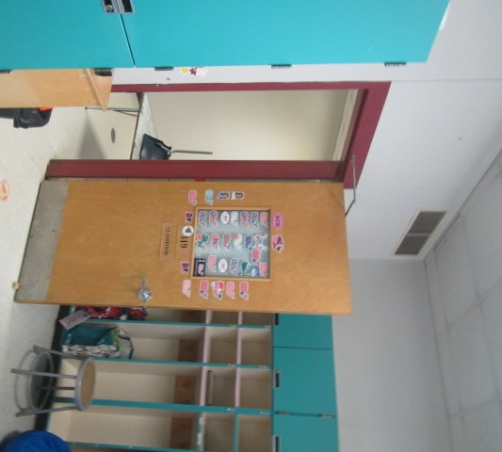

**Location of exhaust vent (arrows) near open classroom door**

**Picture 4**

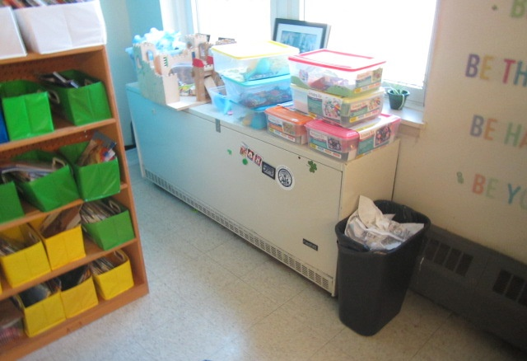

**Classroom univent, note items on top obstructing airflow from supply diffuser**

**Picture 5**

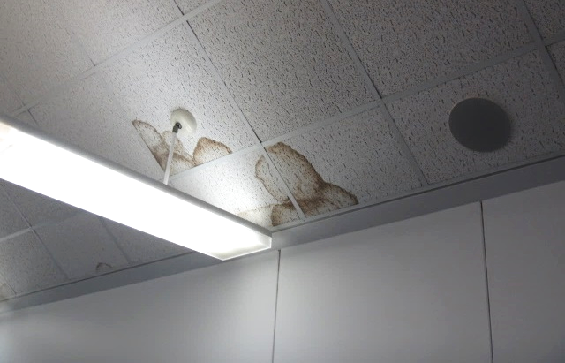

**Water-damaged ceiling tiles**

**Picture 6**

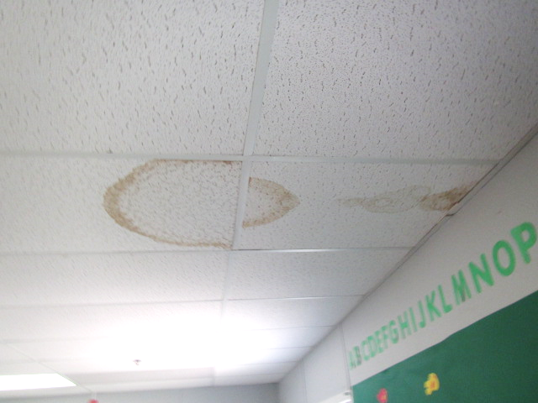

**Water-damaged ceiling tiles**

**Picture 7**

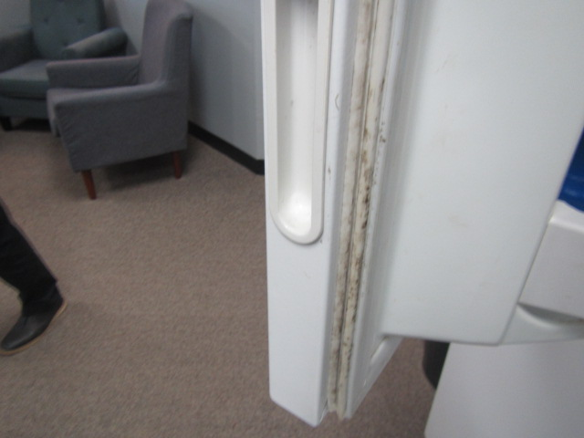

**Mold on gasket of refrigerator in Teacher’s Lunchroom (201)**

**Picture 8**

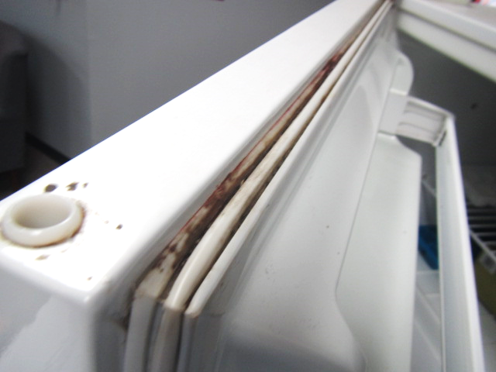

**Mold on gasket of refrigerator in Teacher’s Lunchroom (201)**

**Picture 9**

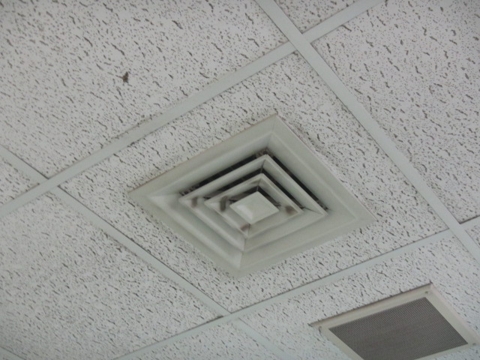

**Accumulated dust/debris on vents and surrounding ceiling tiles**

**Picture 10**

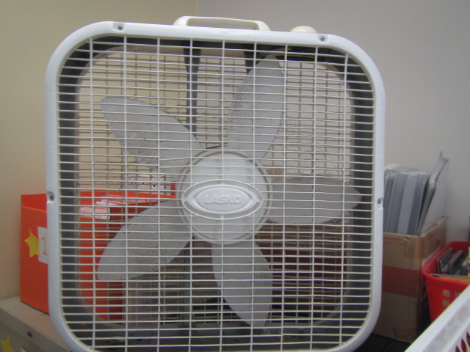

**Classroom fan with accumulated dust/debris**

**Picture 11**

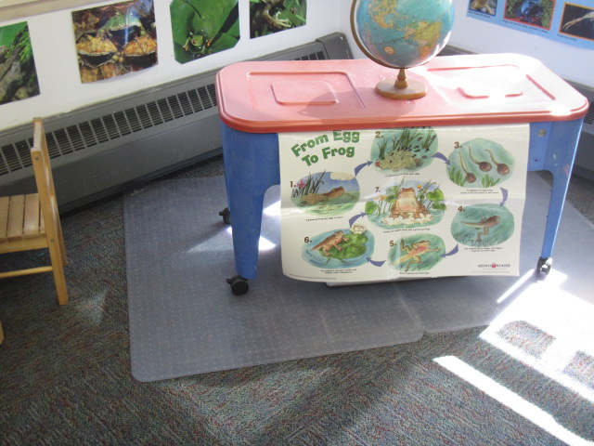

**Plastic mat, which can trap moisture and wet carpet during periods of elevated relative humidity**

**Picture 12**

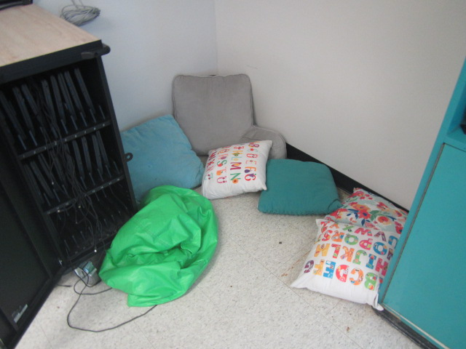

**Pillows and cushions on floor in classroom**

**Picture 13**

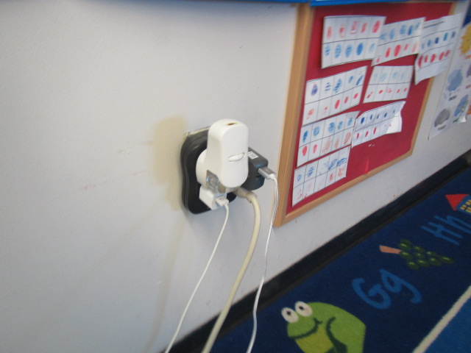

**Plug-in air freshener in classroom**

**Picture 14**

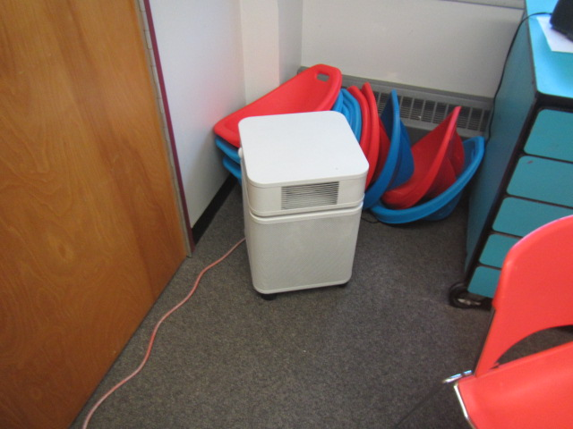

**Air Purifier in classroom**

**Picture 15**

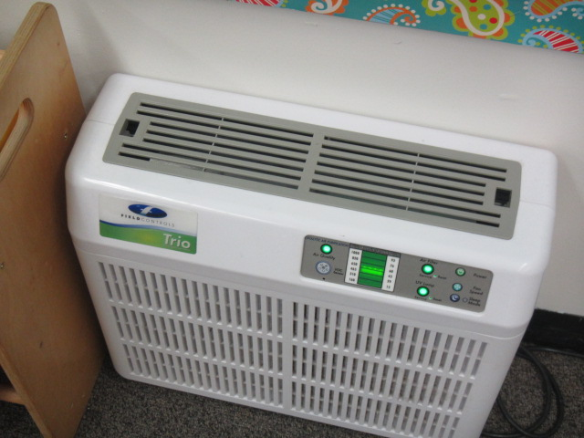

**Air Purifier in classroom, note filter lights indicating maintenance required**

**Picture 16**

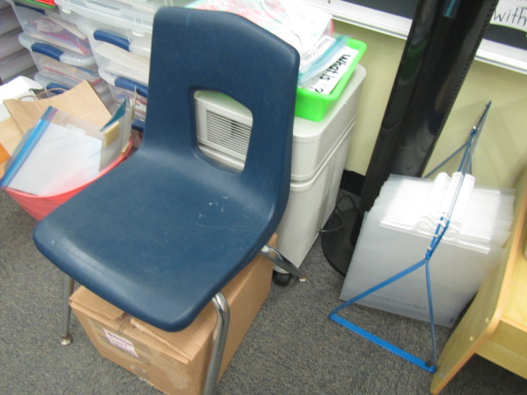

**Air purifier obstructed by various items**

**Picture 17**

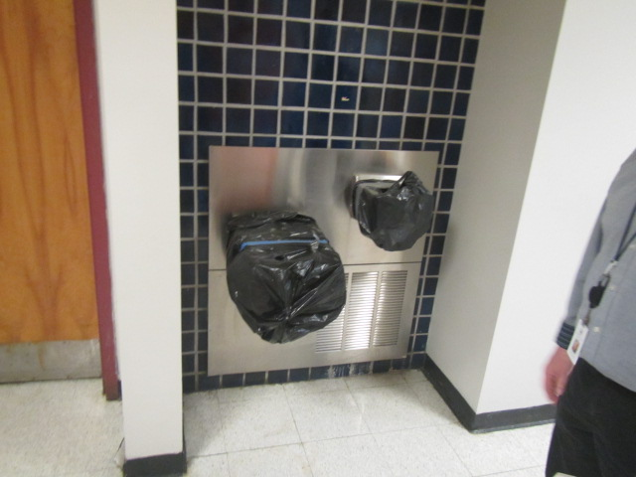

**Abandoned water fountains**

**Picture 18**

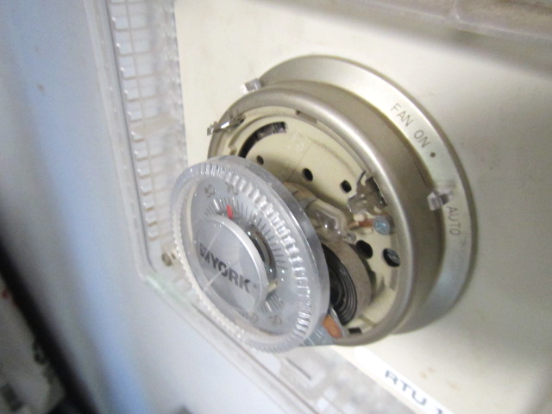

**Wall-mounted thermostat with mercury ampoule (arrow)**

| **Location** | **Carbon**  **Dioxide**  **(ppm)** | **Carbon Monoxide**  **(ppm)** | **Temp**  **(°F)** | **Relative**  **Humidity**  **(%)** | **PM2.5**  **(µg/m**3**)** | **Occupants**  **in Room** | **Windows**  **Openable** | **Ventilation** | | **Remarks** |
| --- | --- | --- | --- | --- | --- | --- | --- | --- | --- | --- |
| **Intake** | **Exhaust** |
| Background | 426 | 1-2 | 57 | 27 | 10 |  |  |  |  | Clear, cool and sunny |
| 105 Nurse’s Suite | 652 | ND | 70 | 27 | 1 | 0 | Y | Y | Y | DO, 3 WD CTs |
| 107 | 747 | ND | 70 | 27 | 1 | 17 | Y | Y | Y | DO, wall to wall carpet, area carpets, AP, 5 WD CTs |
| 109 | 589 | ND | 69 | 25 | 1 | 0 | N | Y | N | Laminator, PC |
| 111 | 780 | ND | 69 | 27 | 1 | 13 | Y | Y | Y | DO, wall to wall carpet, area carpets, AP, PF(2), interlocking CTs |
| 112 | 850 | ND | 67 | 29 | 1 | 1 | Y | Y | Y | DO, wall to wall carpet, area carpets, AP, 15 occupants gone ~5 mins |
| 114 | 631 | ND | 68 | 28 | 1 | 1 | Y | Y | Y | MT, AP, area carpets |
| 115 | 766 | ND | 69 | 27 | 1 | 18 | Y | Y | Y | DO, area carpets, CP |
| 116 | 858 | ND | 68 | 30 | 1 | 18 | Y | Y  Off | Y | Univent-off/airflow partially obstructed, plug in AD, plants, area carpets, PF (2), recommend relocating furniture/items |
| Library | 609 | ND | 69 | 26 | 1 | ~20 | Y | Y | Y | DO, wall to wall carpet, area carpets, AP, CF, plants, dust/debris on vents, PC |
| Speech Therapy | 1063 | ND | 69 | 26 | 1 | 4 | N | Y | Y | AP, wall to wall carpet, PF |
| Cafeteria | 529 | ND | 70 | 24 | 1 | 3 | Y | Y | Y | CF |
| 132 Workroom | 583 | ND | 69 | 26 | 1 | 0 | N | Y | Y | AP, PC |
| 145 | 828 | ND | 69 | 29 | 1 | 22 | Y | Y | Y | DO, wall to wall carpet, area carpets, AP, PF (2), 5 WD CTs |
| 147 | 652 | ND | 68 | 27 | 1 | 0 | Y | Y | Y | DO, area carpets, carpet squares |
| 148 | 733 | ND | 70 | 26 | 1 | 16 | Y | Y | Y | DO, carpet squares, area carpets, AP |
| 149 | 657 | ND | 69 | 25 | 1 | 0 | Y | Y | Y | Wall to wall carpet, area carpets, AP |
| 150 | 725 | ND | 69 | 26 | 1 | 0 | Y | Y | Y | Wall to wall carpet, area carpets, AP |
| 151 | 688 | ND | 68 | 26 | 1 | 14 | Y | Y | Y | 2 WD CTs, wall to wall carpet, area carpets, 1 broken CT |
| 152 | 727 | ND | 69 | 26 | 1 | 13 | Y | Y | Y | AP, DO, 6 WD CTs (over windows), wall to wall carpet, area carpets, plant |
| 153 | 762 | ND | 68 | 26 | 1 | 10 | Y | Y | Y | Wall to wall carpet, AP |
| 155 | 687 | ND | 68 | 27 | 1 | 16 | Y | Y | Y | Area carpets, AP |
| Gym | 642 | ND | 65 | 29 | 1 | ~40 | Y | Y | Y | DO |
| 158 | 755 | ND | 67 | 27 | 1 | 15 | Y | Y | Y | Wall to wall carpet, area carpets, plant, AP-filter light “on” |
| 160 | 700 | ND | 68 | 26 | 1 | 14 | Y | Y | Y | DO, carpet squares, plant, plastic mats on carpet |
| 165 | 775 | ND | 67 | 28 | 1 | 16 | Y | Y | Y | AP, area carpets, plant |
| 166 | 626 | ND | 67 | 28 | 1 | 6 | Y | Y | Y | WD CT, wall to wall carpet, area carpets, plant |
| 167 | 560 | ND | 67 | 27 | 1 | 2 | Y | Y | Y | Wall to wall carpet, AP |
| 201 | 540 | ND | 69 | 25 | 1 | 2 | Y | Y | Y | Wall to wall carpet, visible mold on refrigerator gaskets, 5 WD CTs |
| 203 | 646 | ND | 69 | 25 | 1 | 17 | Y | Y | Y | DO, wall to wall carpet, area carpets, AP, dust/debris on vents, 4 WD CTs, plants |
| 205 | 782 | ND | 69 | 27 | 1 | 18 | Y | Y | Y | DO, wall to wall carpet, area carpets, AP, PF |
| 207 | 844 | ND | 70 | 27 | 1 | 17 | Y | Y | Y | DO, wall to wall carpet, area carpets, AP, aqua, WD CT, PF |
| 208 | 834 | ND | 68 | 27 | 1 | 16 | Y | Y | Y | Wall to wall carpet, area carpets, AP, PF, aqua |
| 209 | 792 | ND | 68 | 28 | 1 | 19 | Y | Y | Y | DO, wall to wall carpet, area carpets, AP, PF |
| 210 | 833 | ND | 67 | 29 | 1 | 18 | Y | Y | Y | Dust/debris on vents, DO, pillows on floor |
| 219 | 791 | ND | 67 | 28 | 1 | 15 | Y | Y | Y | DO, wall to wall carpet, area carpets |
| 220 | 797 | ND | 37 | 27 | 1 | 17 | Y | Y | Y | DO, AP, PF, bee’s nest (prop), dust/debris on vents |
| 221 | 785 | ND | 67 | 29 | 1 | 21 | Y | Y | Y | Dust/debris on vents, DO, wall to wall carpet, area carpets, AP, aqua, 15 WD CTs |
| 222 | 705 | ND | 67 | 27 | 1 | 17 | Y | Y | Y | Dust/debris on vents, DO, wall to wall carpet, area carpets, AP, 7 WD CTs, PF |
| 224 | 530 | ND | 68 | 26 | 1 | 0 | Y | Y | Y | DO, wall to wall carpet, AP, PF, WD CT |
| 228 | 567 | ND | 68 | 26 | 1 | 0 | N | Y | Y | Wall to wall carpet, AP, dust/debris on vents, PF |
| 228 A | 652 | ND | 70 | 26 | 1 | 3 | N | Y | Y | 3 WD CTs, AP, plug-in AD |
| 228 B | 664 | ND | 70 | 27 | 1 | 1 | N | Y | Y | WD CT, wall to wall carpet, DO |
| 230 PT/OT | 572 | ND | 70 | 25 | 1 | 0 | N | Y | Y | 3 WD CTs, AP, wall to wall carpet |
| 231 | 618 | ND | 70 | 26 | 1 | 0 | N | Y | Y | Wall to wall carpet, AP, PF, WD CT |
| 233 | 596 | ND | 70 | 25 | 1 | 2 | Y  Open | Y | Y | DO, wall to wall carpet, AP, PF |
| 235 Art | 793 | ND | 69 | 28 | 1 | 18 | Y | Y | Y | Kiln-ducted, 7 WD CTs, AP, dust/debris on vents |
| 236 | 509 | ND | 69 | 25 | 1 | 0 | Y | Y | Y | Wall to wall, AP |
| 237 | 779 | ND | 69 | 26 | 1 | 15 | Y | Y | Y | DO, wall to wall carpet, area carpets, AP, dust/debris on vents, 8 WD CTs |
| 238 | 544 | ND | 70 | 24 | 1 | 1 | Y | Y | Y | Wall to wall carpet, AP, dust/debris on vents, 7 WD CTs |
| 239 | 561 | ND | 70 | 25 | 1 | 2 | Y | Y | Y | DO, wall to wall carpet, dust/debris on vents, WD CTs, |
| 240 | 613 | ND | 70 | 25 | 1 | 1 | Y | Y | Y | DO, wall to wall carpet, area carpets, AP, students at lunch |
| 241 | 603 | ND | 70 | 25 | 1 | 2 | Y | Y | Y | DO, wall to wall carpet, area carpets, AP, dust/debris on vents, WD CT |
| 242 | 622 | ND | 71 | 24 | 1 | 15 | Y | Y | Y | DO, carpet squares, dust/debris on vents, WD CT |
| 243 | 677 | ND | 72 | 26 | 1 | 17 | Y | Y | Y | DO, carpet squares, area carpets, AP, dust/debris on vents, 8 WD CTs |
| 247 | 721 | ND | 71 | 24 | 1 | 17 | Y | Y | Y | DO, carpet squares, AP, PF, 2 WD CTs |
| 248 | 692 | ND | 71 | 26 | 1 | 11 | Y | Y | Y | DO, dust/debris on vents, carpet squares, area carpets, 7 WD CTs |
| 250 | 1100 | ND | 72 | 32 | 1 | 2 | Y | Y | Y | 4 WD CTs, AP |
| 254 | 679 | ND | 73 | 24 | 1 | 15 | Y | Y | Y | DO, carpet squares, area carpets, AP, PF, 2 WD CTs |
| 257 | 683 | ND | 69 | 27 | 1 | 16 | Y | Y | Y | DO, carpet squares, area carpets, AP, 16 WD CTs |
| 260 | 740 | ND | 69 | 31 | 1 | 16 | Y | Y | Y | DO, carpet squares, AP, 12 WD CTs, dust/debris on vents |
| 261 | 601 | ND | 70 | 26 | 1 | 11 | Y  Open | Y | Y | DO, carpet squares, area carpets, AP, PF, 6 WD CTs, dust/debris on vents |
| **Modular Building** |  |  |  |  |  |  |  |  |  |  |
| Modular 501 | 675 | ND | 68 | 35 | 1 | 2 | Y | Y | Y | Thermostat (auto)-no cover, wall to wall carpet, DO, PF, 2 WD CTs |
| Modular 502 | 768 | ND | 68 | 34 | 1 | 12 | Y | Y | Y | Thermostat (auto)-no cover, wall to wall carpet, DO, area carpets, WD CT |
| Modular 503 | 845 | ND | 70 | 38 | 1 | 9 | Y | Y | Y | Dust/debris on vents, wall to wall carpet, DO, area carpets, WD CT, AP |
| Modular 504 | 656 | ND | 69 | 31 | 1 | 13 | Y | Y | Y | Wall to wall carpet, DO, area carpets, WD CT, AP |
| Modular 505 | 780 | ND | 70 | 35 | 1 | 13 | Y | Y | Y | Wall to wall carpet, DO, area carpets, 2 WD CTs, AP, plants |
| Modular 506 | 772 | ND | 70 | 33 | 1 | 7 | Y | Y | Y | DO, wall to wall carpet, area carpets, AP, thermostat-no cover |

1. The service life is the median time during which a particular system or component of …[an HVAC]… system remains in its original service application and then is replaced. Replacement may occur for any reason, including, but not limited to, failure, general obsolescence, reduced reliability, excessive maintenance cost, and changed system requirements due to such influences as building characteristics or energy prices (ASHRAE, 1991).