BACKGROUND

INDOOR AIR QUALITY/WATER DAMAGE ASSESSMENT

Forestdale Elementary School
151 Route 130
Forestdale, MA

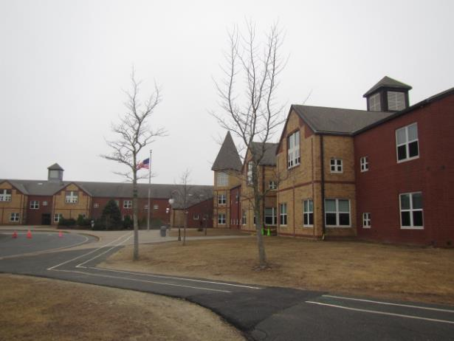

Prepared by:
Massachusetts Department of Public Health
Bureau of Environmental Health
Indoor Air Quality Program
March 2023
Building: | Forestdale Elementary School (FES)
Address: | 151 Route 130, Forestdale/Sandwich, MA
Assessment Requested by: | Christopher George, Director of Facilities,  Sandwich Public Schools
Reason for Request: | Assessment of remediation of water-damaged building materials due to frozen sprinkler head/plumbing leak in the attic, which affected the 2nd and 1st floors below.
Date of Assessment: | February 17, 2023
Massachusetts Department of Public Health/Bureau of Environmental Health (MDPH/BEH) Staff Conducting Assessment: | Cory Holmes, Assistant Director, Indoor Air  Quality (IAQ) Program
Building Description: | The FES is two-story brick building constructed in the late 1980s housing grades preK-2. Classrooms have of full or partial carpeting, with gypsum wallboard (GW) walls, and suspended ceiling tiles. Some rooms on the first floor had interlocking ceiling tiles that are adhered directly to the ceiling substrate.
Windows: | Openable

It was reported that on Saturday February 4, 2023, a pipe burst on a sprinkler head in the attic due to extreme cold that occurred in New England over that weekend. Significant water damage was reported on the 2nd and 1st floors in this wing of the building. An initial alarm was sounded at the Sandwich Fire Department, which contacted school administration. Sandwich Public Schools Facilities staff arrived on scene to begin wet carpet extraction and drying operations. That evening Service Master, a commercial restoration company, was contacted. Service Master arrived on site Sunday February 5, to remove wet ceiling tiles (Pictures 1 through 3) and initiate remediation with drying machines, fans, dehumidifiers and high, efficiency particulate arrestance (HEPA) filtration units on the affected floors (Pictures 4 and 5). On Monday, February 6, moisture measurements were conducted, and water-damaged GW was identified and removed (Pictures 6 through 9). Although the building was open, classrooms were relocated for instruction to allow for the drying/cleaning mitigation to be completed. MDPH IAQ staff arrived on-site February 17 (the Friday prior to February vacation) to conduct an IAQ Assessment of the affected areas.

METHODS
Please refer to the IAQ Manual for methods, sampling procedures, and interpretation of results (MDPH, 2015).

RESULTS AND DISCUSSION
Media sampled |  | MDPH Guideline/  Comparison Value |  | Measured Range |  |  | Comments
 |  |  |  | Outdoors/  Background | Indoors
Water-Damaged Building Materials |  | Normal = Dry |  |  |  |  | All water-damaged materials were either removed (i.e., ceiling tiles, GW), or dried in place (e.g., carpet, ceilings/GW). Carpeting was scheduled to be professionally cleaned over February vacation.
Carbon Dioxide (CO₂) |  | < 800 parts per million (ppm) is preferred |  | 421 | 457-546 |  | HVAC operating providing adequate airflow
Total Volatile Organic Compounds (TVOCs) |  | Equal to or below background level measured |  | ND | ND
Carbon Monoxide (CO) |  | Non-detectable (ND) or equal to or below background level measured |  | ND | ND
Particulate Matter 2.5 (PM2.5) |  | US EPA National Ambient Air Quality Standards (NAAQS) 35 μg/m³ or less |  | 10 | 2-6 |  | Below NAAQS
Temperature |  | 70 to 78ºF |  | 55 | 66-77 |  | Within/close to MDPH comfort guidelines
Relative Humidity (RH) |  | 40% to 60% |  | 100 (intermittent rain) | 44-60 |  | Within MDPH comfort guidelines and below outdoor/background conditions, indicating successful drying operations
ppm = parts per million | µg/m³ = microgram per cubic meter |  | ND = non-detectable |  |  | TVOCs = Total Volatile Organic Compounds

Ventilation
A heating, ventilating, and air conditioning (HVAC) system has several functions. First it provides heating and, if equipped, cooling. Second, it is a source of fresh air. Finally, an HVAC system will dilute and remove normally occurring indoor environmental pollutants by not only introducing fresh air, but by filtering the airstream and ejecting stale air to the outdoors via exhaust ventilation. Even if an HVAC system is operating as designed, point sources of respiratory irritation may exist and cause symptoms in sensitive individuals.
The building’s mechanical ventilation system uses air handling units (AHUs), which deliver fresh air into occupied areas via wall or ceiling-mounted air diffusers. Return air is drawn into wall or ceiling-mounted exhaust vents back to AHUs. Fresh air is supplemented by openable windows.

Microbial/Moisture Concerns
The United States Environmental Protection Agency (US EPA) and the American Conference of Governmental Industrial Hygienists (ACGIH) recommend that porous materials be dried with fans and heating within 24 to 48 hours of becoming wet (US EPA, 2008; ACGIH, 1989). If porous materials are not dried within this time frame, they should be removed and discarded.
At the time of assessment, all water-damaged materials had been removed or remediated. Moisture measurements of carpeting and remaining GW were taken by MDPH IAQ staff in areas impacted by the flooding event (Table 1). All moisture measurements were normal (i.e., dry), with no visible mold observed above ceilings and wall cavities (Pictures 6 through 9). It was reported that rebuilding and final cleanup operations were scheduled over February vacation.

Other Issues
As a general rule, carpets should be cleaned annually (or semi-annually in soiled/high traffic areas) in accordance with Institute of Inspection, Cleaning and Restoration Certification (IICRC) recommendations, (IICRC, 2012). The service life of carpeting is approximately 10-11 years (IICRC, 2002). Carpeting of this age and condition becomes increasingly difficult to clean and maintain and may be a source of particulate matter to the indoor environment. Regular cleaning with a high efficiency particulate air (HEPA) filtered vacuum in combination with an annual cleaning will help to reduce accumulation and potential aerosolization of materials from carpeting.
Water-damaged ceiling tiles were observed in other areas of the building unrelated to the frozen sprinkler head, which indicate historic leaks from the building envelope or plumbing system. Ceiling tiles are considered a porous material which, if exposed to chronic moisture, may become a source for microbial colonization. These tiles should be discarded and replaced. However, some ceiling tiles are of a type that are adhered directly to the ceiling substrate (Picture 10). These tiles are difficult to replace and necessitate the destruction of the tile, furthermore, replacement tiles are often obsolete and difficult to obtain.
Finally, some supply diffusers and exhaust/return vents were also observed to have accumulated dust/debris (Picture 11). This dust can be aerosolized when the equipment is activated and provide a source of eye and respiratory irritation.

RECOMMENDATIONS
In view of the findings at the time of the visit, the following recommendations are made:

Water Damage Recommendations
- Finalize drying and cleaning operations.
- Replace water-damaged building materials.
- Continue with plans to investigate insulation conditions in similar parts of the building to prevent further leaks/incidents.
- Store porous items (i.e., cardboard and paper) off the floor in sealed boxes, bags or totes to prevent water damage. Discard water-damaged and/or moldy materials.
- Continue to ensure any roof and plumbing leaks are repaired promptly and replace any remaining water-damaged suspended ceiling tiles or other porous building materials.
- Consider long-term plan to remove/replace adhered interlocking ceiling tiles with a more easily maintained, suspended ceiling tile system.

Ventilation Recommendations
- Change HVAC filters using the best quality/highest MERV rated filters that can be used with current equipment. During filter changes, vacuum debris from AHU cabinets.
- Use windows to provide supplemental fresh air during temperate weather. Close windows tightly during wet and hot, humid weather to prevent moisture accumulation or during extreme cold to prevent frozen pipes.

Other Recommendations
- Clean carpeting annually or semi-annually in soiled high traffic areas as per the recommendations of the Institute of Inspection, Cleaning and Restoration Certification (IICRC 2012).
- Consider replacing carpeting past its useful life (> 10-11 years).
- Regularly clean supply/return/exhaust vents and fans to avoid aerosolizing accumulated particulate matter. To clean ceiling vents/grills, remove and wash, replace if necessary.
- Refer to the resource manual and other related indoor air quality documents located on the MDPH’s website for further building-wide evaluations and advice on maintaining public buildings. These documents are available at http://mass.gov/dph/iaq.

REFERENCES
ACGIH. 1989. Guidelines for the Assessment of Bioaerosols in the Indoor Environment. American Conference of Governmental Industrial Hygienists, Cincinnati, OH.
IICRC. 2002. Institute of Inspection, Cleaning and Restoration Certification. A Life-Cycle Cost Analysis for Floor Coverings in School Facilities.
IICRC. 2012. Institute of Inspection, Cleaning and Restoration Certification. Carpet Cleaning: FAQ.
MDPH. 2015. Massachusetts Department of Public Health. “Indoor Air Quality Manual: Chapters I-III”. Available at: Indoor air quality - manual and appendices | Mass.gov
US EPA. 2008. “Mold Remediation in Schools and Commercial Buildings”. Office of Air and Radiation, Indoor Environments Division, Washington, DC. EPA 402-K-01-001. September 2008. Available at: http://www.epa.gov/mold/mold-remediation-schools-and-commercial-buildings-guide.
Picture 1
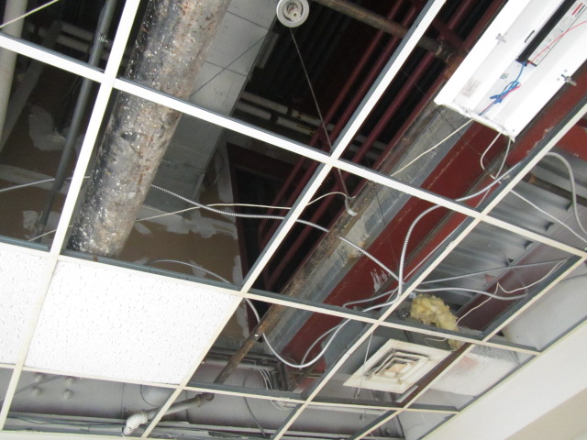
Water-damaged ceiling tiles removed
Picture 2
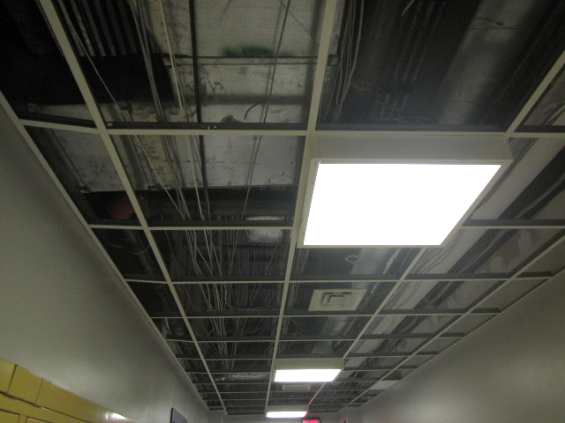
Water-damaged ceiling tiles removed
Picture 3
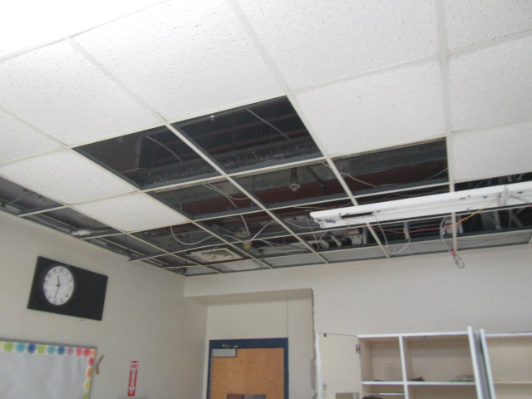
Water-damaged ceiling tiles removed
Picture 4
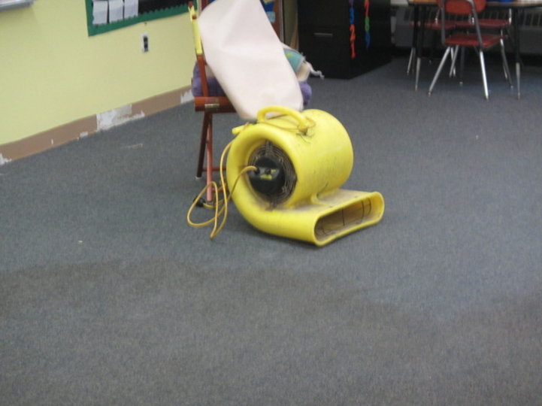
Drying fan in classroom
Picture 5
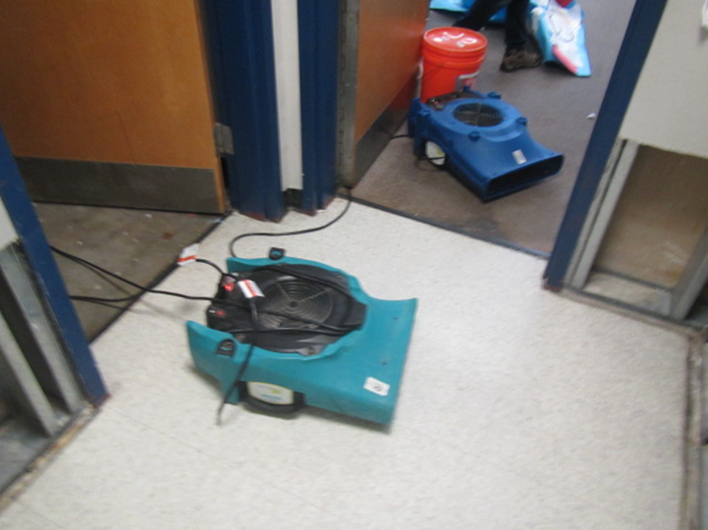
Drying fans in operation
Picture 6
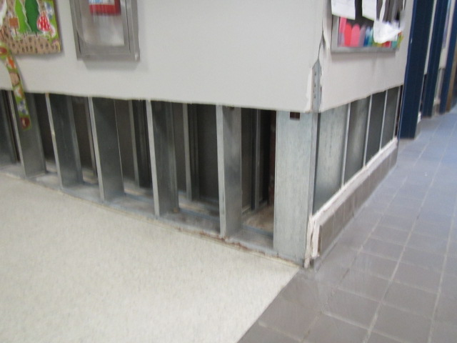
Removed water-damaged gypsum wallboard
Picture 7
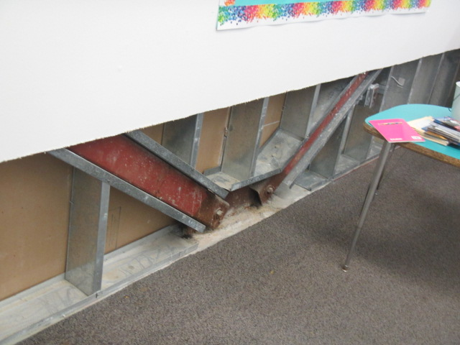
Removed water-damaged gypsum wallboard
Picture 8
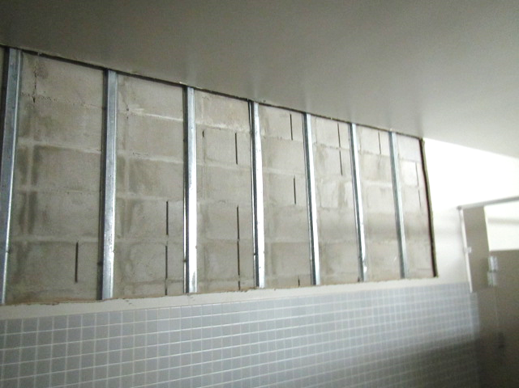
Removed water-damaged gypsum wallboard
Picture 9
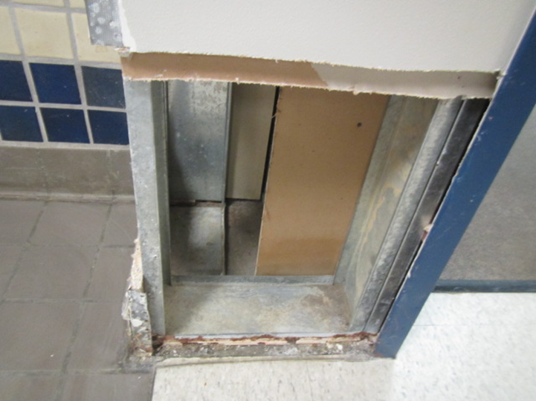
Removed water-damaged gypsum wallboard
Picture 10
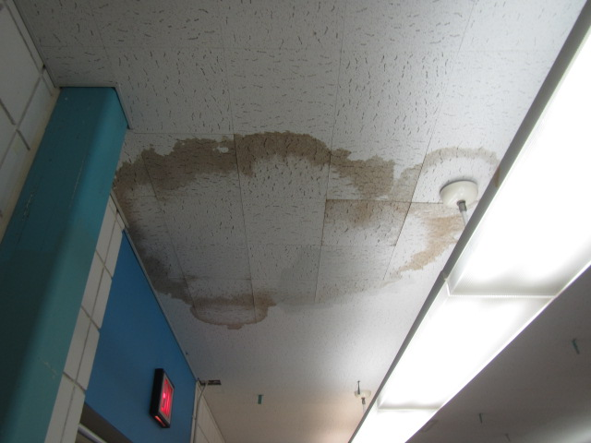
Water-damaged interlocking ceiling tiles on 1st floor
Picture 11
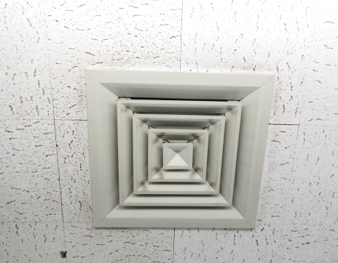
Dust and debris accumulated on supply vent in classroom

