 | Commonwealth of Massachusetts  City/Town of  Percolation Test  Form 12
 | Percolation test results must be submitted with the Soil Suitability Assessment for On-site Sewage Disposal. DEP has provided this form for use by local Boards of Health. Other forms may be used, but the information must be substantially the same as that provided here. Before using this form, check with the local Board of Health to determine the form they use.
Important: When filling out forms on the computer, use only the tab key to move your cursor - do not use the return key.  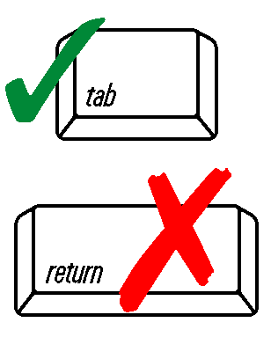 | A. Site Information
 | Owner Name
 | Street Address or Lot #
 | City/Town |  |  | State |  |  | Zip Code
 | Contact Person (if different from Owner) |  |  | Telephone Number
 | B. Test Results
 |  |  | Date | Time |  | Date |  | Time
 | Observation Hole #
 | Depth of Perc
 | Start Pre-Soak
 | End Pre-Soak
 | Time at 12”
 | Time at 9”
 | Time at 6”
 | Time (9”-6”)
 | Rate (Min./Inch)
 |  | Test Passed: Test Failed: |  |  | Test Passed:  Test Failed:
 | Test Performed By:
 | Board of Health Witness
 | Comments:

