 | Massachusetts Department of Environmental Protection  Bureau of Air & Waste • Air Quality  RGGI Annual Net Output Report |  |  |  |  |  |  |  | Reporting Year  Facility ID# (if known)
 | A. Facility Information
Important: When filling out forms on the computer, use only the tab key to move your cursor - do not use the return key. | Facility Name
 | Street Address
 | City/Town |  |  |  |  | State |  |  |  | Zip Code
 | Contact Name |  |  |  |  | Contact Title
 | Telephone Number |  |  |  |  | Email Address
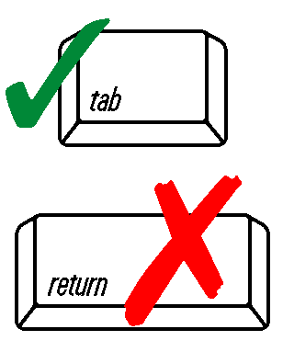 | B. Annual Net Electric Output  All net electric output values must be expressed in megawatt hours (MWh)/month.
 | Reporting Month |  | Unit No. | Unit No. |  |  | Unit No. |  |  |  |  | Unit No.
 | January
 | February
 | March
 | April
 | May
 | June
 | July
 | August
 | September
 | October
 | November
 | December
 | Continue to Next Page ►
Complete this section, Fuel Utilization Equipment and/or Section F, Process Equipment, depending upon the source of the emissions for which you are seeking a restriction.  (use additional pages, if necessary) | C. Annual Net Steam Output  All net steam output values must be expressed in millions of British thermal units (MMBtu)/month.
 | Reporting Month | Unit No. |  |  | Unit No. |  |  | Unit No. |  |  | Unit No.
 | January
 | February
 | March
 | April
 | May
 | June
 | July
 | August
 | September
 | October
 | November
 | December
 | D. Additional Comments:
 | E. Certification
 | This form must be signed by the CO₂ Authorized Account Representative or the Alternate CO₂ Authorized Account Representative.  "I am authorized to make this submission on behalf of the owners and operators of the CO₂ budget sources or CO₂ budget units for which the submission is made. I certify under penalty of law that I have personally examined, and am familiar with, the statements and information submitted in this document and all its attachments. Based on my inquiry of those individuals with primary responsibility for obtaining the information, I certify that the statements and information are to the best of my knowledge and belief true, accurate, and complete. I am aware that there are significant penalties for submitting false statements and information or omitting required statements and information, including the possibility of fine or imprisonment.” |  |  |  |  | Print Name
 |  |  |  |  |  | Authorized Signature
 |  |  |  |  |  | Position/Title
 |  |  |  |  |  | Date (MM/DD/YYYY)

