 | Massachusetts Department of Environmental Protection  Bureau of – Waste Prevention – Solid Waste Management  BWP SW 14 Special Waste Determination |  | Transmittal Number #  Facility ID (if known)
 | A. Project Information
Important: When filling out forms on the computer, use only the tab key to move your cursor - do not use the return key.  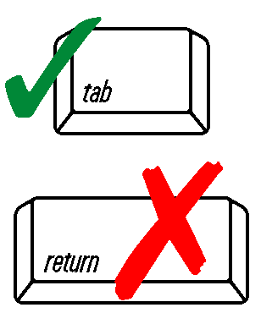 | 1. Identify the special waste: Asbestos Medical/Biological Waste Sludge
 | 2. General Information about the Solid Waste | Page # |  |  | DEP USE ONLY
 | a. General description of the waste
 | b. Source of the waste
 | (1) Name of the generator
 | (2) Address of the generator
 | c. Description of the industrial process which produces the waste
DIRECTIONS:  1. Specify the page numbers in  which the following  information is  located.  2. Enter NA if  information requested is not  applicable. | d. Quantity (volume and/or tonnage)
 | 3. Management options evaluation
 | a. reduction
 | (1) physical/chemical
 | (2) other
 | b. reuse
 | c. recycling
 | (1) composting
 | (2) land application
 | (3) other
 | d. other
 | (1) incineration
 | e. criteria evaluation
(1) protection of public health, safety,
and environment
 | (2) toxicity reduction and volume
 | A. Project Information (cont.)
 |  | Page # |  |  | DEP USE ONLY
 | (3) implementability
 | (4) cost
 | 4. Chemical, Physical and Biological Properties of the Waste
 | a. Chemical properties of the waste
 | (1) pH
 | (2) reactivity
 | (3) leachabilty (TCLP test)
 | (4) total metals
 | (5) VOCs
 | (6) other appropriate constituents
 | b. Physical properties of the waste
 | (1) particulate size
 | (2) density
 | (3) total solids
 | (4) volatile solids
 | (5) moisture content
 | (6) free liquid
 | c. Biological properties of the waste, if applicable
 | (1) pathogens
 | 4. Proposed Disposal Location and Handling Methods
 | a. Proposed handling methods
 | (1) transportation
 | (2) storage
 | A. Project Information (cont.)
 |  | Page # |  |  | DEP USE ONLY
 | (3) processing
 | b. disposal site
 | c. proposed method or methods for disposal
 | B. Responsible Official Certification: 310 CMR 19.011
 | I attest under the pains and penalties of perjury that:  - I have personally examined and am familiar with the information contained in this submittal, including any and all documents accompanying this certification statement;  - Based on my inquiry of those persons responsible for obtaining the information, the information contained in this submittal is, to the best of my knowledge, true, accurate and complete;  - I am fully authorized to bind the entity required to submit these documents and to make this attestation on behalf of such entity; and  - I am aware that there are significant penalties including, but not limited to, administrative and civil penalties for submitting false, inaccurate or incomplete information, and possible fines and imprisonment for knowingly submitting false, inaccurate or incomplete information. | Print Name
 |  | Authorized Signature
 |  | Position/Title
 |  | Date (MM/DD/YYYY)

