Massachusetts Department of Environmental Protection
Bureau of Resource Protection - Drinking Water Program
Form to Report Protocol for Awareness of New
Or Expanded Watershed Projects
Effective January 5, 2001

Important: When filling out forms on the computer, use only the tab key to move your cursor - do not use the return key.  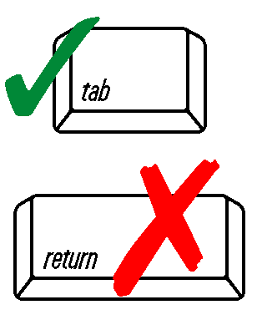 | The watershed protection section of the Massachusetts Drinking Water Regulations, 310 CMR 22.20B, requires that public surface water suppliers document to MassDEP, on a MassDEP form, that they have established a protocol that provides them with the opportunity to review and comment on proposed new or expanded land uses or activities within the watershed. There is no requirement that you review every project. You may have more than one process (i.e. a different process for watershed lands outside the community served by your system). Please use the space below to describe your protocol(s) for staying aware of watershed projects.
 | 1. Describe your protocol (or own/control watershed):
 | 2. Public water supplier information:
 | PWS Name/ID #
 | Name
 | Title
 | Signature |  | Date
Submit two copies to the MassDEP office in your region. The address and telephone number for each regional office can be found on the MassDEP website at: http://www.mass.gov/dep/about/region/findyour.htm.

See MassDEP’s Project Awareness Protocol fact sheet at http://www.mass.gov/dep/water/drinking/swregfs.htm for suggestions on what to look for and what to recommend to local boards for watershed protection.

Contact Kathy Romero, Drinking Water Program, at 617-292-5727, or visit www.mass.gov/dep.
This information is available in alternate format by calling MassDEP’s ADA Coordinator at 617-574-6872.

