# BACKGROUND

**INDOOR AIR QUALITY**

**ASSESSMENT**

**former West Street School**

**14 West Street**

**Granby, MA**

front exterior view of the former West Street School

Prepared by:

Massachusetts Department of Public Health

Bureau of Climate and Environmental Health

Indoor Air Quality Program

July 2023

|  |  |
| --- | --- |
| Building: | Former West Street School (WSS) |
| Address: | 14 West Street, Granby, MA |
| Assessment Requested by: | Chris Martin, Town Administrator, Town of Granby |
| Reason for Assessment: | General IAQ concerns regarding potential remodel for use a town hall |
| Dates of Assessment: | May 12, 2023 |
| Massachusetts Department of Public Health/Bureau of Environmental Health (MDPH/BEH) Staff Conducting Assessment: | Michael Feeney, Director, Indoor Air  Quality (IAQ) Program, and Stefanie  Santora, Environmental Analyst, IAQ  Program |
| Date of Building Construction: | The WSS is a single-story school constructed in the1950s. |
| Building Description: | The former school contains multiple wings with an enclosed courtyard. It contains general classrooms, an auditorium, gymnasium, cafeteria, kitchen, library, and office space. |

# INTRODUCTION

The IAQ Program assessed the former WSS to assist in identifying conditions that may adversely affect reuse of the building related to IAQ issues. These factors include water damage to building materials, physical condition of the heating, ventilating, air-conditioning (HVAC) system, and other conditions that may adversely impact IAQ. Please note this assessment was conducted when the building was unoccupied. No air testing was conducted to assess the HVAC system operation. Such testing is done when a building is fully occupied and operating under normal conditions.

# METHODS

MDPH IAQ staff conducted visual assessments of building components, water damage, and possible sources of materials that may cause respiratory irritation. Air, floor, and wall temperatures were also collected to assess the potential for moistening of building components by condensation. These readings and observations can be found in Table 1. Please refer to the IAQ Manual for methods, sampling procedures, and interpretation of results (MDPH, 2015).

# RESULTS AND DISCUSSION

## Ventilation

An HVAC system has several functions. First, it provides heating and, if equipped, cooling. Second, it is a source of fresh air. Finally, an HVAC system will dilute and remove normally occurring indoor environmental pollutants by not only introducing fresh air, but by filtering the airstream and ejecting stale air to the outdoors via exhaust ventilation. Even if an HVAC system is operating as designed, point sources of respiratory irritation may exist and cause symptoms in sensitive individuals.

Fresh air in the majority of classrooms is supplied by unit ventilators (univents). Univents manufactured by the Nesbitt Co. were installed when the WSS was originally constructed (Picture 1). Univents draw air from the outdoors through a fresh air intake located on the exterior wall of the building and return air through an air intake located at the base of the unit. Fresh and return air are mixed, filtered, heated or cooled, and provided to rooms through an air diffuser located in the top of the unit (Figure 1).

Exhaust ventilation in some classrooms is provided through hand louver-controlled exhaust air shafts (Pictures 2 and 3) connected to rooftop vents (Pictures 4 and 5). Such vents should be closed during hot, humid weather to reduce water vapor entry into the WSS during hot, humid weather. Other classrooms have exhaust vents located in closets (Picture 6), which may be connected to motorized exhaust vents (Picture 7).

The MDPH IAQ Program recommends that supply and exhaust ventilation operate continuously during occupied periods to provide air exchange and filtration. Without sufficient supply and exhaust ventilation, normally occurring environmental pollutants can build-up and lead to indoor air quality/comfort complaints.

It is also important to note that despite ongoing maintenance and replacement of parts/components by facilities staff when the facility operated as a school, many of the HVAC units are at the end of their life cycle. Efficient equipment function of this age (the Nesbitt univents are about 70 years old) is difficult to maintain, since compatible replacement parts are often unavailable. According to the American Society of Heating, Refrigeration, and Air-Conditioning Engineering (ASHRAE), the service life[1] of this type of unit is 15-20 years, assuming routine maintenance of the equipment (ASHRAE, 1991). However, during the course of this assessment, a project to replace some univents in below-grade space was initiated.

To have proper ventilation with a mechanical ventilation system, the systems must be balanced after installation to provide an adequate amount of fresh air to the interior of a room while removing stale air from the room. It is recommended that HVAC systems be re-balanced every five years to ensure adequate air systems function (SMACNA, 1994).

Balancing the HVAC system may not be possible since the exhaust system does not appear to have mechanical components, e.g., motorized exhaust fans. In addition, based on the age, operation status and condition of the univents, balancing of the HVAC system may not be possible.

## Microbial/Moisture Concerns

The WSS did not have any detectable mold odors and did not appear to have *significant* water damage to interior spaces throughout the building. However, the former WSS may experience water damage from the following sources:

### Roof conditions

A new roof was installed. Due to the installation of the roof (Picture 8), depressions have been made in the roof membrane which can collect water (Picture 9) which can cause damage to the roof membrane over time. Pooling water can also occur when roof drains are blocked with debris, such as leaves from nearby trees. Without adequate drainage, pooling water on the roof can also freeze during cold weather to cause degradation of the roof membrane.

### Extreme weather conditions

It is important to note that Massachusetts experienced extended periods of relative humidity during the summer of 2021. July of 2021 was the wettest ever recorded in Massachusetts, and the three-month period from June through August, known as the meteorological summer, was the fourth wettest on record, according to the National Oceanic and Atmospheric Administration’s (NOAA) Centers for Environmental Information. The three-month period also was the third warmest ever in the state and was tied for the warmest on record across the United States (HG, 2021, NOAA, 2021).

Such conditions also occurred in New England prior to Summer 2021. During the summer of 2018, the Boston area also experienced an unprecedented period of extended hot, humid weather. According to the Washington Post, “[d]ata…show[s]…cities in the Northeast have witnessed such humidity levels for record-challenging duration...[i]ncluding Albany, Boston, Burlington, Portland, and Providence” during the summer of 2018 (WP, 2018). “Boston and nearby locations… [saw]…historic numbers of those warm nights with low temperatures at or above 70 degrees…Providence and Blue Hill Observatory have already broken their annual records” (WP, 2018).

During both summers of 2018 and 2021, extended periods of outdoor relative humidity above 70% occurred. Under these weather periods, public buildings experienced extended periods of water vapor exposure from high relative humidity. When exposed to these conditions, porous materials such as gypsum wallboard, cardboard, and other materials may become prone to mold colonization, particularly if located in areas that are prone to developing condensation on floors and walls (e.g., below grade space). According to the American Society of Heating, Refrigerating and Air-Conditioning Engineers (ASHRAE); if relative humidity exceeds 70%, mold growth may occur due to wetting of building materials (ASHRAE, 2019) even in the absence of liquid water.

### Building materials prone to condensation

The lowest floor of the former WSS has both floors and walls that are in direct contact with soil. Uninsulated floor tiles appear to have water damage (Picture 10) that is typical of chronic exposure to condensation. Given this, it is likely that the lowest levels of the building have both floors and walls that are prone to condensation during hot, humid weather. This is further indicated by the temperature measurements of floors that are at least 5°F less than the corresponding air temperatures (Table 1).

The key to managing condensation is understanding dew point. The dew point is the temperature that air must reach for saturation to occur. When warm, moist air passes over a cooler surface, condensation can form. If a building material/component has a temperature below the dew point, condensation will accumulate on that material. Porous materials can be moistened by condensation or by droplets resulting from condensation on nearby surfaces, which creates conditions where mold may grow. Porous building materials such as gypsum wallboard, and stored materials such as cardboard, cloth, paper, and soft wood can all become water-damaged. If porous materials are exposed to water for longer than 24 to 48 hours, mold colonization can occur.

During extreme relative humidity, some building materials can absorb water to cause warping, but not enough moisture to result in mold colonization. A significant number of rooms contained bowed ceiling tiles (Picture 11; Table 1). Ceiling tiles tend to bow with increased water vapor exposure. This condition frequently indicates that ceiling tiles have been repeatedly exposed to high humidity. It is important to note that no water staining or mold growth on ceiling tiles was noted.

### Dry drain traps

The former WSS has a number of sinks and other drains, some of which are not in regular use. It is likely that each of these drains has a dry trap, which can result in infiltration of water vapor and odors into the building from the drainage system, particularly during times of heavy rains. The purpose of a drain trap is to prevent sewer gases from entering the building by having water fill the P- or U-shaped bend beneath the drain. Such an airtight seal also prevents water vapor from readily entering the building. All drains should be wet with water at least once a week, or if not to be used again, sealed of properly cut and capped.

### Poor drainage in the courtyard

The former WSS has a large interior courtyard that has signs of poor water drainage and a significant slope from side to side (Picture 12). Accumulated rainwater likely pools against the foundation around the exterior perimeter, as denoted by ground without grass along the exterior wall perimeters (Picture 13).

Over time, rainwater runoff from the exterior wall can compress soil to produce a furrow-like depression of ground adjacent to the foundation, which, in turn, can result in water pooling. This condition can result in univents drawing water vapor from these pools, which can corrode the univent cabinet, wet cardboard-framed filters to cause mold growth, and increase relative humidity inside the building, particularly if exhaust ventilation is not working as designed. Such pooling can also result in excessive water exposure to foundation walls and floor, which can then lead to water penetrating into below grade space. The slope of the courtyard can direct water towards the courtyard walls, especially during extreme rainfall, which can create conditions for water pooling and damage to exterior walls.

Enhancing water retention and likely affecting courtyard drainage is the presence of large trees and shrubs near exterior walls (Pictures 12 and 14). These trees pose several issues/hazards:

* Leaves and other tree debris accumulate around roof drains, which inhibits rainwater drainage. This can also lead to drain blockage with ice accumulation. Ineffective drains can lead to water running off the roof to moisten exterior walls.
* Trees and shrubs prevent sunlight from drying courtyard exterior walls and soil.
* The trees are a possible danger to the former WSS due to the distance from exterior walls.
  + The recommended safe distance that any tree should be planted is the minimum of the expected maximum growth height of the species from the exterior of a building (BI, 2015).
  + Soil subsidence may also be caused by shrub and tree roots, which can undermine the structure of a building to cause wall and floor cracking as well as other related damage. To prevent subsidence, a sufficient distance appropriate for the trees species is recommended (Williams, 2006).
  + Even within the recommended distance, severe weather may result in trees falling onto the former WSS or having roots damage the foundation. Due to the height of the trees, each is likely located well within recommended distances.
  + Also of note is resistance of trees to uprooting during high wind events accompanied by rain. In general, a tree root system will spread out in all directions from its trunk. In some cases, tree roots can extend for over 100 feet from the trunk. Any structure disrupting the root structure may make the tree unstable if subjected to high winds from a certain direction. Based on the location, the foundation walls likely disrupt the roots of several trees.

The Federal Emergency Management Agency (FEMA) provides a number of recommendations in order to prepare for severe thunderstorms. Of note, FEMA recommends “Cut down or trim trees that may be in danger of falling on your [building]” (FEMA, 2018). Given the proximity to the former WSS exterior walls, removal of trees from the courtyard should be strongly considered.

### Furnace room flooding

Walls and floors to the furnace room had standing water and signs of significant flooding shown by water marks on walls (Picture 15). Of specific concern is the presence of electrical transformers in the basement, which are typically mounted on outdoor telephone poles (Picture 16). Both transformers had water marks indicating likely exposure to standing water from past basement flooding.

## Other Conditions

### Floor tiles

As described above, a number of locations have floor tiles that have been exposed to moisture (Pictures 17 and 18) from condensation during hot, humid weather. Due to the age of the building, the floor tiles and mastic likely contain asbestos. Such materials should be examined by a Massachusetts licensed asbestos inspector to determine the condition and need for repair of the floor tiles.

### Carpeting

A number of areas have wall-to-wall carpet that is water-damaged (Picture 19) and is of undetermined age. If relative humidity indoors is >70 %, that is a sufficient concentration that can cause building materials to become moistened even in the absence of liquid water (ASHRAE, 1989). In addition, if carpeting is moistened and has materials covering it to prevent free air flow to aid drying, carpet can remain moistened. Carpeting has an expected service life of 10 years. Once the service life of carpet is exceeded, fiber from carpeting can become more readily loosened and possibly aerosolized.

Carpeting should be vacuumed regularly with a high efficiency particulate arrestance (HEPA) filter equipped vacuum cleaner to avoid particulates from causing further irritation or serving as a reservoir for microbial colonization. Also, carpeting and rugs should be cleaned at least once per year according to Institute of Inspection Cleaning and Restoration Certification recommendations (IICRC, 2012). Area rugs too worn to be effectively cleaned should be replaced. Area rugs should be rolled up and stored in a clean, dry place when rooms are not occupied during the summer months to prevent moistening due to condensation.

Due to its age and moisture exposure, consideration should be given to replacing carpeting with tile or other appropriate materials. It is important to determine if carpet was installed over floor tiles that contain asbestos. If so, removing carpet would require compliance with all relevant federal and state asbestos laws.

### Window caulking conditions

Due to the age of the building, it is likely that the windows have caulking that contain polychlorinated biphenyl (PCBs). However, the interior of the windows did not produce any damaged/crumbling materials on the interior of the building. It is important to the US EPA issued the [Fact Sheet on Practical Actions for Reducing Exposure to Polychlorinated Biphenyls (PCBs) in Schools and Other Buildings | US EPA](https://www.epa.gov/pcbs/fact-sheet-practical-actions-reducing-exposure-polychlorinated-biphenyls-pcbs-schools-and), which provides guidance on how to manage PCB in buildings.

# RECOMMENDATIONS

The former WSS has a number of issues related to moisture in the building. Management of buildings in such weather without air conditioning can be challenging during periods of extended hot, humid weather. The following documents provide guidance that can be used to reduce the impact of hot, humid weather in buildings:

* Mold Growth Prevention During Hot, Humid Weather <https://www.mass.gov/service-details/preventing-mold-growth-in-massachusetts-schools-during-hot-humid-weather>
* Remediation and Prevention of Mold Growth and Water Damage in Public Schools <https://www.mass.gov/service-details/remediation-and-prevention-of-mold-growth-and-water-damage-in-public-schools-and>
* Methods for Increasing Comfort in Non-air-conditioned Schools <https://www.mass.gov/doc/methods-for-increasing-comfort-in-non-air-conditioned-schools/download>

To remedy building problems, two sets of recommendations are made: **short-term** measures that may be implemented as soon as practicable and **long-term** measures that will require planning and resources to address overall IAQ concerns:

## Short Term Recommendations

### HVAC system

1. Conduct a building-wide ventilation system assessment. Based on historical issues regarding the HVAC system design, physical deterioration and availability of parts for ventilation components, such an evaluation, is necessary to determine the operability and feasibility of replacing existing HVAC system equipment.
2. It is important to note that the building was designed as a school which would have a significant number of occupants in each room. Given the proposed use of the building would have a significantly lower population and different use, the ventilation system should be examined for the potential to adapt for the expected new occupancy as well as appropriate conditions for storage of materials. Adaptation may need to include the addition of cooling/air conditioning.
3. Operate all supply and exhaust ventilation equipment continuously during occupied periods.
4. Ensure all exhaust vents are operating and make repairs, as necessary. Check exhaust vents for air draw periodically.
5. Consider installing bird screens over all exhaust vent openings to prevent bat and other animal entry into building.

### Water damage recommendations

1. Given the conditions noted in the lowest level of the WSS, do not store materials there that are susceptible to mold growth if moistened by condensation. Such materials include paper, cardboard, cloth, books, leather, engineered woods such as particle board or chipboard, and gypsum wallboard.
2. It is recommended that porous material be dried with fans and heating within 24 to 48 hours of becoming wet (US EPA, 2008, ACGIH, 1989). If porous materials are not dried within this time frame, mold growth may occur. Water-damaged porous materials cannot be adequately cleaned to remove mold growth. If porous materials are not dried within this time frame, they should be removed and discarded.
3. Ensure that all sink and floor drains have sufficiently wetted traps. Pour water into each drain a minimum of once a week to maintain trap integrity. Consider sealing or properly abandoning any sinks and drains that are no longer needed.
4. Regularly remove debris from in and around roof drains and inspect the condition of the roof. Repair roof membrane as needed.

### Other recommendations

1. Due to the likelihood of future flooding in the basement, consider relocating the electrical transformers outdoors.
2. Inspect the condition of window sealant on the interior side of windows annually and make repairs as needed in a manner consistent with [Fact Sheet on Practical Actions for Reducing Exposure to Polychlorinated Biphenyls (PCBs) in Schools and Other Buildings | US EPA](https://www.epa.gov/pcbs/fact-sheet-practical-actions-reducing-exposure-polychlorinated-biphenyls-pcbs-schools-and).
3. Have all materials that may contain asbestos inspected by a Massachusetts licensed asbestos inspector. Upon determination by the inspection that the material is damaged, remediate the damage in a manner consistent with state and federal asbestos laws.
4. Clean carpeting annually (or semi-annually in soiled high traffic areas) per the recommendations of the Institute of Inspection, Cleaning and Restoration Certification (IICRC, 2012).
5. Consider replacing any carpeting that is beyond its service life (i.e., > 11yrs.).
6. Refer to resource manual and other related IAQ documents located on the MDPH’s website for further building-wide evaluations and advice on maintaining public buildings. These documents are available at: <http://mass.gov/dph/iaq>.

## Long Term Recommendations

1. Consider removing all trees from the courtyard.
2. Consider other activities to improve water drainage from courtyards.
3. Determine if the roof is still under warranty by the manufacturer. If not, consideration should be given to repairing the roof to prevent water pooling.
4. Since the HVAC system is likely beyond its service life, contact an HVAC engineering firm for advice regarding conditions noted at the former WSS. This should include a building-wide HVAC equipment assessment to determine:
   1. Whether the existing HVAC system can be balanced as recommended if equipment can be repaired.
   2. The operability and feasibility of repairing the existing equipment.
   3. If the equipment should be replaced due to age, physical deterioration, and availability of parts for ventilation components.

# REFERENCES

ASHRAE. 1991. ASHRAE Applications Handbook, Chapter 33 “Owning and Operating Costs”. American Society of Heating, Refrigeration and Air Conditioning Engineers, Atlanta, GA.

ASHRAE, 2019. American Society of Heating, Refrigeration and Air Conditioning Engineers (ASHRAE) Ventilation for Acceptable Indoor Air Quality. ANSI/ASHRAE Standard 62.1-2019. Atlanta, GA.

BI. 2015. A List of Trees and the Recommended Safe Distance from Buildings. Bickers Insurance, Littlehampton, West Sussex, UK. <https://www.bickersinsurance.co.uk/about-us/latest-news/property-owners-news/a-list-of-trees-and-the-recommended-safe-distance-from-buildings/>

FEMA. 2018. How to Stay Safe When a Thunderstorm Threatens. Federal Emergency Management Agency, Washington, DC. FEMA V-1009/May 2018.

HG. 2021. Mold keeps South Hadley High School shuttered. Hampshire Gazette. <https://www.gazettenet.com/South-Hadley-High-School-still-closed-amid-mold-remediation-42413519>.

IICRC. 2012. Institute of Inspection, Cleaning and Restoration Certification. Carpet Cleaning: FAQ.

MDPH. 2015. Massachusetts Department of Public Health. Indoor Air Quality Manual: Chapters I-III. Available at: <https://www.mass.gov/lists/indoor-air-quality-manual-and-appendices>.

NOAA. 2021. Summer 2021 neck and neck with Dust Bowl summer for hottest on record. National Oceanic and Atmospheric Administration, 1401 Constitution Avenue NW, Room 5128, Washington, DC 20230 <https://www.noaa.gov/news/summer-2021-neck-and-neck-with-dust-bowl-summer-for-hottest-on-record>

SMACNA. 1994. HVAC Systems Commissioning Manual. 1st ed. Sheet Metal and Air Conditioning Contractors’ National Association, Inc., Chantilly, VA.

US EPA. 2008. “Mold Remediation in Schools and Commercial Buildings”. Office of Air and Radiation, Indoor Environments Division, Washington, DC. EPA 402-K-01-001. September 2008. Available at: <http://www.epa.gov/mold/mold-remediation-schools-and-commercial-buildings-guide>

Williams, A. 2006. The Distance at Which Trees Can Affect a Building is Quite Significant. The Architects’ Journal. <https://www.architectsjournal.co.uk/home/the-distance-at-which-trees-can-affect-a-building-is-quite-significant/130858.article>

WP. 2018. ‘It’s been relentless’: Smothering summer humidity in the Northeast has crushed records. Washington Post, Washington, DC. <https://www.washingtonpost.com/news/capital-weather-gang/wp/2018/08/30/its-been-relentless-smothering-summer-humidity-in-the-northeast-has-crushed-records/>

**Figure 1**

**Unit Ventilator (Univent)**

Mixed Air

Air Diffuser

**Outdoors Indoors**

Fan

Heating/Cooling Coil

Air Mixing Plenum

Filter

Outdoor Return

Air Air

Air

Flow

Control

Louvers

**Air Flow**

= Fresh Air/Return Air

= Mixed

**Picture 1**

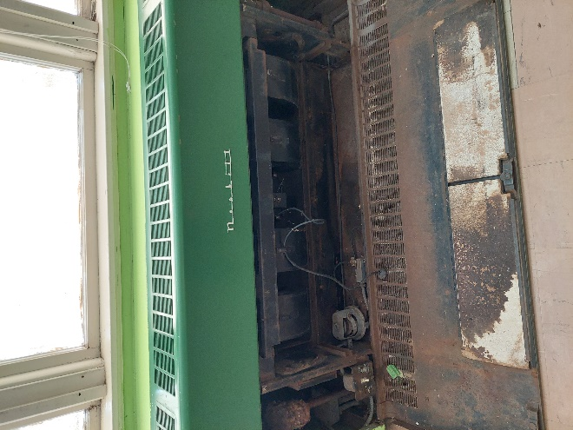

**Univent**

**Picture 2**

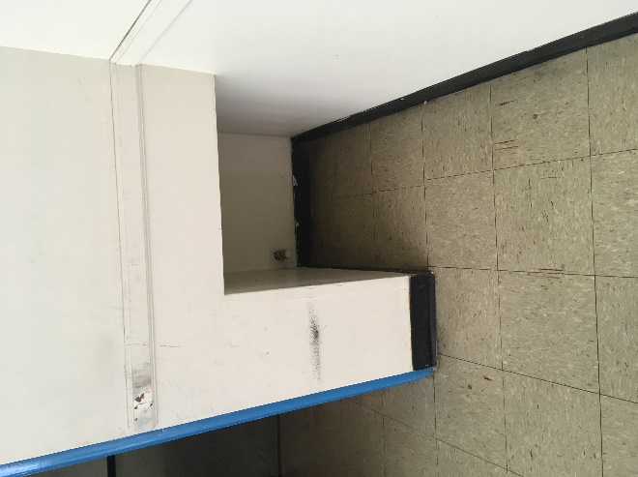

**Exhaust vent**

**Picture 3**

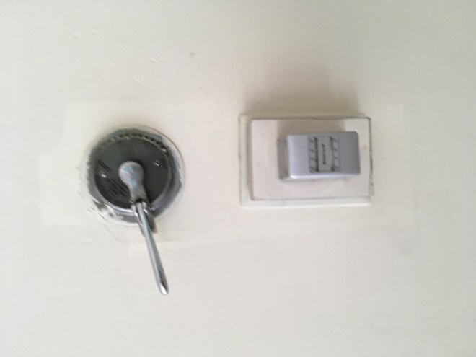

**Exhaust vent louver control with thermostat**

**Picture 4**

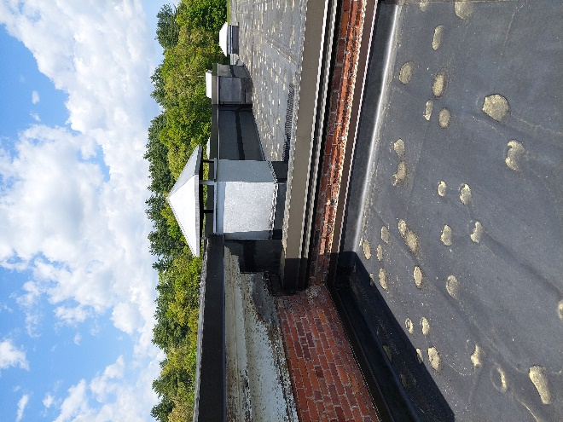

**Rooftop exhaust vent**

**Picture 5**

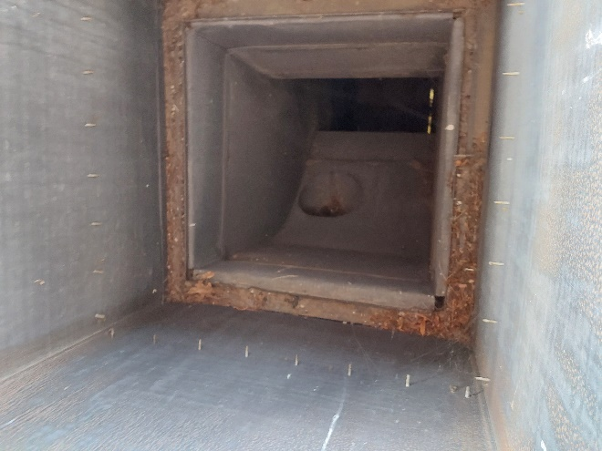

**Louvers inside rooftop exhaust vent in Picture 4**

**Picture 6**

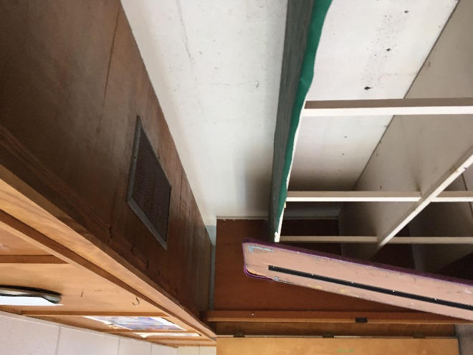

**Closet exhaust vent**

**Picture 7**

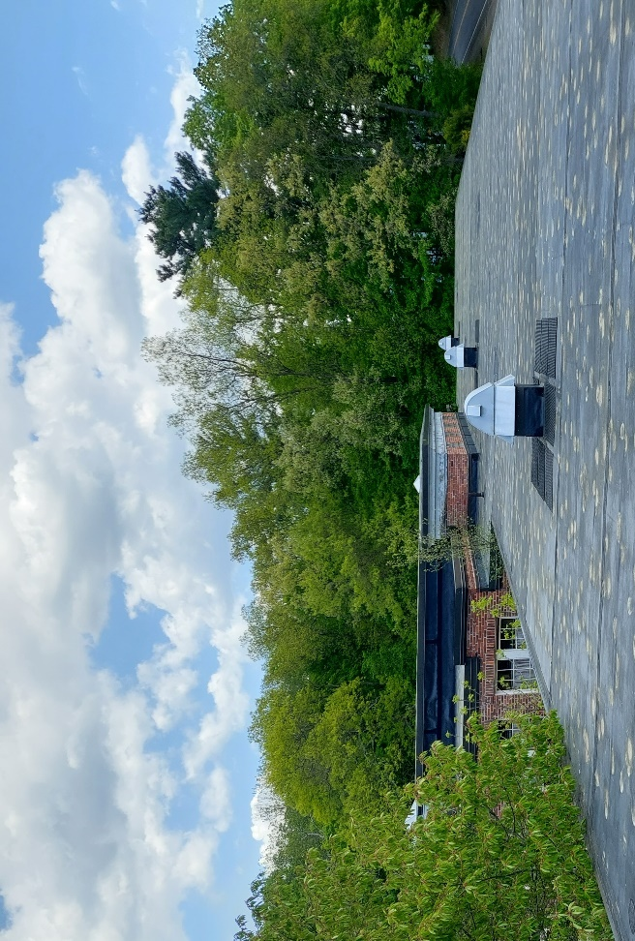

**Possible motorized rooftop exhaust vents**

**Picture 8**

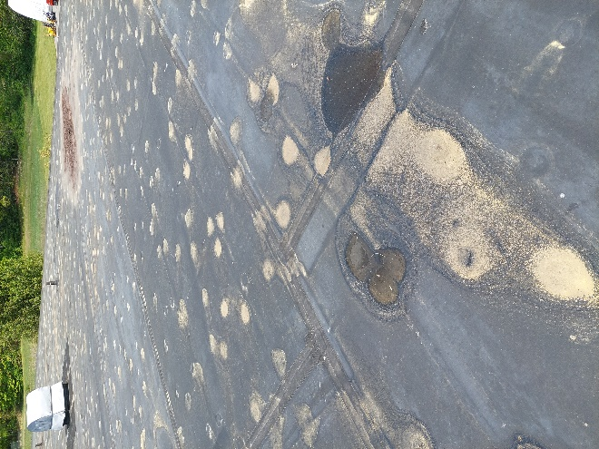

**Roof installation created depressions in roof membrane**

**Picture 9**

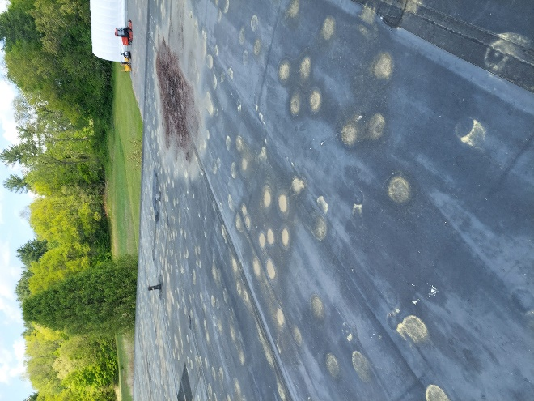

**Location of pooling water on roof**

**Picture 10**

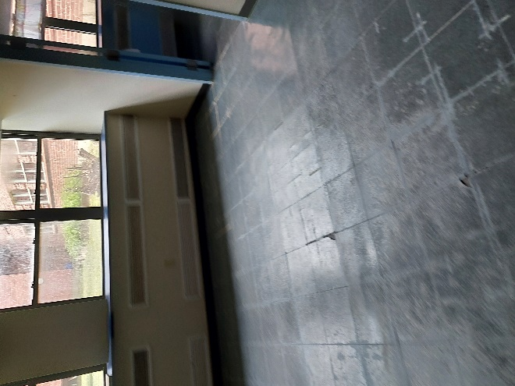

**Water-damaged floor tile, possibly from condensation**

**Picture 11**

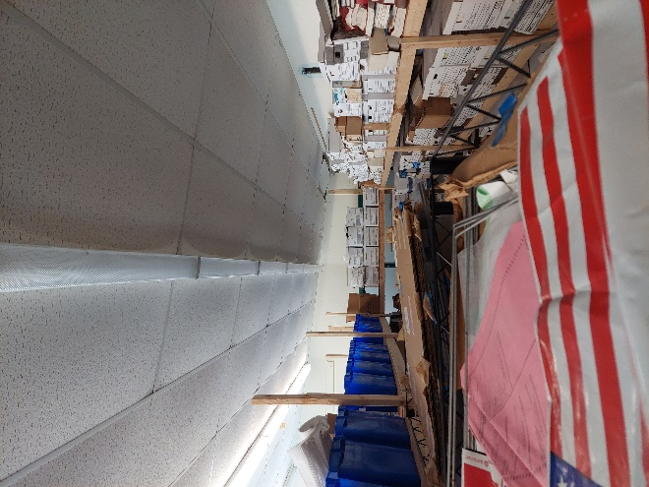

**Bowed ceiling tiles**

**Picture 12**

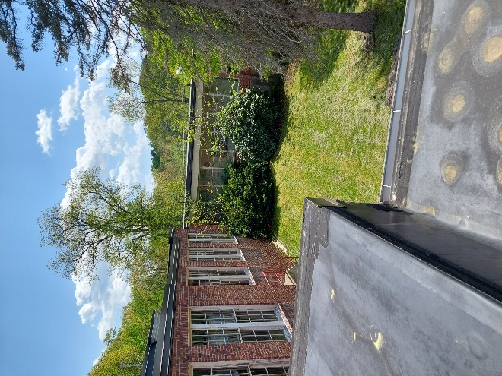

**Interior courtyard, shrubs on uphill side of courtyard on sloped ground**

**Picture 13**

Ground without grass in courtyard likely due to water pooling,
note fresh air intakes over this location (arrows).


**Ground without grass in courtyard likely due to water pooling,**

**note fresh air intakes over this location (arrows).**

**Picture 14**

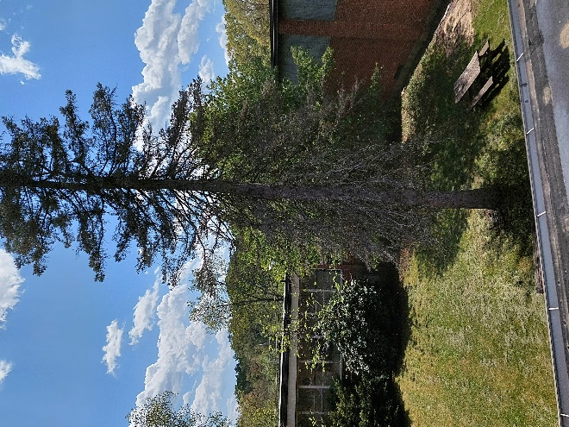

**Trees and shrubs in close proximity to courtyard walls**

**Picture 15**

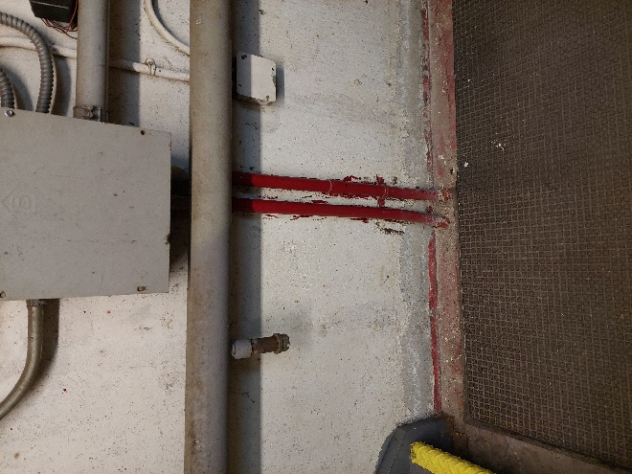

**Flood level marks on basement furnace room walls (arrow indicates water line)**

**Picture 16**

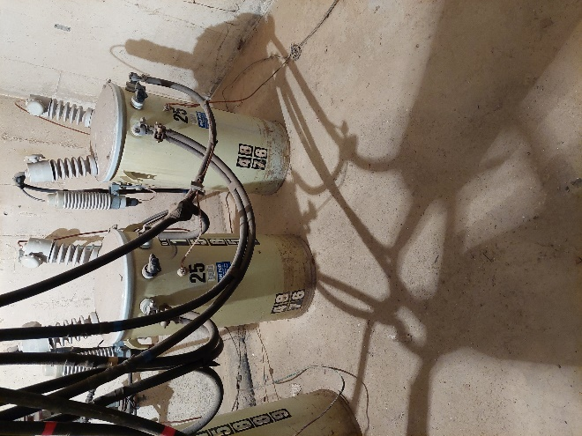

**Transformers in basement (arrow indicates flood level)**

**Picture 17**

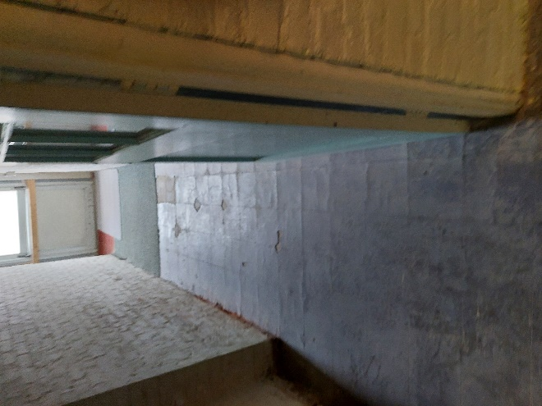

**Water-damaged floor tiles**

**Picture 18**

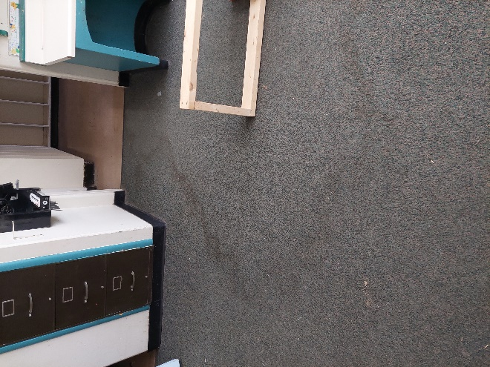

**Water-damaged carpet**

| **Location** | **Air Temp**  **(oF)** | **Relative Humidity**  **(%)** | **Dew Point**  **(oF)** | **Floor Temp**  **(****oF)** | **Temp at Floor/ Exterior Wall Junction**  **(oF)** | **Water- Damaged Ceiling Tiles-stained**  **(#)** | **Water- Damaged**  **Bowed Ceiling Tile**  **(#)** | **Ventilation** | | | **Floor to Air Temp**  **Difference**  **(oF)** | **Comments** |
| --- | --- | --- | --- | --- | --- | --- | --- | --- | --- | --- | --- | --- |
| **Windows openable** | **Supply** | **Exhaust** |
| Background (outdoors) | 84 | 40 | 57 |  |  |  |  |  |  |  |  | Sunny, seasonal temps |
| Learning Center | 72 | 48 | 52 | 66 | 66 | 9 | Y | N | N | N | 6 | W2W |
| Gym | 71 | 50 | 51 | 65 | 64 | N/A | N/A | N | N | N | 6 | tile |
| Kitchen | 75 | 45 | 53 | 62 | 62 | 0 | Y | Y | N | N | 13 | no stove |
| Office | 70 | 50 | 51 | 68 | 66 | 0 | Y | Y | N | N | 2 | W2W, crackling under tile |
| Nurse | 71 | 49 | 51 | 65 | 64 | 0 | N/A | Y | N | N | 6 | TF, sinks, bathrooms |
| Lunchroom | 79 | 42 | 53 | 65 | 64 | 10 | Y | Y | N | N | 14 | TF |
| 1 | 74 | 43 | 51 | 66 | 65 | 3 | Y | Y | N | N | 8 | W2W |
| 2 | 68 | 52 | 50 | 64 | 64 | 1 | Y | Y | N | N | 4 | TF |
| 3 | 69 | 51 | 50 | 64 | 64 | 3 | Y | Y | N | N | 5 | W2W, TF |
| 4 | 70 | 51 | 51 | 64 | 64 | 7 | Y | Y | N | N | 6 | TF, sinks |
| 5 | 71 | 50 | 51 | 66 | 65 | 3 | Y | Y | N | N | 5 | TF, sinks |
| 6 | 71 | 49 | 51 | 67 | 65 | 2 | Y | Y | N | N | 4 | TF |
| 8 | 74 | 43 | 52 | 66 | 67 | 1 | Y | Y | N | N | 8 | TF, sinks |
| 9 | 73 | 47 | 52 | 68 | 68 | 3 | Y | Y | N | N | 5 | TF, sinks |
| 10 | 74 | 46 | 51 | 68 | 68 | 0 | Y | Y | N | N | 6 | TF, sinks |
| 11 | 73 | 47 | 51 | 67 | 68 | 3 | Y | Y | N | N | 6 | W2W, sinks |
| 12 | 74 | 46 | 52 | 67 | 68 | 2 | Y | Y | N | N | 7 | sinks |
| 13 | 73 | 48 | 52 | 65 | 65 | 0 | Y | Y | N | N | 8 | W2W |
| 14 | 71 | 50 | 51 | 65 | 64 | 0 | Y | Y | N | N | 6 | TF, sinks |
| 19 | 70 | 51 | 52 | 68 | 68 | 6 | Y | Y | N | N | 2 | TF |
| 20 | 73 | 46 | 52 | 67 | 68 | 6 | Y | Y | N | N | 6 | TF |

1. The service life is the median time during which a particular system or component of …[an HVAC]… system remains in its original service application and then is replaced. Replacement may occur for any reason, including, but not limited to, failure, general obsolescence, reduced reliability, excessive maintenance cost, and changed system requirements due to such influences as building characteristics or energy prices (ASHRAE, 1991).