INDOOR AIR QUALITY ASSESSMENT

Foster Elementary School
55 Downer Avenue
Hingham, MA 02043

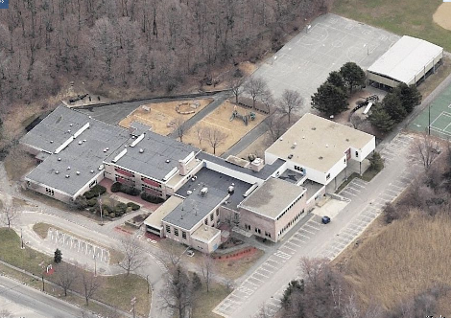

Prepared by:
Massachusetts Department of Public Health
Bureau of Environmental Health
Indoor Air Quality Program
March 2008

Background/Introduction
At the request of David Killory, Business Manager, Hingham Public Schools (HPS), the Massachusetts Department of Public Health (MDPH), Bureau of Environmental Health (BEH) provided assistance and consultation regarding indoor air quality concerns at the Foster Elementary School (FES), 55 Downer Avenue, Hingham Massachusetts. The assessment was prompted by respiratory and other health concerns. On January 15, 2007, a visit to conduct an assessment was made to the FES by Sharon Lee and James Tobin, Environmental Analysts in BEH’s Indoor Air Quality (IAQ) Program. During the assessment, BEH staff were accompanied by Paul E. Field, Supervisor of Buildings and Grounds, HPS.
The FES is a two-story building constructed in 1954. An addition was made to the building in 1973. Improvements completed in the last 10 years include a new boiler, exhaust system, air-handling units (AHU) and univents. The school contains general classrooms, a kitchen, cafeteria, gymnasium, library/computer center, music room, art room, small rooms for special instruction, boiler room and office space. Windows are openable throughout the building.

Methods
Air tests for carbon dioxide, carbon monoxide, temperature and relative humidity were taken with the TSI, Q-TRAK™ IAQ Monitor, Model 8551. Air tests for airborne particle matter with a diameter less than 2.5 micrometers were taken with the TSI, DUSTTRAK™ Aerosol Monitor Model 8520. BEH staff also performed a visual inspection of building materials for water damage and/or microbial growth.

Results
The building houses approximately 610 students in kindergarten through fifth grade and has approximately 80 staff members. Tests were taken under normal operating conditions and results appear in Table 1.

Discussion
Ventilation
It can be seen from Table 1 that carbon dioxide levels were elevated above 800 parts per million (ppm) in 19 of 44 areas surveyed, indicating less than optimal air exchange in these areas. Limiting fresh air intake either by mechanical and/or natural means (e.g., closing of windows) can contribute to an increase in carbon dioxide levels. It is important to note that several areas were unoccupied or sparsely occupied at the time of assessment. Low classroom occupancy can greatly reduce carbon dioxide levels. Carbon dioxide levels would be expected to be higher with full occupancy.
Fresh air is supplied to classrooms by unit ventilator (univent) systems (Picture 1). A univent is designed to draw air from outdoors through a fresh air intake located on the exterior wall of the building (Picture 2) and return air through an air intake located at the base of each unit (Figure 1). Fresh and return air are mixed, filtered, heated and provided to classrooms through a fresh air diffuser located in the top of the unit. Obstructions to airflow such as items on univents and/or furniture in front of univent returns were observed in a large number of classrooms (Pictures 3 and 4).
Exhaust ventilation in classrooms is provided by unit exhaust ventilators and/or wall- or ceiling-mounted vents ducted to rooftop motors (Picture 5). A unit exhaust ventilator appears similar to a univent, but removes air from the classroom and exhausts it out of the building. Many unit exhaust ventilators were enclosed in univent casing (Picture 6); therefore, the unit exhaust vents were equipped with a fresh air diffuser on top of unit, allowing dirt, dust and other materials to fall down into the motor. Several unit exhaust vents were obstructed by items and/or furniture (Picture 7). In addition, several exhaust vents were deactivated at the time of the assessment. The location of some wall-mounted exhaust vents (i.e. above hallway door) can limit exhaust efficiency (Picture 8). When a classroom door is open, exhaust vents tend to draw air from both the hallway and the classroom. The open hallway door reduces the effectiveness of the exhaust vent to remove common environmental pollutants from classrooms. As with univents, in order to function properly, exhaust ventilation must be activated and allowed to operate while rooms are occupied. Without adequate supply and exhaust ventilation, excess heat and environmental pollutants can build up, leading to indoor air/comfort complaints.
Mechanical ventilation in common areas (e.g., gym, cafeteria) is provided by rooftop or ceiling-mounted air-handling units (AHUs). Fresh air is distributed via ceiling-mounted air diffusers and ducted back to AHUs via ceiling or wall-mounted return vents.
To maximize air exchange, the MDPH recommends that both supply and exhaust ventilation operate continuously during periods of school occupancy. In order to have proper ventilation with a mechanical supply and exhaust system, the systems must be balanced to provide an adequate amount of fresh air to the interior of a room while removing stale air from the room. It is recommended that HVAC systems be re-balanced every five years to ensure adequate air systems function (SMACNA, 1994). The last balancing of these systems was likely at the time of installation.
The Massachusetts Building Code requires that each area have a minimum ventilation rate of 15 cubic feet per minute (cfm) per occupant of fresh outside air or openable windows (SBBRS, 1997; BOCA, 1993). The ventilation must be on at all times that the room is occupied. Providing adequate fresh air ventilation with open windows and maintaining the temperature in the comfort range during the cold weather season is impractical. Mechanical ventilation is usually required to provide adequate fresh air ventilation.
Carbon dioxide is not a problem in and of itself. It is used as an indicator of the adequacy of the fresh air ventilation. As carbon dioxide levels rise, it indicates that the ventilating system is malfunctioning or the design occupancy of the room is being exceeded. When this happens, a buildup of common indoor air pollutants can occur, leading to discomfort or health complaints. The Occupational Safety and Health Administration (OSHA) standard for carbon dioxide is 5,000 parts per million parts of air (ppm). Workers may be exposed to this level for 40 hours/week, based on a time-weighted average (OSHA, 1997).
The MDPH uses a guideline of 800 ppm for publicly occupied buildings. A guideline of 600 ppm or less is preferred in schools due to the fact that the majority of occupants are young and considered to be a more sensitive population in the evaluation of environmental health status. Inadequate ventilation and/or elevated temperatures are major causes of complaints such as respiratory, eye, nose and throat irritation, lethargy and headaches. For more information concerning carbon dioxide, consult Appendix A.
Temperature measurements ranged from 67º F to 73º F, which were below or on the low end of the MDPH recommended comfort range. The MDPH recommends that indoor air temperatures be maintained in a range of 70º F to 78º F in order to provide for the comfort of building occupants. In many cases concerning indoor air quality, fluctuations of temperature in occupied spaces are typically experienced, even in a building with an adequate fresh air supply. In addition, it is difficult to control temperature and maintain comfort without operating the ventilation equipment as designed (e.g., univents/exhaust vents deactivated/obstructed).
The relative humidity measured in the building ranged from 22 to 34 percent, which was below the MDPH recommended comfort range. The MDPH recommends a comfort range of 40 to 60 percent for indoor air relative humidity. Relative humidity levels in the building would be expected to drop during the winter months due to heating. The sensation of dryness and irritation is common in a low relative humidity environment. Low relative humidity is a very common problem during the heating season in the northeast part of the United States.

Microbial/Moisture Concerns
Several potential sources of water damage and mold growth were observed in areas of the building. Numerous areas had water-damaged/missing ceiling tiles which can indicate leaks from either the roof or plumbing system (Table 1). Water-damaged ceiling tiles can provide a source of mold and should be replaced after a water leak is discovered and repaired.
The US Environmental Protection Agency (US EPA) and the American Conference of Governmental Industrial Hygienists (ACGIH) recommend that porous materials be dried with fans and heating within 24 to 48 hours of becoming wet (US EPA, 2001; ACGIH, 1989). If not dried within this time frame, mold growth may occur. Once mold has colonized porous materials, they are difficult to clean and should be removed/discarded.
A humidifier was observed in a classroom (Picture 9). As with univents, humidifiers can aerosolize particles and odors. In addition, the water reservoirs can provide a source for mold growth. Water reservoirs for humidifiers should be cleaned as per manufacturer’s directions to prevent microbial growth and odors. The air diffuser should also be cleaned periodically to prevent dust collection and aerosolization of materials.
Plants were located in a number of classrooms (Pictures 3 and 10). Plants, soil and drip pans can serve as sources of mold growth, thus should be properly maintained. Over-watering of plants should be avoided and drip pans should be inspected periodically for mold growth. Plants should also be located away from univents to prevent aerosolization of dirt, pollen or mold.
Plants were also growing in close proximity to the building (Picture 2). The growth of roots against exterior walls can bring moisture in contact with the foundation. Plant roots can eventually penetrate, leading to cracks and/or fissures in the sublevel foundation. Over time, this process can undermine the integrity of the building envelope, providing a means of water entry into the building via capillary action through foundation concrete and masonry (Lstiburek & Brennan, 2001). Damaged brickwork and missing/damaged mortar around masonry were also noted on the building exterior (Pictures 11 and 12). Breaches can provide a source of water penetration. To prevent water penetration, damaged brickwork should be re-pointed.
Exterior brickwork in several areas was visibly moist and had moss growth on the surface (Picture 13). A substantial source of water is needed for moss to grow. Moss growth is a sign of heavy/continuous water exposure which can undermine the structural integrity of the brick and mortar.

Other IAQ Evaluations
Indoor air quality can be negatively influenced by the presence of respiratory irritants, such as products of combustion. The process of combustion produces a number of pollutants. Common combustion emissions include carbon monoxide, carbon dioxide, water vapor and smoke (fine airborne particle material). Of these materials, exposure to carbon monoxide and particulate matter with a diameter of 2.5 micrometers (μm) or less (PM2.5) can produce immediate, acute health effects upon exposure. To determine whether combustion products were present in the school environment, BEH staff obtained measurements for carbon monoxide and PM2.5.
Carbon monoxide is a by-product of incomplete combustion of organic matter (e.g., gasoline, wood and tobacco). Exposure to carbon monoxide can produce immediate and acute health affects. Several air quality standards have been established to address carbon monoxide and prevent symptoms from exposure to these substances. The MDPH established a corrective action level concerning carbon monoxide in ice skating rinks that use fossil-fueled ice resurfacing equipment. If an operator of an indoor ice rink measures a carbon monoxide level over 30 ppm, taken 20 minutes after resurfacing within a rink, that operator must take actions to reduce carbon monoxide levels (MDPH, 1997).
The American Society of Heating Refrigeration and Air-Conditioning Engineers (ASHRAE) has adopted the National Ambient Air Quality Standards (NAAQS) as one set of criteria for assessing indoor air quality and monitoring of fresh air introduced by HVAC systems (ASHRAE, 1989). The NAAQS are standards established by the US EPA to protect the public health from six criteria pollutants, including carbon monoxide and particulate matter (US EPA, 2006). As recommended by ASHRAE, pollutant levels of fresh air introduced to a building should not exceed the NAAQS levels (ASHRAE, 1989). The NAAQS were adopted by reference in the Building Officials & Code Administrators (BOCA) National Mechanical Code of 1993 (BOCA, 1993), which is now an HVAC standard included in the Massachusetts State Building Code (SBBRS, 1997). According to the NAAQS, carbon monoxide levels in outdoor air should not exceed 9 ppm in an eight-hour average (US EPA, 2006).
Carbon monoxide should not be present in a typical, indoor environment. If it is present, indoor carbon monoxide levels should be less than or equal to outdoor levels. On the day of assessment, outdoor carbon monoxide concentrations were non-detect (ND) (Table 1). Carbon monoxide levels measured in the school were also ND.
The US EPA has established NAAQS limits for exposure to particulate matter. Particulate matter is airborne solids that can be irritating to the eyes, nose and throat. The NAAQS originally established exposure limits to particulate matter with a diameter of 10 μm or less (PM10). According to the NAAQS, PM10 levels should not exceed 150 micrograms per cubic meter (μg/m³) in a 24-hour average (US EPA, 2006). These standards were adopted by both ASHRAE and BOCA. Since the issuance of the ASHRAE standard and BOCA Code, US EPA established a more protective standard for fine airborne particles. This more stringent PM2.5 standard requires outdoor air particle levels be maintained below 35 μg/m³ over a 24-hour average (US EPA, 2006). Although both the ASHRAE standard and BOCA Code adopted the PM10 standard for evaluating air quality, MDPH uses the more protective PM2.5 standard for evaluating airborne particulate matter concentrations in the indoor environment.
According to the AIRNow webpage, outdoor PM2.5 concentrations were expected to within a range of 1 to 50 μg/m³, in Massachusetts on the day of assessment (AIRNow, 2008). In the school, the PM2.5 levels ranged from 5 to 35 μg/m³ (Table 1). The majority of PM2.5 measurements were below the NAAQS PM2.5 level of 35 μg/m³; however, the PM2.5 measurement in one specific location was equal to the NAAQS standard of 35 μg/m³. It is important to note that at the time of assessment, table tops were being cleaned using Simple Green; such activity may have resulted in the elevated PM2.5 level.
Frequently, indoor air levels of particulates (including PM2.5) can be at higher levels than those measured outdoors. A number of mechanical devices and/or activities that occur in schools can generate particulate during normal operations. Sources of indoor airborne particulates may include but are not limited to particles generated during the operation of fan belts in the HVAC system, cooking in the cafeteria stoves and microwave ovens; use of photocopiers, fax machines and computer printing devices; operation of an ordinary vacuum cleaner and heavy foot traffic indoors.
Indoor air concentrations can be greatly impacted by the use of products containing volatile organic compounds (VOCs). In an effort to identify materials that can potentially increase indoor VOC concentrations, BEH staff examined classrooms for products containing these respiratory irritants.
A photocopier was observed in a hallway (Picture 14). This area is not equipped with local exhaust ventilation to help reduce excess heat and odors. VOCs and ozone can be produced by photocopiers, particularly if the equipment is older and in frequent use. Ozone is a respiratory irritant (Schmidt Etkin, 1992).
Multiple classrooms contained dry erase boards and related materials. Additionally, each student in some classrooms had their own dry erase boards and markers (Picture 15). Materials such as dry erase markers and dry erase board cleaners may contain VOCs, such as methyl isobutyl ketone, n-butyl acetate and butyl-cellusolve (Sanford, 1999), which can be irritating to the eyes, nose and throat.
Cleaning products were also found on countertops and in unlocked cabinets beneath sinks in a number of classrooms. Like dry erase materials, cleaning products contain VOCs and other chemicals (Pictures 16). These chemicals can be irritating to the eyes, nose and throat and should be kept out of reach of students.
Other conditions that can affect indoor air quality were observed during the assessment. In several classrooms, items were observed on the floor, windowsills, tabletops, counters, bookcases and desks (Pictures 17 and 18). The large number of items stored in classrooms provides a source for dusts to accumulate. These items (e.g., papers, folders, boxes) make it difficult for custodial staff to clean. Items should be relocated and/or be cleaned periodically to avoid excessive dust build up. In addition, these materials can accumulate on flat surfaces (e.g., desktops, shelving and carpets) in occupied areas and subsequently be re-aerosolized causing further irritation.
A number of exhaust/return vents and personal fans (Picture 19) were observed to have accumulated dust. If exhaust vents are not functioning, backdrafting can occur, which can re-aerosolize accumulated dust particles. Re-activated univents and fans can also aerosolize dust accumulated on vents/fan blades.
Several aquariums and terrariums were located in the classrooms (Picture 20). Aquariums should be properly maintained to prevent microbial/algal growth, which can emit unpleasant odors. Similarly, terrariums should be properly maintained to ensure soil does not become a source for mold growth.
An accumulation of chalk dust and pencil shavings was observed in some classrooms (Picture 21). When windows are opened or univents are operating, these materials can become airborne. Once aerosolized, they can act as irritants to eyes and the respiratory system.
Bird and insect nests were observed in a classroom (Picture 22). Nests can contain bacteria and may also be a source of allergenic material. Nests should be placed in resealable bags to prevent aerosolization of allergenic material.
In an effort to prevent scratching from sliding desks, tennis balls had been sliced open and placed on the desk legs (Picture 23). Tennis balls are made of a number of materials that are a source of respiratory irritants. Constant wearing of tennis balls can produce fibers and cause TVOCs to off-gas. Tennis balls are made with a natural rubber latex bladder, which becomes abraded when used as a chair leg pad. Use of tennis balls in this manner may introduce latex dust into the school environment. Some individuals are highly allergic to latex (e.g., spina bifida patients) (SBAA, 2001). It is recommended that the use of materials containing latex be limited in buildings to reduce the likelihood of symptoms in sensitive individuals (NIOSH, 1997).
Airflow in many classrooms is supplemented by ceiling fans (Picture 24). These ceiling fans should be used to aid in air circulation within the room, especially during warmer months when windows are open. It is important to note that before operating, ceiling fans must be cleaned of dust buildup. Accumulated dust on the fan blades can aerosolize causing irritation to eyes and respiratory system.
Unlabeled/poorly labeled spray bottles were also noted. Products should be kept in their original containers, or should be clearly labeled as to their contents, for identification purposes in the event of an emergency.
Of note was food storage/food container reuse in some classrooms. Exposed food products and reused food containers can attract a variety of pests. The presence of pests inside a building can produce conditions that can degrade indoor air quality. For example, rodent infestation can result in indoor air quality related symptoms due to materials in their wastes. Mouse urine is known to contain a protein that is a known sensitizer (US EPA, 1992). A sensitizer is a material that can produce symptoms in exposed individuals, including nose irritations and skin rashes. Pest attractants should be reduced/eliminated. Proper food storage is an integral component in maintaining indoor air quality. Food should be properly stored and clearly labeled. Reuse of food containers (e.g., for art projects) is not recommended since food residue adhering to the container surface may serve to attract pests.

Conclusions/Recommendations
Several issues regarding general building conditions, design and routine maintenance that can affect indoor air quality were observed. The majority of issues listed in the report have been observed in other elementary school environments (clutter, dust control, building maintenance), particularly those built several decades ago. These factors can be associated with a range of IAQ related health and comfort complaints (e.g., eye, nose, and respiratory irritations).
The general building conditions, maintenance, work hygiene practices and the condition of HVAC equipment, if considered individually, present conditions that could degrade indoor air quality. When combined, these conditions can serve to further degrade indoor air quality. Some of these conditions can be remedied by actions of building occupants. Other remediation efforts will require alteration to the building structure and equipment. For these reasons, a two-phase approach is required for remediation. The first consists of short-term measures to improve air quality and the second consists of long-term measures that will require planning and resources to adequately address the overall indoor air quality concerns.

The following short-term measures should be considered for implementation:
- Operate both supply and exhaust ventilation continuously during periods of school occupancy, independent of classroom thermostat control to maximize air exchange.
- Remove all blockages from univents and exhaust vents to ensure adequate airflow. Consider reconfiguring the layout of some classrooms to facilitate airflow.
- Seal fresh air diffusers on all unit exhaust ventilators.
- Ensure classroom doors are closed to maximize air exchange.
- Use openable windows in conjunction with mechanical ventilation to facilitate air exchange. Care should be taken to ensure windows are properly closed at night and weekends to avoid the freezing of pipes and potential flooding.
- Consider adopting a balancing schedule of every 5 years for all mechanical ventilation systems, as recommended by ventilation industrial standards (SMACNA, 1994).
- Change filters for air-handling equipment (e.g., univents, AHUs and ACs) as per the manufacturer’s instructions or more frequently if needed. Vacuum interior of units prior to activation to prevent the aerosolization of dirt, dust and particulates. Ensure filters fit flush in their racks with no spaces in between allowing bypass of unfiltered air into the unit.
- For buildings in New England, periods of low relative humidity during the winter are often unavoidable. Therefore, scrupulous cleaning practices should be adopted to minimize common indoor air contaminants whose irritant effects can be enhanced when the relative humidity is low. To control for dusts, a high efficiency particulate arrestance (HEPA) filter equipped vacuum cleaner in conjunction with wet wiping of all surfaces is recommended. Avoid the use of feather dusters. Drinking water during the day can help ease some symptoms associated with a dry environment (throat and sinus irritations).
- Clean and disinfect humidifiers as per manufacturer’s instructions (or more frequently as needed) to prevent microbial growth.
- Move plants away from univents in classrooms. Avoid over-watering and examine drip pans periodically for mold growth. Disinfect with an appropriate antimicrobial where necessary.
- Store cleaning products properly and out of reach of students. Ensure spray bottles are properly labeled. All cleaning products used at the facility should be approved by the school department and MSDS’ should be made available at a central location.
- Relocate or consider reducing the amount of materials stored in classrooms to allow for more thorough cleaning of classrooms. Clean items regularly with a wet cloth or sponge to prevent excessive dust build-up.
- Clean personal fans, univent air diffusers, return vents and exhaust vents periodically of accumulated dust.
- Clean and maintain aquariums and terrariums to prevent mold growth and associated odors.
- Clean chalk and dry erase trays to prevent accumulation of materials.
- Nests should be placed in resealable bags to prevent aerosolization of allergenic material.
- Replace latex-based tennis balls with latex-free tennis balls or rubber booties.
- Consider adopting the US EPA document, “Tools for Schools” to maintain a good indoor air quality environment on the building (US EPA, 2000). This document can be downloaded from the Internet at: http://www.epa.gov/iaq/schools/index.html.
- Refer to resource manuals and other related indoor air quality documents for further building-wide evaluations and advice on maintaining public buildings. These materials are located on the MDPH’s website: http://mass.gov/dph/indoor_air.

The following long-term measures should be considered:
- Contact an HVAC engineering firm for an assessment of the ventilation system’s control system (e.g., controls, air intake louvers, thermostats). Based on the age, physical deterioration and availability of parts for ventilation components, such an evaluation is necessary to determine the operability and feasibility of repairing/replacing the equipment.
- Consider having exterior walls re-pointed and waterproofed to prevent water intrusion. This measure should include a full building envelope evaluation.
References

ACGIH. 1989. Guidelines for the Assessment of Bioaerosols in the Indoor Environment. American Conference of Governmental Industrial Hygienists, Cincinnati, OH.
AIRNnow. 2008. Air Quality History for Hingham, Massachusetts, January 15, 2008. Available at: http://airnow.gov/index.cfm?action=airnow.displaymaps#map.
ASHRAE. 1989. Ventilation for Acceptable Indoor Air Quality. American Society of Heating, Refrigeration and Air Conditioning Engineers. ANSI/ASHRAE 62-1989
BOCA. 1993. The BOCA National Mechanical Code/1993. 8th ed. Building Officials and Code Administrators International, Inc., Country Club Hill, IL.

Lstiburek, J. & Brennan, T. 2001. Read This Before You Design, Build or Renovate. Building Science Corporation, Westford, MA. U.S. Department of Housing and Urban Development, Region I, Boston, MA
MDPH. 1997. Requirements to Maintain Air Quality in Indoor Skating Rinks (State Sanitary Code, Chapter XI). 105 CMR 675.000. Massachusetts Department of Public Health, Boston, MA.
OSHA. 1997. Limits for Air Contaminants. Occupational Safety and Health Administration. Code of Federal Regulations. 29 C.F.R 1910.1000 Table Z-1-A.
Sanford. 1999. Material Safety Data Sheet (MSDS No: 198-17). Expo® Dry Erase Markers Bullet, Chisel, and Ultra Fine Tip. Sanford Corporation. Bellwood, IL.
NIOSH. 1997. NIOSH Alert Preventing Allergic Reactions to Natural Rubber latex in the Workplace. National Institute for Occupational Safety and Health, Atlanta, GA.
SBAA. 2001. Latex In the Home And Community Updated Spring 2001. Spina Bifida Association of America, Washington, DC.
SBBRS. 1997. Mechanical Ventilation. State Board of Building Regulations and Standards. Code of Massachusetts Regulations. 780 CMR 1209.0
SMACNA. 1994. HVAC Systems Commissioning Manual. 1st ed. Sheet Metal and Air Conditioning Contractors’ National Association, Inc., Chantilly, VA.

US EPA. 1992. Indoor Biological Pollutants. US Environmental Protection Agency, Environmental Criteria and Assessment Office, Office of Health and Environmental Assessment, research Triangle Park, NC. EPA 600/8-91/202 January 1992.
US EPA. 2001. Mold Remediation in Schools and Commercial Buildings. US Environmental Protection Agency, Office of Air and Radiation, Indoor Environments Division, Washington, D.C. EPA 402-K-01-001. March 2001.
US EPA. 2006. National Ambient Air Quality Standards (NAAQS). US Environmental Protection Agency, Office of Air Quality Planning and Standards, Washington, DC. http://www.epa.gov/air/criteria.html.
Picture 1

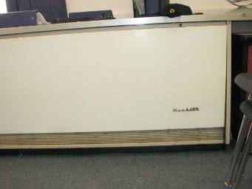

Classroom Univent

Picture 2

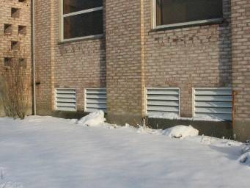

Fresh Air Intake, Garden in front of Intake

Picture 3



Furniture and Items Obstructing Univent

Picture 4

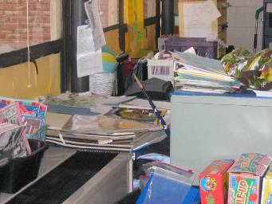

Items Obstructing Univent

Picture 5

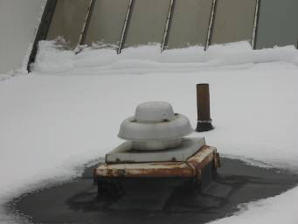

Rooftop Exhaust

Picture 6

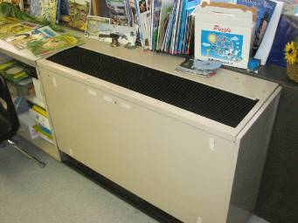

Unit Exhaust Ventilator, Note Air Diffuser on Top

Picture 7

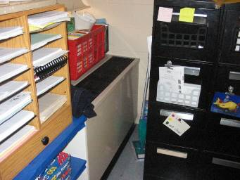

Exhaust vent obstructed by Furniture

Picture 8

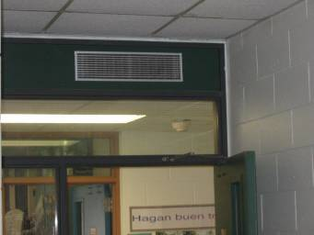

Exhaust located above hallway door

Picture 9
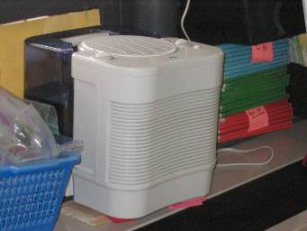

Humidifier

Picture 10



Plants in Classroom; Note Close Proximity to Univent

Picture 11

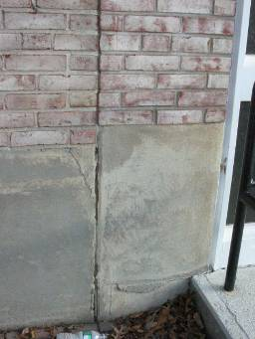

Cracked Brickwork

Picture 12

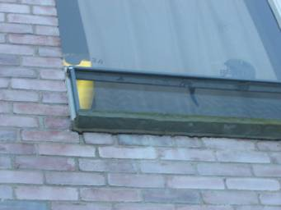

Missing and/or Damaged Mortar

Picture 13

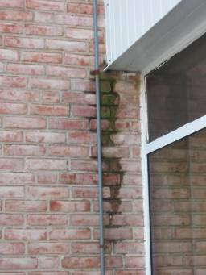

Moss Growth on Brickwork

Picture 14

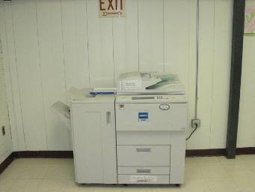

Photocopier in Hallway

Picture 15



Dry Erase Materials

Picture 16

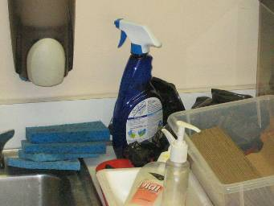

Cleaning Products

Picture 17



Accumulation of Items

Picture 18

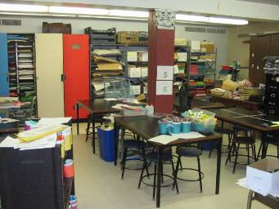

Accumulation of Items

Picture 19

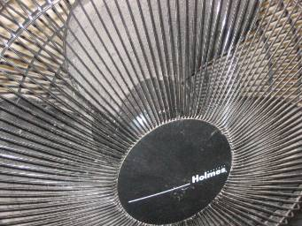

Dusty Personal Fan

Picture 20

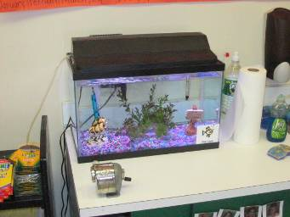

Aquarium in Classroom

Picture 21

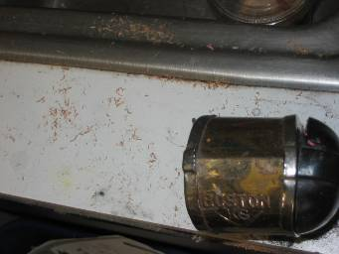

Pencil shavings and dust

Picture 22

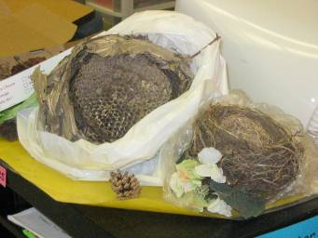

Bird and Insect Nests

Picture 23

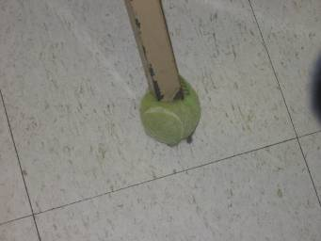

Tennis Ball on Desk Leg

Picture 24

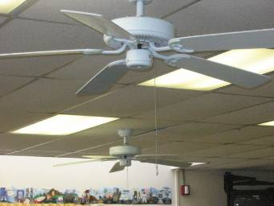

Ceiling Fans in classrooms
Location/ Room | Occupants  in Room | Temp  (°F) | Relative  Humidity  (%) | Carbon  Dioxide  (ppm) | Carbon Monoxide  (ppm) | TVOCs  (ppm) | PM2.5  (µg/m3) | Windows  Openable | Ventilation |  | Remarks
 |  |  |  |  |  |  |  |  | Supply | Exhaust | Remarks
background |  | 41 | 40 | 360 | ND | ND
101 | 20 | 71 | 25 | 651 | ND | ND | 9 | Y | Y | Y | Univent blocked by furniture; aqua./terra.; cleaners; DEM; DO; pets
102 | 19 | 69 | 23 | 602 | ND | ND | 10 | Y | Y | Y | Univent blocked by clutter, furniture and plants; DO; clutter; PF; plants; unlabeled bottles; spray paint
103 | 20 | 70 | 28 | 1089 | ND | ND | 8 | Y | Y | Y | Univent and Exhaust blocked by clutter and furniture, humidifier on univent; DEM; DO; aqua./terra.; cleaners; nests
106 Art | 23 | 73 | 23 | 612 | ND | ND | 6 | Y | Y | Y | Exhaust blocked by furniture; kiln ducted but not in use; PF; clutter; FC-re-use; DO
201 | 20 | 70 | 24` | 700 | ND | ND | 7 | `Y | Y | Y | DEM; CFs
202 | 21 | 70 | 25 | 860 | ND | ND | 7 | Y | Y | Y | Exhaust blocked by desk, dirty; DEM; cleaners; DO; CFs; unlabeled bottles; 2 CT-WD
203 | 22 | 71 | 27 | 923 | ND | ND | 8 | Y | Y | Y | DEM; DO; cleaners; plants
204 | 21 | 69 | 30 | 1299 | ND | ND |  | Y | Y | Y | Univent blocked by boxes and furniture; CD; DEM; DO; PF; CFs
205E | 14 | 70 | 28 | 786 | ND | ND | 9 | N | Y | Y | DEM; DO; UF; CFs
205W | 12 | 73 | 30 | 953 | ND | ND | 9 | Y | Y | Y | DEM; cleaners; CFs; unlabeled bottles
206E | 19 | 70 | 28 | 859 | ND | ND | 11 | N | Y | Y | DEM; DO; plants; CFs; chemicals under sink; 2 CT-WD; 2 MT
206W | 20 | 72 | 29 | 881 | ND | ND | 7 | Y | Y | Y | Univent blocked by furniture; CFs; PF; PS
207E | 1 | 70 | 28 | 738 | ND | ND | 10 | N | Y | Y | DO; CFs; DEM; PF
207W | 2 | 72 | 24 | 583 | ND | ND | 8 |  | Y | Y | DO-interroom; DEM; PF
208E | 0 | 70 | 28 | 652 | ND | ND | 11 | N | Y | Y | Cleaners; DO-hallway, interroom; CFs
208E | 22 | 69 | 32 | 746 | ND | ND | 10 | N | Y | Y
208W | 1 | 71 | 26 | 683 | ND | ND | 9 | N | Y | Y | DEM; CFs; Disinfecting wipes; DO-hallway, inter-room
208W | 25 | 70 | 30 | 825 | ND | ND | 14 | N | Y | Y
209 | 19 | 68 | 28 | 598 | ND | ND | 11 | Y | Y | Y | Univent blocked by desk and plants; aqua/terra; cleaners; PF; plants
209 (Backroom) | 0 | 68 | 29 | 602 | ND | ND | 13 | Y | N | N | Radiant heat; CD
210 | 22 | 71 | 28 | 820 | ND | ND | 35 | Y | Y | Y | Univent blocked by clutter; Cleaning desk tops during assessment with simple green; aqua/terra; DO; cleaners; clutter
211 | 21 | 68 | 29 | 1319 | ND | ND | 12 | Y | Y | Y | Univent blocked by clutter and plants; clearners; food use/storage; clutter; CFs; microwave
212 | 20 | 71 | 26 | 875 | ND | ND | 9 | Y | Y | Y | 2 univents, 1 blocked by furniture and clutter; CFs; DO
301 | 2 | 69 | 23 | 591 | ND | ND | 6 | Y | Y | Y | DEM; clutter; DO; Cfs
302 | 1 | 71 | 23 | 620 | ND | ND | 7 | Y | Y | Y | Exhaust vent above door; DO; PF
303 | 18 | 70 | 23 | 798 | ND | ND | 8 | Y | Y | Y | Exhaust vent above door, weak; DO; DEM
304 | 25 | 72 | 24 | 935 | ND | ND | 13 | `Y | Y | Y | DEM; DO-hallway, inter-room; CFs
305 | 16 | 71 | 23 | 838 | ND | ND | 8 | Y | Y | Y | Univent blocked by clutter; Exhaust vent above door, weak; DO; DEM; cleaners; CFs
306E | 1 | 69 | 25 | 705 | ND | ND | 9 | N | Y | Y | clutter; 3 CT-WD; DEM; PS
306W | 0 | 70 | 25 | 722 | ND | ND |  | Y | Y | Y | strong DEM odors; individual boards in use; CD; PF; CFs; cleaners
307E | 2 | 70 | 26 | 862 | ND | ND | 8 | N | Y | Y | CFs; 3 CT-WD; DEM; DO
307W | 0 | 67 | 28 | 729 | ND | ND | 9 | Y | Y | Y | Exhaust vent blocked by furniture and items; CFs; cleaners; DEM; food use/storage
Cafeteria | 130 | 71 | 27 | 1011 | ND | ND | 10 | Y | Y | Y | Cleaners on univents; DO
Guidance | 4 | 70 | 27 | 865 | ND | ND | 6 | N | Y | Y | Exhaust dusty
Gym | 21 | 67 | 22 | 627 | ND | ND | 6 | N | Y | Y
Library | 8 | 73 | 28 | 770 | ND | ND | 6 | Y | Y | Y | 25 computers; DEM; 3 CT-WD; plants
Math (3rd Floor) | 1 | 69 | 26 | 799 | ND | ND | 8 | Y | N | N | DO; microwave; toaster oven; mini-fridge
Music | 0 | 73 | 25 | 645 | ND | ND | 8 | Y | Y | Y
OT/PT | 0 | 73 | 29 | 1196 | ND | ND | 10 | Y | N | N | DO; PF; cleaners; polyurethane spray paint; blocking access to fire extinguisher
Psychologist | 0 | 71 | 25 | 686 | ND | ND | 5 | N | Y | Y
Special Ed (1st floor) | 2 | 71 | 32 | 945 | ND | ND | 8 | Y | N | N | CD; clutter; PS
Special Ed (2nd Floor) | 0 | 70 | 27 | 805 | ND | ND | 7 | Y | N | N | DO; DEM; clutter
Speech Therapy | 3 | 71 | 34 | 985 | ND | ND | 9 | Y | N | N | CD; PF; TB; plants
Teachers Lounge | 2 | 71 | 25 | 713 | ND | ND | 5 | N | Y | Y | Exhaust vent near door; CFs; FC re-use; food use/ storage; DO; laminator

AIRNow website is internet site developed and run by the U.S. Environmental Protection Agency, National Oceanic and Atmospheric Agency, National Park Services, tribal, state, and local agencies to provide the public with easy access to national air quality information, including Local Air Quality Conditions and Forecasts.

