One Care EIP Monthly SHINE Encounter Data Report—Oct. - Dec. 2013
Introduction
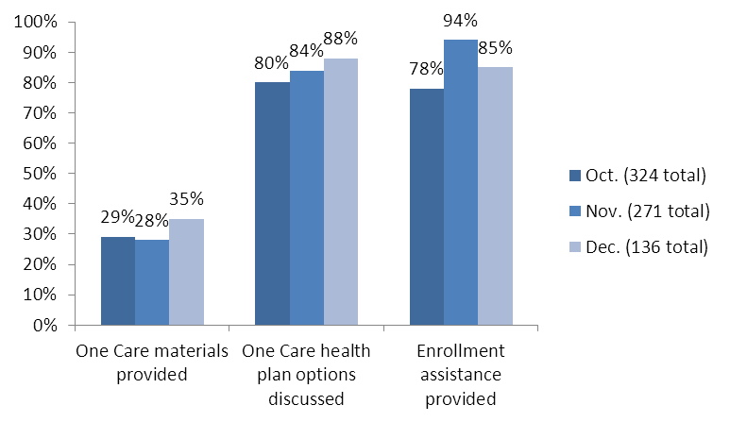
CMS and MassHealth have engaged the Executive Office of Elder Affairs to include information about One Care as part of its Serving the Health Insurance Needs of Everyone (SHINE) program. SHINE provides free and objective health insurance options counseling for elders and people with disabilities. The data in this report reflects SHINE counseling sessions that included One Care topics from October through December, 2013.
Figure 1. Trends in One Care-related SHINE counseling, Oct.-Dec. 2013
How often do SHINE counselors give people One Care informational or enrollment materials?
In October, as part of 324 One Care-related counseling sessions, SHINE counselors provided One Care materials to 95 individuals (29%). This compares to 75 out of 271 in November (28%); 48 out of 136 in December (35%).
How often do SHINE counselors discuss health plan options with people who contact them about One Care?
Depending on what county they live in, many people who are eligible for One Care have a choice of two or more plans. SHINE counselors can review plan options with individuals who are considering One Care. In October, SHINE counselors discussed plan options with 261 of 324 people who contacted them about One Care (80%); in November 228 of 271 people (84%); and in December 119 of 136 people (88%). Over these months, the percent of individuals with whom SHINE counselors discussed One Care plan options increased from 80% to 88%.
How often do SHINE counselors discuss or provide One Care enrollment assistance?
SHINE Counselors can help people review, complete, and submit One Care enrollment materials if they ask for assistance with or information about enrolling, opting-out, or switching plans. In October, SHINE Counselors provided enrollment assistance to or discussed enrollment options with 254 out of 324 people who contacted them about One Care (78%); in November 256 out of 271 people (94%), and in December 116 out of 136 people (85%). Overall, about 86% of individuals who contact SHINE about One Care seek enrollment-related assistance.
How often do both One Care and Medicare-related topics come up in the same SHINE counseling session?
Since people who are eligible for One Care have both MassHealth and Medicare, SHINE counselors often discuss Medicare issues with individuals who are considering One Care. From October to December 2013, SHINE counselors discussed Medicare-related topics in about 56% of One Care-related counseling sessions.
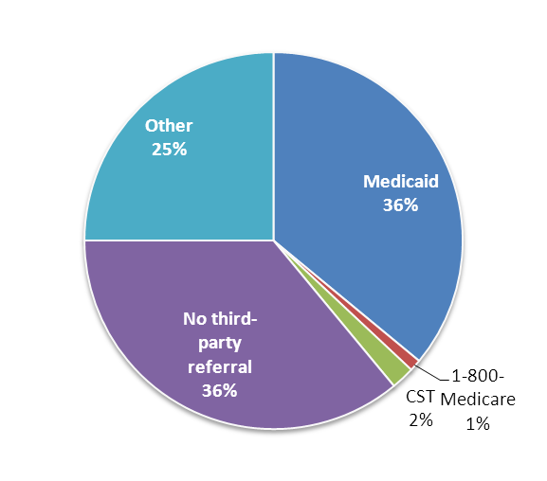
Who refers individuals to SHINE?
Figure 2. Source of SHINE referrals concerning One Care
A variety of sources refer people to SHINE for options counseling related to their options in One Care. Figure 2 show how many referrals concerning One Care SHINE counselors received between October 1, 2013 and January 31, 2014, by source.

What do people who talk with a SHINE counselor decide about One Care at the end of their session?
At the end of an encounter, SHINE counselors record “beneficiary disposition,” which reflects what an individual did or indicates (s)he is likely to do in terms of making an enrollment decision for One Care. Table 1 and Figure 3, below, show what SHINE counselors recorded in this regard from counseling sessions that took place October 1 through December 31, 2013.

Table 1. One Care enrollees' choices through SHINE
Month  (2013) | Decision to enroll  in One Care | Decision to enroll in a different One Care plan | Decision to stay in  current One Care plan
October | 3% | 2% | <1%
November | 3% | 3% | 3%
December | 8% | 2.9% | 7%

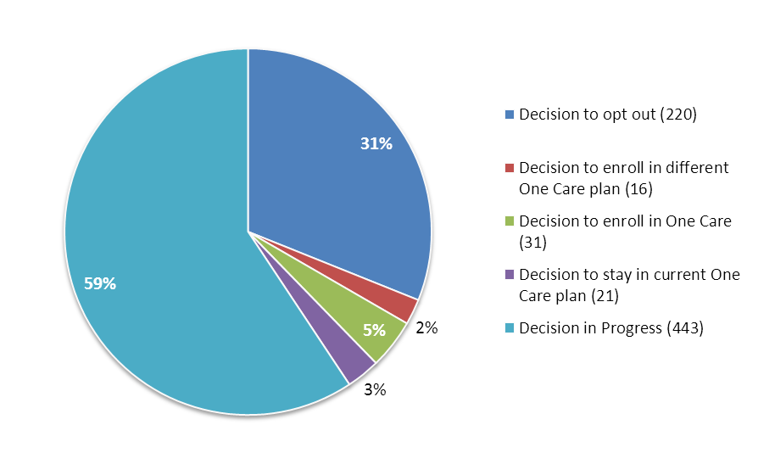
Figure 3. Outcomes of One Care-related SHINE counseling sessions, total Oct. – Dec. 2013 [N=731]

