|  |
| --- |
| INDOOR AIR QUALITY ASSESSMENT  **Fowler Middle School**  **3 Tiger Drive**  **Maynard, Massachusetts**  aerial  Prepared by:  Massachusetts Department of Public Health  Bureau of Environmental Health  Indoor Air Quality Program  December 2015 |

**Background**

|  |  |
| --- | --- |
| **Building:** | Fowler School (FS) |
| **Address:** | 3 Tiger Drive, Maynard, MA |
| **Assessment Requested by:** | Aaron Miklosko, Facilities Manager, Town of Maynard |
| **Date of Assessment:** | November 23, 2015 |
| **Bureau of Environmental Health/Indoor Air Quality (BEH/IAQ) Program Staff Conducting Assessment:** | Ruth Alfasso, Environmental Engineer/Inspector |
| **Date of Building Construction:** | 2001 |
| **Reason for Request:** | Anonymous complaint about general conditions |

**Building Description**

The Fowler School (FS) is a two story brick and concrete building completed in 2001. The school contains general classrooms, resource rooms, science rooms, a wood shop, office space, a cafeteria, auditorium and gymnasium. One wing of the FS currently houses the district’s administrative offices. Windows throughout the building are openable.

# Results and Discussion

Approximately 400 students in grades 4-8 occupy this space, as well as approximately 150 staff. Test results are presented in Table 1. Methods and indoor air related sampling information can be found in the IAQ Manual and Appendices for IAQ Reports, which can be found at:

<http://www.mass.gov/eohhs/gov/departments/dph/programs/environmental-health/exposure-topics/iaq/iaq-rpts/general-appendices-for-iaq-reports.html>

## Ventilation

It can be seen from Table 1 that carbon dioxide levels were below 800 parts per million (ppm) in all but two out of the 69 areas tested, indicating adequate ventilation in the school. Mechanical ventilation for classrooms, offices and common areas is provided by air handling units (AHUs) located in a mechanical space above the second floor of the classroom wings (Picture 1) and on the roof for the common areas. AHUs in the mechanical space draw air from intakes located in the roof (Picture 2). Fresh air is distributed via ceiling-mounted supply vents (Picture 3). Exhaust is provided by ceiling-mounted exhaust vents ducted back to AHUs (Picture 4). Direct venting of exhaust is provided in bathrooms and some other areas. Note that in some areas, such as the nurses’ office, weak or non-existent draw of air was observed from exhaust vents. These vents are necessary to remove bathroom odors and moisture and should be repaired if they are not functioning.

The AHUs for common areas provide cooling as well as heating. Additional cooling for the administrative wing and some classrooms is provided by window-mounted air conditioners (Picture 5).

## Temperature and Relative Humidity

Indoor temperature measurements ranged from 68°F to 72°F (Table 1), which were within or close to the lower end of the MDPH recommended comfort range. The MDPH recommends that indoor air temperatures be maintained in a range of 70°F to 78°F in order to provide for the comfort of building occupants. Occupants in some areas expressed complaints with cold temperatures. Occupants should work with facilities staff to adjust temperatures as the seasons change.

Indoor relative humidity ranged from 11 to 28 percent (Table 1) which was below the MDPH comfort range and reflective of outdoor conditions. The MDPH recommends a comfort range of 40 to 60 percent for indoor air relative humidity. Relative humidity levels in the building would be expected to drop during winter months due to heating. The sensation of dryness and irritation is common in a low relative humidity environment. Low relative humidity is a very common problem during the heating season in the northeast part of the United States.

## Microbial/Moisture Concerns

Water-damaged ceiling tiles were observed in many classrooms and other areas (Pictures 3 and 6; Table 1). These reportedly originate from intermittent roof leaks. Water-damaged ceiling tiles can provide a source of mold and should be removed and replaced when leaks are discovered and repaired. However, no mold staining was visible on any of the tiles examined.

The exterior of the building was examined for potential water penetration and drainage issues. A few doors were observed to be missing weather stripping which can allow unconditioned air, moisture and pests into the building.

Indoor plants were also observed in some areas, which can introduce pollen or mold indoors (Picture 7; Table 1). Plants should be kept away from sources of airflow which may distribute particles, pollen, mold and odors. Plants should be properly maintained, over-watering of plants should be avoided and drip pans should be inspected periodically for mold growth and cleaned or replaced as necessary. An aquarium and a terrarium were observed in classrooms, these should also be well maintained to prevent odors.

Water dispensing equipment and small refrigerators were observed in carpeted areas (Table 1). Spills or leaks from this equipment can moisten carpet and lead to microbial growth and carpet degradation. Some refrigerators examined had gaskets that were stained with mold (Picture 8); these should be cleaned with an antimicrobial solution or replaced. Refrigerators should be cleaned out regularly to prevent odors from spilled/spoiled food.

Some sinks were found to have backsplashes which had gaps where water can penetrate the seam and cause damage to underlying wood. These should be repaired with appropriate caulking material.

## Other IAQ Evaluations

IAQ can be negatively influenced by the presence of respiratory irritants, such as products of combustion. The process of combustion produces a number of pollutants. Common combustion emissions include carbon monoxide, carbon dioxide, water vapor, and smoke (fine airborne particle material). Of these materials, exposure to carbon monoxide and particulate matter with a diameter of 2.5 micrometers (μm) or less (PM2.5) can produce immediate, acute health effects upon exposure. To determine whether combustion products were present in the indoor environment, BEH/IAQ staff obtained measurements for carbon monoxide and PM2.5

### Carbon Monoxide

*Carbon monoxide should not be present in a typical, indoor environment.* If it *is* present, indoor carbon monoxide levels should be less than or equal to outdoor levels. Carbon monoxide levels outdoors were measured at 0.8 ppm likely from traffic. No carbon monoxide was detected inside the building during the assessment.

### Particulate Matter

Outdoor PM2.5 concentrations were measured at 7-16 μg/m3 (Table 1), which were below the NAAQS limit of 35 μg/m3. Indoor PM2.5 levels ranged from 3 to 39 μg/m3 (Table 1), all but one were below the NAAQS PM2.5 level of 35 μg/m3. The level above the NAAQS limit was in the B wing team room, which may be due to the presence of photocopying in this room. Frequently, indoor air levels of particulate matter (including PM2.5) can be at higher levels than those measured outdoors.

### Volatile Organic Compounds (VOCs)

Exposure to low levels of total VOCs (TVOCs) may produce eye, nose, throat and/or respiratory irritation in some sensitive individuals. In order to determine if VOCs were present, BEH/IAQ staff examined rooms for products containing VOCs. BEH/IAQ staff noted air fresheners, hand sanitizer, cleaners and dry erase materials in use within the space (Table 1). All of these have the potential to be irritants to the eyes, nose, throat and respiratory system of sensitive individuals.

## Other Concerns

Other conditions that can affect IAQ were observed during the assessment. The woodshop area had task-based exhaust/vacuum systems that emptied into a collection system outside the building (Picture 9). This system should be used as needed to collect wood chips/shavings and maintained, including emptying the receptacle of sawdust/chips on a regular basis. Sawdust can be a source of mold, and can provide harborage for pests.

Tennis balls were observed sliced open and used at the bottom of table and chair legs (Picture 12). Tennis balls are made of a number of materials that are a source of respiratory irritants. Constant wearing of tennis balls can produce fibers and off-gas VOCs. Tennis balls are made with a natural rubber latex bladder, which becomes abraded when used as a chair leg pad. Use of tennis balls in this manner may introduce latex dust into the school environment. Some individuals are highly allergic to latex (e.g. spina bifida patients) (SBAA, 2001). It is recommended that the use of materials containing latex be limited to reduce the potential for symptoms in sensitive individuals (NIOSH, 1997). Latex-free glides should be used for this purpose.

Some personal fans and supply/exhaust vents were observed to be dusty (Picture 10). Dust on these items can be reaerosolized and cause irritation or odors. A pencil sharpener with shavings spilling out of it was located in front of a personal fan (Picture 11). Pencil shavings can be a source of irritation, and should be kept contained and emptied frequently to avoid becoming airborne and should not be in the airstream of ventilation equipment or fans.

Worn carpeting was observed in some areas. Carpeting that is worn can produce particulates as it ages. Other carpeting should be cleaned annually, or semi-annually in soiled high traffic areas, as per the recommendations of the Institute of Inspection, Cleaning and Restoration Certification (IICRC, 2012).

Filters are present in the AHUs for the building. These filters should be changed on a regular schedule. Window air conditioners also have filters that should be cleaned regularly.

# Conclusions/Recommendations

In view of the findings at the time of the visit, the following recommendations are made:

1. Replace water-damaged ceiling tiles promptly. Make necessary repairs to roof and plumbing to reduce water damage from occurring in the future.
2. Operate HVAC equipment continuously during occupied hours.
3. Investigate draw of air from exhaust vents in bathrooms and other areas and repair if necessary.
4. Work with facilities staff to adjust temperatures for occupied areas.
5. For buildings in New England, periods of low relative humidity during the winter are often unavoidable. Therefore, scrupulous cleaning practices should be adopted to minimize common indoor air contaminants whose irritant effects can be enhanced when the relative humidity is low. To control for dusts, a high efficiency particulate arrestance (HEPA) filter equipped vacuum cleaner in conjunction with wet wiping of all surfaces is recommended. Avoid the use of feather dusters. Drinking water during the day can help ease some symptoms associated with a dry environment (throat and sinus irritations).
6. Repair/replace weather stripping for exterior doors to prevent the entry of unconditioned air, moisture and pests. Monitor for light or drafts around doors.
7. Maintain indoor plants, use non-porous drips pans, prevent overwatering and refrain from placing them near ventilation equipment.
8. Maintain aquariums and terrariums to prevent odors.
9. Consider placing water dispensers/small refrigerators in non-carpeted areas or place a waterproof mat underneath them.
10. Clean out refrigerators often. Clean gaskets with an antimicrobial solution or replace when stained.
11. Repair/caulk backsplashes on sinks to prevent water penetration.
12. Reduce the use of items containing VOCs including scented cleaners, air fresheners, dry erase materials and hand sanitizer. Only school-issued products should be used and products should not be brought in from outside.
13. Use and maintain the sawdust collection system in the wood shop, including regular emptying of the collection receptacle.
14. Use the exhaust vent for the kiln whenever the kiln is in operation. Keep the kiln area clear of materials, particularly flammable materials and those that may off-gas when heated.
15. Clean surfaces, vents, window air conditioner filters and personal fans regularly. Change AHU filters on a preventative maintenance schedule.
16. Clean carpeting annually or semi-annually in soiled high traffic areas as per the recommendations of the Institute of Inspection, Cleaning and Restoration Certification (IICRC, 2012). Consider a schedule for replacing any worn carpeting that is beyond its service life.
17. Refer to resource manuals and other related indoor air quality documents for further building-wide evaluations and advice on maintaining public buildings. These materials are located on the MDPH’s website: <http://mass.gov/dph/iaq>.

# References

IICRC. 2012. Carpet Cleaning FAQ 4 Institute of Inspection, Cleaning and Restoration Certification. Institute of Inspection Cleaning and Restoration, Vancouver, WA.

NIOSH. 1997. NIOSH Alert Preventing Allergic Reactions to Natural Rubber latex in the Workplace. National Institute for Occupational Safety and Health, Atlanta, GA.

SBAA. 2001. Latex In the Home And Community Updated Spring 2001. Spina Bifida Association of America, Washington, DC.

**Picture 1**

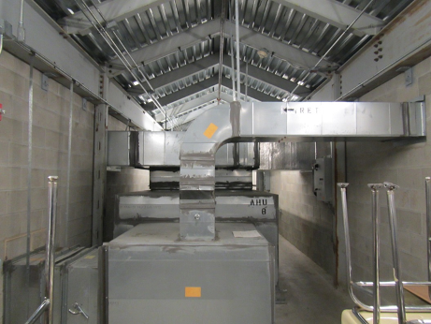

**Air handling unit in mechanical space**

**Picture 2**

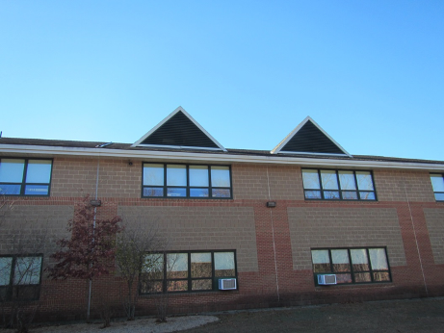

**Air intakes at top of roof**

**Picture 3**

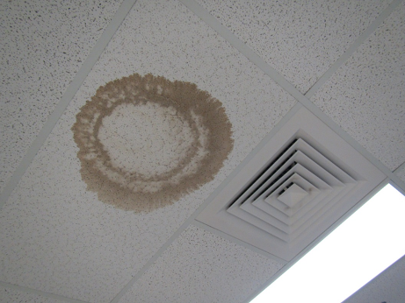

**Ceiling-mounted supply vent (note water-damaged ceiling tile)**

**Picture 4**

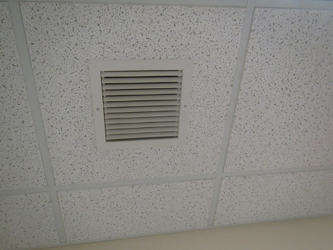

**Return vent**

**Picture 5**

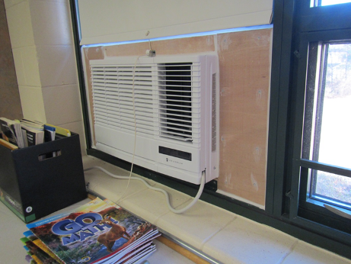

**Window-mounted air conditioner**

**Picture 6**

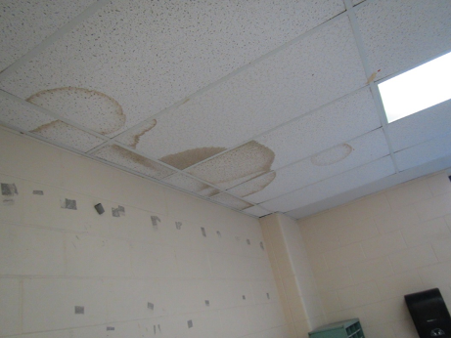

**Water-damaged ceiling tiles**

**Picture 7**

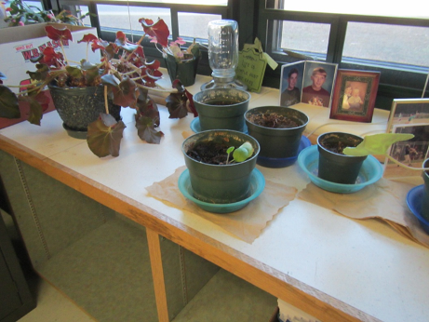

**Plants on porous materials**

**Picture 8**

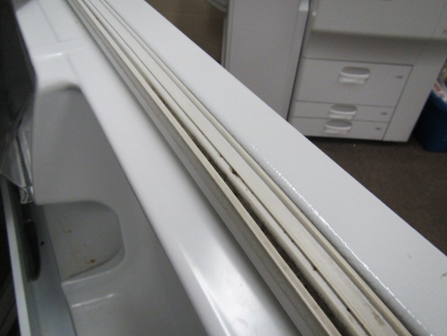

**Stained refrigerator gasket**

**Picture 9**

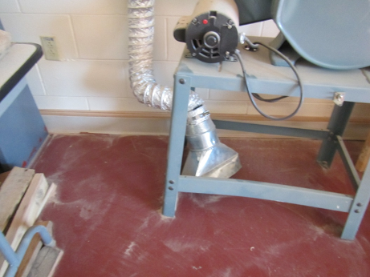

**Woodshop sawdust exhaust**

**Picture 10**

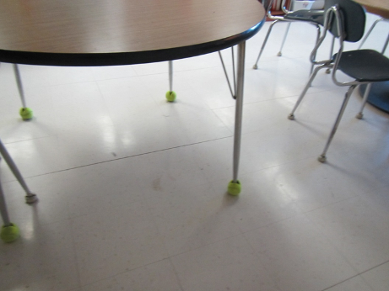

**Tennis balls used as chair and table glides**

**Picture 11**

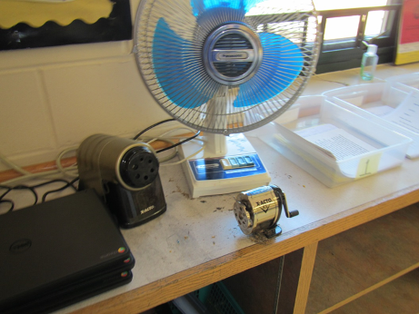

**Dusty personal fan and pencil shavings in front of fan**

| **Location** | **Carbon**  **Dioxide**  **(ppm)** | **Carbon Monoxide**  **(ppm)** | **Temp**  **(°F)** | **Relative**  **Humidity**  **(%)** | **PM2.5**  **(µg/m3)** | **Occupants**  **in Room** | **Windows**  **Openable** | **Ventilation** | | **Remarks** |
| --- | --- | --- | --- | --- | --- | --- | --- | --- | --- | --- |
| **Supply** | **Exhaust** |
| Background | 395 | 0.8 | 40 | 18 | 7-16 |  |  |  |  | Sunny, cold, light wind |
| A team room | 545 | ND | 70 | 16 | 18 | 1 | Y | Y | Y | Food, carpet, fridge on carpet |
| A102 | 341 | ND | 69 | 12 | 4 | 2 | Y | Y | Y | WAC, PF, NC |
| A103 | 323 | ND | 70 | 11 | 3 | 0 | Y | Y | Y | Plants, WAC, DEM, NC |
| A104 | 340 | ND | 70 | 11 | 4 | 2 | Y | Y | Y | Plants, DEM, PC, WAC |
| A108 staff lunch | 325 | ND | 70 | 12 | 3 | 0 | Y | Y | Y | Food, fridge, food odors, NC |
| A109 | 324 | ND | 70 | 11 | 5 | 0 | Y | Y | Y | WAC, plants, DEM,NC |
| A110 | 380 | ND | 70 | 13 | 4 | 2 | Y | Y | Y | WAC, plants |
| A201 | 798 | ND | 71 | 19 | 13 | Some students just left | Y | Y | Y | TBs, DEM, WD CT |
| A202 | 561 | ND | 71 | 15 | 3 | 1 plus some left | Y | Y | Y | DEM |
| A203 | 577 | ND | 70 | 15 | 10 | 5 plus some left | Y | Y | Y | NC, PF dusty, DEM |
| A204 | 482 | ND | 70 | 14 | 5 | 0 | Y | Y | Y | DEM, quiet room with supply/exhaust, 2 MT |
| A207 | 727 | ND | 70 | 17 | 8 | ~20 just left | Y | Y | Y | TBs, DEM, NC |
| A208 | 735 | ND | 71 | 16 | 21 | ~21 just left | Y | Y | Y | DEM, plants |
| A209 | 635 | ND | 70 | 16 | 4 | 9 | Y | Y | Y | TB, NC, DEM |
| A210 | 749 | ND | 70 | 16 | 11 | 15 | Y | Y | Y | NC, DEM, sink (backsplash open) |
| After School Area | 596 | ND | 70 | 24 | 5 | 1 | N | Y | Y | Fan, plush furniture, NC |
| Auditorium | 454 | ND | 68 | 15 | 4 | 0 | N | Y | Y |  |
| B team room | 633 | ND | 70 | 17 | 39 | 3 | Y | Y | Y | Carpet |
| B101 | 411 | ND | 70 | 15 | 4 | 2 | Y | Y | Y | DEM, rubber mats, rocks and dirt |
| B102 | 397 | ND | 70 | 13 | 3 | 1 | Y | Y | Y | NC, area rug, beanbag chairs, sink, fridge |
| B103 | 401 | ND | 71 | 15 | 3 | 1 | Y | Y | Y | Area rugs, TBs, items |
| B104 | 362 | ND | 70 | 12 | 5 | 0 | Y | Y | Y | DEM, WD CT (many), plant |
| B112 | 418 | ND | 70 | 14 | 5 | 1 | Y | Y | Y | DEM, area rug, 2 WD CT |
| B113 | 410 | ND | 70 | 13 | 3 | 1 | Y | Y | Y | Area rug, sink, NC |
| B114 | 427 | ND | 71 | 14 | 3 | 1 | Y | Y | Y dusty | Area rug, PF |
| B115 | 385 | ND | 71 | 13 | 3 | 0 | Y | Y | Y | DEM, WD CT |
| B201 | 690 | ND | 71 | 17 | 5 | 20 | Y | Y | Y | DEM, PF, WD CT, HS |
| B202 | 800 | ND | 71 | 18 | 7 | 20 | Y | Y | Y | DEM, PF, WD CT |
| B203 | 552 | ND | 71 | 15 | 5 | 0 | Y | Y | Y | WD CT, WAC, DEM, carpet |
| B204 | 726 | ND | 70 | 18 | 12-18 | 20 | Y | Y | Y | Terrarium, plants |
| B211 computers | 539 | ND | 70 | 15 | 10 | 14 | Y | Y | Y | NC |
| B212 | 759 | ND | 70 | 18 | 5 | 17 | Y | Y | Y | WD CT, PF, NC |
| B213 | 679 | ND | 70 | 18 | 14 | 24 | Y | Y | Y | PF, WD CT, DEM, NC |
| B214 | 569 | ND | 71 | 16 | 20-24 | 0 | Y | Y | Y | TB, WAC |
| B220 computer | 706 | ND | 71 | 15 | 9 | 10 | Y | Y | Y | 30 computers, WD CT |
| C team room | 545 | ND | 71 | 16 | 3 | 0 | N | Y | Y | Worn carpet, PCs, WC on carpet, toaster and fridge, stand fan |
| C204 | 475 | ND | 69 | 16 | 4 | 2 | Y | Y | Y | Area rug, CT |
| C205 | 589 | ND | 70 | 16 | 4 | 8 | Y | Y | Y | Area rug, 3 WD CT, HS, DEM |
| C206 | 811 | ND | 70 | 18 | 8 | 15 | Y | Y | Y | NC – area rugs, DEM |
| C207 | 542 | ND | 70 | 15 | 6 | 2 | Y | Y | Y | NC and area rugs, HS |
| C209 | 551 | ND | 70 | 16 | 6 | 7 | Y | Y | Y | NC, HS, DEM, storeroom |
| C210 | 621 | ND | 70 | 16 | 11 | 0 | Y | Y | Y | Area rug, DEM, 2 WD CT |
| C211 | 660 | ND | 70 | 18 | 15 | 16 | Y | Y | Y | DEM, plants, area rug |
| C212 | 461 | ND | 69 | 16 | 4 | 0 | Y | Y | y | NC, aquarium, DEM |
| C213 | 503 | ND | 70 | 15 | 7 | 4 | Y | Y | Y | WD CT, NC, microwave, fridge, DEM, HS |
| Cafeteria | 688-727 | ND | 70 | 21 | 12-23 | ~70 | Y | Y | Y | Doors to outside |
| D team room | 556 | ND | 70 | 16 | 25 | 6 | Y | Y | Y | PF, carpet |
| D202 | 613 | ND | 69 | 21 | 16 | 5 | N | Y | Y | WD CT, DEM, NC, kitchen equipment, ovens, dishwashers, etc. |
| D204 | 582 | ND | 71 | 20 | 22 | 0 | N | Y | Y | Many WD CT, and missing CT |
| D206 (wood shop) | 606 | ND | 70 | 20 | 5 | 0 | Y | Y | Y | Wood chips/saw dust, dust collection equipment |
| D215 | 471 | ND | 70 | 22 | 5 | 0 | Y | Y | Y | DEM, items |
| Guidance | 461 | ND | 70 | 17 | 18 | 1 | Y | Y | Y | DEM, carpet, plants |
| Gym | 564 | ND | 71 | 28 | 5 | 0 | N | Y | Y | Rubber/gym items, DEM |
| Janitorial Chemical storage |  |  |  |  |  |  | N | Y | Y |  |
| Kiln room |  |  |  |  |  |  | N | N | Y | Kiln vented to outside, direct exhaust |
| Library | 368 | ND | 69 | 15 | 3 | 0 | N | Y | Y | Carpet, DEM |
| Library control room | 390 | ND | 69 | 16 | 3 | 3 | Y | Y | Y | Plants, NC |
| Main office area | 559 | ND | 70 | 20 | 8 | 2 | Y | Y | Y | PC, plants |
| Main office conference room | 741 | ND | 70 | 21 | 7 | 2 | Y | Y | Y | WD CT |
| Mrs. Cotter | 443 | ND | 69 | 17 | 11-29 | 0 | Y | Y | Y | DEM, carpet |
| Mrs. Hatch | 456 | ND | 70 | 17 | 19 | 0 | Y | Y | Y | Plants, carpet, HS |
| Ms. Morrow | 495 | ND | 69 | 19 | 5 | 0 | N | N | Y | WD CT |
| Music Classroom | 495 | ND | 72 | 20 | 6 | 2 | Y | Y | Y | NC, sink, 3 WD CT, door to outside |
| Music office | 695 | ND | 71 | 22 | 5 | 0 | Y | Y | Y | Instruments, NC |
| Music Storage |  |  |  |  |  |  |  |  |  | Instruments, some dust, dry |
| Nurses’ office | 449 | ND | 69 | 16 | 12 | 3 | N | Y | Y |  |
| Nurses’ office bathroom |  |  |  |  |  |  |  |  | Y | Exhaust off or weak |
| Nurses’ suite | 453 | ND | 69 | 16 | 21 | 1 | N | Y | Y |  |
| Practice room B | 605 | ND | 71 | 20 | 3 | 0 | N | Y | N | NC |
| Principal’s office | 632 | ND | 70 | 18 | 8 | 1 | Y | Y | Y | Plant |
| Superintendent’s office | 355 | ND | 70 | 14 | 11 | 1 | Y | Y | Y | Plants, DEM |
| Teachers room | 319 | ND | 69 | 11 | 3 | 0 | Y | Y | Y | Fridge, microwave, PC |
| Teachers’ room off office area | 444 | ND | 69 | 15 | 5 | 1 | N | Y | Y | NC, PC |
| Unisex adult restroom |  |  |  |  |  |  | N | N | Y | Exhaust off or weak, vent dusty, bathroom odors |