INDOOR AIR QUALITY ASSESSMENT

Executive Office of Health and Human Services Service Center
300 Howard Street
Framingham, MA

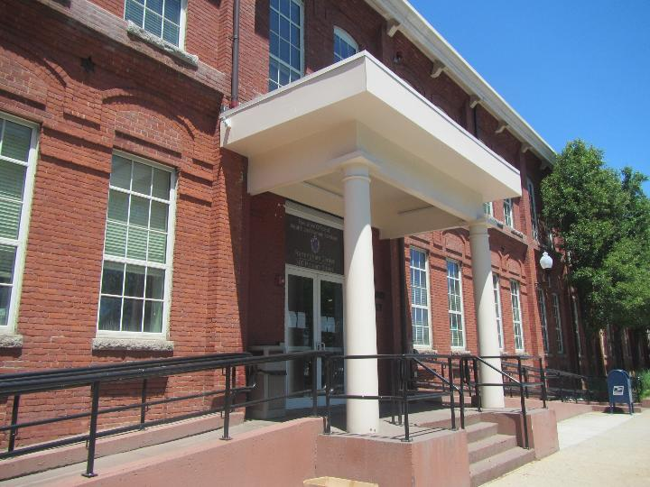

Prepared by:
Massachusetts Department of Public Health
Bureau of Climate and Environmental Health
Division of Environmental Health Regulations and Standards
July 2026

BACKGROUND
Building: | Executive Office of Health and Human Services (EOHHS) Service Center
Address: | 300 Howard Street, Framingham, MA
Assessment Requested by: | Pedro Batista, Project Manager III, EOHHS
Reason for Request: | General indoor air quality (IAQ) and respiratory issues
Date of Assessment: | June 9, 2026
Massachusetts Department of Public Health/Bureau of Climate and Environmental Health/Division of Environmental Health Regulations and Standards (MDPH/BCEH/EHRS) Staff Conducting Assessment: | Thomas Murphy and Patrick Wallace,  EHRS
Building Description: | The Department of Children and Families, the Department of Development Services, and the Department of Transitional Assistance occupy this former manufacturing plant that has been completely renovated into state offices.
Windows: | Windows are not openable.

METHODS
Please refer to the IAQ Manual for methods, sampling procedures, and interpretation of results (MDPH, 2015). Note that this building has been visited by MDPH staff on several occasions since the EOHHS Service Center occupied these offices in 2015; reports which include findings and recommendations from these visits can be found on the MDPH webpage at: https://www.mass.gov/info-details/indoor-air-quality-reports-cities-and-towns-f#framingham

RESULTS AND DISCUSSION
The following is a summary of indoor air testing results (Table 1).
- Carbon dioxide levels were below the MDPH guideline of 800 parts per million (ppm) in all areas assessed, indicating adequate air exchange at the time of assessment. However, the space was minimally occupied at the time of testing. Carbon dioxide levels would be expected to be higher with increased occupancy.
- Temperature was within the recommended range of 70°F to 78°F in all areas assessed.
- Relative humidity was within the MDPH recommended range of 40 to 60% in all areas assessed.
- Carbon monoxide levels were non-detectible (ND) in all areas tested. Carbon monoxide should not be present in a typical, indoor environment. If it is present, indoor carbon monoxide levels should be less than or equal to outdoor levels.
- Fine particulate matter (PM2.5) concentrations measured inside the EOHHS Service Center were ND-2 which is below the National Ambient Air Quality Standard (NAAQS) level of 35 μg/m³ in all areas assessed.
- Volatile Organic Compounds (TVOC) concentrations were ND in all areas tested.

Ventilation
A heating, ventilating, and air conditioning (HVAC) system has several functions. First, it provides heating and, if equipped, cooling. Second, it is a source of fresh air. Finally, an HVAC system will dilute and remove normally occurring indoor environmental pollutants by introducing fresh air, filtering the airstream and ejecting stale air to the outdoors via exhaust ventilation. Even if an HVAC system is operating as designed, point sources of respiratory irritation may exist and lead to symptoms in sensitive individuals.
Fresh air is provided by air-handling units (AHUs) located on the roof (Picture 1). Air from the AHUs is filtered, heated/cooled, and delivered to rooms via ducted supply vents (Picture 2). Air is returned/exhausted through return vents (Picture 3). All occupied spaces should have access to both supply and return ventilation. Some offices and rooms are not equipped with return vents; however the doors have gaps at the bottom for airflow and return vents are located in hallways. It was observed that some of the hallway return vents are located close to supply vents. This may direct the supply air from the adjacent vent back into the return system rather than drawing air from offices with closed doors. It is recommended that HVAC systems be re-balanced every five years to ensure adequate air systems function (SMACNA, 1994). It was reported that the system was balanced over 5 years ago.
The ventilation system should be on and operational to supply fresh air continuously during occupied periods. Without adequate fresh air supply and removal of stale air, common indoor air pollutants can build up and cause irritation. Thermostats were observed throughout the EOHHS Service Center and most appeared to have the fan on, however at least one thermostat was observed to be on “Auto” (Picture 4). Thermostats and building management systems should be set to have the fan on, even when a change in temperature is not called for to allow constant air exchange during occupied periods.
The AHUs for this building were assessed during this visit. The MDPH/EHRS recommends that AHU filters be changed 2-4 times a year (or per the manufacturer’s recommendations) and be at least a minimum efficiency reporting value (MERV) 8, or higher if the equipment can handle them without a degradation in airflow, as these are adequate to filter out pollen, mold, and similar particulates (ASHRAE, 2012). The filters found inside an AHU had MERV 8 pleated filters (Picture 5). When the filters were examined, one was found to be recently replaced and in good condition, but another needed to be changed due to it being dirty (Pictures 6 and 7). According to the building’s facilities staff, this filter was scheduled to be replaced soon, and they are reportedly changed twice a year.

Microbial/Moisture Concerns
A few water-damaged ceiling tiles were noted in the building (Table 1; Pictures 8 and 9). These water-damaged tiles could be from the roof, building envelope, or potentially from plumbing connections/HVAC leaks or condensation above the ceiling. Water-damaged ceiling tiles should be replaced once the cause of the water damage has been identified and repaired.
Plants were noted in some areas of the EOHHS Service Center (Table 1). Plants can be a source of pollen or mold especially if overwatered or not well maintained. Plants without drip pans can damage porous surfaces they are placed on. At least one plant was on top of a paper towel (Picture 10), which can be a source of mold growth. Another plant was on top of a paper plate (Picture 11), which can also become mold colonized. Plants should be kept away from the airstream of ventilation equipment to prevent the spread of pollen or mold.
Mini refrigerators were found in carpeted areas of the building (Table 1; Pictures 12 and 13). Refrigerators can spill or leak and moisten carpeting. Use of a waterproof mat underneath these types of appliances, or moving them to a non-carpeted area, can help prevent water damage.
Food/liquid stains were observed in a refrigerator (Picture 14), and the interior of a microwave was dirty. Food storage and preparation equipment should be kept clean and free from spills to prevent mold growth, pests, and odors. Note that while refrigerators in this office building are not covered by the food code, it is good practice to have a thermometer in each refrigerator that is visible to ensure refrigerated food temperatures are kept at 5ºC (41ºF) or less (US FDA, 2022).
Food, food preparation equipment, and related items were found in many areas of the EOHHS Service Center (Pictures 15 and 16). To reduce the potential for rodent activity, all food should be stored in closed, rodent-proof containers at all times other than active use. All crumbs and other food debris need to be removed from surfaces and appliances such as the popcorn machine (Picture 17), toasters, and microwaves to avoid attracting pests.
The US Environmental Protection Agency (US EPA) and the American Conference of Governmental Industrial Hygienists (ACGIH) recommend that porous materials (e.g., ceiling tiles, carpet) be dried with fans and heating within 24 to 48 hours of becoming wet (US EPA, 2008; ACGIH, 1989). If not dried within this time frame, mold growth may occur. Once mold has colonized porous materials, they are difficult to clean and should be discarded. Frequently, solid/non-porous items can be cleaned to remove water stains and microbial growth.
Pooling of water was observed in multiple locations on the roof including near severely clogged drains (Pictures 18 through 20). Water pooling on the roof may eventually leak into the building and create water damage to interior components such as ceiling tiles. Debris in the pooled water may also provide a medium on which weeds can grow and further damage the roof membrane. A deceased bird was observed on the roof near a drain (Picture 21). It should be safely removed and the area properly cleaned.
Efflorescence and moss/algae growth were observed on the exterior of the building envelope (Pictures 22 and 23). Efflorescence results when rainwater penetrates into brick and mortar. A suspension of water and salts forms in the brick and mortar, which then travels to the wall surface. As the water evaporates, a white, powdery material is formed (efflorescence). While efflorescence is a sign of water exposure to brick, and water intrusion, it is not mold growth. Evidence of moss/algae growth indicates moisture and a lack of drying or draining. It appeared the moss/algae growth was the result of a broken downspout which prevented water from properly being drained to the ground (Picture 24). All gutters and downspouts should be checked and repaired as necessary to allow for proper drainage to prevent damage to the building envelope.
According to property facilities staff, there is a repointing project occurring in the front of the building (Picture 25) and it is scheduled to be completed in the near future. The exterior of the building should be checked for any other areas which need to be repointed, and work should be completed as necessary to prevent any water infiltration into the EOHHS Service Center.
Trees were noted in close proximity to the front of the building (Picture 26) as well as the rear of the building. The presence of trees is likely enhancing water retention, preventing drying of the exterior, and affecting drainage as well as overhanging the roof. These trees pose several hazards:
  - Leaves and other debris accumulate around gutters, (and roof drains where present, which inhibits rainwater drainage. Clogged gutters and/or ineffective drains can lead to water running off the roof to moisten exterior walls.
  - Trees prevent sunlight from drying walls and soil.
  - The trees are a possible danger due to the distance from exterior walls:
    - The recommended safe distance that any tree should be planted is the minimum of the expected maximum growth height of the species from the exterior of a building (BI, 2015).
    - Soil subsidence may also be caused by tree roots, which can undermine the structure of a building to cause wall and floor cracking and related damage. To prevent subsidence, a sufficient distance appropriate for the tree species is recommended (Williams, 2006).
    - Severe weather may result in the tree falling onto the building or the tree roots damaging the foundation. Due to the height of the trees, each is likely located closer than recommended distances.
    - In general, a tree root system will spread out in all directions from its trunk. In some cases, tree roots can extend over 100 feet from its trunk. Any structure disrupting the root structure may make the tree unstable if subjected to high winds from a certain direction. Based on the location, the foundation walls likely disrupt the roots of several trees.
    - The Federal Emergency Management Agency (FEMA) provides several recommendations to prepare for severe thunderstorms. Of note FEMA recommends “Cut down or trim trees that may be in danger of falling on your [building]” (FEMA, 2018). Given the proximity to exterior walls, removal of trees near the building should be considered.

Other IAQ issues
Personal products, particularly those with volatile organic compounds (VOCs) including scents, can also be a source of respiratory irritation. VOCs are carbon-containing substances that can evaporate at room temperature. Exposure to low levels of total-VOCs (TVOCs) may produce eye, nose, throat and/or respiratory irritation in some sensitive individuals. While TVOCs measured in the office were all non-detect, products were noted in the EOHHS Service Center that can be sources of VOCs. These include cleaning/disinfecting wipes, hand sanitizers, and scented candles, (Table 1; Pictures 27 and 28). They should be used with good ventilation, and kept closed when not in use. Products with strong scents, including scent sprays and essential oils should not be used in a shared office space as many people are sensitive to fragrance compounds. Candles should never be lit inside an office. Consult “Clean Air Is Odor Free” for more information on fragrances in buildings.
A fan with dust accumulated on it was noted in an area (Picture 29). When dust accumulates on the blades, it can be aerosolized during use. Fans should be checked and cleaned periodically to remove any dust.
Cardboard boxes and other items were observed including on floors, desks, and other surfaces (Table 1; Picture 30). Too many items can make it difficult for custodial staff to clean and may become attractive to pests as harborage. Items should be stored neatly, off the floor, and be moved periodically for cleaning. Items that have been in long term storage or that are brought from home should be inspected to ensure they do not carry dust, pet hair, or odors.
In some areas, there are gaps between workstations and walls. These areas can accumulate debris (Picture 31) and can be a source of harborage for pests. Cleaning of these areas should be conducted periodically, and they should not be used for storage.
At least one air purifier was noted in the space (Picture 32). All air purifiers should be cleaned and maintained in accordance with manufacturers’ instructions. Air purifiers that may produce ozone should not be used (EPA, 2003).
A large amount of the EOHHS Service Center is covered with wall-to-wall carpeting. Carpeting has a service life of approximately 10-11 years (IICRC, 2002). Carpeting that is beyond its service life becomes increasingly difficult to clean and may release fibers which can be irritating if airborne. Carpets should be vacuumed regularly with a high efficiency particulate arrestance (HEPA) filter equipped vacuum cleaner and cleaned annually (or semi-annually in soiled/high traffic areas) in accordance with Institute of Inspection, Cleaning, and Restoration Certification (IICRC) recommendations (IICRC, 2012).

CONCLUSIONS/RECOMMENDATIONS
In view of the findings at the time of the visit, the following recommendations are made:

Ventilation recommendations
- Operate the HVAC system (supply/exhaust) to provide continuous fresh air ventilation during occupied hours.
- Determine if adding additional exhaust vents to offices without them could supplement airflow and remove stale air during maximum occupancy.
- Continue to change filters for HVAC units at least two to four times a year or as per the manufacturers’ recommendations using filters with a Minimum Efficiency Rating Value (MERV) of 8 or better. Ensure HVAC cabinets are cleaned of debris during filter changes.
- Have the HVAC system balanced every 5 years in accordance with SMACNA recommendations (SMACNA, 1994).
- For buildings in New England, periods of low relative humidity during the year are often unavoidable. Therefore, scrupulous cleaning practices should be adopted to minimize common indoor air contaminants whose irritant effects can be enhanced when the relative humidity is low. To control dust, a high efficiency particulate arrestance (HEPA) filter equipped vacuum cleaner in conjunction with wet wiping of all surfaces is recommended. Avoid the use of feather dusters. Drinking water during the day can help ease some symptoms associated with a dry environment (throat and sinus irritations).

Water damage recommendations
- Replace all water-damaged ceiling tiles. Disinfect areas of water leaks with an appropriate antimicrobial, as needed. Check surrounding areas for additional water-damaged materials and sources of water leaks.
- Keep all indoor plants in good condition with non-porous drip pans and do not overwater. Properly maintain plants to avoid mold and odors. Keep plants out of the airstream of ventilation equipment.
- Consider putting refrigerators on waterproof mats or in areas without carpeting to prevent water damage.
- Consider consolidating to use fewer small refrigerators in the EOHHS Service Center.
- Clean all food storage and preparation equipment (microwaves, refrigerators, popcorn machine etc.) to prevent mold growth, pests, and odors.
- Ensure all food and food packets are stored in pest-proof containers and clean up food waste and crumbs promptly to deter rodents.
- Place a thermometer in each refrigerator that is visible to ensure refrigerated food temperatures are kept at 5ºC (41ºF) or less (US FDA, 2022).
- Clean out all roof drains on a consistent basis to prevent the pooling of water and determine if alterations are needed to allow sufficient draining of water in other areas on the roof.
- Safely remove the deceased bird on the roof and appropriately clean the area.
- Clean/scrape efflorescence off the exterior of the building envelope.
- Remove moss/algae off the exterior of the building to ensure drying of the building envelope.
- Repair any broken downspout to ensure proper drainage of water and to prevent water infiltrating the building envelope.
- Complete the repointing project for the front of the building. Have the rest of the building exterior, including brickwork, examined by a building envelope contractor to determine if repointing or other work is needed to increase water-tightness.
- Remove trees and plants away from exterior walls and windows to allow for better drying of building materials and prevent pollen and odors from being drawn into the building.

Other IAQ recommendations
- Use VOC-containing products in areas with good ventilation and keep tightly closed when not in use. Avoid products with strong scents and avoid mixing incompatible products.
- Refer to “Clean Air Is Odor Free” for more information on fragrances in buildings.
- Periodically check and clean the blades of fans.
- Reduce clutter and ensure items have a location for proper storage. Items may need to be thoroughly sorted to discard unneeded/outdated items to make space for necessary items. Items should be organized and stored off the floor to allow for thorough cleaning.
- Ensure areas between workstations and walls are cleaned out periodically and not used for storage.
- Have the carpets vacuumed regularly and deep cleaned once or twice a year. Consider replacing if past its service life.
- Refer to https://www.airnow.gov/ for Framingham MA for more information about outdoor air quality conditions, specifically ozone, PM2.5 and PM10. Provide outdoor air quality updates/resources to building staff to keep them informed.
- Consider installing digital sensor technology readouts in different offices of the EOHHS Service Center to provide continuous monitoring of the indoor air parameters such as carbon dioxide, carbon monoxide, temperature, relative humidity, and particulate matter. Sensors should be re-calibrated quarterly or according to manufacturers’ specifications and building management software updated as per manufacturers’ instructions, industrial standards, and/or change in operating systems. As an example, the following link illustrates how this technology is serving Boston Public Schools to improve air quality (i.e., carbon dioxide, temperature, relative humidity, carbon monoxide, and particulate matter). COVID-19 Health & Safety Information / Indoor Air Quality Sensor Dashboard (bostonpublicschools.org)
- Consider providing portable air purifiers as an additional method to filter air in the EOHHS Service Center. If air purifiers are provided, replace filters and equipment in accordance with manufacturers’ instructions. While air purifiers do not supply fresh air, they can remove particles including mold spores and microbes. Avoid the use of air purifiers that may produce ozone (EPA, 2003).
- Please refer to resource manual and other related IAQ documents located on the MDPH’s website for further building-wide evaluations and advice on maintaining public buildings. These documents are available at: http://mass.gov/dph/iaq.

REFERENCES
ACGIH.1989. Guidelines for the Assessment of Bioaerosols in the Indoor Environment. American Conference of Governmental Industrial Hygienists, Cincinnati, OH.
ASHRAE. 2012. American Society of Heating, Refrigeration and Air Conditioning Engineers (ASHRAE) Standard 52.2-2012 -- Method of Testing General Ventilation Air-Cleaning Devices for Removal Efficiency by Particle Size (ANSI Approved).
BI. 2015. A List of Trees and the Recommended Safe Distance from Buildings. Bickers Insurance, Littlehampton, West Sussex, UK. https://www.bickersinsurance.co.uk/a-list-of-trees-and-the-recommended-safe-distance-from-buildings/.
FEMA. 2018. How to Stay Safe When a Thunderstorm Threatens. Federal Emergency Management Agency, Washington, DC. FEMA V-1009/May 2018.
IICRC. 2002. Institute of Inspection, Cleaning and Restoration Certification. A Life-Cycle Cost Analysis for Floor Coverings in School Facilities.
IICRC. 2012. Institute of Inspection, Cleaning and Restoration Certification. Carpet Cleaning: FAQ.
MDPH. 2015. Massachusetts Department of Public Health. Indoor Air Quality Manual: Chapters I-III. Available at: https://www.mass.gov/lists/indoor-air-quality-manual-and-appendices.
SMACNA. 1994. HVAC Systems Commissioning Manual. 1st ed. Sheet Metal and Air Conditioning Contractors’ National Association, Inc., Chantilly, VA.
US EPA. 2003. “Ozone Generators that are Sold as Air Cleaners: An Assessment of Effectiveness and Health Consequences”. United States Environmental Protection Agency, Office of Air and Radiation, Indoor Environments Division, Washington, DC. Last updated September, 2018. https://www.epa.gov/indoor-air-quality-iaq/ozone-generators-are-sold-air-cleaners.
US EPA. 2006. National Ambient Air Quality Standards (NAAQS). United States Environmental Protection Agency, Office of Air Quality Planning and Standards, Washington, DC. https://www.epa.gov/criteria-air-pollutants/naaqs-table.
US EPA. 2008. Mold Remediation in Schools and Commercial Buildings. US Environmental Protection Agency, Office of Air and Radiation, Indoor Environments Division, Washington, D.C. EPA 402-K-01-001. http://www.epa.gov/mold/mold-remediation-schools-and-commercial-buildings-guide.
US EPA. 2025. National Ambient Air Quality Standards (NAAQS). US Environmental Protection Agency, Office of Air Quality Planning and Standards, Washington, DC. Last updated on November 4, 2025
US FDA. 2022. 2022 Food Code. U.S. Department of Health and Human Services. U.S. Food and Drug Administration. College Park, MD January 18, 2023 Version. https://www.fda.gov/media/164194/download
Williams. 2006. The Distance at Which Trees Can Affect a Building is Quite Significant. The Architects’ Journal. https://www.architectsjournal.co.uk/home/the-distance-at-which-trees-can-affect-a-building-is-quite-significant/130858.article

Picture 1
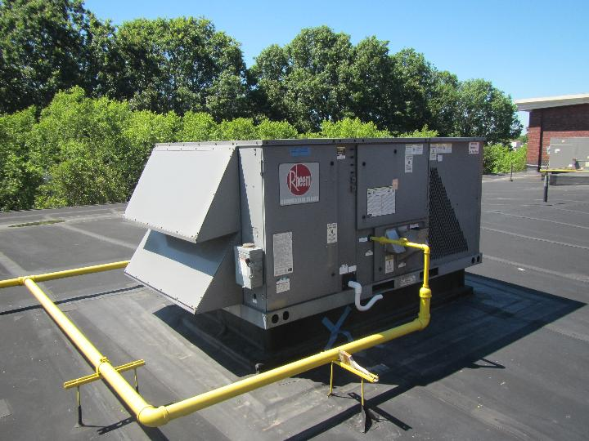
Air handling unit on roof
Picture 2
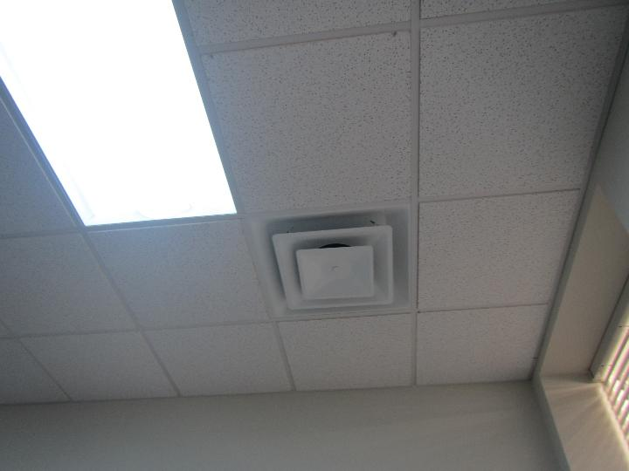
Typical supply vent

Picture 3
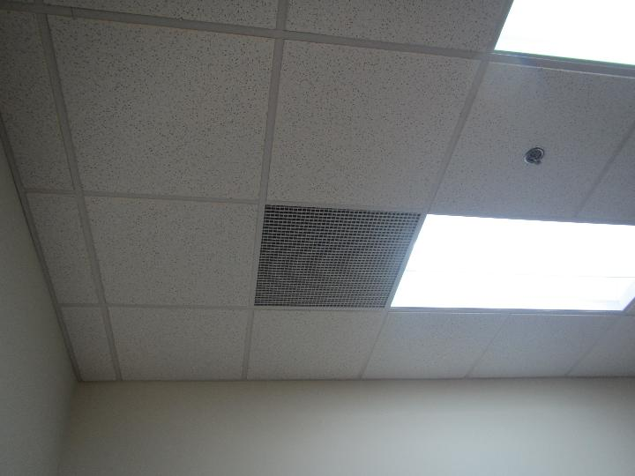
Typical return vent

Picture 4
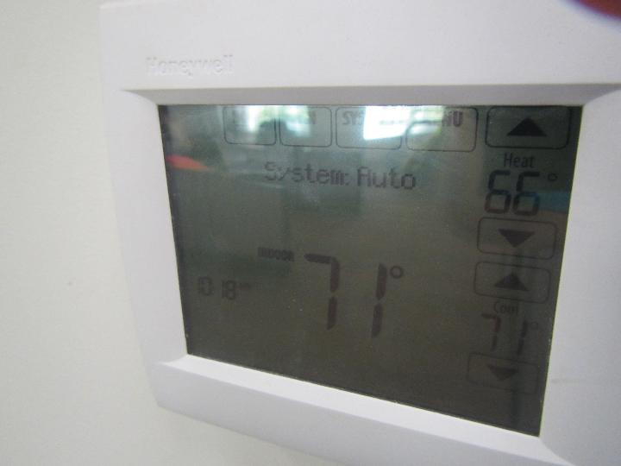
Thermostat indicating the system is set to “Auto”
Picture 5
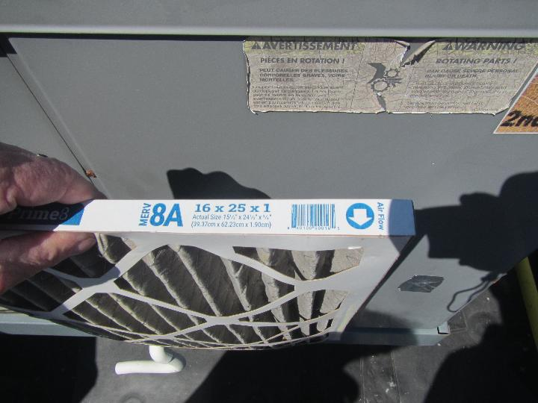
MERV 8 filter in AHU on roof
Picture 6
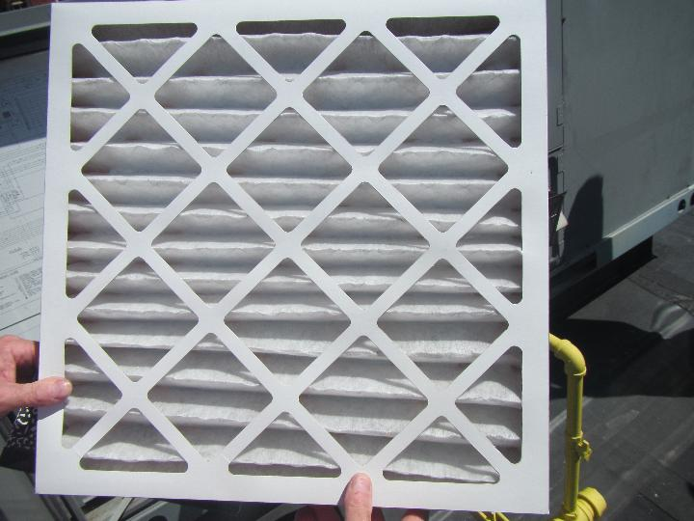
Recently replaced filter in good condition

Picture 7
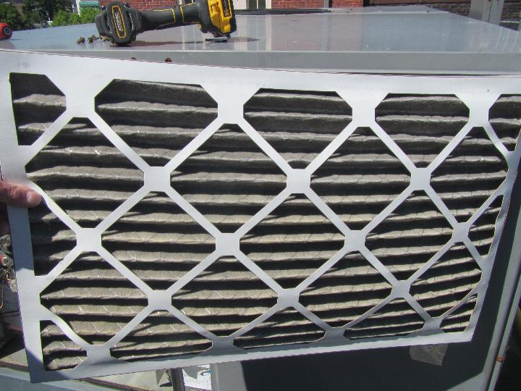
Dirty filter in need of replacement

Picture 8
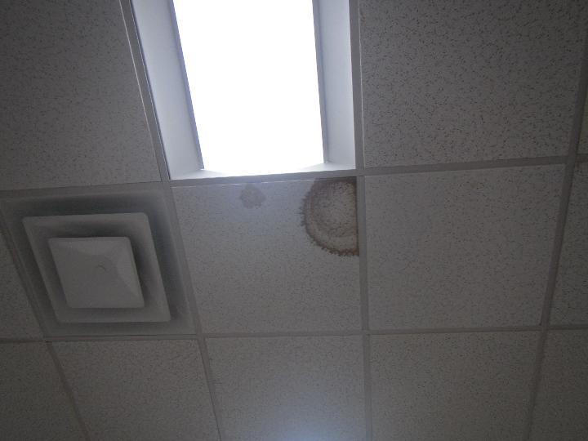
Water-damaged ceiling tile
Picture 9
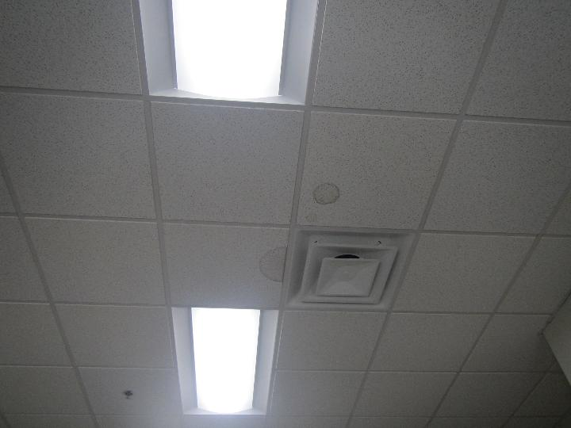
Water-damaged ceiling tiles

Picture 10
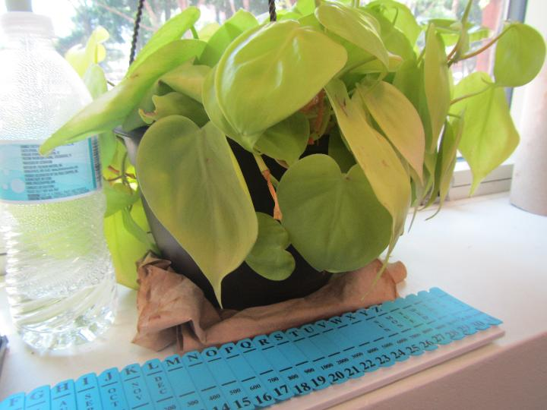
Plant on a paper towel
Picture 11
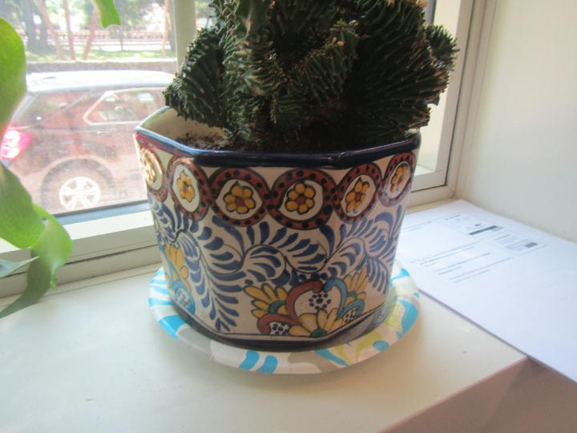
Plant on a paper plate

Picture 12
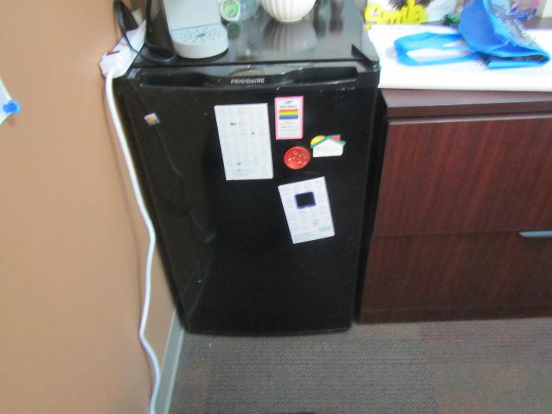
Mini refrigerator on carpet
Picture 13
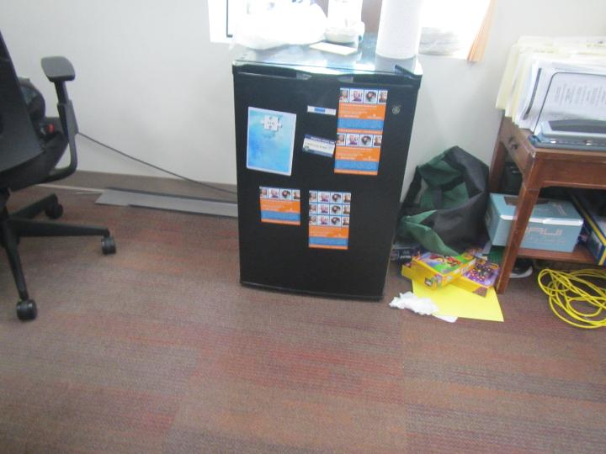
Mini refrigerator on carpet

Picture 14
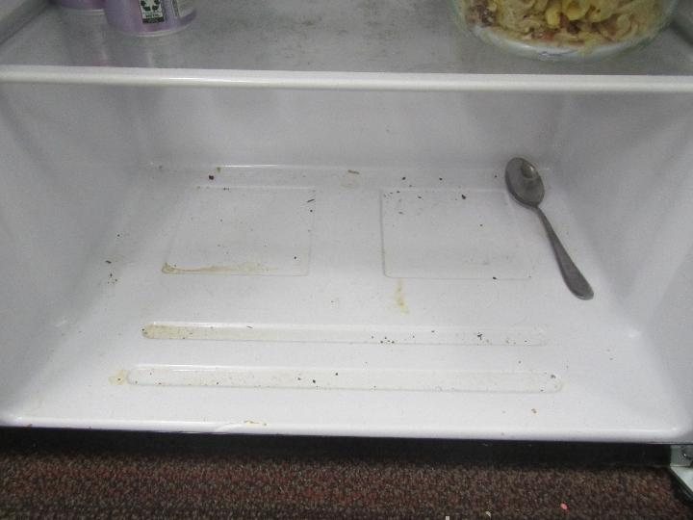
Dirty refrigerator on carpet
Picture 15
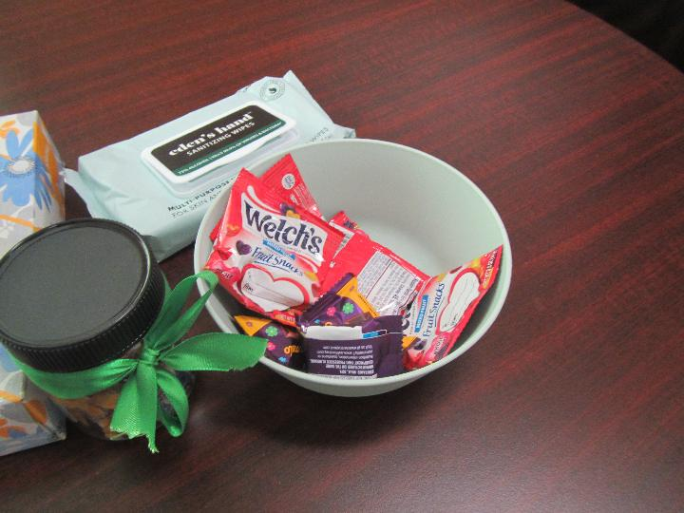
Food on a desk

Picture 16
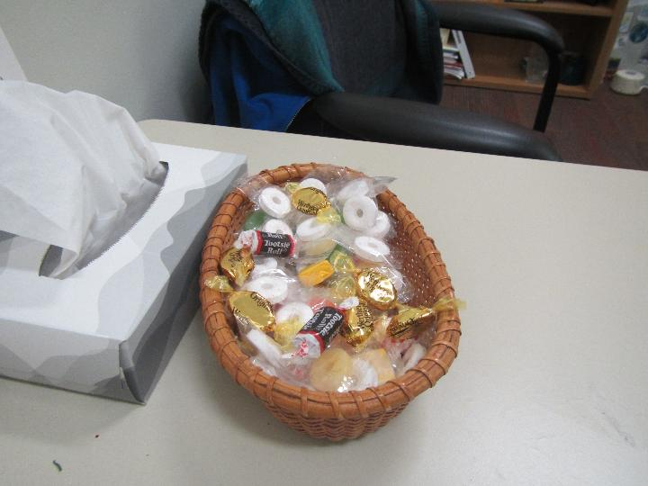
Candy on a desk
Picture 17
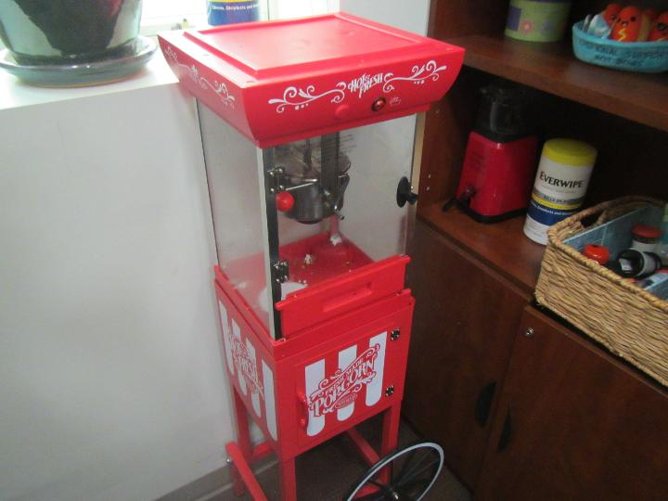
Popcorn machine with crumbs in it
Picture 18
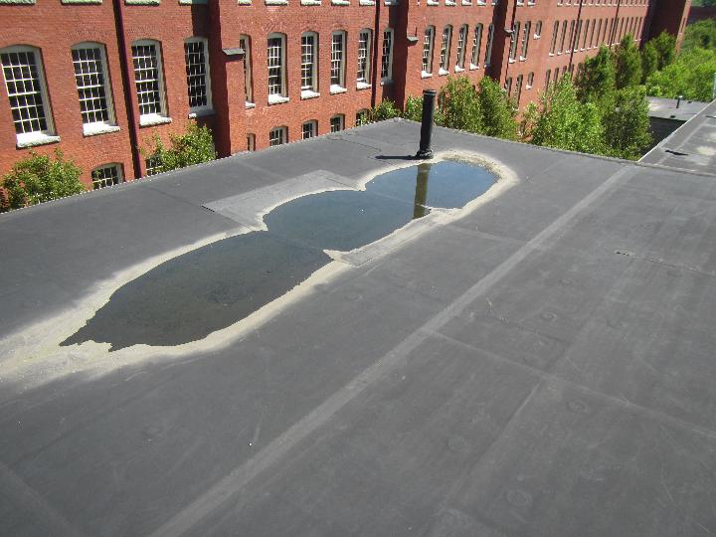
Water pooling on roof

Picture 19
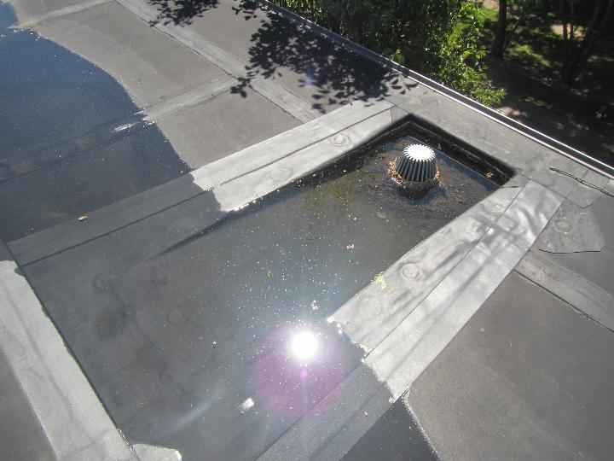
Water pooling on roof, unable to drain due to clogged drain
Picture 20
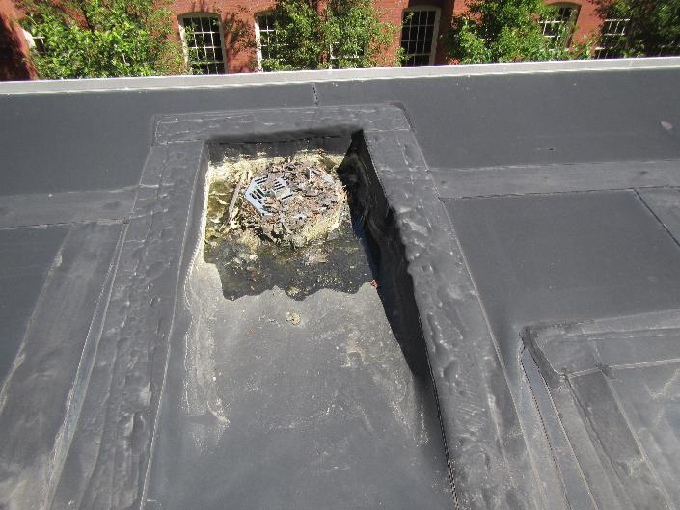
Drain filled with severe amount of debris

Picture 21
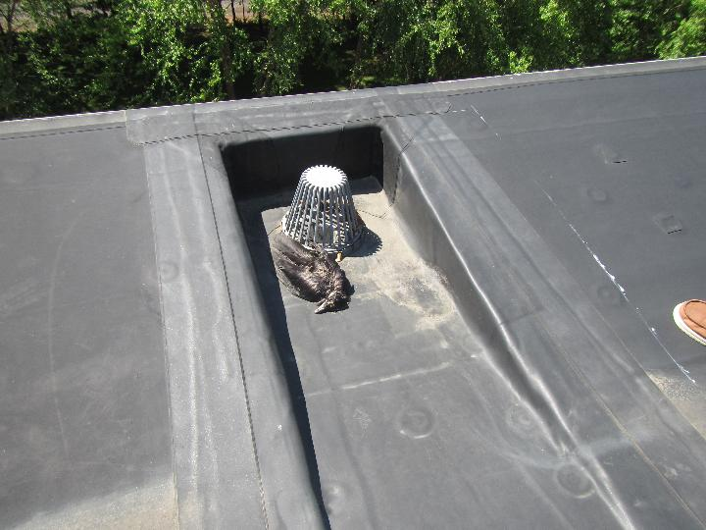
Deceased bird on roof next to drain

Picture 22
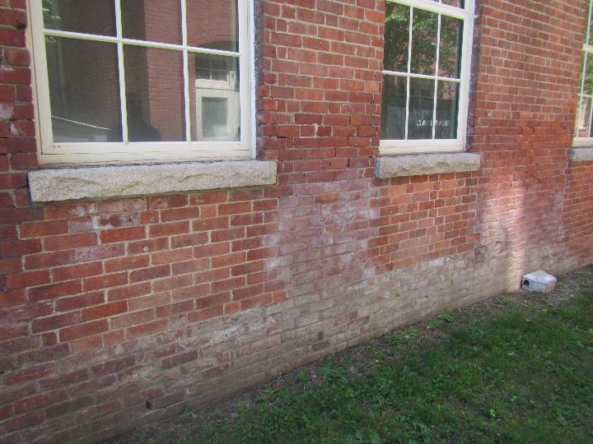
Efflorescence on exterior of building
Picture 23
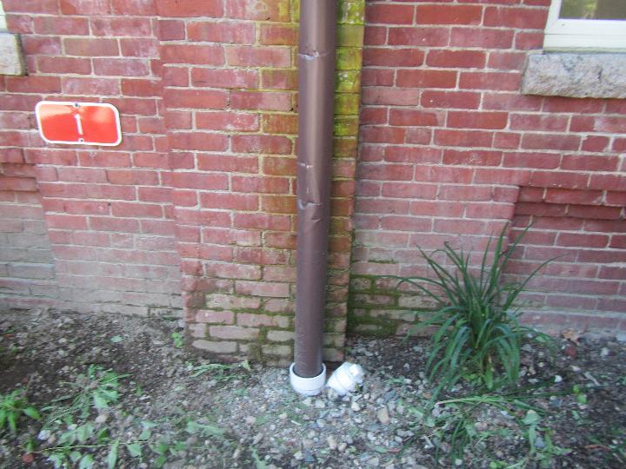
Moss/algae growth on the exterior of the building

Picture 24
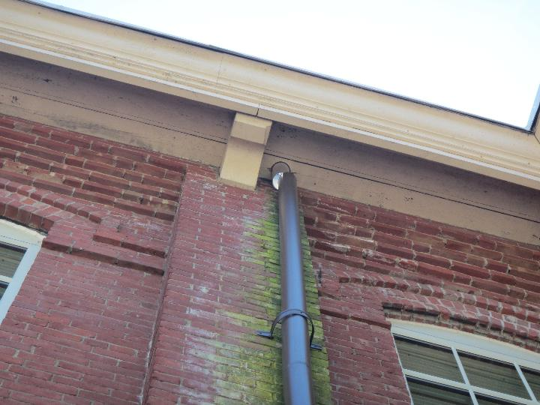
Broken downspout below the roof, note moss/algae growth
Picture 25
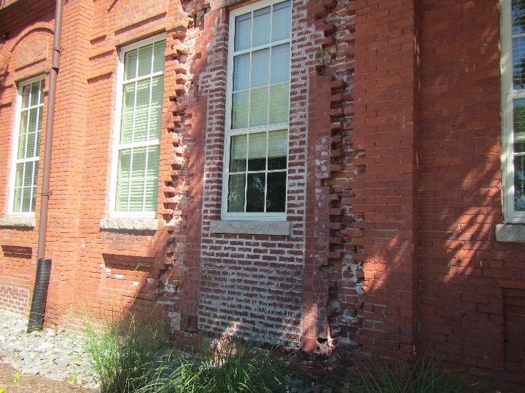
Repointing project in the front of the building
Picture 26
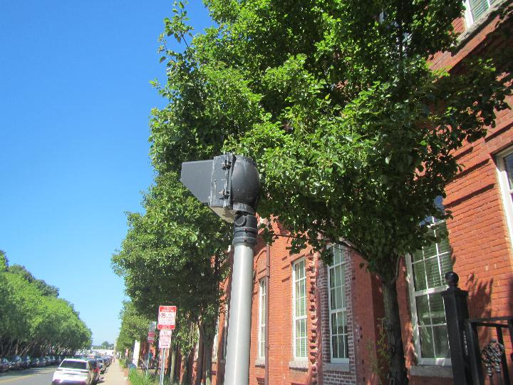
Trees in close proximity to the front of the building

Picture 27
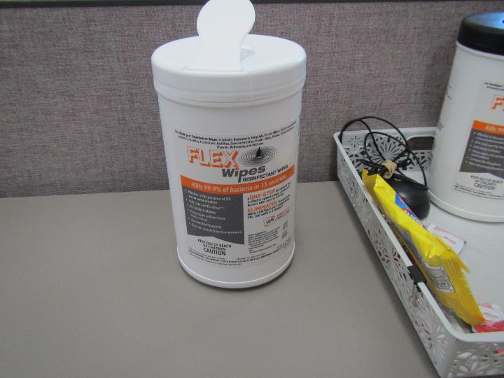
Cleaning wipes on a desk
Picture 28
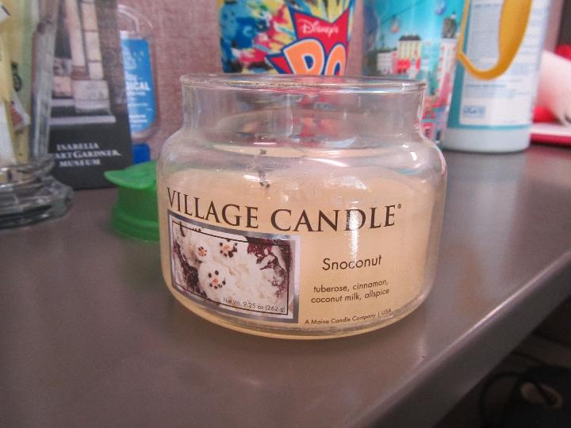
Scented candle on a desk

Picture 29
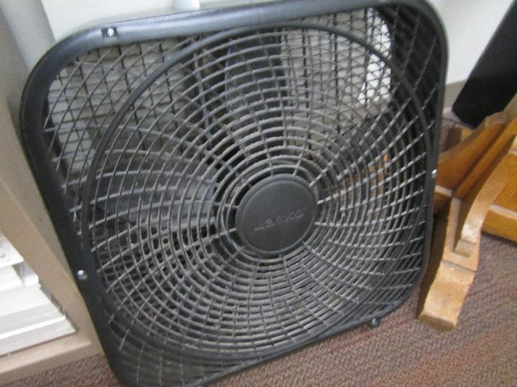
Dusty fan
Picture 30
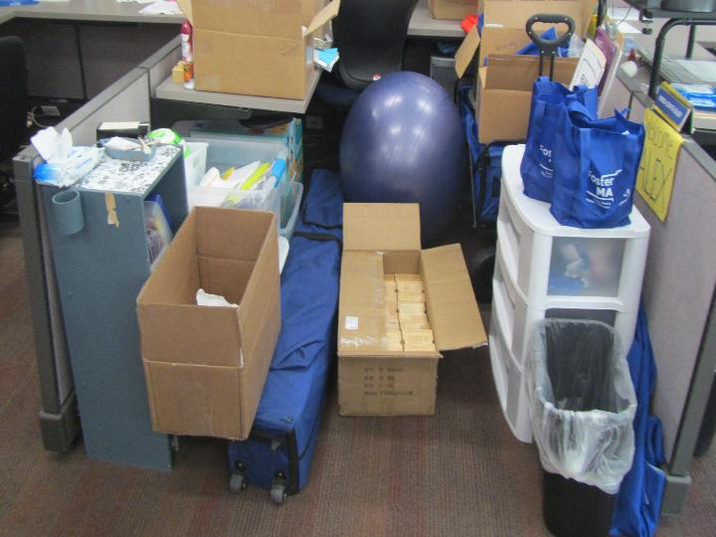
Accumulation of items in a cubicle area

Picture 31
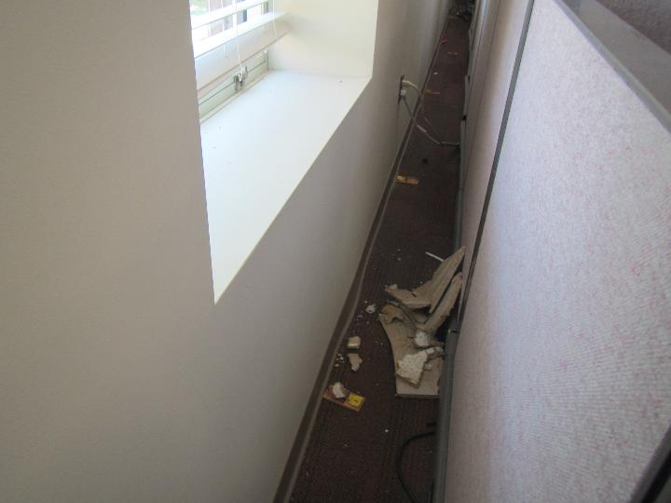
Debris in gap between workstation and wall
Picture 32
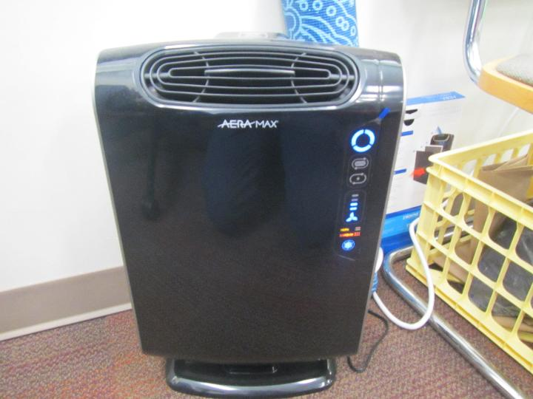
Air purifier

Location | Carbon  Dioxide  (ppm) | Carbon Monoxide  (ppm) | Temp  (°F) | Relative  Humidity  (%) | PM2.5  (µg/m³) | TVOC  (ppm) | Occupants  in Room | Windows  Openable | Ventilation |  | Remarks
 |  |  |  |  |  |  |  |  | Supply | Exhaust | Remarks
Background (outside) | 420 | ND | 88 | 30 | 2 | ND |  |  |  |  | Busy street in front of building, busy intersection close by, train tracks
DTA Lobby | 782 | ND | 73 | 52 | ND | ND | 10 | N | Y | Y
DTA Reception 1125 | 779 | ND | 75 | 50 | 1 | ND | 1 | N | Y | Y | Dusty fan, food
Mailroom | 693 | ND | 74 | 49 | ND | ND | 0 | N | Y | N
DTA Lobby Cubicles | 780 | ND | 72 | 52 | ND | ND | 1 | N | Y | Y | Plants
1108 Client Interview Room | 770 | ND | 71 | 53 | ND | ND | 0 | N | Y | N
1105 Training Room | 754 | ND | 71 | 54 | ND | ND | 0 | N | Y | N | Cleaning wipes
1123 Office | 668 | ND | 70 | 55 | ND | ND | 0 | N | Y | N | Hand sanitizer
1120 Office | 677 | ND | 70 | 57 | ND | ND | 0 | N | Y | N
1117 Office | 743 | ND | 71 | 56 | ND | ND | 0 | N | Y | N
DCF Meeting Room 1143 | 769 | ND | 73 | 51 | ND | ND | 0 | N | Y | N | WD CT
DCF Visiting Room 1141 | 741 | ND | 73 | 51 | ND | ND | 0 | N | Y | N
DCF Visiting Room 1139 | 726 | ND | 73 | 51 | ND | ND | 0 | N | Y | N
1146 Conference Room Side 1 | 595 | ND | 73 | 51 | ND | ND | 0 | N | Y | Y
1146 Conference Room Side 2 | 630 | ND | 74 | 52 | ND | ND | 0 | N | Y | Y | Loose CTs
DDS Secure Side 1st Floor
Cubicle Area 1 | 741 | ND | 74 | 52 | ND | ND | 1 | N | Y | Y | Hand sanitizer
Cubicle Area 2 | 751 | ND | 73 | 53 | ND | ND | 2 | N | Y | Y | Plants, personal fan, plant, hand sanitizer
Cubicle Area 3 | 724 | ND | 73 | 53 | ND | ND | 1 | N | Y | Y | Plant on paper towel
Cubicle Area 4 | 743 | ND | 73 | 54 | ND | ND | 1 | N | Y | Y | Cleaning wipes
1157 Office | 699 | ND | 73 | 52 | ND | ND | 0 | N | Y | N | Food (candy)
1156 Office | 686 | ND | 73 | 53 | ND | ND | 0 | N | Y | Y
1155 Office | 677 | ND | 72 | 55 | ND | ND | 0 | N | Y | N | Scented candle, food
1154 Office | 687 | ND | 72 | 56 | ND | ND | 0 | N | Y | N | Plants
1147 Office | 750 | ND | 72 | 57 | ND | ND | 1 | N | Y | N
DDS Kitchenette | 754 | ND | 73 | 55 | ND | ND | 0 | N | Y | Y | Odor from fridge, dirty fridge/freezer, toaster, popcorn machine
DTA 2nd Floor
Rooms 2210, 2211, 2212 |  |  |  |  |  |  |  |  |  |  | Unable to access - locked
DTA Kitchen | 509 | ND | 72 | 46 | ND | ND | 0 | N | Y | Y | WD CT, toaster, fridge
DTA Kitchenette | 506 | ND | 73 | 48 | ND | ND | 0 | N | Y | Y | Fridge, coffee maker, microwave, toaster oven
Cubicles (C) 2301, 2313, 2312, 2299 | 529 | ND | 73 | 48 | ND | ND | 0 | N | Y | Y | Cleaning wipes
C 2310, 2311, 2297, 2309 | 507 | ND | 72 | 48 | 1 | ND | 0 | N | Y | Y
C 2308, 2295, 2307 | 512 | ND | 72 | 49 | 1 | ND | 1 | N | Y | Y | Bowing CT
C 2306, 2305, 2294, 2293 | 527 | ND | 72 | 49 | 1 | ND | 1 | N | Y | Y
2303 and copy machine area | 531 | ND | 72 | 51 | 1 | ND | 0 | N | Y | Y | Copy machine
2204 Office | 518 | ND | 72 | 51 | 1 | ND | 0 | N | Y | Y
2203 Office | 569 | ND | 73 | 51 | 1 | ND | 0 | N | Y | Y
2202 Conference Room | 461 | ND | 72 | 53 | 1 | ND | 0 | N | Y | Y | Cardboard boxes on floor
C 2316, 2315, 2314 | 606 | ND | 72 | 52 | 0 | ND | 0 | N | Y | Y
C 2261-2265 | 535 | ND | 74 | 48 | 2 | ND | 1 | N | Y | Y
C 2267-2272 | 514 | ND | 74 | 48 | 2 | ND | 0 | N | Y | Y | Hand sanitizer, lotion, personal fan
C 2273-2278 | 556 | ND | 74 | 48 | ND | ND | 1 | N | Y | Y
C 2279-2284 | 526 | ND | 73 | 48 | 1 | ND | 1 | N | Y | Y | Scented candle, cleaning wipes
C 2285-2286 | 521 | ND | 73 | 48 | 1 | ND | 0 | N | Y | Y | Hand sanitizer spray
C 2287, 2288, 2296, 2298 | 527 | ND | 73 | 47 | 1 | ND | 0 | N | Y | Y | Cardboard boxes on floor
2289, 2290, 2300 | 601 | ND | 73 | 48 | ND | ND | 0 | N | Y | Y | Dusty personal fan
2291, 2302, 2292 | 550 | ND | 73 | 48 | ND | ND | 1 | N | Y | Y
DCF 2nd Floor
2257 | 576 | ND | 78 | 40 | ND | ND | 1 | N | Y | Y | Personal fan
2255 | 498 | ND | 77 | 43 | ND | ND | 0 | N | Y | Y | Mini fridge on elevated cabinet on carpet
Cubicle Section 4, includes 2410 | 509 | ND | 77 | 45 | ND | ND | 4 | N | Y | Y
Cubicle Section 3 | 584 | ND | 76 | 46 | ND | ND | 0 | N | Y | Y | Cardboard items on floor, cleaning wipes
Cubicle Section 2 | 504 | ND | 74 | 47 | ND | ND | 0 | N | Y | Y | Food
Cubicle Section 1 | 547 | ND | 74 | 46 | 1 | ND | 0 | N | Y | Y | Personal fan, air purifier
Cubicle Section Rear | 519 | ND | 74 | 46 | 1 | ND | 2 | N | Y | Y
2258 | 515 | ND | 75 | 45 | ND | ND | 0 | N | Y | N
2259 | 518 | ND | 75 | 45 | 1 | ND | 0 | N | Y | N | Mini fridge on carpet
2251 Kitchen | 551 | ND | 73 | 50 | ND | ND | 0 | N | Y | N | WD CT
DCF/DTA Shared Space
Shared Kitchen | 573 | ND | 72 | 51 | 1 | ND | 0 | N | Y | N | Toaster oven, refrigerator, hot cocoa mix
DCF Entry | 619 | ND | 72 | 50 | ND | ND | 3 | N | Y | N
2219 | 505 | ND | 74 | 46 | ND | ND | 0 | N | Y | Y | Previous WD on wall
2218 | 611 | ND | 75 | 45 | ND | ND | 0 | N | Y | N | Plant, mini fridge on carpet

