BACKGROUND

INDOOR AIR QUALITY
POST-OCCUPANCY ASSESSMENT

MassHire Framingham Career Center
39 Grant Street
Framingham, MA

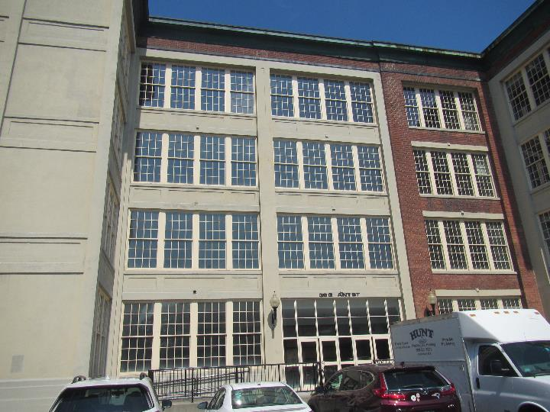

Prepared by:
Massachusetts Department of Public Health
Bureau of Environmental Health
Indoor Air Quality Program
September 2022
Building: | MassHire Framingham Career Center
Address: | 39 Grant Street, Framingham, MA
Assessment Requested by: | Angie Grant, Career Center Operations Manager, MassHire Framingham
Date of Post-Occupancy Assessment: | August 30, 2022
Massachusetts Department of Public Health/Bureau of Environmental Health (MDPH/BEH) Staff Conducting Assessment: | Ruth Alfasso, Inspector, Indoor Air  Quality (IAQ) Program
Building Description: | The building at 39 Grant Street was originally part of the Dennison Manufacturing Plant built in 1840. The building was vacant from 1990 to the early 2000s when the city of Framingham began working with developers to redevelop the site. The MassHire space has undergone a complete gut renovation. The suite contains offices, workstations, storage, and a small kitchen area.
Windows: | Not openable

METHODS
Please refer to the IAQ Manual for methods, sampling procedures, and interpretation of results (MDPH, 2015).

RESULTS AND DISCUSSION
The following is a summary of indoor air testing results (Table 1).
- Carbon dioxide levels were below the MDPH guideline of 800 parts per million (ppm) in the areas surveyed indicating adequate air exchange.
- Temperature was within or slightly below the MDPH recommended range of 70°F to 78°F in all areas tested. Some occupants reported the office was cold.
- Relative humidity was above the MDPH recommended range of 40 to 60% in all areas tested. This is reflective of outdoor conditions and is discussed further below.
- Carbon monoxide levels were non-detectable (ND) in all areas tested.
- Fine particulate matter (PM2.5) concentrations measured were below the National Ambient Air Quality Standard (NAAQS) limit of 35 μg/m³ in all indoor areas tested.
- Total volatile organic compounds (TVOCs) were ND in all areas tested.

Ventilation
A heating, ventilating, and air conditioning (HVAC) system has several functions. First it provides heating and, if equipped, cooling. Second, it is a source of fresh air. Finally, an HVAC system will dilute and remove normally occurring indoor environmental pollutants by not only introducing fresh air, but by filtering the airstream and ejecting stale air to the outdoors via exhaust ventilation. Even if an HVAC system is operating as designed, point sources of respiratory irritation may exist and cause symptoms in sensitive individuals.
The HVAC system consists of air handling units (AHUs) located on the roof (Picture 1), which draw in outside air and heat/cool it. Conditioned air is ducted to supply vents and returned via other ducted vents (Picture 2).
The HVAC system is controlled by digital thermostats. The MDPH IAQ Program recommends that the fan be set to the “on” setting to provide continuous circulation/filtration during occupied hours. At the time of assessment, some of the thermostats had not yet been set up for the space, which may account for the temperatures below the MDPH comfort level.
To have proper ventilation with a mechanical ventilation system, the systems must be balanced after installation to provide an adequate amount of fresh air to the interior of a room while removing stale air from the room. It is recommended that HVAC systems be re-balanced every five years to ensure adequate air systems function (SMACNA, 1994). These systems should have been balanced prior to occupancy.

Microbial/Moisture Concerns
No water-damaged materials, water stains or musty odors were observed during the visit. Note that relative humidity in the occupied space was above the MDPH comfort range. Furthermore, humidity in excess of 70% for long periods of time can lead to water damage of porous materials even in the absence of liquid water/condensation (ASHRAE, 2019). Condensate was being removed by the AHU, as indicated by water dripping out of the unit and puddling on the roof (Pictures 1 and 3). In addition, the dew point inside the building, which can be calculated from temperature and relative humidity, was lower than outside, which indicates that water has been removed from the air. Moving the thermostat set point up a few degrees would reduce the relative humidity given the same dew point. For example, at a temperature of 68°F and a relative humidity of 70%, the dew point would be 58°F. That same dew point at an air temperature of 74°F would lead to a relative humidity of 57%, which would be within the MDPH comfort range. For additional control of humidity, if the percent of outside air brought into the building is easily adjustable, the settings can be temporarily changed to bring less outside air in during periods of high outside temperature and humidity, and then returned to normal once the weather becomes more temperate.
As shown in Pictures 1 and 3, condensate from the AHU puddles on the roof. The roof height under the AHU is lower than that of the nearest roof drains, preventing this water from draining. Rainwater is also likely to collect here. While the roof is currently in good condition, puddling water can eventually lead to damage to the roof and leaks into the building. In addition, chronic puddling can lead to stagnant water and microbial growth which can result in odors being drawn into the AHU. Puddles may also attract both birds or insects (e.g., mosquitoes) for egg laying.
A wet cardboard box was noted inside the AHU cabinet (Picture 4). This item should be removed. Nothing should be stored inside the AHU cabinet.
Plants were noted in some areas of the office (Table 1; Picture 5). Plants should be well maintained, not overwatered, and placed on waterproof drip pans that are cleaned periodically.

Other Concerns
The AHU filters were examined and appear to need to be changed (Picture 6). AHU filters should be changed a minimum of twice a year, and more often if they appear significantly soiled when changed. During filter changes, the AHU cabinet should be cleaned/vacuumed out to remove debris that may be a source of particulates and odors to the indoor air. Filters should be at least a Minimum Efficiency Rating Value (MERV) of 8, or higher if they fit and the equipment can handle the pressure reductions caused by more restrictive filters.
Most of the office floors are not carpeted. A few walk-off mats and area rugs were noted (Table 1). Carpets and area rugs should be vacuumed regularly with a high efficiency particulate arrestance (HEPA) filter-equipped vacuum cleaner and cleaned annually (or semi-annually in soiled/high traffic areas) in accordance with Institute of Inspection, Cleaning and Restoration Certification (IICRC) recommendations (IICRC, 2012).
As noted during the pre-occupancy assessment, the configuration of the workstation walls in some areas creates a hidden channel behind furniture (Picture 5). Items and debris can be dropped into these areas out of sight, where it can be difficult to clean. A regular program of cleaning these areas will eliminate debris which can become a source of odors or harborage for pests.
Food and food preparation equipment were noted in the office (Table 1). Food preparation equipment should be kept clean to reduce smoke and odors. All food should be kept in tightly closed pest-proof containers.
As other areas in the building are being renovated for tenants, care should be taken to avoid impacts of construction on occupants of the MassHire suite. Use the guidance in the document “Construction and renovation generated pollutants in occupied buildings” to minimize impacts of construction in adjacent areas.
While not part of the office, the suspended ceiling in the shared bathrooms were missing tiles. An incomplete ceiling tile grid can allow moisture and odors into the plenum where they may migrate to other areas and will reduce the effectiveness of the exhaust vents.

RECOMMENDATIONS
In view of the findings at the time of assessment, the following recommendations are made:

Ventilation recommendations
- Ensure thermostats are activated. Set thermostat timers to the fan “on” setting to provide continuous filtration and ventilation during occupied hours.
- Raise the thermostat set point a few degrees to increase comfort and reduce relative humidity.
- Change the AHU filters now, and regularly at least twice a year and more often if needed. Use the best quality/highest MERV rated filters that can be used with current equipment.
- During filter changes, vacuum debris from AHU cabinet.
- If the HVAC system has not been balanced prior to this assessment, consider balancing the system and every five years (SMACNA, 1994).

Water damage recommendations
- If the amount of outside air can be changed easily, temporarily reduce outside air percentage during periods of very humid weather. Return to normal set points once the weather moderates.
- Remove water-damaged box from AHU cabinet and avoid storing other materials in this area.
- Consider repairs to the roof to slope the area under the AHU to a roof drain. Until such repairs are made, periodically monitor the roof, e.g. during filter changes, for membrane degradation, a buildup of debris, and pest (bird or mosquito) activity and clean/repair as needed.

Other recommendations
- Clean area rugs and mats regularly and deep clean once a year.
- Have a regular schedule of cleaning areas hidden behind workstation walls. Avoid using these areas for storage.
- Keep food in tightly closed pest-proof containers and keep food preparation equipment and areas clean.
- Ensure the restroom ceiling tile grid is intact.
- Follow guidance in the document “Construction and renovation generated pollutants in occupied buildings” to minimize impacts of construction as other spaces in the building get built out.
- Refer to the resource manual and other related indoor air quality documents located on the MDPH’s website for further building-wide evaluations and advice on maintaining public buildings. These documents are available at http://mass.gov/dph/iaq.

REFERENCES
ASHRAE, 2019. American Society of Heating, Refrigeration and Air Conditioning Engineers (ASHRAE) Ventilation for Acceptable Indoor Air Quality. ANSI/ASHRAE Standard 62.1-2019. Atlanta, GA.
IICRC. 2012. Institute of Inspection, Cleaning and Restoration Certification. Carpet Cleaning: FAQ.
MDPH. 2015. Massachusetts Department of Public Health. “Indoor Air Quality Manual: Chapters I-III”. Available at: Indoor air quality - manual and appendices | Mass.gov
SMACNA. 1994. HVAC Systems Commissioning Manual. 1st ed. Sheet Metal and Air Conditioning Contractors’ National Association, Inc., Chantilly, VA.
Picture 1
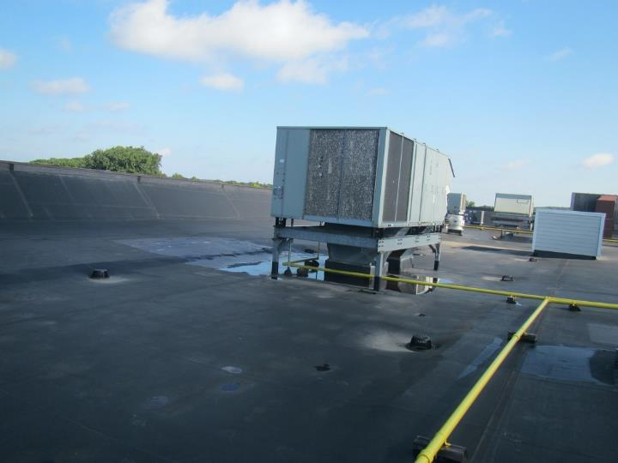
Rooftop AHU, note water pooling
Picture 2
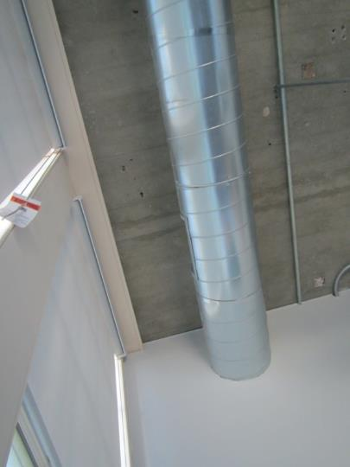
Supply vent, pointing towards exterior wall (arrow)
Picture 3
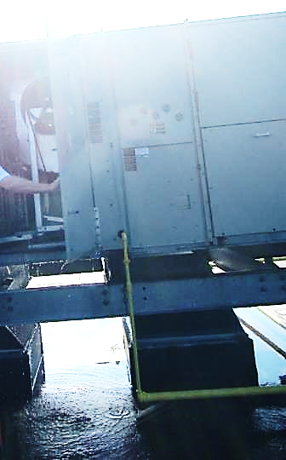
Water dripping from the AHU
Picture 4
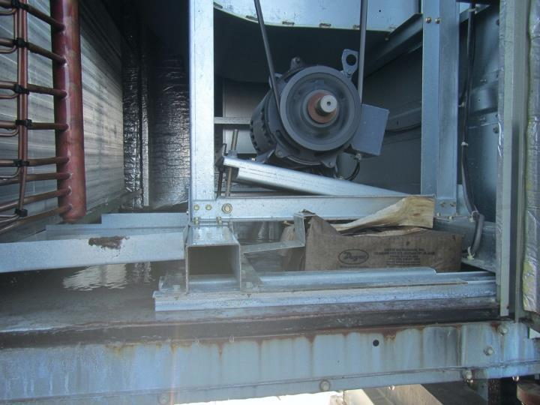
Wet cardboard box inside AHU
Picture 5
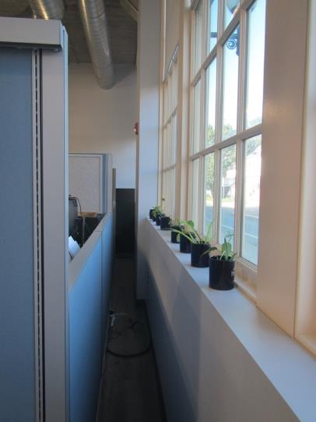
Channel between wall and cubicle
Picture 6
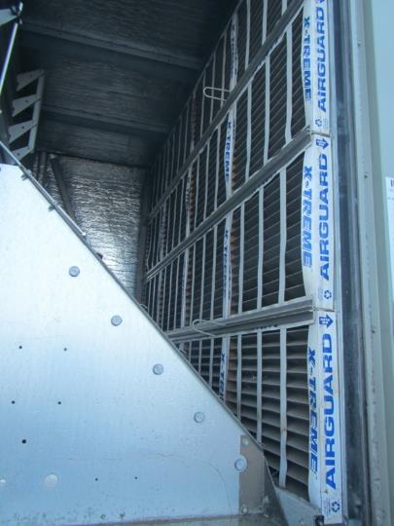
Bank of filters inside AHU, dark color shows they are soiled

Location | Carbon  Dioxide  (ppm) | Carbon Monoxide  (ppm) | Temp  (°F) | Relative  Humidity  (%) | PM2.5  (µg/m³) | TVOC  (ppm) | Occupants  in Room | Windows  Openable | Ventilation |  | Remarks
 |  |  |  |  |  |  |  |  | Supply | Exhaust
Background | 347 | ND | 80 | 74 | 17 | ND |  |  |  |  | Partly sunny
Kitchen | 413 | ND | 71 | 65 | 13 | ND | 1 | N | Y | Y | Plants, cooking equipment, crumbs in toaster oven
O’Hara workstation | 395 | ND | 70 | 68 | 11 | ND | 0 | N | Y | Y | Plants on windowsill, area rugs
Biran | 389 | ND | 69 | 68 | 11 | ND | 1 | N | Y | Y
Self Service desks | 462 | ND | 69 | 70 | 12 | ND | 0 | N | Y | Y
Receptionist | 390 | ND | 70 | 69 | 11 | ND | 1 | N | Y | Y
McQuaid | 401 | ND | 68 | 71 | 11 | ND | 1 | N | Y | N
Grant | 415 | ND | 68 | 72 | 13 | ND | 2 | N | Y | N
Bradshaw | 391 | ND | 68 | 73 | 12 | ND | 0 | N | Y | Y
Moriera | 379 | ND | 67 | 73 | 14 | ND | 0 | N | Y | N | Dry erase markers
Fernandez | 381 | ND | 67 | 73 | 12 | ND | 0 | N | Y | N | Hand sanitizer
McKenna | 387 | ND | 67 | 74 | 12 | ND | 0 | N | Y | N
IT support | 366 | ND | 67 | 74 | 12 | ND | 0 | N | Y | Y | Items
Vacant cube | 386 | ND | 74 | 64 | 14 | ND | 0 | N | Y | Y | Photocopier outside cube
Fernandez cute | 389 | ND | 73 | 64 | 12 | ND | 1 | N | Y | Y
Corner room | 379 | ND | 70 | 69 | 12 | ND | 0 | N | Y | Y
Jaklitsch | 379 | ND | 70 | 69 | 10 | ND | 0 | N | Y | Y | Cleaning products, food
Exterior office | 390 | ND | 69 | 71 | 14 | ND | 1 | N | Y | Y
Interior office | 376 | ND | 69 | 72 | 14 | ND | 0 | N | Y | Y
Diaz | 378 | ND | 68 | 73 | 11 | ND | 0 | N | Y | Y | Plant
Cubicle | 384 | ND | 68 | 73 | 11 | ND | 0 | N | Y | Y
Partners cubicle | 388 | ND | 68 | 73 | 13 | ND | 0 | N | Y | Y
Pena | 381 | ND | 68 | 73 | 12 | ND | 0 | N | Y | Y
Self service area | 379 | ND | 69 | 73 | 10 | ND | 0 | N | Y | Y
Rosen | 399 | ND | 68 | 74 | 11 | ND | 1 | N | Y | Y | Food
Conference/  training | 391 | ND | 68 | 74 | 12 | ND | 0 | N | Y | Y
Sibbald | 408 | ND | 70 | 74 | 11 | ND | 2 | N | Y | Y | Personal fan
Alvarado | 401 | ND | 68 | 74 | 8 | ND | 0 | N | Y | Y

