INDOOR AIR QUALITY ASSESSMENT

Franklin County Courthouse
425 Main Street
Greenfield, Massachusetts

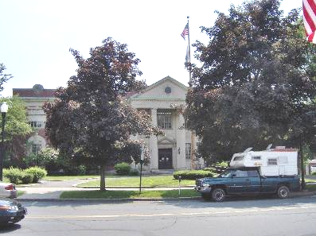

Prepared by:
Massachusetts Department of Public Health
Bureau of Environmental Health
Emergency Response/Indoor Air Quality Program
August 2007

Background/Introduction
At the request of Steve Carroll, Director of Court Facilities, Administrative Office of the Trial Court, an indoor air quality assessment was done at the Franklin County Courthouse (FCC), 425 Main Street, Greenfield, Massachusetts. This assessment was conducted by the Massachusetts Department of Public Health (DPH), Bureau of Environmental Health (BEH). Complaints of poor indoor air quality from occupants on the ground floor of the building prompted the assessment.
On June 8, 2007 a visit was made to the FCC by Michael Feeney, Director of BEH’s Emergency Response/Indoor Air Quality (ER/IAQ), Program. The FCC is a red brick, three-story building built in 1931. The third floor contains the judge’s chambers, the law library and the Franklin County Superior Court (SC). The second floor contains the Franklin County Family and Probate Court (FPC), Registry of Deeds, Clerk of Probate office, judge’s lobby and offices. The ground floor contains the Greenfield District Court (DC), civil clerk’s office, criminal clerk’s office, judge’s lobby, Franklin Regional Council of Governments office, lock-up and offices. Windows are openable throughout the building. An elevator was added to the eastern side of the building in the 1990s (Picture 1).

Methods
Air tests for carbon dioxide, temperature and relative humidity were taken with the TSI, Q-Trak, IAQ Monitor, Model 8551. BEH staff also performed a visual inspection of building materials for water damage and/or microbial growth.
Results
The FCC has an employee population of approximately 75. The tests were taken under normal operating conditions. Test results appear in Table 1.

Discussion
Ventilation
It can be seen from Table 1 that carbon dioxide levels were above 800 parts per million (ppm) in forty of fifty-five areas surveyed on the day of the assessment, which is indicative of poor air exchange in the majority of the areas. Of note were the lock-up, which had a carbon dioxide measurement of 2,461 ppm and the DC court room, which had a carbon dioxide measurement of 4,423 ppm. Please note that several areas were unoccupied during the assessment, which can greatly reduce carbon dioxide levels.
At this time, no functioning centralized heating, ventilating and air conditioning (HVAC) system exists in the building. The sole source of fresh air appears to be via openable windows. A number of offices and the holding area have window-mounted air conditioners (WACs) to temper indoor air during hot weather. The WACs observed do not seem likely to have the means to introduce fresh air.
The building originally had fresh air supplied by unit ventilator (univent) systems (Figure 1, Picture 2). Univents were found deactivated in all locations at the time of the assessment. A univent draws air from the outdoors through a fresh air intake located on the exterior wall of the building (Picture 3) and returns air through an air intake located at the base of the unit. Fresh and return air are mixed, filtered, heated and provided through an air diffuser located in the top of the unit. Adjustable louvers were set by hand to control the ratio of outside to recirculated air (Picture 4). The univents appear to be original to the construction of the building (1931), which would make them over 75 years old. Replacement parts from the manufacturer are unlikely to be obtainable to repair this equipment. In addition, this type of univent is not likely to have a filtration system, which would allow for normally occurring outdoor pollutants (e.g., pollen/dusts) to readily enter the building via the univents.
Mechanical exhaust ventilation was originally provided by wall-mounted vents (Picture 5) ducted to rooftop motors. Airflow was controlled by adjusting louvers by hand (Picture 6). FCC staff reported that rooftop exhaust motors were inoperable. It appears that an exhaust fan was installed in the holding cell to remove odors. While a transfer vents exist to allow for the draw of air (Picture 7), carbon dioxide measurements in the holding cell indicate minimal air exchange in this area. Without proper supply and exhaust ventilation normally occurring environmental pollutants can build up indoors and lead to IAQ/comfort complaints.
The building was originally designed to use cross-ventilation in the summer to provide comfort for building occupants. The FCC is equipped with windows on opposing exterior walls. This design allows for airflow to enter an open window, pass through a room, pass through the open door, enter the hallway, pass through the opposing room door and exit the building on the leeward side (opposite the windward side) (Figure 2). With all windows and doors open, airflow can be maintained in a building regardless of the direction of the wind. The system fails if the windows or doors are closed (Figure 3). Windows and doors were closed in most areas closed during the assessment, which can inhibit natural airflow.
To maximize air exchange, the MDPH recommends that both supply and exhaust ventilation operate continuously during periods of occupancy. In order to have proper ventilation with a mechanical supply and exhaust system, the systems must be balanced to provide an adequate amount of fresh air to the interior of a room while removing stale air from the room. It is recommended that existing ventilation systems be re-balanced every five years to ensure adequate air systems function (SMACNA, 1994). The date of the last balancing was not available at the time of the assessment. Due to the age and operational condition of the HVAC system, it is not likely that these systems can be balanced.
The Massachusetts Building Code requires that each area have a minimum ventilation rate of 15 cubic feet per minute (cfm) per occupant of fresh outside air or openable windows (SBBRS, 1997; BOCA, 1993). The ventilation must be on at all times that the room is occupied. Providing adequate fresh air ventilation with open windows and maintaining the temperature in the comfort range during the cold weather season is impractical. Mechanical ventilation is usually required to provide adequate fresh air ventilation.
Carbon dioxide is not a problem in and of itself. It is used as an indicator of the adequacy of the fresh air ventilation. As carbon dioxide levels rise, it indicates that the ventilating system is malfunctioning or the design occupancy of the room is being exceeded. When this happens a buildup of common indoor air pollutants can occur, leading to discomfort or health complaints. The Occupational Safety and Health Administration (OSHA) standard for carbon dioxide is 5,000 parts per million parts of air (ppm). Workers may be exposed to this level for 40 hours/week based on a time weighted average (OSHA, 1997).
The MDPH uses a guideline of 800 ppm for publicly occupied buildings. A guideline of 600 ppm or less is preferred in schools due to the fact that the majority of occupants are young and considered to be a more sensitive population in the evaluation of environmental health status. Inadequate ventilation and/or elevated temperatures are major causes of complaints such as respiratory, eye, nose and throat irritation, lethargy and headaches. For more information concerning carbon dioxide, please see Appendix A.
Temperature measurements ranged from 71º F to 77º F, which were within the MDPH recommended comfort guidelines during the assessment. The MDPH recommends that indoor air temperatures be maintained in a range of 70 º F to 78 º F in order to provide for the comfort of building occupants. Personal fans were observed in a number of work areas to increase comfort. In many cases concerning indoor air quality, fluctuations of temperature in occupied spaces are typically experienced, even in a building with an adequate fresh air supply. In addition, temperature control is often difficult in an old building without the ventilation system functioning as designed (e.g., univents deactivated, exhaust vents not functioning).
The relative humidity measurements during the assessment ranged from 34 to 61 percent which were within or near the lower end of the MDPH recommended comfort range. The MDPH recommends a comfort range of 40 to 60 percent for indoor air relative humidity. It is important to note however, that relative humidity measured indoors in certain areas of the ground floor exceeded outdoor measurements (range + 2 to 17 percent) (Table 1). This increase in relative humidity can indicate that the exhaust system alone is not operating sufficiently to remove normal indoor air pollutants (e.g., water vapor from respiration). Moisture removal is important since the sensation of heat conditions increases as relative humidity increases (the relationship between temperature and relative humidity is called the heat index). As indoor temperature rises, the addition of more relative humidity will make occupants feel hotter. If moisture is removed, the comfort of the individuals is increased. Removal of moisture from the air, however, can have some negative effects. The sensation of dryness and irritation is common in a low relative humidity environment. Low relative humidity is a common problem during the heating season in the northeast part of the United States.

Microbial/Moisture Concerns
The FCC has a history of water penetration problems, particularly in the crawlspace along the front of the building. Upon entering room 11, a musty odor was detected. Efflorescence (i.e., mineral deposits) and peeling paint was observed on the brickwork of exterior walls in room 11 (Picture 8). Efflorescence is a characteristic sign of water intrusion. As moisture penetrates and works its way through mortar around brick, stone or cementitious material it leaves behind these characteristic mineral deposits. The likely source of the moisture is rainwater accumulation against the foundation, seeping through cracks and crevices in the tarmac apron along the foundation of the north and west walls (Pictures 9 through 11). Of note is a large space between the apron and the foundation, which roughly corresponds to the efflorescence in room 11 (Picture 11).
The US Environmental Protection Agency (US EPA) and the American Conference of Governmental Industrial Hygienists (ACGIH) recommends that porous materials (e.g., ceiling tiles, carpet and wood) be dried with fans and heating within 24 to 48 hours of becoming wet (US EPA, 2001; ACGIH, 1989). If porous materials are not dried within this time frame, mold growth may occur. Water-damaged porous materials cannot be adequately cleaned to remove mold growth. The application of a mildewcide to moldy porous materials is not recommended.
Plants were observed in several areas. Plants, soil and drip pans can serve as sources of mold growth, thus should be properly maintained. Over-watering of plants should be avoided and drip pans should be inspected periodically for mold growth. Furthermore, plants and related materials should also not be located directly on porous materials (e.g., carpeting, paper products) to prevent damage and potential microbial growth in/on these materials.

Other Concerns
A number of other conditions that can affect indoor air quality were noted during the assessment. An open pipe with insulation that consists of a white, powdered material was found in the crawlspace (Picture 12). The material may contain asbestos and should be remediated in conformance with all applicable Massachusetts asbestos abatement and hazardous materials disposal laws. Concerns were raised regarding asbestos and wall materials. The interior walls of the FCC appear to be horsehair plaster built over walls constructed of terra cotta (Picture 13). In the early part of the 1900’s asbestos was commonly mixed into plaster as a replacement for horsehair. However, this material would not pose an exposure and related health risk if left intact.

Conclusions/Recommendations
The conditions related to indoor air quality problems at the FCC raise a number of issues. The building has an HVAC system that was installed when the building was originally constructed, but this system is likely inoperable. Therefore the only method available to introduce fresh air is opening windows. This problem is particularly acute in the DC court room, where lack of air exchange and high occupancy creates uncomfortable conditions (Table 1). If windows remain open during hot, humid weather, the building will not likely be cooled by WACs. For these reasons, a two-phase approach recommended. The first consists of short-term measures to improve air quality and the second consists of long-term measures that will require planning and resources to adequately address overall indoor air quality concerns.

The following short-term measures should be considered for implementation:
- Repair the tarmac apron around the edge of the foundation. Remove plants from the exterior wall/apron junction and seal with an appropriate material.
- Carpet and coving along all exterior walls in offices on the ground floor at the front (north wall) of the building should be removed. Carpeting should be removed in a manner consistent with recommendations in “Mold Remediation in Schools and Commercial Buildings” published by the US Environmental Protection Agency (US EPA, 2001). This document is available from the US EPA website: http://www.epa.gov/iaq/molds/mold_remediation.html. Replace with a non-porous material (e.g., non-slip tile).
- On days that do not require the use of window-mounted air conditioners, open windows in the DC court room and operate the univents (if functional) to create airflow. If feasible, consider moving DC hearings to the SC room when the SC is not in session.
- Consider moving some court activities in the 1st session courtroom to other areas within the FCC to reduce occupancy until long-term measures can be implemented.
- Ascertain if the exhaust ventilation system can be repaired. Examine the feasibility of repairing the motors to the original exhaust ventilation system and opening the exhaust vent ducts and hallway doors to create airflow.
- Examine the lockup and restroom exhaust vents. Repair is needed to maximize the air drawn by these vents.
- Remediate exposed pipe insulation in crawlspace in conformance with Massachusetts asbestos remediation and hazardous waste disposal laws.
- Have a sample of the plaster tested for asbestos content. If it contains asbestos, remediate plaster in a manner consistent with asbestos remediation laws and regulations and maintain intact plaster to prevent friability of asbestos.
- Ensure plants have drip pans. Examine drip pans periodically for mold growth and disinfect with an appropriate antimicrobial where necessary. Do not store on porous materials.

The following long-term measures should be considered.
- A ventilation engineer should be consulted to resolve air supply/exhaust ventilation issues building-wide. During the evaluation the following areas should be addressed:
  - Examine whether univents can be repaired. If not feasible, consideration should be given to replacing univents.
  - Examine the feasibility of rehabilitating and expanding the existing ventilation ductwork for retrofitting a mechanical ventilation system for first and second floor offices.
  - Examine the feasibility of providing an HVAC system for all basement offices.
References
ACGIH. 1989. Guidelines for the Assessment of Bioaerosols in the Indoor Environment. American Conference of Governmental Industrial Hygienists, Cincinnati, OH.

BOCA. 1993. The BOCA National Mechanical Code/1993. 8th ed. Building Officials and Code Administrators International, Inc., Country Club Hill, IL.
OSHA. 1997. Limits for Air Contaminants. Occupational Safety and Health Administration. Code of Federal Regulations. 29 C.F.R 1910.1000 Table Z-1-A.

SBBRS. 1997. Mechanical Ventilation. State Board of Building Regulations and Standards. Code of Massachusetts Regulations. 780 CMR 1209.0

SMACNA. 1994. HVAC Systems Commissioning Manual. 1st ed. Sheet Metal and Air Conditioning Contractors’ National Association, Inc., Chantilly, VA.
US EPA. 2001. Mold Remediation in Schools and Commercial Buildings. US Environmental Protection Agency, Office of Air and Radiation, Indoor Environments Division, Washington, D.C. EPA 402-K-01-001. March 2001.
Picture 1

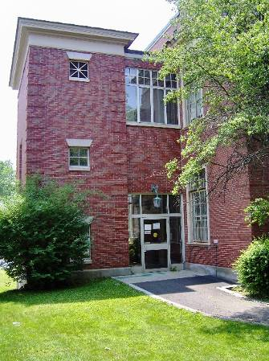

Elevator Added to East Wall of FCC

Picture 2

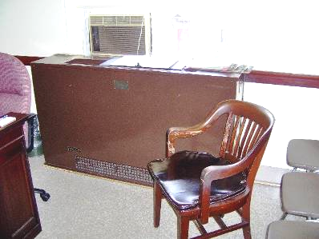

1930’s Vintage Univent
Picture 3

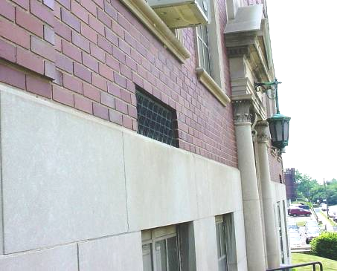

Univent Fresh Air Intake

Picture 4

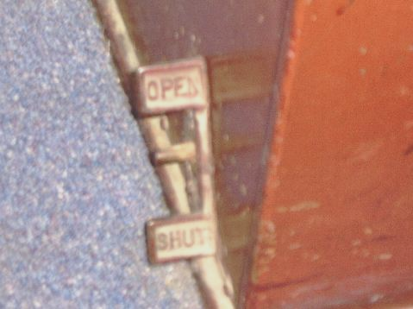

Univent Louver Control
Picture 5

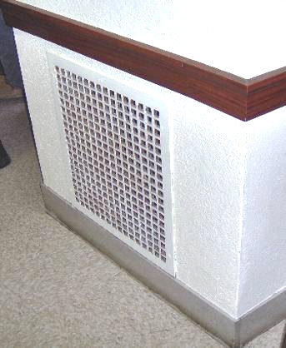

Exhaust Vent

Picture 6

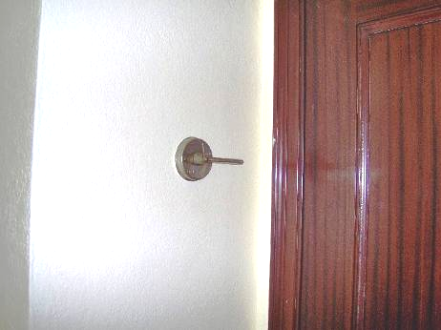

Exhaust Vent Louver Control
Picture 7

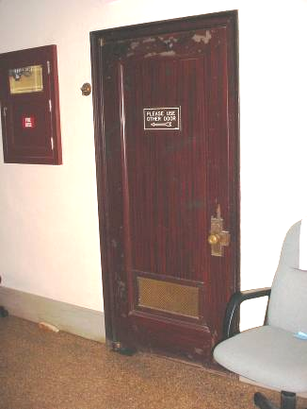

Lock-Up Transfer Air Vent (Bottom of Door)

Picture 8

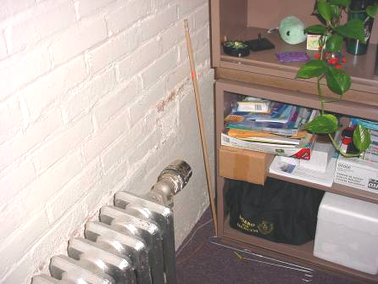

Efflorescence in Room 11
Picture 9

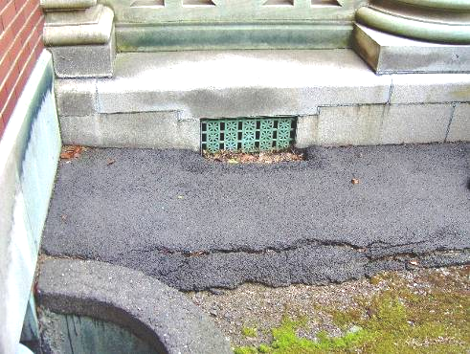

Cracks in Apron, North Wall of Building

Picture 10

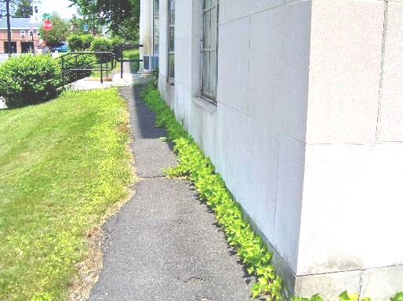

Cracks in Apron and Plants in Apron/Wall Junction, West Wall of Building
Picture 11

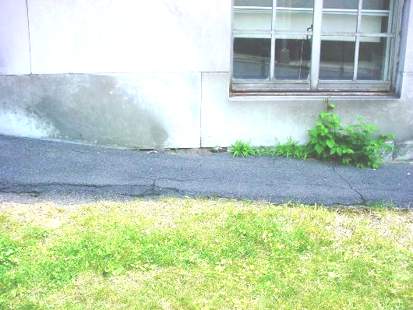

Cracks in Apron Exposing Foundation of Room 11 Window, West Wall of Building

Picture 12

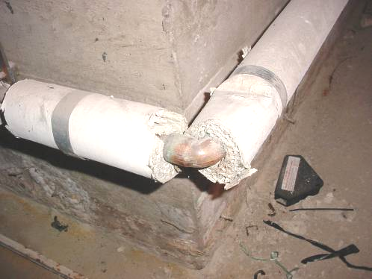

Insulation on Pipes in Crawlspace
Picture 13

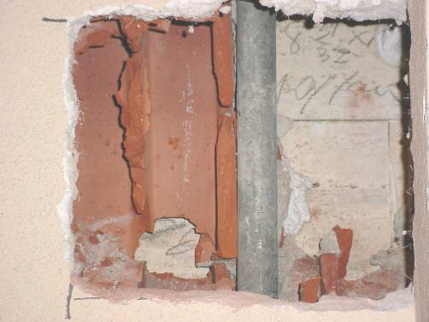

Hole in Wall, First Floor, Note Terracotta
Location | Carbon  Dioxide  (ppm) | Temp  (°F) | Relative  Humidity  (%) | Occupants  in Room | Windows  Openable | Ventilation |  | Remarks
 |  |  |  |  |  | Supply | Exhaust | Remarks
Outside  (Background) | 372 | 84 | 44
Law library | 485 | 73 | 40 | 3 | Y | Y | Y | Ceiling fans  Supply off  Exhaust off
205 | 777 | 74 | 40 | 2 | Y | N | N | Window -mounted air-conditioner
205 office | 763 | 73 | 36 | 1 | Y | N | N | Window -mounted air-conditioner
206 superior court | 599 | 71 | 41 | 0 | Y | Y | Y | Supply off  Exhaust off
222 | 1650 | 72 | 40 | 5 | Y | N | N | Window -mounted air-conditioner
219 | 788 | 73 | 41 | 1 | Y | N | N | Window -mounted air-conditioner  Door open
218 | 889 | 72 | 40 | 2 | Y | N | N | Window -mounted air-conditioner
216 | 750 | 74 | 43 | 0 | Y | N | N | Window -mounted air-conditioner  Door open
215 | 587 | 74 | 44 | 0 | Y | N | N | Window -mounted air-conditioner  Photocopier  Hole in wall  Window open
212 | 618 | 75 | 45 | 3 | Y | N | N | Window -mounted air-conditioner  Window open  Door open
210 | 600 | 74 | 42 | 0 | Y | N | N
Registry of Deeds | 779 | 74 | 37 | 10 | Y | Y | Y | Supply off  Exhaust off  6 water damaged ceiling tiles  Window -mounted air-conditioner
134 | 808 | 74 | 36 | 1 | Y | N | N | Window -mounted air-conditioner Door open
138 | 792 | 74 | 35 | 0 | Y | N | ` | Window -mounted air-conditioner
Registry of Deeds Plans | 793 | 74 | 34 | 0 | Y | N | N | Window -mounted air-conditioner
132 | 796 | 74 | 36 | 0 | Y | N | N | Window -mounted air-conditioner  Door open
Registry of Deeds copier room | 951 | 77 | 38 | 0 | Y | N | N | Window -mounted air-conditioner  Door open
129 | 744 | 77 | 40 | 0 | Y | N | N | Window -mounted air-conditioner  Door open
Probate court room | 1218 | 76 | 37 | 0 | Y | Y | Y | Supply off  Exhaust off  Window -mounted air-conditioner
145 | 1267 | 76 | 38 | 2 | N | N | N | Door open
Probate vault | 1257 | 76 | 39 | 0 | N | N | N | Door open
111 | 1198 | 76 | 39 | 7 | Y | Y | Y | Window -mounted air-conditioner  Plants  Door open
153 | 1202 | 76 | 42 | 4 | Y | N | N | Window -mounted air-conditioner  Door open
112 | 1215 | 76 | 43 | 1 | Y | N | N | Window -mounted air-conditioner  Door open
Registry of Probate | 1184 | 76 | 44 | 1 | U | N | N | Window -mounted air-conditioner
Probate judge’s lobby | 1090 | 76 | 44 | 2 | Y | N | N | Window -mounted air-conditioner
Main hall 1st floor | 931 | 77 | 46 | 10 | Y | Y | Y
101 | 869 | 76 | 44 | 0 | Y | N | N | Window open  Window -mounted air-conditioner
102 | 734 | 75 | 40 | 0 | Y | N | Y
105 | 966 | 76 | 41 | 4 | Y | N | N | Window -mounted air-conditioner
121 | 973 | 74 | 36 | 0 | Y | N | N | Hole in wall
20 | 872 | 77 | 45 | 3 | Y | N | N | Window open  Window -mounted air-conditioner  Ceiling fan  Door open
22 | 890 | 77 | 45 | 2 | Y | N | N | Ceiling fan  Door open
11 | 1695 | 74 | 49 | 0 | Y | N | N | Window -mounted air-conditioner  Musty odor openr  Efflorescence
24 | 961 | 75 | 49 | 1 | Y | N | N | Window -mounted air-conditioner  Door open
Building inspector office | 969 | 76 | 50 | 0 | N | N | N | Door open
25 inner office | 991 | 77 | 51 | 2 | N | N | Y | Exhaust off  Door open
25 | 981 | 77 | 51 | 0 | N | N | Y | Exhaust off  Door open
16 | 947 | 75 | 44 | 0 | N | N | Y
26 | 1356 | 75 | 42 | 0 | N | N | N
27 | 1480 | 74 | 40 | 0 | Y | N | N | Window -mounted air-conditioner
District court room | 4423 | 74 | 43 | 50+ | Y | Y | Y | Supply off  Exhaust off  Window -mounted air-conditioner
29 | 1495 | 74 | 46 | 4 | 4 | N | N | Window -mounted air-conditioner  Door open
29 private office | 1494 | 74 | 48 | 2 | Y | N | N | Window -mounted air-conditioner  Door open
District court room hallway | 1232 | 75 | 54 | 30+ | N | N | N
40 | 968 | 76 | 48 | 4 | Y | N | N | Window -mounted air-conditioner
41 | 908 | 76 | 46 | 1 | N | N | N | Window -mounted air-conditioner  Plants
44 | 939 | 76 | 45 | 0 | Y | N | N | Window -mounted air-conditioner  Plants
48 | 1006 | 76 | 53 | 0 | Y | Y | Y | Supply off  Exhaust off  Window -mounted air-conditioner  Door open
50-51 | 934 | 76 | 50 | 4 | N | N | N | Personal fan
51 private office | 1054 | 76 | 47 | 0 | N | N | N | Window -mounted air-conditioner
Probation | 1425 | 73 | 46 | 4 | Y | N | N | Window -mounted air-conditioner
56 | 1348 | 74 | 40 | 3 | N | N | N | Window -mounted air-conditioner
58 | 1366 | 73 | 38 | 0 | Y | N | N | Window -mounted air-conditioner plants
10 lock up | 2461 | 75 | 61 | 6 | N | N | Y | Transfer air vents as supplies

Buckeye Heatovents manufactured by the Buckeye Blower Company of Columbus, OH. No on-line references for the manufacturer could be located.

